**Cyclistic Bike-Share Case Study: Analyzing Rider Behavior to Drive Membership Growth**

**Author:** Jatin Sharma

**Date:** july 30, 2025

**1. Introduction**

The primary objective of this case study is to understand the differences in how annual members and casual riders use Cyclistic bikes. The insights derived from this analysis will inform a new marketing strategy aimed at converting casual riders into annual members, thereby maximizing the company's annual membership count.

**2. The Business Problem**

The Director of Marketing at Cyclistic has identified a key business challenge: maximizing the number of annual memberships. My role as a junior data analyst is to investigate the usage patterns of Cyclistic's two primary user types—annual members and casual riders—to determine how they use the bikes differently. This analysis will provide the data-backed insights necessary to develop a new marketing strategy and present compelling recommendations to Cyclistic executives.

**3. Data Preparation and Processing**

The data used for this analysis was sourced from two public datasets provided by Divvy (the company that manages Cyclistic's bike-share program): Divvy 2019 Q1 and Divvy 2020 Q1.

* **Data Source Credibility (ROCCC):** The data is considered **Reliable**, **Original**, **Comprehensive**, and **Current** for the analyzed quarters. It is **Cited** as it is a public data source from the bike-share company itself.
* **Data Cleaning and Transformation:**
  + Downloaded and stored the data in a spreadsheet format.
  + Created a ride_length column by subtracting the ride start time from the end time.
  + Created a day_of_week column using the WEEKDAY() function to identify ride patterns across the week.
  + Filtered out corrupted data, including rows with negative ride lengths, indicating a data entry error.

**4. Analysis and Key Findings**

To identify key trends and relationships, the data from both quarters was aggregated using pivot tables and descriptive calculations.

* **Average Ride Length:**
  + The average ride length for **annual members** was consistently around **12 minutes** in both 2019 Q1 and 2020 Q1.
  + The average ride length for **casual riders** was significantly longer, at approximately **28-30 minutes** in both periods.
* **Ride Patterns:**
  + The stark difference in average ride length is the most significant finding. It suggests that annual members primarily use the bikes for short, purposeful trips, such as commuting.
  + In contrast, casual riders are using the service for much longer durations, indicating a preference for leisurely, recreational, or sightseeing activities.
* **Data Visualization:** A clustered bar chart was created to visualize this key finding. The chart clearly shows the average ride lengths for casual riders and members, with a side-by-side comparison of 2019 and 2020 data. This visualization serves as a compelling and easily digestible summary of the core insight.

**5. Conclusion and Recommendations**

The analysis clearly demonstrates that annual members and casual riders are two distinct user segments with fundamentally different needs. Annual members prioritize efficiency and convenience, while casual riders prioritize flexibility and leisure.

Based on this analysis, the following three recommendations are proposed to the Cyclistic marketing team to drive membership growth:

**Recommendation 1: Develop a New Membership Tier for Leisure Riders.** Introduce a "Day Pass" or "Leisure Pass" to offer unlimited rides for a fixed, predictable fee over a 24-hour period. This new tier would address the needs of casual riders who are likely deterred by the per-minute costs of longer, recreational trips.

**Recommendation 2: Launch Targeted Marketing Campaigns.** Focus marketing efforts on channels that reach the casual rider demographic, particularly during high-use periods like weekends. Campaigns should highlight the value proposition of the new leisure pass and emphasize the freedom and affordability it offers for longer, enjoyable rides.

**Recommendation 3: Enhance the User Experience to Support Leisure-based Rides.** Integrate features into the Cyclistic app that cater to the casual rider's exploratory behavior. This could include partnerships with local businesses to offer discounts, in-app guides for scenic routes, and a "savings tracker" that shows how much a rider has saved by choosing a pass over a pay-per-ride model.

By implementing these recommendations, Cyclistic can better align its product offerings and marketing with the unique behavior of casual riders, ultimately leading to a successful strategy for converting them into loyal, long-term members.

FAUTLT IN DATA:

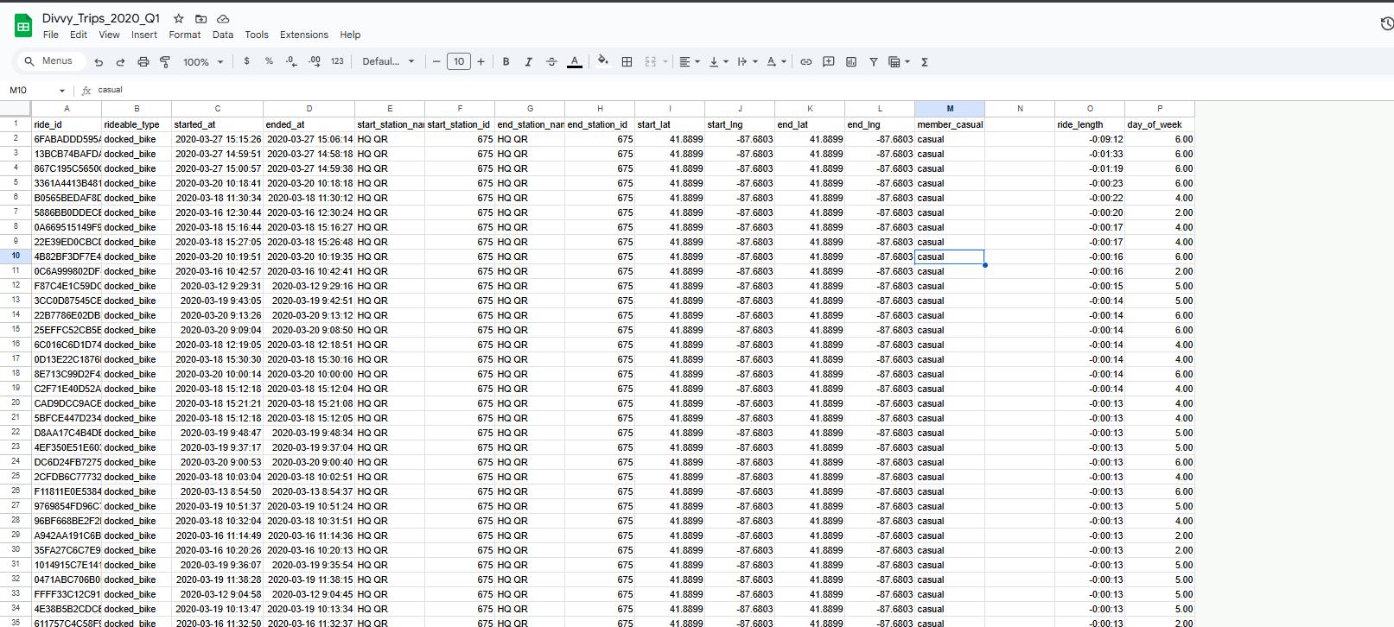the 2020 data sets has ride length in -ve which means there is fault in data entry while the time of starting ride and ending the ride

PIVOT TABLES:

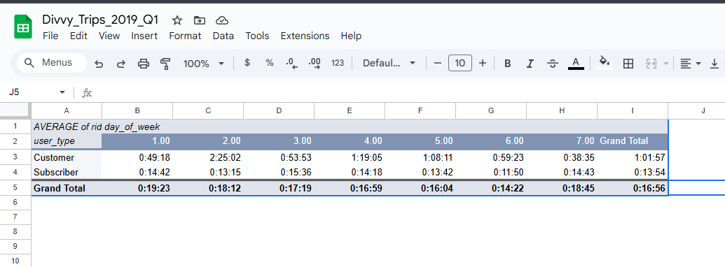

VISUALIZATION:

