CERTIFICATE 2
ACKNOWLEDGEMENT 3
CHAPTER 1: INTRODUCTION 9
1.1 Background 9
1.2 Problem Statement 9
CHAPTER 2: LITERATURE REVIEW AND SYSTEM ANALYSIS 11
2.1 Introduction 11
2.2 Review of Existing Systems 11
CHAPTER 3: METHODOLOGY AND SYSTEM DESIGN 13
3.1 System Architecture 13
3.2 Modules 13
3.3 Database Design 13
3.4 Input Design 13
3.5 ER Diagram 14
3.6 ER Diagram Explanation 14
CHAPTER 4: IMPLEMENTATION 15
CHAPTER 5: RESULTS AND DISCUSSION 17
CHAPTER 6: CONCLUSION AND FUTURE SCOPE 19
6.1 Conclusion 19
6.2 Future Scope 19
REFERENCES / BIBLIOGRAPHY 20

Certificate

I hereby recommend that the project report is prepared under my supervision Jatin Kumar, Gopal, Suvarna KB, Ratna and Saba Fairoz entitled “DIgiAttend” be accepted in complete fulfilment of the requirements for the degree of “Masters of Computer Application”.

Mr. P Arvindu Devi Pattabhi
Department of Compute’s Application
Kishkindha University, Ballari.

Acknowledgement

I would like to express my sincere gratitude to all those who supported and guided me in the successful completion of the project titled “DigiAttend”.
First, I thank our respected HOD of the Department of Computer Applications for providing the opportunity and necessary facilities to carry out this project successfully.
I would like to express my heartfelt thanks to our project guide and faculty members for their valuable guidance, encouragement, and continuous support throughout the development of this project. Their suggestions and motivation helped me improve the quality of the work.
I also thank my friends and classmates for their cooperation, ideas, and support during the project development process.
Finally, I would like to thank my parents and family members for their constant encouragement and moral support, which helped me complete this project successfully.
This project has helped me gain practical knowledge and improve my technical and problem-solving skills in the field of software development.

Introduction Of Problem And Feasibility Study

In the modern world, educational institutions and organizations are increasingly adopting digital technologies to improve efficiency and accuracy in their daily activities. Attendance management is an important task that is traditionally performed using manual registers and paperwork. These manual methods are time-consuming, difficult to maintain, and may lead to errors such as incorrect entries, loss of records, and difficulty in generating reports.
To overcome these problems, the DigiAttend project is developed as a digital attendance management system. DigiAttend is designed to automate the process of recording, storing, and monitoring attendance information in a simple and efficient manner. The system allows teachers or administrators to mark attendance electronically, while students can view their attendance details through the platform.
The project aims to reduce manual work, improve data accuracy, save time, and provide secure management of attendance records. It also helps institutions generate attendance reports quickly and monitor student performance effectively. DigiAttend uses modern software technologies and database systems to ensure smooth functioning and easy accessibility.
This project demonstrates how digital solutions can improve administrative tasks and create a smarter and more efficient attendance management system.

Problem Statement

Traditional attendance systems rely heavily on paper-based registers and manual calculations, which create several challenges for educational institutions and organizations. Manual attendance tracking consumes more time, increases paperwork, and may lead to human errors such as incorrect marking, duplicate entries, and loss of data.
Maintaining attendance records manually also makes it difficult to generate reports, monitor attendance percentages, and track student or employee performance efficiently. In large institutions, handling attendance data for many users becomes complex and less secure.
Therefore, there is a need for an automated and reliable attendance management system that can simplify attendance tracking, reduce manual effort, improve accuracy, and provide quick access to attendance records. DigiAttend is proposed to solve these issues by offering a secure and efficient digital attendance management solution.

Feasibility Study

A feasibility study is conducted to determine whether the DigiAttend project can be developed successfully and implemented effectively.
1. Technical Feasibility
The DigiAttend system is technically feasible because it can be developed using commonly available technologies such as Python/Java, MySQL databases, and web or mobile development tools. The required hardware and software resources are easily accessible, and the system can run efficiently on standard computers or smartphones.
2. Economic Feasibility
The project is economically feasible because it reduces paperwork, manual labor, and administrative costs. The development cost is affordable, and the system helps save time and resources in the long term.
3. Operational Feasibility
The system is easy to use for administrators, teachers, and students. Users can quickly learn how to operate the application with minimal training. DigiAttend improves the overall attendance management process and increases efficiency in daily operations.
4. Schedule Feasibility
The project can be completed within the planned time using proper project management and development methods. The modules and features can be implemented step by step according to the project schedule.
5. Social Feasibility
DigiAttend supports digital transformation and promotes a paperless environment. It provides transparency, better communication, and efficient record management, making it beneficial for educational institutions and organizations.

Literature Review
The rapid growth of digital technologies has encouraged educational institutions and organizations to replace traditional manual systems with automated solutions. Attendance management is one of the important administrative activities where automation can improve efficiency, accuracy, and transparency. Several researchers and developers have proposed different attendance management systems using various technologies.
Traditional attendance systems based on paper registers require significant manual effort and are more likely to produce errors such as incorrect entries, duplicate records, and data loss. These systems also make report generation and attendance analysis difficult. Due to these limitations, many institutions have started adopting digital attendance systems.
Mobile-based attendance applications are another modern approach where attendance can be recorded using smartphones. Such systems provide real-time access to attendance information for students, teachers, and parents. Cloud-based attendance systems further improve accessibility and data storage by allowing users to access records from anywhere through the internet.
The proposed project, DigiAttend, is designed by considering the advantages of existing attendance systems while reducing complexity and cost. The system focuses on providing a user-friendly, secure, and efficient digital attendance management solution that simplifies attendance tracking and improves record maintenance for educational institutions and organizations.

System Design – DigiAttend

Overview
The DigiAttend system is designed to automate the attendance management process in educational institutions and organizations. The system provides a digital platform where administrators and faculty members can manage attendance records efficiently, while students can view their attendance details in real time.
The system follows a simple client-server architecture where users interact with the application through a user interface connected to a centralized database.

System Architecture
+-------------------+
|STUDENT
+-------------------+
|
v
+-------------------+
|USER
INTERFACE
+-------------------+
|
v
+-------------------+
|APPLICATION
LOGIC
+-------------------+
|
v
+-------------------+
|DATABASE
+-------------------+
^
|
+-------------------+
|ADMIN/FACULTY
+-------------------+

Modules of DigiAttend

1. Admin Module
The admin manages the overall system operations.
Functions:
- Add/Delete student records
- Add faculty details
- Manage courses and subjects
- Generate attendance reports
- Monitor attendance records

2. Faculty Module
Faculty members are responsible for marking attendance.
Functions:
- Login securely
- Select Particular subject
- Mark attendance
- Update attendance records
- View attendance reports

3. Student Module
Students can access their attendance details.
Functions:
- Login to the system
- View attendance percentage
- Check daily attendance status
- View reports and notifications

Database Design

Tables Used
1. Student Table
Field Name | Description
Student_ID | Unique student ID
Student_Name | Name of student
Email | Student email

2. Faculty Table
Field Name | Description
Faculty_ ID | Unique faculty ID
Faculty_ Name | Faculty name
Email | Faculty email

3. Attendance Table
Field Name | Description
Attendance_ ID | Attendance record ID
Student_ ID | Student reference
Faculty_ ID | Faculty reference
Date | Attendance date
Status | Present/Absent

Input Design

The input design ensures accurate data entry into the system.
Inputs include:
- Student details
- Faculty details
- Attendance status
- Login credentials
Validation methods are used to avoid incorrect or duplicate entries.

Output Design
The system generates outputs in a user-friendly format.
Outputs include:
- Attendance reports
- Student attendance percentage
- Daily attendance status
- Faculty attendance records

Security Design
The DigiAttend system includes security features to protect data.
Security measures:
- Username and password authentication
- Secure database storage
- Restricted access for users
- Backup and recovery support

Advantages of System Design
- Reduces manual work
- Improves attendance accuracy
- Saves time and paperwork
ER Diagram for DigiAttend

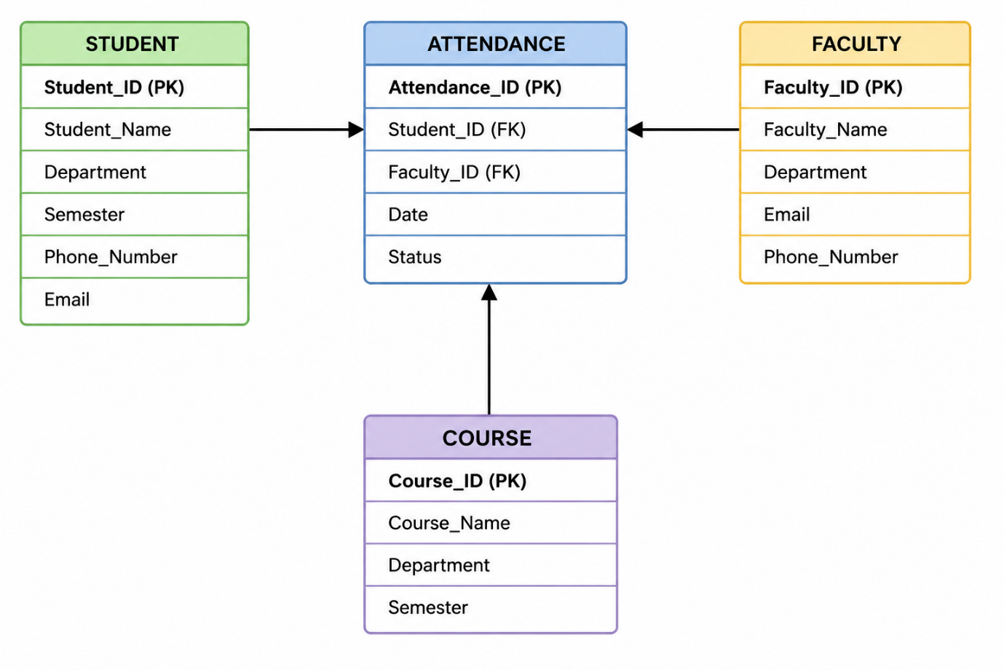

ER Diagram Explanation – DigiAttend

The above ER (Entity Relationship) Diagram represents the database structure of the DigiAttend project. It contains four main entities: Student, Attendance, Faculty, and Course. These entities are connected through relationships to manage attendance information efficiently.

1. STUDENT Entity
The STUDENT entity stores all information related to students.
Attributes:
- Student_ ID (PK) – Unique identification number for each student.
- Student_ Name – Name of the student.
- Department – Department of the student.
- Semester – Current semester of the student.
- Phone_ Number – Contact number.
- Email – Student email address.
Purpose:
This entity helps maintain student details and connect students with attendance records.

2. ATTENDANCE Entity
The ATTENDANCE entity stores daily attendance details.
Attributes:
- Attendance_ ID – Unique attendance record ID.
- Student_ ID (FK) – Foreign key connected to Student entity.
- Faculty_ ID (FK) – Foreign key connected to Faculty entity.
- Date – Date of attendance.
- Status – Attendance status such as Present or Absent.
Purpose:
This entity records attendance information for students and links faculty members who mark attendance.

3. FACULTY Entity
The FACULTY entity stores information about teachers or faculty members.
Attributes:
- Faculty_ ID (PK) – Unique faculty identification number.
- Faculty_ Name – Name of faculty member.
- Department – Department name.
- Email – Faculty email address.
- Phone_ Number – Contact number.
Purpose:
This entity helps manage faculty details and their attendance activities.

4. COURSE Entity
The COURSE entity stores course or subject details.
Attributes:
- Course_ ID (PK) – Unique course identification number.
- Course_ Name – Name of the course.
- Department – Department offering the course.
- Semester – Semester associated with the course.
Purpose:
This entity manages subject or course information related to students and faculty.

Relationships in the ER Diagram
- One student can have multiple attendance records.
- One faculty member can mark attendance for many students.
- Attendance records are connected using foreign keys.
- Courses are associated with students and departments for academic management.

Advantages of the ER Diagram
- Provides clear database structure.
- Reduces data redundancy.
Implementation of DigiAttend

Overview
The implementation phase of the DigiAttend project focuses on developing and integrating all modules of the digital attendance management system. The system is designed using programming languages, database management systems, and user-friendly interfaces to automate attendance recording and management.
The implementation process includes database creation, user interface development, coding of modules, testing, and deployment of the system.

Technologies Used
Component | Technology Used
Programming Language | Python / Java
Frontend | HTML, CSS, JavaScript
Backend | Python (Django/Flask) or Java
Database | Mongo DB / Firebase
Operating System | Windows/Linux
Tools Used | VS Code / PyCharm / Eclipse

Modules Implementation
1. Login Module
This module provides secure access to users such as administrators, faculty members, and students.
Features:
Username and password authentication
Role-based login
Secure access control
Process:
User enters login credentials.
System validates details from the database.
Access is granted based on user role.
2. Student Management Module
This module manages student information.
Functions:
Add new student records
Update student details
Delete student records
Search student information
Implementation:
Student details are stored in the database using SQL queries and displayed through the user interface.

3. Faculty Management Module
This module stores and manages faculty information.
Functions:
Add faculty details
Update faculty records
Assign courses
Manage attendance activities

4. Attendance Module
This is the core module of DigiAttend.
Functions:
Mark student attendance
Update attendance status
Store attendance records
View attendance history
Implementation Steps:
Faculty selects class and subject.
Student list is displayed.
Attendance is marked as Present/Absent.
Data is stored in the attendance table.
5. Report Generation Module
This module generates attendance reports automatically.
Features:
Daily attendance reports
Monthly attendance reports
Attendance percentage calculation
Export and print reports

Database Implementation
The DigiAttend system uses a relational database to store records securely.
Main Tables:
Student Table
Faculty Table
Attendance Table
Course Table

Testing in DigiAttend Project

Testing is an important phase in the development of the DigiAttend system. It helps identify errors, improve system performance, and ensure that all modules work correctly. Different types of testing are performed to verify the functionality, security, and reliability of the attendance management system.

Unit Testing for DigiAttend Project
Definition
Unit Testing is a type of software testing in which individual modules or components of the system are tested separately to verify that each function works correctly.
In the DigiAttend project, unit testing is performed on each module such as Login, Student Management, Faculty Management, Attendance Management, and Report Generation.

Unit Test Cases
Test Case ID | Module | Test Description | Input | Expected Result | Status
UT01 | Login Module | Verify valid login | Correct username & password | Login successful | Pass
UT02 | Login Module | Verify invalid login | Wrong password | Error message displayed | Pass
UT03 | Student Module | Add new student | Student details | Student record added | Pass
UT04 | Student Module | Delete student record | Student ID | Student removed successfully | Pass
UT05 | Faculty Module | Add faculty details | Faculty information | Faculty record saved | Pass
UT06 | Attendance Module | Mark attendance | Present/Absent status | Attendance stored correctly | Pass
UT07 | Attendance Module | View attendance | Student ID | Attendance displayed | Pass
UT08 | Report Module | Generate report | Attendance data | Report generated successfully | Pass
UT09 | Database Module | Verify database connection | Database request | Connection established | Pass

Unit Testing Process
- Identify individual modules.
- Test each module separately.
- Provide valid and invalid inputs.
- Compare actual results with expected results.
- Fix errors if any issues are found.

Advantages of Unit Testing
- Detects errors at an early stage.
- Improves code quality.
- Simplifies debugging process.
- Ensures individual module reliability.
- Reduces development cost and time.

Conclusion
Unit testing in the DigiAttend project ensures that each module functions properly before integrating them into the complete system. It helps improve system reliability, accuracy, and performance.

Future Scope of DigiAttend
The DigiAttend project has a wide scope for future improvements and advanced features. As technology continues to develop, the system can be enhanced to provide better efficiency, security, and user experience.
Future Enhancements:
1. Biometric Attendance Integration
The system can be integrated with fingerprint or facial recognition technology to improve security and prevent proxy attendance.
2. Mobile Application Development
A mobile version of DigiAttend can be developed for Android and iOS devices, allowing users to access attendance records anytime and anywhere.
3. Cloud-Based Storage
Cloud integration can be implemented for secure online data storage and remote accessibility.
4. SMS and Email Notifications
Automatic notifications can be sent to students and parents regarding attendance status and low attendance alerts.
5. AI and Analytics Features
Artificial Intelligence can be used to analyze attendance patterns and generate smart reports and predictions.
Problems in DigiAttend Project
Although DigiAttend improves attendance management, some challenges may occur during implementation and usage.
Common Problems:
1. Internet Dependency
If the system is web-based, poor internet connectivity may affect attendance operations.
2. System Security Risks
Unauthorized access or hacking attempts may affect data security if proper protection is not implemented.
3. Technical Issues
Software bugs, server failures, or database errors may interrupt system performance.
4. User Training Requirement
Some users may require training to use the system effectively.
Maintenance of DigiAttend
Maintenance is important to ensure the system works efficiently after deployment. It helps improve performance, fix errors, and update features regularly.
Types of Maintenance
1. Corrective Maintenance
Fixing software bugs and errors identified after implementation.
2. Adaptive Maintenance
Updating the system according to new technologies or organizational requirements.
3. Perfective Maintenance
Improving system performance, speed, and user interface.
4. Preventive Maintenance
Regular monitoring and backup procedures to avoid future system failures.

Result
The DigiAttend project was successfully developed and implemented as a digital attendance management system. The system effectively automates the process of recording, storing, and monitoring attendance information for students and faculty members.
The application provides a user-friendly interface where administrators and faculty members can manage attendance records efficiently. Students can also view their attendance details and reports easily. The attendance data is stored securely in a centralized database, reducing paperwork and minimizing manual errors.
The system successfully achieved the following results:
- Accurate and fast attendance management.
- Reduction in manual work and paperwork.
- Secure storage of attendance records.
- Easy generation of attendance reports.
- Improved efficiency and transparency.
- Better monitoring of student attendance.
Testing results confirmed that all modules such as Login, Student Management, Attendance Module, and Report Generation worked correctly and efficiently. The project demonstrated reliable performance and met the intended objectives successfully.

Snapshots

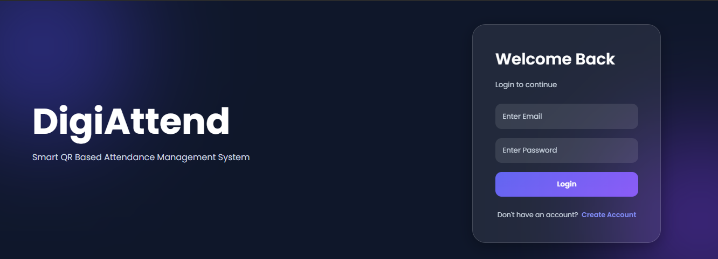

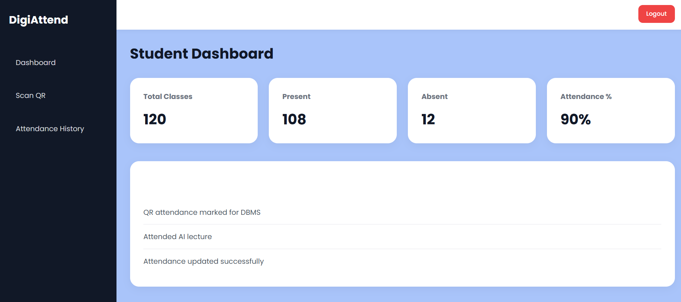

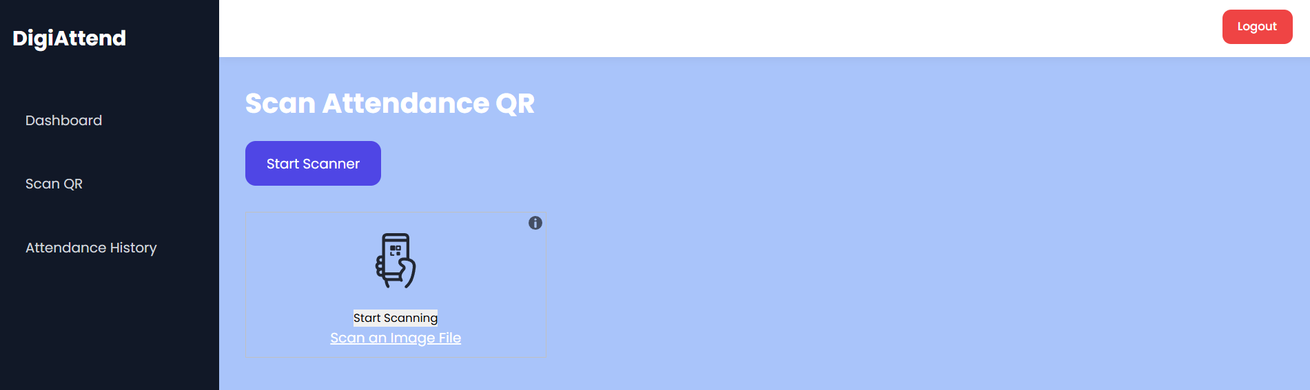

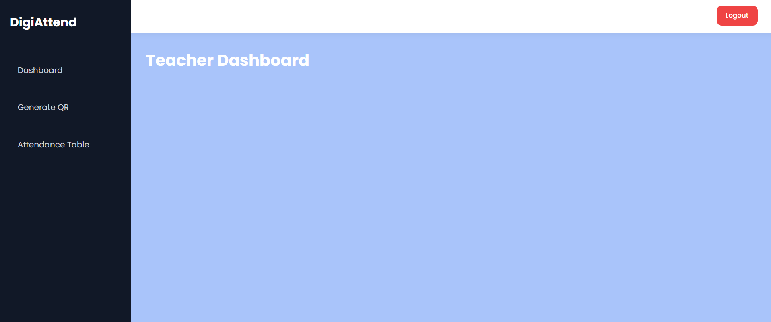

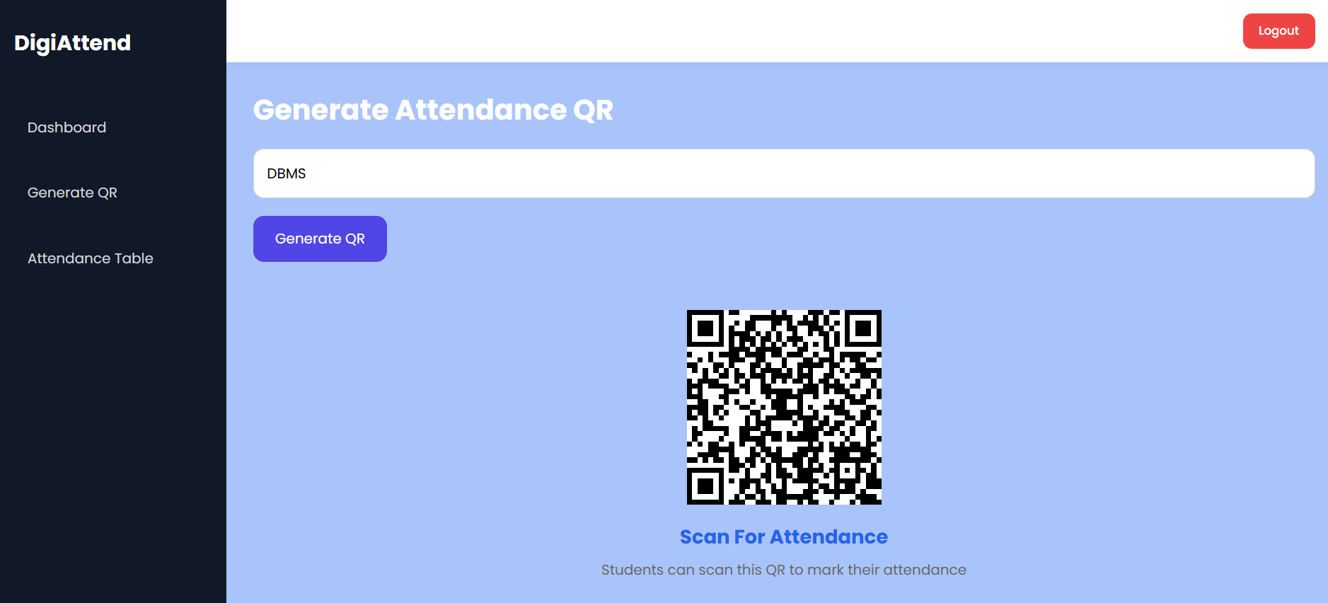

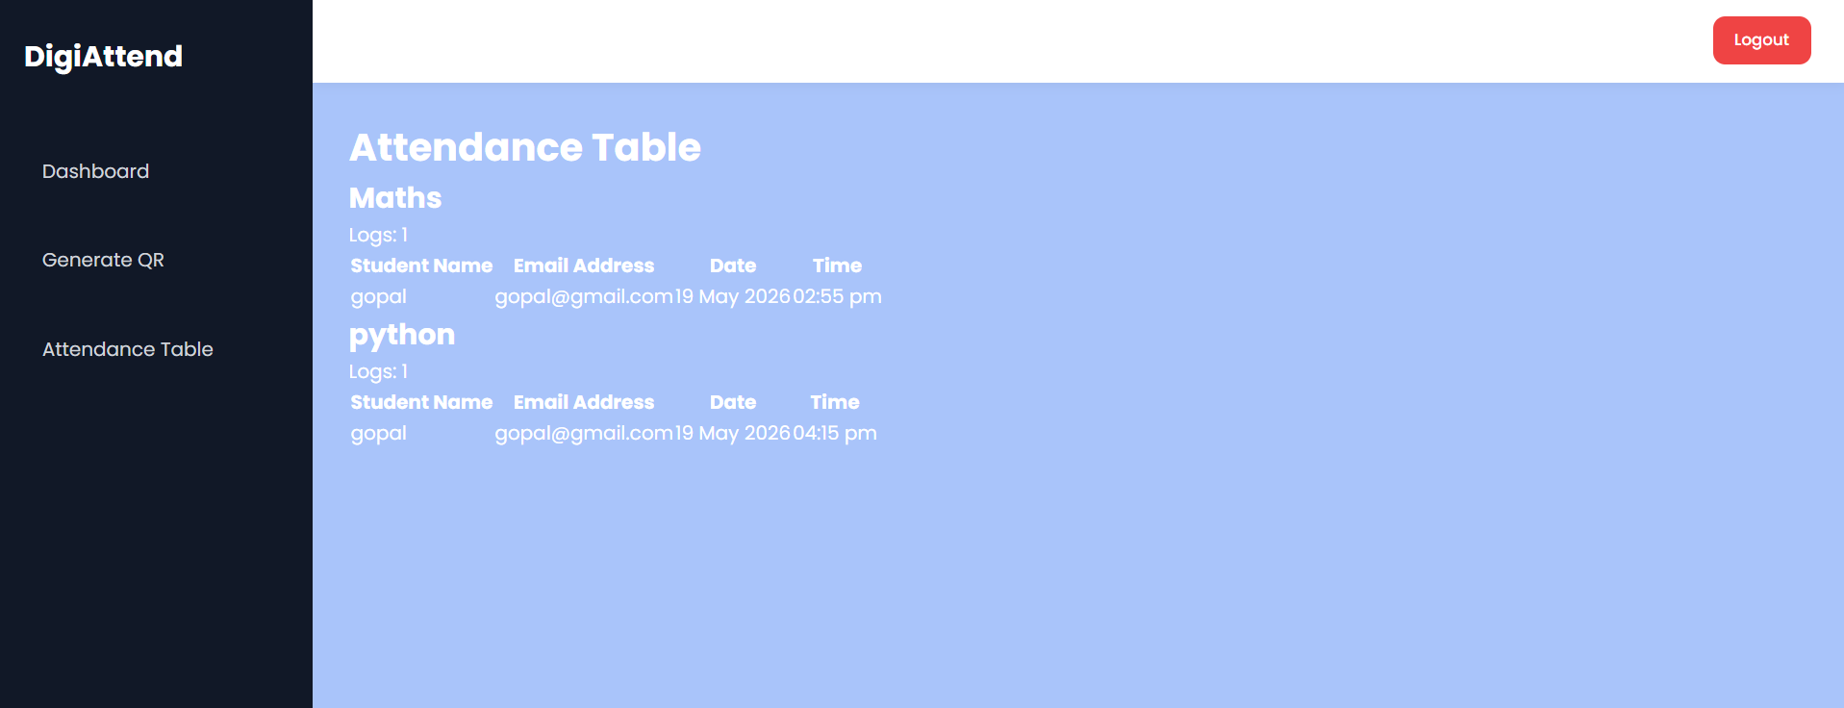

Conclusion
The DigiAttend project concludes that digital attendance management systems are more efficient, reliable, and accurate compared to traditional manual attendance methods. The project successfully automated attendance recording and management processes using modern software technologies and database systems.
DigiAttend helps educational institutions and organizations save time, reduce human errors, improve record maintenance, and enhance productivity. The system also provides secure data management and easy access to attendance information for administrators, faculty members, and students.
The project improved understanding of software development concepts such as database management, system design, testing, and implementation. It also demonstrated the importance of digital transformation in simplifying administrative tasks.
Overall, DigiAttend is an effective attendance management solution that can be further enhanced with advanced technologies such as biometric authentication, cloud storage, mobile applications, and AI-based analytics in the future.

References
- Ian Sommerville, Software Engineering, 10th Edition, Pearson Education.
- Elmasri and Navathe, Fundamentals of Database Systems, Pearson Publication.
- Roger S. Pressman, Software Engineering: A Practitioner’s Approach, McGraw Hill.
- Python Documentation – Python Official Website
- MySQL Documentation – MySQL Official Website
- HTML and CSS Tutorials – W3Schools
- Database Management Concepts from academic notes and online resources.
- Attendance management system research papers and journals.

Bibliography
- Sommerville, Ian. Software Engineering. Pearson Education.
- Pressman, Roger S. Software Engineering: A Practitioner’s Approach. McGraw Hill Education.
- Elmasri, Ramez and Navathe, Shamkant. Fundamentals of Database Systems. Pearson Publication.
- Python Documentation
- MySQL Documentation
- W3Schools Tutorials
- Research articles related to digital attendance management systems.
- Online educational resources and technical documentation related to software development and database systems.

