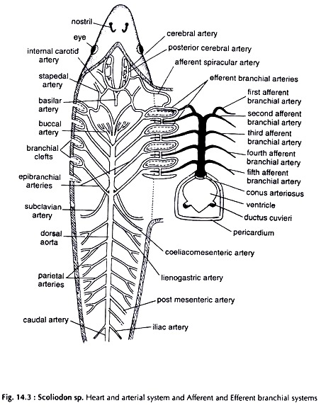

Fig: Arterial System of *Scoliodon*

**CLASSIFICATION**

**Kingdom -** Animalia

**Phylum -** Chordata

**Subphylum -** Vertebrata

**Class -** Chondrichthyes

**Subclass -** Elasmobranchii

**Family** - Carcharhinidae

**Genus** - Scoliodon

ATERIAL SYSTEM

COMMENTS:

* **Heart -** It is a dorso-ventrally bent muscular tube containing four chambers, namely sinus venosus, auricle, ventricle and conus arteriosus.
* **Afferent branchial arteries -** The conus arteriosus is continued forward as ventral aorta which gives rise to afferent branchial arteries.  
  The ventral aorta runs up to the posterior border of the pharynx. Distally it divides into two innominate arteries. Each innominate artery again divides into I afferent branchial artery and II afferent branchial artery. III, IV and V afferent branchial arteries originate directly from the ventral aorta at equal distances from each other. Five pairs of afferent branchial arteries supply to five pairs of gills.
* **Efferent Branchial Arteries -**For efferent branchial arteries dissect the fish from the roof of the pharynx. There are 9 efferent branchial arteries on each side. The 1+11, 1I1+IV, V+VI and VII+VIII efferent  
  branchial artery form four pairs of loops. The ninth efferent branchial artery joins with the VIII branchial artery. The four loops are connected together by longitudinal vessels. Each loop is continued as an epibranchial artery. Such as I epibranchial artery, II-epibranchial artery, III epibranchial artery and IV epibranchial artery. These four pairs of epibranchial arteries unite to form dorsal aorta.

NAME: VANSHIKA SUNHARE

CLASS: B.Sc. II Year

SUBJECT: ZOOLOGY(MAJOR)

BATCH: 2023-24

ROLL NO.: 22312146

SUBMITTED TO: DR. JYOTI UIKEY MA’AM