Technical Design Document

Project name: **Wallet App**

* JATIN MADAAN (46022683)

**Introduction:**

Wallet App is created to meet the needs of online wallet application, with 1 actor: Customer. The architecture implemented is Spring Boot.

**Functional Requirements:**

The functional requirements of the project are:

**For the User:**

* Login/Register
* Withdraw
* Deposit
* Transfer
* View Transactions
* View Balance
* Update Account

**Services**

The different services in which this project is divided into are:

* **User Service:** Register a new account and login (as a customer), View Balance.
* **Transaction Service:** Withdraw, Deposit, Fund Transfer and View Transactions

**Overall Architecture Diagram:**

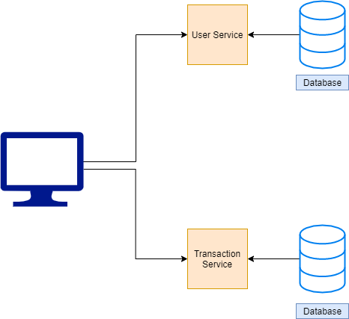

**Overall Entity Relationship Diagram:**

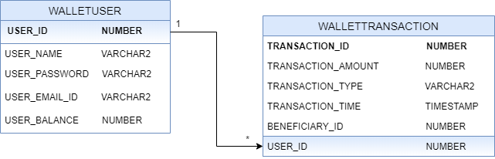

**Sequence Diagrams**

**User Service:**

**Login –**

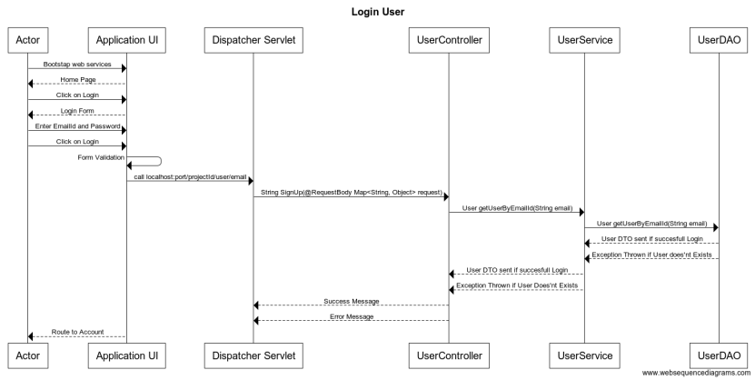

**Registration of new User –**

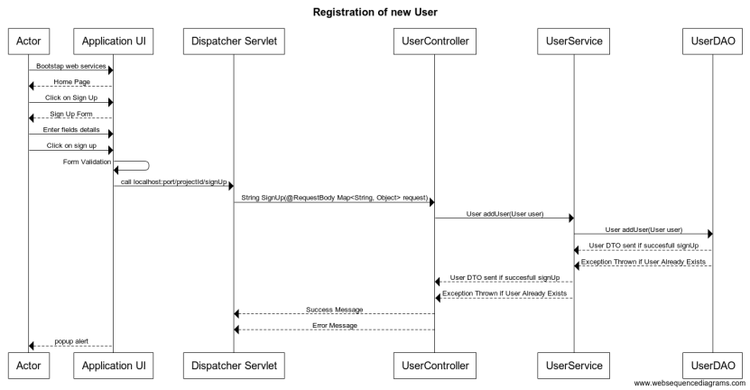

**Transaction Service:**

**Add transaction:**

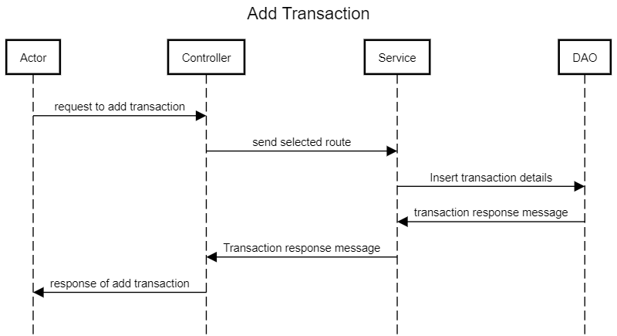

**List Transactions By User Id:**

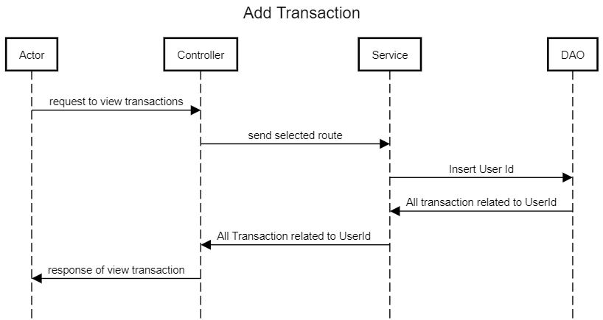

**Class Diagrams**

User Service:

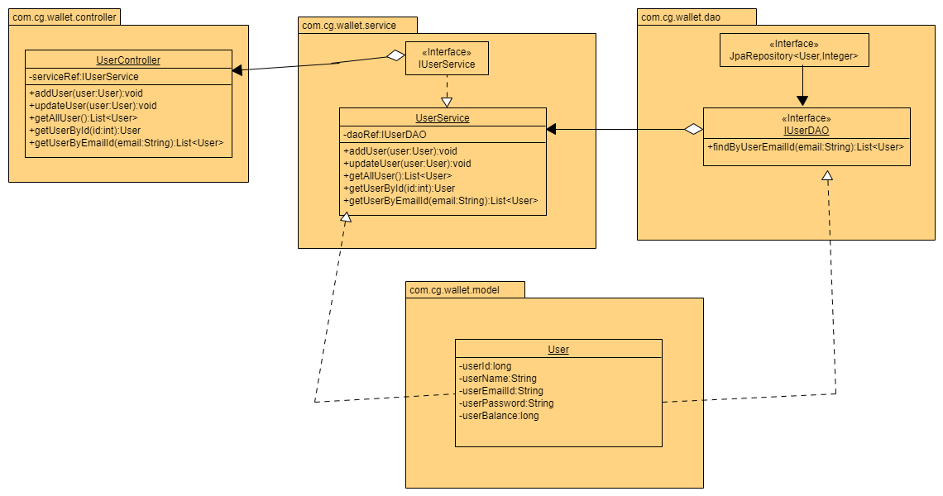

Transaction Service:

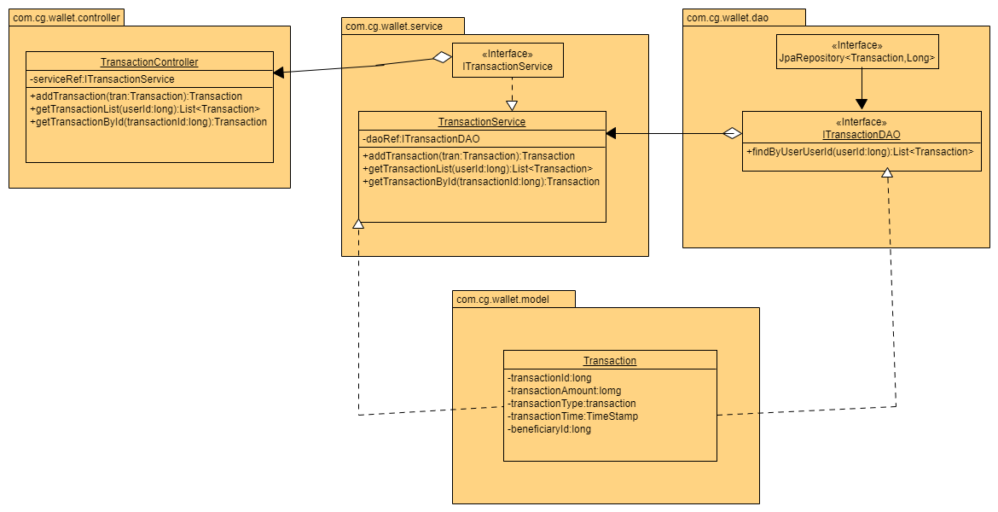

**Activity Diagrams**

User Service:

**Login:**

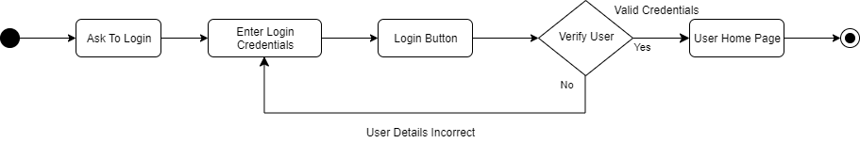

**Registration:**

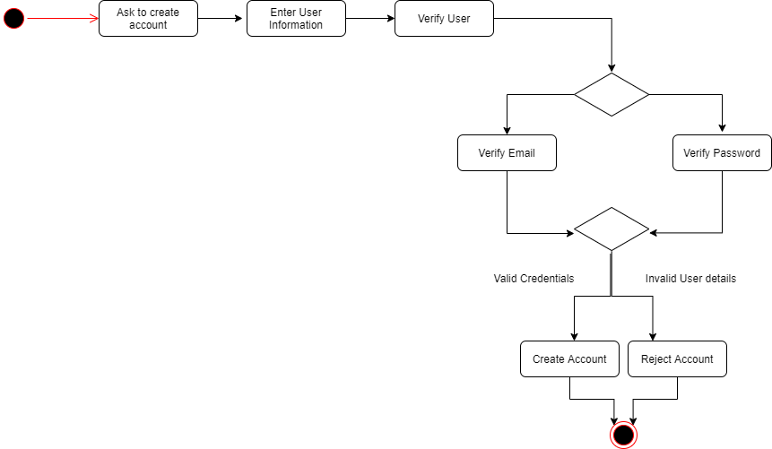

**Update Account Settings:**

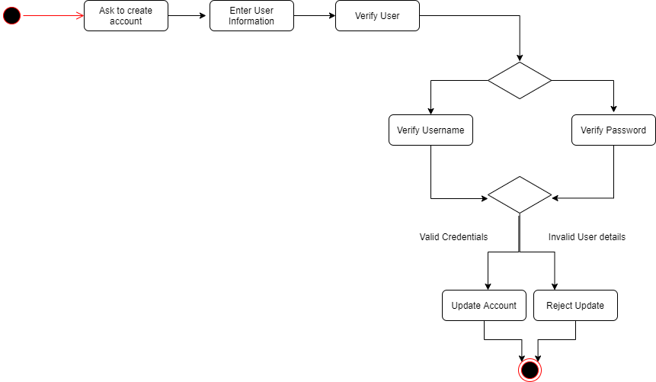

Transaction Service:

**Withdraw:**

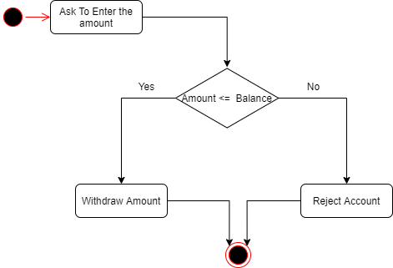

**Deposit:**



**Fund Transfer:**

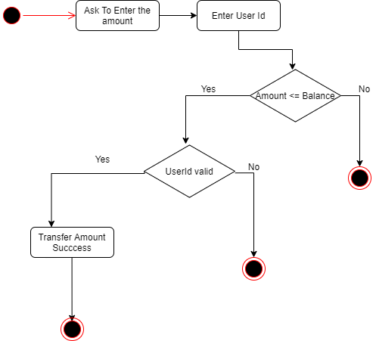

**View Transactions:**



**Wireframes**

**User Login:**

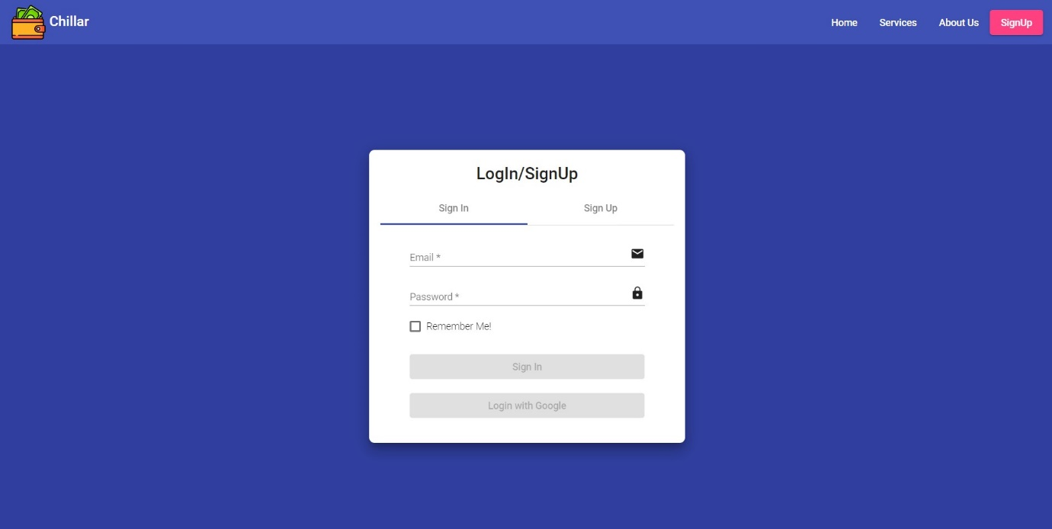

**User Account:**

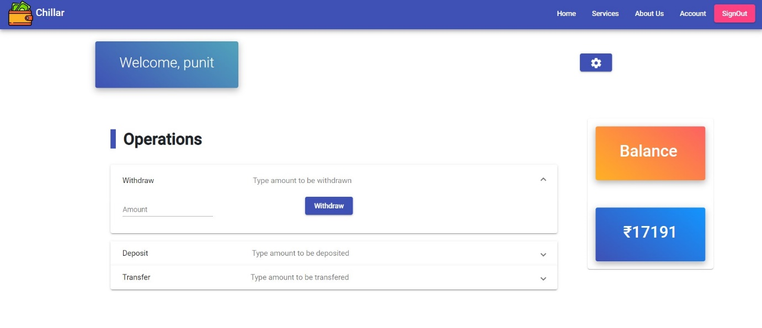

**Transactions:**

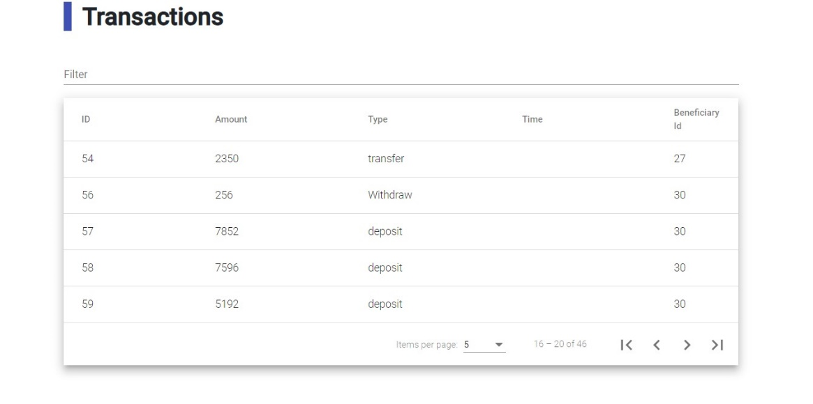

**Account Setting:**

