EXPERIMENT 6
Student Name: Jatin Tasoria UID: 25MCC20054
Branch: MCA-Cloud Computing Section/Group: MCC 101-A
Semester: 2nd Date of Performance: 02/03/26
Subject Name: Technical Training-I Subject Code: 25CAP-652

- Aim
To learn how to create, query, and manage views in SQL to simplify database queries and provide abstraction for end-users.

- Objective:
After completing this practical, the learner will be able to:
  - Understand the concept of data abstraction using views
  - Create simple and complex views
  - Restrict access to sensitive columns
  - Manage views using CREATE, ALTER, DROP
  - Apply views in real-world enterprise applications

- Practical / Experiment Steps
  - Start the system.
  - Open pgAdmin.
  - Create and select the database in which you want to perform the experiment.
  - Establish connection to the database.
  - Create simple and complex views
  - Execute SELECT queries on views
- Procedure of the Practical

1. Start the system and log in
2. Start the PostgreSQL service
3. Open PostgreSQL client (psql or pgAdmin)
4. Create a new database
5. Create the required table
6. Insert sample data into the table
7. Create views
8. Query views
9. Save the work for documentation

- SQL Queries Used in the Experiment
  - Simple View
CREATE VIEW active_employees AS
SELECT id, name, department
FROM employees
WHERE status = 'Active';

  - View With Joins
CREATE VIEW employee_department_view AS
SELECT e.id, e.name, d.department_name
FROM employees e
JOIN departments d
ON e.department_id = d.department_id

  - Summarization View
CREATE VIEW department_summary AS
SELECT department_id, COUNT(*) AS total_employees,
AVG(salary) AS average_salary
FROM employees
GROUP BY department_id

- Input / Output Analysis (I/O Analysis)
- Simple View:
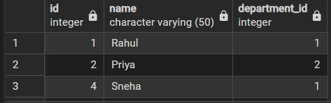
- View With Joins:

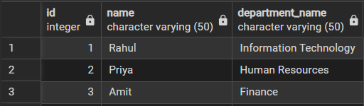
- Summarize View:

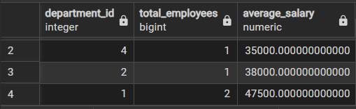
- Learning Outcome
      - Mastery in creating and managing views
      - Understanding abstraction and security concepts
      - Ability to design views for payroll, HR, and reporting systems
      - Real-world application of SQL abstraction layer

