EXPERIMENT 7
Student Name: Jatin Tasoria UID: 25MCC20054
Branch: MCA-Cloud Computing Section/Group: MCC 101-A
Semester: 2nd Date of Performance: 31/03/26
Subject Name: Technical Training-I Subject Code: 25CAP-652

- Aim
Implementation of joins in PostgreSQL (inner join ,left join, right join, self-join and cross join)
- Objective:
Apply joins to a real-world database schema (e.g., Students, Courses, Enrollments, Departments)
- Practical / Experiment Steps
- Start the system
- Open pgAdmin
- Create and select the database in which you want to perform the experiment
- Establish connection to the database
- Create tables (Students, Courses, Enrollments, Departments)
- Execute SELECT queries using different joins

- Procedure of the Practical

  - Start the system and log in
  - Start the PostgreSQL service
  - Open PostgreSQL client (psql or pgAdmin)
  - Create a new database
  - Create the required tables
  - Insert sample data into the tables
  - Apply different joins (INNER, LEFT, RIGHT, SELF, CROSS)
  - Execute queries and verify results
  - Save the work for documentation

- SQL Queries Used in the Experiment
- Table Creation
CREATE TABLE departments (
department_id SERIAL PRIMARY KEY,
department_name VARCHAR(40)
);

CREATE TABLE students (
student_id SERIAL PRIMARY KEY,
name VARCHAR(40),
department_id INT,
FOREIGN KEY (department_id) REFERENCES departments(department_id)
);

CREATE TABLE courses (
course_id SERIAL PRIMARY KEY,
course_name VARCHAR(40)
);

CREATE TABLE enrollments (
student_id INT,
course_id INT,
PRIMARY KEY (student_id, course_id),
FOREIGN KEY (student_id) REFERENCES students(student_id),
FOREIGN KEY (course_id) REFERENCES courses(course_id)
);

- Data Insertion
INSERT INTO departments (department_name) VALUES
('Computer Science'),
('Mechanical'),
('Electrical');

INSERT INTO students (name, department_id) VALUES
('Harsh', 1),
('Daniel', 2),
('Ajay', 1),
('Jatin', 3),
('Yuvraj', NULL);

INSERT INTO courses (course_name) VALUES
('DBMS'),
('Cloud'),
('Maths'),
('AI');

INSERT INTO enrollments (student_id, course_id) VALUES
(1, 1),
(1, 2),
(2, 3),
(3, 1);

- Write queries to list students with their enrolled courses (INNER JOIN).
SELECT
s.student_id,
s.name,
c.course_name
FROM students s
INNER JOIN enrollments e
ON s.student_id = e.student_id
INNER JOIN courses c
ON e.course_id = c.course_id;

- Find students not enrolled in any course (LEFT JOIN).
SELECT
s.student_id,
s.name
FROM students s
LEFT JOIN enrollments e
ON s.student_id = e.student_id
WHERE e.student_id IS NULL;

- Display all courses with or without enrolled students (RIGHT JOIN).
SELECT
c.course_name,
s.name AS student_name
FROM enrollments e
RIGHT JOIN courses c
ON e.course_id = c.course_id
LEFT JOIN students s
ON e.student_id = s.student_id;

- Show students with department info using SELF JOIN or multiple joins.
SELECT
s1.name AS student1,
s2.name AS student2
FROM students s1
JOIN students s2
ON s1.department_id = s2.department_id
WHERE s1.student_id <> s2.student_id;

- Display all possible student-course combinations (CROSS JOIN).
SELECT
s.name,
c.course_name
FROM students s
CROSS JOIN courses c;

- Input / Output Analysis (I/O Analysis)
- Write queries to list students with their enrolled courses (INNER JOIN).

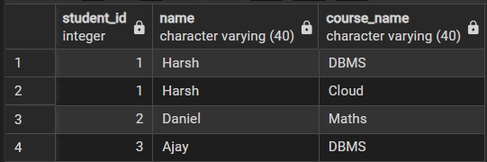

- Find students not enrolled in any course (LEFT JOIN).

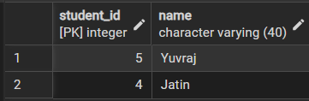

- Display all courses with or without enrolled students (RIGHT JOIN).

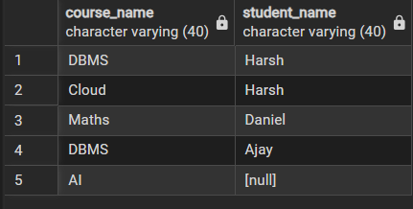
- Show students with department info using SELF JOIN or multiple joins.

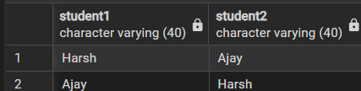
- Display all possible student-course combinations (CROSS JOIN).

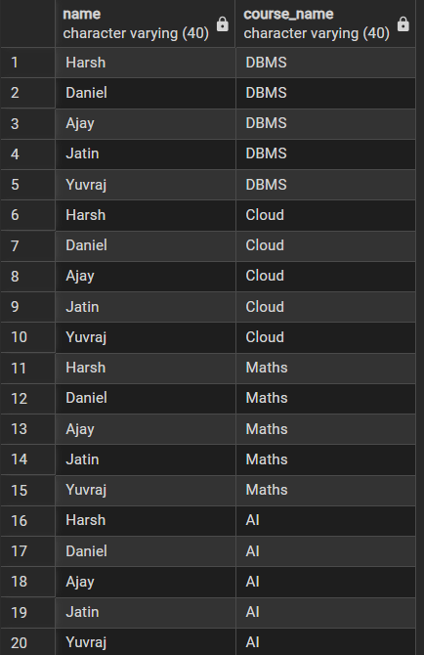

- Learning Outcome
      - Understanding different types of joins in PostgreSQL
      - Ability to combine data from multiple tables
      - Knowledge of handling real-world relational database queries
      - Practical implementation of relational database concepts
      - Improved SQL query writing skills for data analysis

