EXPERIMENT 5
Student Name: Jatin Tasoria UID: 25MCC20054
Branch: MCA-Cloud Computing Section/Group: MCC 101-A
Semester: 2nd Date of Performance: 01/03/26
Subject Name: Technical Training-I Subject Code: 25CAP-652

- Aim
To gain hands-on experience in creating and using cursors for row-by-row processing in a database, enabling sequential access and manipulation of query results for complex business logic.

- Objective:
After completing this practical, the learner will be able to:
      - Understand sequential row-by-row data processing using cursors
      - Learn the lifecycle of a cursor: DECLARE, OPEN, FETCH, CLOSE
      - Perform row-level manipulation using procedural logic
      - Handle cursor-related exceptions and termination conditions
      - Apply cursor logic in real-world enterprise scenarios

- Practical / Experiment Steps
  - Start the system.
  - Open pgAdmin.
  - Create and select the database in which you want to perform the experiment.
  - Establish connection to the database.
Execute cursor-based queries
- Procedure of the Practical

1. Start the system and log in
2. Start the PostgreSQL service
3. Open PostgreSQL client (psql or pgAdmin)
4. Create a new database
5. Create the required table
6. Insert sample data into the table
7. Declare and use CURSOR
8. Execute queries successfully
9. Save the work for documentation

- SQL Queries Used in the Experiment
  - Simple Forward-Only Cursor
DO $$
DECLARE
rec RECORD;
emp_cursor CURSOR FOR
SELECT id, name, salary FROM employee;
BEGIN
OPEN emp_cursor;
LOOP
FETCH emp_cursor INTO rec;
EXIT WHEN NOT FOUND;
RAISE NOTICE 'ID: %, Name: %, Salary: %', rec.id, rec.name, rec.salary;
END LOOP;
CLOSE emp_cursor;
END $$;

  - Salary Update
DO $$
DECLARE
rec RECORD;
emp_cursor CURSOR FOR
SELECT id, experience, salary FROM employee;
BEGIN
OPEN emp_cursor;
LOOP
FETCH emp_cursor INTO rec;
EXIT WHEN NOT FOUND;

IF rec.experience > 5 THEN
UPDATE employee
SET salary = salary * 1.20
WHERE id = rec.id;
ELSE
UPDATE employee
SET salary = salary * 1.10
WHERE id = rec.id;
END IF;
END LOOP;
CLOSE emp_cursor;
END $$;

  - Exception Handling with Cursor
DO $$
DECLARE
rec RECORD;
emp_cursor CURSOR FOR SELECT id FROM employee;
BEGIN
OPEN emp_cursor;
LOOP
FETCH emp_cursor INTO rec;
EXIT WHEN NOT FOUND;
RAISE NOTICE 'Employee ID: %', rec.id;
END LOOP;
CLOSE emp_cursor;
EXCEPTION
WHEN OTHERS THEN
RAISE NOTICE 'An error occurred while processing cursor.';
END $$;

- Input / Output Analysis (I/O Analysis)
- Simple Forward:

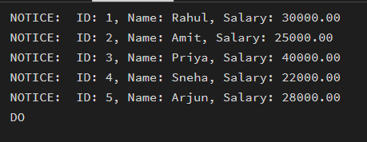
- Salary Update using Cursor:

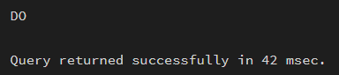
- Exceptional Handling:

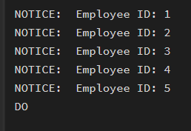
- Learning Outcome
      - Ability to implement and manage cursors
      - Understanding of row-by-row processing
      - Knowledge of exception handling in PL/pgSQL
      - Application of cursor logic in payroll and enterprise systems

