EXPERIMENT 4
Student Name: Jatin Tasoria UID: 25MCC20054
Branch: MCA-Cloud Computing Section/Group: MCC 101-A
Semester: 2nd Date of Performance: 03/02/26
Subject Name: Technical Training-I Subject Code: 25CAP-652

- Aim
To understand and implement iterative control structures in PostgreSQL conceptually, including FOR loops, WHILE loops, and basic LOOP constructs, for repeated execution of database logic.

- Objective:
After completing this practical, the learner will be able to:
- To understand why iteration is required in database programming
- To learn the purpose and behavior of FOR, WHILE, and LOOP constructs
- To understand how repeated data processing is handled in databases
- To relate loop concepts to real-world batch processing scenarios
- To strengthen conceptual knowledge of procedural SQL used in enterprise systems.

- Practical / Experiment Steps
  - Start the system.
  - Open pgAdmin.
  - Create and select the database in which you want to perform the experiment.
  - Establish connection to the database using Alt+Shift+Q.
  - Run the following queries given in Experiment Steps (5).
- Procedure of the Practical

- 1. Start the system and log in
- 2. Start the PostgreSQL service
- 3. Open PostgreSQL client (psql or pgAdmin)
- 4. Create a new database
- 5. Create the required table
- 6. Insert sample data into the table
- 7. Execute SELECT queries for LOOP, WHILE, FOR
- 8. Ensure successful execution of queries
- 9. Save the work for documentation

- SQL Queries Used in the Experiment
  - For Loop (simple iteration):
DO $$
BEGIN
FOR i IN 1..5 LOOP
RAISE NOTICE 'Number: %', i;
END LOOP;
END $$;

  - For Loop with Query (Row-by-Row Processing):
DO $$
DECLARE
rec RECORD;
BEGIN
FOR rec IN
SELECT id, marks FROM students
LOOP
RAISE NOTICE 'ID: %, Marks: %', rec.id, rec.marks;
END LOOP;
END $$;

  - While Loop (conditional iteration):
DO $$
DECLARE
i int:=1;
BEGIN
WHILE i<=5 LOOP
RAISE NOTICE 'WHILE LOOP turn %',i;
i:=i+1;
END LOOP;
END $$

  - Loop with ‘EXIT WHEN’:
DO $$
DECLARE
i int :=1;
BEGIN
LOOP
RAISE NOTICE 'i=%',i;
i:=i+1;
EXIT WHEN i>5;
END LOOP;
END $$;

  - Salary increment using For Loop:
DO $$
DECLARE
rec RECORD;
BEGIN
FOR rec IN
SELECT id, salary FROM salaries
LOOP
UPDATE salaries
SET salary = rec.salary * 1.10
WHERE id = rec.id;
END LOOP;
END $$;

  - Combining Loop with IF condition:
DO $$
DECLARE
rec RECORD;
BEGIN
FOR rec IN
SELECT id, marks FROM students
LOOP
IF rec.marks > 50 THEN
RAISE NOTICE 'ID: %, Marks: %', rec.id, rec.marks;
END IF;
END LOOP;
END $$;

- Input / Output Analysis (I/O Analysis)
- For Loop (simple iteration):

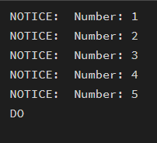

- For Loop with Query (Row-by-Row Processing):

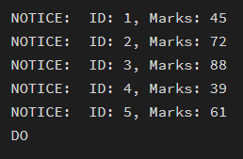
- While Loop (conditional iteration):

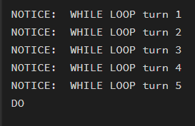
- Loop with ‘EXIT WHEN’:

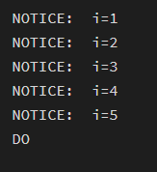
- Salary increment using For Loop:

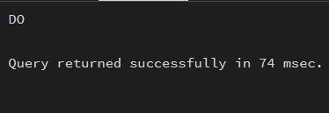

- Combining Loop with IF condition:
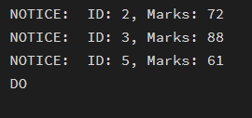

- Learning Outcome
  - Understanding of how iterative control structures work in PostgreSQL at a conceptual level.
  - Usage of loops in database systems, such as workflow engines, complex decision cycles, validation loops, etc.
  - Foundational knowledge required for writing procedural logic in enterprise-grade applications.

