EXPERIMENT 3
Student Name: Jatin Tasoria UID: 25MCC20054
Branch: MCA-Cloud Computing Section/Group: MCC 101-A
Semester: 2nd Date of Performance: 27/01/26
Subject Name: Technical Training-I Subject Code: 25CAP-652

- Aim
To implement conditional decision-making logic in PostgreSQL using IF–ELSE constructs and CASE expressions for classification, validation, and rule-based data processing.

- Objective:
After completing this practical, the learner will be able to:
    - To understand conditional execution in SQL
    - To implement decision-making logic using CASE expressions
    - To simulate real-world rule validation scenarios
    - To classify data based on multiple conditions
    - To strengthen SQL logic skills required in interviews and backend systems

- Practical / Experiment Steps
1. Create a table to store schema violation details
2. Insert sample data with different violation counts
3. Use CASE expressions to classify violation severity
4. Apply CASE logic inside UPDATE statements
5. Implement IF–ELSE logic using PL/pgSQL blocks
6. Create a grading system using conditional logic
7. Use CASE for custom sorting based on priority

- Procedure of the Practical
1. Start PostgreSQL and connect to the database
2. Create required tables
3. Insert sample records
4. Execute SELECT queries using CASE expressions
5. Perform UPDATE operations using CASE
6. Execute PL/pgSQL DO blocks using IF–ELSE logic
7. Observe and verify output

- SQL Queries Used in the Experiment
- Table Creation and Sample Data
CREATE TABLE schema_violations (
schema_id SERIAL PRIMARY KEY,
schema_name VARCHAR(50),
violation_count INT
);

INSERT INTO schema_violations (schema_name, violation_count) VALUES
('Finance', 0),
('HR', 2),
('Sales', 5),
('Audit', 10);

- Classifying Data Using CASE Expression
SELECT schema_name, violation_count,
CASE
WHEN violation_count = 0 THEN 'No Violation'
WHEN violation_count BETWEEN 1 AND 3 THEN 'Minor Violation'
WHEN violation_count BETWEEN 4 AND 6 THEN 'Moderate Violation'
ELSE 'Critical Violation'
END AS violation_status
FROM schema_violations;

- Applying CASE Logic in UPDATE Statement
ALTER TABLE schema_violations
ADD COLUMN approval_status VARCHAR(20);

UPDATE schema_violations
SET approval_status =
CASE
WHEN violation_count = 0 THEN 'Approved'
WHEN violation_count BETWEEN 1 AND 3 THEN 'Needs Review'
ELSE 'Rejected'
END;

- Implementing IF–ELSE Logic Using PL/pgSQL
DO $$
DECLARE
v_count INT := 5;
BEGIN
IF v_count = 0 THEN
RAISE NOTICE 'No violations found';
ELSIF v_count BETWEEN 1 AND 3 THEN
RAISE NOTICE 'Minor violations detected';
ELSIF v_count BETWEEN 4 AND 6 THEN
RAISE NOTICE 'Moderate violations detected';
ELSE
RAISE NOTICE 'Critical violations detected';
END IF;
END $$;

- Real-World Classification Scenario
CREATE TABLE students (
student_id SERIAL PRIMARY KEY,
student_name VARCHAR(50),
marks INT
);

INSERT INTO students (student_name, marks) VALUES
('Amit', 85),
('Neha', 72),
('Rahul', 55),
('Sneha', 38);

SELECT
student_name,
marks,
CASE
WHEN marks >= 80 THEN 'A'
WHEN marks >= 60 THEN 'B'
WHEN marks >= 40 THEN 'C'
ELSE 'Fail'
END AS grade
FROM students;
- Using CASE for Custom Sorting
SELECT
schema_name,
violation_count
FROM schema_violations
ORDER BY
CASE
WHEN violation_count = 0 THEN 1
WHEN violation_count BETWEEN 1 AND 3 THEN 2
WHEN violation_count BETWEEN 4 AND 6 THEN 3
ELSE 4
END;

- Input / Output Analysis (I/O Analysis)
SQL queries for:
- Table creation
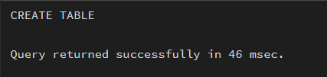

- Data Insertion
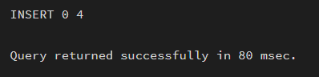

- Classifying Data Using CASE Expression
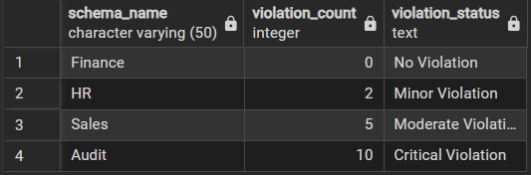

- Altering Table
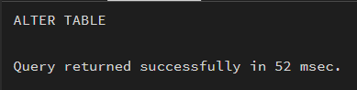

- Updating
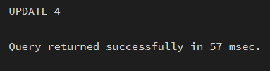

- After altering and updating
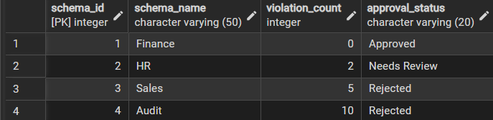
- IF–ELSE Logic Using PL/pgSQL
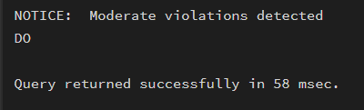

- Real-World Classification Scenario
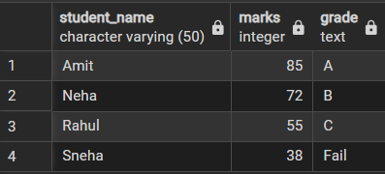

- Using CASE for Custom Sorting
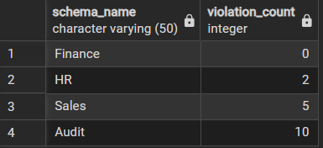

- Learning Outcome
    - Understood searched CASE and IF–ELSE constructs
    - Learned real-world data classification techniques
    - Implemented backend-level rule validation
    - Reduced dependency on application-side logic
    - Gained SQL skills commonly tested in interviews

