EXPERIMENT 1
Student Name: Jatin Tasoria UID: 25MCC20054
Branch: MCA-Cloud Computing Section/Group: MCC 101-A
Semester: 2nd Date of Performance: 16/01/26
Subject Name: Technical Training-I Subject Code: 25CAP-652

- Aim
To design and implement a sample database system using DDL, DML, and DCL commands, including database creation, data manipulation, schema modification, and role-based access control.

- Objective:
After completing this practical, the learner will be able to:
- Implement DDL commands to create and modify database objects
- Use DML commands to insert, update, and delete data
- Apply DCL commands for access control and security
- Enforce data integrity using constraints
- Provide read-only access to authorized users

- Practical / Experiment Steps
- Analyze database requirements
- Create tables using DDL commands
- Insert and manipulate data using DML commands
- Apply access control using DCL commands
- Modify database schema using ALTER TABLE
- Drop unnecessary tables
- Procedure of the Practical
- Start the system and log in
- Start the PostgreSQL service
- Open PostgreSQL client (psql / pgAdmin)
- Create a new database
- Create the required table
- Insert sample records
- Update and delete records using UPDATE and DELETE
- Create role and grant SELECT privileges
- Modify table structure using ALTER TABLE
- Drop unused table using DROP TABLE

- SQL Queries Used in the Experiment
  - Database Creation
CREATE DATABASE Empolyee_Management;

  - Table Creation
CREATE TABLE Department (
dept_id INT PRIMARY KEY,
dept_name VARCHAR(50) UNIQUE NOT NULL,
location VARCHAR(50)
);

CREATE TABLE Employee (
emp_id INT PRIMARY KEY,
emp_name VARCHAR(50) NOT NULL,
salary NUMBER CHECK (salary > 0),
dept_id INT,
FOREIGN KEY (dept_id) REFERENCES Department(dept_id)
);

CREATE TABLE Project (
project_id INT PRIMARY KEY,
project_name VARCHAR(50) NOT NULL,
dept_id INT,
FOREIGN KEY (dept_id) REFERENCES Department(dept_id)
);

  - Inserting Sample Records
INSERT INTO Department VALUES (1, 'IT', 'Bangalore');
INSERT INTO Department VALUES (2, 'HR', 'Delhi');

INSERT INTO Employee VALUES (101, 'Rahul', 50000, 1);
INSERT INTO Employee VALUES (102, 'Anita', 45000, 2);

INSERT INTO Project VALUES (201, 'Cloud Migration', 1);
INSERT INTO Project VALUES (202, 'Recruitment System', 2);

  - Update & Delete Data
UPDATE Employee
SET salary = 55000
WHERE emp_id = 101;

DELETE FROM Employee
WHERE emp_id = 102;

  - Access Control
CREATE ROLE Manager;
GRANT SELECT ON Department TO Manager;
GRANT SELECT ON Employee TO Manager;
GRANT SELECT ON Project TO Manager;
REVOKE CREATE FROM Manager;

  - Modification
ALTER TABLE Employee ADD email VARCHAR(50);

  - Drop Table
DROP TABLE project;

- Input / Output Analysis (I/O Analysis)
SQL queries for:
- Table creation
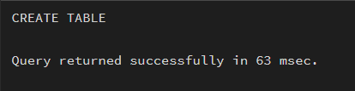

- Data insertion
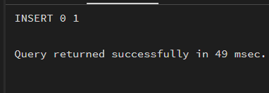
- TABLE employee
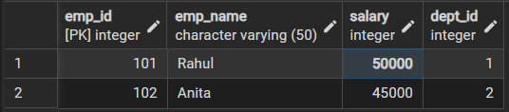
- TABLE department
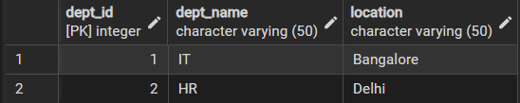
- TABLE project
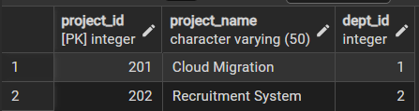

- Updating Value
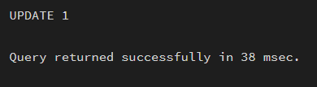
- After Updating Value
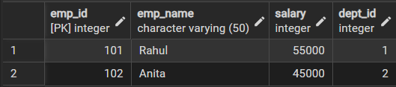
- Deleting
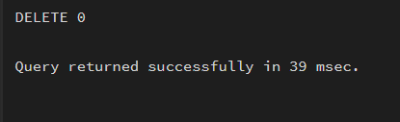
- After Deleting Value
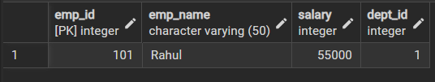
- Access Control
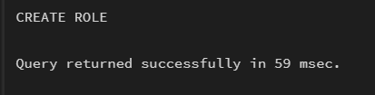
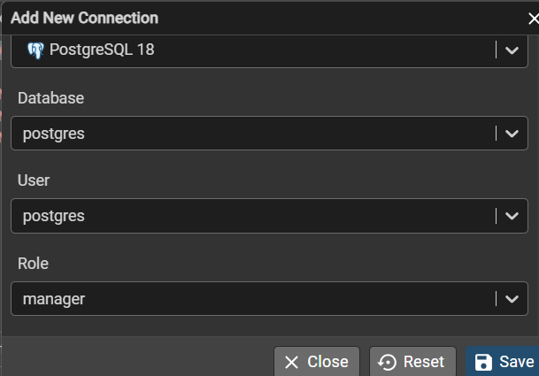

- GRANT & REVOKE
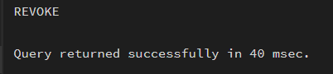
- Alter table
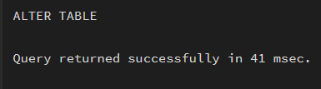
- After altering the table
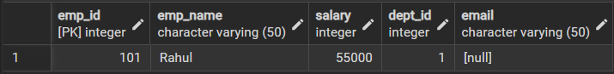
- Drop Table
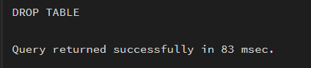

- Learning Outcome
    - Practical understanding of DDL, DML, and DCL commands
    - Experience with constraints and referential integrity
    - Knowledge of role-based access control
    - Hands-on exposure to schema modification
    - Improved database design and security skills

