Cosmetics Store Management

Prepared by   
Jatin Thakur  
Jatinthakur082003@gmail.com

# ABSTRACT

In the rapidly evolving world of retail, managing customer relationships, inventory, and sales processes effectively is crucial for success. The Cosmetics Store Management project leverages Salesforce to provide a streamlined solution that empowers cosmetic store owners and managers to handle their operations with increased efficiency and accuracy.

The solution integrates various features of Salesforce to facilitate better management of customers, consultants, and retailers, offering a comprehensive platform for operational oversight. By utilizing a centralized system, Cosmetics Store Management improves the following key areas:

* **Customer Relationship Management (CRM):** Track customer preferences, interactions, and history to provide personalized services and drive customer loyalty.
* **Inventory Management:** Optimize product stock levels, monitor item availability, and streamline the supply chain from suppliers to store shelves.
* **Sales Monitoring:** Gain real-time insights into sales trends, performance, and profitability across multiple channels.

### Key Features:

* **Centralized Management Dashboard:** A powerful interface offering real-time insights into customer data, sales figures, and inventory management.
* **Consultant Management:** Efficient tracking and management of consultants to ensure seamless collaboration between sales personnel and customers.
* **Custom Reporting & Analytics:** Generate dynamic reports on various aspects of store operations, providing actionable insights for continuous improvement.

By utilizing Salesforce's robust tools, Cosmetics Store Management not only improves operational efficiency but also elevates customer engagement, ensuring that retail cosmetic businesses can thrive in a competitive market.

# INTRODUCTION

### ****INTRODUCTION****

Retail cosmetic stores face unique challenges in managing customer relationships, inventory, and sales operations. To address these challenges, the Cosmetics Store Management project harnesses the capabilities of the Salesforce platform, delivering a comprehensive system designed specifically to streamline and optimize operations within the cosmetic retail industry.

This project introduces a cloud-based solution where store managers can effortlessly handle the complexities of customer service, consultant management, and inventory tracking. The system is tailored to meet the needs of various stakeholders—store owners, sales consultants, and retail partners—enabling them to manage daily tasks more efficiently.

Key Benefits:

* **Enhanced Customer Engagement:** The system provides a complete view of customer interactions, allowing stores to deliver personalized experiences and build long-term relationships with their clientele.
* **Improved Workflow Efficiency:** Automation of routine processes such as inventory tracking and sales reporting reduces manual effort, helping staff focus on delivering superior customer service.
* **Scalable for Growth:** As stores expand, the platform can scale to accommodate new locations, products, and sales channels, ensuring that operations remain efficient even with business growth.

Cosmetics Store Management is a transformative project for the retail cosmetics industry, enabling stores to not only manage their current operations efficiently but also prepare for future growth and customer demands. By integrating Salesforce, this project delivers a modern, flexible solution that enhances operational efficiency and fosters a deeper connection with customers.

# INDEX

1. Introduction  
2. Objects  
3. Fields & Relationships  
4. Page Layout  
5. Lightning App  
6. Profiles  
7. Roles  
8. Users  
9. Reports  
10. Dashboards  
11. Conclusion

# OBJECTS

The following objects were created in the Cosmetics Store Management system:

1. Our Customers

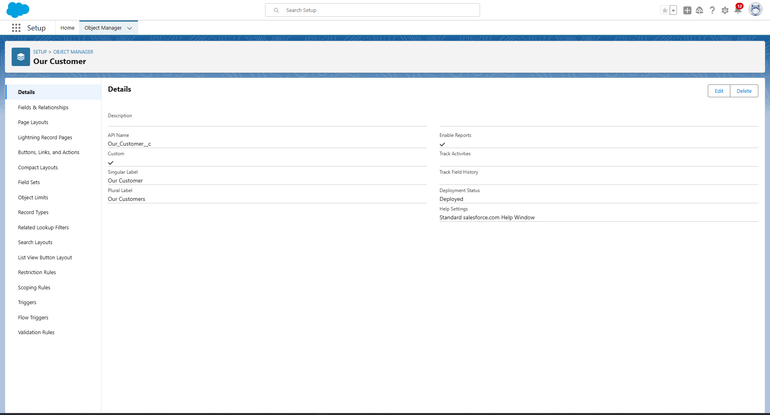

2. Consultants

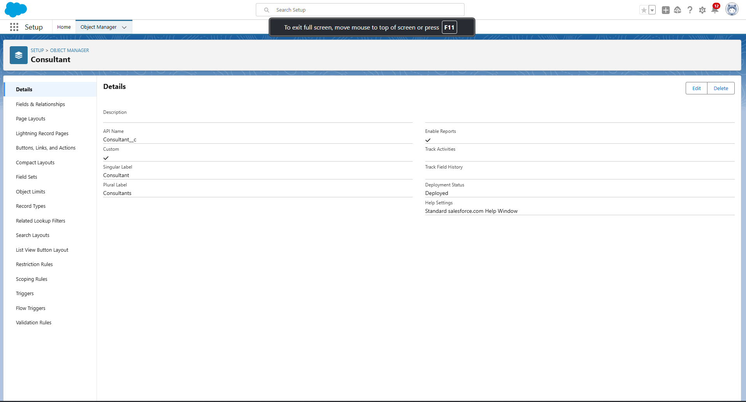

3. Retailers

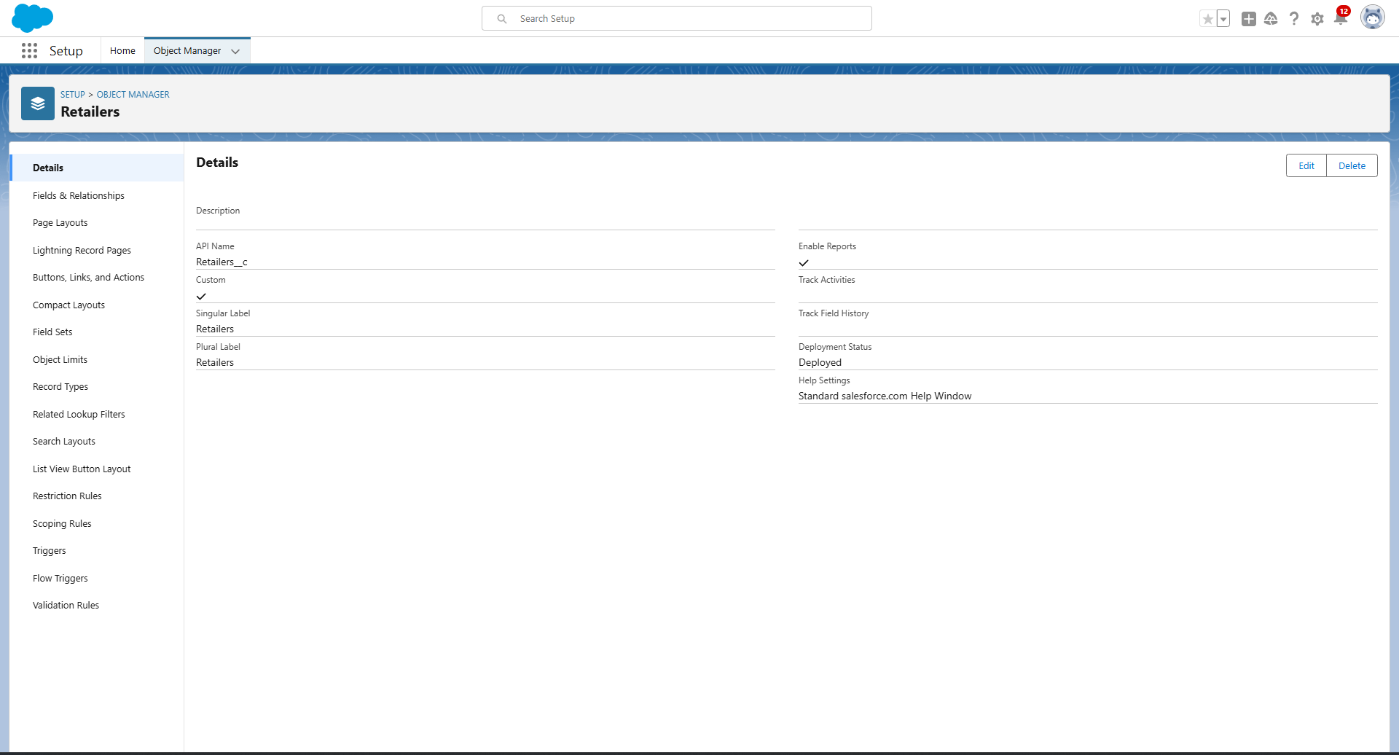

4. Others

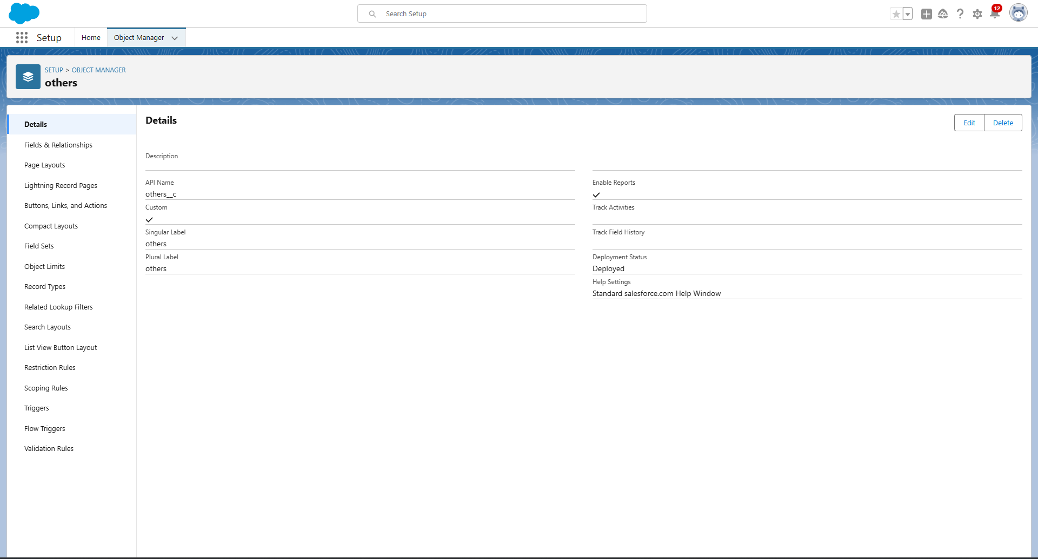

# FIELDS & RELATIONSHIPS

An object relationship in Salesforce is a two-way association between two objects. Relationships are created by creating custom relationship fields on an object. This is done so that when users view records, they can also see and access related data.

### Fields in Our Customers objects

Fields in Our Customers objects follow below data types:

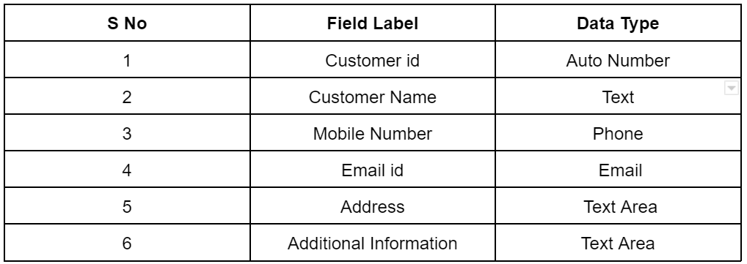

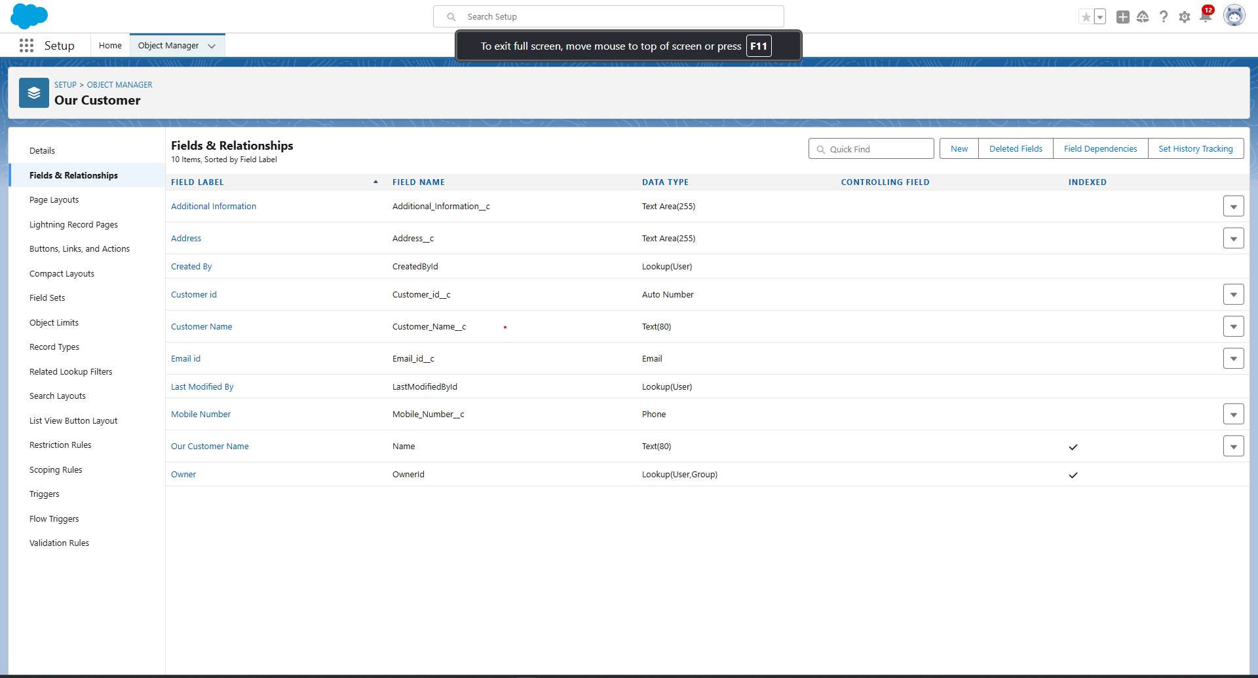

### Fields in Consultants objects

Fields in Consultants objects follow below data types:

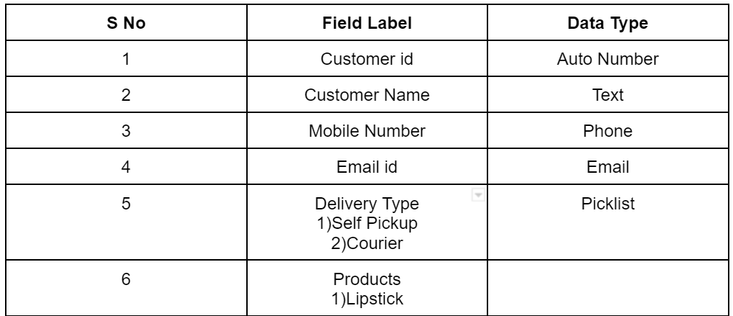

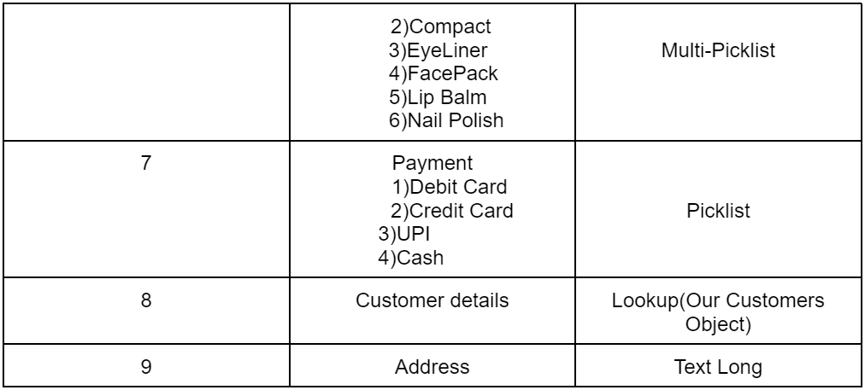

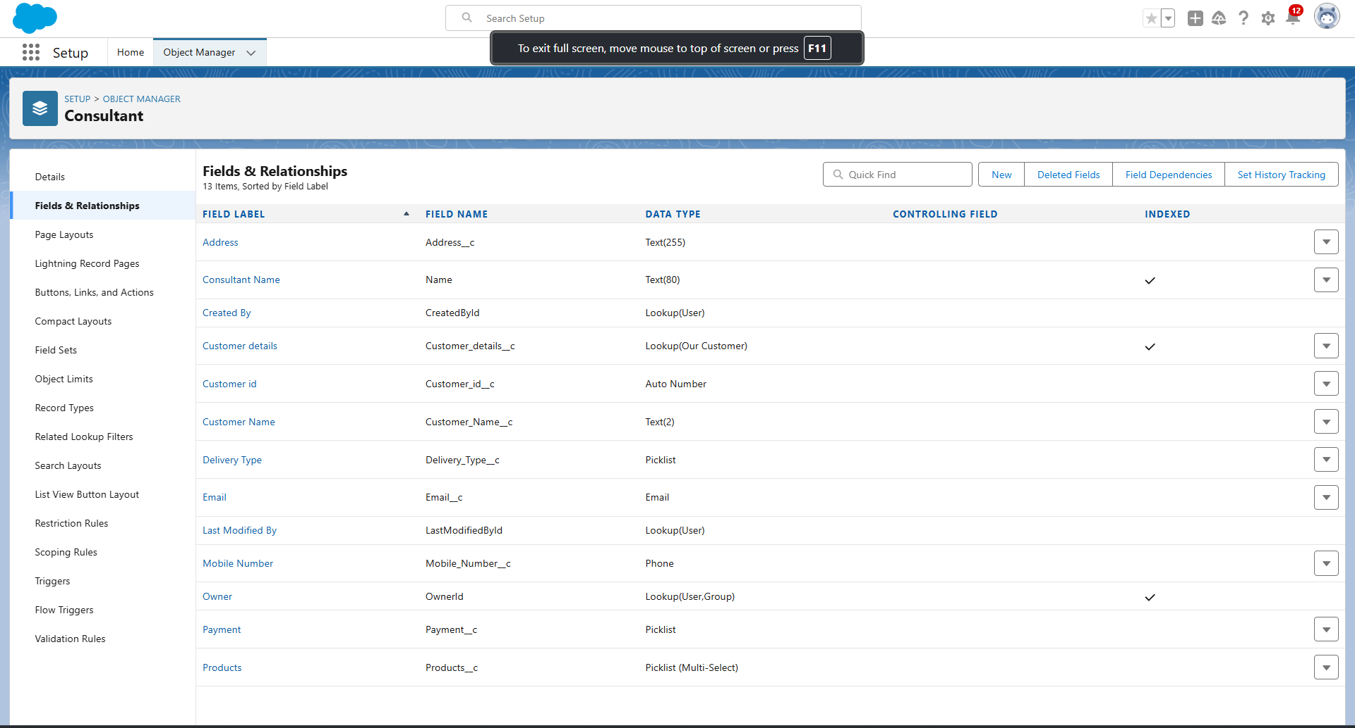

### Fields in Retailers objects

Fields in Retailers objects follow below data types:

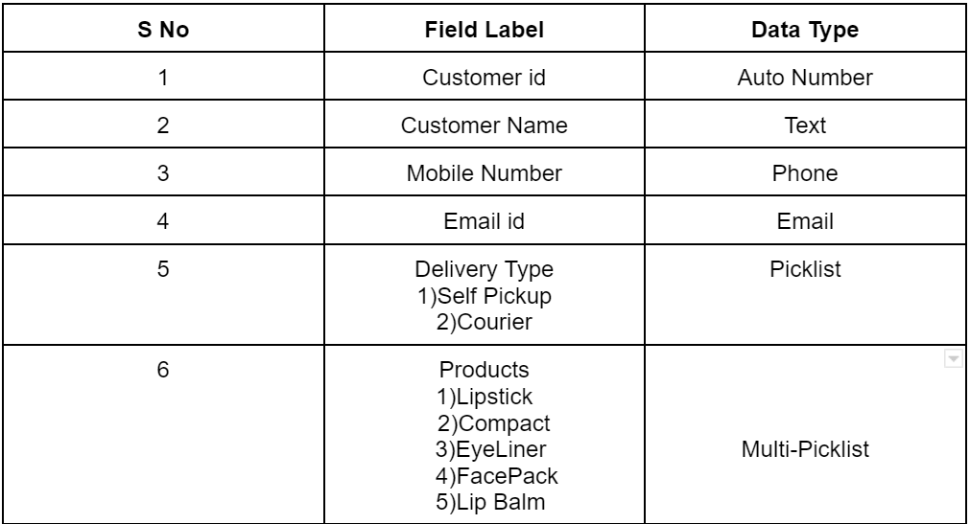

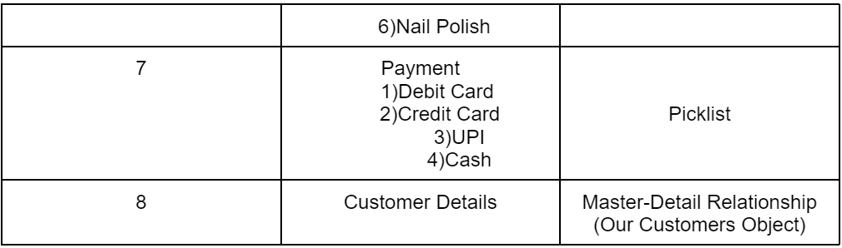

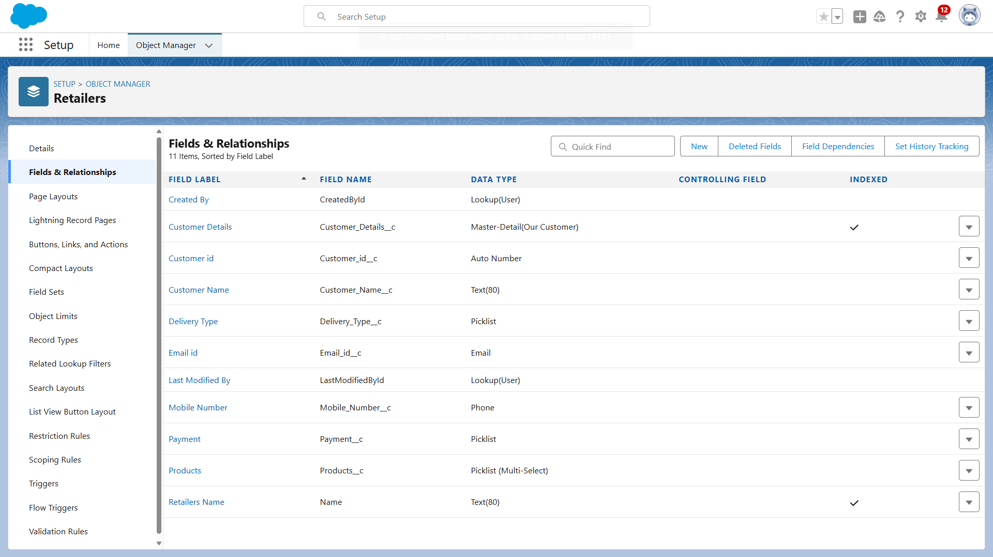

### Fields in Others objects

Fields in Others objects follow below data types:

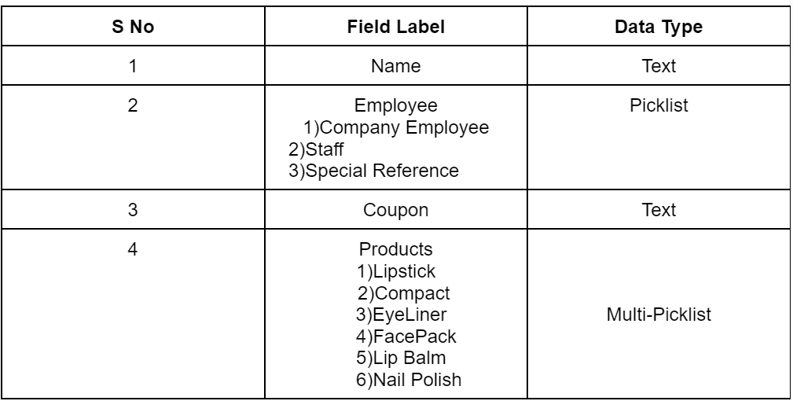

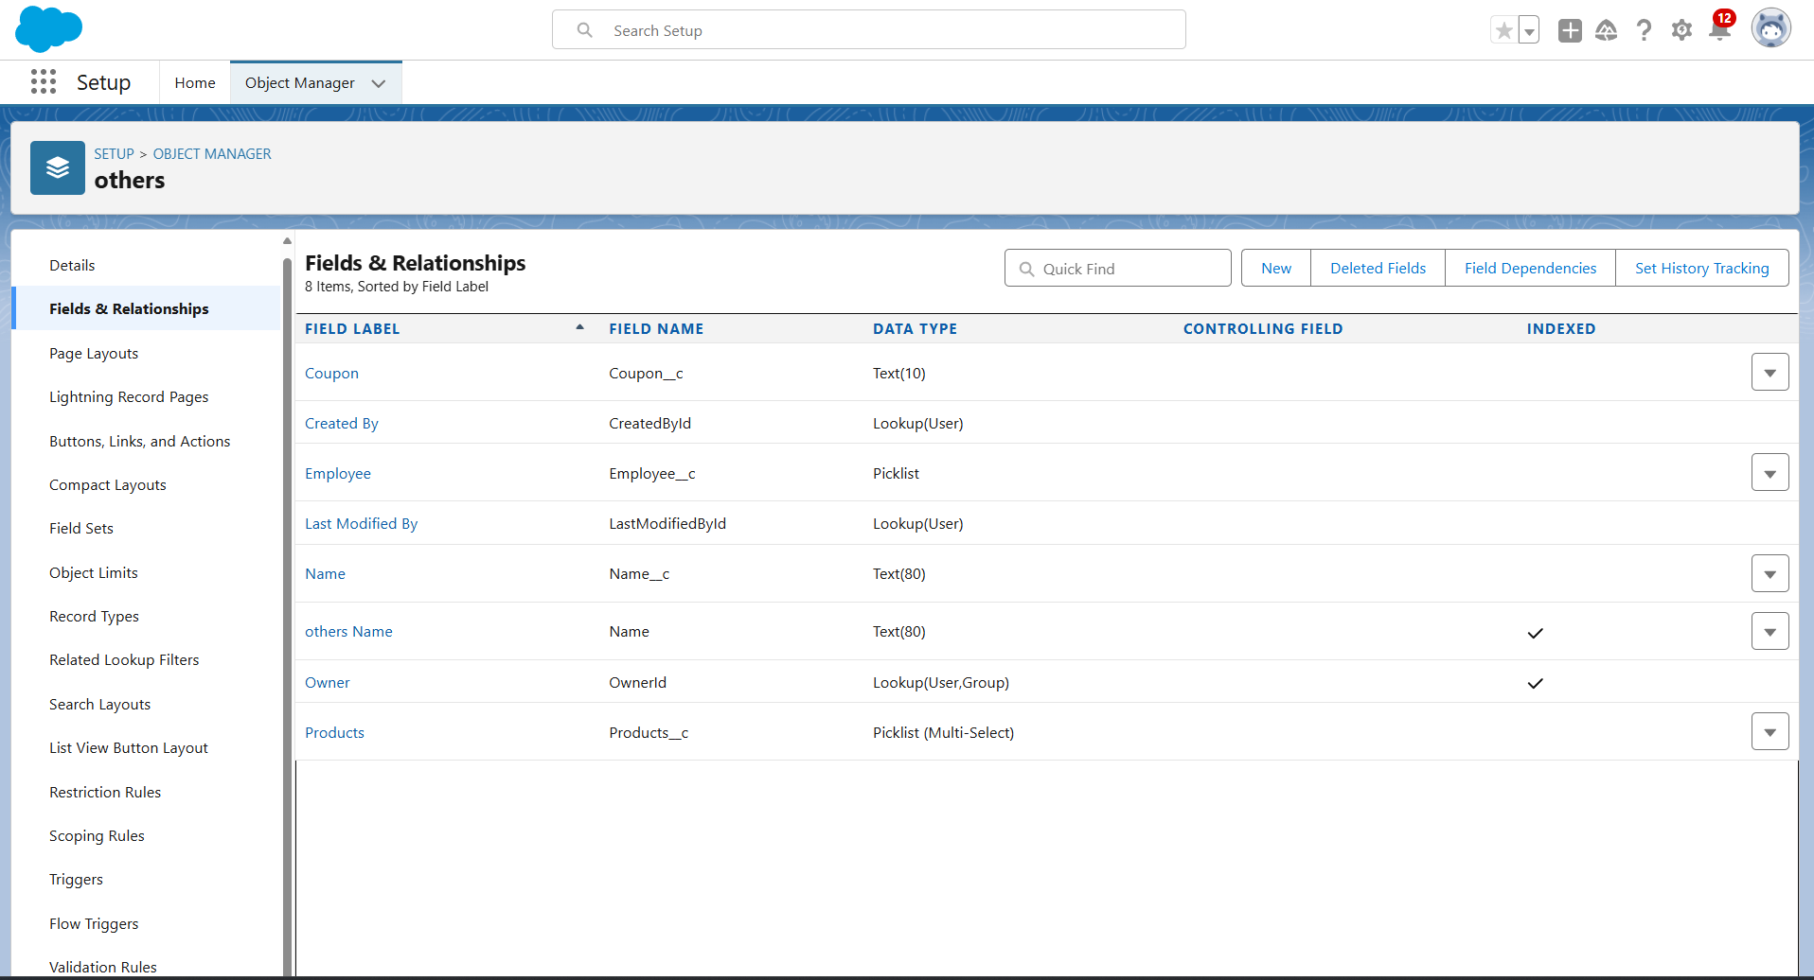

# PAGE LAYOUTS

In Salesforce, page layouts define the organisation and arrangement of fields, buttons, related lists, and other components on an object's detail and edit pages. They allow you to control the user interface and tailor it to meet the specific needs of your organisation.

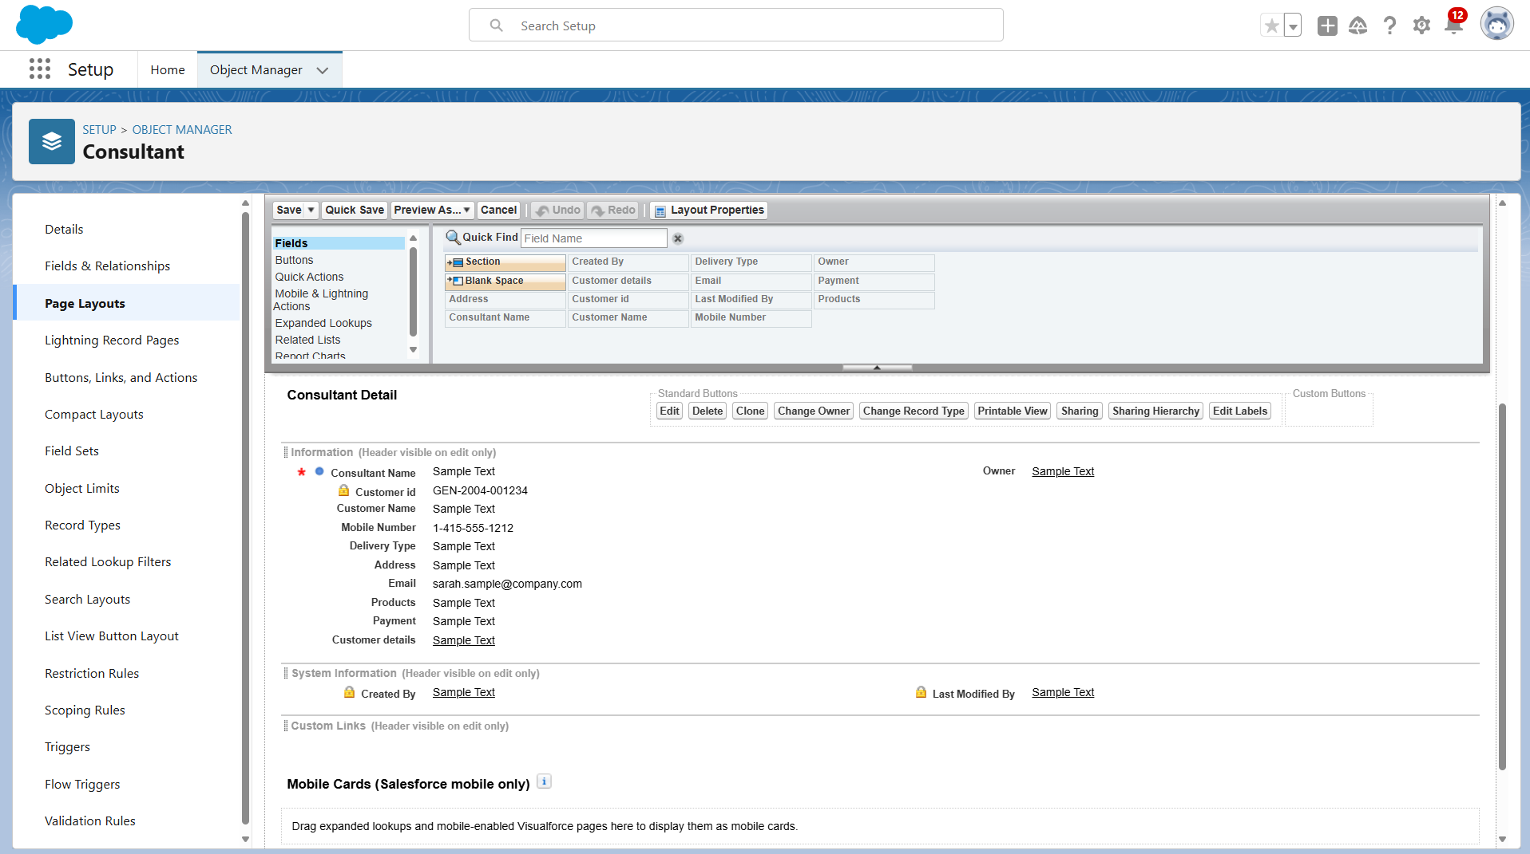

# THE LIGHTNING APP

An app is a collection of items that work together to serve a particular function. In Lightning Experience, Lightning apps give your users access to sets of objects, tabs, and other items all in one convenient bundle in the navigation bar.

Lightning apps let you brand your apps with a custom Color and logo. You can even include a utility bar and Lightning page tabs in your Lightning app. Members of your org can work more efficiently by easily switching between apps.

To create a lightning app page:

1. Go to setup page --> search “app manager” in quick find --> select “app manager” --> click on New lightning App.
2. Fill the app name as Urban Color in app details and branding --> Next --> (App option page) keep it as default --> Next --> (Utility Items) keep it as default --> Next.
3. To Add Navigation Items:
4. Select the items (Our Customers,Consultants,Retailers,Others,Reports,Dashboards ) from the search bar and move it using the arrow button --> Next.
5. To Add User Profiles:
6. Search profiles (System administrator) in the search bar --> click on the arrow button --> save & finish.

# PROFILES

Profiles control what users can access in the system. For this project, the following profiles were created:  
1. Store Supervisor: Full access to all objects.

Creating a Store Supervisor profile and setting its object permissions.

1. From Setup enter Profiles in the Quick Find box, and select Profiles.
2. From the list of profiles, find Standard User.
3. Click Clone.
4. For Profile Name, enter Store Supervisor.
5. Click Save.
6. While still on the Store Supervisor profile page, then click Edit.
7. Scroll down to Custom Object Permissions and give access for Create,Read,Edit,Delete,View all and modify all for Our Customers,Consultants,Retailers,Others.
8. Scroll down to Custom App Settings and give access for Urban Color.

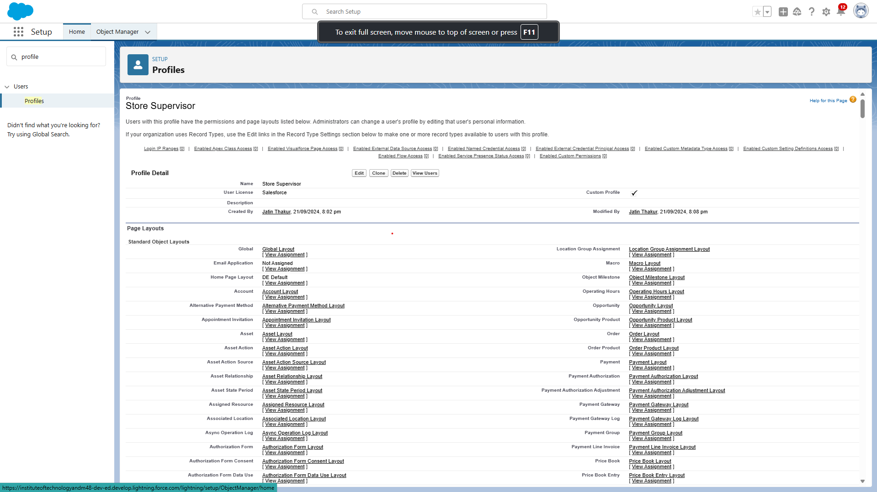

2. Billing Operator: Limited access, primarily for managing payments.

Similarly Create operator profile ,Clone Salesforce Platform user and give access only for Billing Operator.

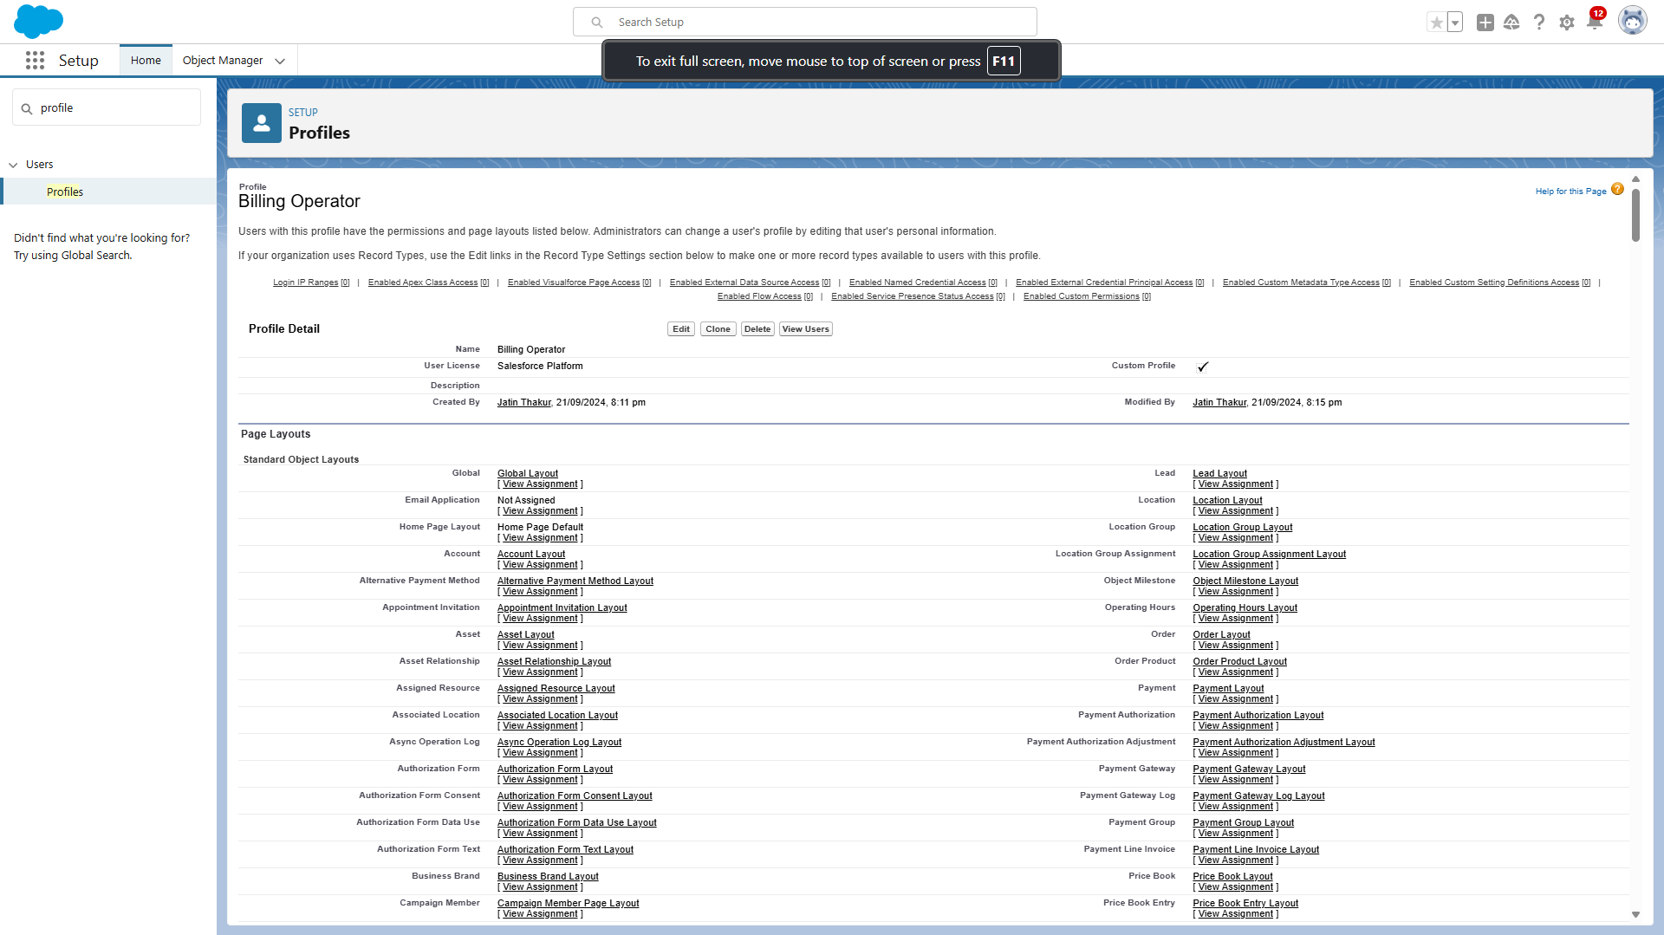

# ROLES

Roles determine the level of access a user has to records within Salesforce. In this project, we created two roles:  
1. Store Head: Manages overall store operations and has access to all records.  
2. Billing Operator: Manages payment-related tasks with restricted access.

### Setup Roles

1. Click on the Gear Icon
2. Click "Setup"
3. In the Quick Find box, enter "Roles"
4. Click "Roles"
5. Click on "Set Up Roles"
6. Click "Expand All"
7. Under the CEO, click on "Add Role"
8. Fill up the Label as Store Head, Role Name Store_Head.
9. Enter a Role name that will be displayed on Report.
10. Click Save

Similarly create One Roles under Store Head as Billing Operator.

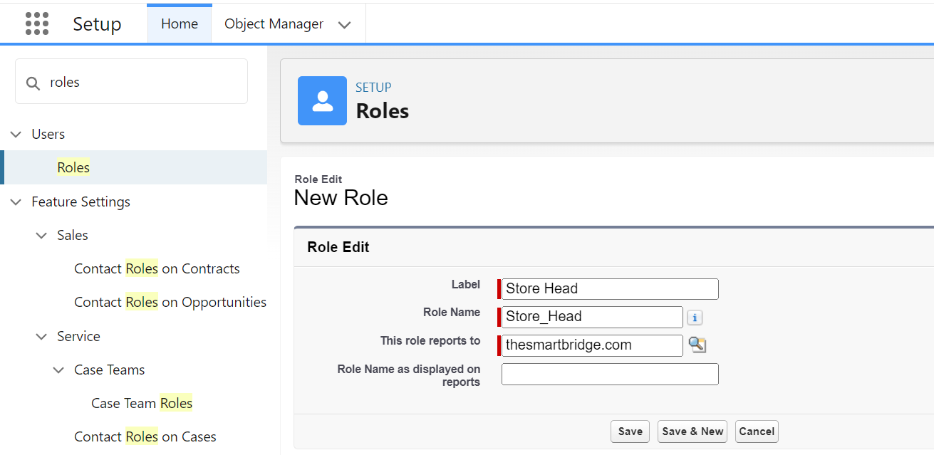

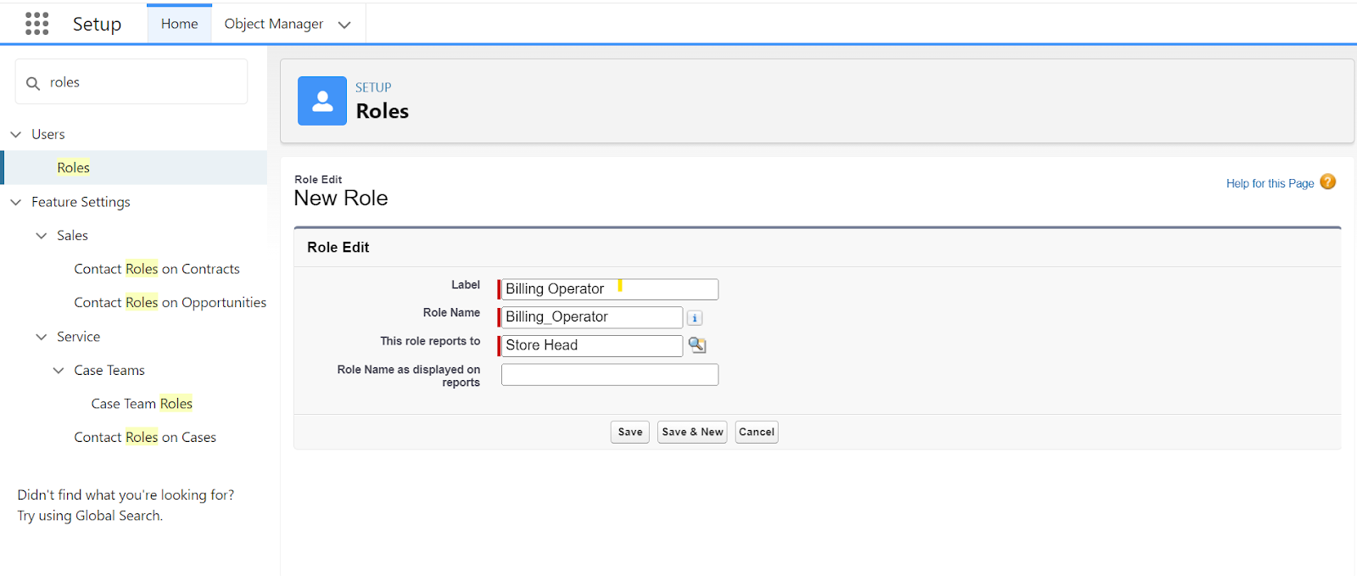

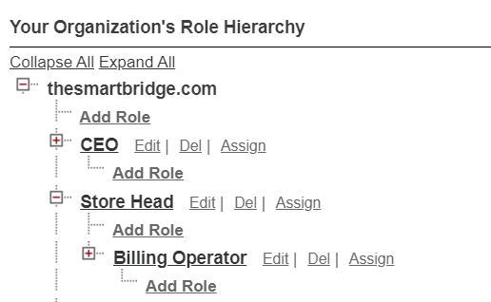

# USERS

A user is anyone who logs in to Salesforce. Users are employees at your company, such as sales reps, managers, and IT specialists, who need access to the company's records. Every user in Salesforce has a user account.

For this project, two users were created:  
1. Amar K (Store Head)

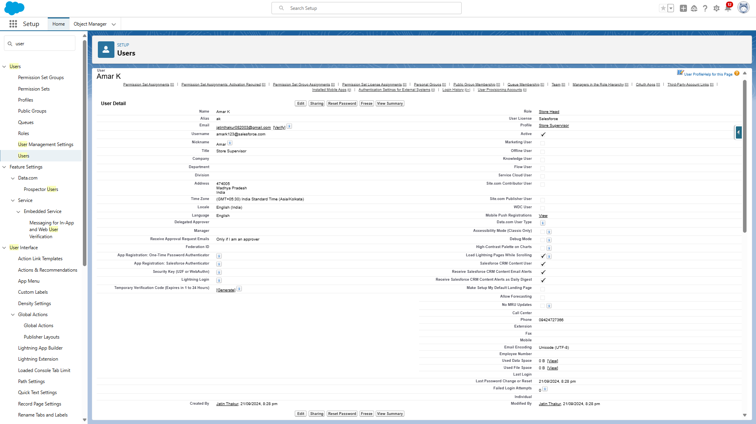

2. John Teddy (Billing Operator)

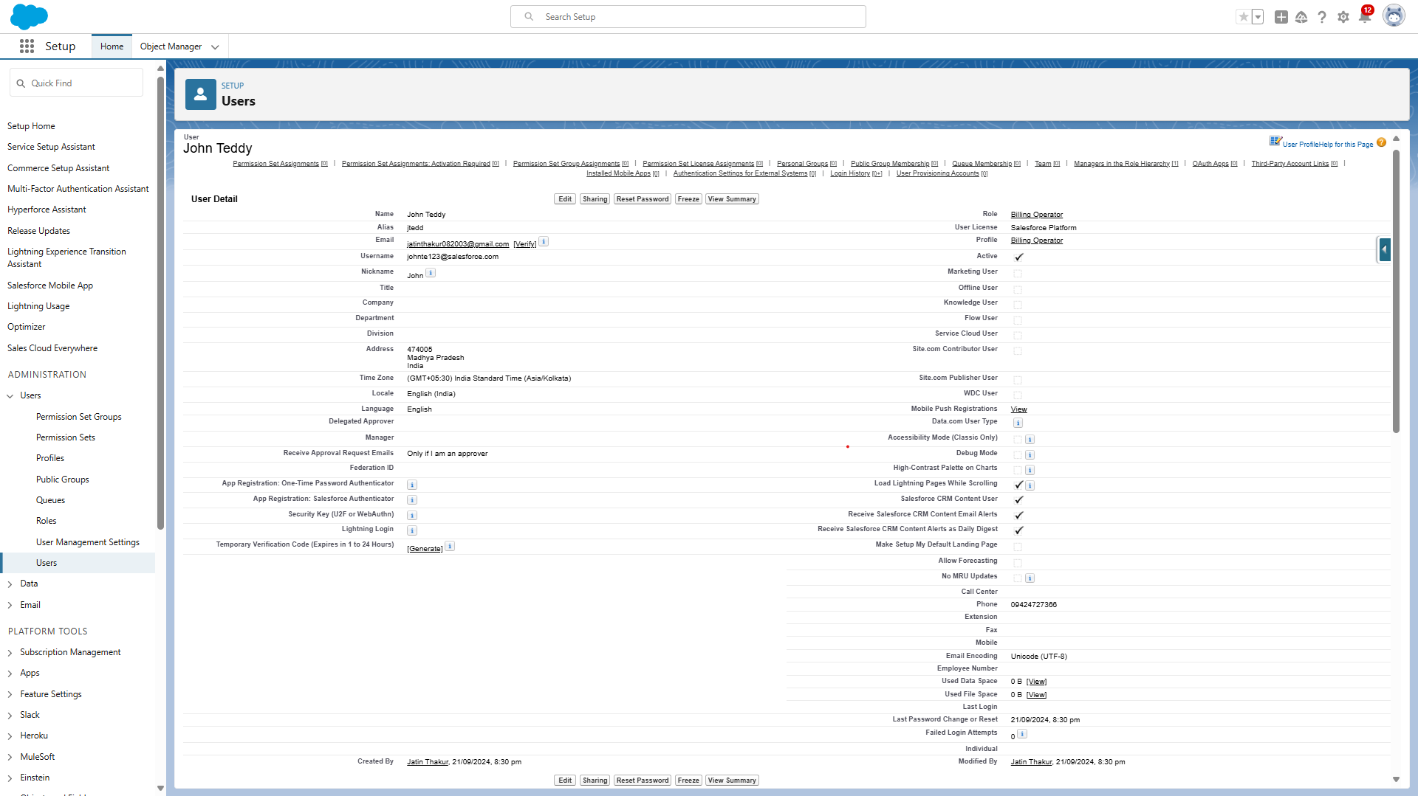

# USER ADOPTION

We need to understand user adoption and navigation. How to interact with database and their records.

### Create Our Customer Record

1. Click on App Launcher on left side of screen.
2. Search Urban Color & click on it.
3. Click on Our Customer  tab.
4. Click new button
5. Fill all Our Customer record details.
6. Click on Save Button

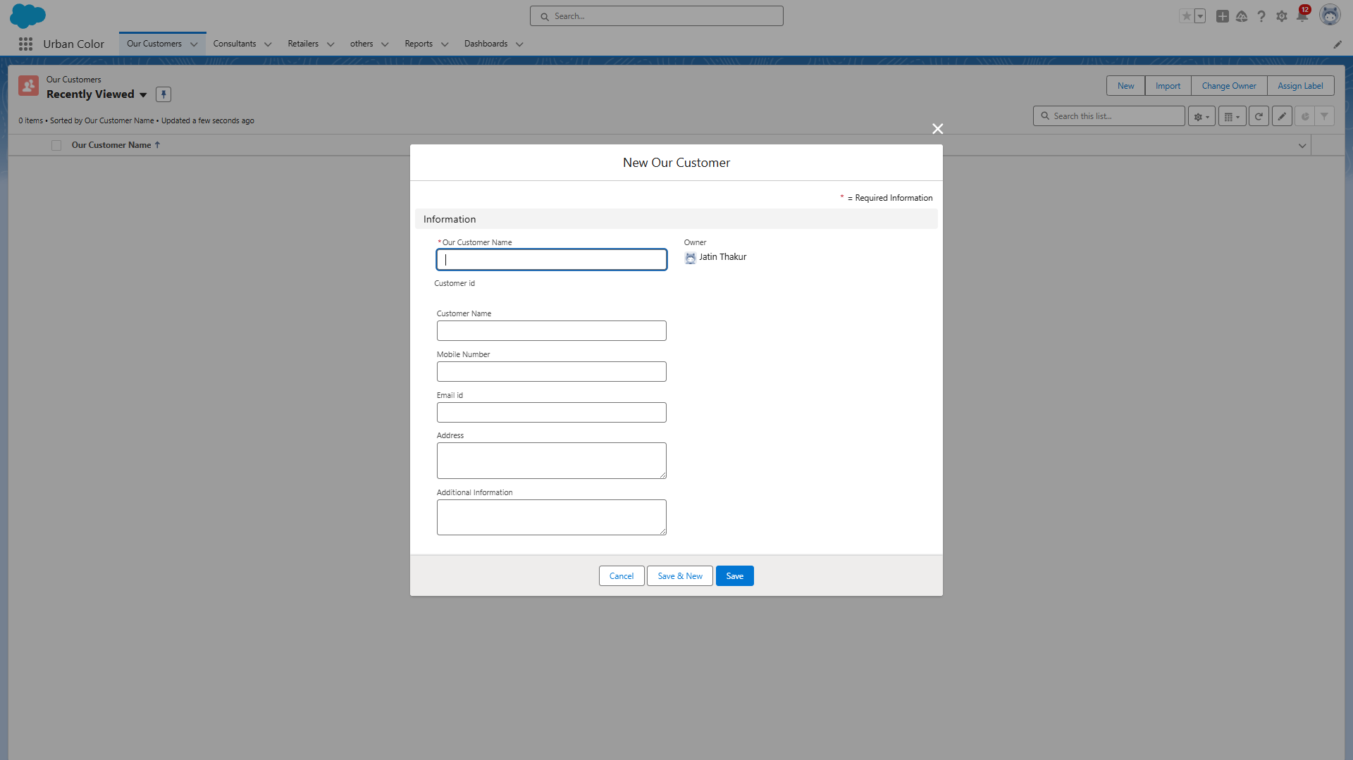

### View Record (Our Customer)

1. Click on App Launcher on the left side of the screen.
2. Search Urban Color & click on it.
3. Click on Our Customer Tab.
4. Click on any record name. you can see the details of the Our Customer

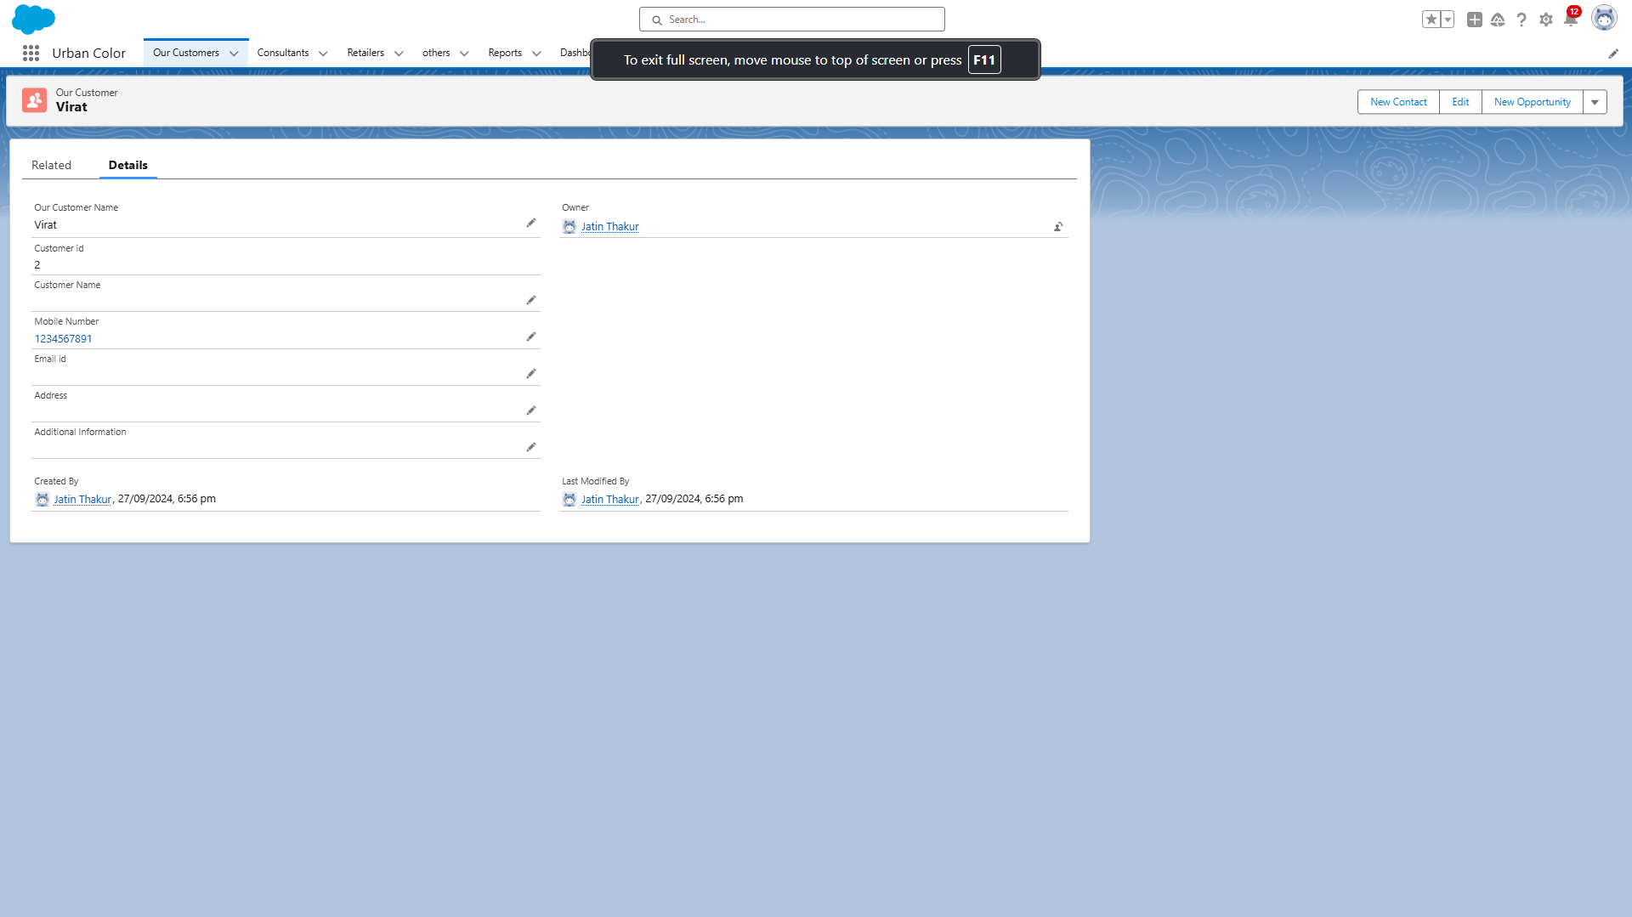

### Delete Record (Our Customer)

1. Click on App Launcher on the left side of the screen.
2. Search Urban Color & click on it.
3. Click on Our Customer Tab.
4. Click on Arrow at right hand side on that Particular record.
5. Click delete and delete again.

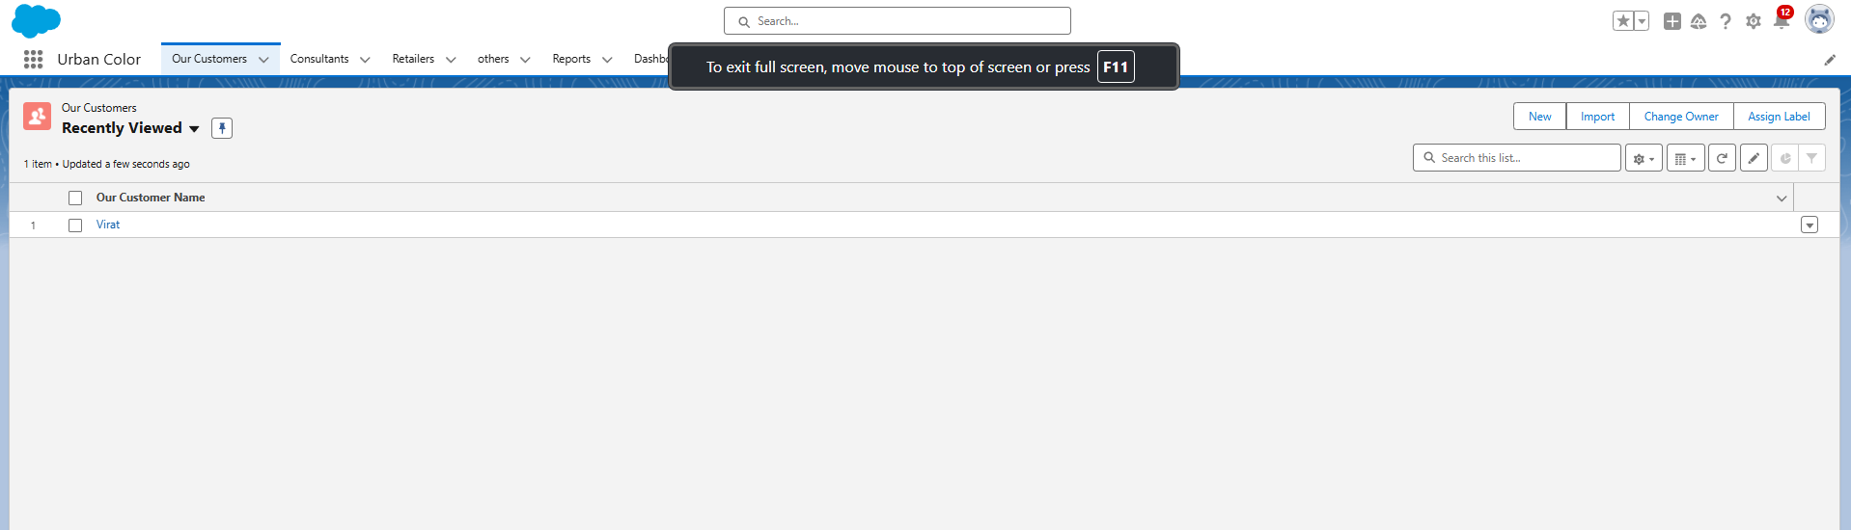

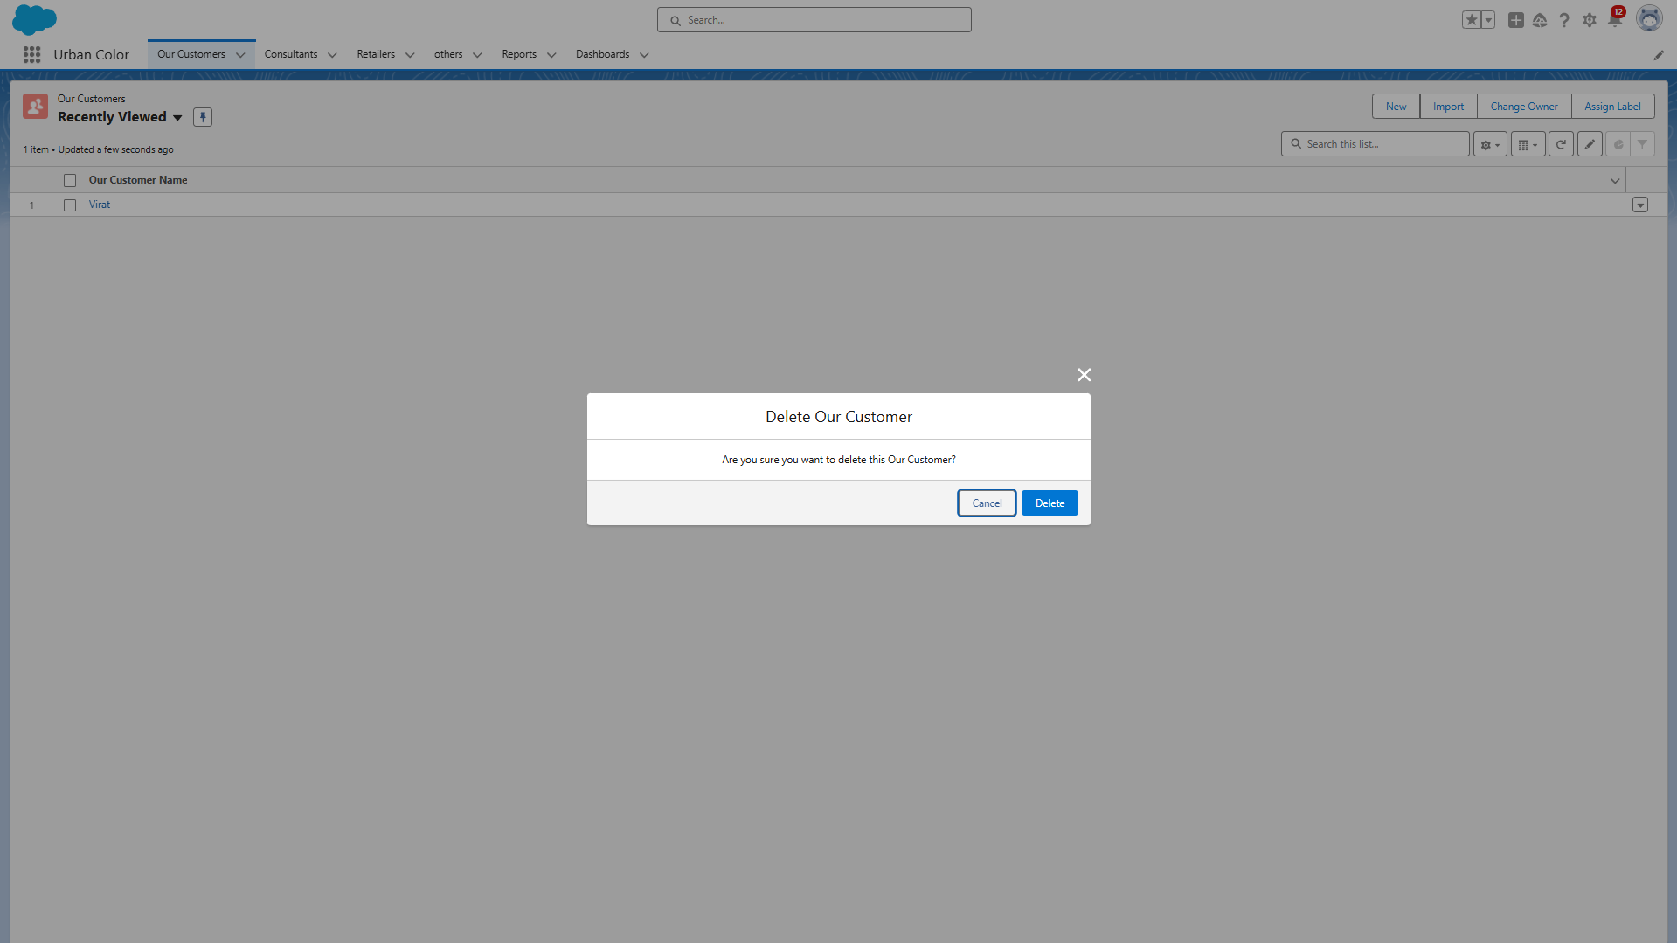

# IMPORT DATA

Data Import Wizard—this tool, accessible through the Setup menu, lets you import data in common standard objects, such as contacts, leads, accounts, as well as data in custom objects.

1. From Setup, click the Home tab.
2. In the Quick Find box, enter Data Import and select Data Import Wizard
3. Click Launch Wizard!
4. Click the Custom Objects tab and select the Consultant object.
5. Select Add new records.
6. Click CSV and choose file Consultant_CSV which we made earlier. Click Next.
7. Since the field names in the CSV file (CSV Header) are the same as the field names in your object (Mapped Salesforce Object), the fields are automatically mapped. Click Next.
8. The next screen gives you a summary of your data import. Click Start Import.

# REPORTS

### What are Reports?

Reports in Salesforce is a list of records that meet a particular criterion which gives an answer to a particular question. These records are displayed as a table that can be filtered or grouped based on any field.

There are 4 types of report formats in Salesforce:

1. Tabular Reports:  
   This is the most basic report format. It just displays the row of records in a table with a grand total. While easy to set up they can’t be used to create groups of data or charts and also cannot be used in Dashboards. They are mainly used to generate a simple list or a list with a grand total.
2. Summary Reports:  
   It is the most commonly used type of report. It allows grouping of rows of data, view subtotal, and create charts.
3. Matrix Report:  
   It is the most complex report format. Matrix report summarizes information in a grid format. It allows records to be grouped by both columns and rows. It can also be used to generate dashboards. Charts can be added to this type of report.
4. Joined Reports:  
   These types of reports let us create different views of data from multiple report types. The data is joined reports are organized in blocks. Each block acts as a subreport with its own fields, columns, sorting, and filtering. They are used to group and show data from multiple report types in different views.

**Report types:**

Report type determines which set of records will be available in a report. Every report is based on a particular report type. The report type is selected first when we create a report. Every reporttype has a primary object and one or more related objects. All these objects must be linked together either directly or indirectly.

* A report type cannot include more than 4 objects.
* Once a report is created its report type cannot be changed.

There are 2 types of report types:

1. Standard Report Types:  
   Standard Report Types are automatically included with standard objects and also with custom objects where “Allow Reports” is checked.  
   Standard report types cannot be customized and automatically include standard and custom fields for each object within the report type. Standard report types get created when an object is created, also when a relationship is created.  
   **Note:** Standard report types always have inner joins.
2. Custom Report Types:  
   Custom report types are reporting templates created to streamline the reporting process. Custom Reports are created by an administrator or User with “Manage Custom Report Types” permission. Custom report types are created when standard report types cannot specify which records will be available on reports.  
   In custom report types we can specify objects which will be available in a particular report. The primary object must have a relationship with other objects present in a report type either directly or indirectly.

There are 3 types of access levels of folders:

1. Viewer:  
   With this access level, users can see the data in a report but cannot make any changes except cloning it into a new report.
2. Editor:  
   With this access level, users can view and modify the reports it contains and can also move them to/from any other folders they have access level as Editor or Manager.
3. Manager:  
   With this access level, users can do everything Viewers & Editors can do, plus they can also control other user’s access levels to this folder. Also, users with Manager Access levels can delete the report.
4. 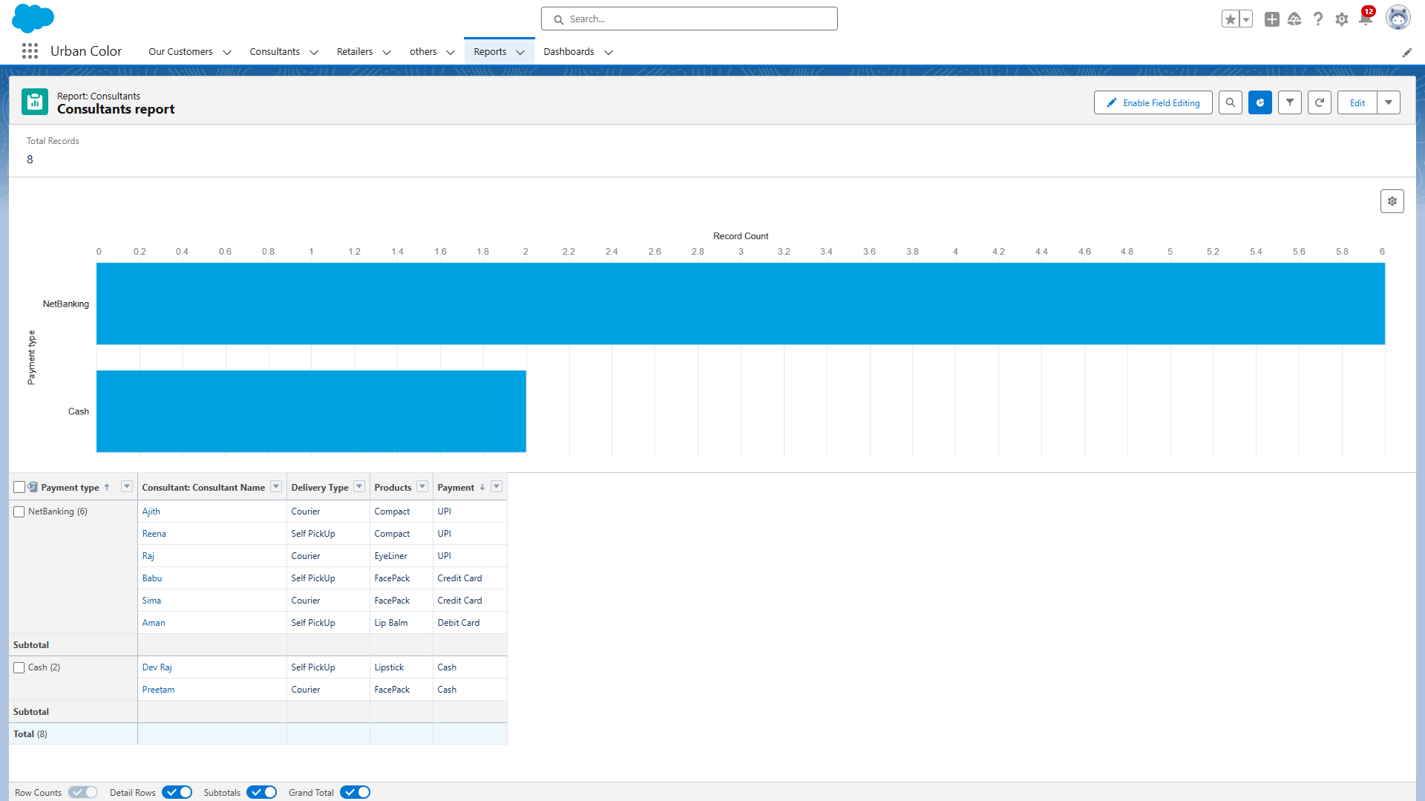

# DASHBOARDS

Dashboards let you curate data from reports using charts, tables, and metrics. If your colleagues need more information, then they're able to view your dashboard's data supplying reports. Dashboard filters make it easy for users to apply different data perspectives to a single dashboard.

### Create Dashboard

1. Click on the Dashboards tab from the Urban Color application.
2. Click on the new dashboard.
3. Give name- Consultant Dashboard
4. Click create
5. Give your dashboard a name and click on +component
6. Select the Consultants Report which you created.
7. For the data visualization select any of the chart, table etc. as per your choice/requirement.
8. Click add.
9. Click save.

### View Dashboard

1. Click on App Launcher on the left side of the screen.
2. Search Candidate Internal Result Card & click on it.
3. Click on Dashboard Tab.
4. Click on Candidate Internal Result Card see graph view of records

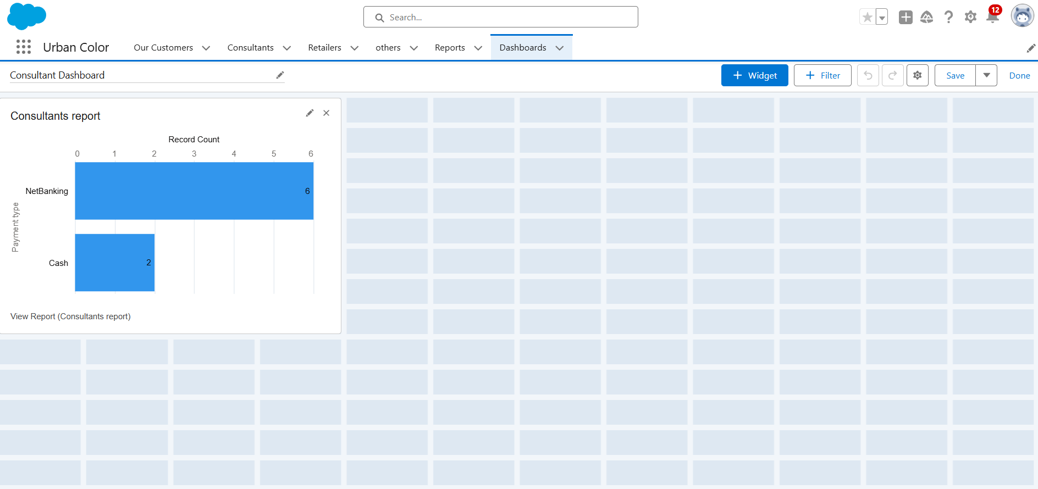

# CONCLUSION

By using the Salesforce platform, the Cosmetics Store Management project successfully created a system that streamlines operations, improves customer engagement, and enhances overall efficiency. The project showcases the power of Salesforce in handling complex workflows and data management tasks for retail businesses.