**Online Test Application –Phase 4**

**Online Test Application:**

**This document contains sections for:**

* Project Description
* Core concepts used in project
* Flow of the Application.
* Project Users Stories : ( Agile and Scrum )
* Git Repositories
* How to run project
* Demonstrating the product capabilities, appearance, and user interactions.
* Unique Selling Points of the Application
* Conclusions

The code for this project is hosted at :

[**https://github.com/Jatin-wadhwani/Phase-4-Online-Test-Application.git**](https://github.com/Jatin-wadhwani/Phase-4-Online-Test-Application.git)

The project is developed by JATIN WADHWANI

* 1. **Project Description:**

**Project objective:**

The Online Test Application system creates an application that enables users to provide online tests, review them, and display the results.

**System Details**  
This system contains three main modules: Quiz, Review, and Result. The quiz section of the online test application accepts the questions in JSON format. The JSON file can be easily shared from the server in the pre-defined format. The application renders the test at the client-side.  
The “Review and display result” section allows users to declare the results immediately.

**Core concepts used in the project:**

-> Used VS Code.

-> Typescript and Angular

TECHNOLOGIES AND TOOLS USED:

Typescript and Angular

• JSON: to handle the presentation view.

•Angular-Service: to simplify the development and the interaction with the UI

• CSS: to format the contents.

• Bootstrap: to use some CSS and JavaScript designs.

•Npm: to manage the project.

•VSCode: to write and run the code.

**Architecture diagram / flow chart**

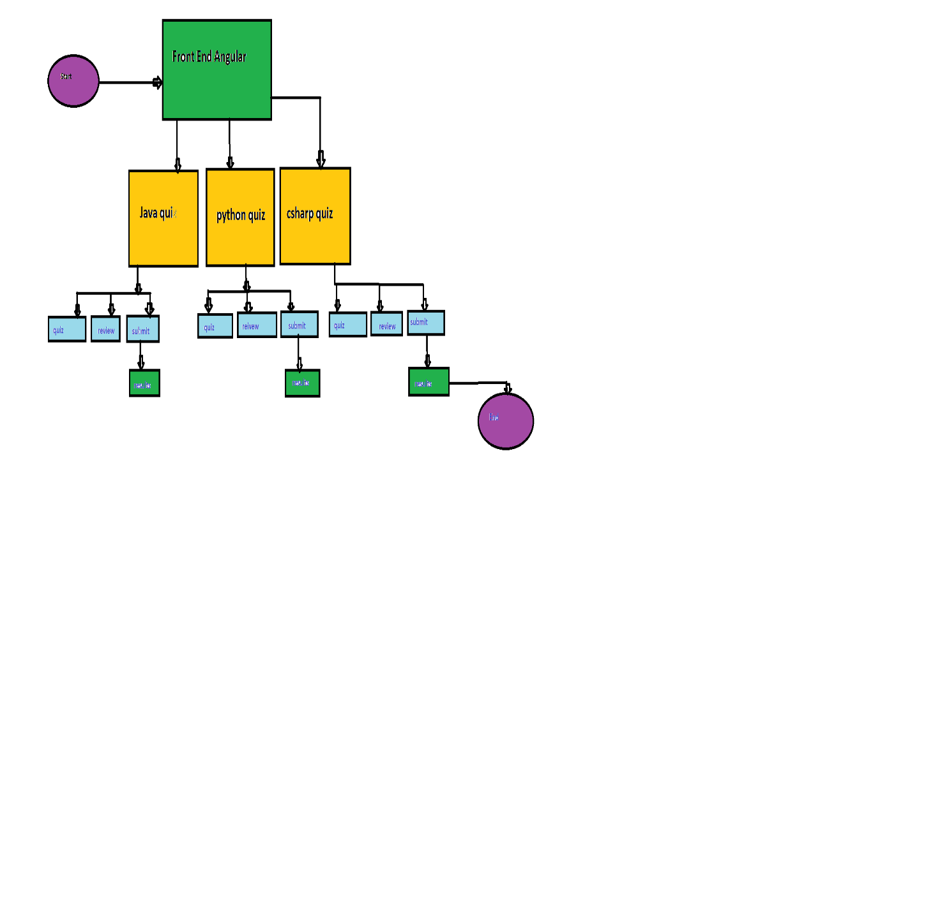

**Project Users Stories : ( Agile and Scrum )**

The project is planned to be completed in 3 sprints. Tasks assumed to be completed in the sprint are:

* Creating the flow of the application
* Initializing git repository to track changes as development progresses.
* Writing the Java program to fulfill the requirements of the project.
* Testing the Java program with different kinds of User input
* Pushing code to GitHub.

1) As an Dev,the User can take Quiz.

2) As an Dev, Attempt the quiz.

3) As an Dev,User Can Get the results

The goal of the company is to deliver a high-end quality product as early as possible.

Sprint 1

1) Start the quiz with in the 3 quiz’s.

2) Take one quiz and start the test.

3) Get the results Finally.

Sprint 2

1. Make the UI manage the users.
2. Push the code to the GitHub.

The goal of the company is to deliver a high-end quality product as early as possible.

**Directory Structure / package:**

## **C:\Users\SURA KUSALA\Pictures\Screenshots\Screenshot (211).png**

## **Demonstrating the product capabilities, appearance, and user interactions**

To demonstrate the product capabilities, below are the sub-sections configured to highlight appearance and user interactions for the project:

## **Step 1:** Creating a new project in Eclipse

* Open VS Code
* Go to File -> Open Folder -> Create new Project -> Next.
* Type in any project name and click on “Finish.”
* Select your project and go to Terminal->npm install ->npm start or ng serve.

## **Step 2 :** Pushing the code to GitHub repository

* Open your command prompt and navigate to the folder where you have created your files.

*cd <folder path>*

* Initialize repository using the following command:

*git init*

* Add all the files to your git repository using the following command:

*git add .*

* Commit the changes using the following command:

*git commit . -m <commit message>*

* Push the files to the folder you initially created using the following command:

*git push -u origin master*

## **Unique Selling Points of the Application**

1. Scheduled products for users can be maintained easily.
2. The data of the users and products can be edited easily.
3. High security for the data as the admin only can access the data.
4. Searching for any data about users is made easy