Experiment -1.1

### Install Git and creating repository

|  |  |  |
| --- | --- | --- |
| **Student Name:** | Jatin Arora | **UID:** 22BDO10051 |
| **Branch:** | CSE(DEVOPS) | **Section/Group:** 22BCD-1/B |
| **Semester:** | 4th | **Date of Performance:** 17-01-2024 |
| **Subject Name:** | Git and GitHub | **Subject Code:** 22CSH-293 |

1. **Aim/Overview of the practical:** Install Git and creating repository.
2. **Task to be done:** Download Git for Windows. And, to make repositories.
3. **Steps for experiment:**
4. Browse to the official Git website and download the Application.

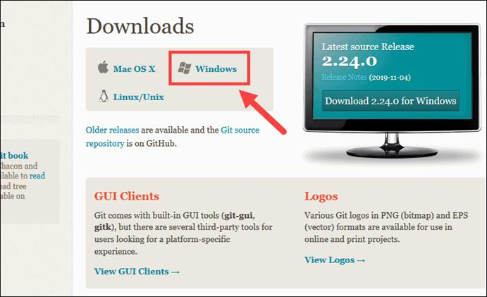

1. Browse to the download location and Double-click the file to launch the installer.
2. Click Yes on the User Account Control dialog that opens.
3. When you’re ready to install, click Next
4. The installer will ask for an installation location. Leave the default (or select custom location by browsing) and click Next.
5. The installer will offer to create a start menu folder. Simply click Next.
6. Select a text editor you’d like to use with Git. Use the drop-down menu to select Visual Studio code and click Next.
7. The next step allows you to choose a different name for your initial branch. The default is 'master’. Leave the default option and click Next.
8. This installation step allows you to change the PATH environment. The PATH is the default set of directories included when you run a command from the command line. Leave this on the middle (recommended) selection and click Next.
9. The installer now asks which SSH client you want Git to use. Git already comes with its own SSH client so leave the default option and click Next.
10. The next option relates to server certificates. Click Next.
11. The next selection converts line endings. Leave the default selection. Click Next.
12. Choose the [terminal emulator](https://phoenixnap.com/glossary/terminal-emulation) you want to use. The default MinTTY is recommended, for its features. Click Next.
13. The installer now asks what the git pull command should do. The default option is to be selected. Click Next to continue with the installation.
14. Next you should choose which credential helper to use. Git uses credential helpers to fetch or save credentials. Leave the default option as it is the most stable one, and click Next.
15. Depending on the version of Git you’re installing, it may offer to install experimental features. Leave them unchecked and click Install.
16. Once the installation is complete, tick the boxes to view the Release Notes or Launch Git Bash, then click Finish.

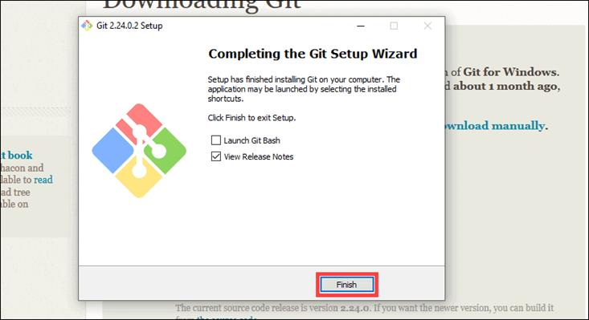

# How to Launch Git in Windows

To launch Git BASH :

Open the Windows Start menu, type *git bash* and press Enter.

### Configure GitHub Credentials

1. Configure local Git installation to use GitHub by entering the following:

git config --global user.name "github_username"

git config --global user.email "email_address"

1. Type git config - - list to see list of configurations.

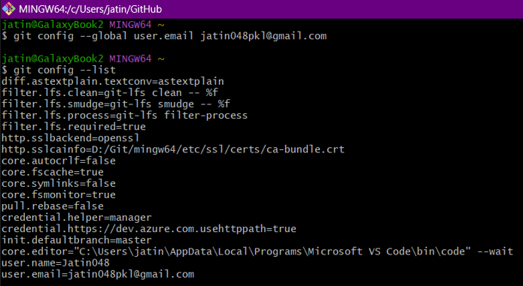

### Clone a GitHub Repository

Go to your repository on GitHub. In the top right above the list of files, open the **Clone or download** drop-down menu. Copy the **URL for cloning over HTTPS**.

Switch to your Bash, and enter the following:

git clone repository_url

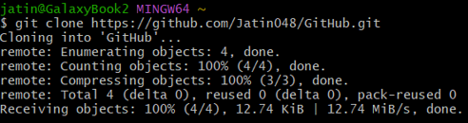

## List Remote Repositories

* Your working directory should now have a copy of the repository from GitHub. It should contain a directory with the name of the project. Change to the directory:
* Type ‘ls’ to list the name of files available in the directory.

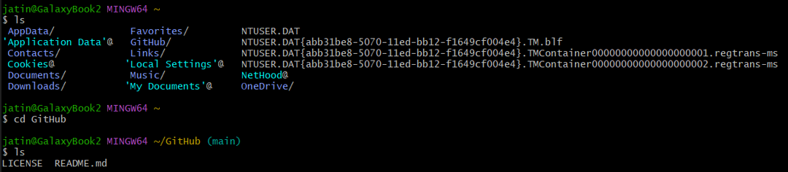



1. Creating file in local machine in clone repository

Using touch command we can create files

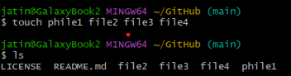

### Creating Repository on GitHub

* 1. After successful login ,click on the option (+) to add new repository to your account.

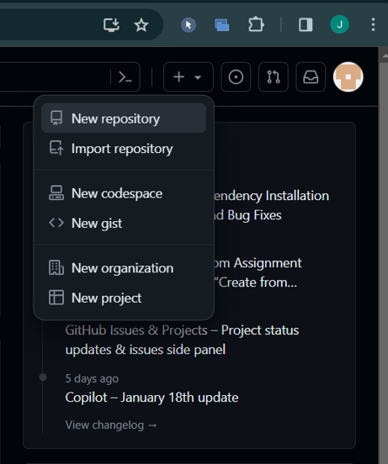

* 1. After clicking **new repository** option, we will have to initialize some things like, **naming our project**, choosing the **visibility** etc. After performing these steps click **Create Repository** button.

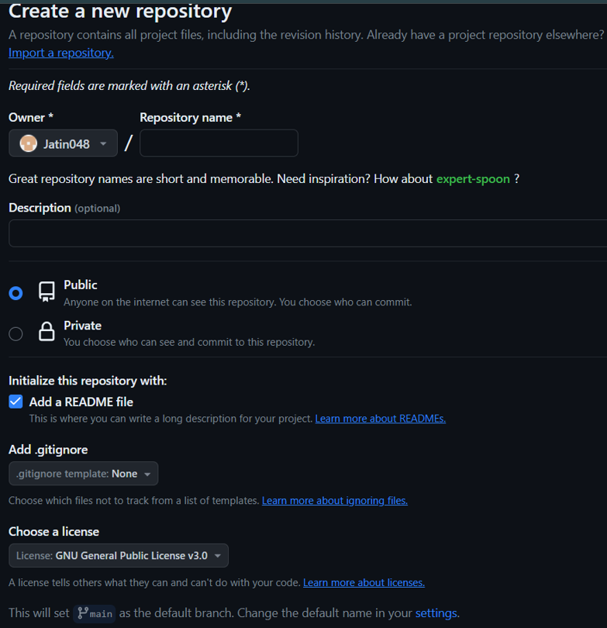

* 1. After clicking the button, we will be directed to the next page. After that we added some files using add files option.

This is how our repository looks now.

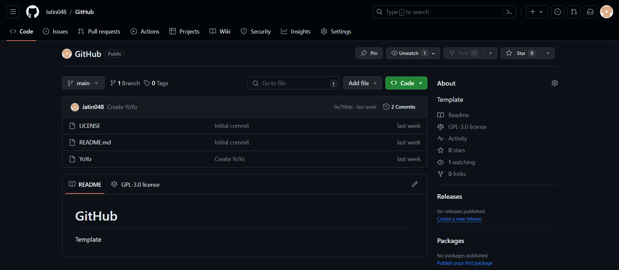

# Result/Output/Writing Summary:

We have successfully created a repository and applied some commands on that.

# Learning outcomes (What I have learnt):

* 1. Learnt about GitHub.
  2. Learnt about Git.
  3. Learnt about various git commands that can be applied on Git Bash.
  4. Learnt about repositories.
  5. Learnt about how to pull request and push.

**Evaluation Grid (To be created as per the SOP and Assessment guidelines by the faculty):**

|  |  |  |  |
| --- | --- | --- | --- |
| Sr. No. | Parameters | Marks Obtained | Maximum Marks |
| 1. |  |  |  |
| 2. |  |  |  |
| 3. |  |  |  |
|  |  |  |  |