Experiment -2.3

### Creation of forks on GitHub

|  |  |  |
| --- | --- | --- |
| **Student Name:** | Jatin Arora | **UID:** 22BDO10051 |
| **Branch:** | CSE(DEVOPS) | **Section/Group:** 22BCD-1/B |
| **Semester:** | 4th | **Date of Performance:** 21-02-2024 |
| **Subject Name:** | Git and GitHub | **Subject Code:** 22CSH-293 |

1. **Aim/Overview of the practical:** Creation of forks on GitHub
2. **Task to be done:** Examine the Git configurations, git push and clone, resolve conflicts, fork, commits, merge techniques etc.
3. **Steps for experiment:**
4. Click on the search bar of your profile and search for the repository that you want to fork: **Tempestyash123456/Automatic-drum-slinger.**

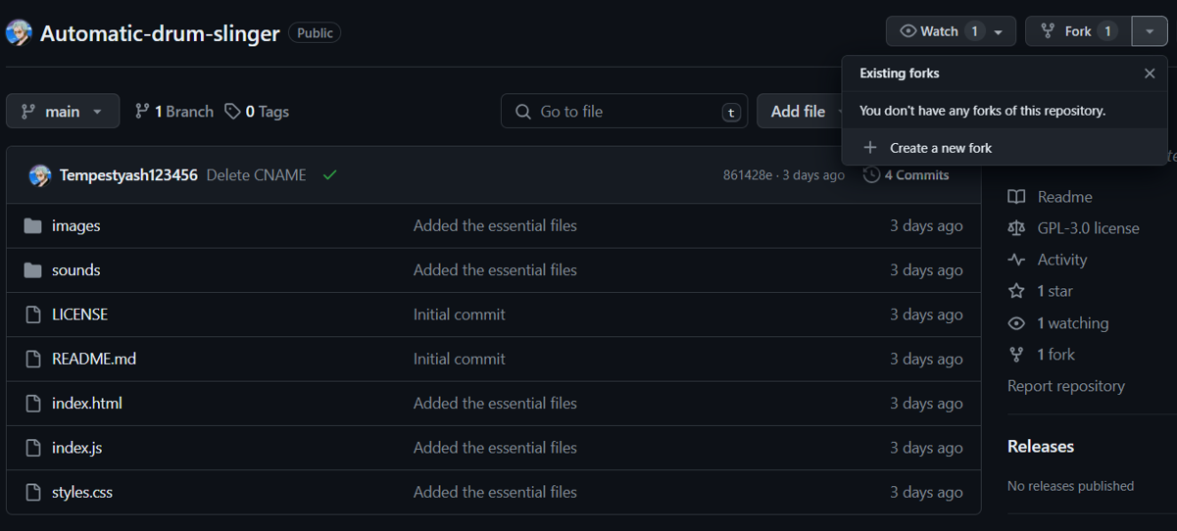

# Click on fork on right side of the window.

# Set the repository name as default or change it accordingly. Also configure if you want to copy contents of main branch only or not.

# Description is optional.

# 

# Now the forked repository i.e. the clone of original repository can be seen in your repositories.

# Now clone this forked repositor in local machine using git clone followed by https link to the repository.

# Create a file in the repository, test.txt , add it to the staging area using git add and then commit the changes using git commit.

# 

# Push the changes to the remote branch from the local machine using git push origin main.

# 

# Now the file can be viewed in the remote repository also.

# 

# 

# Learning outcomes (What I have learnt):

* 1. Learnt about GitHub and Git.
  2. Learnt about commit, merge and add commands.
  3. Learnt about various git commands that can be applied on Git Bash.
  4. Learnt about repositories, branches and local and remote repository.
  5. Learnt about how to pull request and push in git bash.

**Evaluation Grid (To be created as per the SOP and Assessment guidelines by the faculty):**

|  |  |  |  |
| --- | --- | --- | --- |
| Sr. No. | Parameters | Marks Obtained | Maximum Marks |
| 1. |  |  |  |
| 2. |  |  |  |
| 3. |  |  |  |
|  |  |  |  |