Experiment -1.2

### Creating branches with GitHub

|  |  |  |
| --- | --- | --- |
| **Student Name:** | Jatin Arora | **UID:** 22BDO10051 |
| **Branch:** | CSE(DEVOPS) | **Section/Group:** 22BCD-1/B |
| **Semester:** | 4th | **Date of Performance:** 24-01-2024 |
| **Subject Name:** | Git and GitHub | **Subject Code:** 22CSH-293 |

1. **Aim/Overview of the practical:** Creating branches with GitHub
2. **Task to be done:** Creating branch in GitHub and merge changes made in branch to main;

Creating branch using Git Bash and merge changes made in branch to main.

1. **Steps for experiment:**
2. Navigate to the repository in GitHub.
3. From the file tree view on the left, select the branch dropdown menu, then click View all branches.
4. Click on new branch.
5. Type branch_name in the branch name box.

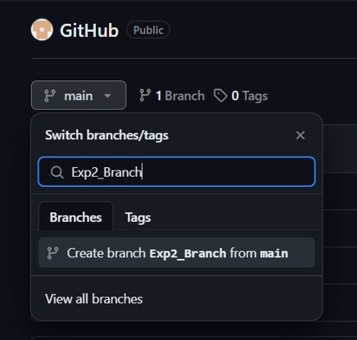

1. Click on create branch.
2. Below is the file Exp2.java created in main branch:

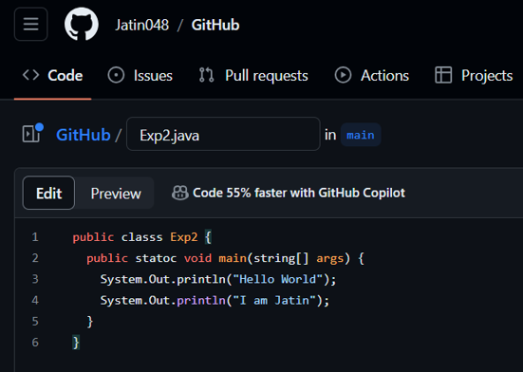

# 

# 

# Now click on the branch to display its contents (same as main branch at time of creation).

# Now open the same file Exp2.java and make necessary changes.

# 

# After doing the changes save the file and commit changes to this branch only.

# 

# Now upon navigating to the main branch a message (shown in above image) will pop up, simply click on compare and pull request button.

# 

# Here all changes will be highlighted review the changes and click on merge pull request (set to automatically merge).

# After merging the files, the message will be displayed and asked if we wanted to delete the branch.

# 

# 1.2.2 Creating branch in repository and merging changes in main branch

# 1) Open git bash on your system and initialize it using given command

# 

# 2) Change to working directory/Repository using “cd” command

# 

# 3) Now create a file named “Exp2.txt” using touch command.

# 4) Using “cat” command enter the contents in the file.

# 

# 5) Now using git add and commit commit the changes made to the file as shown below:

# 

# 6) Using checkout -b command create a branch named test_Exp2 and shift current working directory to the branch created.

# 7) Use cat command to check the contents of file before changing.

# 

# 8) Now modify the file using cat command and change the contents of the file.

# 

# 9) Now using add and commit again save the changes made to the file and move it to the staging area.

# 

# 10) Switch back to master/main branch using checkout command.

# 11) Now merge both files (inside branch and main) using the following command:

# 

# 12) Check the status using git status command

# 

# 13) Both files are now merged and final file is present in main branch.

# Learning outcomes (What I have learnt):

* 1. Learnt about GitHub and Git
  2. Learnt about commit, merge and add commands.
  3. Learnt about various git commands that can be applied on Git Bash.
  4. Learnt about repositories and branches.
  5. Learnt about how to pull request and push.

**Evaluation Grid (To be created as per the SOP and Assessment guidelines by the faculty):**

|  |  |  |  |
| --- | --- | --- | --- |
| Sr. No. | Parameters | Marks Obtained | Maximum Marks |
| 1. |  |  |  |
| 2. |  |  |  |
| 3. |  |  |  |
|  |  |  |  |