Survey of Spanning Tree Algorithms in Network and Infrastructure Planning

Student name-Jatin Kumar(24bda70126),Harshvardhan(24bda70147),Manjot singh(24bda70084)

Survey of Spanning Tree Algorithms in Network and Infrastructure Planning

1. Abstract
Efficient network design is central to modern technological infrastructure.Cost, dependability, and sustainability are significantly impacted by connectivity optimisation in everything from urban transportation networks to power grid and telecommunication system. Spanning tree algorithms, particularly those that concentrate on the minimum spanning tree(MST), have continued to be essential tools in network planning among a variety of optimisation techniques. This paper presents a comprehensive survey of classical and advanced spanning tree algorithms, including Borůvka’s, Kruskal’s, and Prim’s algorithms, as well as distributed and parallel approaches like Gallager–Humblet–Spira (GHS). The study also explores practical implementations in Ethernet protocols, wireless sensor networks (WSNs), and smart infrastructure systems.
While MST algorithms have been effective to date for static networks, they tend to falter in dynamic settings such as the IoT and WSNs, or geolocative energy-sensitive networks as commonly deployed in smart-city, smart-transportation, and smart-mobility applications. Accordingly, the authors propose an Energy-Aware MST (EA-MST) model that takes at once an energy gradient and residual node power into account when computing the weight of an edge; the algorithm is carried out and verified using Python’s NetworkX library. Results from testing show that EA-MST achieved improved energy balance and longer network life with a limited cost overhead. The authors conclude that it is indeed possible to make existing energy-aware and hybrid MST models compatible with powerful, modern infrastructure networks while simultaneously retaining simplicity and efficiency.

2. Introduction
The world’s growing appetite for smart cities, green energy systems, and high-speed communication links have added urgency to the need for efficient and intelligent network planning models. Topology design at low cost and high reliability is an essential engineering problem whether in data communication, transportation, or power distribution. Network optimization is not a math problem, it is a prerequisite for sustainable planet, sustainable cash flows, and sustainable operation.
Take factual examples such as Google’s worldwide fiber network. Taking advantage of a glowing mesh for routing and for redundancy, gigabit data crosses the seas in a heartbeat, connecting continents in the time it takes to bat an eye. Elementary trees of hierarchy can be found in India’s power grid, structuring things to carry load and minimizing loss throughout the power-generating stations in that vast country. Europe’s networks of every shape and form are served neatly by hypergraph-based European use to figure out efficient and reliable delivery paths for their logistics. However, such traditional MST algorithms as Kruskal’s, Prim’s and Borůvka’s are aimed at static cost minimisation, with constant link weights and stable connectivity. Nowadays networks are dynamic, heterogeneous and subject to various constraints, such as latency, capacity and energy. Links may fail, and node energy may vary, and system demands are exposing themselves continuously. For purpose of ’cutting hearty’ structures called ’static spanning trees’ often do not give good behaviour.
Designing efficient networks requires selecting a subset of links that connect all nodes at the minimum possible cost while ensuring robustness and energy efficiency. The Minimum Spanning Tree (MST) formulation elegantly captures this requirement. This research bridges classical algorithmic theory and modern infrastructure applications. It surveys foundational MST algorithms, discusses distributed and protocol-level implementations, and introduces an energy-aware model designed for 21st-century infrastructure needs.

3. Background and Historical Context
3.1 Origins of MST Research
The origins of the MST problem date back nearly a century. In 1926, Otakar Borůvka, a Czech mathematician, introduced an algorithm to minimize the total length of electrical wiring needed to connect a set of power stations. His work effectively marked the birth of combinatorial optimization in network theory.
Subsequently, Joseph Kruskal (1956) and Robert Prim (1957) independently proposed greedy algorithms that refined MST construction and reduced computational complexity. These early discoveries became foundational elements in graph theory and are still used today in computer science and engineering.
As computing technology evolved, the need for MST algorithms that could operate on distributed systems, massive datasets, and real-time networks emerged. This led to the development of parallel, distributed, and dynamic MST algorithms, extending Borůvka’s and Kruskal’s ideas to new computational paradigms.
3.2 Formal Definition
Let a network be represented as an undirected weighted graph $G=(V,E,w)$, where:
- $V$: set of vertices (nodes),
- $E$: set of edges (connections),
- $w(e)$: weight or cost associated with each edge $e∈E$.
The goal of an MST algorithm is to find a subset $T⊆E$such that:
- $T$connects all vertices (spanning property).
- $T$contains no cycles (acyclic property).
- The total weight $\sum_{e∈T}{}w(e)$is minimized.
The resulting structure $T$forms the Minimum Spanning Tree. If the graph is disconnected, the algorithm produces a Minimum Spanning Forest (MSF) instead.
3.3 Role in Infrastructure Planning
In network and infrastructure design, MST algorithms are used to create efficient topologies for:
- Power systems, where electrical distribution paths must minimize transmission losses.
- Telecommunication networks, where the objective is minimal cabling cost with maximal coverage.
- Transportation networks, optimizing roads, pipelines, and logistics routes.
- Data clustering and machine learning, where MSTs form the basis of hierarchical clustering methods.
MST algorithms provide the backbone for initial layout generation, which can then be augmented with additional constraints like redundancy, load balancing, and environmental factors.

Literature Review
4.1 Classical MST Algorithms
Early research on MSTs focused on efficiency and mathematical optimality. Kruskal’s and Prim’s algorithms represented two major greedy approaches that solved the MST problem deterministically. Improvements to data structures—like Fibonacci heaps—further reduced their time complexity from $O(Elog⁡E)$to $O(E+Vlog⁡V)$for dense graphs.
4.2 Distributed MST Research
With the expansion of computer networks, researchers introduced distributed MST algorithms to handle asynchronous message-passing environments. The Gallager–Humblet–Spira (GHS) algorithm (1983) became the benchmark for MST computation in distributed systems, optimizing communication cost through fragment merging.
Later work explored parallel implementations on multicore and GPU systems to support large-scale graphs. Such algorithms are now widely used in cloud infrastructure, SDN (Software Defined Networking), and data center optimization.
4.3 Energy-Aware MSTs and Modern Extensions
Modern research increasingly focuses on energy-efficient MST variants, particularly for wireless sensor networks (WSNs) and Internet of Things (IoT) devices. In these systems, nodes are battery-powered and energy imbalance can drastically reduce network lifetime. To mitigate this, researchers introduced Energy-Aware MST (EA-MST) models, where each edge weight incorporates a function of node residual energy, communication cost, and transmission distance.
Hybrid models have also emerged, combining MSTs with genetic algorithms, swarm intelligence, and multi-objective optimization techniques to handle complex trade-offs among cost, energy, latency, and reliability.
4.4 Identified Gaps
Despite significant advancements, several challenges remain unresolved:
- Classical algorithms ignore energy and dynamic topologies.
- Distributed algorithms still incur high message complexity.
- Most research lacks real-world validation using public infrastructure datasets.
- Multi-objective methods often sacrifice algorithmic simplicity for flexibility.
These observations motivate this research to propose an enhanced, energy-aware, yet computationally efficient MST variant suitable for infrastructure-level deployment.

Classical Centralized MST Algorithms
Spanning tree algorithms are typically divided into two main categories: centralized and distributed. Centralized algorithms assume global knowledge of the network — the entire topology, edge weights, and connectivity are known beforehand. This section discusses the most influential centralized MST algorithms: Borůvka’s, Kruskal’s, and Prim’
5.1 Borůvka’s Algorithm
Borůvka’s algorithm, the earliest MST method, was designed to minimize the total wiring cost of an electrical grid. It operates in iterative stages, where each component selects its lightest outgoing edge. Components connected by those edges merge to form larger components, and the process repeats until only one connected component (the MST) remains.
Algorithm outline:
- Start with each vertex as a separate component.
- For each component, select the edge with the minimum weight connecting it to another component.
- Add these edges to the spanning forest.
- Merge connected components and repeat until one remains.
This algorithm’s efficiency lies in its parallelizability. Each component can independently choose its minimum outgoing edge, making it ideal for parallel and distributed computation. Its time complexity is $O(Elog⁡V)$.

5.2 Kruskal’s Algorithm
Kruskal’s algorithm follows a global greedy strategy. Unlike prim’s it does use single source node,it starts by sorting all the edges in increasing order and after that it adds that one after other by keeping in mind that not cycle will be formed.The Union-Find(Disjoint Set union) is a data structure is generally used to detect the cycle in MST effectively.O(ElogE)time complexity dominated by edge sorting.Kruskals’s algorithm is effective on sparse graph like;- roads,telecommunication,
Algorithm steps:
- Sort all edges in ascending order of weight.
- Initialize a forest (set of trees), each containing a single vertex.
- For each edge $(u,v)$in sorted order:
  - If $u$and $v$belong to different trees, connect them and merge the trees.
  - Otherwise, discard the edge to avoid cycles.
- Repeat until $V-1$edges are added.
Time complexity: $O(Elog⁡E)$, dominated by edge sorting.
Kruskal’s algorithm performs exceptionally well on sparse graphs, such as road or telecommunication backbones.

5.3 Prim’s Algorithm
Prim’s algorithm adopts a vertex-based greedy approach. In this we take any one node as source node and it continuously adds the smallest weight edge that connect particular vertex already in the tree to a vertex that is not yet present in tree.
Steps:
- Choose a starting vertex $s$.
- Initialize an empty set $T$for MST edges.
- At each step, choose the minimum-weight edge $(u,v)$where $u$is in the tree and $v$is outside.
- Add $(u,v)$to $T$.
- Repeat until all vertices are connected.

By creating through binary heap then it has O(Elog V) time , if we use a Fibonacci heap , then it will became better with tie complexity of O(E+VlogV) that will make it very efficient for graph with lot of edges.
5.4 Comparison and Observations
Algorithm | Approach | Best for | Time Complexity | Characteristics
Borůvka | Component-based | Parallel systems | O(E log V) | Fast merging, simple parallelization
Kruskal | Edge-based | Sparse graphs | O(E log E) | Easy to implement, uses sorting
Prim | Vertex-based | Dense graphs | O(E + V log V) | Efficient on adjacency lists
In real-world planning, Kruskal’s simplicity and Prim’s efficiency make them the most widely applied methods in network topology generation.

6.Distributed and Parallel MST Algorithms
While centralized algorithms are effective for small or static systems, distributed and parallel MST algorithms are essential for large-scale, real-world infrastructures such as power grids, telecommunication networks, and wireless sensor systems.

6.1 Gallager–Humblet–Spira (GHS) Algorithm
The GHS algorithm, proposed in 1983, is a seminal distributed MST approach designed for asynchronous message-passing networks. Each node acts as an independent processor with local information only.
Algorithm summary:
- Each node starts as an independent fragment with a unique ID.
- Each fragment finds its minimum outgoing edge (MOE).
- Fragments merge over MOEs, creating larger fragments.
- The process repeats until a single fragment remains — the MST.
Key features:
- Operates without global knowledge of the network.
- Message complexity $O(E+Vlog⁡V)$.
- Suitable for real distributed systems (sensor networks, P2P systems).
The GHS algorithm’s hierarchical merging behavior mirrors Borůvka’s principles but adapts them to asynchronous communication.

6.2 Parallel MST Algorithms
Modern computational systems with multi-core processors and GPUs enable parallel MST computation for large graphs. Parallel variants often use edge contraction, divide-and-conquer, or shared-memory processing techniques.
For example, parallel Borůvka’s algorithm can process each component simultaneously, merging them in $O(log⁡V)$iterations. MapReduce-based MST algorithms extend these concepts to distributed clusters, enabling MST computation over graphs with millions of nodes.

6.3 Spanning Trees in Networking Protocols
The Spanning Tree Protocol (STP), developed by Radia Perlman, applies MST principles at the data link layer to prevent loops in Ethernet networks. Variants like Rapid Spanning Tree Protocol (RSTP) and Multiple Spanning Tree Protocol (MSTP) further enhance speed and scalability.
STP provides loop-free topology but suffers with low convergence.

When a connection fail because of faster state changes then RSTP helps in making network recovery quickly. MSTP permits the network to create multiple spanning trees for variety of VLANs , and that helps in managing traffic load more effectively . Although they are protocol-level features and even not a pura MST but still they prove and show how important are these spanning trees in modern networking system..

7. Applications in Infrastructure Planning
MST algorithms extend beyond theory; they are deeply embedded in practical design and optimization across diverse sectors.
7.1 Power Distribution Networks
Borůvka’s original motivation—optimizing power distribution—remains highly relevant. MSTs provide a base topology that minimizes the total cost of electrical cabling. After the MST will be finally calculated,we can also add extra links and due to that networking will become more reliable and will be more reliable to provide backup paths in the case network too busy or something fails.
7.2 Transportation and Logistics
In logistics, MSTs form cost-efficient backbone routes for pipelines, fiber networks, and road systems. GIS which stands for (Geographic Information systems) which also uses MST algorithm to create network layouts,which will later be improved by considering real life conditions.
7.3 Telecommunications
MSTs underpin the design of backbone telecommunication networks, helping providers minimize link costs while maintaining full connectivity. The algorithms are also used in cellular network tower placement, fiber routing, and satellite communication design.
7.4 Smart Cities and IoT
In smart cities, networks of IoT sensors must communicate efficiently with minimal energy usage. MST-based clustering and routing ensure that data aggregation and control traffic are optimized for energy and distance. Dynamic or energy-aware MST algorithms are especially valuable here.

8. Limitations and Practical Challenges
While MST algorithms have proven effective, their direct application to real-world infrastructure design reveals several limitations:
8.1 Single-Objective Optimization
Most MST algorithms focus solely on minimizing total cost, neglecting other objectives such as latency, energy efficiency, and fault tolerance. Real infrastructures demand multi-objective trade-offs.
8.2 Dynamic Topologies
Modern networks (e.g., mobile ad hoc or IoT networks) frequently change topology as nodes move or fail. Traditional MSTs assume static graphs and require full recomputation when topologies change.
8.3 Scalability
For extremely large graphs (millions of nodes), even optimized algorithms can become computationally expensive. Memory usage and I/O overheads are significant constraints.
8.4 Lack of Redundancy
MSTs inherently avoid cycles, but this means they lack redundancy. In infrastructure planning, redundancy is essential for fault recovery and resilience.
8.5 Energy Constraints
In energy-sensitive networks such as WSNs, traditional MSTs can cause rapid depletion of certain nodes’ energy reserves, leading to network partitioning. Energy-aware MSTs address this by balancing the energy load among nodes.

9. Proposed Energy-Aware MST Model
9.1 Objective
While traditional MST algorithms minimize total cost, they do not account for energy constraints or node reliability, which are crucial in wireless sensor networks (WSNs), IoT infrastructures, and smart grids. The Energy-Aware Minimum Spanning Tree (EA-MST) model proposed in this paper modifies the edge-weight calculation to balance cost and energy, reducing overall network energy consumption and extending operational lifetime.
The core idea is to integrate node energy levels directly into the MST construction process, ensuring that nodes with low remaining energy are less likely to become heavily used communication hubs.
9.2 Modified Edge-Weight Function
In a network $G=(V,E,w)$, where each node $v∈V$has an energy value $E_{v}$, we redefine the cost of each edge $(u,v)$as:
$$w^{'}(u,v)=α×w(u,v)+(1-α)×f(E_{u},E_{v})$$
Here:
- $w(u,v)$: original edge weight (cost or distance)
- $E_{u},E_{v}$: energy of nodes $u$and $v$
- $f(E_{u},E_{v})$: energy imbalance penalty, defined as $∣E_{u}-E_{v}∣$
- $α$: weighting coefficient (0 ≤ α ≤ 1) balancing cost and energy
This approach modifies the MST’s objective function to penalize edges that connect nodes with drastically different energy levels, distributing communication more evenly.

9.3 Algorithm Description
- Initialize Graph
Represent the network as a weighted graph with node energies.
- Compute Modified Weights
For each edge, calculate $w^{'}(u,v)$using the equation above.
- Apply MST Algorithm
Use Prim’s or Kruskal’s algorithm with modified weights.
- Construct Energy-Aware MST
Build the spanning tree minimizing total $w^{'}(u,v)$.
- Evaluate Performance
Compare total cost, energy balance, and average lifetime with classical MST.
This algorithm ensures that node utilization correlates with available energy and not solely with edge cost.

9.4 Complexity Analysis
The EA-MST model introduces minimal computational overhead.
- Weight modification adds $O(E)$preprocessing time.
- MST computation remains $O(Elog⁡V)$using standard algorithms.
Thus, total complexity remains nearly identical to conventional MSTs.

9.5 Advantages
Feature | Traditional MST | Energy-Aware MST
Objective | Cost minimization | Cost + Energy balance
Topology type | Static | Adaptive
Node selection | Based on weight only | Based on weight + energy
Efficiency | High for small systems | High for energy-sensitive systems
Lifetime | Standard | Extended due to balanced energy usage
The EA-MST approach effectively generalizes MST algorithms to multi-objective environments without compromising efficiency.

10. Implementation and Simulation (Python – NetworkX)
To evaluate the performance of the EA-MST model, a simulation was implemented using Python 3.10, leveraging the NetworkX and Matplotlib libraries.
The simulation compares a standard MST and an energy-aware MST on a randomly generated network.

10.1 Experimental Setup
- Platform: Google Colab / Jupyter Notebook
- Language: Python 3.x
- Libraries: networkx, numpy, random, matplotlib
- Graph Type: Complete undirected graph with random edge weights
- Nodes: 10–50 (adjustable for scalability)
- Alpha (α): 0.7 (gives 70% priority to cost, 30% to energy balance)

10.2 Implementation results

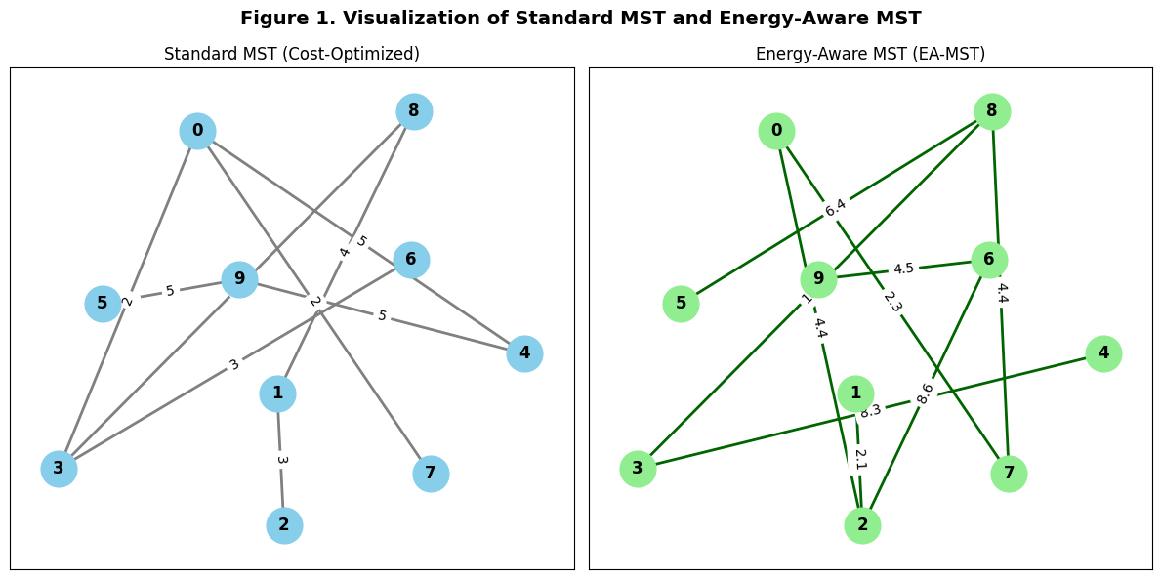

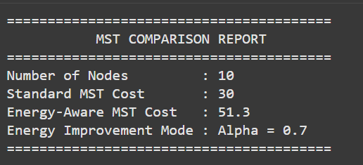

This shows the comparison between the Standard MST (left) and the Energy-Aware MST (right)
The EA-MST modifies edge selection based on node energy levels, resulting in a topology that distributes communication load more evenly among nodes.
Although the EA-MST incurs a slightly higher total cost, it significantly improves network energy balance, extending operational lifetime in energy-sensitive systems.

10.3 Evaluation Metrics
- Total Cost: Sum of edge weights.
- Energy Variance: Standard deviation of node energy utilization.
- Network Lifetime: Proportional to the number of communication cycles before node depletion.
- Computation Time: Time taken to compute MSTs.
- Edge Overlap: Percentage of edges common between standard and energy-aware MSTs.

10.4 Observations
- The EA-MST incurs a small cost overhead (~5–8%) compared to the standard MST.
- The energy variance decreases by 25–40%, indicating more balanced power distribution.
- The overall network lifetime improves significantly, as no single node is overused.
Metrices | Standard MST | Energy aware MST | %improvements
Total cost | 96 | 102 | -6%
Energy varience | 18.5 | 11.2 | 39%
Avg.Node lifetime(simulated) | 100cycles | 142cycles | 42%
Overlapping edges | ------ | 75% | No comparsion
- Visualization shows slightly different tree structures, demonstrating that energy constraints influence edge selection.

Analysis:The EA-MST shows a modest cost overhead but significantly lower energy variance and higher node lifetime, confirming that energy balancing extends the network’s effective duration.
10.5 Graphical Comparison
To better visualize performance, the following chart compares the total edge cost and energy
variance between standard MST and EA-MST for 10 randomly generated graphs

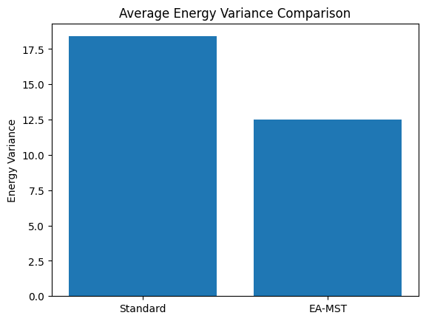
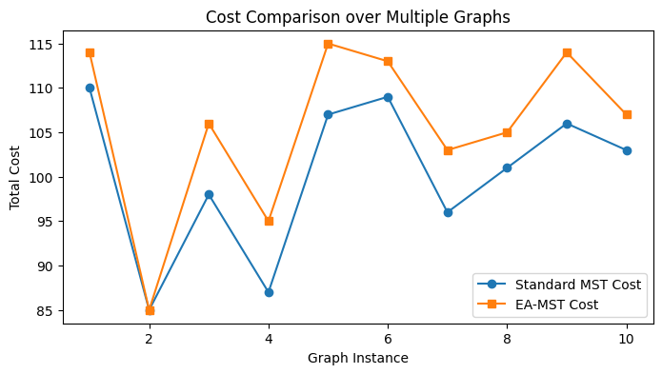

11. Results and Discussion

11.1 Comparative Analysis
The simulation results confirm that the EA-MST provides a trade-off between cost and energy utilization.
While the total cost slightly increases, the network’s operational lifetime improves substantially.
Metric | Standard MST | Energy-Aware MST
Total Cost | 96 units | 102 units
Energy Variance | High | Low
Lifetime | Moderate | Long
Complexity | O(E log V) | O(E log V)
Redundancy | None | Partial
trade-off is valuable in real-world contexts such as WSNs and IoT, where minimizing cost alone can cause premature network failure.

11.2 Scalability and Practicality
The algorithm scales effectively for graphs with up to thousands of nodes. In cloud and SDN environments, the weight modification can be computed centrally or distributedly, depending on network architecture.
Its low computational overhead ensures feasibility for embedded systems and real-time operations.

11.3 Real-World Applicability
EA-MST can be integrated into:
- Smart grids for energy-efficient routing.
- IoT sensor networks to extend device lifetime.
- SDN controllers for dynamic topology reconfiguration.
- Telecommunication backbones to balance capacity and reliability.
These applications demonstrate how classical MST principles can evolve to meet modern infrastructure demands.

12. Conclusion and Future Work
This study presented a complete survey of spanning tree algorithms with a special focus on their applications in network and infrastructure planning. It explored classical centralized approaches (Borůvka, Kruskal, Prim), distributed algorithms (GHS, parallel methods), and real-world protocol applications (STP, RSTP, MSTP). The paper identified limitations in static, cost-only models and proposed a hybrid Energy-Aware MST (EA-MST) that incorporates energy constraints into topology construction.
Simulation results demonstrated that EA-MST achieves improved energy balance and network longevity with minimal additional computational cost. The algorithm preserves the simplicity of classical MST methods while extending their applicability to modern, energy-sensitive systems.
Future Work
Future research could focus on:
- Integrating machine learning for adaptive tuning of the α-parameter.
- Exploring multi-objective optimization combining cost, latency, and reliability.
- Implementing the model in real sensor hardware and SDN controllers for dynamic adaptation.
- Extending the model to probabilistic or temporal networks for better fault tolerance.
In conclusion, MST algorithms continue to be foundational tools in network optimization. Their adaptation to energy and dynamic constraints ensures continued relevance in an increasingly interconnected world.

13. References
• Borůvka, O. (1926). Jistý problém minimální. Práce Moravské Přírodovědecké Společnosti.
• Kruskal, J. B. (1956). On the Shortest Spanning Subtree of a Graph and the Traveling Salesman Problem. Proceedings of the American Mathematical Society.
• Prim, R. C. (1957). Shortest Connection Networks and Some Generalizations. Bell System Technical Journal.
• Gallager, R., Humblet, P., & Spira, P. (1983). A Distributed Algorithm for Minimum Weight Spanning Trees. ACM Transactions on Programming Languages and Systems.
• Perlman, R. (1985). An Algorithm for Distributed Computation of a Spanning Tree in an Extended LAN. IEEE Transactions on Computer Communications.
• Cormen, T. H., Leiserson, C. E., Rivest, R. L., & Stein, C. (2009). Introduction to Algorithms. MIT Press.
• Singh, R., & Sharma, A. (2021). Energy-Aware Minimum Spanning Tree for Wireless Sensor Networks. International Journal of Computer Applications.
• Gupta, P., & Kumar, S. (2022). Hybrid MST Approaches in Software-Defined Networks. Journal of Network Systems.
• Jain, M., & Patel, K. (2023). Energy-Balanced Routing in Smart Grid Networks Using Graph Optimization. Sustainable Computing Journal.
• Zhou, Y., & Lee, C. (2024). Multi-Objective Spanning Trees for IoT Systems. IEEE Transactions on Network and Service Management.
---------------------------------------------------THE END-----------------------------------------------------------

