AI Voice RM Platform
Developer Implementation Plan
HLD · LLD · Integration Guide · 36-Week Roadmap
Indian Bank × Silver Suits AI | Version 1.0 | May 2026

Document Purpose
This document is the engineering blueprint for building the AI Voice RM platform in production. The Voice-to-Command demo repository and architecture Word docs are reference implementations only. Use this plan to scope sprints, assign modules, and integrate with an existing banking Android app or internet-banking website.
Audience: backend engineers, mobile/web developers, DevOps, QA, and bank integration teams. Platform scope: in-app voice and screen assistants only (V1–V5). All interaction stays inside the bank mobile or web application.

How to use this document
Section | Use when you need to…
§2 Reference vs Target | Understand what the demo already proves vs what must be built
§3 AG-UI Integration | Wire form assistants into Android or web using the AG-UI protocol
§4 Channel Integration | Choose WebView vs React Native vs native vs iframe vs NPM SDK
§5 HLD | Explain system context, deployment, and service boundaries to architects
§6 LLD | Implement APIs, data models, auth, and SDK modules
§7 Security & Ops | Configure Azure, bank VPC, logging, and compliance controls
§8 Roadmap | Plan sprints, owners, acceptance criteria, and dependencies
§9 Testing & CI/CD | Define test pyramid and release gates

────────────────────────────────────────────────────────────────────────────────

1. Reference Demo vs Production Target

1.1 What the demo proves (keep)
Capability | Demo location | Production action
Manifest voice engine (UPI, bills, transfer) | server/engine/ + server/manifests/ | Keep; add Redis sessions + bank adapters
AG-UI form agents (5 journeys) | server/agui/* + client LoanAguiPanel | Keep; align events with AG-UI spec; add auth
Frustration detection | client/src/hooks/useRageDetect.js | Extract to SDK; wire to Trigger API
STT/TTS proxies | server/index.js /api/stt, /api/tts | Keep; India residency keys in Key Vault
Mock banking REST | server/data/backend.js | Replace with bank core adapter layer

1.2 What must be built (not in demo)
Gap | Priority | Owner | V1 deliverable
Customer JWT auth + session binding | P0 | Backend + Bank | Bearer token on every API call
Redis session store (replace in-memory Map) | P0 | Backend | Horizontal scale + 30 min TTL
Bank DocumentDB writes (sessions, turns) | P0 | Backend + Bank DBA | Async write pipeline
POST /api/trigger + rule engine | P0 | Backend | IF/THEN evaluator + audit log
Server-side MPIN verify (replace client 1234) | P0 | Bank + Backend | Step-up token before CONFIRMATION
@silversuits/voice-rm-sdk npm package | P0 | Frontend | Publishable embed layer
Android WebView shell + JS bridge | P0 | Bank mobile | Load hosted bundle with auth injection
Analytics dashboard + post-session LLM | P1 | Full stack | V3
Visual rule-builder UI | P1 | Frontend | V2

────────────────────────────────────────────────────────────────────────────────

2. AG-UI Protocol — Research & Integration Guide
AG-UI (Agent-User Interaction Protocol) is an open, event-based standard maintained by the ag-ui-protocol community (originally from CopilotKit). It defines how a frontend application connects to an AI agent backend using HTTP POST + Server-Sent Events (SSE). Official docs: https://docs.ag-ui.com

2.1 Protocol stack position
Protocol | Layer | Role in this platform
MCP | Agent ↔ Tools | Future: connect to bank internal tools via MCP gateway (V3+)
A2A | Agent ↔ Agent | Not required V1–V3; home router uses in-process navigate_to tool
AG-UI | Agent ↔ User UI | Primary: form filling, routing, streaming chat in bank screens

2.2 How the demo maps to AG-UI
The demo implements an AG-UI-compatible subset in client/src/lib/aguiClient.js and server/agui/*. It is not yet using the official @ag-ui/client npm package but emits compatible event shapes.
AG-UI standard event | Demo implementation | Notes
RUN_STARTED | ✓ { thread_id, run_id } | Emitted at stream start
TEXT_MESSAGE_START/CONTENT/END | Partial — TEXT_MESSAGE_CHUNK | Migrate to 3-phase in V2 for CopilotKit compat
TOOL_CALL_START/ARGS/END | ✓ Full sequence | Used for set_field, navigate_to
TOOL_CALL_RESULT | ✓ After tool exec | Client updates form via onToolCall
STATE_DELTA | ✓ JSON Patch ops | applyStateDelta() in aguiClient.js
STATE_SNAPSHOT | Not emitted | Add on reconnect / thread resume (V2)
RUN_FINISHED / RUN_ERROR | ✓ | LoanAguiPanel handles both
MESSAGES_SNAPSHOT | Not emitted | Optional; client keeps local message array

2.3 Standard request contract (RunAgentInput)
POST /api/agui/{agentId}
Authorization: Bearer {customer_jwt}
Accept: text/event-stream
Content-Type: application/json
{
"thread_id": "uuid-v4",
"run_id": "uuid-v4",
"state": { "beneficiary_name": "", "amount": "" },
"messages": [
{ "id": "msg_1", "role": "user", "content": "Transfer 50000 to Rahul" }
],
"tools": [],
"context": [{ "type": "user_profile", "data": { "lang": "hi", "tier": "gold" } }],
"forwarded_props": { "screen_id": "imps_transfer", "journey": "fund_transfer" }
}

2.4 Registered agents (extend by adding runner + config)
agentId | Screen | Tools | Config file
indian_bank_home_assistant | Home / global FAB | navigate_to, STATUS_UPDATE | homeAguiConfig.js
indian_bank_imps_transfer | IMPS fund transfer form | set_field | impsAguiConfig.js
indian_bank_loan_los | Loan application | set_field | loanAgentConfig.js
indian_bank_deposit | FD/RD creation | set_field | depositAguiConfig.js
indian_bank_txn_history | Statement / fraud advisory | set_field, explain_txn | txnHistoryAguiConfig.js

2.5 Migration path to official @ag-ui/client
Recommended for V2 after V1 ships with the custom client (lower risk). Steps:
- Install @ag-ui/client in voice-rm-sdk package.
- Replace runAgent() in aguiClient.js with HttpAgent from @ag-ui/client.
- Map demo TEXT_MESSAGE_CHUNK → TEXT_MESSAGE_CONTENT in a thin adapter layer.
- For React Native: use expo/fetch (supports SSE streaming) — React Native global fetch does NOT stream.
- Optional: adopt CopilotKit React components for chat UI; keep LoanAguiPanel for form-specific UX.
React Native AG-UI client is community status ("Help Wanted" per ag-ui-protocol repo). Production pattern: wrap HttpAgent with expo/fetch or react-native-sse. See GitHub issue #510, #1316.

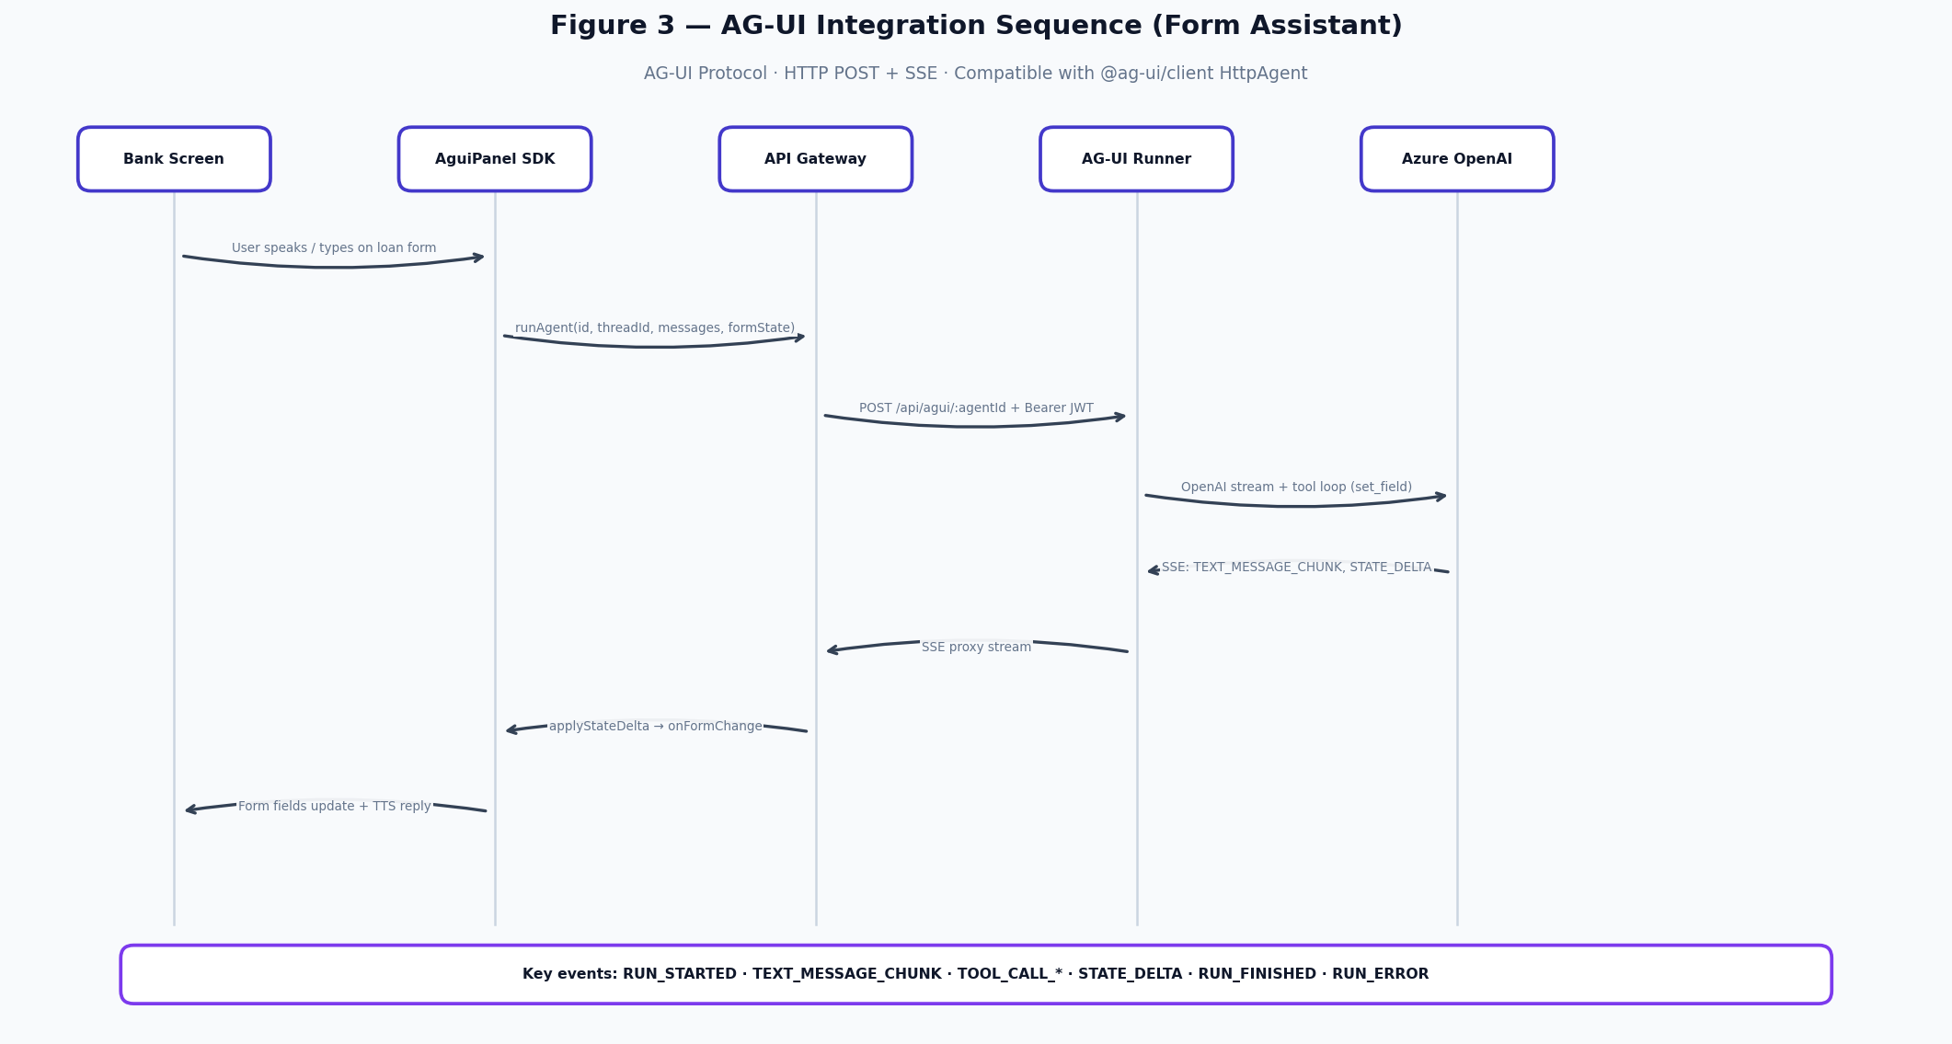
Figure 3 — AG-UI integration sequence for form assistant screens

────────────────────────────────────────────────────────────────────────────────

3. Channel Integration — Android & Web
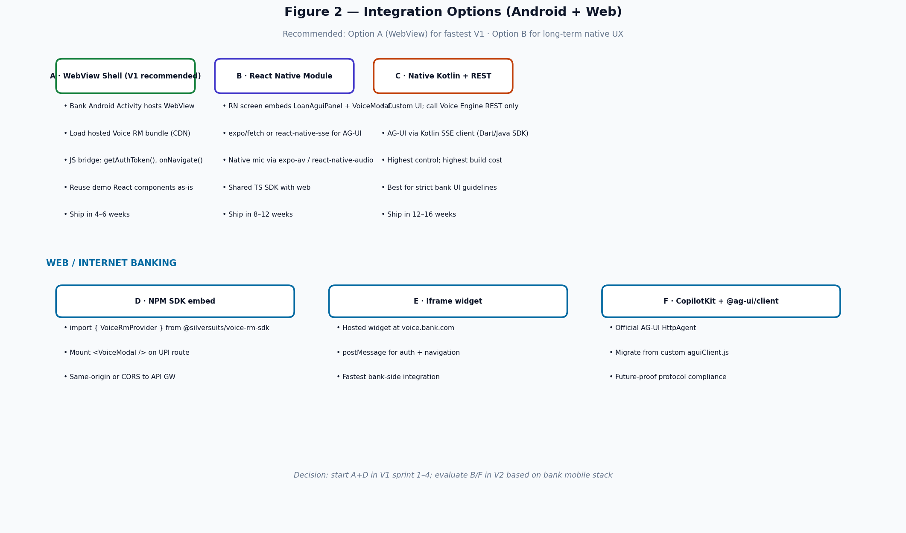
Figure 2 — Integration options for Android banking app and internet banking website

3.1 Recommended approach (V1 — fastest path)
Option A (Android WebView) + Option D (NPM SDK embed for web) minimizes rework of the existing React demo while meeting bank security requirements.

3.1.1 Android WebView integration (step-by-step)
- Bank mobile team creates VoiceRmActivity (Kotlin) with a hardened WebView (no file access, JS enabled).
- Load https://voice-cdn.bank.in/embed/v1/index.html?screen=home from bank CDN (built from voice-rm-sdk).
- Inject auth before page load via @JavascriptInterface or evaluateJavascript:
- window.__VOICE_RM_CONFIG__ = { apiBase, jwt, lang, userId, onNavigate: nativeBridge };
- Native bridge implements: onNavigate(dest), requestMpin(callback), logEvent(name, payload).
- WebView requests mic permission at runtime; pass grant result to JS via postMessage.
- On session end, native receives postMessage { type: "SESSION_END", outcome, sessionId } for bank analytics.
// Kotlin — minimal bridge
class VoiceRmBridge(private val activity: Activity) {
@JavascriptInterface
fun getAuthToken(): String = SessionManager.currentJwt
@JavascriptInterface
fun navigateTo(screen: String, contextJson: String) {
activity.runOnUiThread { Router.open(activity, screen, contextJson) }
}
@JavascriptInterface
fun verifyMpin(onResult: String) {
MpinActivity.launch(activity) { ok ->
webView.evaluateJavascript("window.__voiceRm.onMpinResult($ok)", null)
}
}
}

3.1.2 Web / Internet banking NPM embed
// Bank React app — UPI route
import { VoiceRmProvider, VoiceModal, useVoiceSession } from '@silversuits/voice-rm-sdk';
function UpiPaymentPage() {
const { session, sendUtterance } = useVoiceSession({ journey: 'send_money', lang: 'hi' });
return (
<VoiceRmProvider apiBase={process.env.VOICE_RM_API} getToken={() => bankAuth.getJwt()}>
<ExistingUpiForm />
<VoiceModal session={session} onUtterance={sendUtterance} />
</VoiceRmProvider>
);
}

3.2 Integration decision matrix
Option | Time to V1 | Reuse demo code | Native UX | AG-UI SSE | Bank effort
A · WebView shell | 4–6 wks | 95% | Good | Via WebView fetch | Low — 1 Android dev
B · React Native module | 8–12 wks | 80% | Excellent | expo/fetch required | Medium — RN team
C · Native Kotlin UI | 12–16 wks | 20% | Excellent | Java/Dart AG-UI SDK | High — full rewrite
D · NPM SDK (web) | 3–4 wks | 90% | N/A (web) | Native fetch SSE | Low — frontend embed
E · Iframe widget | 2–3 wks | 95% | N/A (web) | Same as D | Lowest — postMessage only
F · CopilotKit + @ag-ui/client | 6–8 wks | 70% | Good | Official client | Medium — new deps

────────────────────────────────────────────────────────────────────────────────

4. High-Level Design (HLD)
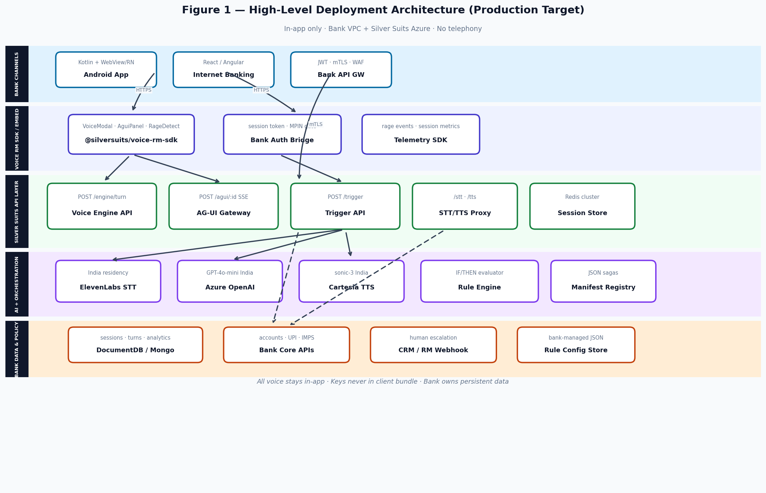
Figure 1 — Production deployment topology

4.1 System context
The platform sits between bank customer channels and bank core systems. Silver Suits hosts the voice/AG-UI API layer in Azure India. The bank hosts customer-facing apps and owns all persistent customer data in DocumentDB / on-prem databases.

4.2 Logical service boundaries
Service | Responsibility | Scaling | State
voice-rm-gateway | TLS termination, JWT validation, rate limits, routing | Azure APIM + App Service | Stateless
voice-engine | Manifest saga, LLM extract, confirm parser | Horizontally scaled pods | Session in Redis
agui-service | SSE agent runners, tool loop, STATE_DELTA | Same pods as engine | Thread state ephemeral per run
trigger-service | Rule evaluation, actuation dispatch | Dedicated worker + queue | Rules in config store
speech-proxy | STT/TTS key proxy, PII redaction in logs | Co-located with gateway | Stateless
bank-adapter | Core banking API client, idempotency, circuit breaker | Sidecar or module | Connection pools
analytics-worker | Post-session LLM analysis (V3) | Queue consumer | Writes to bank DB

4.3 Deployment zones
Zone | Components | Connectivity
Bank DMZ / Mobile | Android app, WebView bundle, IB frontend | HTTPS to APIM only
Silver Suits Azure (India Central) | App Service, Redis, Key Vault, App Insights | Private endpoint to bank DB
Bank VPC (Mumbai) | DocumentDB, core APIs, CRM webhook | mTLS from Azure via Private Link
AI providers (India residency) | ElevenLabs STT, Azure OpenAI, Cartesia TTS | Outbound HTTPS from Azure

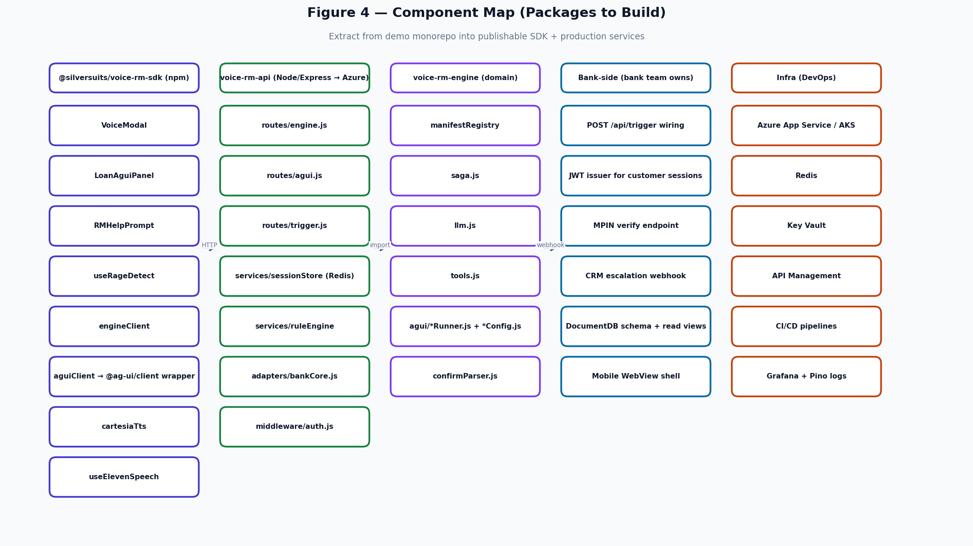
Figure 4 — Component / package map for engineering teams

────────────────────────────────────────────────────────────────────────────────

5. Low-Level Design (LLD)
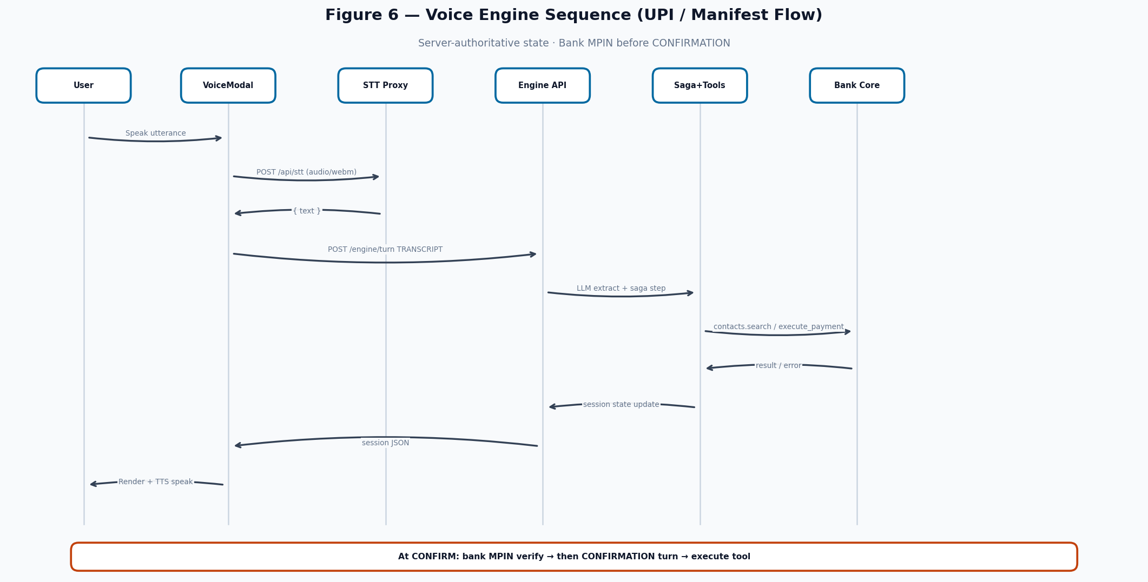
Figure 6 — Voice engine turn sequence with bank MPIN gate

5.1 Package structure — @silversuits/voice-rm-sdk
@silversuits/voice-rm-sdk/
├── src/
│ ├── index.ts # public exports
│ ├── provider/VoiceRmProvider.tsx # auth + apiBase context
│ ├── voice/
│ │ ├── VoiceModal.tsx # from demo (refactored)
│ │ ├── useVoiceSession.ts # wraps engineClient
│ │ └── engineClient.ts
│ ├── agui/
│ │ ├── LoanAguiPanel.tsx
│ │ ├── aguiClient.ts # → @ag-ui/client wrapper (V2)
│ │ └── applyStateDelta.ts
│ ├── behavior/
│ │ ├── useRageDetect.ts
│ │ └── RMHelpPrompt.tsx
│ ├── speech/
│ │ ├── useElevenSpeech.ts
│ │ └── cartesiaTts.ts
│ └── bridge/
│ └── nativeBridge.ts # WebView postMessage adapter
├── package.json
└── rollup.config.js # ESM + CJS; peerDeps: react>=18

5.2 Voice Engine API — POST /api/engine/turn
input.type | When | Required fields | Response session.state
INIT | Session create | lang? | IDLE → greeting in history
START_ACTION | Open journey | action (manifest id) | FILL — first slot prompt
TRANSCRIPT | User spoke/typed | text | FILL | DISAMBIGUATE | CHOOSE | CONFIRM
SELECTION | User picked option | optionId | Advances saga
CONFIRMATION | After MPIN OK | confirmed: boolean | EXECUTING → DONE | FAILED
CANCEL | User aborts | — | CANCELLED
SET_LANG | Language switch | lang | Re-prompts current slot in new lang

// Request
POST /api/engine/turn
Authorization: Bearer eyJ...
X-Idempotency-Key: {uuid} // required on CONFIRMATION
X-Bank-Session-Id: {bank_sid} // bank mobile session correlation
{
"sessionId": "sess_abc123", // omit on first call
"lang": "hi",
"input": { "type": "TRANSCRIPT", "text": "Rahul ko paanch sau bhejo" }
}
// Response (client renders verbatim)
{
"ok": true,
"sessionId": "sess_abc123",
"session": {
"state": "FILL",
"action": "send_money",
"pending": { "kind": "free_text", "slot": "amount", "prompt": "..." },
"history": [...],
"executing": false
}
}

5.3 Trigger API — POST /api/trigger (production build)
POST /api/trigger
Authorization: Bearer {service_token} // bank backend calls this
Content-Type: application/json
{
"event_type": "rage_click",
"user_id": "CIF123456",
"screen_id": "imps_transfer",
"field_context": { "invalid_field": "ifsc_code", "attempts": 2 },
"lang": "hi",
"device": { "platform": "android", "app_version": "4.2.1" }
}
// Response
{
"matched_rule_id": "rule_frustrated_imps",
"action": "trigger_popup",
"action_config": {
"script_id": "imps_assist",
"agent_id": "indian_bank_imps_transfer",
"visibility": "modal"
}
}

5.4 Rule engine actuation handlers (in-app only)
action | Handler | Side effect
trigger_popup | WebSocket / SSE push to client SDK | Opens VoiceModal or AguiPanel with script_id
assign_human_rm | POST bank CRM webhook | Creates ticket; RM notified
push_notif | FCM/APNs via bank push gateway | Re-engagement message with deep link
form_prefill | Push STATE_DELTA to active AguiPanel thread | Warm-starts form with context

5.5 Data model — DocumentDB collections
Collection | Key fields | Written when | Retention
sessions | session_id, user_id, journey, outcome, started_at, ended_at, lang | Session start/end | 7 years (bank policy)
turns | session_id, turn_idx, role, text, intent, slots, latency_ms | Each engine turn | 7 years
form_events | session_id, field_id, value_hash, valid | AG-UI set_field | 7 years
rule_audit | rule_id, user_id, event_type, action, ts | Rule match | 7 years
escalations | user_id, rm_id, priority, reason, ts | assign_human_rm | 7 years
analytics | session_id, sentiment_arc[], churn_risk, qa_score, intent_category | Post-session LLM (V3) | 7 years

5.6 Auth & session binding
Token | Issuer | Claims | Used on
Customer JWT | Bank IAM | sub (CIF), sid, lang, tier, exp (15m) | /engine/turn, /agui/*, /stt, /tts
Service token | Bank API GW | client_id, scope:trigger:write | POST /api/trigger only
Step-up token | Bank MPIN service | sub, action, exp (2m), jti | CONFIRMATION turns only

5.7 Rage detection — bank embed contract
Port useRageDetect.js unchanged. Bank wraps each high-friction screen root view:
const { containerProps, markInvalidField, dismiss } = useRageDetect({
onFrustrated: () => {
bankAnalytics.track('rage_detected', { screen: 'imps_transfer' });
// Option 1: open in-app help immediately
setHelpOpen(true);
// Option 2: call bank backend → POST /api/trigger (async rule eval)
bankApi.postTrigger({ event_type: 'rage_click', screen_id: 'imps_transfer' });
},
});
return <div {...containerProps}><ImpsForm onInvalid={(f) => markInvalidField(f.id)} /></div>;

5.8 Bank adapter interface (replace mock backend)
// server/adapters/bankCore.js — implement per bank
export const bankAdapter = {
async searchContacts(userId, query) { /* GET bank core */ },
async getAccounts(userId) { /* balances */ },
async sendUpi(userId, payload, idempotencyKey) { /* NPCI / bank UPI API */ },
async internalTransfer(userId, payload, idempotencyKey) { /* CBS */ },
async verifyMpin(userId, mpinHash) { /* bank auth service */ },
};
────────────────────────────────────────────────────────────────────────────────

6. Security, Observability & Compliance

6.1 Security controls (V1 minimum)
- All API endpoints require Bearer JWT; reject missing/expired with 401.
- Rate limit: 60 engine turns / user / hour; 20 AG-UI runs / user / hour.
- STT/TTS/LLM API keys in Azure Key Vault; never in client bundle.
- PII redaction in logs: mask account numbers, VPAs, phone numbers (server/lib/log.js pattern).
- CORS: allowlist bank domains only (no wildcard in production).
- Consent gate: first session turn blocked until consent_accepted=true in JWT or explicit API call.
- Idempotency-Key mandatory on CONFIRMATION and all payment tool executions.

6.2 Observability
Signal | Tool | Key metrics
Structured logs | Pino → App Insights | turn_latency_ms, intent, outcome, error_code
Traces | OpenTelemetry | STT → LLM → TTS waterfall per turn
Dashboards | Grafana / Azure Monitor | sessions/day, escalation rate, STT empty rate
Alerts | PagerDuty | error rate > 2%, p95 latency > 3s, Redis down

────────────────────────────────────────────────────────────────────────────────

7. Development Roadmap — 36 Weeks
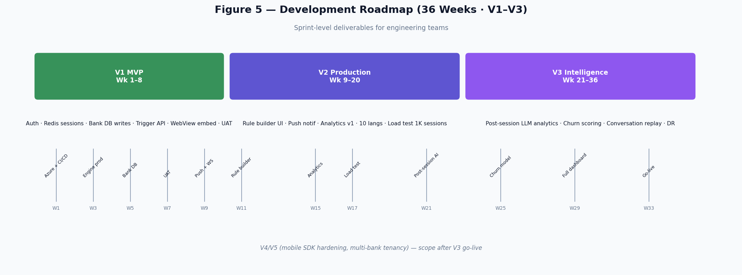
Figure 5 — 36-week development roadmap (V1–V3)

7.1 V1 MVP — Weeks 1–8 (Go-live criteria)
Sprint | Deliverable | Owner | Acceptance criteria
1–2 | Azure infra + CI/CD + APIM + Key Vault | DevOps | Staging URL live; secrets rotated; TLS 1.2+
1–2 | JWT middleware + CORS allowlist | Backend | 401 without token; bank test JWT accepted
3–4 | Redis session store replaces in-memory | Backend | 2 pod load test; session survives pod restart
3–4 | voice-rm-sdk v0.1 published (internal npm) | Frontend | VoiceModal + AguiPanel importable in sample app
3–4 | Android WebView shell (bank team) | Bank mobile | Demo journey loads; mic works; bridge callbacks fire
5–6 | DocumentDB write pipeline | Backend + Bank DBA | sessions + turns persisted; bank can query
5–6 | POST /api/trigger + 5 seed rules | Backend | rage_click → trigger_popup in < 100ms eval
5–6 | Bank adapter v1 (accounts, contacts, UPI mock→real) | Backend + Bank | send_money executes against bank UAT API
7–8 | Server-side MPIN gate | Bank + Backend | CONFIRMATION rejected without step-up token
7–8 | UAT + VAPT + consent flow | QA + All | Bank sign-off; zero P0 bugs; consent logged

7.2 V2 Production — Weeks 9–20
Sprint | Deliverable | Acceptance criteria
9–10 | Push notification actuation (FCM/APNs) | Rule match fires push; deep link opens correct screen
11–12 | Visual rule-builder UI | Bank ops can edit JSON rules without deploy
11–12 | 6 additional languages (10 total) | STT + manifests + TTS for gu/kn/pa/mr/ml/bn
13–14 | Emergency override dashboard | Ops can disable rule in < 60s; audit logged
15–16 | Analytics dashboard v1 | Volume, outcomes, branch-wise, language charts live
17–18 | Load test 1,000 concurrent sessions | p95 turn latency < 1.5s; zero session loss
19–20 | Migrate aguiClient → @ag-ui/client | All 5 agents pass AG-UI compatibility test suite

7.3 V3 Intelligence — Weeks 21–36
Sprint | Deliverable | Acceptance criteria
21–24 | Post-session LLM analysis worker | sentiment_arc, intent_category, qa_score per session
25–28 | Churn risk scoring + predictive triggers | Rules can match on churn_risk_prev > threshold
29–32 | Full analytics dashboard | Conversation replay, multi-journey funnel, cohort views
33–36 | Multi-region DR + ISO 27001 audit prep | Failover tested; audit evidence pack complete

7.4 Team allocation
Role | FTE | V1 focus | V2–V3 focus
Backend Engineer | 2 | Engine prod, Redis, trigger API, bank adapter | Rule builder API, analytics worker
Frontend / SDK Engineer | 1 | voice-rm-sdk extract, WebView bundle | Rule builder UI, dashboard
AI / Conversation Engineer | 1 | Manifest tuning, AG-UI prompts, eval harness | Post-session analysis pipeline
DevOps | 1 | Azure, CI/CD, APIM, monitoring | DR, load test infra
QA Engineer | 1 | Scripted flows, UAT scripts, regression | Load test, security regression
Bank Mobile Dev | 1 (bank) | WebView shell, bridge, MPIN | Push deep links, native mic polish
Bank Backend Dev | 1 (bank) | JWT issuer, trigger wiring, DB schema | CRM webhook, core API UAT
Product Manager | 1 | Sprint planning, bank stakeholder sync | Analytics requirements, rule-builder UX

────────────────────────────────────────────────────────────────────────────────

8. Testing Strategy & CI/CD

8.1 Test pyramid
Layer | What | Tooling | Gate
Unit | confirmParser, applyStateDelta, rule eval, expr.js | Vitest / Node test | Every PR
Integration | Scripted engine flows (existing tests/) | runScriptedFlows.test.js + LLM stub | Every PR
Contract | OpenAPI schema for /engine/turn, /agui/*, /trigger | Schemathesis / Dredd | Weekly
E2E | WebView journey: rage → help → UPI payment | Playwright + device farm | Pre-release
Load | 1K concurrent AG-UI + engine sessions | k6 / Azure Load Testing | V2 week 17–18
Security | VAPT, dependency scan, secret scan | Bank-approved vendor + GitHub Advanced Security | Pre go-live

8.2 CI/CD pipeline (Azure DevOps / GitHub Actions)
- PR → lint + manifest AJV validation + unit tests + scripted flow tests (LLM stubbed).
- Merge to main → build Docker image → push to ACR → deploy to staging.
- Staging smoke: /api/health, one scripted send_money flow, one AG-UI loan run.
- Manual approval → deploy to production (blue/green via App Service slots).
- voice-rm-sdk: separate npm publish pipeline on tag v*.*.*.

8.3 Demo → production migration checklist
Demo artifact | Production replacement | Done?
server/engine/session.js in-memory Map | Redis session store + serialization
server/data/backend.js mock | bankAdapter → real core APIs
client MpinSheet hardcoded 1234 | Bank MPIN service + step-up JWT
cors() open | APIM + allowlist
VITE_API_BASE inconsistency | Single SDK config: apiBase + getToken()
aguiClient.js custom SSE | @ag-ui/client HttpAgent (V2)
No /api/trigger | trigger-service + rule config store
DemoPanel.jsx | Remove from production bundle

────────────────────────────────────────────────────────────────────────────────

9. Open Decisions Log
Decision | Options | Recommendation | Decide by
Android integration pattern | WebView vs RN vs Native | WebView for V1 (Option A) | Week 1
AG-UI client library | Custom vs @ag-ui/client | Custom V1; migrate V2 | Week 9
Session store | Redis vs Cosmos DB | Redis (lower latency for turns) | Week 2
Rule config storage | DocumentDB vs Git-backed JSON | DocumentDB with admin UI | Week 11
WebSocket vs SSE for trigger_popup | Both viable | SSE (already used for AG-UI) | Week 5
Bank DB access pattern | Private Link vs VPN | Private Link (Azure ↔ AWS Mumbai) | Week 2

AI Voice RM Developer Implementation Plan v1.0 · Silver Suits AI · Confidential
Reference repo: Voice-to-Command (demo) · Architecture docs: Documentation/*.docx

