SILVER SUITS AI

AI Voice RM Platform
Technical Architecture
Integrated: Demo Codebase + Production Target + Roadmap

Client: Indian Bank
Provider: Silver Suits AI
Version: 3.0 Integrated — May 2026
Repo: Voice-to-Command (demo codebase)
Status: Confidential — Internal Use Only

Table of Contents
1. Executive Summary & Scope
2. Demo Codebase
3. System Architecture — Current Demo (Figures 1–4)
4. System Architecture — Production Target (Figures 5–8)
5. Complete Data Workflow (Demo → Production)
6. Behavior Analysis & AI Triggers
7. Rule Engine — Demo vs Production
8. AG-UI Streaming Agents
9. Voice Bot Interaction & Logging
10. Bank DB Integration (Productization V1+)
11. Analytics Dashboard (Productization V2/V3)
12. Resource Requirements
13. Timeline & Version Feature List
14. Compliance Quick-Reference
15. Exception Handling & Fallbacks
16. Non-Functional Requirements

List of Figures
Figure | Title | Section
1 | Current demo — layered architecture (Voice/UPI + AG-UI) | §3
2 | Voice turn sequence (demo) | §3
3 | AG-UI SSE screen agent flow (demo) | §3
4 | Dialogue state machine + repository map (demo) | §3
5 | Production — six-layer architecture | §4
6 | Production runtime — voice + rule engine | §4
7 | Rule engine pipeline (production) | §4 / §7
8 | DocumentDB + AWS deployment (production) | §4

1. Executive Summary & Scope
The AI Voice RM Platform is a web-based AI banking assistant embedded inside the Indian Bank mobile app. When a user shows frustration signals rage-clicking, repeated invalid field entries, or extended inactivity the system automatically presents a contextual AI assistant popup. The user can speak or type; the AI guides them through the form, executes banking transactions, and routes them to the right banking journey, all within the mobile app session.
The demo codebase (Voice-to-Command repo) is a fully working web simulation of this product. It runs a React frontend (simulated mobile banking UI) backed by an Express server with ElevenLabs STT, OpenAI LLM, and Cartesia TTS — all interaction stays inside the bank app. The productization roadmap adds bank DB integration, analytics, rule engine, and a visual rule-builder.
Metric | Demo (Codebase Today) | Full Product (V3)
Trigger mechanism | Rage-tap detection (JS hook) or DemoPanel button | Rage taps + inactivity + bank API events
Interaction channel | In-app popup (web session only) | In-app popup + push notification (V2)
STT | ElevenLabs Scribe v2 (proxy) or Web Speech API (browser) | ElevenLabs Scribe v2 (India data residency)
LLM | OpenAI GPT-4o-mini | Azure OpenAI GPT-4o (India endpoint)
TTS | Cartesia sonic-3 (proxy) | Cartesia sonic-3 (India region)
Banking flows | 5 voice flows + 5 AG-UI screen agents | Same + extensible via new manifests
Data storage | In-memory mock only (no real DB writes) | Bank-owned DocumentDB (AWS Mumbai / OnPrem)

2. Demo Codebase

2.1 Repository Structure
Path | What It Is
client/src/App.jsx | Root React app — wires all state, voice hooks, and screens together
client/src/components/VoiceModal.jsx | Main AI assistant popup — chat bubbles, mic button, TTS playback, input bar
client/src/components/HomeScreen.jsx | Home banking screen — balance card, quick actions, AI concierge button
client/src/components/LoanApplicationScreen.jsx | Loan form with live AG-UI form-fill
client/src/components/ImpsFundTransferScreen.jsx | IMPS fund transfer form with AI guidance
client/src/components/CreateDepositScreen.jsx | FD/RD/MMD deposit creation with AI
client/src/components/TransactionHistoryScreen.jsx | Account statement with AI query support
client/src/components/RMHelpPrompt.jsx | Bottom-sheet popup shown on frustration detection
client/src/components/MpinSheet.jsx | MPIN authentication gate before payment confirmation
client/src/hooks/useRageDetect.js | Behavior detection: rage taps (5+ in 900ms) and repeated invalid fields
client/src/hooks/useElevenSpeech.js | ElevenLabs STT hook — MediaRecorder + VAD silence detection
client/src/hooks/useSpeech.js | Web Speech API fallback STT hook (browser built-in)
client/src/lib/cartesiaTts.js | Cartesia TTS client — single audio channel, VAD gate
client/src/engine/simEngine.js | Thin client wrapper — forwards all turns to POST /api/engine/turn
client/src/services/engineClient.js | HTTP client for engine API, account statement, and server reset
server/index.js | Express app — all API routes: /api/stt, /api/tts, /api/engine/*, /api/agui/*
server/engine/engine.js | Server-side state machine — processInput(), intent routing, state transitions
server/engine/saga.js | Generic saga runner — walks manifest steps, handles tool calls, validates
server/engine/llm.js | LLM call — OpenAI extract() for intent + slots + reply
server/engine/tools.js | Tool registry: contacts.search, billers.search, balance.check, payment execution
server/manifests/*.json | 5 flow manifests: send_money, check_balance, internal_transfer, pay_bill, book_flight
server/manifestRegistry.js | Loads and indexes all manifests at startup
server/agui/loanAguiRoute.js | SSE route dispatcher for all 5 AG-UI agents
server/agui/homeAguiRunner.js | Home screen agent — navigate_to tool, UPI/IMPS routing rules
server/agui/loanAguiRunner.js | Loan LOS agent — set_field tool calls, form validation
server/agui/impsAguiRunner.js | IMPS transfer agent — fill transfer form fields
server/agui/depositAguiRunner.js | Deposit creation agent
server/agui/txnHistoryAguiRunner.js | Transaction history agent
server/data/backend.js | Pure mock banking logic: payments, transfers, bill pay, flight booking
server/data/mock.js | Static data: contacts, accounts, billers, per-transaction limits

2.2 Current Technical Stack
Component | Actual Implementation | File
STT (primary) | ElevenLabs Scribe v2 — MediaRecorder + VAD → POST /api/stt → ElevenLabs API | useElevenSpeech.js, server/index.js
STT (fallback) | Web Speech API (browser built-in) — Chrome/Edge best support | useSpeech.js
LLM | OpenAI GPT-4o-mini — intent + slots + reply extraction per turn | server/engine/llm.js
TTS | Cartesia sonic-3 — POST /api/tts → MP3 bytes → browser Audio() | cartesiaTts.js, server/index.js
State machine | Manifest/saga runner — 5 registered flows, 9 states | server/engine/engine.js, saga.js
AG-UI agents | 5 SSE streaming agents via OpenAI function calling | server/agui/*Runner.js
Behavior detect | useRageDetect hook — pointerdown timestamps + invalid field counter | useRageDetect.js
Auth gate | MpinSheet — intercepts voice/tap confirm before executing payment | MpinSheet.jsx, App.jsx
Framework | React 18 + Framer Motion (animations) + Tailwind CSS | client/
Server | Node.js 20 LTS + Express 4 + cors + pino logging | server/

3. System Architecture — Current Demo (Voice-to-Command)
IN DEMO CODEBASE Figures 1–4 describe the verified implementation in the repository. Web in-app only — mock backend (no bank DB in demo).
TECHNICAL ARCHITECHTURE STILL TO BE DONE

3.1 Layered Architecture — Demo
Figure 1 shows five layers with two parallel paths: Voice/UPI (left) uses the manifest-driven state machine; AG-UI screen agents (right) use SSE streaming independently.
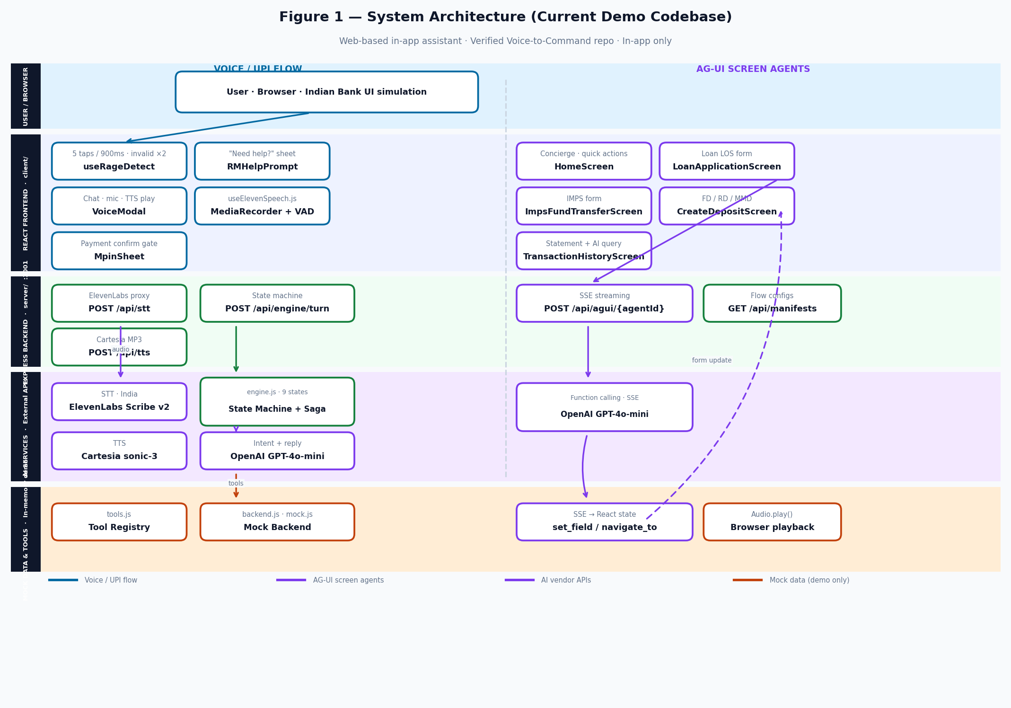
Figure 1 — Current demo: layered architecture (Voice/UPI + AG-UI, mock backend)

Layer | Components | Repo path
User / Browser | Indian Bank UI simulation | client/ · index.html
React Frontend | VoiceModal, rage detect, 5 banking screens | client/src/components/, hooks/
Express Backend | /api/stt, /api/tts, /api/engine/turn, /api/agui/* | server/index.js
AI Services | ElevenLabs STT, OpenAI GPT-4o-mini, Cartesia TTS | Proxied via server
Mock & Tools | Tool registry, in-memory contacts/billers/payments | server/data/, engine/tools.js

3.2 Voice / UPI Flow — Sequence
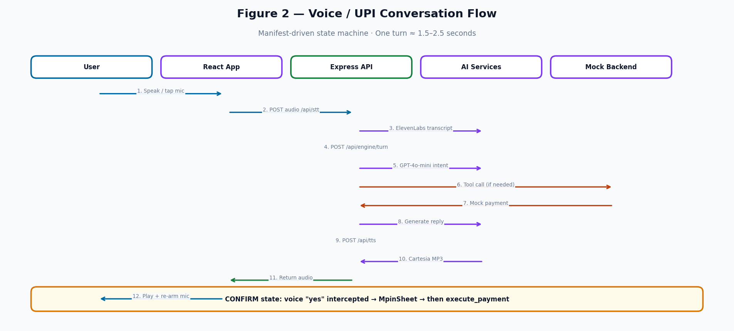
Figure 2 — Voice turn sequence: speak → STT → engine → tools → TTS → playback

3.3 AG-UI Screen Agent Flow — Sequence
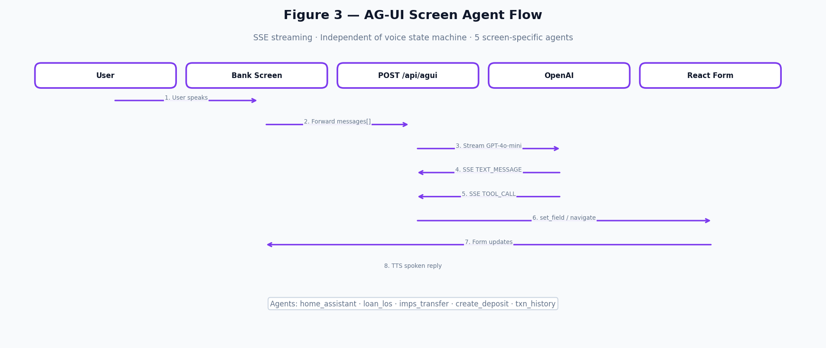
Figure 3 — AG-UI: screen → SSE agent → set_field / navigate_to → live form update

3.4 State Machine & Repository Map
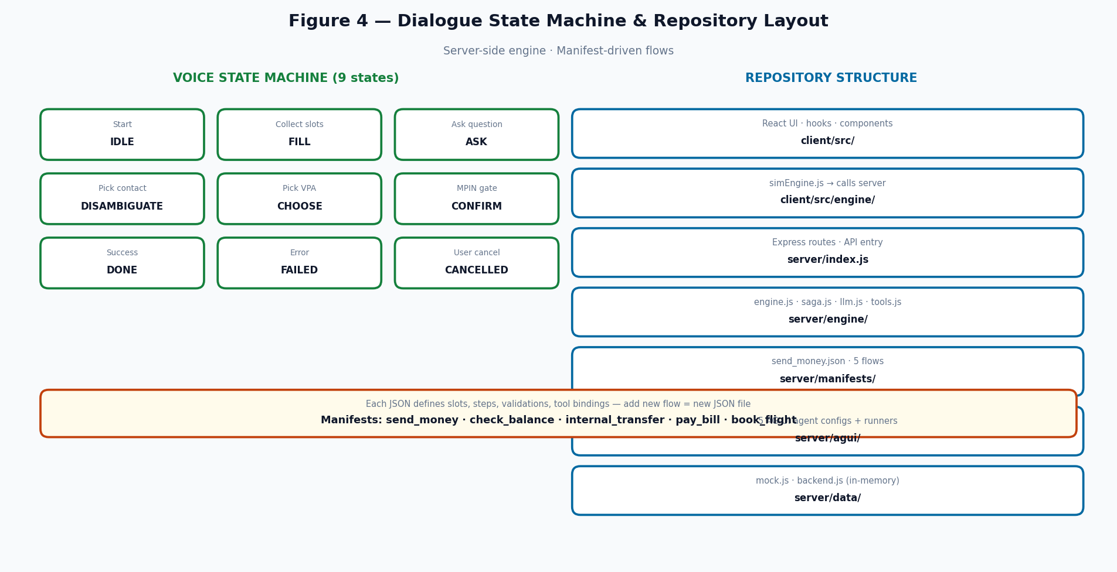
Figure 4 — Nine dialogue states + key repository folders

Manifest | Slots | Mock tools
send_money | recipient, amount, VPA | contacts.search → execute_upi_payment
check_balance | account type | balance.check
internal_transfer | amount, from, to | accounts.list → execute_transfer
pay_bill | biller, account, amount | billers.search → execute_bill_payment

4. System Architecture — Production Target
NOTE Figures 5–8 describe the V1+ product deployed in bank VPC (AWS Mumbai). Builds on the demo engine; adds bank integration, rule engine, DocumentDB, analytics.

4.1 Layered Production Architecture
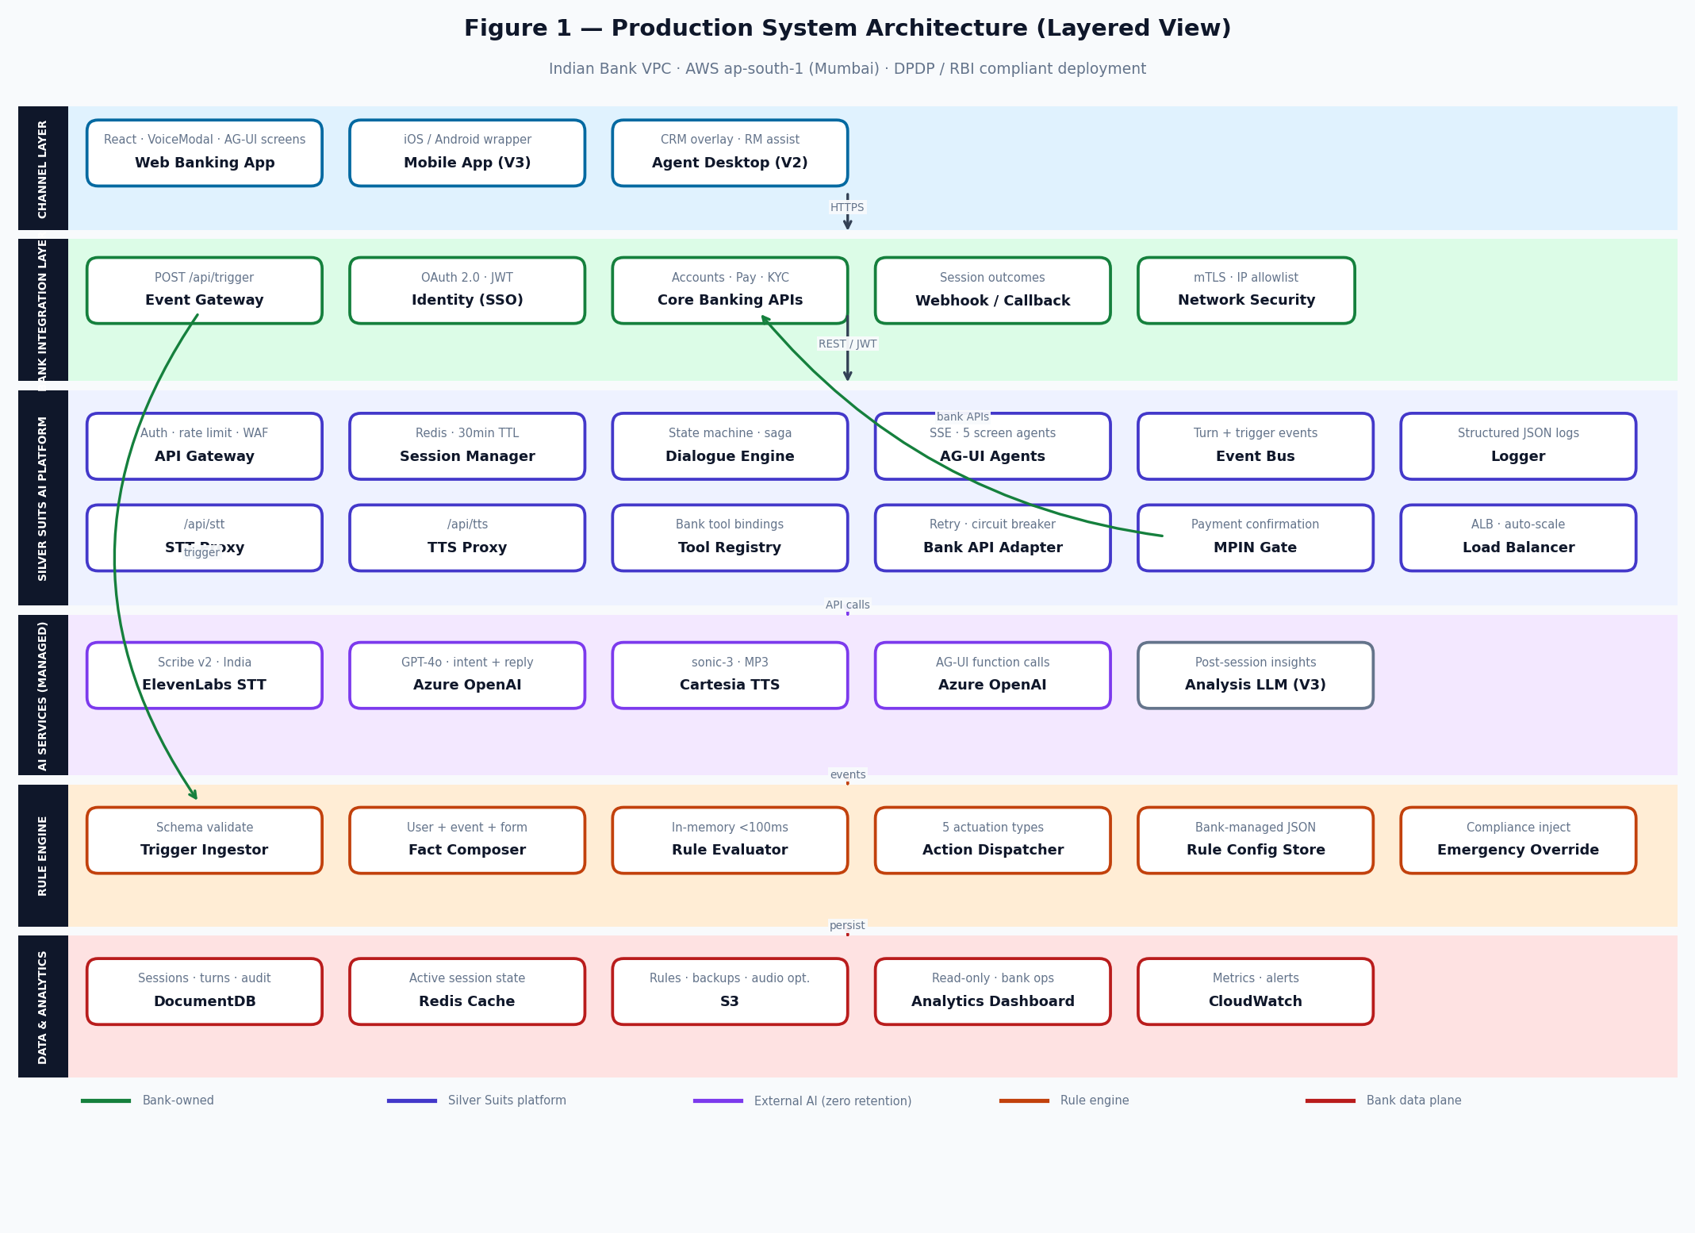
Figure 5 — Production: six layers (channel → bank → platform → AI → rules → data)

Layer | Owner | Key addition vs demo
Channel | Bank | Native mobile (V3), agent desktop (V2)
Bank Integration | Bank | SSO, CBS events, core APIs, webhooks, mTLS
Silver Suits Platform | Silver Suits | Gateway, Redis sessions, event bus, bank API adapter
AI Services | Silver Suits | Azure OpenAI India; zero retention contracts
Rule Engine | Silver Suits · bank configures | POST /api/trigger, JSON rules, <100ms

4.2 Runtime Flows — Voice + Rule Engine
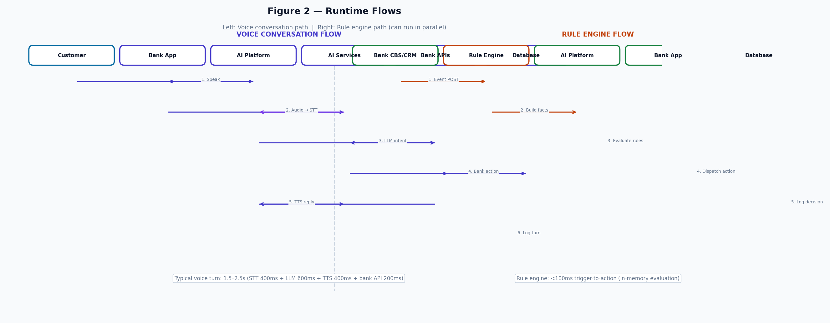
Figure 6 — Production runtime: voice turn path and rule engine path (parallel)

4.3 Rule Engine Architecture
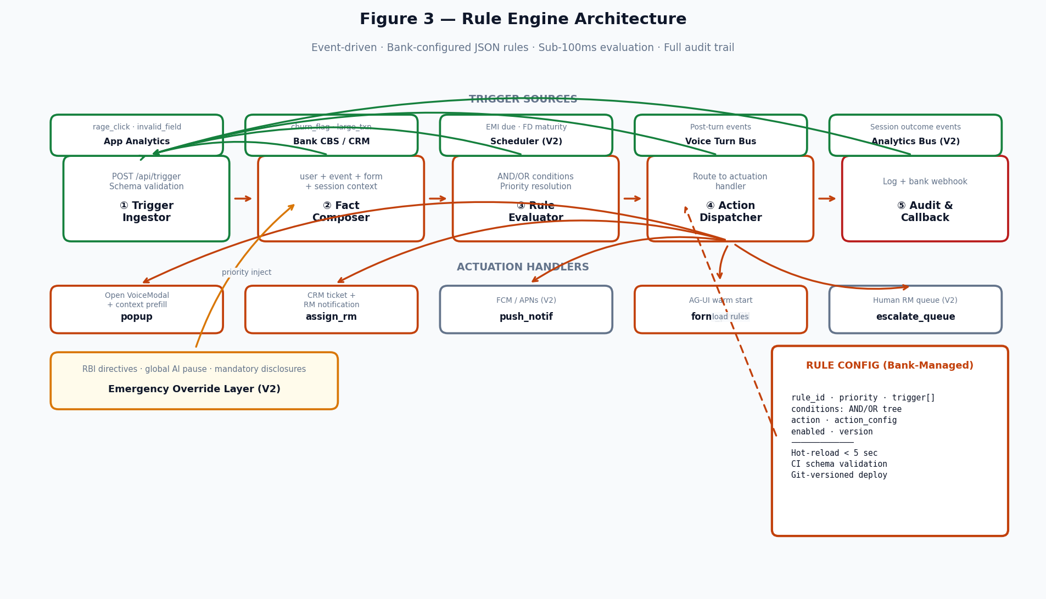
Figure 7 — Rule engine: trigger → facts → evaluate → dispatch → audit

4.4 Data Model & AWS Deployment
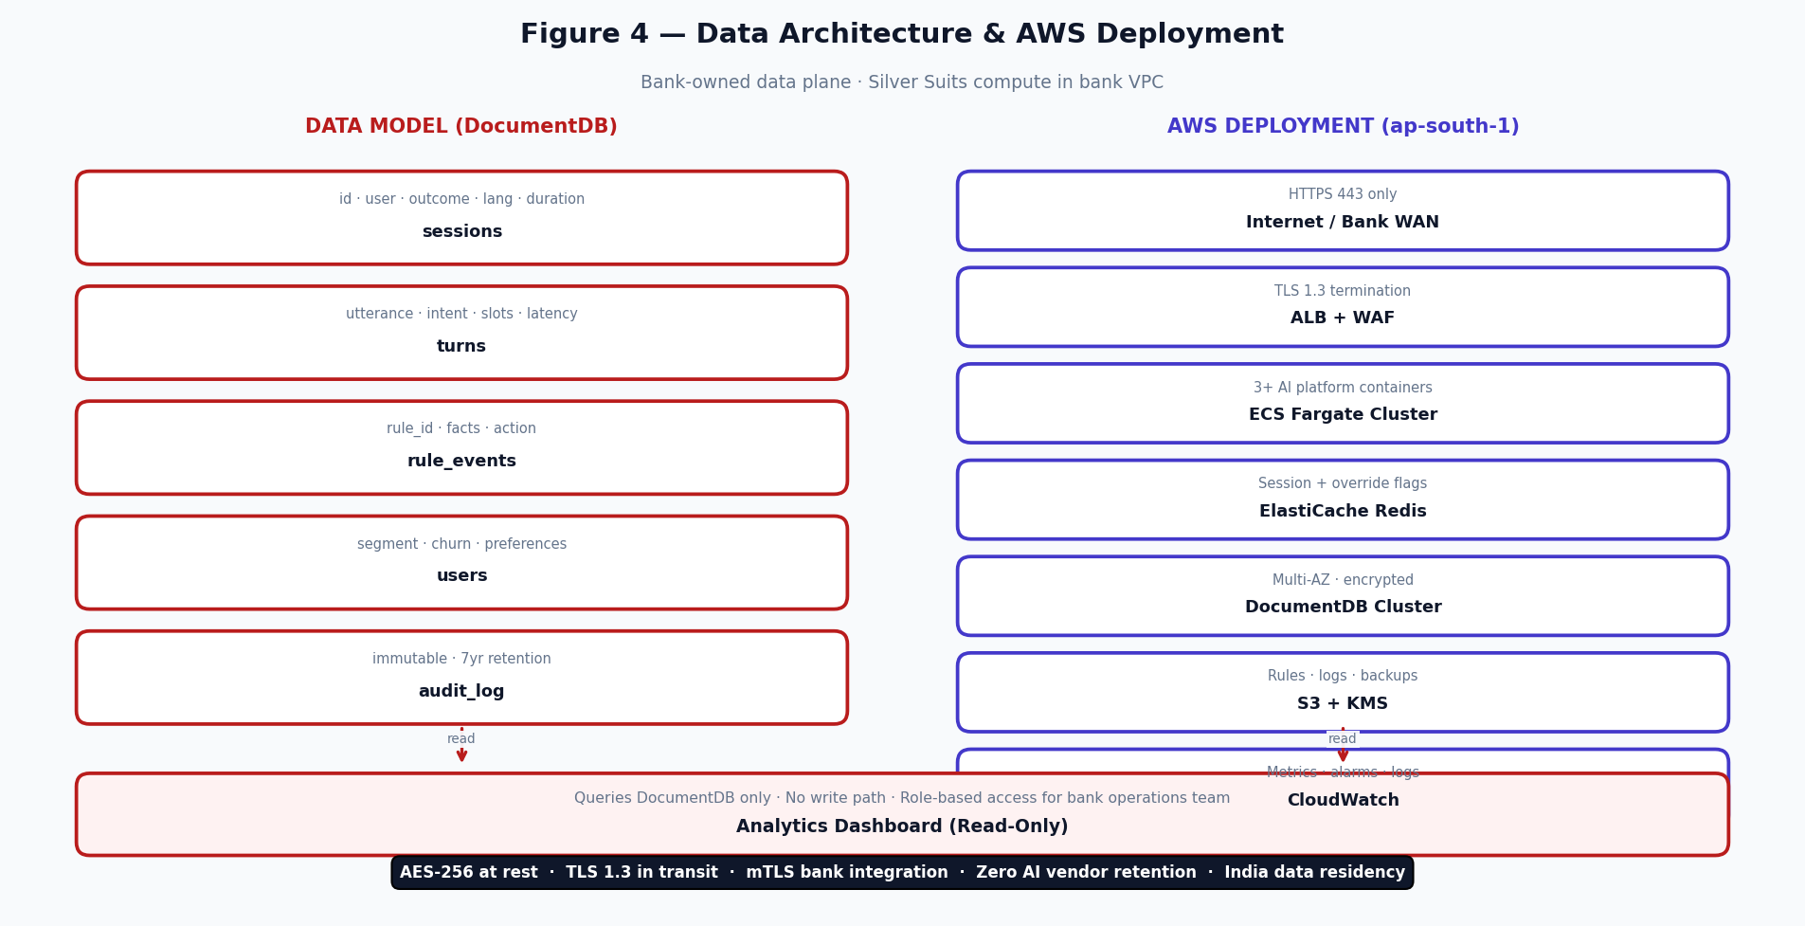
Figure 8 — DocumentDB collections + AWS ap-south-1 deployment topology

4.5 Demo vs Production — Component Matrix
Component | Demo (today) | Production (V1+) | Host
Backend | Express :3001 | ECS Fargate + ALB + rule engine | Bank VPC Mumbai
STT | ElevenLabs proxy (dev keys) | ElevenLabs India residency | ElevenLabs India
LLM | OpenAI GPT-4o-mini | Azure OpenAI GPT-4o | Azure India
TTS | Cartesia proxy | Cartesia India region | Cartesia India
Banking data | mock.js in-memory | Bank REST via adapter | Bank CBS
Sessions | React state only | DocumentDB + Redis cache | Bank-owned
Rule engine | Client rage detect only | Full trigger → actuate pipeline | Silver Suits

5. Complete Data Workflow

5.1 Demo Data Flow (Current)
Step | Component | Data In | Data Out | Stored?
1 | useRageDetect (browser) | pointerdown events, field validation errors | onFrustrated() callback fired | No — in-memory counters only
2 | RMHelpPrompt | onFrustrated event | User taps "Yes, help me" | No
3 | VoiceModal opens | Session object (blank) | INIT turn sent to server | No — session in React state
4 | MediaRecorder + VAD | Microphone audio stream | Audio blob (webm/opus) | No
5 | POST /api/stt | Audio blob + lang param | Transcript text + detected lang | No (ElevenLabs zero retention)
6 | POST /api/engine/turn | Transcript + sessionId + lang | Updated session (state, history, pending) | No — server session map in-memory
7 | LLM (OpenAI) | Utterance + state context + history (last 6) | intent, slots{}, reply, language | No (OpenAI zero retention)
8 | Saga runner + tools | Resolved intent + slots | Tool results (contacts, payment) | No — mock in-memory
9 | POST /api/tts | Bot reply text + lang | MP3 audio bytes (44100Hz, 128kbps) | No (Cartesia zero retention)
10 | Browser Audio | MP3 blob URL | Audio played to user | No — blob URL revoked after play
11 | MpinSheet (CONFIRM only) | User MPIN entry | Success → confirmation sent to server | No
12 | Session result | DONE/FAILED/CANCELLED state | Result in session.history[] (React state only) | No

5.2 Production Data Flow — Pre-Conversation
Step | Action | Data Involved | Stored? | Version
1 | Bank system emits event (button click, rage-click, inactivity) | event_type, user_id, form_profile{}, frontend_context{} | No | V1
2 | Bank calls POST /api/trigger on Silver Suits backend | user_profile{}, event_type, form_profile{}, branch_context{} | No (rule evaluation only) | V1
3 | Rule engine evaluates conditions in-memory (< 100ms) | All trigger payload tokens + loaded rule set | No | V1
4 | Rule decision: action + script_id + language | action_type, script_id, lang, visibility | No | V1
5 | Backend creates session record in bank DB | session_id, user_id, journey_type, lang, started_at | YES — bank DB | V1
5a | WebSocket push to browser → VoiceModal popup | script_id, lang, user_name, field_context | No (WebSocket ephemeral) | V1

5.3 Production Data Flow — During Conversation (Per Turn)
This is identical to the demo flow (steps 4–9 above) except AI provider keys use India data-residency configs, and step 7 additionally writes the turn to bank DB.

5.4 Production Data Flow — Post-Conversation
Step | Action | Data | Destination | Version
1 | Session state → DONE/CANCELLED/FAILED | outcome, duration_s, turn_count | Bank DB — sessions collection (UPDATE) | V1
2 | Optional result callback | session_id, outcome, transcript_summary | Bank backend (POST webhook) | V2
3 | Post-session LLM analysis | Full transcript text | Azure OpenAI (India) — zero retention on LLM | V3
4 | Structured analytics JSON stored | sentiment_arc, churn_risk, qa_score, script_compliance, flags[] | Bank DB — analytics collection | V3
5 | Rule audit log written | rule_id, matched_params{}, action_taken, ts | Bank DB — rule_audit collection | V1

5.5 Data That Is NEVER Stored (Demo and Production)
- Voice audio recordings — discarded immediately after STT processing (zero retention on ElevenLabs)
- Voice biometric data — not collected at any stage of the pipeline
- Raw audio files — no disk writes on any AI service (STT, LLM, TTS)
- LLM conversation context — Azure OpenAI and OpenAI both configured with zero data retention
- Cartesia TTS inputs — not stored after audio generation
- Customer PII outside bank DB — Silver Suits backend never caches PII on disk (stateless)

6. Behavior Analysis — How Frustration Is Detected & What Triggers the AI

6.1 Current Implementation (IN DEMO CODEBASE — useRageDetect.js)
IN DEMO CODEBASE This is the actual behavior detection implemented in the code. It runs entirely client-side in the browser.
The useRageDetect hook monitors two independent frustration signals and fires a single onFrustrated() callback when either threshold is crossed. This opens the 'Need a little help?' bottom-sheet prompt. The hook auto-resets after 8 seconds so it can fire again if needed.
Signal | Threshold | Detection Logic | Code Location
Rage taps | 5+ taps in 900ms on same element/screen | pointerdown timestamps pushed to array; array filtered to last 900ms; count >= RAGE_TAP_COUNT fires | useRageDetect.js — handleTap()
Repeated invalid field | 2+ invalid submissions of same field | markInvalidField(fieldId) called on validation failure; counter per fieldId; >= INVALID_FIELD_THRESHOLD fires | useRageDetect.js — markInvalidField()

Constants (from code)
Constant | Value | Purpose
RAGE_TAP_COUNT | 5 | Number of taps needed within the window to trigger
RAGE_TAP_WINDOW | 900ms | Sliding time window for tap counting
INVALID_FIELD_THRESHOLD | 2 | Times same field set invalid before triggering
Auto-reset delay | 8000ms | Prevents re-fire for 8 seconds after triggering

What happens after frustration is detected (App.jsx)
1. onFrustrated() callback fires → setRmUpiPromptOpen(true)
2. RMHelpPrompt bottom-sheet appears: "Looks like you hit a snag. Want me to take over?"
3. User taps "Yes, help me" → setOpen(true) → VoiceModal opens → INIT turn sent to server
4. User taps "No, thanks" → dismiss() → rage detection resets → no AI session starts

6.2 Additional Trigger Points (IN DEMO CODEBASE)
Trigger | Where | How
HomeScreen AI button tap | HomeScreen.jsx | Mic button on home → handleMicTap() → VoiceModal opens with INIT turn
DemoPanel scripted prompt | DemoPanel.jsx | onSpeak(text) → runUtterance(text) → TRANSCRIPT turn with preset text
Quick action button | HomeScreen.jsx | onQuickAction(actionName) → handleOpenWithAction → START_ACTION turn
Navigate-to from AG-UI | homeAguiRunner.js | Home agent fires navigate_to tool → App.handleNavigate() → opens destination screen

6.3 Production Behavior Signals (Productization Roadmap)
In production, behavior signals come from both the client (same rage detection) and the bank backend system via the trigger API payload.
Signal | Source | How Sent to Silver Suits | Version
Rage taps (in-app) | Mobile app JS | Same useRageDetect hook + POST /api/trigger | V1
Inactivity duration | Mobile app timer | inactive_time_s in secondary_signals[] | V1
Form completion percentage | Mobile app | form_completion_pct in form_profile{} | V1
Repeat-click count | Mobile app | repeat_click_count in secondary_signals[] | V1
User profile / segment | Bank DB | user_profile{} in trigger payload | V1
Previous churn risk score | Bank analytics DB | user_profile.churn_risk_prev | V3
Session language preference | Bank user profile | user_profile.language_pref | V1

7. Rule Engine — Demo vs Production
In the demo, only client-side frustration detection opens the AI popup. In production (Figure 7), the bank sends events to POST /api/trigger and a full rule engine evaluates JSON rules in under 100ms.

7.1 What Exists in Demo Today (IN DEMO CODEBASE)
IN DEMO CODEBASE The demo has a routing rule set in homeAguiConfig.js (hardcoded) and a manifest/saga engine for conversation flows. No visual rule-builder exists yet.

Banking channel routing rules (homeAguiConfig.js — hardcoded)
Condition | Destination | Rationale
Amount > ₹1,00,000 OR IMPS/NEFT/bank account/IFSC mentioned | fund_transfer | Above UPI per-transaction limit of ₹1 lakh
Amount ≤ ₹1,00,000 OR UPI/mobile pay/phone mentioned | upi_payment | Within UPI limit
Loan request mentioned | loan_application | Loan LOS journey
Deposit/FD/RD/MMD/fixed deposit/recurring mentioned | create_deposit | Deposit creation journey
Transaction history/account statement/suspicious credit | transaction_history | Statement view journey
Completely ambiguous | Ask 1 clarifying question | Avoid wrong routing

Conversation state machine rules (server/engine/engine.js)
State | Allowed Inputs | Transition Logic
IDLE | INIT, START_ACTION, TRANSCRIPT | TRANSCRIPT → LLM extracts action → START_ACTION
FILL | TRANSCRIPT, CANCEL | TRANSCRIPT → extract slots → advance saga
ASK | TRANSCRIPT, CANCEL | TRANSCRIPT → fill slot → advance
DISAMBIGUATE | TRANSCRIPT, SELECTION, CANCEL | Pick from options list → advance
CHOOSE | TRANSCRIPT, SELECTION, CANCEL | Pick sub-option → advance
CONFIRM | CONFIRMATION, TRANSCRIPT (yes/no), CANCEL | yes → execute tool_call; no → CANCELLED
DONE | RESET, START_ACTION | Terminal — auto-reset on next action
FAILED | RESET, START_ACTION | Terminal — error surfaced to user
CANCELLED | RESET, START_ACTION | Terminal — transcript saved as-is

7.2 Productization Rule Engine (V1+ — New Build)
IMPORTANT The production rule engine is a new build on top of the same backend, evaluating bank-provided trigger payloads rather than in-app routing.
Production trigger payload — what the bank sends to POST /api/trigger:
Field | Type | Description | Required
user_id | string | Bank's internal user identifier | Yes
user_profile | object | name, segment, language_pref, account_type, churn_risk_prev | Yes
event_type | enum | help_button_clicked / rage_click / inactivity / account_created / custom | Yes
form_profile | object | field_ids[], field_statuses{}, validation_regex{}, form_completion_pct | Conditional
frontend_context | object | current_page, journey_type, button_id, timestamp_ms | Yes
branch_context | object | branch_code, nearest_human_rm_id, geography | Optional
secondary_signals | array | rage_click_count, inactivity_duration_s, repeat_click_count | Optional

Example production rules:
IF [form_completion_pct > 75] AND [repeat_click_count > 5]
THEN [action=trigger_popup, script=loan_help, lang=en]

IF [inactive_time_s > 20] AND [event_type = inactivity]
THEN [action=trigger_popup, script=push_user, lang=hi]

IF [churn_risk_prev > 70] AND [event_type = rage_click]
THEN [action=assign_human_rm, script=retention_assist, priority=high]

7.3 Actions the Rule Engine Can Actuate (Production)
Action | How Actuated | Parameters | Version
trigger_popup | WebSocket push to browser | script_id, lang, user_name, field_context | V1
assign_human_rm | POST bank's CRM webhook | user_id, branch_code, rm_id, priority | V1
send_notification | Bank notification API (SMS/push) | user_id, template_id, params{} | V2
fill_form_field | WebSocket command to browser | field_id, value, validation_regex | V1
log_event | Write to bank DB | session_id, event_type, payload, ts | V1
abort_session | WebSocket close + state = CANCELLED | reason_code, user_id | V1

8. AG-UI Streaming Agents — Per-Screen AI (Deep Dive)

8.1 What AG-UI Is (IN DEMO CODEBASE)
AG-UI (Agent-UI) is a Server-Sent Events (SSE) protocol where the backend streams AI agent actions to the browser in real time. Each screen has its own dedicated agent running OpenAI function calling. The agent can call tools (e.g. set_field) that update the form live while the user is speaking — no waiting for a full response before the form starts filling.

8.2 Per-Agent Specification

Home Screen Agent (indian_bank_home_assistant)
File: server/agui/homeAguiRunner.js + homeAguiConfig.js
Role: Acts as a smart banking concierge. Understands what the customer wants (payment, loan, deposit, statement) and routes them to the correct screen using the navigate_to tool.

Tools
navigate_to(destination: upi_payment|fund_transfer|loan_application|create_deposit|transaction_history, context: string, routing_status: string)

Logic / Flow
- Amount > ₹1L OR IMPS/NEFT → fund_transfer
- Amount ≤ ₹1L OR UPI → upi_payment
- Loan request → loan_application
- Deposit/FD/RD → create_deposit
- Transaction query → transaction_history

Loan LOS Agent (indian_bank_loan_los)
File: server/agui/loanAguiRunner.js + loanAgentConfig.js + loanTools.js
Role: Fills the loan application form in real time as the user speaks. Can infer multiple field values from one utterance and fill them simultaneously.

Tools
set_field(fieldId: occupation|subProduct|purposeLoan|variant|facility|proposal|interestType|loanAmount|tenureMonths|branchPin, value: string)
validate_form(state: current form state — returns validation snapshot)

Logic / Flow
- 10 loan fields
- Select fields: enum-validated (o0/o1/o2, lp1-lp5, etc.)
- Numeric: loanAmount, tenureMonths
- Text: branchPin

IMPS Fund Transfer Agent (indian_bank_imps_transfer)
File: server/agui/impsAguiRunner.js + impsAguiConfig.js + impsTools.js
Role: Guides the user through within-bank or other-bank IMPS transfer form.

Tools
set_field(fieldId: transferType|payeeType|payeeName|payeeAccountNo|ifsc|payeeBank|mobileNo|amount|remarks)

Logic / Flow
- Asks ONE question at a time (strict flow)
- within-bank: name + account number
- other-bank/account: IFSC + account
- other-bank/mobile: bank name + mobile number

Create Deposit Agent (indian_bank_create_deposit)
File: server/agui/depositAguiRunner.js + depositAguiConfig.js
Role: Helps user select deposit type (FD/RD/MMD) and fill amount, tenure, maturity instructions.

Tools
set_field(fieldId: various deposit form fields)

Logic / Flow
- FD: lump sum, fixed tenure
- RD: monthly installment, tenure
- MMD: money multiplier deposit

Transaction History Agent (indian_bank_txn_history)
File: server/agui/txnHistoryAguiRunner.js + txnHistoryAguiConfig.js
Role: Answers user questions about their account statement, suspicious transactions, or expected credits. Can navigate to payment flows for relevant queries.

Tools
set_field(display/filter fields)
navigate_to(when user wants to initiate a payment based on a transaction)

Logic / Flow
- Suspicious credit / fraud alert → explain, log
- Wanted to pay someone → navigate_to upi_payment

8.3 SSE Streaming Protocol
All AG-UI agents stream via Server-Sent Events. Each SSE event is a JSON object with a type field. The browser processes events in order to update UI state in real time.
SSE Event Type | Payload | Browser Effect
TEXT_MESSAGE_START | {messageId, role} | New message bubble opened
TEXT_MESSAGE_CONTENT | {messageId, delta} | Text appended to bubble (streaming)
TEXT_MESSAGE_END | {messageId} | Bubble finalised; TTS triggered on text
TOOL_CALL_START | {toolCallId, toolCallName} | Agent about to call a tool
TOOL_CALL_ARGS | {toolCallId, delta} | Tool args streamed
TOOL_CALL_END | {toolCallId} | Tool call complete
RUN_FINISHED | {threadId, runId} | Agent turn complete
RUN_ERROR | {message, code} | Error shown to user

9. Voice Bot Interaction Flow & Per-Turn Logging

9.1 Per-Turn Pipeline (IN DEMO CODEBASE)
Step | Component | Action | Target Latency
1 | Browser (in-app) | User speaks; MediaRecorder starts on mic permission grant | —
2 | AnalyserNode (VAD) | RMS checked every animation frame; 1.5s silence-stop armed after speech starts | —
3 | MediaRecorder.stop() | chunks[] → Blob (webm/opus); recording ends | —
4 | POST /api/stt?lang=en | Audio blob → ElevenLabs Scribe v2 → transcript text + lang code | 300–500ms
5 | POST /api/engine/turn | Transcript + sessionId → server state machine processes turn | —
6 | LLM extract() (OpenAI) | utterance + state context + last 6 history turns → intent JSON | 400–700ms
7 | applyIntent() + advance() | Slots merged; saga stepped forward; next pending computed | < 20ms
8 | Tool calls (if needed) | contacts.search / billers.search / execute_payment (mock) | 50–200ms (mock)
9 | Bot reply text resolved | Session updated; history[] and state returned to client | —
10 | POST /api/tts | Bot reply text → Cartesia sonic-3 → MP3 bytes returned | 300–500ms
11 | Audio.play() | MP3 blob URL played in browser; TTS flag set | —
12 | waitUntilTtsIdle() | Auto-mic arms 500ms after TTS ends; loop back to step 1 | —

9.2 Hands-Free Auto-Mic Logic (App.jsx)
The auto-mic effect re-arms the microphone after each bot reply so the user never has to tap the mic button between turns. It is gated by multiple conditions to prevent the mic from capturing TTS audio or opening while the state machine is thinking.
Condition Checked | Why
open === true | Modal must be visible
mpinOpen === false | MPIN sheet takes priority — user is entering their PIN
speech.supported === true | STT backend available
session.thinking === false | LLM is not currently processing
session.executing === false | Tool call is not in flight
session.state in VOICE_INPUT_STATES | Only arm in FILL / DISAMBIGUATE / CHOOSE / CONFIRM states
ttsPlaying === false | Bot is not currently speaking
waitUntilTtsIdle() resolved | Belt-and-suspenders TTS idle check
500ms pause after TTS ends | Let user absorb the bot message before mic opens

9.3 MPIN Authentication Gate (MpinSheet.jsx + App.jsx)
Every payment confirmation is gated by MPIN authentication. The voice "yes" interceptor in App.jsx catches voice confirmations and routes them through the MPIN sheet before the actual confirmation is sent to the server.
Scenario | Flow
User taps "Confirm" button | handleConfirm() → setMpinOpen(true) → MpinSheet shown
User speaks "yes"/"haan" during CONFIRM state | looksLikeYes() → speech.abort() → setMpinOpen(true)
User speaks "no"/"cancel" | Passes through normally → handleConfirmTap(session, false)
MPIN success | setMpinOpen(false) → handleConfirmTap(session, true) → server executes payment
MPIN cancel | setMpinOpen(false) → stay on CONFIRM screen → user can re-tap Confirm

9.4 What Is Logged Per Turn (session.history[] — Demo)
Field | Type | Description
role | enum: user | bot | Who said it
text | string | Exact STT transcript or LLM-generated bot reply
t | unix timestamp ms | Date.now() at time of push to history

IMPORTANT In the demo, session.history[] lives in server-side in-memory Map only. Nothing is written to a database. In production (V1+), every turn is INSERTed into bank DB (turns collection) with additional fields: intent, slots, engine_state, lang.

9.5 Production Session Lifecycle Events (V1+ — Written to Bank DB)
Event | Trigger | Data Written to Bank DB
SESSION_STARTED | First turn processed | session_id, user_id, journey_type, lang, channel, trigger_event, consent_given, ts
TURN_LOGGED | After every conversation turn | session_id, role, text, intent, slots{}, engine_state, lang, t
FORM_FIELD_FILLED | fill_form_field tool succeeds | session_id, field_id, value, validated, ts
CONFIRMATION_GIVEN | User confirms (post-MPIN) | session_id, action_summary, slots_snapshot, ts
FALLBACK_TRIGGERED | Exception path entered | session_id, fallback_type, reason, ts
CONSENT_RECORDED | User accepts/declines session start | session_id, consent_given: bool, channel, ts
SESSION_ENDED | State → DONE/CANCELLED/FAILED | session_id, outcome, duration_s, turn_count, final_state, ended_at
HUMAN_RM_ASSIGNED | Escalation rule fires | session_id, user_id, rm_id, branch_code, reason, ts

10. Bank DB Integration — Read / Write Specification (Productization V1+)
IMPORTANT None of this exists in the demo. All data in demo is mock/in-memory. This section describes the V1+ production integration.

10.1 Database Schema (DocumentDB / MongoDB)
Collection | Key Fields | Indexes | Retention
sessions | session_id, user_id, journey_type, outcome, started_at, ended_at, lang, turn_count, channel | user_id + started_at; outcome + started_at | Per bank policy (≥7 yrs financial per RBI)
turns | session_id, role, text, intent, slots{}, engine_state, lang, t | session_id + t | Same as sessions
form_events | session_id, field_id, value, validated, ts | session_id + field_id | Same as sessions
analytics | session_id, user_id, sentiment_arc[], churn_risk, qa_score, script_compliance, talk_ratio, flags[] | session_id; user_id + churn_risk | Same as sessions
rule_audit | rule_id, version, matched_params{}, action_taken, ts | ts; rule_id | 2 years (compliance audit)
escalations | session_id, user_id, rm_id, branch_code, reason, ts | user_id + ts | 2 years

10.2 Write Operations
Operation | Trigger | Collection | Payload Size | Version
INSERT session | Session starts | sessions | ~500 B | V1
INSERT turn (per turn) | After each dialogue turn | turns | 200–800 B | V1
INSERT form_event | Form field filled | form_events | ~200 B | V1
UPDATE session outcome | Session ends | sessions | Patch only | V1
INSERT analytics | Post-session LLM analysis (V3) | analytics | 2–5 KB | V3
INSERT rule_audit | Rule match fires | rule_audit | ~300 B | V1
INSERT escalation | Human RM assigned | escalations | ~200 B | V2

10.3 Read Operations
Operation | When | Purpose | Collection
GET user profile | Pre-session (rule engine) | Contextualise script + language selection | Bank's user table (read-only view)
GET previous sessions (user) | Pre-session (V3 churn) | Feed prior outcomes into rule engine | sessions
GET session + turns | Dashboard: timeline | Per-user history + conversation replay | sessions + turns
GET analytics record | Dashboard: QA/sentiment | Display analytics per session | analytics
GET aggregate by date | Dashboard: volume charts | Session count / outcome rate over time | sessions
GET escalations by user | Rule engine cap check | Count recent escalations for abuse guard | escalations

12. Resource Requirements

12.1 Bank-Side Integration Effort
Task | Bank Role | Effort | When
Wire rage-detect + trigger API in mobile app | Mobile/Backend engineer | 1–2 weeks | V1 — Wk 2
Provision DocumentDB schema + access grants | DBA | 1 week | V1 — Wk 2
Whitelist Silver Suits IPs on DB + API firewall | Security / DBA | 1–2 days | V1 — Wk 2
Implement result callback receiver | Backend engineer | 3–5 days | V2 — Wk 10
Connect human RM escalation webhook | CRM / Backend | 3–5 days | V2 — Wk 11
Provide branding guidelines | Marketing / Design | 1 week | V2 — Wk 11
Compliance and legal review | Compliance / Legal | 2–3 weeks | V1 — Wk 1–3

13. Timeline & Version Feature List
Version | Weeks | Theme | Key Milestone
V1 — MVP | 1–8 | Bank integration + real DB | Trigger API live, real sessions persist to bank DB
V2 — Production-Ready | 9–20 | Rule builder + analytics v1 | Rule-builder UI, analytics dashboard, push notifications

13.1 Sprint Plan
Sprint | Ver | Deliverables
1–2 | V1 | Azure backend, bank API contract signed, DB schema v1, CI/CD, TLS/auth setup
3–4 | V1 | Production rule engine (IF/THEN), POST /api/trigger endpoint, real STT/TTS keys (India residency)
5–6 | V1 | Bank DB writes (sessions, turns, form_events), consent flow, cap/rate limiting
7–8 | V1 | Exception handling (all paths), human RM webhook, V1 UAT with bank team
9–10 | V2 | Push notification gateway (FCM/APNs), WebSocket session channel hardening
11–12 | V2 | Rule-builder UI (visual editor → JSON config), 6 additional languages
13–14 | V2 | Emergency override dashboard, DEV/PROD split, eval harness
15–16 | V2 | Result callback API, branding customisation, V2 load testing (1000 concurrent)
17–18 | V2 | Compliance audit, DPA/NDA execution, VAPT, V2 go-live
18–19 | V3 | Full analytics (multi-journey, timeline, conversation replay)
19–20 | V3 | Revenue-opportunity extraction, predictive triggers from churn score, V3 go-live

13.2 V1 Feature List — Weeks 1–8 (Building on Demo)
Feature | Demo Status | V1 Action
STT (ElevenLabs Scribe v2) | IN DEMO (dev keys) | Switch to India data residency + production keys
LLM (OpenAI GPT-4o-mini) | IN DEMO (dev keys) | Switch to Azure OpenAI India endpoint
TTS (Cartesia sonic-3) | IN DEMO (dev keys) | Switch to Cartesia India region + production keys
Manifest/saga state machine | IN DEMO (complete) | No change needed — add new manifests as required
AG-UI screen agents (all 5) | IN DEMO (complete) | No change needed for V1
useRageDetect behavior detection | IN DEMO (complete) | Bank embeds in their mobile app SDK
Trigger REST API | NOT IN DEMO | Build POST /api/trigger with rule engine evaluation
Production rule engine | NOT IN DEMO | Build in-memory expression evaluator, JSON rule configs
Bank DB writes (sessions + turns) | NOT IN DEMO (mock only) | Wire DocumentDB driver; write on every turn
Consent management | NOT IN DEMO | Add consent gate before first session turn
Per-user cap / rate limiting | NOT IN DEMO | Read escalations count from DB; abort at cap
Result callback API | NOT IN DEMO | POST outcome + transcript summary to bank after session

14. Compliance Quick-Reference
Component | Host | Data Stored? | AI Training? | India? | Cert
Backend API | Azure India (Central + South) | No (stateless) | N/A | Yes | SOC2/ISO27001/PCI DSS
STT (ElevenLabs) | ElevenLabs India data residency | Zero retention | No | Yes | SOC2 Type II, HIPAA
LLM (Azure OpenAI) | Azure India — Chennai endpoint | Zero retention | No | Yes | SOC2 Type II, ISO27001
TTS (Cartesia) | Cartesia India region | Zero retention | No | Yes | SOC2 Type II
Bank Database | Bank-controlled AWS Mumbai / OnPrem | Permanent — bank owns | N/A | Yes | AWS SOC2 / bank cert
Analytics Dashboard | Azure India | No (reads bank DB) | N/A | Yes | SOC2/ISO27001

Encryption: AES-256 at rest, TLS 1.2+ in transit — mandatory across all components. DPDP Act 2023 + RBI guidelines compliance. 7-year minimum retention for financial records (PMLA). Bank owns all persistent data. Silver Suits never retains voice audio or customer PII on disk.

15. Exception Handling & Fallbacks

15.1 Demo — Currently Handled (IN DEMO CODEBASE)
Exception | How Handled (code) | File
STT returns empty transcript | engine re-prompts with "didnt_catch"; previousBotMessage re-spoken | engine.js — handleSmalltalk()
LLM unavailable / API error | Speaks "model unavailable" message; does not loop; turn ends gracefully | engine.js — intent.error === llm_unavailable
Unknown intent (no action match) | handleSmalltalk() — speaks LLM contextual reply OR re-prompts pending slot | engine.js — handleSmalltalk()
User says cancel/nahi/stop | State → CANCELLED; cancellation message spoken | engine.js — doCancel()
Bank mock API returns error | State → FAILED; BackendError code shown to user; retryable flag | backend.js — BackendError class
Bank mock: random 5–7% failure | Simulates real bank decline; user sees FAILED with retry option | backend.js — flaky()
Force-fail mode (demo panel) | bank_declined / network_error injected via X-Force-Fail header | backend.js + DemoPanel.jsx
Disambiguation (multiple matches) | State → DISAMBIGUATE; options list shown; user picks by voice or tap | saga.js + VoiceModal.jsx
TTS 503 (Cartesia not configured) | Console warning only; conversation continues without TTS audio | cartesiaTts.js

15.2 Production — Additional Fallbacks (V2+)
Exception | Detection | Action | Logged?
Tech glitch / connection failure | WebSocket or API error event | Log; assign to nearest human RM | Yes
Session abandoned | User closes app mid-session | Log; 2 abandons/day → human RM | Yes
Session dropped midway | WebSocket close / network loss | Save transcript; log as incomplete | Yes
Insufficient rule parameters | Rule eval fails validation | Use default action; flag to team | Yes
User exceeds per-session cap | Cap counter in DB | Abort; log; assign human RM | Yes

16. Non-Functional Requirements
Requirement | Demo (Current) | Production Target | Notes
E2E turn latency | ~1.0–1.5s (STT+LLM+TTS) | < 1.2s in-app | STT 500ms + LLM 600ms + TTS 400ms (parallel where possible)
Rule engine decision | N/A (instant in-browser routing) | < 100ms | In-memory eval; no DB calls during evaluation
Concurrent sessions | ~10 (dev server) | 1,000+ simultaneous | Azure App Service auto-scale; load tested in V2 (week 17–18)
System availability | N/A (local dev) | 99.9% uptime | Azure + ElevenLabs + Cartesia SLAs combined
Data freshness (dashboard) | N/A | < 5 min lag | Async DB writes; dashboard reads directly from bank DB
Rule change cycle | Instant (hardcoded) | 14 business days avg (prod rules) | Emergency override bypasses for urgent compliance updates
VAPT / Security | Not applicable (mock) | Before each major go-live | Penetration testing before V2 and V3 go-live
RBI/DPDP audit | N/A | Continuous readiness | 30-day purge cycle; full audit logs in bank DB

This document is confidential and intended for Indian Bank's technical and product teams only.
Silver Suits AI · Demo + Production architecture + Productization roadmap — May 2026

