SILVER SUITS AI
AI Voice RM Platform
Production Architecture
& Rule Engine Specification

Document | Value
Client | Indian Bank
Classification | Confidential — Internal / Partner Use
Version | 3.0
Date | May 2026
Deployment | Bank VPC · AWS ap-south-1 (Mumbai)
Compliance | DPDP Act 2023 · RBI Digital Lending · Zero AI retention

1. Executive Summary
The AI Voice RM Platform embeds an intelligent voice and screen assistant inside the bank's digital channels. It helps customers complete banking journeys by voice, detects frustration in real time, and executes bank-defined business rules to intervene with the right action — AI popup, human RM assignment, or notification.
Scope: In-app voice assistant (V1). Optional outbound telephony via Exotel (V2). All customer data remains in bank-owned infrastructure in India.

Solution at a Glance
Capability | Description | Owner
Voice banking | 5 flows: send money, balance, transfer, bill pay, flight (demo) | Silver Suits AI + Bank APIs
Screen assistants | 5 AG-UI agents fill loan, IMPS, deposit, txn screens via voice | Silver Suits AI
Behavior detection | Rage taps (5 in 900ms) and invalid field (2×) trigger help | Bank App + Platform
Rule engine | Real-time IF/THEN on bank events; <100ms; JSON-configured rules | Silver Suits builds · Bank configures
Persistence | Sessions, turns, rule decisions, audit — DocumentDB | Bank
Analytics | Volume, outcomes, timelines, rule effectiveness | Bank

Architecture Principles
- Bank owns customer data — Silver Suits is a data processor under DPDP.
- Deploy inside bank VPC — no public exposure of application tier.
- AI vendors operate with zero retention — ephemeral requests only, India regions.
- Rules are bank-managed — product team edits JSON; no code deploy for rule changes.
- Every decision is auditable — rule matches, actions, and API calls logged immutably.

2. System Architecture
Figure 1 presents the layered production architecture. Each layer has a defined ownership boundary and communicates only through documented APIs. The platform supports three concurrent capabilities: voice dialogue, AG-UI screen agents, and the rule engine.
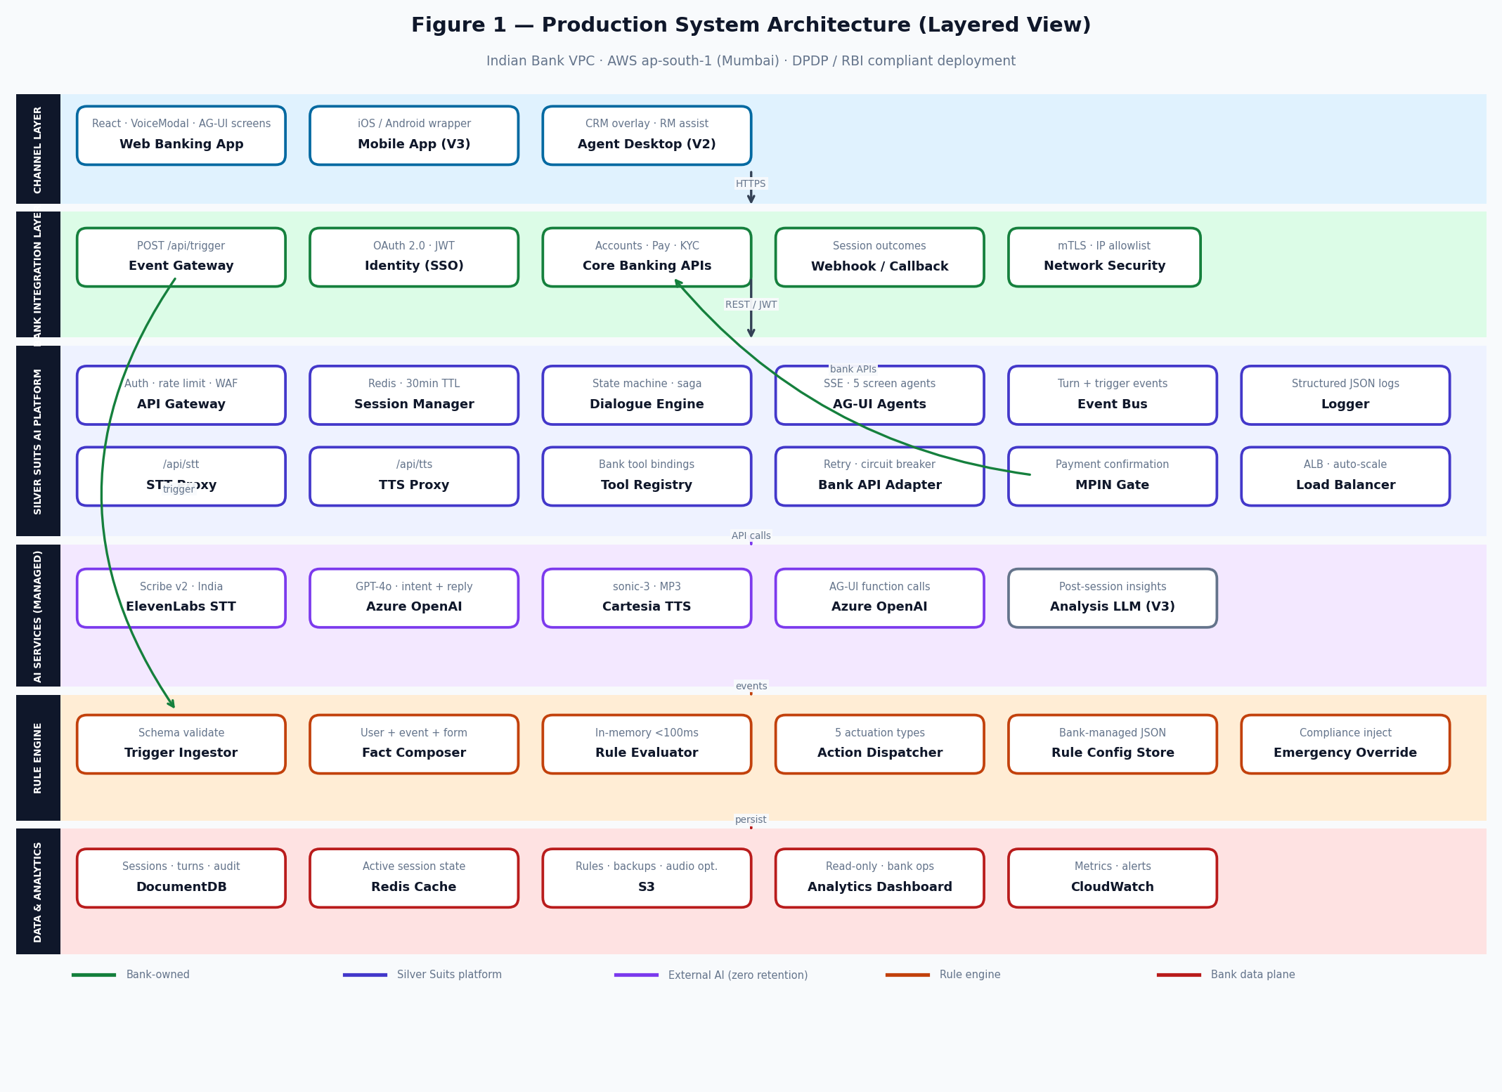
Figure 1 — Layered production architecture (6 layers, bank VPC deployment)

2.1 Layer Responsibilities
Layer | Components | Responsibility | Owner
Channel | Web app, mobile (V3), agent desktop (V2) | User interface, mic, rage detection, MPIN gate | Bank
Bank Integration | SSO, CBS events, core APIs, webhooks, mTLS | Identity, banking operations, outcome callbacks | Bank
AI Platform | Gateway, sessions, dialogue engine, AG-UI, proxies, event bus | Orchestrate AI flows, isolate API keys, scale compute | Silver Suits
AI Services | ElevenLabs STT, Azure OpenAI, Cartesia TTS | Speech and language intelligence — zero retention | Silver Suits (contracted)
Rule Engine | Ingestor, fact composer, evaluator, dispatcher, config | Evaluate bank rules and actuate interventions | Silver Suits · Bank configures
Data & Analytics | DocumentDB, Redis, S3, dashboard, CloudWatch | Persist, query, monitor — read-only analytics | Bank

2.2 Runtime Flows
Figure 2 separates the voice conversation path from the rule engine path. Both can execute in parallel — e.g. a rage-click trigger fires the rule engine while an active voice session continues.
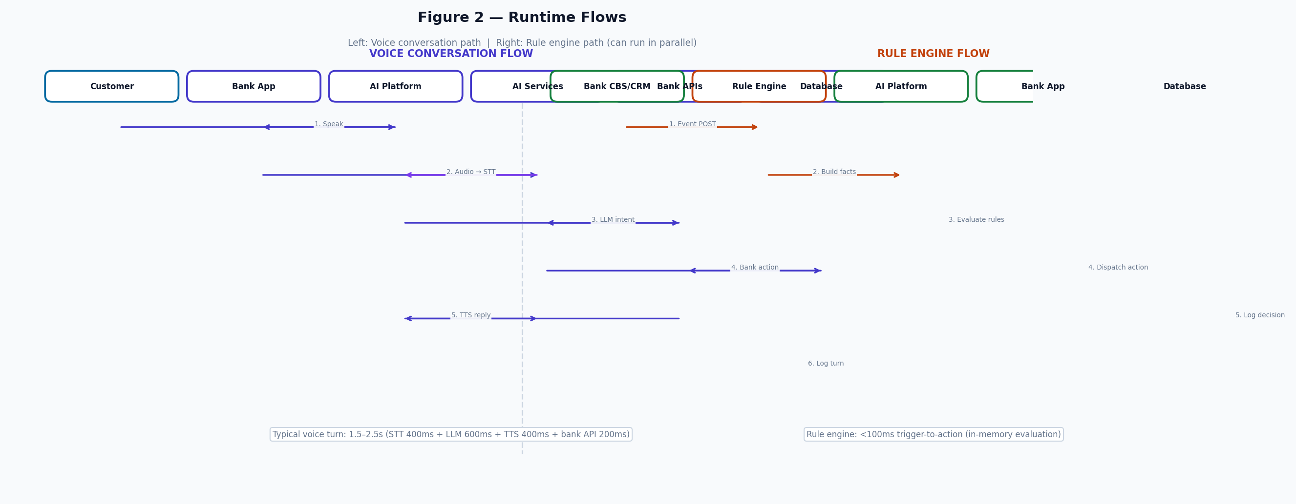
Figure 2 — Runtime sequence: voice turn path and rule engine path

Voice Turn Latency Budget
Step | Component | Target latency
Speech-to-text | ElevenLabs Scribe v2 (via proxy) | 300–500 ms
Intent extraction | Azure OpenAI GPT-4o | 400–700 ms
Bank tool execution | Bank API Adapter | 100–300 ms
Reply generation | Azure OpenAI | included in LLM call
Text-to-speech | Cartesia sonic-3 (via proxy) | 300–500 ms
End-to-end per turn | Full pipeline | 1.5–2.5 s (p50)

3. AI Platform — Component Specification

3.1 Core Services
Component | Technology | Interface | Function
API Gateway | Nginx + Express | HTTPS / JWT | Authentication, rate limiting (100 req/min/user), routing
Session Manager | Redis ElastiCache | Internal | Active session state, 30-min TTL, multi-instance sync
Dialogue Engine | Node.js engine.js + saga.js | POST /api/engine/turn | Manifest-driven state machine; 9 states; tool orchestration
AG-UI Agents | Node.js + SSE | POST /api/agui/{id} | Streaming form-fill agents for 5 banking screens
STT Proxy | Node.js → ElevenLabs | POST /api/stt | Audio in → transcript + language code
TTS Proxy | Node.js → Cartesia | POST /api/tts | Text in → MP3 bytes
Tool Registry | Node.js | Internal | Maps dialogue steps to bank API calls
Bank API Adapter | Axios + Opossum | Bank REST | Retry, circuit breaker, timeout on bank integrations
Event Bus | Redis Pub/Sub | Internal | Publishes turn events to rule engine subscribers
Logger | Winston → CloudWatch + DocumentDB | Internal | Structured per-turn and per-session logs

3.2 Voice Flow Manifests
Manifest | Slots collected | Bank tools invoked | Confirmation
send_money | recipient, amount, VPA | contacts.search → execute_upi_payment | MPIN + yes/no
check_balance | account type | balance.check | Verbal confirm
internal_transfer | amount, from, to account | accounts.list → execute_transfer | MPIN
pay_bill | biller, account, amount | billers.search → execute_bill_payment | MPIN
book_flight | route, date, passenger | flights.search → execute_flight | Verbal confirm

3.3 AG-UI Screen Agents
Screen | Agent ID | Tools | Primary use
Home | indian_bank_home_assistant | navigate_to | Route by amount: UPI ≤₹1L, IMPS >₹1L
Loan LOS | indian_bank_loan_los | set_field, validate_form | 10-field loan application by voice
IMPS Transfer | indian_bank_imps_transfer | set_field | 9-field transfer form
Create Deposit | indian_bank_create_deposit | set_field | FD / RD / MMD selection and fill
Transaction History | indian_bank_txn_history | set_field, navigate_to | Query txns; navigate on fraud signal

3.4 Bank Integration APIs
API | Direction | Auth | Payload summary
POST /api/trigger | Bank → Platform | mTLS + API key | user_id, event_type, user_profile, form_profile, event_data
POST /api/engine/turn | App → Platform | JWT | session_id, input{type, text|selection|confirm}
POST /api/stt | App → Platform | JWT | audio blob (WebM/MP3/WAV)
POST /api/tts | App → Platform | JWT | text, language code
POST /api/agui/{agentId} | App → Platform | JWT | messages[], threadId — SSE response stream
Webhook callback | Platform → Bank | mTLS | session_id, outcome, transcript_summary, slots, metrics

4. Rule Engine Architecture
The rule engine is an event-driven decision service. Banks define rules as versioned JSON documents. On each trigger, the engine composes a fact object, evaluates conditions in memory, dispatches the highest-priority matching action, and writes an immutable audit record.
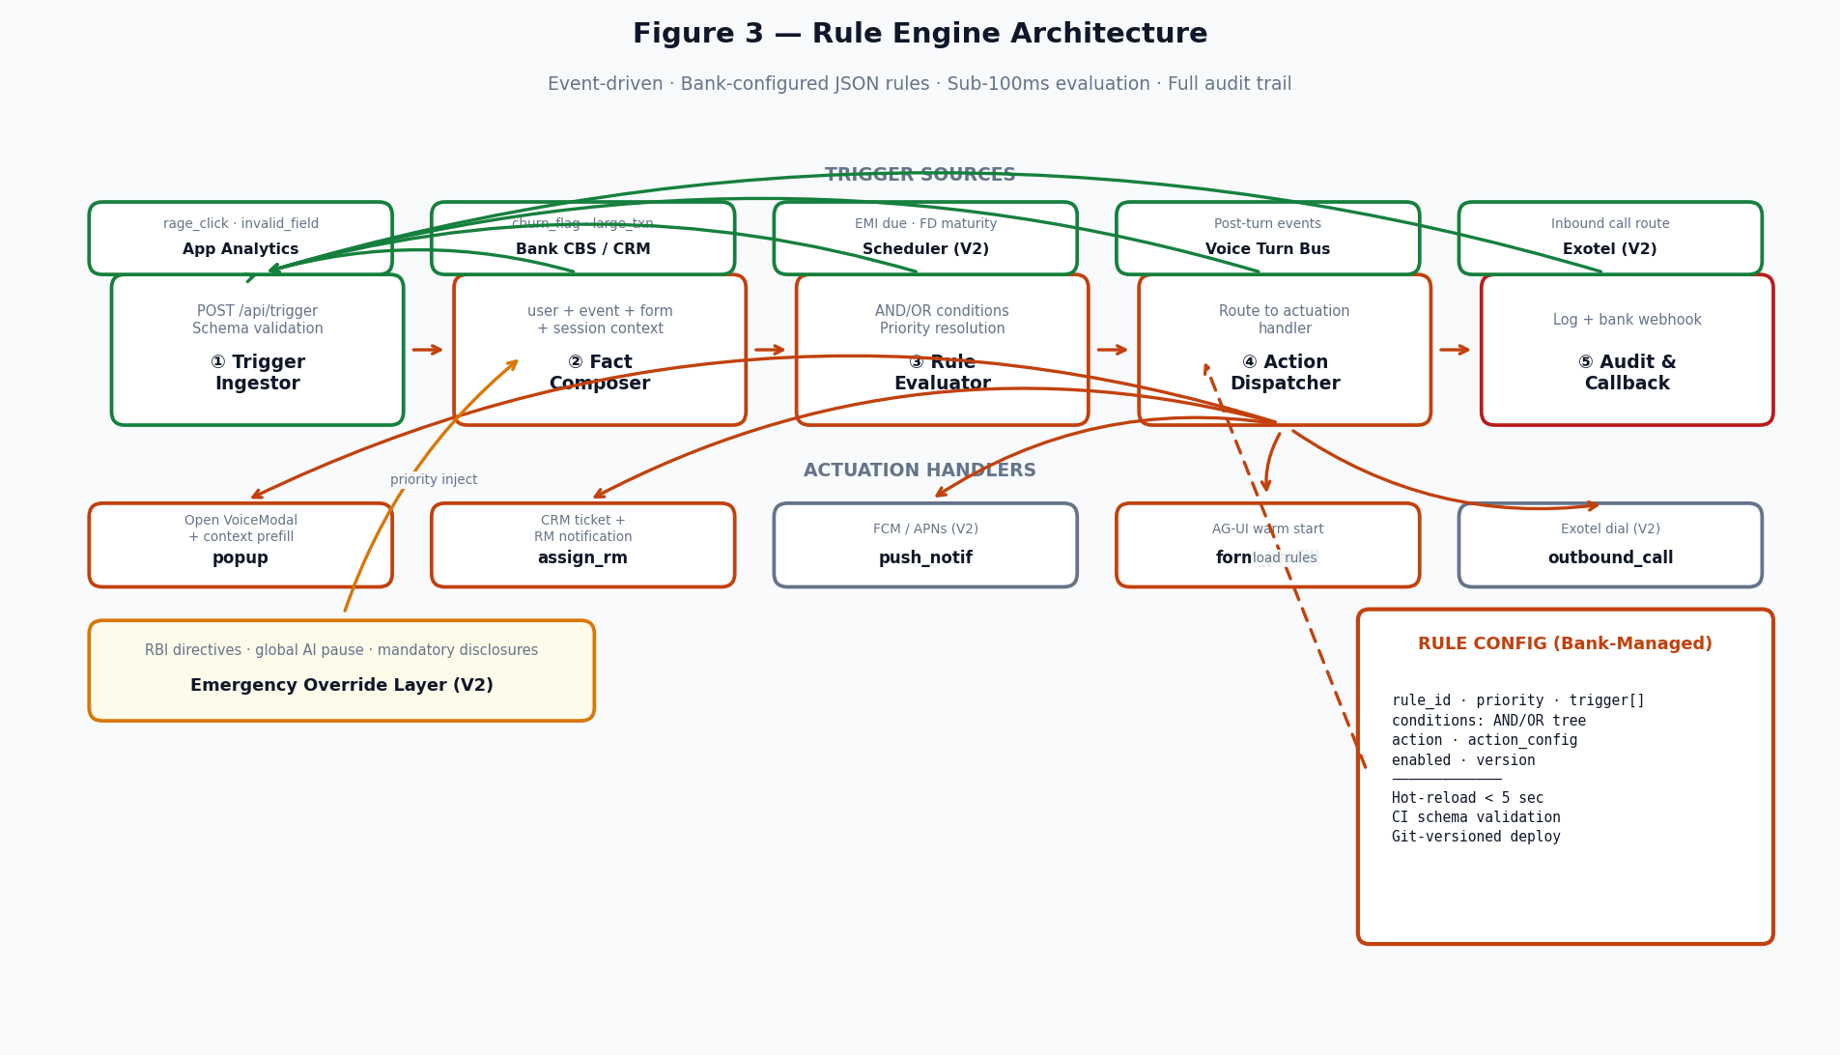
Figure 3 — Rule engine: ingest → compose → evaluate → dispatch → audit

4.1 Processing Pipeline
Stage | Input | Output | SLA
Trigger Ingestor | POST /api/trigger JSON | Validated event envelope | < 10 ms
Fact Composer | Event + user_profile + form_profile + Redis session | Flat fact object | < 15 ms
Rule Evaluator | Facts + rule config store | Matched rule_id + action | < 50 ms
Action Dispatcher | Matched rule + action_config | Side effect (popup, CRM, etc.) | < 25 ms
Audit & Callback | Decision record | DocumentDB write + bank webhook | < 20 ms
Total | — | — | < 100 ms p99

4.2 Trigger Catalog
event_type | Source | Typical use case | Release
rage_click | Bank app | User frustration — offer AI help | V1
invalid_field | Bank app | Repeated form errors | V1
churn_risk_flag | Bank CRM | Proactive retention outreach | V1
large_txn_attempt | Bank CBS | High-value transaction guardrail | V1
form_abandoned | Bank app | Loan/deposit form drop-off | V1
inbound_call | Exotel | Route caller to AI before agent | V2
loan_emi_due | Scheduler | Payment reminder + assist | V2
high_churn_risk | Post-call analysis | Follow-up after negative session | V3

4.3 Actuation Matrix
Action | Mechanism | Customer experience | Release
popup | SSE push to app → VoiceModal | In-app AI assistant opens with context | V1
assign_rm | POST bank CRM API | Human RM receives ticket + transcript summary | V1
form_prefill | SET_CONTEXT on AG-UI agent | Target screen opens with fields pre-populated | V1
push_notif | Bank notification service → FCM/APNs | Mobile alert with deep link | V2
outbound_call | POST Exotel → audio bridge | Phone call with AI voice | V2

4.4 Rule Configuration Schema
{
"rule_id": "R042",
"name": "Premium customer — rage intervention",
"priority": 10,
"enabled": true,
"trigger": ["rage_click", "invalid_field"],
"conditions": {
"AND": [
{ "field": "user.segment", "op": "==", "value": "premium" },
{ "field": "event.rage_count", "op": ">=", "value": 3 }
]
},
"action": "popup",
"action_config": {
"message": "Need help with your application?",
"manifest": "loan_assist",
"prefill": { "screen": "loan_form" }
}
}

4.5 Condition Operators
Operator | Type | Example
== != | Equality | user.segment == "premium"
>= <= > < | Numeric / timestamp | event.rage_count >= 3
CONTAINS | String / array | user.products CONTAINS "home_loan"
IN NOT_IN | Set membership | user.lang_pref IN ["hi","ta","te"]
AND OR NOT | Logic combinators | {"AND": [cond1, cond2]}
COUNT (V2) | Event frequency | COUNT("rage_click", 3600000) >= 3
WITHIN_HOURS (V2) | Recency | user.last_session_ts WITHIN_HOURS 24

4.6 Emergency Override (V2)
Control | Effect | Authority
Global AI pause | All dialogue endpoints return 503 | Bank CISO
System prompt injection | Compliance text prepended to every LLM call | Bank compliance + Silver Suits SRE
Rule blocklist | Named rules skipped at evaluation | Bank product / compliance
Action blocklist | Action type disabled globally | Bank compliance
Mandatory disclosure prefix | Prepended to every bot reply | Bank legal

5. Data Architecture & Deployment
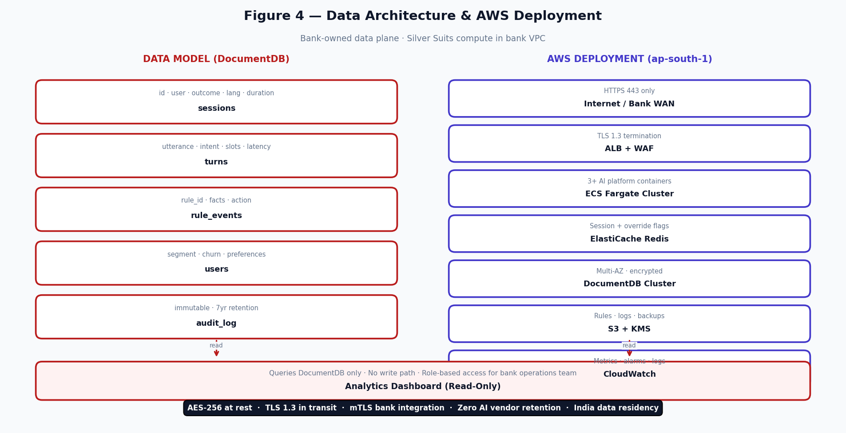
Figure 4 — DocumentDB data model and AWS deployment topology

5.1 Data Collections
Collection | Key fields | Written by | Read by
sessions | session_id, user_id, outcome, manifest, lang, turn_count, timestamps | Logger | Dashboard, replay (V2)
turns | utterance, intent, slots, bot_reply, tool_calls, latency_ms{stt,llm,tts} | Logger | Dashboard, analysis (V3)
rule_events | rule_id, fact_snapshot, action, action_config, timestamp | Rule engine | Dashboard, audit
users | segment, lang_pref, churn_score, consent_ts, session_count | Platform | Rule enricher (V2)
audit_log | actor, action, entity, hash — append-only | All services | Compliance, regulators

5.2 Analytics Dashboard Views
View | Metrics | Release
Operations overview | Session volume, success/fail/cancel rates, daily trend | V1
Conversation explorer | Per-user timeline, turn-by-turn detail | V1
Language & region | Distribution across en/hi/ta/te (+6 in V2) | V1
Journey funnel | Step dropout by manifest and segment | V2
Latency & reliability | p50/p95/p99 per service (STT, LLM, TTS) | V2
Rule performance | Fire rate, action conversion, A/B results | V2
Sentiment & churn | Post-call scores, cohort trends | V3

5.3 AWS Infrastructure
Service | Purpose | Configuration
ALB + WAF | HTTPS entry, DDoS protection | TLS 1.3, access logs → S3
ECS Fargate | AI platform containers | Min 3 tasks, CPU auto-scale, rolling deploy
ElastiCache Redis | Sessions, pub/sub, override flags | Multi-AZ, encryption in transit + at rest
DocumentDB | Persistent data | Multi-AZ, 35-day backup, TLS required
S3 + KMS | Rule configs, artifacts, optional audio | SSE-KMS, versioning, cross-region DR (V3)
CloudWatch | Monitoring | Dashboards: latency, error rate, rule eval count
PrivateLink (V2) | Private Azure OpenAI connectivity | No public internet for LLM traffic

5.4 Security & Compliance Controls
Control | Implementation | Regulation
Data residency | AWS ap-south-1 only; AI vendors India region | RBI IT Framework
Encryption at rest | AES-256, bank-managed KMS | DPDP 2023
Encryption in transit | TLS 1.3, mTLS for bank integration | DPDP 2023
Zero AI retention | Contractual + technical ephemeral context | RBI Digital Lending
Consent management | Logged before first AI session | DPDP Section 6
Audit trail | 7-year immutable append-only log | RBI audit requirements
Access control | RBAC on dashboard; JWT scoped API access | Internal security policy

6. Delivery Roadmap & Team

6.1 Release Phases
Phase | Timeline | Deliverables | Exit criteria
V1 — Production | Months 1–3 | VPC deploy, bank API integration, 4 languages, 5 voice flows, rule engine (popup + assign_rm), DocumentDB logging, basic dashboard, DPDP DPA | 500 concurrent sessions, p99 <2s voice turn, bank security sign-off
V2 — Scale | Months 4–6 | 10 languages, visual rule builder, emergency override UI, Exotel + push notif, advanced analytics, agent desktop, PrivateLink | Rule builder UAT, Exotel pilot, ISO 27001 gap report
V3 — Intelligence | Months 7–12 | Post-call LLM analysis, native mobile SDK, churn analytics, conversation replay, ISO 27001 cert, multi-region DR | Analysis accuracy >85%, ISO audit passed

6.2 Team Structure
Role | FTE | V1 responsibility
Full-Stack Engineer | 2 | API platform, bank adapter, rule engine, frontend productionization
DevOps / Cloud Engineer | 1 | VPC, ECS, DocumentDB, Redis, CI/CD, KMS, monitoring
AI / LLM Engineer | 1 | Azure OpenAI, prompts, multilingual STT/TTS tuning
QA Engineer | 1 | Integration tests, load test, security scan, UAT support
Solutions Architect | 0.5 | Bank API contracts, integration design, sprint governance
Compliance Consultant | 0.5 | DPDP, data flow, DPA, audit preparation

Silver Suits AI · prateek@silversuits.ai · +91 738 173 2333 · Mumbai | Bangalore
Document Version 3.0 · Confidential · May 2026

