SILVER SUITS AI
AI Voice RM Platform
System Architecture
Current Demo Codebase

Document | Value
Repository | Voice-to-Command (verified code audit)
Classification | Confidential — Internal / Partner Use
Version | 3.0
Date | May 2026
Deployment model | Local / demo — React + Express :3001
Scope note | Web in-app only — No Exotel · No phone calls · Mock backend

1. Executive Summary
This document describes the system architecture of the Voice-to-Command demo as implemented in source code. It is the reference for what exists today before productization (bank VPC, rule engine, DocumentDB, production APIs).
Verified finding: Architecture is web-based only. No Exotel, Pipecat, or telephony code exists in the repository. Two parallel capabilities: Voice/UPI dialogue engine and AG-UI screen agents.

Solution Overview
Capability | Implementation | Location in repo
In-app voice assistant | VoiceModal + server state machine | client/components · server/engine/
Frustration detection | useRageDetect → RMHelpPrompt | client/src/hooks/ · components/
5 voice banking flows | JSON manifests + saga runner | server/manifests/
5 screen AI agents | SSE + OpenAI function calling | server/agui/
Speech services | ElevenLabs STT, Cartesia TTS (proxied) | server/index.js
Language model | OpenAI GPT-4o-mini | server/engine/llm.js · server/agui/
Banking operations | Mock in-memory data | server/data/mock.js · backend.js
Languages supported | 4: English, Hindi, Tamil, Telugu | client/src/data/languages.js

Demo vs Production (Summary)
Area | Current demo | Production target (see Production Architecture doc)
Hosting | Local dev (Vite + Express) | Bank VPC · AWS Mumbai
Bank APIs | Mock backend.js | Real CBS / payment APIs
Data persistence | React state only — no DB | DocumentDB sessions + turns
Rule engine | Client rage detect only | Full trigger → evaluate → actuate
Telephony | Not implemented | Optional Exotel (V2)
Analytics | None | Bank dashboard
LLM | OpenAI GPT-4o-mini | Azure OpenAI GPT-4o (India)

2. System Architecture
Figure 1 shows five architectural layers. The system splits into two runtime paths that share the same Express server and AI vendors but use different orchestration logic.
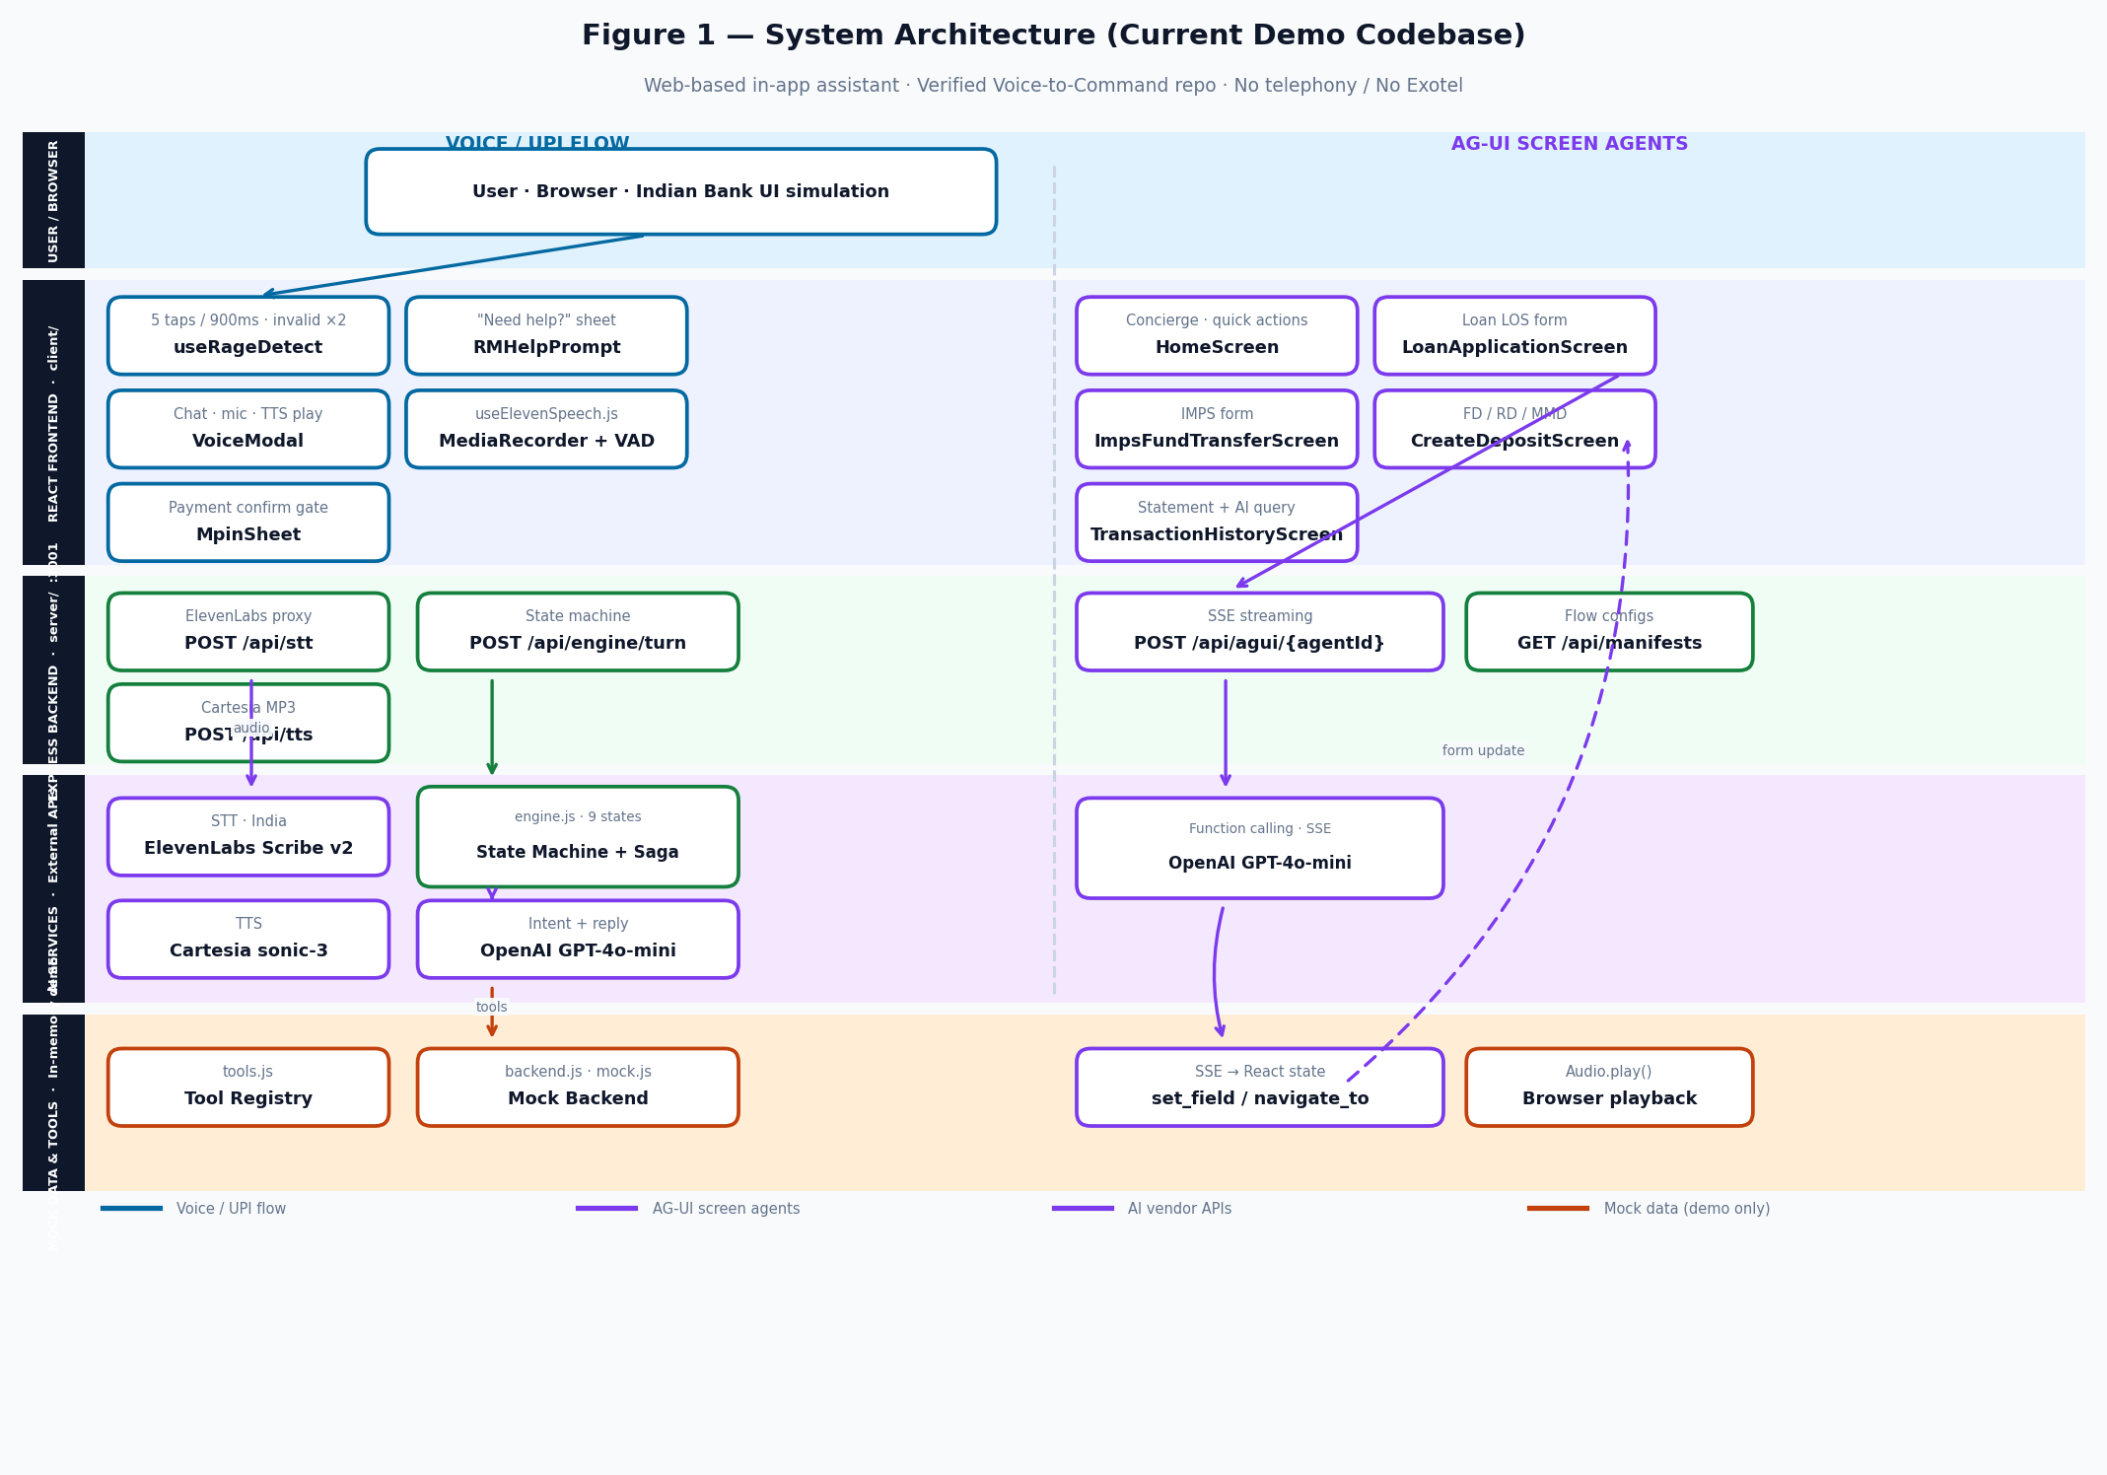
Figure 1 — Layered architecture: Voice/UPI flow (left) and AG-UI agents (right)

2.1 Layer Specification
Layer | Technology | Responsibility | Key artifacts
User / Browser | Chrome / mobile browser | Indian Bank UI simulation, mic, taps | App.jsx, index.html
React Frontend | React 18 · Vite · Tailwind | UI, rage detect, voice modal, banking screens | client/src/components/, hooks/
Express Backend | Node.js · Express :3001 | API proxies, state machine, AG-UI runners | server/index.js, engine/, agui/
AI Services | ElevenLabs · OpenAI · Cartesia | STT, intent, TTS — keys server-side only | Env vars · proxy routes
Mock & Tools | In-memory JS objects | Contacts, billers, payments — demo data | server/data/, engine/tools.js

2.2 Dual Runtime Paths
Path | Entry point | Orchestration | Output
Voice / UPI | VoiceModal mic or RMHelpPrompt | POST /api/engine/turn → engine.js → saga.js | Spoken reply + optional mock payment
AG-UI agents | Mic on banking screen | POST /api/agui/{id} → SSE stream | Live form fields + navigation + spoken reply

3. Voice / UPI Conversation Architecture
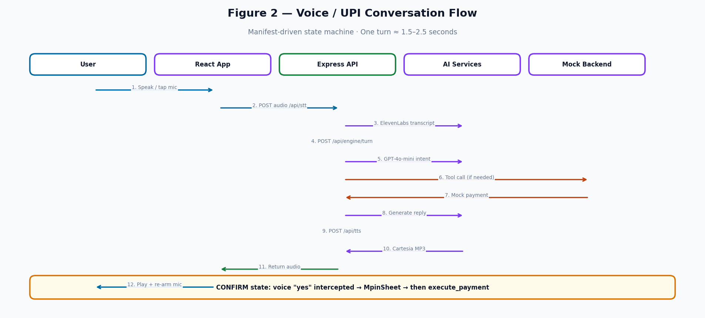
Figure 2 — Voice turn sequence across components

3.1 Turn Processing Pipeline
Step | Component | Action | Typical latency
1 | useRageDetect / VoiceModal | Capture intent to speak or open from help prompt | —
2 | useElevenSpeech (MediaRecorder + VAD) | Record audio; stop after 1.5s silence | —
3 | POST /api/stt | Proxy to ElevenLabs Scribe v2 | 300–500 ms
4 | POST /api/engine/turn | processInput(TRANSCRIPT) | < 20 ms
5 | llm.js extract() | GPT-4o-mini → action, slots, reply | 400–700 ms
6 | saga.js + tools.js | Run manifest steps; mock tool calls | 50–200 ms
7 | POST /api/tts | Proxy to Cartesia sonic-3 | 300–500 ms
8 | VoiceModal | Audio.play(); re-arm mic after idle | —

3.2 Frustration Detection → AI Entry
Signal | Threshold | Component | Result
Rage taps | 5 pointerdown events within 900 ms | useRageDetect.js | onFrustrated() → RMHelpPrompt
Invalid field | Same field fails validation 2× | useRageDetect.js | onFrustrated() → RMHelpPrompt
User accepts help | Tap "Yes, help me" | RMHelpPrompt.jsx | VoiceModal opens · INIT turn

3.3 Voice Flow Manifests
Manifest | Slots | Tools | Limits
send_money | recipient, amount, VPA | contacts.search → execute_upi_payment | UPI ≤ ₹1L
check_balance | account type | balance.check | savings / current / all
internal_transfer | amount, from, to | accounts.list → execute_transfer | No same-account transfer
pay_bill | biller, account, amount | billers.search → execute_bill_payment | Biller min amount
book_flight | route, date, passenger, flight | flights.search → execute_flight | Demo flow

3.4 State Machine (9 States)
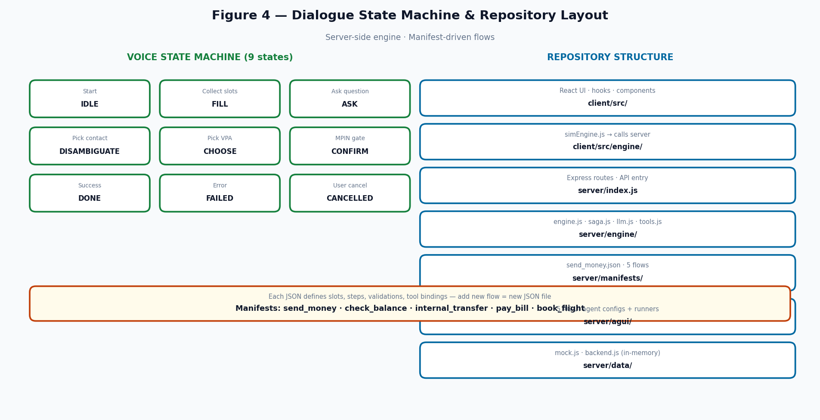
Figure 4 — State machine states and repository layout (excerpt)

State | Purpose | Key transitions
IDLE | Awaiting start | TRANSCRIPT → FILL (LLM picks action)
FILL / ASK | Collecting slots | Slot fill → next saga step
DISAMBIGUATE / CHOOSE | Multiple matches | User SELECTION
CONFIRM | Payment approval | MPIN gate · yes/no parser
DONE / FAILED / CANCELLED | Terminal | RESET or new START_ACTION

4. AG-UI Screen Agent Architecture
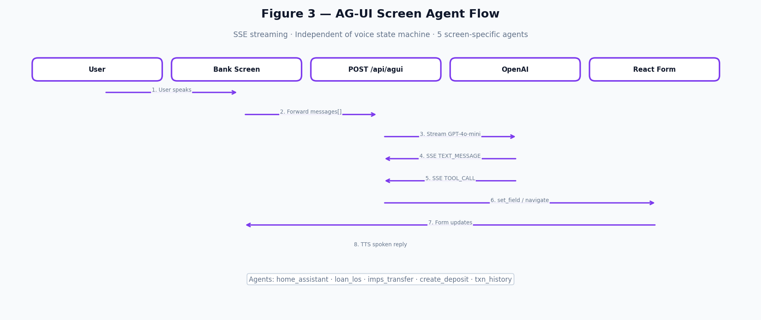
Figure 3 — AG-UI SSE streaming flow

AG-UI agents operate independently of the voice state machine. Each banking screen mounts its own agent ID and streams Server-Sent Events for text and tool calls.

4.1 Agent Catalog
Screen | Agent ID | Tools | Behaviour
Home | indian_bank_home_assistant | navigate_to | Route by amount: ≤₹1L UPI, >₹1L IMPS
Loan LOS | indian_bank_loan_los | set_field, validate_form | 10 loan fields · multi-slot inference
IMPS | indian_bank_imps_transfer | set_field | 9 fields · one question at a time
Deposit | indian_bank_create_deposit | set_field | FD / RD / MMD
Txn History | indian_bank_txn_history | set_field, navigate_to | Query txns · fraud navigation

4.2 SSE Event Protocol
Event | Purpose
TEXT_MESSAGE_START / CONTENT / END | Streaming chat bubble text
TOOL_CALL_START / ARGS / END | set_field or navigate_to execution
RUN_FINISHED / RUN_ERROR | Turn complete or failure

5. Component Reference

5.1 React Frontend Components
Component | File | Role
useRageDetect | hooks/useRageDetect.js | Frustration signals → onFrustrated callback
useElevenSpeech | hooks/useElevenSpeech.js | STT via MediaRecorder + /api/stt
VoiceModal | components/VoiceModal.jsx | Primary voice UI · chat · mic · TTS
RMHelpPrompt | components/RMHelpPrompt.jsx | Bottom-sheet help entry
MpinSheet | components/MpinSheet.jsx | Blocks voice confirm until MPIN OK
simEngine | engine/simEngine.js | Client wrapper — POST /api/engine/turn
HomeScreen + 4 screens | components/*Screen.jsx | Banking UI + AG-UI integration

5.2 Express API Surface
Route | Method | Purpose
/api/stt | POST | Audio → transcript (ElevenLabs proxy)
/api/tts | POST | Text → MP3 (Cartesia proxy)
/api/engine/turn | POST | Dialogue state machine step
/api/engine/session/:id | GET | Session state retrieval
/api/agui/:agentId | POST | AG-UI SSE agent stream
/api/manifests | GET | List voice flow manifests
/api/account-statement | GET | Mock balance + transactions
/api/health | GET | Service health + key status
/api/mock/* | GET/POST | Direct mock banking REST

5.3 AI Services & Mock Tools
Service / Tool | Provider / File | Function
STT | ElevenLabs Scribe v2 | Speech → text + language code
LLM (voice) | OpenAI GPT-4o-mini | extract() per turn
LLM (AG-UI) | OpenAI GPT-4o-mini | Function calling + SSE
TTS | Cartesia sonic-3 | Text → MP3
contacts.search | tools.js → backend.js | Fuzzy contact lookup
execute_upi_payment | backend.js | Simulated UPI with random failure
Mock data store | mock.js | 15 contacts · 20 billers · 2 accounts

5.4 Technology Stack
Tier | Stack
Frontend | React 18 · Vite · Tailwind CSS · TypeScript-ready JSX
Backend | Node.js · Express · ES modules
AI | ElevenLabs (STT) · OpenAI (LLM) · Cartesia (TTS)
Dev | concurrently — client :5173 + server :3001

6. Path to Production
The following are not in the demo codebase but are specified in the Production Architecture document (AI_Voice_RM_Production_Architecture.docx).
Capability | Target version | Description
Bank VPC deployment | V1 | ECS · ALB · Redis · DocumentDB in ap-south-1
Real bank APIs | V1 | Replace mock backend with Bank API Adapter
Rule engine | V1 | POST /api/trigger · JSON rules · actuation
Session persistence | V1 | All turns logged to bank DocumentDB
Analytics dashboard | V1–V2 | Volume · outcomes · timelines
10 languages | V2 | Extend beyond en/hi/ta/te
Exotel outbound | V2 | Optional phone channel
Post-call analysis | V3 | Sentiment · churn · QA scoring

Silver Suits AI · prateek@silversuits.ai · +91 738 173 2333
Document Version 3.0 · Code-verified · Confidential · May 2026

