**SYNOPSIS**

**Report on**

**SAATHI**

**by**

Jatin Gupta (2300290140080)

Ayushi Verma (2300290140047)

Lalit Sharma (2300290140096)

**Session:2024-2025 (III Semester)**

Under the supervision of

**Prof. Mr. Prashant Agrawal**

### KIET Group of Institutions, Delhi-NCR, Ghaziabad



### Department Of Computer Applications

**KIET GROUP OF INSTITUTIONS, DELHI-NCR, GHAZIABAD-201206**

(2024 - 2025)

**ABSTRACT**

Saathi is a student-focused rental platform built using Java Servelet, designed to help students save money and earn while studying. The animation starts with a vibrant college campus, highlighting the common issue of high student expenses. Saathi offers an innovative solution by enabling students to rent items instead of buying them, making it an affordable and convenient option.

The platform features a user-friendly landing page with seamless social login options through Google, Twitter, and Facebook, allowing for quick and easy access. Once logged in, users are greeted with a personalized dashboard where they can manage both their rentals and earnings. The core functionalities of Saathi include comprehensive item listings, an interactive map to find nearby rentals, and secure payment options for hassle-free transactions.

Additionally, the platform supports notifications, keeping users updated on rental activity, and a review system to foster trust among the community. For platform management, there is an admin panel for efficient oversight. With a supportive community, Saathi provides a compelling call to action for students, inviting them to join and take advantage of this cost-effective and student-centric solution.

**TABLE OF CONTENTS**

Page Number

1. Introduction 4
2. Literature Review 5
3. Project / Research Objective 6
4. Hardware and Software Requirements 7
5. Project Flow/ Research Methodology 8
6. Project / Research Outcome 10
7. Proposed Time Duration 11

References/ Bibliography 12

**Introduction**

Saathi is a student-centric rental platform developed with Java Servelet, designed to help students save money and earn by renting out items they no longer need. The platform caters specifically to the unique financial needs of students by offering a cost-effective solution, providing access to a wide range of rentable goods, including textbooks, electronics, furniture, and more, making essential items both affordable and accessible.

With a user-friendly interface, Saathi offers convenient social login options (Google, Twitter, Facebook) and a personalized dashboard for managing rentals, including listing items, tracking rental history, and handling payments. The platform also features an interactive map, allowing users to easily find and rent items from nearby locations, adding convenience and speed to the process.

Security and trust are at the forefront of Saathi's design, with secure payment gateways ensuring safe transactions and a robust review system helping users evaluate renters and lenders, building a trusted community. The platform includes a powerful admin panel for efficient management of listings, users, and transactions, ensuring that both users and administrators have a smooth, seamless experience.

More than just a rental service, Saathi fosters resource-sharing and community-building among students, encouraging a sustainable approach to managing personal items. By promoting peer-to-peer rentals, Saathi empowers students to tackle financial challenges, reduce waste, and focus on their studies while contributing to an eco-friendly, collaborative economy.

**Literature Review**

The rise of the sharing economy has reshaped the way individuals access goods and services, particularly among students facing financial constraints. Botsman and Rogers (2010) introduced the concept of collaborative consumption, which allows people to rent or share items rather than purchase them. This model has proven especially useful for students, providing cost-effective solutions for accessing essential items.

Studies by Hamari et al. (2016) show that students are highly motivated to participate in the sharing economy due to the potential for cost savings and the opportunity to earn money by renting out unused items. Moreover, platforms like Unirent and RentHoop already serve the student rental market, but they lack some key features that Saathi aims to improve upon, such as secure payments, interactive maps, and real-time notifications.

Trust within peer-to-peer platforms is crucial, and Saathi builds on existing research, such as Teubner & Flath (2015), which emphasizes the importance of review systems in fostering community trust. Saathi, with its enhanced features and student-centric approach, addresses the financial challenges of students while promoting a sustainable and resource-sharing culture.

**Project Objective**

The objective of the Saathi project is to create a comprehensive student-centric rental platform. The platform’s key objective are:

1. **Enhancing Affordability and Accessibility:**

Saathi aims to provide students with an affordable alternative to purchasing essential goods by offering a wide range of rentable items, from textbooks to electronics, furniture, and more. By making expensive or rarely used items accessible on a rental basis, Saathi helps students manage their financial resources more effectively.

1. **Creating a Seamless and Intuitive User Experience:**

The platform is designed with ease of use in mind, offering social login options (Google, Twitter, Facebook) for quick account creation, a personalized dashboard to manage rental listings, and an interactive map that allows students to easily locate items available for rent in their vicinity. Saathi ensures that the entire rental process is as smooth as possible, from searching for items to making secure payments.

1. **Ensuring Security and Trust:**

One of the primary objectives of Saathi is to create a secure and trustworthy environment for both renters and lenders. With secure payment gateways integrated into the platform, students can safely conduct financial transactions. Additionally, the review and rating system allows users to evaluate the trustworthiness and reliability of others in the community, promoting transparency and building long-term trust.

1. **Empowering Students Financially:**

By allowing students to rent out their underutilized items, Saathi provides an opportunity to generate additional income. This helps students cover their living expenses or other academic costs, while also providing access to items they may need without the financial burden of purchasing them outright.

1. **Sustainability and Eco-Friendliness:**

Saathi promotes sustainable consumption by extending the lifecycle of items. Rather than purchasing new products that may be used only for a short time, students can rent from their peers, thereby reducing waste and encouraging responsible resource utilization.

**Hardware and Software Requirements**

Hardware specification:

* **PROCESSOR:** INTEL CORE i3
* **RAM:** 4 GB
* **HDD:** 1TB

Software specification:

* **Frontend :** HTML , CSS. , BOOTSTRAP , Javascript
* **Backend :** Jdbc. , JSP , Java
* **Database :** Mysql

**Project Flow/ Research Methodology**

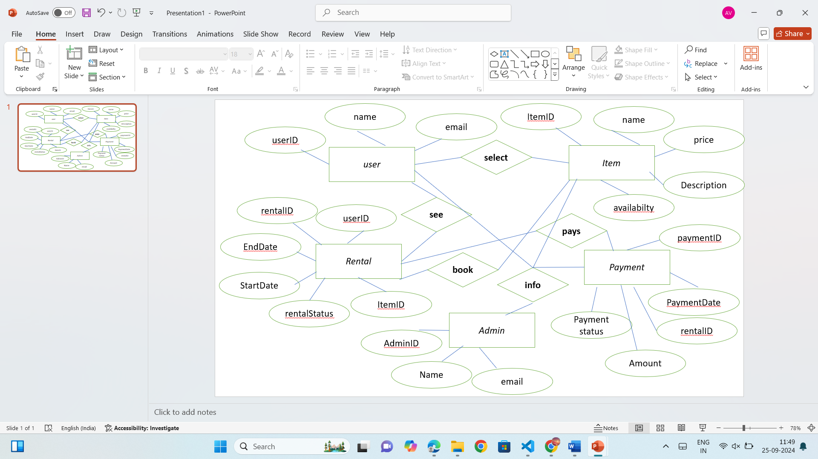

The flow of the Saathi platform ensures that students can easily navigate through the various features and functionalities offered. Below is a detailed theoretical explanation of the platform's project flow, guiding users from the initial access to the completion of transactions, community building, and administrative management.

• **User Registration/Login**: Students can sign up using social login options (Google, Twitter, Facebook).

• **User Dashboard**: After logging in, users manage rentals, item listings, rental history, and payments from a personalized dashboard.

• **Item Listing**: Users list items (textbooks, electronics, furniture, etc.) with descriptions, prices, and availability.

• **Search and Interactive Map**: Users search for items using filters or view items on an interactive map to find nearby rentals.

• **Rental Request and Approval**: Renters request items for a specific period, and lenders approve or reject the requests.

• **Secure Payment Gateway**: Payments are processed securely, and deposits are held until the item is returned in good condition.

• **Item Pick-Up/Delivery**: Renters and lenders arrange item pick-up or delivery based on mutual convenience.

• **Return of the Item**: Once the rental period ends, the item is returned, and deposits (if applicable) are refunded.

• **Admin Panel**: Admins manage users, items, transactions, and resolve disputes.

• **Notifications**: Users receive real-time alerts for rental approvals, payments, and return reminders.

• **Community Engagement**: Saathi fosters resource sharing and sustainability, promoting eco-friendly practices and collaboration among students.

**Project / Research Outcome**

The outcome of the **Saathi** platform is a fully functional **student-centric rental marketplace** that enables students to:

1. **Save and Earn**: Students can save money by renting essential items like textbooks, electronics, and furniture, while others earn income by renting out their unused items.
2. **Resource Sharing**: The platform promotes **peer-to-peer resource sharing**, allowing students to access a wide variety of items affordably without needing to purchase them.
3. **Enhanced Convenience**: The platform offers features like a **personalized dashboard**, **interactive map**, and **social login options**, making it easy for users to manage rentals, payments, and item searches.
4. **Secure Transactions**: With a **secure payment gateway** and a **robust review system**, Saathi ensures **safe and reliable** transactions, fostering trust within the community.
5. **Community Building**: Saathi builds a **trusted student community** through feedback and reputation systems, encouraging collaboration and helping students meet their financial needs while supporting each other.
6. **Sustainability**: By encouraging the reuse of items, Saathi contributes to **sustainable consumption**, reducing waste and promoting eco-friendly practices in student communities.
7. **Efficient Management**: The admin panel ensures smooth operations, allowing for effective management of users, listings, and transactions, leading to a **seamless user experience** for both students and administrators.

In essence, Saathi successfully achieves its goal of providing a **cost-effective**, **sustainable**, and **student-friendly** rental solution.

**Proposed Time Duration**

The development of the Saathi platform can be divided into several phases. Here's a breakdown of the proposed timeline:

1. Planning and Requirement Gathering (1 weeks)
   * Define the platform’s features, user roles, and requirements.
   * Design initial wireframes and workflows.
2. Design and Prototyping (1 weeks)
   * Create design, focusing on user dashboard, item listings, and interactive map.
   * Develop wireframes and clickable prototypes for user feedback.
3. Backend Development (2 weeks)
   * Set up the Java Servelet backend, database architecture, and API integration.
   * Implement user authentication (social login), item listings, and rental management.
   * Develop the payment gateway integration and security measures.
4. Frontend Development (2 weeks)
   * Build the user interface with Bootstrap/React.
   * Implement responsive design, interactive maps, and search filters.
   * Develop the personalized dashboard for managing rentals.
5. Testing and Quality Assurance (2 weeks)
   * Conduct unit testing, integration testing, and user acceptance testing.
   * Identify and fix bugs, optimize performance, and ensure security.
6. Deployment and Launch (2 weeks)
   * Deploy the platform to a cloud service (AWS, Azure, etc.).
   * Finalize documentation, and provide user onboarding materials.

**REFERENCES/ Bibliography**

**Web Resources**

* Bootstrap. (n.d.). *Bootstrap Documentation*. Retrieved from https://getbootstrap.com/docs/5.3/getting-started/introduction/
* [www.javatpoint.com](http://www.javatpoint.com/)
* [www.tutorialspoint.com](http://www.tutorialspoint.com/)
* Wikipedia
* <http://www.cssbuilder.com/>
* <http://www.w3schools.comphp/default.as>