**//Make a simple game with random module**

import random

maxn=10

n=random.randint(1,maxn)

print("Welcome to guess the number game!")

print("Guess the number form 1 to %d"%maxn)

guess=None

while guess!=n:

guess=int(input("your try:"))

if guess>n:

print("too high")

if guess<n:

print("too low")

print("congratulation you won")

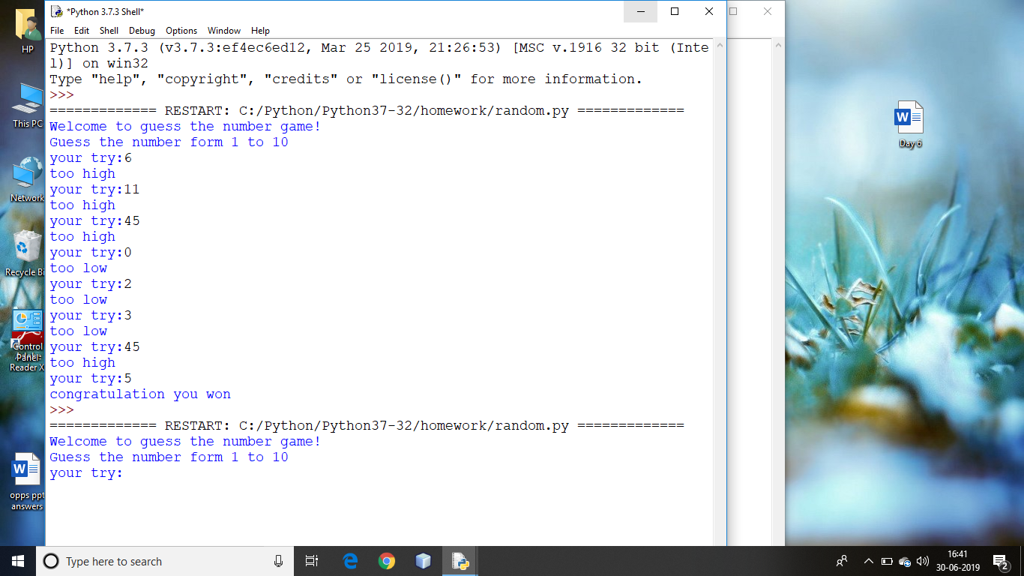

**//Python program to solve a quadratic equation**

import cmath

def solvequadeq(a,b,c):

D=b**2-4*a*c

x1=(-b-cmath.sqrt(D))/(2*a)

x2=(-b-cmath.sqrt(D))/(2*a)

return x1,x2

a=1

b=-4

c=3

print('Equation:%d*x**2+%d*x+%d=0'%(a,b,c))

solutions=solvequadeq(a,b,c)

print('roots')

print('x1=%s'%solutions[0])

print('x2=%s'%solutions[1])

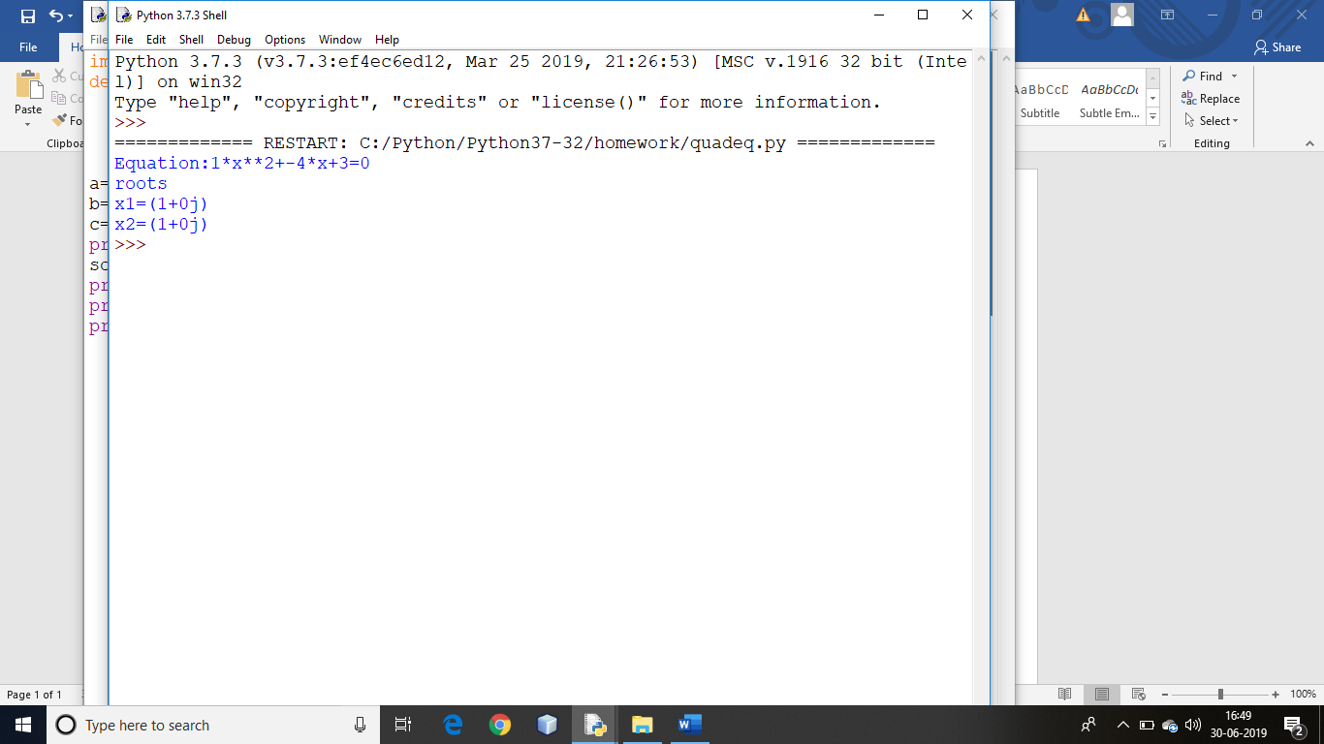

**//Find difference between two lists**

list1=[10,15,20,25,30,35,40]

list2=[25,40,35]

l3=list(set(list1)-set(list2))

print(l3)

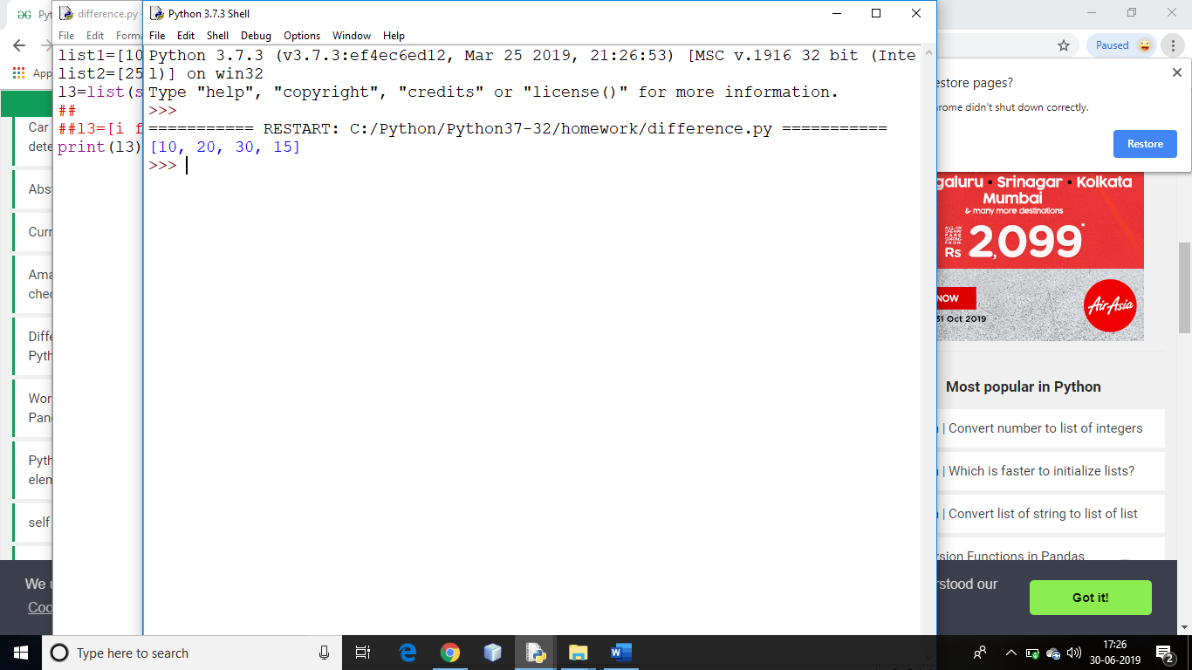

list1=[10,15,20,25,30,35,40]

list2=[25,40,35]

l3=[i for i in list1 + list2 if i not in list1 or i not in list2]

print(l3)



from collections import Counter

x={'b':10,'a':5,'c':90}

y={'b':78,'a':45}

z={'a':90,'c':10}

a=dict(Counter(x)+Counter(y)+Counter(z))

print(a)

