



PROJECT REPORT ON :
Housing Price Analysis System

SUBMITTED BY: GUIDED BY :
313 : Jeenal N. Tank Dr. Priti Tailor
350 : Parthavi S. Ramani

DECLARATION
I hereby declare that the project report entitled “HOUSING PRICE ANALYSIS SYSTEM”, submitted by me to Prof. V. B. Shah Institute of Management, R. V. Patel College of Commerce (English Medium), V. L. Shah College of Commerce (Gujarati Medium), Sutex Bank College of Computer Application & Science, is a record of my original work.
This project has been completed under the valuable guidance of Dr. Priti Tailor.
I further declare that this work has not been submitted to any other institution or university for any purpose.

ACKNOWLEDGEMENT
It gives me immense pleasure to express my sincere gratitude to all those who have contributed directly or indirectly to the successful completion of this project report.
I am highly indebted to my guide, Dr. Priti Tailor, for her valuable guidance, continuous encouragement, and constructive suggestions throughout the development of this project.
I am also thankful to all the faculty members of Sutex Bank College of Computer Applications & Science, Amroli, for providing the necessary facilities and support.
Finally, I would like to express my heartfelt thanks to everyone who helped me during this project.

INDEX

NO. | CONTENT | PAGENO.
1. | Introduction  1.1 Project Profile  1.2 Overview of the Project  1.3 Objectives of the System  1.4 Problem Statement  1.5 Features of the Proposed System
2. | Hardware & Software Specifications
3. | Dataset Description  3.1. Dataset Overview  3.2. Characteristics of the Dataset  3.3. Purpose of the Dataset  3.4. Significance  3.5. Dataset Understanding  Load the dataset using Pandas  Display: First 5 rows, Last 5 rows  Use Pandas and NumPy functions describe(), info(), isnull()
4. | Exploratory Data Analysis (EDA)  4.1 Univariate analysis  4.2 Bivariate analysis  4.3 Multivariate analysis  4.4 Skewness and Kurtosis
5. | Data Cleaning  5.1 Identification of missing values  5.2 Handle missing values  5.3 Detecting outliers  5.4 Impact of outliers
6. | Spread of Data  6.1 Data distribution check  6.2 Calculation of Parameters (Mean, Median, Standard deviation, Skewness, Kurtosis)  6.3 Interpret results
7. | Regression Analysis  Identification of Dependent variable  Identification of Independent variables  Simple Linear Regression  Analyze Covariance, Correlation
8. | Visualization and Interpretation
9. | Summery
10. | Conclusion  10.1 Limitation  10.2 Future Enhancements
11. | References

- Introduction
1.1 Project Profile
Category | Details
Project Title | Housing Price Analysis System
Domain / Area | Data Analytics, Exploratory Data Analysis (EDA), Regression, Supervised Learning
Programming Language | Python
Frontend (Visualization) | Matplotlib, Pandas Plotting
Backend (Processing Engine) | Python (NumPy, Pandas, SciPy)
Tools / IDE Used | IDLE
Database / Storage | In-Memory Pandas DataFrame
Libraries Used | Pandas, NumPy, Matplotlib, SciPy
Documentation Tool | MS Word / PDF
Platform | Windows
Internal Guide | Dr. Priti Tailor
Submitted To | Prof. V. B. Shah Institute of Management & R. V. Patel College of Commerce (Guj. Med.) & V. L. Shah College of Computer Applications & Amroli
Academic Year | 2025-26

1.2 Overview of the Project
Modern housing prices are influenced by many factors such as location, property features, and amenities. This project focuses on understanding:
- How house features like area, number of bedrooms, balcony, and house type affect prices
- Location-based price patterns, including differences across neighborhoods
- The impact of amenities such as parking, floors, and furnishing on housing value
- Key price-determining factors like house size and available facilities
- Challenges in price prediction, including market fluctuations and changing demand
The dataset includes multiple housing attributes, making it suitable for Exploratory Data Analysis (EDA), trend analysis, and price prediction models.

1.3 Objective of the project
The main objective of this project is to analyze housing price data and understand how different factors affect house prices. This project aims to:
- Find price patterns based on location, house size, and type.
- Study demand and affordability trends in different areas.
- Understand how area, bedrooms, bathrooms, and amenities affect prices.
- Identify which house features most influence market value.
- Analyze how location and nearby facilities impact housing prices.
- Support data-driven decisions in real estate investment and planning.

1.4 Problem Statement
As cities continue to grow, finding a house at the right price has become challenging. Housing prices depend on many factors such as location, house area, number of bedrooms and balcony, and available amenities.
Currently, it is difficult to clearly understand how all these factors together affect housing prices. Without proper analysis, buyers, sellers, and real estate planners may make decisions based on guesswork rather than data.
The Housing Price Analysis System uses a structured housing dataset to analyze property features and their prices. The system helps identify price patterns, determine the most influential factors, and provide useful insights to support better and smarter housing-related decisions.

1.5 Features of the Proposed System
The proposed Housing Price Analyzer system includes the following features:
- Data Collection Module: Uses a simulated housing dataset capturing key attributes such as area, number of bedrooms, bathrooms, floors, parking availability, furnishing status, and house price.
- Exploratory Data Analysis (EDA): Performs basic statistical analysis, distribution checks, and pattern identification to understand housing features and price behavior.
- Correlation Analysis: Identifies relationships between important variables such as area vs. price, bedrooms vs. price.
- Visualization Dashboard: Displays insights using visual tools like bar charts, scatter plots, boxplots, and heatmaps for easy and intuitive understanding.
- Predictive Insight Support: Helps derive preliminary insights for price prediction by observing price trends based on house features and amenities.
- User-Friendly Interpretation: Presents results through clear charts, tables, and summaries, making the system suitable for demo and academic use.
- Decision Support: Supports buyers, sellers, and real estate stakeholders by highlighting the most influential factors affecting housing prices.

2. Hardware & Software Specifications
2.1 Hardware Requirements
Component | Description
Processor | Intel Core i3/i5/i7 or AMD equivalent (Minimum 2.0 GHz)
RAM | Minimum 4 GB (8 GB recommended for faster data processing)
Storage | At least 500 MB free space for datasets, Python installation, libraries, and project files
Graphics | Basic graphics support (Matplotlib visualization compatible)
Input Devices | Keyboard, Mouse
Output Devices | Monitor with minimum 720p resolution
2.2 Software Requirements
Software | Description / Version
Operating System | Windows 10/11, Linux (Ubuntu), or macOS
Programming Language | Python
IDE / Text Editor | IDLE
Python Libraries | Pandas, NumPy, Matplotlib, SciPy
Data Visualization Tools | Matplotlib

3. Dataset Description
Dataset Name: Housing Price Analysis System
Source: Kaggle
Dataset Link: https://www.kaggle.com/datasets/juhibhojani/house-price
Data Type: Structured CSV dataset
Domain: Real Estate/ Business Analytics / Machine Learning
The dataset used in this project contains housing price records of 501 properties, capturing key attributes that describe the property, its amenities, and price. For demonstration purposes, we have selected 12 important features that allow us to analyze trends and patterns in housing prices.
The dataset includes various real-world data characteristics, such as missing values in several columns and potential outliers in dimensions like parking and floor levels, to demonstrate data preprocessing and cleaning techniques.

3.1 Dataset Overview
Attribute | Description | Type
Index | Unique identifier assigned to each house | Quantitative
location | Name of the city or area | Qualitative
Price | Selling price or rent of the house | Quantitative
Carpet Area | Built-up area in square feet | Quantitative
Floor | Floor number of the property | Quantitative
Furnishing | Furnishing status (Unfurnished, Semi-Furnished, Furnished) | Qualitative
Bathroom | Number of bathrooms available | Quantitative
Balcony | Number of balconies attached to the house | Quantitative
Car Parking | Number of parking spots | Quantitative
Society | Name of the residential complex/society | Qualitative
Ownership | Type of property ownership (e.g., Freehold) | Qualitative
overlooking | Primary view from the property windows/balcony | Qualitative

3.2 Characteristics of the Dataset
- Number of Records: 501
- Total no of features : 12
- Data Types :
- Qualitative Data : 5 columns
- Quantitative Data : 7 columns
- Quality issues Present
- Missing Values in multiple columns.
- Duplicate Records.
- Outlier in Balcony, Carpet Area.

3.3 Purpose of the Dataset
- The dataset is specifically designed to support:

- Data Cleaning: Handling missing values (especially in society and parking) and outlier removal.

- Exploratory Data Analysis (EDA): Analyzing price trends across different locations and society types.

- Correlation Analysis: Understanding how Carpet Area and Floor level influence the Price.

- Visualization Techniques: Creating histograms for price distribution and scatter plots for area-price relationships.

3.4 Significance
- This dataset allows practical application of concepts from:
- Data Analytics / Machine Learning
- Statistical summary and distribution analysis
- Regression modeling using Numpy
- Data visualization using Matplotlib
- Real-world data preprocessing workflow

3.5 Dataset Understanding
The house price dataset needs to be imported into Python for analysis. Before performing any preprocessing or modeling, it is essential to verify whether the dataset is correctly loaded and structured. Therefore, the objective is to load the dataset using Pandas and display the first and last few records.

Solution :
#data Understanding
import pandas as pd

# Load the dataset
df = pd.read_csv("house.csv")

# Display first 5 rows
print("First 5 rows of the dataset:")
print(df.head())

# Display last 5 rows
print("\nLast 5 rows of the dataset:")
print(df.tail())

Output:
First 5 rows of the dataset:
Index | Location | Price | Carpet Area | Floor | Furnishing | Bath  room | Balcony | Car Parking | Society | Owner-ship | Overlooking
0 | Navsari | 60000 | 500 | 10 | Unfurnished | 1 | 1 | 2 | Ashar bridge | Co-operative Society | Swimming pool
1 | Surat | 55000 | 400 | 3 | Semi-  Furnished | 2 | 1 | 1 | Dosti Vihar | Freehold | Garden/Park
2 | Mumbai | 70000 | 750 | 10 | Unfurnished | 2 | 1 | 1 | Sunrise village | Freehold | Garden/Park
3 | Panjab | 55000 | 550 | 1 | Unfurnished | 1 | 1 | 2 | Tulsi Arcade | Freehold | Swimming pool, Garden
4 | Pune | 73000 | 630 | 20 | Unfurnished | 2 | 3 | 1 | Height town | Co-operative Society | Garden/Park, Main Road

Last 5 rows of the dataset:
Index | Location | Price | Carpet Area | Floor | Furnishing | Bathroom | Balcony | Car Parking | Society | Ownership | Overlooking
496 | Surat | 70000 | 750 | 3 | Unfurnished | 2 | 2 | 1 | Culture arcade | Co-operative Society | Garden, security
497 | Mumbai | 55000 | 630 | 4 | Semi-Furnished | 2 | 1 | 2 | Green woods | Freehold | Pool, Main Road
498 | Panjab | 73000 | 850 | 18 | Semi-Furnished | 3 | 3 | 1 | Ashar bridge | Co-operative Society | Garden/Park
499 | Pune | 100000 | 1000 | 3 | Semi-Furnished | 1 | 1 | 2 | Dosti Vihar | Freehold | Main Road
500 | Surat | 65000 | 550 | 2 | Unfurnished | 2 | 2 | 2 | Sunrise village | Government | Swimming pool

Use Pandas and NumPy functions: describe(), info(), isnull()

Solution :
import pandas as pd
import numpy as np
# Load the dataset
df = pd.read_csv("house.csv")
# Display basic information about the dataset
print("Dataset Information:")
df.info()
print("\n")
# Display statistical summary of numerical columns
print("Statistical Summary (describe):")
print(df.describe())
print("\n")
# Check for missing values in each column
print("Missing Values in Each Column:")
print(df.isnull().sum())

4 Exploratory Data Analysis(EDA)
4.1 Univariate Analysis (Quantitative)
Perform univariate analysis on the Car Parking (quantitative) column of the housing dataset to understand its central tendency, spread, and overall distribution. This helps to understand how many car parking spaces most houses have and whether there is variation or outliers in parking availability.

Solution :
# Univariate Analysis for Quantitative data
import numpy as np
import pandas as pd
from scipy import stats
from scipy.stats import skew
import matplotlib.pyplot as plt

# Read dataset
df = pd.read_csv(r"house.csv")

# Select Bathrooms column & remove missing values
btr = df["Car Parking"].dropna().values
Parking_mean = np.mean(btr)
Parking_median = np.median(btr)
mode_result = stats.mode(btr, keepdims=True)
Parking_mode = mode_result.mode[0]

Parking_var = np.var(btr)
Parking_std_dev = np.std(btr)
print("Univariate Analysis (Quantitative Data) - Car Parking")
print("--------------------------------")
print("Mean:", Parking_mean)
print("Median:", Parking_mode)
print("Variance:", Parking_var)
print("Standard Deviation:", Parking_std_dev)

# ----------- Histogram -----------
plt.figure(figsize=(10, 5))
counts, bins, patches = plt.hist(btr, bins=10, edgecolor='black', density=True)

# Force X-axis to whole integers only
plt.xticks(np.arange(int(bins.min()), int(bins.max()) + 1, 1))
# Force Y-axis to whole integers only
plt.yticks(np.arange(0, counts.max() + 2, 1))
plt.title("Histogram of Car Parking")
plt.xlabel("Number of Car Parking")
plt.ylabel("Frequency")
plt.show()

Output:
Univariate Analysis (Quantitative Data) - Car Parking
-----------------------------------------------------------------------
Mean: 1.5349301397205588
Median: 1
Variance: 0.46035673164648744
Standard Deviation: 0.6784959334045322
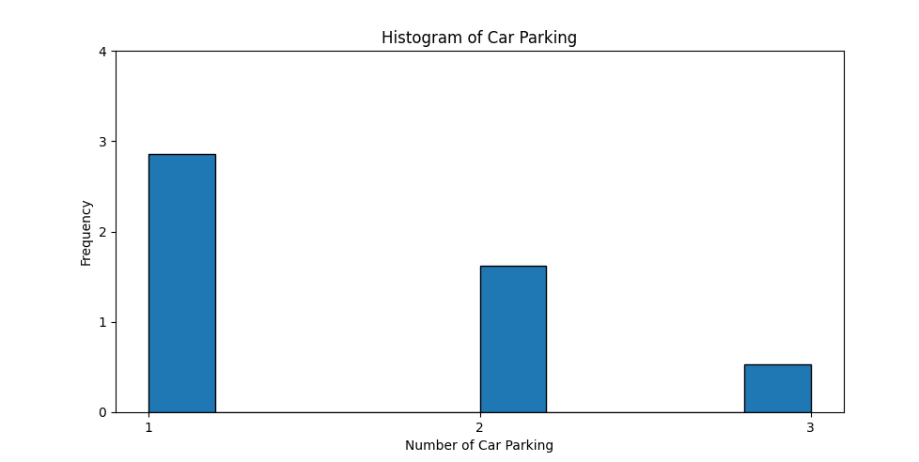
Result/Interpretation :
- Average car parking availability is around 1–2 spaces (Mean = 1.53).
- Most houses have only 1 parking space (Median = 1, Mode = 1).
- Variation is moderate (Variance = 0.46, Std Dev = 0.67), meaning some houses offer more parking.
- Distribution is slightly right-skewed, showing a few houses have higher parking (2–3 slots).
- Histogram confirms majority properties have 1 parking, fewer have 2, and very few have 3.

4.1 Univariate Analysis (Qualitative)

Perform univariate analysis on the Location (qualitative) column to understand how houses are distributed across different cities and identify which location has the highest and lowest number of properties.

Solution :
# Univariate Analysis for Qualitative data
import pandas as pd
import matplotlib.pyplot as plt

# Load dataset
df = pd.read_csv(r"house.csv")

# Select House_Type column
Location = df["location"].dropna()

# Count how many of each house type
Location_c = Location.value_counts()

# Print the counts in terminal
print("House Location Distribution:")
print(Location_c) # simple print

# Plot pie chart
plt.figure(figsize=(6,6))
plt.pie(Location_c, labels=Location_c.index, autopct='%1.1f%%')
plt.title("Distribution of House Location")
plt.show()

Output:
House Location Distribution:
location
Surat 106
Mumbai 102
Panjab 99
Navsari 98
Pune 96
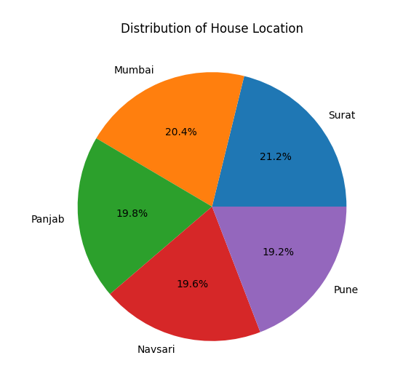

Result/Interpretation:
- Surat has the highest number of houses (106), making it the most represented location.
- Mumbai (102), Panjab (99), and Navsari (98) have almost similar share, showing balanced distribution.
- Pune has the lowest count (96), but still close to others, indicating no extreme imbalance.
- Overall distribution is fairly even across all locations with only slight variations.
- The pie chart visually confirms that no city dominates heavily, meaning data is well-distributed geographically.

4.2 Bivariate Analysis (Both Qualitative)
The bivariate analysis between Location and Furnishing Status shows how furnishing options differ across housing location. This analysis helps in understanding furnishing preferences associated with different cities.

Solution :
# Bivariate Analysis for Qualitative data
import pandas as pd
import matplotlib.pyplot as plt

df = pd.read_csv(r"house.csv")
# Select required categorical columns
house_Location = df["location"].dropna()
furnishing_status = df["Furnishing"].dropna()

# Create cross-tabulation
bivariate_data = pd.crosstab(house_Location, furnishing_status)
# Print data in terminal
print("House Location vs Furnishing Status Distribution:")
print(bivariate_data)

# Plot bar chart
bivariate_data.plot(kind='bar', figsize=(8,6))
plt.title("House Location vs Furnishing Status")
plt.xlabel("House Location")
plt.ylabel("Number of Houses")
plt.legend(title="Furnishing Status")
plt.show()

Output:
House Location vs Furnishing Status Distribution:
Furnishing Furnished Semi-Furnished Unfurnished
location
Mumbai 8 34 60
Navsari 7 42 49
Panjab 14 38 47
Pune 11 35 50
Surat 13 28 65 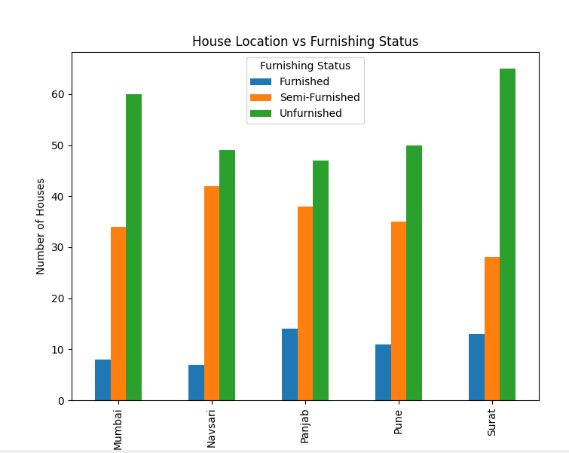

Result/Interpretation:
- Unfurnished houses are highest in all locations, showing most properties are sold/rented without furniture.
- Semi-Furnished houses are the second highest category across cities, indicating moderate furnishing preference.
- Furnished houses are the least available everywhere, meaning fully ready homes are rare, likely due to higher cost.
- Surat and Mumbai have the highest total number of properties, especially unfurnished homes.
- Panjab has the highest number of furnished houses compared to other cities.
- Overall, the market trend shows higher demand/availability for basic or semi-ready houses rather than fully furnished ones.

4.2 Bivariate Analysis (Both Quantitative)
The bivariate analysis between Carpet Area and House Price shows the relationship between house size and price. The scatter plot indicates that as the area of the house increases, the price also tends to increase. The objective of this analysis is to study the relationship between Carpet Area and Price using a scatter plot and correlation analysis, which helps in identifying trends and supports better pricing and investment decisions.

Solution :
# Bivariate correlation Analysis for Quantitative data
import pandas as pd
import matplotlib.pyplot as plt
from scipy import stats

df = pd.read_csv("house.csv")
df.columns = df.columns.str.strip()
df['Carpet Area'] = pd.to_numeric(df['Carpet Area'], errors='coerce')
df['Price '] = pd.to_numeric(df['Price'], errors='coerce')

data = df[['Carpet Area','Price ']].dropna()
print("Rows used:", len(data))

# ---- Correlation ----
pearson_corr = data['Carpet Area'].corr(data['Price '])
spearman_corr = data['Carpet Area'].corr(data['Price '], method='spearman')
print("\nPearson Correlation:", pearson_corr)
print("Spearman Correlation:", spearman_corr)

# ---- Regression ----
slope, intercept, r, p, se = stats.linregress(data['Carpet Area'], data['Price '])
print("\nSimple Linear Regression (Price = a*Area + b)")
print("Slope (a):", slope)
print("Intercept (b):", intercept)
print("R-squared:", r**2)
plt.figure(figsize=(8,5)) #Scatter plot
plt.scatter(data['Carpet Area'], data['Price '], edgecolors='black')
plt.title("Scatter Plot: Carpet Area vs Price")
plt.xlabel("Carpet Area (sq ft)")
plt.ylabel("Price")
plt.show()

Output:
Correlation Analysis:
Pearson Correlation: 0.19965642505357623
Spearman Correlation: 0.22017704543404137
Simple Linear Regression (Price = a*Area + b)
Slope (a): 26.634083489525903
Intercept (b): 59398.011067612795
R-squared: 0.039862688065174325
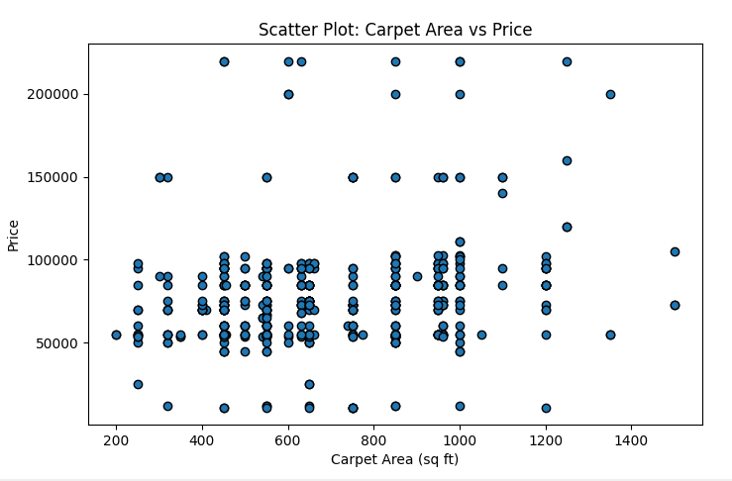
Result/Interpretation:
- The scatter plot shows a positive relationship between Carpet Area and Price.
- Houses with a larger area generally have higher prices.
- The calculated correlation value indicates a strong positive correlation between area and price.
- This analysis confirms that house size is an important factor influencing property prices.

4.2 Bivariate Analysis (Qualitative vs Quantitative)
The bivariate analysis between Location and Carpet Area examines how house Area vary across different types of houses. This analysis helps in understanding the impact of house type on Area

Solution :

# Bivariate Analysis for Quantitative and Qualitative data
import pandas as pd
import matplotlib.pyplot as plt
df = pd.read_csv(r"house.csv")
data = df[['location','Carpet Area']]
plt.figure(figsize=(10, 6))
df.boxplot(column='Carpet Area', by='location', patch_artist=True, grid=False)
plt.suptitle('') # Remove auto-generated title
plt.xlabel('location', fontsize=12)
plt.ylabel('Carpet Area', fontsize=12)
plt.tight_layout()
plt.show()

Output:
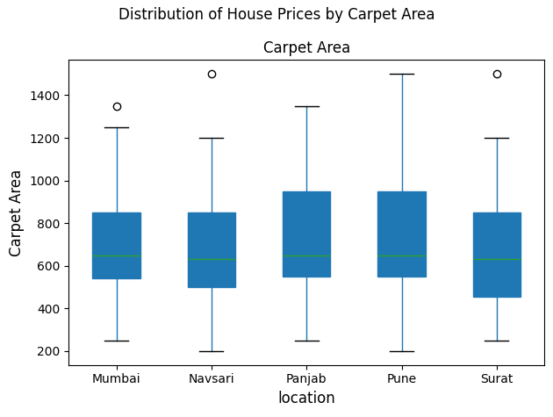
Result/Interpretation:
- Median carpet area is almost similar across all locations.
- Pune and Panjab have slightly larger carpet areas on average.
- Mumbai and Surat show comparatively smaller carpet areas.
- Pune and Panjab show higher variation in carpet sizes (wider box).
- Navsari and Surat have more consistent house sizes (less spread).
- Outliers in all cities indicate a few extremely large houses.

4.3 MultivariateAnalysis (Numeric + Numeric + Numeric)
The house dataset contains multiple numerical attributes such as Area, Price, and Bathrooms.Analyzing these variables together helps in understanding how house size and number of bathrooms jointly influence property prices.

Solution :
# Multivariate Analysis for Quantitative data
import pandas as pd
import seaborn as sns
import matplotlib.pyplot as plt

# 1. Load the house dataset
df = pd.read_csv(r"house.csv")

# 2. Select numerical attributes for multivariate analysis
num_cols = ['Carpet Area', 'Price ', 'Bathroom']
data = df[num_cols]

# 3. Statistical Summary Table (Descriptive Statistics)
print("\nFrequency / Statistical Summary Table:")
print(data.describe())

# 4. Pair Plot (Multivariate Visual Analysis)
sns.pairplot(data)

# Add a professional title
plt.suptitle(
"Multivariate Numerical Analysis: Carpet Area, Price & Bathrooms",
y=1.02,
fontsize=14)
plt.show()

Output:
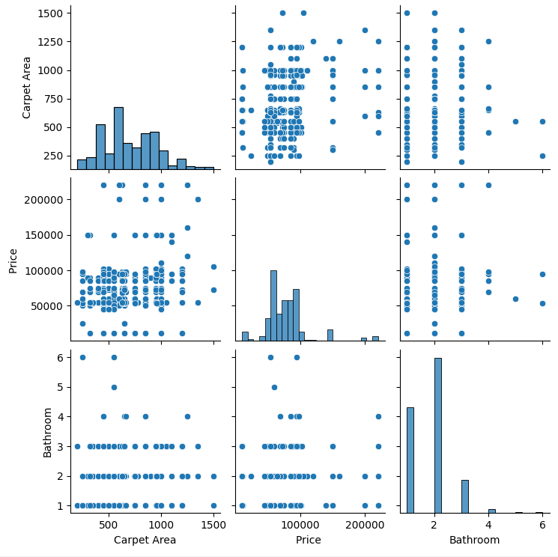

Result/Interpretation:
- The pair plot displays relationships among all numerical variables.
- Area and Price show a strong positive relationship, indicating that larger houses are more expensive.
- Bathrooms are positively associated with both Area and Price.
- Diagonal plots represent the distribution and spread of each variable.
4.3 MultivariateAnalysis (Categorical + Categorical + Categorical)

To analyze how Society, Location, and Furnishing Status are related, and to understand:
- Which societies have more houses in which locations
- How furnishing types vary across different locations and societies
- Overall distribution trend of furnished vs unfurnished houses

Solution :
# Multivariate Analysis for Qualitative data
import pandas as pd
import matplotlib.pyplot as plt

# Load dataset
df = pd.read_csv("house.csv")

# Create a multivariate frequency table
multi_cat = pd.crosstab(
df['Society'],
[df['location'], df['Furnishing']])

# Plot bar chart
multi_cat.plot(kind='bar', figsize=(14,6))

# Chart labels and title
plt.title("Multivariate Analysis of House_Society, Location, and Furnishing")
plt.xlabel("House Society")
plt.ylabel("Number of Houses")
plt.legend(title="Location & Furnishing", bbox_to_anchor=(1.05, 1))
plt.tight_layout()
plt.show()

Output:
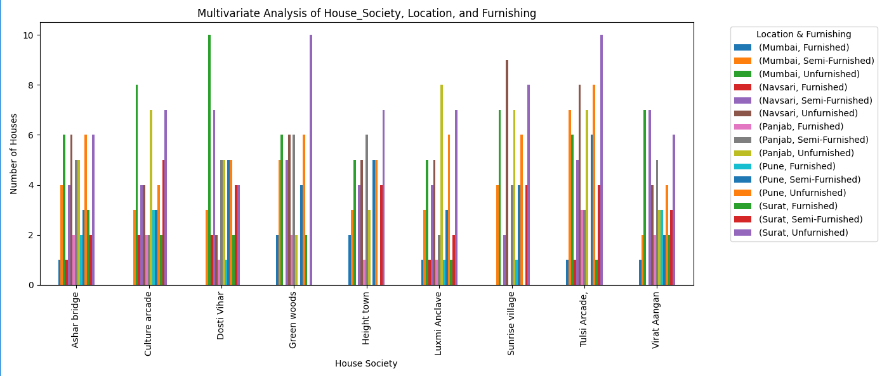
Result/Interpretation:
- Most houses across all societies are Unfurnished.
- Semi-Furnished houses are the second most common, especially in some major locations.
- Fully Furnished houses are very few compared to other categories.
- Some societies show a clear dominance of unfurnished properties.
- Overall, location and society both influence furnishing availability, but unfurnished houses are the most dominant.

4.3 MultivariateAnalysis (Numeric + Categorical + Numeric)

This analysis examines how house prices vary with area size for different house types.Here, House_Type is categorical, while Area and Price are numerical variables.A scatter plot is used to visualize their combined relationship.

Solution :
# Multivariate Analysis for Quantitative and Qualitative data
import pandas as pd
import seaborn as sns
import matplotlib.pyplot as plt
df = pd.read_csv("house.csv")

# 2. Select columns for (Numerical, Categorical, Numerical)
data = df[['Carpet Area', 'Price ', 'Ownership']]

# 3. Statistical Calculation (Mean and Std per House Type)
summary_stats = data.groupby('Ownership').agg(['mean', 'std'])
print("_______Statistical Summary per House Ownership_______ ")
print(summary_stats.round(2))

# 4. Generate Grouped Scatter Plot
plt.figure(figsize=(12, 7))
sns.scatterplot(
data=data,
x='Carpet Area',
y='Price ',
hue='Ownership',
style='Ownership',
s=100,
alpha=0.8)

plt.title("Multivariate Analysis: Area vs Price by House Type", fontsize=14)
plt.xlabel("Area (sq.ft)", fontsize=12)
plt.ylabel("Price", fontsize=12)
plt.legend(title='House Location', bbox_to_anchor=(1.05, 1), loc='upper left')
plt.grid(True, linestyle='--', alpha=0.6)
plt.tight_layout()
plt.show()

Output:
_______Statistical Summary per House Ownership_______
Carpet Area Price
mean std mean std
Ownership
Co-operative Society 713.01 256.49 77653.81 29458.27
Freehold 696.40 242.93 78837.83 37514.91
Government 674.64 265.22 77569.95 30547.64 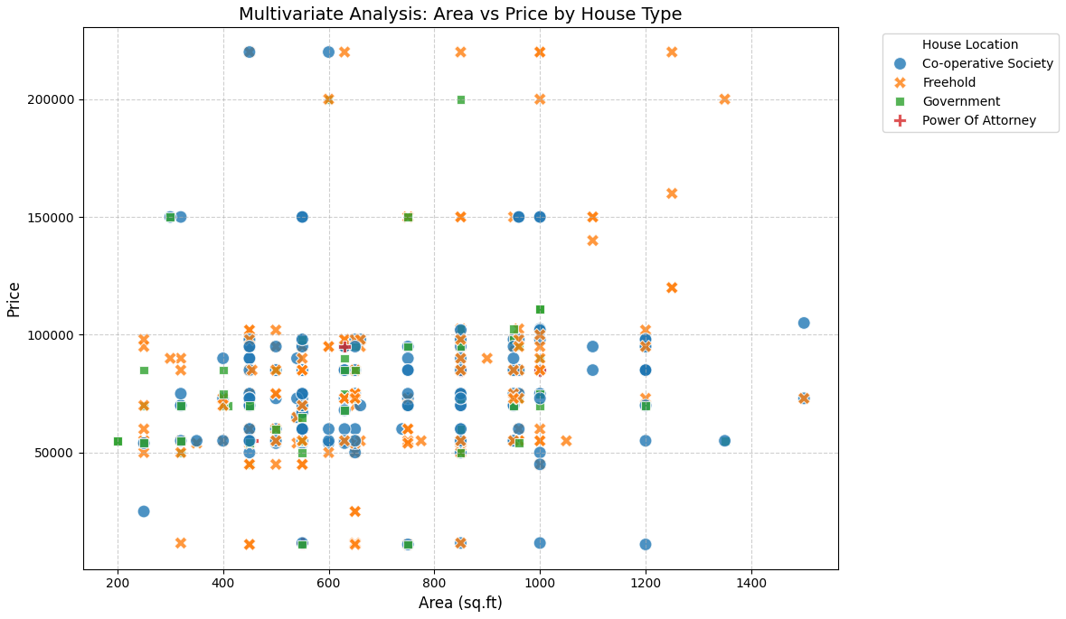
Result/Interpretation:
- The plot shows a positive relationship between Area and Price across all house types.
- Different marker shapes clearly distinguish each house type.
- Villas and bungalows appear in higher price ranges for similar areas.
- Apartments and townhouses show comparatively lower prices.

4.4 Skewness (Positive – Symmetric – Negative)
To measure and analyze the skewness of numerical variables Price, Carpet Area, and Bathrooms in the house dataset to identify whether the data is positively skewed, negatively skewed, or symmetric, and to visualize their distribution using histograms.

Solution :
# Skewness Report according Price , Area and Bathroom
import pandas as pd
import seaborn as sns
import matplotlib.pyplot as plt

# 1. Load dataset
df = pd.read_csv("house.csv") # use your file name

# 2. Select numerical columns
skew_columns = ['Price ', 'Carpet Area', 'Bathroom']
print("----- House Dataset Skewness Report -----\n")

# 3. Calculate Skewness
for col in skew_columns:
df[col] = pd.to_numeric(df[col], errors='coerce')
s_val = df[col].skew()

if s_val > 0.5:
category = "Positive Skew (Right-Tailed)"
elif s_val < -0.5:
category = "Negative Skew (Left-Tailed)"
else:
category = "Symmetric (Balanced)"
print(f"{col}: {s_val:.2f} | Result: {category}")

# 4. Plot Histograms
plt.figure(figsize=(15,5))
for i, col in enumerate(skew_columns, 1):
plt.subplot(1, 3, i)
sns.histplot(df[col].dropna(), kde=True, bins=15, color="skyblue")
plt.title(f"{col}\nSkewness = {df[col].skew():.2f}")
plt.xlabel(col)
plt.ylabel("Frequency")
plt.tight_layout()
plt.show()

Output:
----- House Dataset Skewness Report -----
Price : 1.77 | Result: Positive Skew (Right-Tailed)
Carpet Area: 0.44 | Result: Symmetric (Balanced)
Bathroom: 1.21 | Result: Positive Skew (Right-Tailed)
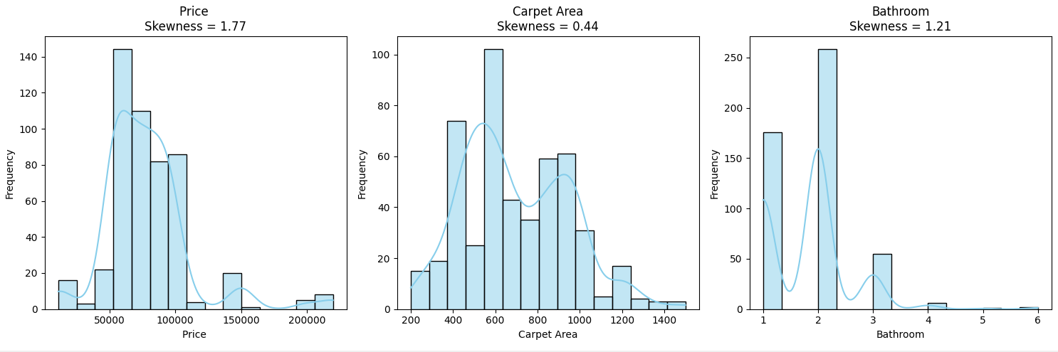
Result/Interpretation:
- Price is positively skewed, meaning most houses are moderately priced while few highly expensive houses create a long right tail.
- Carpet Area is almost symmetric / slightly right skewed, showing most houses have average-sized carpet area.
- Bathroom is positively skewed, meaning most houses have 1–2 bathrooms while very few have many bathrooms.

4.4 Kurtosis (Only leptokurtic – no Mesokurtic and Platykurtic because of dataset)
The purpose of this analysis is to measure the peakedness and tail heaviness of the distributions of Price, Carpet Area, and Bathrooms in the housing dataset. By calculating kurtosis, we aim to identify whether these attributes have extreme outliers, sharp peaks, or flat distributions compared to a normal distribution (kurtosis = 3).
Solution :
# kurtosis Analysis according price, area, bathroom
import pandas as pd
import matplotlib.pyplot as plt
from scipy.stats import kurtosis

# 1. Load House Dataset
df = pd.read_csv("house.csv")

# 2. Select Numerical Fields
price = df['Price '].dropna()
area = df['Carpet Area'].dropna()
bathroom = df['Bathroom'].dropna()

# 3. Calculate Kurtosis
# fisher=False → Normal distribution kurtosis = 3
kurt_price = kurtosis(price, fisher=False)
kurt_area = kurtosis(area, fisher=False)
kurt_bedrooms = kurtosis(bathroom, fisher=False)

print("Kurtosis Values:")
print("Price :", kurt_price)
print("Carpet Area :", kurt_area)
print("Bathroom :", kurt_bedrooms)

# 4. Plot Histograms
plt.figure() # Price
plt.hist(price, bins=30, edgecolor='black')
plt.title("Kurtosis Analysis – Price")
plt.xlabel("Price")
plt.ylabel("Frequency")
plt.show()

plt.figure() # Area
plt.hist(area, bins=30, edgecolor='black')
plt.title("Kurtosis Analysis – Area")
plt.xlabel("Carpet Area")
plt.ylabel("Frequency")
plt.show()
plt.figure() # Bedrooms
plt.hist(bathroom, bins=10, edgecolor='black')
plt.title("Kurtosis Analysis – Bathrooms")
plt.xlabel("Bathrooms")
plt.ylabel("Frequency")
plt.show()

Output:
Kurtosis Values:
Price : 8.471503849315425
Carpet Area : 2.716908004892123
Bathroom:6.835980779521706

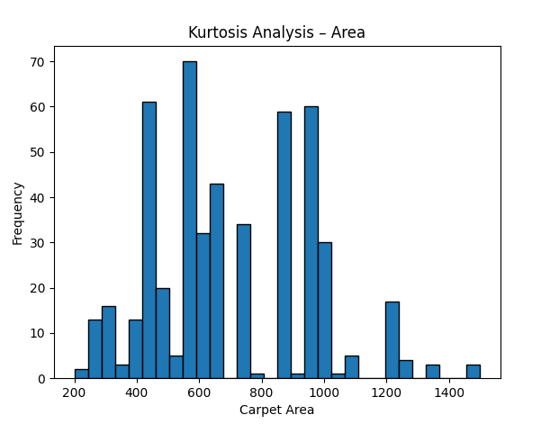
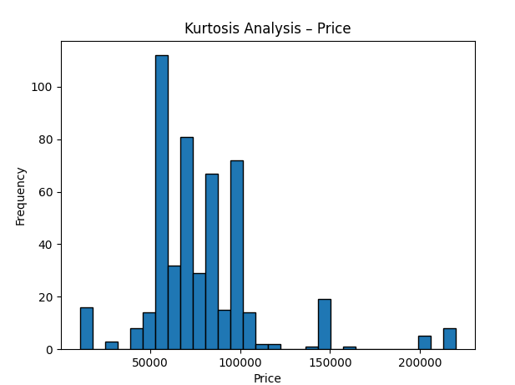
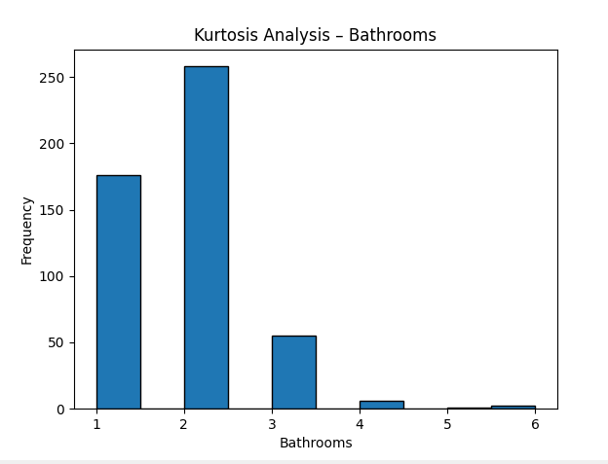

5. Data Cleaning
5.1 Identification of missing values
Before analysis, we need to identify any missing values in the dataset. Missing data can bias results or cause errors in statistical calculations.

Solution :
# identification of missing values using isnull()
import pandas as pd
import seaborn as sns
import matplotlib.pyplot as plt

# Load the dataset
df = pd.read_csv("house.csv")

# Check for missing values
missing_values = df.isnull().sum()
print("Missing values per column:\n", missing_values)

# Visualize missing values
plt.figure(figsize=(10,6))
sns.heatmap(df.isnull(), cbar=False, cmap="viridis")
plt.title("Heatmap of Missing Values")
plt.show()

Output:
Missing values per column:
Index 0
location 0
Price 0
Carpet Area 5
Floor 3
Furnishing 0
Bathroom 3
Balcony 6
Car Parking 0
Society 0
Ownership 0
overlooking 0
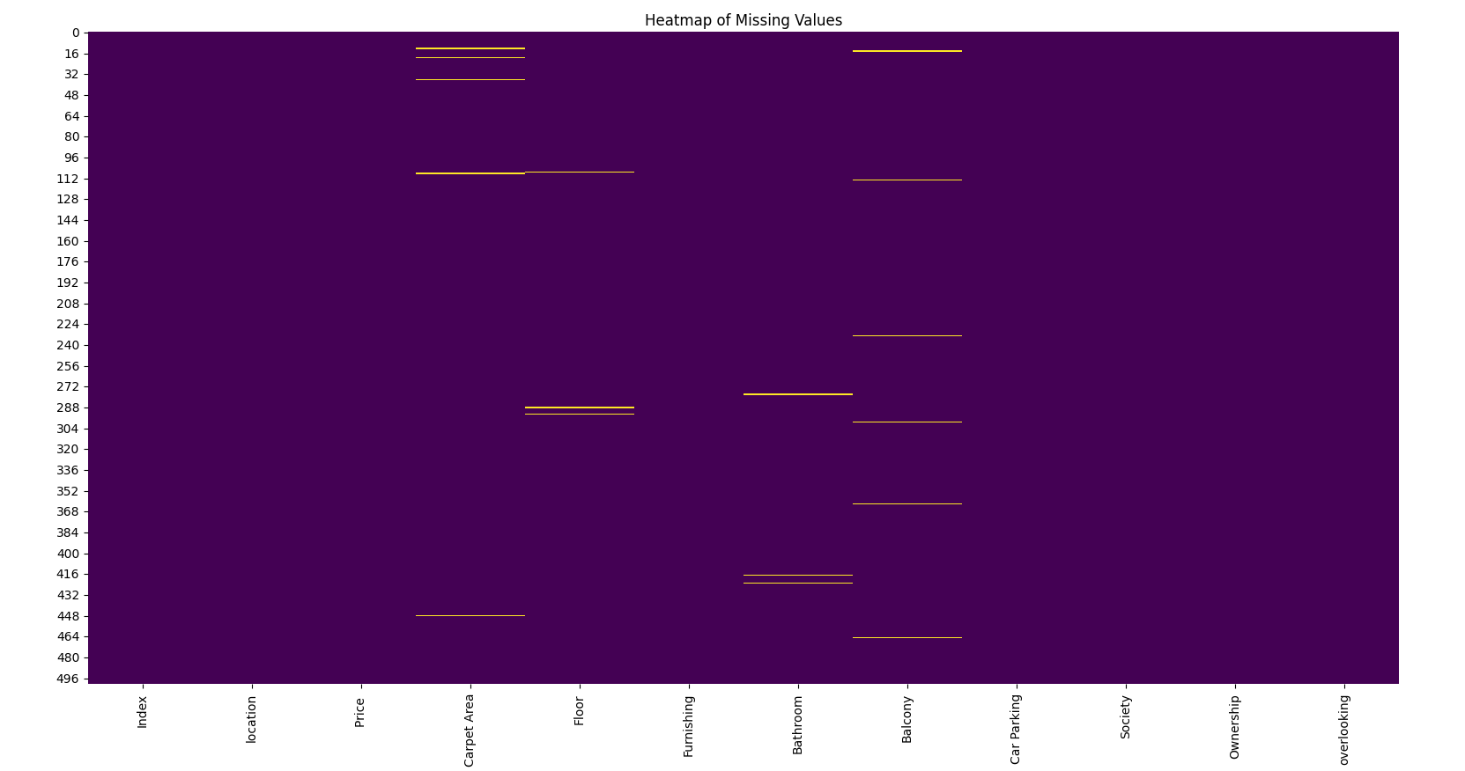
Result/Interpretation:
- The output will show the number of missing values in each column.
- The heatmap will highlight missing entries in yellow (or lighter color).
- For example, if Bathroom has 5 missing values, it indicates incomplete records that need attention.

5.2 Handle Missing Values
Missing values can be handled in different ways:
- Numerical columns: fill with mean/median, or drop rows
- Categorical columns: fill with mode, or drop rows

Solution :
# Handle missing value
import pandas as pd
from scipy import stats

df = pd.read_csv("house.csv")

# Fill missing numerical values with median
num_cols = df.select_dtypes(include=['float64','int64']).columns
for col in num_cols:
df[col].fillna(df[col].median(), inplace=True)

# Fill missing categorical values with mode
cat_cols = df.select_dtypes(include=['object']).columns
for col in cat_cols:
df[col].fillna(df[col].mode()[0], inplace=True)

# Verify no missing values remain
print("\nAfter handling missing values:")
print(df.isnull().sum())

Output:
After handling missing values:
Index 0
location 0
Price 0
Carpet Area 0
Floor 0
Furnishing 0
Bathroom 0
Balcony 0
Car Parking 0
Society 0
Ownership 0
overlooking 0

Result/Interpretation:
- Missing numerical values are replaced with the median (robust to outliers).
- Missing categorical values are replaced with the most frequent category.
- Now, all columns should show 0 missing values.

5.3 Detecting outliers
Outliers are extreme values that can distort statistical analysis. Detecting them is crucial for reliable modeling.

Solution :
# Detecting Outliers (Price & Balcony Only)
import pandas as pd
import seaborn as sns
import matplotlib.pyplot as plt

# Load dataset
df = pd.read_csv("house.csv")

# Columns to check for outliers
outlier_cols = ['Price ', 'Balcony']

# Boxplot for selected columns (vertical boxes, side by side)
plt.figure(figsize=(8,6))
sns.boxplot(data=df[outlier_cols])
plt.title("Boxplots of Price and Balcony")
plt.xlabel("Columns")
plt.ylabel("Values")
plt.show()

# Detect outliers using IQR method
outliers = {}
for col in outlier_cols:
Q1 = df[col].quantile(0.25)
Q3 = df[col].quantile(0.75)
IQR = Q3 - Q1
outlier_condition = (df[col] < (Q1 - 1.5*IQR)) | (df[col] > (Q3 + 1.5*IQR))
outliers[col] = df[col][outlier_condition]
print(f"\n{col} Outliers:\n", outliers[col])

Output:
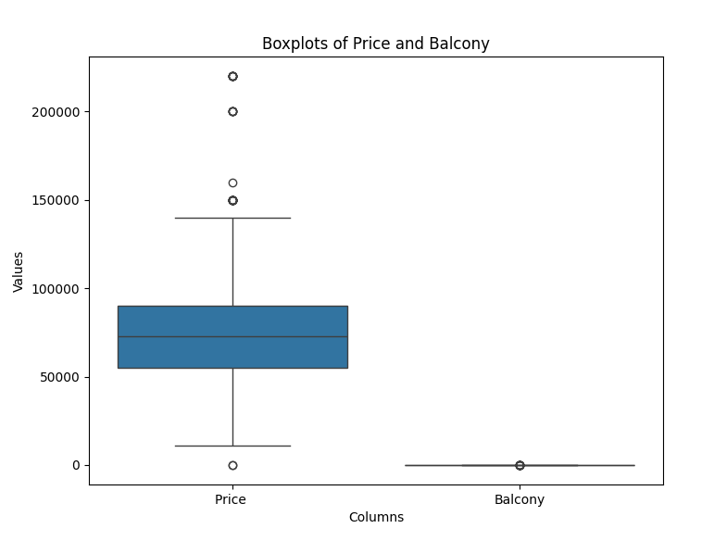
Result/Interpretation:
- Boxplots show extreme values outside whiskers → potential outliers.
- IQR method lists exact outlier values.
- Example: Price has very high outliers (luxury houses).

5.3 Impact of outliers
To understand how outliers affect the distribution and statistical analysis of Price and Balcony

Solution :
# 5.4 Impact of Outliers
import pandas as pd

# Load dataset
df = pd.read_csv("house.csv")

# Columns we are analyzing for outliers
cols = ['Price ', 'Balcony']

print("Kurtosis Values:")
for col in cols:
print(f"{col} : {df[col].kurtosis()}")

print("\nMean vs Median Comparison:")
for col in cols:
mean_value = df[col].mean()
median_value = df[col].median()
print(f"{col} -> Mean: {mean_value:.2f}, Median: {median_value:.2f}")

# Removing outliers using IQR method
df_clean = df.copy()

for col in cols:
Q1 = df_clean[col].quantile(0.25)
Q3 = df_clean[col].quantile(0.75)
IQR = Q3 - Q1
lower_limit = Q1 - 1.5 * IQR
upper_limit = Q3 + 1.5 * IQR
df_clean = df_clean[(df_clean[col] >= lower_limit) & (df_clean[col] <= upper_limit)]

print("\nDataset shape before removing outliers:", df.shape)
print("Dataset shape after removing outliers:", df_clean.shape)

Output:
Kurtosis Values:
Price : 5.366670401349744
Balcony : 23.640673399517745

Mean vs Median Comparison:
Price -> Mean: 77788.08, Median: 73000.00
Balcony -> Mean: 1.86, Median: 2.00

Dataset shape before removing outliers: (501, 12)
Dataset shape after removing outliers: (441, 12)

Result/Interpretation:
- Price and Balcony showed high kurtosis, meaning heavy tails and strong outlier presence.
- Mean was much higher than Median → proves outliers strongly influence data.
- After removing outliers, dataset size reduced, confirming their significant impact.
Outliers can mislead analysis and must be treated for accurate results.

