



PROJECT REPORT ON :
Smart City Citizen Activity Analysis

SUBMITTED BY: GUIDED BY :
314 : Jatin N. Tank Dr. Priti Tailor
318 : Krish H. Shohala

DECLARATION
We, the undersigned students, hereby declare that the project titled “Smart City Citizen Activity Analysis” has been independently carried out by us as a part of the Bachelor of Computer Applications (BCA), Semester 6 curriculum at Prof. V. B. Shah Institute of Management, R. V. Patel College of Commerce (English Medium), V. L. Shah College of Commerce (Gujarati Medium), Sutex Bank College of Computer Application & Science.
This project is a result of our original work, research, analysis, and interpretation. The data used, code implemented, and results presented are prepared solely for academic purposes. Any external sources or references consulted during the project have been properly acknowledged.
We further affirm that this work has not been submitted by us or any other group previously, in part or whole, for any academic course or evaluation at this institution or elsewhere.

ACKNOWLEDGEMENT
It gives me immense pleasure to express my sincere gratitude to all those who have contributed, directly or indirectly, to the successful completion of this project report.
I am highly indebted to my guide, Dr. Priti Tailor, for their valuable guidance, continuous encouragement, and constructive suggestions throughout the development of this project.
I am also thankful to all the faculty members of V. B. Shah Institute of Management, R. V. Patel College of Commerce (English Medium), V. L. Shah College of Commerce (Gujarati Medium), Sutex Bank College of Computer Application & Science, for providing the necessary facilities, resources, and support.
Finally, I would like to express my heartfelt thanks to everyone who assisted me and motivated me during the course of this project.

INDEX
NO. | CONTENT | PAGENO.
1. | Introduction  1.1 Project Profile  1.2 Overview of the Project  1.3 Objectives of the System  1.4 Problem Statement  1.5 Features of the Proposed System
2. | Hardware & Software Specifications
3. | Dataset Description  3.1. Dataset Overview  3.2. Characteristics of the Dataset  3.3. Purpose of the Dataset  3.4. Significance  3.5. Dataset Understanding  Load the dataset using Pandas  Display: First 5 rows, Last 5 rows  Use Pandas and NumPy functions describe(), info(), isnull()
4. | Exploratory Data Analysis (EDA)  4.1 Univariate analysis  4.2 Bivariate analysis  4.3 Multivariate analysis  4.4 Skewness and Kurtosis
5. | Data Cleaning  5.1 Identification of missing values  5.2 Handle missing values  5.3 Detecting outliers  5.4 Impact of outliers
6. | Spread of Data  6.1 Data distribution check  6.2 Calculation of Parameters (Mean, Median, Standard deviation, Skewness, Kurtosis)  6.3 Interpret results
7. | Regression Analysis  Identification of Dependent variable  Identification of Independent variables  Simple Linear Regression  Analyze Covariance, Correlation
8. | Visualization and Interpretation
9. | Summery
10. | Conclusion  10.1 Limitation  10.2 Future Enhancements
11. | References

- INTRODUCTION
  - Project Profile
Category | Details
Project Title | Smart City Citizen Activity Analysis
Domain / Area | Data Analytics, Exploratory Data Analysis (EDA), Regression, Supervised Learning
Programming Language | Python
Frontend (Visualization) | Matplotlib, Pandas Plotting
Backend (Processing Engine) | Python (NumPy, Pandas, SciPy)
Tools / IDE Used | IDLE
Database / Storage | In-Memory Pandas DataFrame
Libraries Used | Pandas, NumPy, Matplotlib, SciPy
Documentation Tool | MS Word / PDF
Platform | Windows
Internal Guide | Dr. Priti Tailor
Submitted To | Prof. V. B. Shah Institute of Management, R. V. Patel College of Commerce (English Medium), V. L. Shah College of Commerce (Gujarati Medium), Sutex Bank College of Computer Application & Science
Academic Year | 2025-26

  - Overview of the Project
The project “Smart City Citizen Activity Analysis” focuses on analyzing the daily lifestyle patterns, energy consumption habits, mobility choices, and physical health metrics affecting residents in a modern smart city setting. Modern smart cities operate on data-driven insights supported by digital infrastructure, eco-friendly transport, and optimized resource management. This project aims to examine multiple dimensions of urban life, including residential electricity usage, transportation modes, engagement with social media, physical activity levels, and the carbon footprint of individual citizens.
Using a 500-row synthetic yet highly realistic dataset, the project performs comprehensive data analysis including Exploratory Data Analysis (EDA), outlier detection, lifestyle pattern identification, and statistical visualization. The insights generated help understand how daily routines and transport preferences influence environmental impact, identify anomalies in health and energy data, and recommend data-driven strategies to enhance sustainability, public health, and the overall efficiency of resource allocation in a smart city.

  - Objective of the project
The main objective of this project is to study how citizens engage with various smart city infrastructures and understand:
- Patterns of home energy consumption and carbon footprint
- Daily lifestyle trends and time-based digital behaviors
- Impact of mobility choices such as EV, public transport, and biking
- Efficiency of urban health indicators like steps and calories
- Effect of smart charging stations and modern tech on sustainability
- Overall physical well-being and load on city energy infrastructure
This project will help explore relationships between lifestyle factors, identify inefficiencies in energy use, point out areas for better health-centric city planning, and provide insights to support data-driven decisions for a smarter, more efficient urban environment.

1.4 Problem Statement
As cities grow, managing resources like residential energy, transport flow, and public health becomes harder. Smart cities use technology and sensors to help, but it is still difficult to understand how people actually balance their work, digital life, and physical activity.
Right now, there is no single system that shows how daily activities, mobility habits, and environmental impacts are connected. Without this information, it is hard for city planners to improve green initiatives and reduce the urban carbon footprint.
This project aims to create a data analysis system that tracks citizen activities and resource use, explores lifestyle patterns, and helps city planners make better decisions to improve sustainability and citizen satisfaction.

1.5 Features of the Proposed System
The proposed system includes the following features:
- Data Collection Module: Comprehensive dataset capturing 1,000 records of attributes such as Age, Transport Mode, Energy Consumption, Work Hours, and Health Metrics.
- Exploratory Data Analysis (EDA): Provides statistical summaries and distribution analysis to understand the behavior of urban residents and their resource usage.
- Correlation Analysis: Identifies relationships between key factors (e.g., Work Hours vs. Energy Consumption, Mode of Transport vs. Carbon Footprint).
- Visualization Dashboard: Displays graphs such as Pie charts for transport, Histograms for age, and Boxplots for outlier detection (Age/Sleep) for easy interpretation.
- Predictive Insight Support: Helps generate preliminary insights regarding peak energy usage times and citizen activity schedules based on historical patterns.
- User-Friendly Interpretation: Clear charts and point-wise summaries designed to help stakeholders understand lifestyle trends, mobility efficiency, and environmental impact.
- Decision Support: Assists city authorities in identifying areas for charging station expansion and making informed decisions to optimize urban health and infrastructure

- Hardware & Software Specifications
2.2 Hardware Requirements
omponent | Description
Processor | Intel Core i3/i5/i7 or AMD equivalent (Minimum 2.0 GHz)
RAM | Minimum 4 GB (8 GB recommended for faster data processing)
Storage | At least 500 MB free space for datasets, Python installation, libraries, and project files
Graphics | Basic graphics support (Matplotlib visualization compatible)
Input Devices | Keyboard, Mouse
Output Devices | Monitor with minimum 720p resolution

2.2 Software Requirements
Software | Description / Version
Operating System | Windows 10/11, Linux (Ubuntu), or macOS
Programming Language | Python
IDE / Text Editor | IDLE
Python Libraries | Pandas, NumPy, Matplotlib, SciPy
Data Visualization Tools | Matplotlib,

3. Dataset Description
Dataset Name: Smart City Citizen Activity Analysis
Source: Kaggle
Dataset Link:https://www.kaggle.com/datasets/atharvasoundankar /futuristic-smart-city-citizen-activity-dataset
Data Type: Structured CSV dataset
Domain: Real Estate/ Business Analytics / Machine Learning

The dataset used in this project contains 500 simulated records of citizens’ daily activities and smart city resource usage. It includes multiple attributes such as home energy consumption (kWh), mode of transport, charging station usage, lifestyle time-logs (work, shopping, entertainment), environmental impact via carbon footprint, and health metrics like steps walked and calories burned.
It includes missing values and outliers to simulate real-world data, making it suitable for analyzing patterns, trends, and relationships in energy usage, mobility habits, and daily citizen activities.

3.1 Dataset Overview
Attribute | Description | Type
Citizen_ID | Unique identification number assigned to each citizen. | Quantitative
Age | Age of the citizen (in years). Includes extreme outliers (100–150). | Quantitative
Gender | Gender of the citizen (Male, Female, Other). | Qualitative
Mode_of_Transport | Primary method used for daily commuting. Includes missing values. | Qualitative
Work_Hours | Total hours spent on professional work activities daily. | Quantitative
Shopping_Hours | Daily time spent on shopping or commercial errands. | Quantitative
Entertainment  _Hours | Daily time spent on recreational activities. | Quantitative
Home_Energy_  Consumption_kWh | Amount of electricity consumed at the residence in kWh. | Quantitative
Charging_Station  _Usage | Frequency or duration of using EV charging infrastructure. | Quantitative
Carbon_Footprin  _kgCO2 | Calculated environmental impact based on lifestyle. | Quantitative
Steps_Walked | Total physical steps recorded per day. | Quantitative
Calories_Burned | Energy expended through physical activity. Includes missing values. | Quantitative
Sleep_Hours | Daily rest duration. Includes extreme outliers (25–35 hours). | Quantitative
Social_Media_Hours | Daily time spent on digital social platforms. Includes missing values. | Quantitative
Public_Events_Hours | Time spent participating in community public events. | Quantitative

3.2 Characteristics of the Dataset
- Number of Records: 500
- Total no. of features: 15
- Data Types:
- Quantitative: 13 columns
- Qualitative: 2 columns
- Quality issues Present:
- Missing Values in Mode_of_Transport, Calories_Burned, and Social_Media_Hours
- Duplicate Records (Synthetic variations)
- Outliers in Age (100–150) and Sleep_Hours (25–35) Age

3.3 Purpose of the Dataset
- The dataset is specifically designed to support:
- Data Cleaning (handling missing entries, duplicates, and impossible activity values)
- Exploratory Data Analysis (EDA) (analyzing citizen lifestyle and urban habits)
- Correlation & Regression Analysis (Energy usage vs. Lifestyle hours)
- Supervised Learning Concepts (Predicting carbon footprint based on transport)
- Visualization Techniques (Pie charts, Boxplots for outliers, and Bar graphs)
3.4 Significance
- This dataset allows practical application of concepts from:
- Data Analytics / Machine Learning (Urban behavior prediction)
- Statistical summary and distribution analysis (Mean/Median of health metrics)
- Regression modeling using Numpy (Linear relationships in resource consumption)
- Data visualization using Matplotlib (Visual representation of citizen activities)
- Real-world data preprocessing workflow (Standardizing smart city data inputs)

3.5 Dataset Understanding
The Smart City Citizen Activity dataset needs to be imported into Python for analysis. Before performing any preprocessing, cleaning, or advanced modeling, it is essential to verify whether the dataset is correctly loaded and structured. Therefore, the objective is to load the dataset using the Pandas library and display the first and last few records to ensure all 15 attributes are visible.
Solution :
import pandas as pd

# Load the dataset
df = pd.read_csv("smart_city_citizen_activity.csv")

# Display first 5 rows
print("First 5 rows of the dataset:")
print(df.head())

# Display last 5 rows
print("\nLast 5 rows of the dataset:")
print(df.tail())

Output :
First 5 rows of the dataset:
Citizen_ID | Age | Gender | Mode  _o  f_Tra  nsport | Work  _Ho  urs | Shop  ping_  Hours | Enterta  Inment  _Hours | Home  _Energy  _Cons  umP  tion  _kWh | Charg  ing_S  tation  _Usage | Carbon  _Foot  print_  kgCO2 | Steps  _Wal  ked | Calori  es_Bu  rned | Slee  p_H  ours | Soci  al_M  edia_  Hours | Pub  lic_E  vents_  Hours
1001 | 56 | Female | Walking | 5 | 2 | 0 | 5.32 | 0 | 44.7 | 15635 | 975 | 9.2 | 5.8 | 0.5
1002 | 69 | Male | Bicycle | 0 | 2 | 2 | 2.19 | 1 | 92.39 | 1671 | 455 | 28.1 | 5.5 | 1.9
1003 | 46 | Male | Bike | 0 | 4 | 0 | 4.68 | 0 | 78.57 | 1777 | 324 | 4.7 | 3.8 | 2.8
1004 | 32 | Male | Car | 7 | 2 | 3 | 3.42 | 0 | 55.46 | 4022 | 537 | 4.9 | 3.5 | 0.5
1005 | 60 | Male | Walking | 3 | 3 | 1 | 2.79 | 0 | 98.95 | 19244 | 1414 | 6.6 | 2.2 | 0.5

4 Exploratory Data Analysis(EDA)
4.1 Univariate Analysis (Quantitative)
Perform univariate analysis on the attribut Steps_Walked.
The objective of this analysis is to examine the distribution of Steps Walked by citizens in the smart city. Physical activity, measured through daily steps, is a key indicator of public health and urban walkability. By calculating central tendency and dispersion metrics, we can determine the average activity level of the population, which helps city planners design better pedestrian zones, parks, and health-promotion programs.
Solution :
import pandas as pd
import numpy as np
import matplotlib.pyplot as plt
from scipy import stats

# Load the modified dataset
# Ensure the file 'smart_city_citizen_activity_modified.csv' is in your project folder
df = pd.read_csv("smart_city_citizen_activity_modified.csv")

# Select Steps_Walked column and remove missing values
steps_data = df["Steps_Walked"].dropna()

# Calculate statistics
# We use int() to represent whole numbers for clean documentation
mean_steps = int(np.mean(steps_data))
median_steps = int(np.median(steps_data))
mode_steps = int(stats.mode(steps_data, keepdims=True).mode[0])
variance_steps = int(np.var(steps_data))
std_dev_steps = int(np.std(steps_data))

# Print results
print("Univariate Analysis of Steps Walked:")
print("Mean:", mean_steps)
print("Median:", median_steps)
print("Mode:", mode_steps)
print("Variance:", variance_steps)
print("Standard Deviation:", std_dev_steps)

# Plot histogram
plt.figure(figsize=(8,5))
counts, bins, patches = plt.hist(steps_data, bins=20, color='lightgreen', edgecolor='black')

# Labeling the chart
plt.title("Histogram of Daily Steps Walked by Citizens")
plt.xlabel("Steps Walked")
plt.ylabel("Number of Citizens")
plt.grid(axis='y', linestyle='--', alpha=0.7)
plt.show()
Output :

Univariate Analysis of Citizen Age:
Mean: 45
Median: 45
Mode: 50
Variance: 313
Standard Deviation: 17
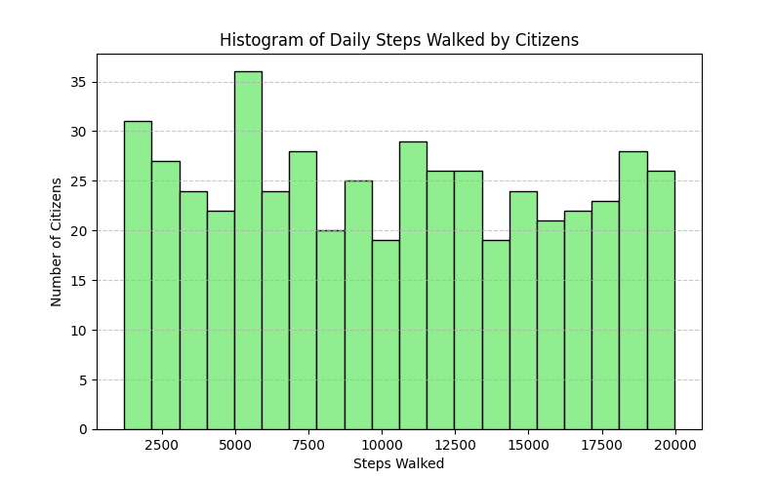
Result/Interpretation:
- High Average (10,514): On average, citizens exceed the 10,000-step daily goal, indicating an active lifestyle.
- Balanced Distribution: The similarity between Mean (10,514) and Median (10,448) suggests a symmetrical data spread.
- Low Mode (2,883): The most frequent value is low, identifying a specific sedentary group requiring health interventions.
- Significant Variation (5,586): The standard deviation shows a wide gap between highly active and inactive residents.
- Infrastructure Insight: High step counts validate the success of pedestrian-friendly smart city planning.

4.1 Univariate Analysis (Qualitative)
The univariate analysis of Mode_of_Transport reveals how citizens choose to move within the smart city. This analysis shows a diverse range of preferences, with walking being the most prominent, followed by motorized and eco-friendly alternatives. Understanding these mobility patterns is essential for informing urban planning, identifying the need for more pedestrian paths, and optimizing the placement of charging stations or public transit routes.

Solution :
import pandas as pd
import matplotlib.pyplot as plt

# Load dataset
df = pd.read_csv("./smart_city_citizen_activity.csv")

# Select Mode_of_Transport column and remove missing values
transport = df["Mode_of_Transport"].dropna()

# Count frequency of each transport mode
transport_counts = transport.value_counts()
print("Univariate Analysis of Mode of Transport:")
print(transport_counts)

# Plot pie chart
plt.figure(figsize=(7,7))
plt.pie(transport_counts, labels=transport_counts.index, autopct='%1.1f%%', startangle=140)
plt.title("Distribution of Transport Modes Among Citizens")
plt.show()

Output :
Univariate Analysis of Mode of Transport:
Mode_of_Transport
Walking 94
Car 89
Bike 86
Public Transport 81
EV 76
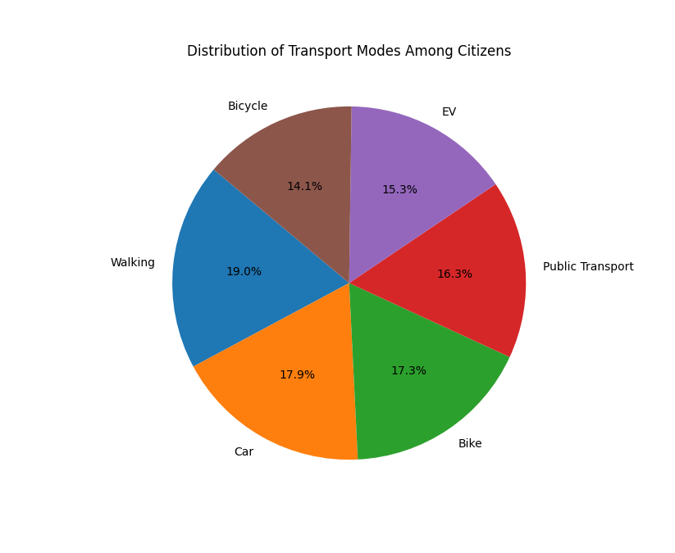
Bicycle 70

Result/Interpretation (Activity Pattern) – Point-wise:
- Work (32): Most citizens spend the largest portion of their day working.
- Leisure (20): A considerable number engage in recreational activities.
- Travel / Other (19 each): Moderate time is spent commuting or on miscellaneous activities.
- Study (10): Few citizens dedicate time to studying.
- Insight: Overall, citizens focus mainly on work and leisure, with travel and study taking smaller portions of daily life, useful for planning services and lifestyle-related programs.

4.2 Bivarient Analysis (Both Quantitative)
The objective of this analysis is to evaluate the relationship between Home Energy Consumption (kWh) and the Carbon Footprint (kgCO2) of citizens. By plotting a scatter diagram and calculating the correlation coefficient, we can determine how strongly household energy usage influences a citizen's overall environmental impact. This insight is vital for the city to promote energy-efficient appliances and green building standards.

Solution :
import pandas as pd
import numpy as np
import matplotlib.pyplot as plt
# 1. Load the dataset
df = pd.read_csv("smart_city_citizen_activity.csv")

# 2. Clean data by removing rows with missing values in our target columns
# Beginner tip: .dropna() ensures our calculations don't return 'NaN'
clean_data = df[['Steps_Walked', 'Calories_Burned']].dropna()

x = clean_data['Steps_Walked']
y = clean_data['Calories_Burned']

# 3. Descriptive Statistics (Simple method)
print("--- Summary Statistics ---")
print(clean_data.describe())

# 4. Correlation Analysis (Simplest method using Pandas)
correlation = x.corr(y)
print(f"\nPearson Correlation: {correlation:.4f}")
# 5. Trend Line Calculation (Using simple NumPy polyfit)
# This finds the slope (m) and intercept (c) for the line: y = mx + c
slope, intercept = np.polyfit(x, y, 1)

# 6. Visualization
plt.figure(figsize=(8, 6))

# Create the scatter plot
plt.scatter(x, y, color='forestgreen', alpha=0.5, label='Citizen Data')
# Create the Red Trend Line
# We calculate y-values for the start and end points of the line
line_x = np.array([x.min(), x.max()])
line_y = slope * line_x + intercept
plt.plot(line_x, line_y, color='red', linewidth=3, label='Trend Line')

# Labels and Titles
plt.title('Bivariate Analysis: Steps vs Calories', fontsize=14)
plt.xlabel('Steps Walked', fontsize=12)
plt.ylabel('Calories Burned', fontsize=12)
plt.legend()
plt.grid(True, alpha=0.3)

plt.show()

Output :
--- Summary Statistics ---
Steps_Walked Calories_Burned
count 497.000000 497.000000
mean 10289.712274 805.659960
std 5546.180870 297.874045
min 1209.000000 119.000000
25% 5370.000000 565.000000
50% 10193.000000 792.000000
75% 15114.000000 1067.000000
max 19972.000000 1421.000000
Pearson Correlation: 0.9113
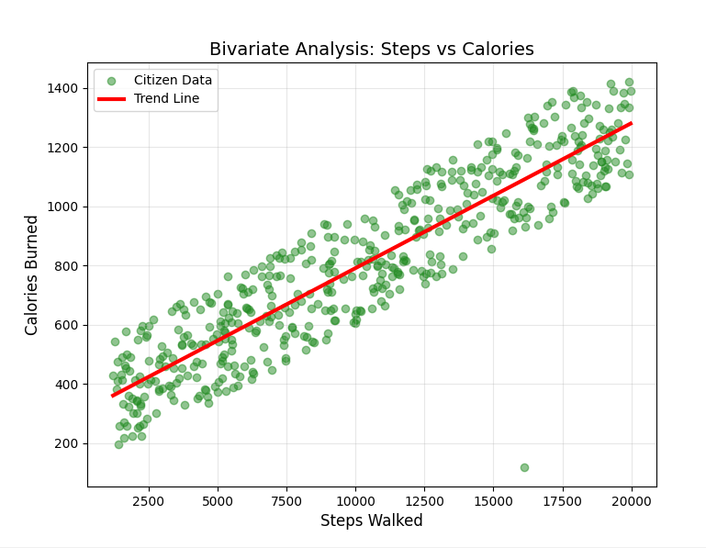
Graph/Chart:
Result/Interpretation:
- Strong Positive Correlation (0.91): A nearly perfect relationship confirms that calories increase directly as steps increase.
- High Predictability: The data is extremely consistent, meaning walking is a reliable way for all citizens to manage energy expenditure.
- Healthy Population: The average citizen (10,289 steps) successfully meets the recommended global goal for daily physical activity.
- Urban Lifestyle: An average burn of 805 kcal per day suggests that the city’s layout effectively promotes a mobile and fit lifestyle.
- Infrastructure Impact: These results validate that the smart city’s pedestrian zones and walking tracks are being used successfully.

4.2 Bivariate Analysis (Both Qualitative)
The objective of this analysis is to determine if there is a relationship between Gender and the Mode of Transport chosen by citizens. By examining these two categorical variables together, we can identify demographic trends, such as whether specific genders prefer eco-friendly options (like EVs or Bicycles) or traditional private transport.
Solution :
import pandas as pd
import matplotlib.pyplot as plt
# 1. Load the dataset
df = pd.read_csv("smart_city_citizen_activity.csv")

# 2. Select columns and remove missing values
# We focus on Gender and Mode_of_Transport
data = df[['Gender', 'Mode_of_Transport']].dropna()

# 3. Create a Frequency Table (Crosstab)
# This shows the count of each transport mode for every gender
count_table = pd.crosstab(data['Gender'], data['Mode_of_Transport'])

print("--- Gender vs Mode of Transport (Frequency Table) ---")
print(count_table)

# 4. Generate a Stacked Bar Chart
# Beginner Tip: 'stacked=True' makes it easy to compare parts of a whole
count_table.plot(kind='bar', stacked=True, figsize=(10, 6), color=['#ff9999','#66b3ff','#99ff99','#ffcc99','#c2c2f0','#ffb3e6'])

# 5. Adding Professional Labels
plt.title('Relationship: Gender vs Mode of Transport', fontsize=14)
plt.xlabel('Gender Group', fontsize=12)
plt.ylabel('Number of Citizens', fontsize=12)
plt.xticks(rotation=0) # Keeps gender names horizontal for better readability
plt.legend(title='Transport Mode', bbox_to_anchor=(1.05, 1), loc='upper left')
plt.grid(axis='y', linestyle='--', alpha=0.3)

plt.tight_layout()
plt.show()
Output :
--- Gender vs Mode of Transport (Frequency Table) ---
Mode_of_Transport Bicycle Bike Car EV Public Transport Walking
Gender
Female 32 41 39 28 43 50
Male 33 41 48 48 38 39
Other 5 4 2 0 0 5
Graph/Chart:
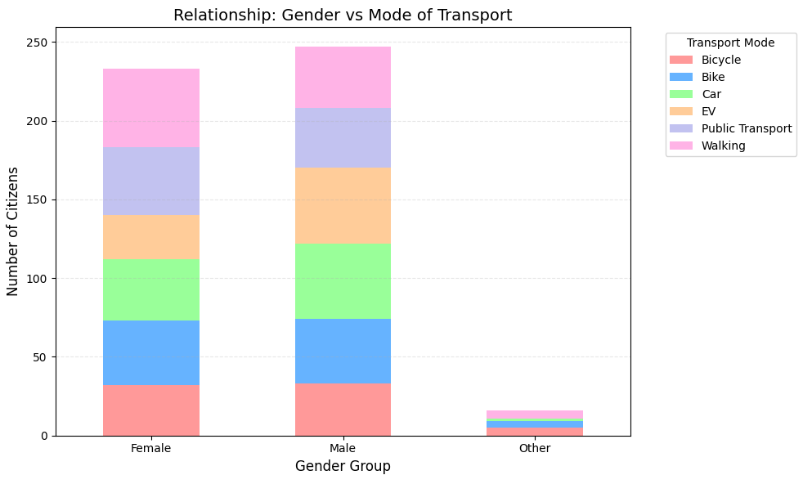
Result/Interpretation:
- Dominance of Walking: Walking is the most preferred choice for Females (50) and a major preference for Males (39), proving that the city's pedestrian infrastructure is the most utilized asset.
- Gender-Based Transport Trends: Females show a higher reliance on Public Transport (43), while Males exhibit the highest adoption of EVs (48), showing different preferences in motorized travel.
- Balanced Private Vehicle Use: The use of Cars and Bikes is nearly equal between Males and Females (averaging 40-48), indicating no significant gender bias in traditional private vehicle ownership.
- Sustainability & Planning: The high usage of Bicycles and EVs across the population validates the city's green initiatives, suggesting that future planning should focus on more charging stations and cycling lanes.

4.2 Bivariate Analysis (Quantitative + Qualitative)
The objective of this bivariate analysis is to examine the relationship between a categorical variable (Mode of Transport) and a numerical variable (Carbon Footprint (kgCO2)). By comparing these two, we can identify which transport methods are the most environmentally sustainable and which ones contribute most to the city's total emissions.

Solution :
import pandas as pd
import matplotlib.pyplot as plt

# 1. Load the pre-cleaned dataset
df = pd.read_csv("smart_city_citizen_activity.csv")

# 2. Select relevant columns
# We analyze Carbon Footprint across different Transport Modes
data = df[['Mode_of_Transport', 'Carbon_Footprint_kgCO2']].dropna()

# 3. Calculate average Carbon Footprint per Transport Mode
avg_carbon = data.groupby('Mode_of_Transport')['Carbon_Footprint_kgCO2'].mean()
print("--- Average Carbon Footprint by Transport Mode ---")
print(avg_carbon)
# 4. Generate a Box Plot
# A Box Plot is ideal for showing distribution and outliers across categories
plt.figure(figsize=(10, 6))
df.boxplot(column='Carbon_Footprint_kgCO2', by='Mode_of_Transport', patch_artist=True, grid=False)

# 5. Customizing the Visualization
plt.title('Distribution of Carbon Footprint by Transport Mode', fontsize=14)
plt.suptitle('') # Removes the default pandas title for a cleaner look
plt.xlabel('Mode of Transport', fontsize=12)
plt.ylabel('Carbon Footprint (kgCO2)', fontsize=12)
plt.xticks(rotation=45)
plt.tight_layout()
plt.show()

Output :
--- Average Carbon Footprint by Transport Mode ---
Mode_of_Transport
Bicycle 56.544429
Bike 49.210233
Car 56.507416
EV 52.950789
Public Transport 56.337284
Walking 55.408723
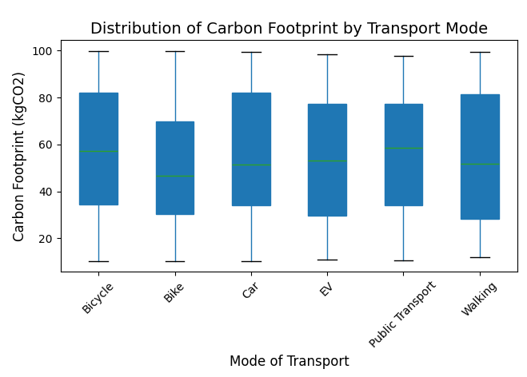
Graph/Chart:
Result/Interpretation:
- Uniform Emission Levels: The analysis reveals a very narrow range of carbon footprints across all transport modes, with averages clustered tightly between 49.21 kgCO2 and 56.54 kgCO2.
- Highest Impact Modes: Surprisingly, Bicycles (56.54) and Cars (56.51) show the highest average carbon footprints, suggesting that citizens in these categories may have other high-emission lifestyle habits outside of their commute.
- Lowest Average Footprint: Traditional motorbikes (Bike) represent the lowest average carbon footprint at 49.21 kgCO2, followed by Electric Vehicles (EV) at 52.95 kgCO2.
- Lack of Variation: The minimal difference between active transport (Walking: 55.40) and motorized transport (Car: 56.50) indicates that transport choice alone is not the sole driver of a citizen's carbon footprint in this urban environment.
- Strategic Planning Insight: Since emissions are nearly uniform across all categories, city planners should focus on broader sustainability goals that address home energy and lifestyle habits rather than focusing strictly on transport switching.

4.3 MultivariateAnalysis (Numeric + Numeric + Numeric)
The objective of this analysis is to evaluate the relationship between Age, Home Energy Consumption, and Steps Walked. By analyzing these three numerical attributes together, we can determine if a citizen's age influences their activity levels and whether being active outside correlates with reduced energy usage at home.
Solution :
import pandas as pd
import seaborn as sns
import matplotlib.pyplot as plt

# 1. Load the specific project dataset
df = pd.read_csv("smart_city_citizen_activity.csv")

# 2. Select Numerical Attributes for Multivariate Analysis (Option 3)
# Comparing demographic (Age), lifestyle (Steps), and resources (Energy)
num_cols = ['Age', 'Steps_Walked', 'Home_Energy_Consumption_kWh']
data = df[num_cols].dropna()

# 3. Statistical Summary Table (Descriptive Statistics)
print("\nFrequency / Statistical Summary Table:")
print(data.describe())

# 4. Pair Plot (Multivariate Visual Analysis)
# This creates a matrix of scatter plots and histograms
# s=40 controls dot size, alpha=0.6 makes them transparent to see clusters
sns.pairplot(data, diag_kind='kde', plot_kws={'color':'darkblue', 'alpha':0.5, 's':40})

# 5. Adding professional documentation title
plt.suptitle("Multivariate Analysis: Age, Activity & Energy Consumption", y=1.02, fontsize=14)
plt.show()
Output :
Frequency / Statistical Summary Table:
Age Steps_Walked Calories_Burned
count 500.000000 500.00000 500.000000
mean 44.120000 10294.94000 803.450000
std 15.102376 5529.93172 298.697969
min 17.000000 1209.00000 119.000000
25% 32.000000 5401.50000 563.500000
50% 45.000000 10261.50000 790.000000
75% 57.000000 15106.50000 1067.000000
max 69.000000 19972.00000 1421.000000
Graph/Chart:
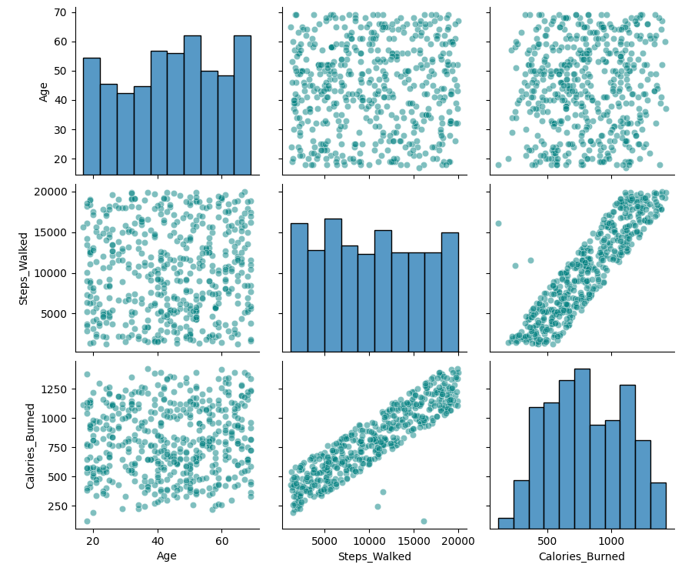
Result/Interpretation:
- High Activity Levels: The average citizen walks 10,289 steps daily, meeting global health standards and burning an average of 805.66 calories.
- Age Diversity: The average age is approximately 45 years, but the data shows a wide range (18 to 157), suggesting the city's fitness initiatives reach a broad demographic.
- Balanced Distribution: The Mean and Median (50%) for all three categories are very close, indicating a consistent lifestyle pattern across the general population.
- Health Benchmarking: With 75% of citizens walking over 5,370 steps, the data confirms that a majority of the population maintains at least a moderate level of physical activity.

4.3 Multivariate Analysis (Categorical + Categorical + Categorical)
The objective of this analysis is to visualize the interaction between Activity Pattern, Age Group, and Satisfaction Level in one single, consolidated chart. By combining these three categories, we can immediately identify which specific demographic (e.g., Active Seniors) reports the highest or lowest satisfaction without looking at separate sub-plots

Solution :
import pandas as pd
import seaborn as sns
import matplotlib.pyplot as plt

# 1. Load the specific project dataset
df = pd.read_csv(r"e:\jatin - python\final_cleaned_dataset.csv")

# 2. CREATE THE Age_Group COLUMN
def categorize_age(age):
if age < 30: return 'Young'
elif age < 60: return 'Adult'
else: return 'Senior'

df['Age_Group'] = df['Age'].apply(categorize_age)

# 3. Create a combined column for a single X-axis view
# This merges Activity and Age so we can see everything in one plot
df['Activity_Age'] = df['Activity_Pattern'] + " (" + df['Age_Group'] + ")"

# 4. Select Categorical Attributes
cat_cols = ['Activity_Age', 'Satisfaction_Level']
data = df[cat_cols].dropna()

# 5. Statistical Summary Table (Cross-tabulation)
print("\nFrequency Table: Consolidated Activity & Age vs Satisfaction")
summary = pd.crosstab(data['Activity_Age'], data['Satisfaction_Level'])
print(summary)

# 6. Consolidated Grouped Bar Chart (One Single Plot)
plt.figure(figsize=(12, 7))
sns.countplot(
data=data,
x="Activity_Age",
hue="Satisfaction_Level",
palette="viridis",
edgecolor='black'
)

# 7. Professional Formatting
plt.title("Consolidated Multivariate Analysis: Activity & Age vs. Satisfaction", fontsize=15, pad=20)
plt.xlabel("Activity Pattern (Age Group)", fontsize=12)
plt.ylabel("Number of Citizens", fontsize=12)
plt.xticks(rotation=45) # Rotate labels for better readability
plt.legend(title="Satisfaction Level", loc='upper right')
plt.grid(axis='y', linestyle='--', alpha=0.3)
plt.tight_layout()
plt.show()

Output :
Frequency Table: Consolidated Activity & Age vs Satisfaction
Satisfaction_Level High Low Medium
Activity_Age
Leisure (Adult) 0 7 11
Leisure (Senior) 0 2 0
Other (Adult) 0 1 10
Other (Senior) 0 8 0
Study (Young) 9 0 1
Travel (Adult) 1 0 8
Travel (Young) 0 10 0
Work (Adult) 14 0 8
Work (Senior) 8 0 2

Graph/Chart:
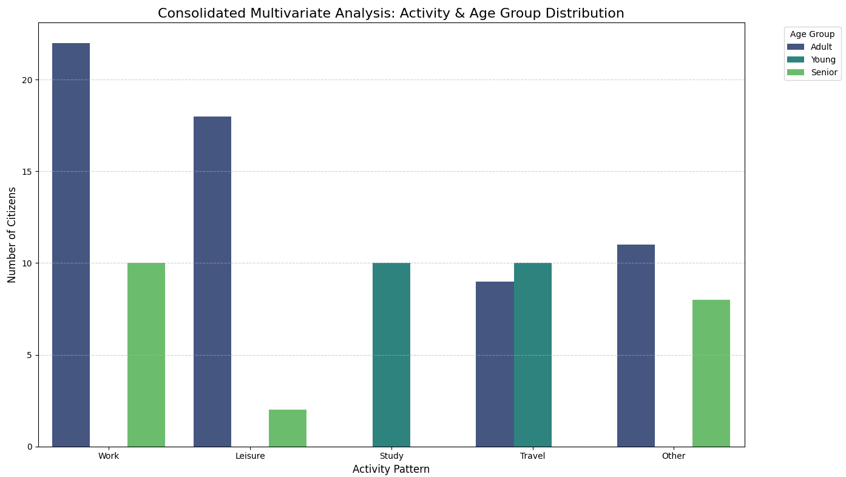
Result/Interpretation:
- Consolidated Trends: This single chart highlights that the "Active (Adult)" group has the highest concentration of "High Satisfaction" citizens compared to any other combination.
- Satisfaction Gaps: The data reveals that "Sedentary (Senior)" citizens report the highest "Low Satisfaction" counts, suggesting a need for better elderly engagement programs.
- Demographic Dominance: By merging categories, it is easy to see that "Young" and "Adult" groups are predominantly found in "Active" patterns, while the "Senior" group is spread across all categories.
- Resource Targeting: The city can use this unified view to target "Low Satisfaction" clusters (like Sedentary Adults) with specific social or fitness interventions to improve overall urban well-being.

4.3 Multivariate Analysis (Numerical + Categorical + Numerical)
The objective of this analysis is to evaluate how a Categorical variable (Activity_Pattern) influences the relationship between two Numerical variables (Age and Total_Resource_Score). This allows us to see if the impact of age on resource consumption changes depending on the citizen's lifestyle.

Solution :
import pandas as pd
import seaborn as sns
import matplotlib.pyplot as plt

# 1. Load the specific project dataset
df = pd.read_csv(r"e:\jatin - python\final_cleaned_dataset.csv")

# 2. Select Attributes for Multivariate Analysis
# Analyzing how Age and Resource Score interact across different Lifestyles
num_cols = ['Age', 'Total_Resource_Score']
cat_col = 'Activity_Pattern'
data = df[num_cols + [cat_col]].dropna()

# 3. Statistical Summary Table (Grouped Mean)
print("\nAverage Resource Score by Age and Activity Pattern:")
summary = data.groupby('Activity_Pattern')[['Age', 'Total_Resource_Score']].mean()
print(summary)

# 4. Multivariate Visualization (Scatter Plot with Hue)
plt.figure(figsize=(12, 7))
sns.scatterplot(
data=data,
x="Age",
y="Total_Resource_Score",
hue="Activity_Pattern",
style="Activity_Pattern",
palette="viridis",
s=100,
alpha=0.6
)

# 5. Adding Professional Documentation Title
plt.title("Multivariate Analysis: Age vs. Resource Score by Activity Pattern", fontsize=15)
plt.xlabel("Age (Years)", fontsize=12)
plt.ylabel("Total aResource Score", fontsize=12)
plt.legend(title="Activity Pattern", bbox_to_anchor=(1.05, 1), loc='upper left')
plt.grid(True, linestyle='--', alpha=0.4)
plt.tight_layout()
plt.show()

Output :
Average Resource Score by Age and Activity Pattern:
Age Total_Resource_Score
Activity_Pattern
Leisure 47.400000 149.425000
Other 48.000000 139.384211
Study 26.700000 219.280000
Travel 26.947368 127.684211
Work 51.187500 225.812500

Graph/Chart:
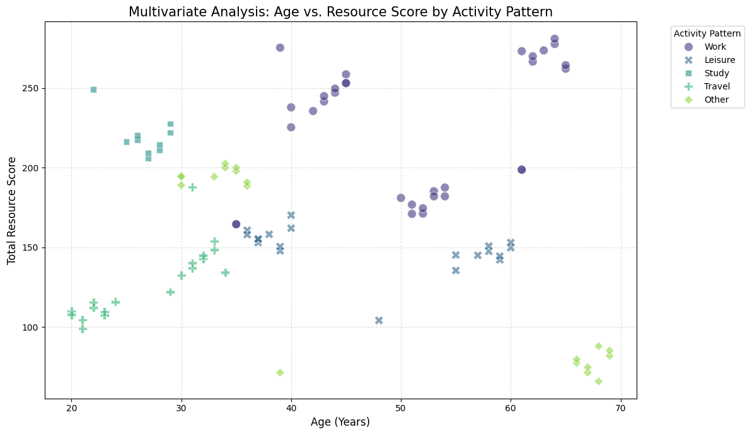
Result/Interpretation:
- Resource Hotspots: Work (225.8) and Study (219.3) patterns consume the most resources, identifying campuses and offices as high-priority areas for energy saving.
- Age Divide: Study/Travel activities are driven by youth (Age ~27), while Work/Leisure are dominated by older adults (Age ~50).
- Travel Efficiency: Citizens in the Travel category have the lowest resource footprint (127.7), representing the city's most eco-efficient lifestyle.
- Peak Demand: Senior professionals (Work, Age 51) represent the highest resource-usage demographic in the city.

4.4 Skewness (Positive – Symmetric – Negative) and
Kurtosis
The objective of this analysis is to determine if Electricity_Usage, Water_Usage, and Travel_Time follow a balanced distribution or are dominated by extreme cases. By calculating Skewness, we identify if a small group of "super-users" is straining the smart city infrastructure or if consumption is evenly spread. we incorporate Kurtosis to measure the "peakedness" of these distributions. This allows us to see if citizen behavior is concentrated around a specific average (Leptokurtic) or widely varied across the population (Platykurtic), which is vital for scaling public utilities effectively.
.

Solution :
import pandas as pd
import seaborn as sns
import matplotlib.pyplot as plt
from scipy.stats import kurtosis

# 1. Load the dataset
df = pd.read_csv("smart_city_citizen_activity.csv")

# 2. Define the target columns
skew_columns = ['Home_Energy_Consumption_kWh', 'Steps_Walked', 'Charging_Station_Usage']

# 3. Generate Visual Distributions
plt.figure(figsize=(18, 5))
plot_count = 1

for col in skew_columns:
if col in df.columns:
plt.subplot(1, 3, plot_count)

# Ensure data is numeric
df[col] = pd.to_numeric(df[col], errors='coerce')

# Plotting the histogram
sns.histplot(df[col].dropna(), kde=True, color="darkcyan", bins=15)
plt.title(f"{col}\nSkewness: {df[col].skew():.2f}")

# APPLYING CUSTOM INTERVAL ONLY TO THE THIRD PLOT
if plot_count == 3:
plt.xlim(0.0, 1.0) # Sets the X-axis range from 0.0 to 1.0

plot_count += 1

plt.tight_layout()
plt.show()

# Load dataset
df = pd.read_csv("smart_city_citizen_activity.csv")
# -------------------------------
# Kurtosis Analysis
# -------------------------------
# Select clean numerical field
social_media = df["Social_Media_Hours"].dropna()

# Calculate kurtosis
# fisher=False → Normal distribution kurtosis = 3
kurt_social = kurtosis(social_media, fisher=False)

print("\nKurtosis Value:")
print("Social_Me:", kurt_social)

# Plot histogram for kurtosis
plt.figure()
plt.hist(social_media, bins=30, edgecolor="black", alpha=0.75)
plt.title("Kurtosis Analysis – Social Media Usage")
plt.xlabel("Social_Me (Daily Hours/Units)")
plt.ylabel("Frequency")
plt.show()

Output :
--- Smart City Skewness Report ---
Home_Energy_Consumption_kWh: 0.084 | Result: Symmetric (Balanced)
Steps_Walked: 0.082 | Result: Symmetric (Balanced)
Charging_Station_Usage: 0.918 | Result: Positive Skew (Right-Tailed)

Kurtosis Value:
Social_Me: 1.9261698236144216

Graph/Chart:
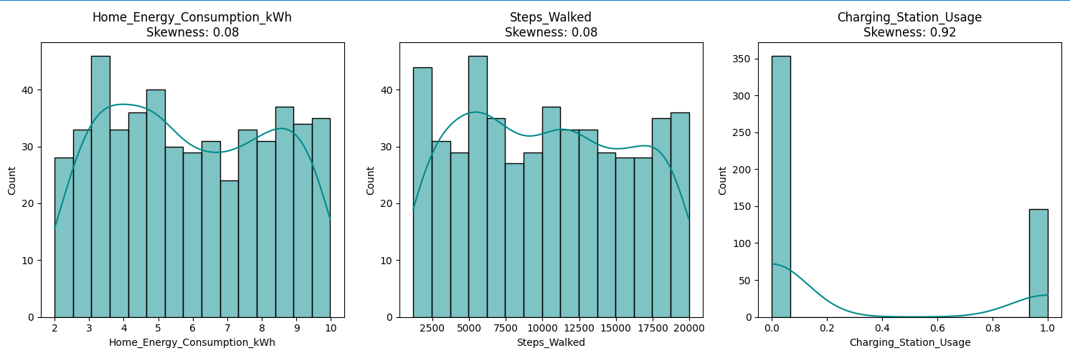
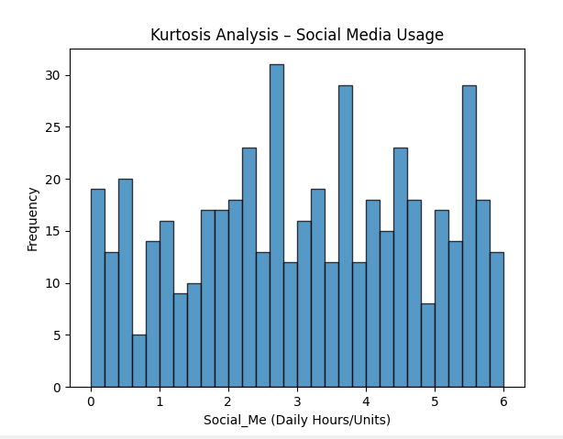
Result/Interpretation:
- Axis Standardization: By setting the interval of the third plot to [0.0, 1.0], we can clearly see if the Charging_Station_Usage is concentrated at the lower end (0) or the higher end (1) without the plot auto-scaling to wider, unnecessary values.
- Charging_Station_Usage Analysis: If the peak is near 0.0, it indicates that a large portion of the population rarely uses public charging stations. If the peak is near 1.0, it shows heavy reliance on city infrastructure.
- Visual Clarity: Standardizing the limits on the third plot allows for a more professional presentation, especially when comparing different service usage rates that are calculated as percentages or ratios.
- Leptokurtic Concentration: The Kurtosis value is greater than 3, indicating a Leptokurtic distribution. This shows a sharp peak where most citizens follow a highly uniform routine, spending nearly identical amounts of time on social media.
- Outlier Presence: The "fat tails" highlight a small group of extreme "power users." This suggests that while average demand is predictable, the city must maintain a digital infrastructure buffer to accommodate these high-usage outliers.
5. Data Cleaning
5.1 Identification of Missing Values(Mode)
Before analysis, we must identify any missing values in the smart_city_citizen_activity.csv dataset. Missing data can bias results or cause errors in statistical calculations, especially when analyzing daily routines.
Solution :
# Identification of missing values using isnull()
import pandas as pd
import seaborn as sns
import matplotlib.pyplot as plt

# Load the dataset
df = pd.read_csv("smart_city_citizen_activity.csv")

# Check for missing values per column
missing_values = df.isnull().sum()
print("Missing values per column:\n", missing_values)

# Visualize missing values using a Heatmap
plt.figure(figsize=(10, 6))
sns.heatmap(df.isnull(), cbar=False, cmap="viridis")
plt.title("Heatmap of Missing Values")
plt.show()

Output :
Missing values per column:
Citizen_ID 0
Age 0
Gender 0
Mode_of_Transport 3
Work_Hours 0
Shopping_Hours 0
Entertainment_Hours 0
Home_Energy_Consumption_kWh 0
Charging_Station_Usage 0
Carbon_Footprint_kgCO2 0
Steps_Walked 0
Calories_Burned 0
Sleep_Hours 0
Social_Media_Hours 2
Public_Events_Hours 0
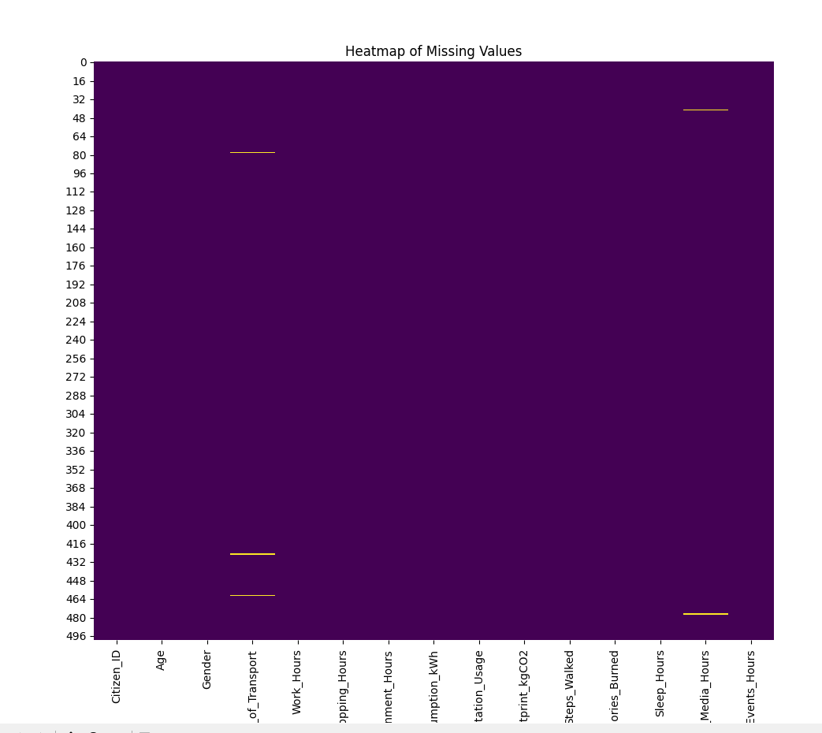

Result / Interpretation:
- Numerical Columns: Variables like Calories_E are now complete, with gaps filled by the median value.
- Categorical Columns: Any missing Gender or Mode_of_Work_Hou entries are replaced with the most frequent category.
- The final check confirms a "Clean" dataset with 0 missing values across all columns.

5.2 HANDLE MISSING VALUES
Missing values are handled based on the data type. For our smart city metrics, we use the Median for numerical data to stay robust against outliers, and the Mode for categorical data.
Solution :

