JATIN DHALL

20BCE0832

**DATA VISUALIZATION LAB FAT**

**CODE**

#

# This is a Shiny web application. You can run the application by clicking

# the 'Run App' button above.

#

# Find out more about building applications with Shiny here:

#

#    http://shiny.rstudio.com/

#

#code by JATIN DHALL

#20BCE0832

library(shiny)

library(shinydashboard)

library(DT)

library(dplyr)

library(ggplot2)

library(broom)

library(lmtest)

library(ggplot2)

library("tm")

library("SnowballC")

library("wordcloud")

library("RColorBrewer")

#Importing the dataset into the code

df <- read.csv("C:/Users/Jatin Dhall/Desktop/Desktop File/VIT/VIT/SEM 3/DATA VIZ/LAB/LABFAT/coursea_data.csv")

head(df)

#Creating dataframe for Q1(Table)

table_cols <- data.frame(

    course_title = df$course_title,

    course_rating = df$course_rating,

    course_students_enrolled = df$course_students_enrolled)

head(table_cols)

#Q2]

#Finding the organisation names and their counts

org_courses_count = count(df, vars = course_organization)

org_names = org_courses_count$vars

org_count = org_courses_count$n

org_names

org_count

# Define UI for application that draws a histogram

ui <- fluidPage(

    dashboardPage(

        dashboardHeader(title="Jatin Dhall 20BCE0832 DA"),

        dashboardSidebar(disable = TRUE),

        dashboardBody(

            fluidRow(box(

                title = "Table(Jatin Dhall)",

                solidHeader = TRUE,

                collapsible = TRUE,

                DT::dataTableOutput("table"),

                width = 12

            )),

            fluidRow(

                box(

                    title = "Bar chart(Jatin Dhall)",

                    solidHeader = TRUE,

                    collapsible = TRUE,

                    plotOutput("bar",height = 500),

                    width = 12

                )

            ),

            fluidRow(

                box(

                    title = "Linear Regression Plot(Jatin Dhall)",

                    solidHeader = TRUE,

                    collapsible = TRUE,

                    plotOutput("regplot"),

                    width = 12

                )

            ),

            fluidRow(

                box(

                    title = "Tag cloud of the inferences(Jatin Dhall)",

                    solidHeader = TRUE,

                    collapsible = TRUE,

                    plotOutput("inferences")

                ),

            )

        )

    )

)

# Define server logic required to draw a histogram

server <- function(input, output) {

    output$table = DT::renderDataTable({

        table_cols

    })

    output$bar <- renderPlot({

        barplot(org_count,names.arg=org_names,xlab="",ylab="No. of courses offered",col="blue",

                main="No. of courses vs Organisation Bar Chart",las=2)

    })

    y <- df$course_rating

    x <- df$course_students_enrolled

    fit <- lm(y ~ x)

    model <- augment(fit)

    output$regplot <- renderPlot({

        ggplot(data = df, aes(x = x, y = y)) +

            geom_point(color='blue') +

            geom_line(color='red',data = model, aes(x=x, y=y))

    })

    output$inferences <- renderPlot({

        filePath <- "C:/Users/Jatin Dhall/Desktop/Desktop File/VIT/VIT/SEM 3/DATA VIZ/LAB/LABFAT/Inference.txt.txt"

        text <- readLines(filePath)

        # Load the data as a corpus

        docs <- Corpus(VectorSource(text))

        inspect(docs)

        toSpace <- content_transformer(function (x , pattern ) gsub(pattern, "

", x))

        docs <- tm_map(docs, toSpace, "/")

        docs <- tm_map(docs, toSpace, "@")

        docs <- tm_map(docs, toSpace, "\\|")

        # Convert the text to lower case

        docs <- tm_map(docs, content_transformer(tolower))

        # Remove numbers

        docs <- tm_map(docs, removeNumbers)

        # Remove english common stopwords

        docs <- tm_map(docs, removeWords, stopwords("english"))

        # Remove punctuations

        docs <- tm_map(docs, removePunctuation)

        # Eliminate extra white spaces

        docs <- tm_map(docs, stripWhitespace)

        # Text stemming

        # docs <- tm_map(docs, stemDocument)

        dtm <- TermDocumentMatrix(docs)

        m <- as.matrix(dtm)

        v <- sort(rowSums(m),decreasing=TRUE)

        d <- data.frame(word = names(v),freq=v)

        head(d, 10)

        set.seed(1234)

        wordcloud(words = d$word, freq = d$freq, min.freq = 1,

                  max.words=200, random.order=FALSE, rot.per=0.35,

                  main = "Tag Cloud with Inference",colors=brewer.pal(8,

                                                                      "Dark2"))

    })

}

# Run the application

shinyApp(ui = ui, server = server)

OUTPUTS OF DASHBOARD

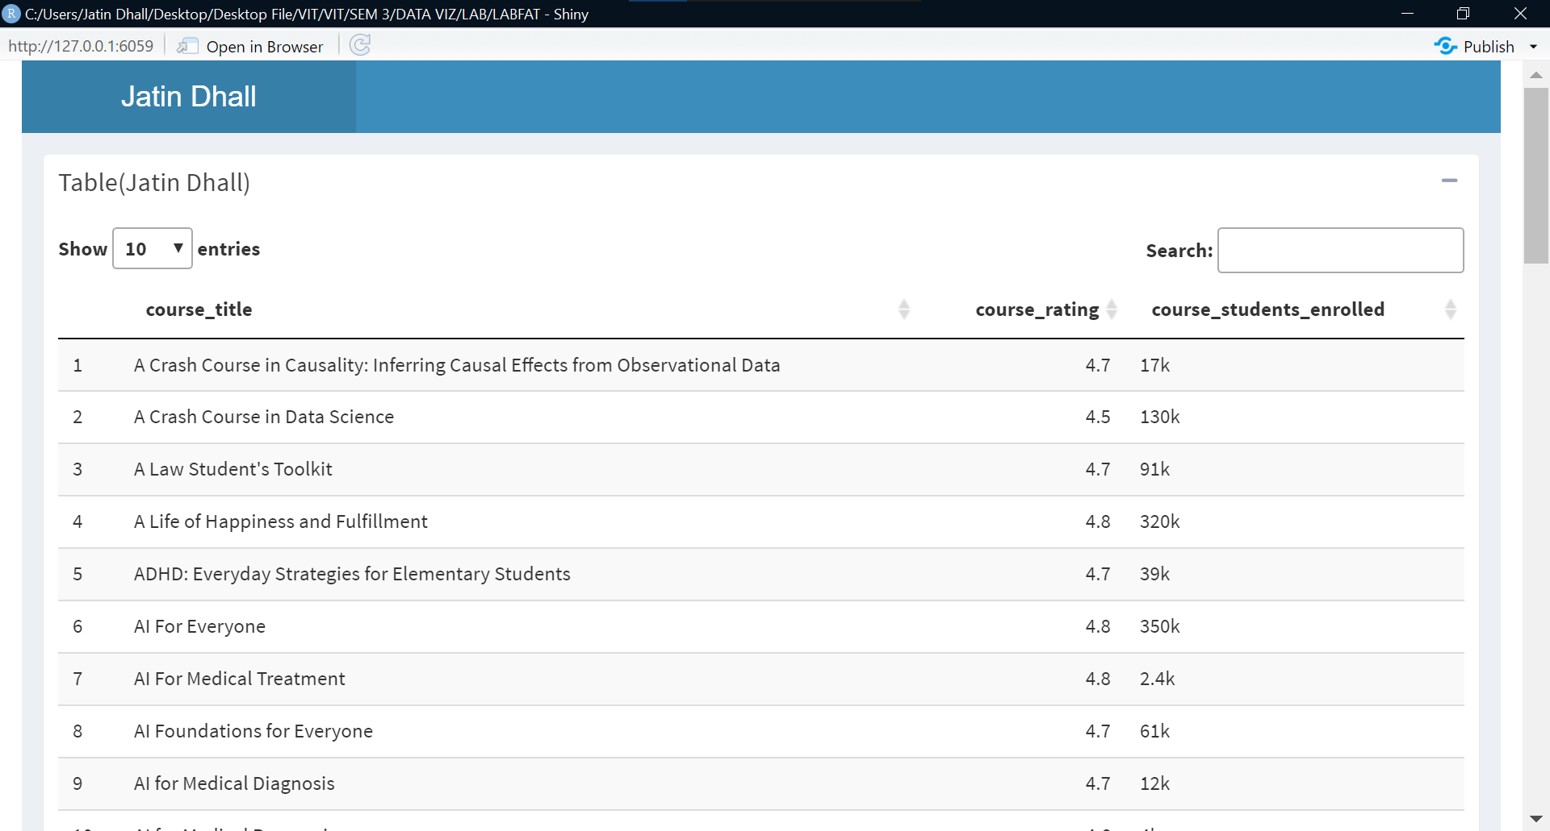

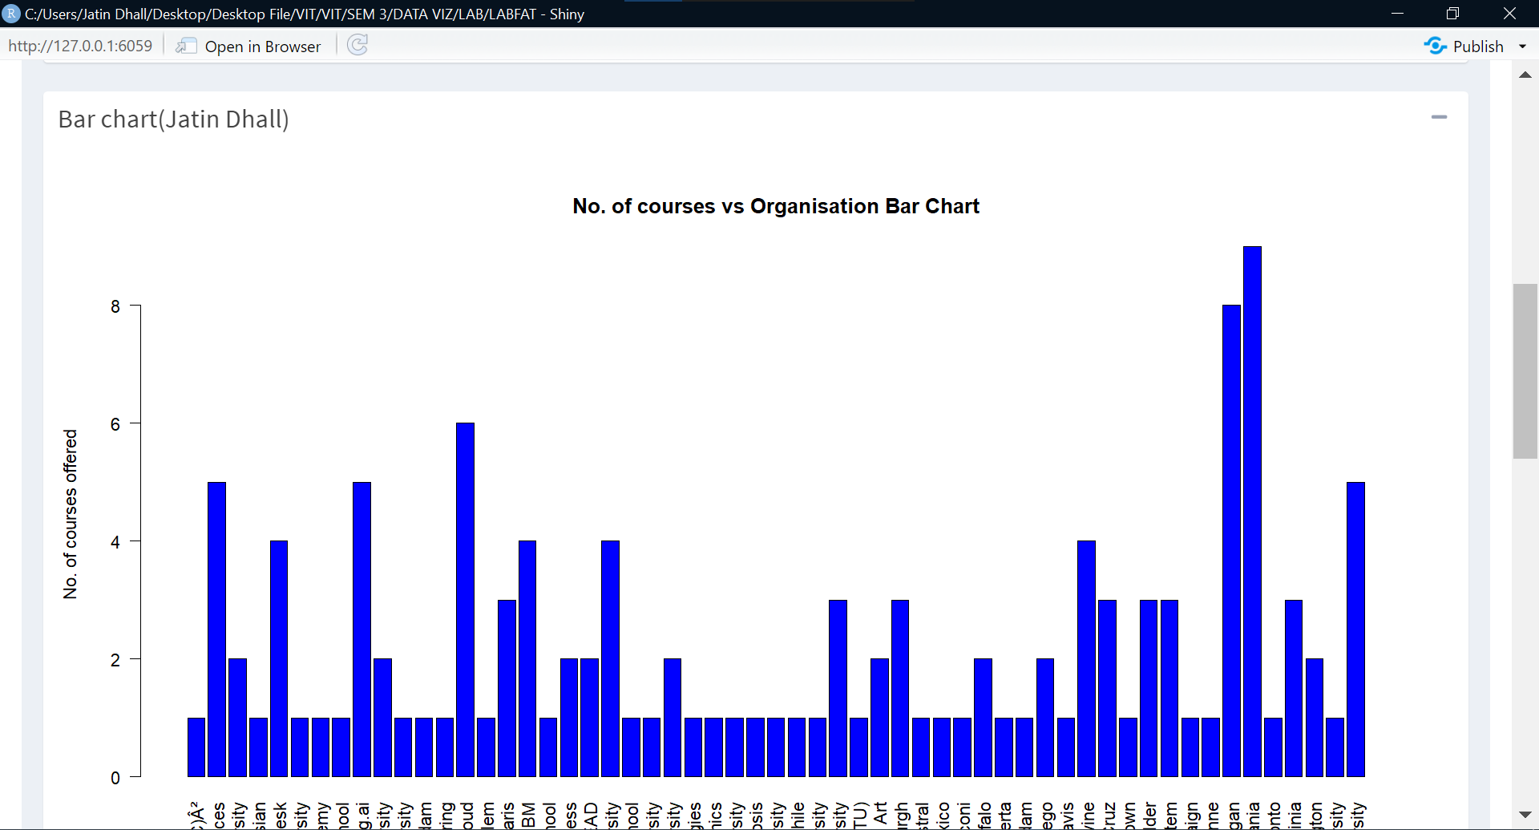

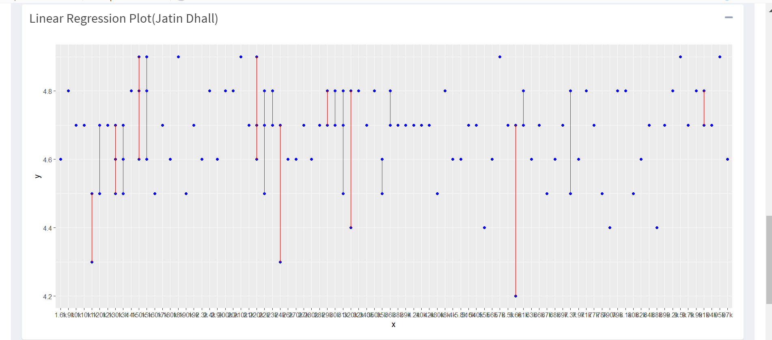

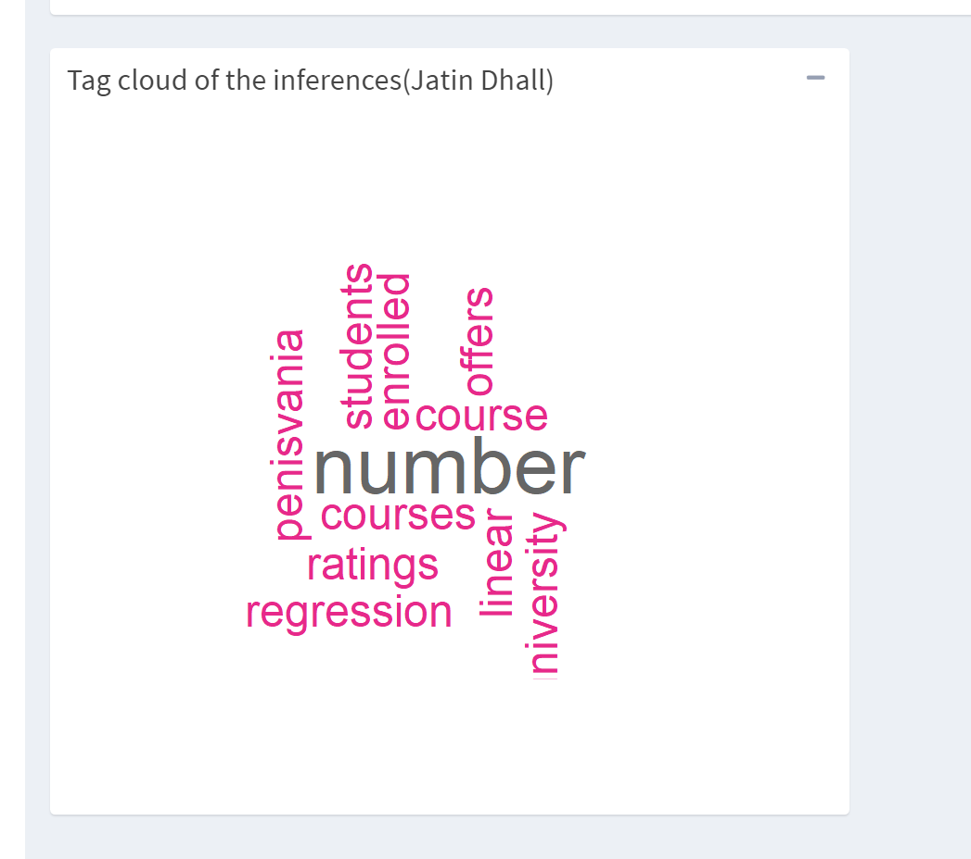

Q3]

INFERENCE

University of Penisvania offers the most number of courses. There is no linear regression between number of students enrolled and course ratings