Say No to Unhealthy Food: A Path to Better Food India

Jatin Reddy# , Bhumika Godbole#

#Students of, Sagar Institute of Research and Technology, Bhopal

[rjatin124@gmail.com](mailto:rjatin124@gmail.com) , [bhumikagodbole29@gmail.com](mailto:bhumikagodbole29@gmail.com)

Abstract— **The increasing presence of unhealthy substances in packaged food products in India raises significant health concerns if it does not monitor. Many commonly consumed foods contain excessive sugar, artificial sweeteners, unhealthy fats, and chemical additives, which contribute to diseases like obesity, diabetes, heart problems, and even cancer. While global regulatory bodies, such as the European Union (EU), U.S. Food and Drug Administration (FDA), and Japan’s Consumer Affairs Agency (CAA), have imposed stricter bans and rules on harmful food additives, substances that are used in package foods, India still permits several controversial substances in many foods and drinks. This research explores the misleading labelling practices, and the regulatory gaps in India's food industry. It highlights the impact of bad advertising, lack of consumer awareness, and weak enforcement of food safety laws. A comparative analysis with countries like the EU, USA, Japan and Australia reveals the urgent need for stronger food safety policies, transparent labelling, and stricter enforcement in India. The study concludes the harm of products inside human body and also this study concludes how companies do marketing gimmicks to show a how well and healthy their products are**.

***Keywords*— Ingredients, Package Food, Gimmicks, India**

1. **Introduction**

Food safety and consumer protection have become growing concerns in India due to the increasing reports of harmful additives, misleading labelling, and regulatory loopholes in packaged food products. The lazy guidelines set by Food Safety and Standards Authority of India (FSSAI), many products in the market continue to contain non-permissible ingredients, and miss leading labels practices. This research aims to examine issues such as allowing harmful substances in food, showing best analysis by hiding or not highlighting the actual analysis of a product and also gaps in food regulations that allow such practices to persist. This study highlights the urgent need for stricter enforcement, greater transparency, and consumer awareness in ensuring food safety in India.

* 1. **Objectives**

This research will analyse the impact of consuming such products on human health by using graphical data representation. It will also explore how customers think before purchasing these misleading products (through trademarks and big claims) and comparing with other countries manufacturers vs Indian manufacturers.

**1.2 Methodology**

The research follows a mixed-method approach, including case studies, literature reviews, and analysis of existing Food ingredients that are used in Food products. Data is collected from customers feedback, products available in markets, articles, and reports present in internet and social media accounts for current based analysis and to know the current knowledge that a person has before buying a product.

**1.3 Scope**

This study covers:

* **Non-addable ingredients** in food that should not be used but are still used in products by increasing profits for companies.
* **Fake trademarks** used to create brand trust by name.
* **False test results** mentioned on packets that mislead consumers.
* **Synthetic/artificial food products** marketed as natural with no warning.

1. **Overview on Package Foods of India**

India's packaged food market has experienced significant growth in recent years, driven by changing consumer lifestyles, increased urbanization, and rising disposable incomes. As of 2023, the market was valued at approximately $113.9 billion and is projected to reach $210.81 billion by 2032, with a compound annual growth rate (CAGR) of 7.08% during 2024-2032.

India’s packaged food industry is growing fast due to urban life and the need for easy food. Problems like food fraud, false labels, weak checks, and unsafe chemicals use. Many companies put profit first, using harmful additives that risk people’s health.

Brands trick buyers by showing bigger results. False test results on packs make food seem safer and nutritiousness than it is. Many artificial foods are sold as "natural" without clear warnings, spreading wrong information. These tricks hurt trust and put health in danger.

Unlike India, the EU and Japan have strict food rules. They ban unsafe chemicals and require clear labels. The U.S. allows some preservatives but has strong recall systems. India still faces food fraud, like fake milk, honey, and spices, because of weak checks and old rules.

1. **Finding and Analysis**
   1. **Harmful Food Substances & Their Impact**

High Sugar & Artificial Sweeteners:

* Problem: Excessive sugar leads to obesity, diabetes, and other health issues. Artificial sweeteners like aspartame and sucralose may have long-term risks.
* Common Sources: Soft drinks (Coca-Cola, Pepsi, Fanta), packaged fruit juices (Real, Tropicana), flavored dairy drinks (Yakult, Amul Kool), breakfast cereals (Kellogg’s Chocos, Nestlé Koko Krunch), energy drinks (Red Bull, Monster).

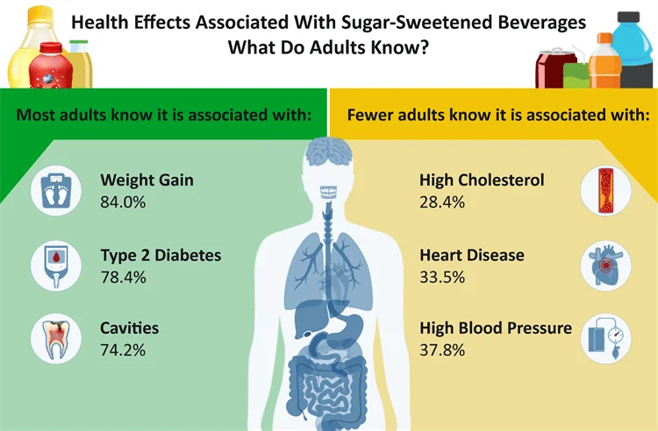

Trans Fats (Unhealthy Fats):

* Problem: Raises bad cholesterol, increasing the risk of heart disease.
* Common Sources: Fried snacks, bakery items, margarine, packaged food.

Too Much Salt (Sodium & Preservatives):

* Problem: Leads to high blood pressure, heart disease, and stroke.
* Common Sources: Chips, instant noodles, processed meats, canned food.

Artificial Colors & Preservatives (Chemical Additives: Tartrazine, Sunset Yellow, Sodium Nitrate):

* Problem: Can cause allergies, hyperactivity (especially in kids), and cancer in high amounts.
* Common Sources: Soft drinks, candies, instant noodles, packaged ready-to-eat meals.
* Regulations: Banned or restricted in the EU but still widely used in India.

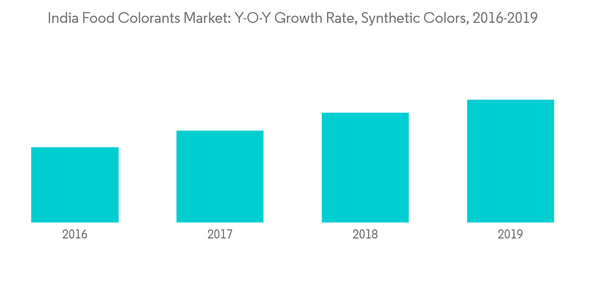

3.2. **Harmful Preservatives & Artificial Colors**

Many packaged foods contain preservatives like benzoates, sulfites, and nitrates, which can cause allergies and other health problems. Artificial colors, such as Tartrazine (E102) and Sunset Yellow (E110), can lead to hyperactivity and other risks.

* Common Products: Instant noodles: Maggi, yippee, Top Ramen, Kurkure, Bingo, Pickles & sauces: Kissan, Tops, Priya (often have chemicals and extra salt)
* Hidden Risk: Some preservatives and colors are allowed, but consuming too much can be harmful over time.

3.3. **MSG & Flavor Enhancers**

Monosodium Glutamate (MSG) (E621) and other flavor enhancers (E635, E627) make food taste better but can cause headaches, nausea, and allergies.

* Common Products: Instant noodles & soups: Maggi, Knorr, Top Ramen, Secret, Chips & snacks: Lay’s Magic Masala, Kurkure, Bingo Mad Angles
* Hidden Risk: MSG can be listed under names like "Yeast Extract" or "Hydrolyzed Vegetable Protein," making it hard to find.

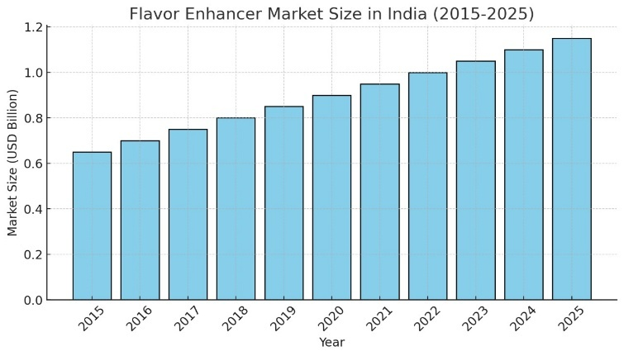

3.4. **Misleading Labels & False Claims**

Some food brands trick customers with claims like "No Added Sugar," "Natural," or "High Protein," even though their products might have artificial ingredients, or unhealthy ingredients.

* Common Misleading Products:

Nestlé Cereal: Marketed as healthy for babies but has a lot of sugar and lots of preservatives.

Bourn Vita & Horlicks: Advertised as nutritious but have high sugar and artificial ingredients.

* Hidden Risk: Many products labeled as "organic" may not be truly organic due to weak regulations.

1. **Challenges & Limitations**

India faces several challenges in ensuring the safety of packaged food like FSSAI regulations, weak enforcement, lack of awareness, and corporate influence that results to un-nutrition food products to reach the market. Addressing these challenges is crucial to improving food safety standards.

**4.1. Challenges:**

* Ineffective Ban Enforcement – Although FSSAI bans harmful substances but poor enforcement and regulatory gaps enable their continued presence in food products.
* Consumer Unawareness – Many consumers do not check food labels or understand the risks associated with harmful additives, because they don’t have much information about used ingredients.
* Outdated Regulations – Some food additives banned in other countries remain legally permitted in India, resulting to potential health risks after their regular use.
* Hidden Health Hazards – The long-term effects of certain food additives are not immediately visible but can lead to serious health issues over time, that as it consumes as daily products that they are not meant for based on the amount of ingredients use.
* False Nutritional Claims – Some brands mislead people by saying their products have "zero trans-fat" or are "high in fibre," even when this is not true. They use tricky words to make the food seem healthier than it really is.
* Misleading Labels – Some food brands use confusing marketing to hide actual ingredients that can be unhealthy.

**4.2. Solutions:**

* Strengthen Food Safety Laws & Increase Penalties – Strict laws and higher fines for violators will ensure better improvements for misleading marketing gimmicks.
* Educate Consumers on Food Safety – Awareness campaigns should teach people how to read labels and recognize marketing gimmicks before using products.
* Stricter Monitoring of Food Advertising – False nutrition claims should be penalized to prevent misleading marketing by Food verification organizations of India as other countries do i.e., Japan, North-Western Countries.
* Encourage Sustainable & Ethical Food Production – Organic and locally sourced food should be promoted as safer alternatives, i.e. producing ingredients within country is best way to make fresh and quality products.

**V.** **Conclusion**

Our Research shows and indicate that some companies prioritize consumer health and many prioritize profits by using unhealthy additives and misleading labels. Packaged foods in our country, i.e. India often contain excessive sugar, artificial sweeteners, trans fats, and chemical additives, leading to serious health risks like obesity, diabetes, and heart disease by using them in regular bases. Unlike the EU, Japan, and the U.S., where stricter regulations and recalls protect consumers, India still allows many of these substances with weak enforcement. To ensure public health, stronger policies, transparent labelling, and increased consumer awareness are important aspects as they improve country health index in world. A shift toward natural, minimally processed foods is important for a healthier future of a country.

Final Thoughts: Increasing awareness will increase the understanding of the products, and eventually companies has to change their way towards healthy ingredients.

**VII. References**

**Web Articles & Reports**

Times of India. (2025, March 24). *Cancer-causing chemicals found in 527 Indian food items by EU food safety authorities*. Retrieved from <https://timesofindia.indiatimes.com/life-style/food-news/cancer-causing-chemicals-found-in-527-indian-food-items-by-eu-food-safety-authorities/articleshow/109598657.cms>

The Better India. (n.d.). *Artificial food preservatives in India*. Retrieved from <https://thebetterindia.com/65429/artificial-food-preservatives-india/>

Greater Kashmir. (2025). *Sweet poison in Kashmir: Will government act?*. Retrieved from <https://www.greaterkashmir.com/opinion/sweet-poison-in-kashmir-will-government-act/>

India Today. (2024, December 19). *Many Indian packaged foods are healthy, except certain snacks*. Retrieved from <https://www.indiatoday.in/health/story/many-indian-packaged-foods-are-healthy-except-certain-snacks-2652287-2024-12-19>

Business Standard. (2024, February 5). *Govt amends food safety rules: Only FSSAI nod mandatory for products*. Retrieved from <https://www.business-standard.com/india-news/govt-amends-food-safety-rules-only-fssai-nod-mandatory-for-products-124020501660_1.html>

Times of India. (2025, March 24). *FSSAI issues new rules for food packaging to prevent misleading consumers*. Retrieved from <https://timesofindia.indiatimes.com/life-style/health-fitness/health-news/fssai-issues-new-rules-for-food-packaging-to-prevent-misleading-of-consumers/articleshow/111551260.cms>

Research Papers & Government Regulations

Journal of Chemical and Health Research. (n.d.). *Analysis of food safety in India*. Retrieved from <https://jchr.org/index.php/JCHR/article/view/1133>

Indian Kanoon. (n.d.). *Legal document on food safety regulations*. Retrieved from <https://indiankanoon.org/doc/61800811/>

Legality Simplified. (2025). *Draft notification of food safety and standards (Labelling and Display) amendment regulations, 2025*. Retrieved from <https://www.legalitysimplified.com/draft-notification-of-food-safety-and-standards-labelling-and-display-amendment-regulations-2025/>

Food Safety and Standards Authority of India (FSSAI). (n.d.). *Food safety and standards (Packaging and Labelling) regulations*. Retrieved from <https://www.fssai.gov.in/upload/uploadfiles/files/Packaging_Labelling_Regulations.pdf>

Food Safety and Standards Authority of India (FSSAI). (n.d.). *Note on Nutritional and Safety Standards (NSS)*. Retrieved from <https://fssai.gov.in/upload/uploadfiles/files/note%20on%20NSS.docx.pdf>

**Instagram**

foodpharmer Channel [based on all information on food]-<https://www.instagram.com/foodpharmer/?hl=en>

**YouTube Video**

[NEWS9 Live](https://www.youtube.com/@NEWS9LIVE) Channel. (Apr 22, 2024). *[*Cancerous Chemicals Detected in Indian Spice Brands; Everest Spices In The List

*]* [Video]. YouTube. <https://www.youtube.com/watch?v=7cP2iIEeYiA>

**Wikipedia Entry**

Wikipedia. (n.d.). *Maggi noodles safety concerns in India*. Retrieved from <https://en.wikipedia.org/wiki/Maggi_noodles_safety_concerns_in_India>

**Market Reports & Graphs**

News Medical. (2024, December 17). *Knowing the risks: Americans still sip sugary beverages daily*. Retrieved from <https://www.news-medical.net/news/20241217/Knowing-the-risks-Americans-still-sip-sugary-beverages-daily.aspx>

Mordor Intelligence. (2025). *India food colorants market industry report*. Retrieved from <https://www.mordorintelligence.com/industry-reports/india-food-colorants-market-industry>