USE-CASE MODELLING
Learning Management System (LMS) Platform
Prepared from the LMS README. This models intended behaviour and does not imply that every feature is already implemented.

1. Objective
Identify the actors, system boundary, major functions, and interactions for the LMS Platform using UML use-case modelling.

2. Actors
Actor | Type | Responsibility
Public Visitor | Unauthenticated | Browses public pages and courses; can begin registration or sign-in.
Student | Primary | Accesses learning content, purchases courses/subscriptions, attends classes, attempts tests, and reviews performance.
Educator | Primary | Manages learning materials, schedules live classes, creates tests, and reviews student performance.
Administrator | Administrative | Manages users and roles, moderates content, manages payments/content, and reviews analytics.
Payment Gateway | External system | Processes payments and returns status; backend verifies results before granting paid access.
Live-Class Provider | External system, if integrated | Provides the live meeting service for scheduled sessions.

3. Use-Case Identification
ID | Use Case | Actor(s)
UC-01 | Browse Public Website / Courses | Public Visitor, Student
UC-02 | Register / Sign In | Public Visitor, Student, Educator, Administrator
UC-03 | Browse Course Catalogue | Student
UC-04 | Access Free Learning Content | Student
UC-05 | Purchase Course / Subscription | Student, Payment Gateway
UC-06 | Access Premium Content | Student
UC-07 | Attend Live Class | Student, Live-Class Provider
UC-08 | Schedule / Manage Live Class | Educator, Live-Class Provider
UC-09 | Upload / Manage Learning Materials | Educator
UC-10 | Create / Manage Tests and Questions | Educator
UC-11 | Attempt Test and Submit Answers | Student
UC-12 | View Results / Performance | Student, Educator
UC-13 | Manage Users and Roles | Administrator
UC-14 | Moderate Content / Manage CMS | Administrator
UC-15 | Manage Payments / Subscriptions | Administrator
UC-16 | View Platform Analytics | Administrator

4. Use-Case Diagram
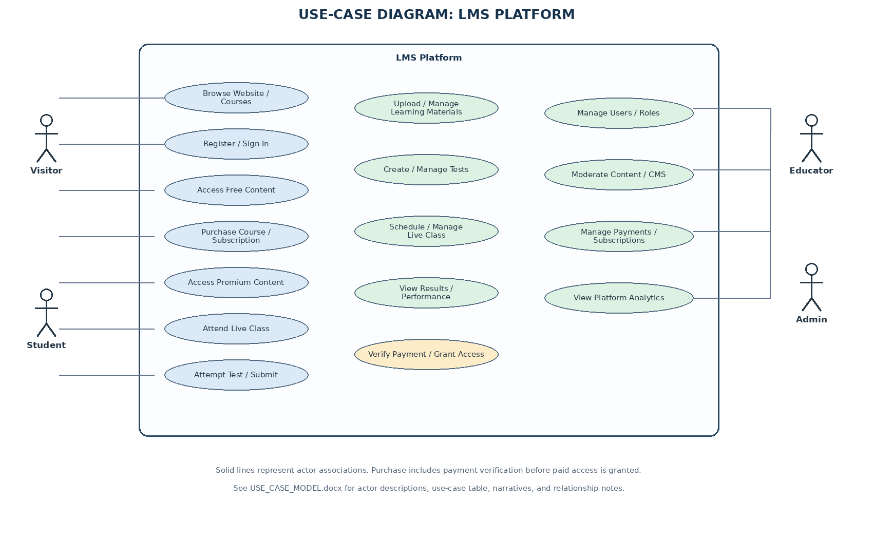
Solid lines show actor associations. Purchase Course / Subscription includes payment verification. External payment and live-class actors apply when those providers are separate from the LMS boundary.

5. Use-Case Narratives

UC-05: Purchase Course / Subscription
Primary actor: Student
Preconditions: Student is signed in and the selected item is available.
Main success flow:
- System displays item, price, and terms.
- Student confirms purchase.
- System creates a pending transaction and initiates gateway checkout.
- Gateway processes payment.
- Backend verifies the payment result or signed webhook.
- System records the verified transaction and grants matching access.
- System shows confirmation and updates purchase history.
Alternative / exception flow:
- Payment fails/cancels: record result and do not grant access.
- Confirmation is delayed: keep transaction pending until verified.
- Duplicate callbacks are handled idempotently.
Postconditions: Verified successful payment grants the appropriate access; unsuccessful payment does not.

UC-09: Upload / Manage Learning Materials
Primary actor: Educator
Preconditions: Educator is authenticated and authorized for the course.
Main success flow:
- Educator selects a course or subject.
- Educator uploads a supported file or creates rich-text material.
- System validates fields and file type/size.
- Educator sets title, tags, and free/paid access level.
- System stores the material and associates it with the course and educator.
Alternative / exception flow:
- Unsupported/unreadable file: reject it with a clear message.
- If moderation is required, keep the material pending approval.
Postconditions: Material is stored and associated with the selected course.

UC-11: Attempt Test and Submit Answers
Primary actor: Student
Preconditions: Student is authenticated and the test is published and available.
Main success flow:
- Student opens the test and reviews instructions and duration.
- System creates an attempt and displays questions.
- Student answers and navigates between questions.
- Student submits the test, or the timer expires according to test rules.
- System evaluates objective questions and calculates the result.
- System saves the attempt and makes the result available.
Alternative / exception flow:
- If submission fails, show a clear status and avoid duplicate attempts.
- Resume behaviour depends on the implementation's save/resume policy.
Postconditions: Attempt and result are saved for later review.

UC-12: View Results / Performance
Primary actor: Student / Educator
Preconditions: Actor is authenticated and relevant test or course data exists.
Main success flow:
- Actor opens the performance dashboard or permitted course analytics.
- System retrieves only data the actor is authorized to view.
- System displays scores, attempt history, and relevant progress summaries.
Alternative / exception flow:
- If no results exist, show an empty state.
- If data is unavailable, show pending/error status rather than fabricated values.
Postconditions: Authorized performance information is displayed.

UC-13: Manage Users and Roles
Primary actor: Administrator
Preconditions: Administrator is authenticated and authorized.
Main success flow:
- Administrator opens user management and selects an account.
- System displays permitted account details and current status.
- Administrator updates an allowed field, role, or account status.
- System validates permissions and saves the change.
- System confirms the result and records an audit event where implemented.
Alternative / exception flow:
- If the account is not found or permission is insufficient, reject the action with a clear message.
Postconditions: Authorized changes are saved; unauthorized changes are blocked.

6. UML Relationship Notes
- Association: solid line between actor and use case.
- <<include>>: required reused behaviour; purchase includes verification of payment before access is granted.
- <<extend>>: optional/conditional behaviour; use only when a feature is truly conditional.
- System boundary: rectangle contains functions delivered by the LMS Platform.

7. Assumptions and Open Decisions
- Student, Educator, and Administrator are the main authenticated roles.
- Payment and live-class providers are external actors only if integrated as separate systems.
- The README describes intended capabilities; exact availability depends on MVP scope and implementation.

