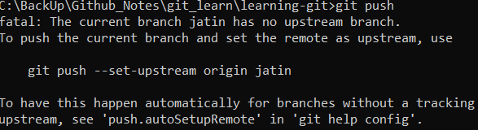

This means that branch “jatin” changes which you want to push is present in local repo and that branch is not present in remote repo.

**git push --set-upstream origin jatin**

Above cmd will create branch in remote repo and then push changes.