**Thymleaf**

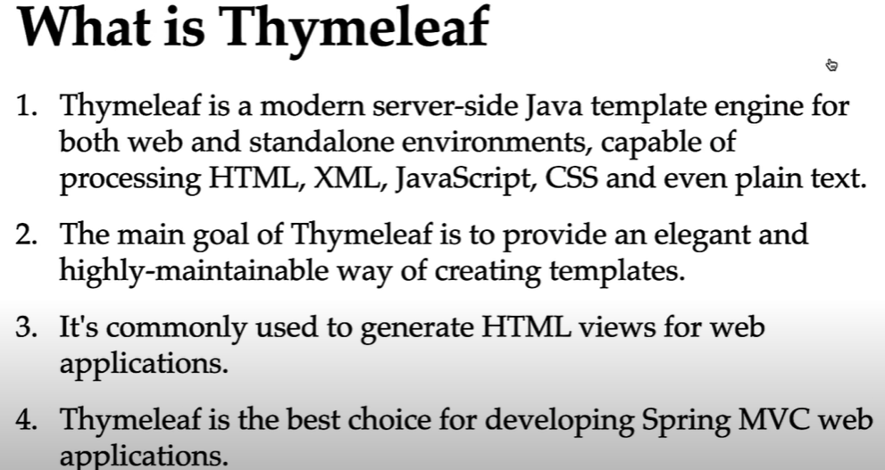

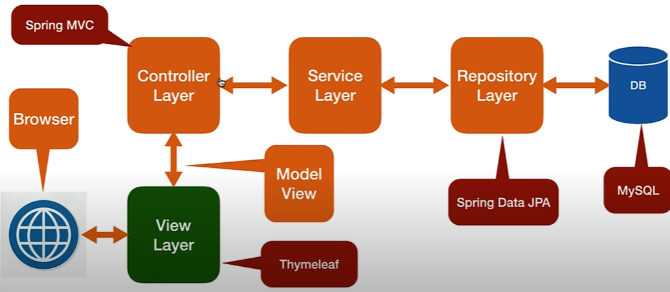

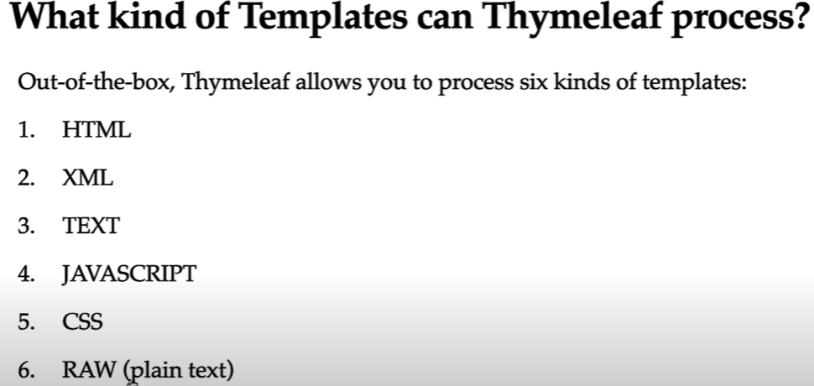

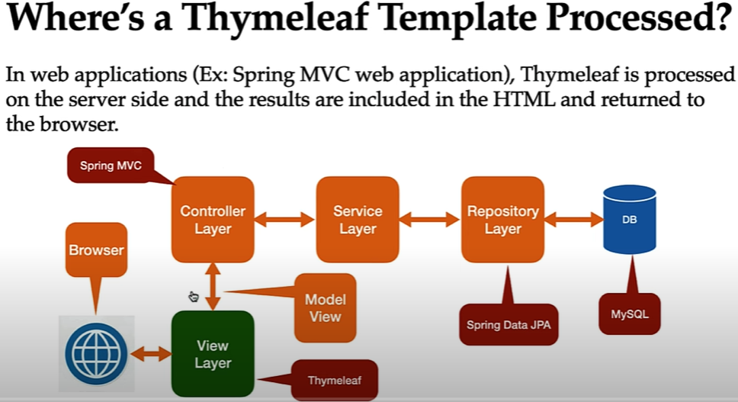

### Step-by-Step Workflow of Thymeleaf Engine:

#### 1. User Request

* A user sends an HTTP request (e.g., via a browser) to a Spring Boot application.

#### 2. Controller Processes Request

* A Spring @Controller method is mapped to handle the request.
* It performs business logic and prepares data (model attributes).

#### 3. Controller Returns View Name + Model

* The controller returns:
* A **view name** (e.g., "home" or "greeting")
* A **Model** object (key-value pairs of data)

#### 4. View Resolver Looks Up Template

* Spring Boot uses **InternalResourceViewResolver** (or another view resolver) to map the view name to a **Thymeleaf template** file (e.g., resources/templates/greeting.html).

#### 5. Thymeleaf Engine Kicks In

* Thymeleaf loads the template and:
* Parses the HTML
* Finds special Thymeleaf attributes like th:text, th:each, etc.
* Replaces placeholders with actual model data

#### 6. HTML is Rendered

* Thymeleaf renders the complete HTML page with dynamic content.

#### 7. Response Sent Back

* The rendered HTML is returned to the browser as the HTTP response.