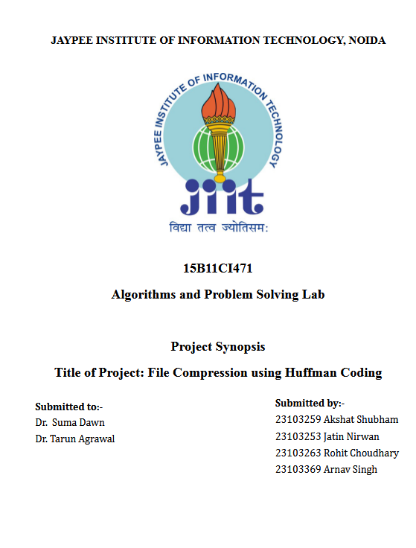

AIM
To implement and analyze Huffman coding as an efficient lossless compression algorithm to minimize file size by encoding characters with shorter binary codes based on their frequencies.

INTRODUCTION
File compression is a crucial aspect of data storage and transmission, reducing file size without compromising content integrity. Huffman coding, a well-known greedy algorithm, generates an optimal prefix-free binary tree to represent characters based on their frequencies, achieving significant compression rates.
This project extends Huffman coding beyond text compression to support multiple file formats, including PDFs, images, and Word documents. The primary challenge is ensuring that compression preserves metadata and structure for each file type.

OBJECTIVES
1. To study the principles of lossless compression and Huffman coding.
2. To implement the Huffman coding algorithm for encoding and decoding files.
3. To analyze the efficiency of Huffman coding in terms of compression ratio and execution time.
4. To compare Huffman coding with other compression techniques.
5. To extend Huffman coding to handle PDFs, images, and Word files while preserving metadata.

METHODOLOGY
1. Identifying test data with varying character distributions.
2. Calculate character frequencies in the input file.
3. Use a priority queue to construct the Huffman tree.
4. Generate binary codes and reconstruct original data.
5. Measure compression ratio and execution efficiency.
6. Enhancing Huffman coding for different file types:
- Read files as binary data to support all formats.
- Extract and store file metadata separately for correct reconstruction.
- Compress only file content, preserving essential headers (e.g., PDF signatures, EXIF data).
- Reassemble the original file after decompression.

BLOCK DIAGRAM
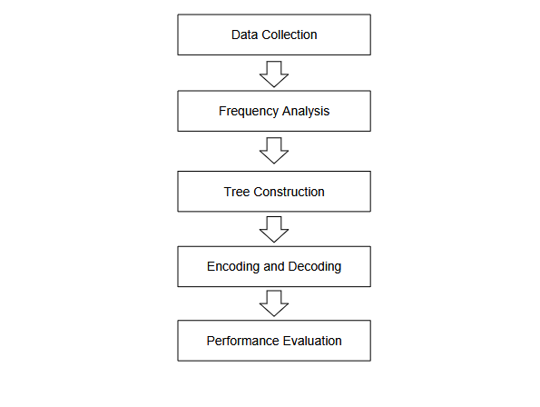

EXPECTED OUTCOMES
1. Efficient implementation of Huffman coding for file compression.
2. Reduction in file size while maintaining data integrity.
3. Support for multiple file formats (Text, PDF, Images, Word).
4. Analysis showcasing Huffman coding’s effectiveness across different file types.

DATA STRUCTURES AND ALGORITHMS INVOLVED
1. Priority Queue (Min Heap) – Used to efficiently construct the Huffman tree by repeatedly extracting the two lowest-frequency nodes.
2. Binary Tree – The Huffman tree is a specialized binary tree where each character is stored at a leaf node, and traversal determines encoding.
3. Greedy Algorithm – Huffman coding follows a greedy approach, always combining the least frequent nodes first to ensure optimal prefix codes.
4. Hash Maps – Used to store character-to-code mappings for fast lookup during encoding and decoding.
5. Bit Manipulation – Essential for encoding data efficiently by representing characters in their compressed binary form.
6. Metadata Handling – Ensures correct reconstruction of non-text files (PDF, images, Word) by preserving essential structural data.

CONCLUSION
Huffman coding provides an optimal solution for lossless data compression, significantly reducing storage requirements and enhancing transmission efficiency. This project extends its capabilities by adding support for multiple file formats, ensuring that compression is not limited to plain text but also works for PDFs, images, and Word documents while preserving file integrity.

REFERENCES
- "Huffman Coding | Greedy Algorithm," GeeksforGeeks. [Online]. Available: https://www.geeksforgeeks.org/huffman-coding-greedy-algo-3/. [Accessed: Feb., 2025].
- "File Compression Using Huffman Coding," Tutorialspoint. [Online]. Available: https://www.tutorialspoint.com/file-compression-using-huffman-coding. [Accessed: Feb., 2025].
- "Huffman Coding - Design and Analysis of Algorithms," The University of Texas at Arlington. [Online]. Available: https://ranger.uta.edu/~huang/teaching/CSE5311/CSE5311_Lecture17.pdf. [Accessed: Feb., 2025].
- "Lecture 19 - Compression and Huffman Coding," MIT OpenCourseWare. [Online]. Available: https://ocw.mit.edu/courses/6-046j-design-and-analysis-of-algorithms-spring-2012/. [Accessed: Feb., 2025].

