# Software Requirements Specification

**Project:** Fiber AI — Company Intelligence Dashboard
**Version:** 1.0.0
**Date:** 2026-03-12
**Status:** Internal Engineering Reference

---

## Table of Contents

1. [System Overview](#1-system-overview)
2. [Technology Stack](#2-technology-stack)
3. [System Architecture](#3-system-architecture)
4. [Database Schema](#4-database-schema)
5. [API Documentation](#5-api-documentation)
6. [Frontend Architecture](#6-frontend-architecture)
7. [Important Components](#7-important-components)
8. [UI Flow](#8-ui-flow)
9. [Data Flow](#9-data-flow)

---

## 1. System Overview

### 1.1 Purpose

The **Fiber AI Company Intelligence Dashboard** is a full-stack web application that allows analysts and sales intelligence teams to explore, filter, and export a curated dataset of companies and their detected technology stacks. The system provides a rich filtering UI over a structured SQLite database, enabling users to drill down into company data by geography, industry category, and the technologies each company uses.

### 1.2 Problem Statement

Sales and intelligence teams need a fast, queryable view into large sets of company-technology relationships. Raw data exports or spreadsheets are not interactive and cannot express compound filters (e.g., "companies in Germany or France that use Shopify but not Salesforce and have between 5 and 20 technologies"). This dashboard solves that problem with a purpose-built filtering interface backed by a structured database.

### 1.3 High-Level System Architecture
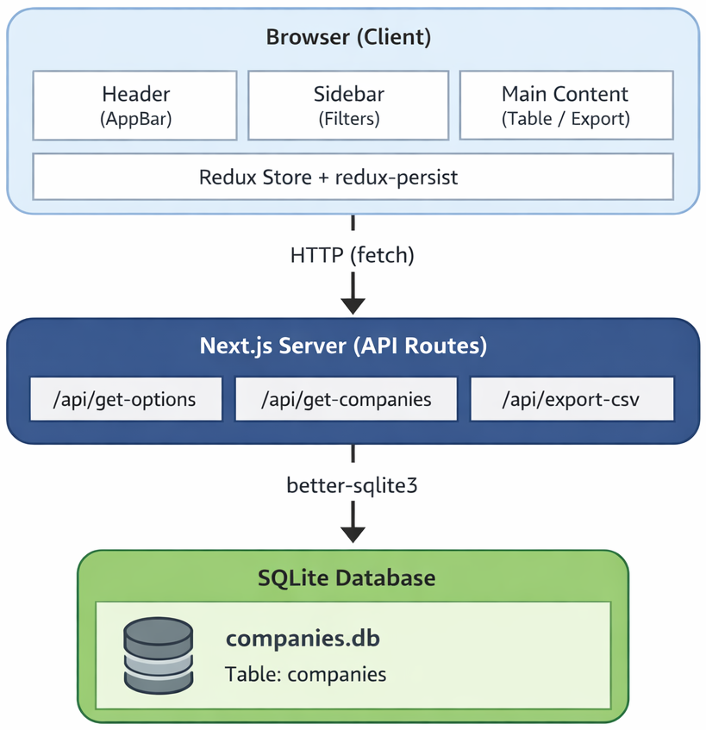

### 1.4 Main Modules

| Module | Description |
|---|---|
| **Filter Sidebar** | Accordion-style panel with multiselect, range slider, and include/exclude filter controls |
| **Search Bar** | Full-text search against company name and domain |
| **Data Table** | Paginated, column-configured table displaying company records |
| **Save View** | Named snapshots of the current filter state, persisted to localStorage |
| **CSV Export** | Downloads all currently filtered companies (all pages) as a CSV file |
| **API Layer** | Three Next.js API route handlers for options, company data, and CSV export |
| **Database** | Single SQLite file with one denormalized table indexed for fast filtering |
| **Redux Store** | Global state management with selective persistence per slice |

---

## 2. Technology Stack

### 2.1 Runtime Requirements

| Requirement | Version |
|---|---|
| Node.js | >= 22.0.0 |

### 2.2 Frontend

| Technology | Version | Purpose |
|---|---|---|
| **Next.js** | 15.5.0 | Full-stack React framework (App Router, API routes, SSR layout) |
| **React** | 19.1.0 | UI component model |
| **TypeScript** | ^5.x | Static typing across all source files |
| **Material UI (MUI)** | ^6.5.0 | Component library — tables, accordions, modals, buttons, autocomplete |
| **@mui/icons-material** | ^6.5.0 | Icon set used in the sidebar and header |
| **@emotion/react + styled** | ^11.x | CSS-in-JS runtime required by MUI |
| **Tailwind CSS** | ^4.x | Utility CSS (used minimally via `globals.css`) |
| **react-icons** | ^5.6.0 | Additional icon sets (react-icons/md, react-icons/fa, etc.) |

### 2.3 State Management

| Technology | Version | Purpose |
|---|---|---|
| **Redux Toolkit** | ^2.11.2 | Slice-based state management |
| **react-redux** | ^9.2.0 | React bindings for Redux |
| **redux-persist** | ^6.0.0 | Automatic state persistence to sessionStorage / localStorage |

### 2.4 Backend / Database

| Technology | Version | Purpose |
|---|---|---|
| **better-sqlite3** | ^12.6.2 | Synchronous SQLite driver for Node.js |
| **SQLite** | (bundled) | Embedded relational database storing all company data |
| **winston** | ^3.19.0 | Structured server-side logging |

### 2.5 Tooling

| Technology | Version | Purpose |
|---|---|---|
| **Biome** | 2.2.0 | Linting and formatting (replaces ESLint + Prettier) |
| **tsx** | ^4.x | TypeScript script runner for the database setup script |
| **json5** | ^2.2.3 | Parses source data files in JSON5 format during setup |
| **Turbopack** | (bundled with Next.js) | Fast development bundler |

---

## 3. System Architecture

### 3.1 Frontend Architecture

The application uses the **Next.js 15 App Router**. The root layout (`src/app/layout.tsx`) is a **Server Component** that wraps children with the `Providers` client component. The single page (`src/app/page.tsx`) is marked `"use client"` and composes three top-level layout components: `Header`, `Sidebar`, and `MainContent`.

State is managed entirely through a **Redux store** with selective persistence. No server-side rendering of page content occurs — the page is fully client-rendered after hydration.

**Component tree:**

```
RootLayout (Server Component)
└── Providers (Client — Redux Provider + PersistGate + ThemeProvider)
└── Home/page.tsx (Client)
├── Header
│ ├── Sidebar toggle button
│ └── Theme toggle button
├── Sidebar
│ ├── MultiSelect (countries, categories, tech, tech categories)
│ ├── RangeSlider (number of technologies)
│ ├── Apply button
│ └── Saved Filters list
└── MainContent
├── CompaniesSearchBar + Search button
├── SaveViewModal
├── ExportCompaniesCsvModal
└── DataTableBody<CompanyRow>
```

### 3.2 Backend Architecture

The Next.js API routes run in **Node.js** (not Edge runtime). They share a singleton SQLite connection obtained via `getDb()` from `src/lib/db.ts`. All SQL queries are **parameterized** (using `better-sqlite3` prepared statements) to prevent injection.

```
src/app/api/
├── get-options/route.ts — GET — returns filter dropdown options
├── get-companies/route.ts — POST — returns filtered + paginated company data
└── export-companies-csv/route.ts — POST — returns CSV file for download
```

### 3.3 API Layer

API routes follow a consistent structure:
1. Parse and validate the request body
2. Log the call with `winston`
3. Execute one or more parameterized SQLite queries
4. Return a `NextResponse.json()` or a raw `NextResponse` (for CSV)
5. Handle errors with a 500 response

---

## 4. Database Schema

### 4.1 Overview

The database is a single **SQLite file** located at `companies.db` in the project root. It contains one table: `companies`. The schema is **denormalized** — each row represents a unique `(domain, technology)` pair. A company with five detected technologies appears as five rows in the table, each sharing the same `domain`, `companyName`, location fields, etc., but differing in `tech` and `techCategory`.

### 4.2 Primary Key

The table uses a **composite primary key** on `(domain, tech)`, ensuring that each company-technology pair is unique. A single domain can appear in multiple rows if it uses multiple technologies.

### 4.4 DBML Code
```
// Table storing company metadata along with detected technologies.
// Each row represents a (domain, technology) pair.

Table companies {

// Company domain (always present)
domain text [not null, note: "Primary identifier for a company"]

// Basic company information
companyName text [note: "Human readable company name"]
companyCategory text [note: "Industry or category the company belongs to"]

// Location data
city text
state text
country text [note: "Country where the company operates"]
zipcode text

// Technology detected on the company's website
tech text [note: "Technology used by the company. May be NULL if no technology detected"]

// High-level grouping of technologies
techCategory text [note: "Category of the technology (e.g. Analytics, CMS, Payments)"]

// Composite primary key
// Ensures each domain-technology pair appears only once
Indexes {
(domain, tech) [pk, note: "Composite primary key ensuring unique domain-technology pair"]

companyCategory [note: "Helps filtering companies by industry/category"]

country [note: "Optimizes country-based filtering queries"]

tech [note: "Speeds up queries searching companies using a specific technology"]

techCategory [note: "Optimizes technology category based filtering"]
}
}
```

### 4.5 Database Diagram
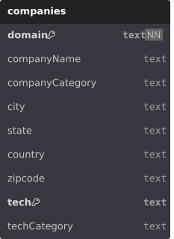

### 4.7 Example Row

```
domain | companyName | companyCategory | city | country | tech | techCategory
--------------|---------------|--------------------------|---------|---------|------------|-------------
stripe.com | Stripe | Technology And Computing | Dublin | IE | React | JS Frameworks
stripe.com | Stripe | Technology And Computing | Dublin | IE | Cloudflare | CDN
stripe.com | Stripe | Technology And Computing | Dublin | IE | Stripe | Payments
```

### 4.8 Setup Script

The database is populated by running `npm run setup`, which executes `src/setup.ts`. This script:
1. Reads raw data files in JSON5 format (UTF-16LE encoded)
2. Parses company metadata, technology lists, and category mappings
3. Creates the `companies` table with the schema above
4. Builds all indexes
5. Inserts all rows via a prepared statement transaction

---

## 5. API Documentation

All API routes live under `/api/` and are implemented as Next.js App Router route handlers in `src/app/api/`. They run in the **Node.js runtime** (not Edge). All endpoints return `application/json` except the CSV export, which returns `text/csv`.

---

### 5.1 GET /api/get-options

#### Purpose
Returns all distinct values for each filterable dimension from the database, plus the maximum number of technologies any single company has. This endpoint is called once on application mount to populate all filter dropdowns and configure the technology count range slider.

#### Method
`GET`

#### Response

```json
{
"maxTechsInDomain": 42,
"companyCategoryOptions": ["Analytics", "E-Commerce", "Technology And Computing"],
"countryOptions": ["AT", "CA", "DE", "FR", "GB", "HK", "NL", "US"],
"techOptions": ["Cloudflare", "jQuery", "React", "Shopify"],
"techCategoryOptions": ["Analytics", "CDN", "CMS", "JavaScript Frameworks", "Payments"]
}
```

#### Error Responses
| 500 | Database error or unexpected server exception |

#### Example cURL
```bash
curl -X GET http://localhost:3000/api/get-options
```

---

### 5.2 POST /api/get-companies

#### Purpose
The primary data endpoint. Accepts a compound filter specification and returns a paginated list of matching companies along with the full list of matching domains (used for CSV export). Filters are combined with AND logic at the company level. Include/exclude filters within the same dimension are combined with OR logic.

#### Method
`POST`

#### Headers
```
Content-Type: application/json
```

#### Request Body
All fields are optional. Omitting a field means "no constraint" for that dimension.

```json
{
"searchStr": "stripe",
"countries": ["US", "GB"],
"companyCategories": ["Technology And Computing"],
"includedTechList": ["React", "Cloudflare"],
"excludedTechList": ["Salesforce"],
"includedTechCategoryList": ["Payments"],
"excludedTechCategoryList": ["Advertising"],
"minNumberOfTech": 3,
"maxNumberOfTech": 20,
"skip": 0,
"limit": 10
}
```

#### Response

```json
{
"totalCount": 142,
"domains": ["acme.com", "stripe.com", "shopify.com"],
"data": [
{
"domain": "acme.com",
"companyName": "Acme Corp",
"companyCategory": "Technology And Computing",
"city": "San Francisco",
"state": "CA",
"country": "US",
"zipcode": "94107",
"tech": ["React", "Cloudflare", "Stripe"],
"techCategory": ["JavaScript Frameworks", "CDN", "Payments"]
}
]
}
```
#### Error Responses
| 400 | `{ "error": "searchStr must be a non-empty string if provided" }` | Validation failed |
| 400 | `{ "error": "includedTechList and excludedTechList share conflicting values: React" }` | Include/exclude overlap |
| 400 | `{ "error": "minNumberOfTech must be <= maxNumberOfTech" }` | Invalid range |
| 500 | `{ "error": "Internal server error" }` | Database or server exception |

#### Example cURL

```bash
# Filter to US companies using React but not Salesforce, with 5-30 technologies, page 1
curl -X POST http://localhost:3000/api/get-companies \
-H "Content-Type: application/json" \
-d '{
"countries": ["US"],
"includedTechList": ["React"],
"excludedTechList": ["Salesforce"],
"minNumberOfTech": 5,
"maxNumberOfTech": 30,
"skip": 0,
"limit": 10
}'
```

```bash
# Full-text search for "stripe", return page 2
curl -X POST http://localhost:3000/api/get-companies \
-H "Content-Type: application/json" \
-d '{
"searchStr": "stripe",
"skip": 10,
"limit": 10
}'
```

---

### 5.3 POST /api/export-companies-csv

#### Purpose
Accepts an array of domain strings (as returned in the `domains` field of `/api/get-companies`) and returns a complete CSV file containing one row per `(domain, technology)` pair for those companies. The file is returned as a downloadable attachment.

#### Method
`POST`

#### Headers
```
Content-Type: application/json
```

#### Request Body
```json
{
"domains": ["acme.com", "stripe.com", "shopify.com"]
}
```

#### Response
On success, returns a `text/csv` file as a downloadable attachment.

**Response Headers:**
```
Content-Type: text/csv; charset=utf-8
Content-Disposition: attachment; filename="companies.csv"
```

**CSV Structure:**

```csv
Company Domain,Company Name,Company Category,Company City,Company State,Company Zipcode,Company Country,Technology Name,Technology Category
acme.com,Acme Corp,Technology And Computing,San Francisco,CA,94107,US,React,JavaScript Frameworks
acme.com,Acme Corp,Technology And Computing,San Francisco,CA,94107,US,Cloudflare,CDN
stripe.com,Stripe,Technology And Computing,Dublin,,,IE,Stripe,Payments
```

> **Note:** Because the export query does not use `GROUP BY`, each `(domain, technology)` pair is a separate row. A company with 10 technologies will produce 10 CSV rows.

#### Error Responses
| 400 | `{ "error": "domains must be a non-empty array" }` | Missing or empty domains |
| 400 | `{ "error": "Invalid JSON body" }` | Malformed request |
| 500 | `{ "error": "Internal server error" }` | Database or server exception |

#### Example cURL

```bash
curl -X POST http://localhost:3000/api/export-companies-csv \
-H "Content-Type: application/json" \
-d '{"domains": ["acme.com", "stripe.com"]}' \
--output companies.csv
```

---

## 6. Frontend Architecture

### 6.1 UI Framework — Material UI

The application uses **Material UI (MUI) v6** as its primary component library. MUI provides:

- `AppBar`, `Toolbar` — fixed-position top navigation bar
- `Accordion`, `AccordionSummary`, `AccordionDetails` — collapsible filter sections in the sidebar
- `Autocomplete`, `TextField` — multi-select filter dropdowns
- `Slider` — range slider for technology count filter
- `Table`, `TableBody`, `TableHead`, `TableRow`, `TableCell`, `TablePagination` — data table
- `TableContainer`, `TableHead`, `Skeleton` — loading state
- `Modal`, `Button`, `IconButton`, `Tooltip` — modals and interactive controls
- `Alert` — inline error messages
- `CircularProgress` — loading spinners
- `Chip` — technology display chips (via custom `CustomChip` wrapper)
- `Typography`, `Box`, `Divider` — layout and typographic primitives

All MUI components consume the **global theme** defined in `src/lib/theme.ts`.

### 6.2 Global Theme

The theme is created via `createAppTheme(mode: 'dark' | 'light')` in `src/lib/theme.ts`. It is applied globally through MUI's `ThemeProvider`. The active mode is stored in Redux (`themeSlice`) and persisted to `localStorage` so the user's preference survives browser sessions.

**Dark mode palette (key colors):**

| Role | Color |
|---|---|
| Background default | `#000000` |
| Background paper | `#0F0F10` |
| Text primary | `#FFFFFF` |
| Text secondary | `#919EAB` |
| Info (primary action) | `#40BFF7` |
| Success | `#009D7B` |
| Warning | `#FFAA55` |
| Error | `#FF8884` |

**Light mode palette (key colors):**

| Role | Color |
|---|---|
| Background default | `#FFFFFF` |
| Background paper | `#FAFAFA` |
| Text primary | `#000000` |
| Text secondary | `#637381` |
| Info (primary action) | `#108FC7` |

Global shape: `borderRadius: 8px`. Typography: `Lato` (loaded via `next/font/google`).

### 6.3 Application Layout

**`src/app/layout.tsx`** — Server Component root layout. Imports the Lato font, sets page metadata, and wraps all children with the `Providers` client component.

**`src/components/Providers.tsx`** — Client Component. The composition root for all providers:

```
<Provider store={store}> ← Redux store
<PersistGate loading={null}> ← Blocks render until persisted state is rehydrated
<ThemeWrapper> ← Reads themeMode from Redux, creates MUI theme
<ThemeProvider theme={...}> ← Injects MUI theme into component tree
<CssBaseline /> ← MUI CSS reset
{children}
</ThemeProvider>
</ThemeWrapper>
</PersistGate>
</Provider>
```

**`src/app/page.tsx`** — The single page of the application. Renders the three layout panels in a horizontal flex container:
---

## 7. UI Flow

### 7.1 Application Load

1. User navigates to `http://localhost:3000`
2. Next.js serves the root layout (Server Component) and hydrates the React app
3. `PersistGate` waits for redux-persist to rehydrate state from sessionStorage/localStorage before rendering
4. `ThemeWrapper` reads `themeMode` from the rehydrated Redux store and creates the MUI theme
5. The page renders with `Header` (fixed top), `Sidebar` (left panel), and `MainContent` (right content area)
6. `MainContent` mounts and fires `GET /api/get-options` (skipped if `optionsData` already in sessionStorage)
7. `MainContent` fires `POST /api/get-companies` with the current (possibly rehydrated) filters and `page: 0`
8. The table renders with skeleton loading rows, then populates with data once the response arrives

### 7.2 Applying Filters

1. User clicks on a filter accordion section (e.g., "Technologies")
2. User types in the `MultiSelect` autocomplete and selects "React" under "Any of"
3. User optionally selects "Salesforce" under "None of"
4. Filter changes update `Sidebar`'s local `draft` state (no API call yet)
5. User clicks the **Apply** button
6. `handleApply` dispatches `setFilters(draft)` to Redux
7. Redux updates `companiesTable.filters`; `pagination.page` resets to `0`
8. `MainContent`'s `useEffect` (watching `filters`) fires, calling `fetchCompanies`
9. A new `POST /api/get-companies` request is made with the updated filter body
10. The table displays skeleton rows during loading, then updates with filtered results
11. The `totalCount` updates the pagination footer

### 7.3 Searching by Name / Domain

1. User types in the search bar input (debounced — local state updates after 300ms of inactivity)
2. User clicks the **Search** button
3. `dispatch(setSearchStr(searchStr.trim()))` is called
4. Redux updates `filters.searchStr`; pagination resets to page 0
5. `fetchCompanies` fires with the updated search string
6. Results update in the table

### 7.4 Pagination

1. User clicks a page number or next/previous arrow in the `TablePagination` footer
2. `handlePageChange(newPage)` dispatches `companiesTableSliceActions.setPage(newPage)`
3. `useEffect` fires and calls `fetchCompanies` with the new `skip` value (`page * rowsPerPage`)
4. The table updates with the new page's data

### 7.5 Changing Rows Per Page

1. User selects a new page size (5 / 10 / 25 / 50 / 100) from the pagination dropdown
2. `handleRowsPerPageChange` dispatches `setPage(0)` then `setRowsPerPage(value)`
3. A new fetch fires with `skip: 0` and the new `limit`

### 7.6 Saving a View

1. User configures filters as desired and clicks **Save View**
2. The `SaveViewModal` opens with a name text field
3. User types a unique name and presses Enter or clicks **Save**
4. Validation checks: name must be non-empty and not already exist (case-insensitive)
5. On success: `savedFiltersSliceActions.addFilter({ filterName, ...filters })` is dispatched
6. The saved filter appears in the Sidebar's **Saved Filters** section
7. The modal closes and the filter name input resets

### 7.7 Applying a Saved View

1. User sees a saved filter name in the Sidebar's "Saved Filters" section
2. User clicks the filter icon (apply) next to a saved view
3. `handleApplySavedFilter` dispatches `setFilters({ ...filterValues })` (the saved filter without `filterName`)
4. The sidebar's local `draft` syncs to the new filters via `useEffect`
5. The table re-fetches with the saved filter configuration

### 7.8 Deleting a Saved View

1. User clicks the delete icon next to a saved view
2. `handleDeleteSavedFilter` dispatches `savedFiltersSliceActions.deleteFilter(filterName)`
3. The slice removes the entry and writes the updated array to `localStorage`
4. The saved filter disappears from the sidebar

### 7.9 Exporting to CSV

1. After a filter is applied, the `companiesDomains` state in `MainContent` holds all matching domains
2. The **Export Data** button becomes enabled when `domains.length > 0`
3. User clicks **Export Data** — the `ExportCompaniesCsvModal` opens
4. The modal shows the company count and a note about multi-row output
5. User clicks **Download as CSV**
6. A `POST /api/export-companies-csv` request is sent with the full `domains` array
7. The server queries all `(domain, technology)` pairs for those domains and generates CSV
8. The browser receives a Blob, creates an object URL, and triggers a file download as `companies.csv`
9. The modal closes automatically on success

### 7.10 Toggling Theme

1. User clicks the theme icon in the `Header`
2. `dispatch(themeSliceActions.toggleThemeMode())` is called
3. Redux updates `theme.themeMode` between `'dark'` and `'light'`
4. `ThemeWrapper` detects the change, recreates the MUI theme via `useMemo`
5. `ThemeProvider` propagates the new theme to all components
6. The new theme is persisted to `localStorage` for future sessions

---

