Wafer-handling cell — bench measurement sheet
Cross-check of the Gazebo digital twin against the real bench, with a tape measure, ruler and calipers.
Prepared 2026-09-11 from the simulation at commit 19f4edc (taught-pose layout, uncommitted working tree). Values are in centimetres, one decimal.

1. Purpose and the rule of sources
The simulation was placed from photographs (±2 cm) and then from the taught robot poses. This sheet lists every distance in the model that a person can measure on the bench, so the model can be corrected once, from real numbers, instead of assumption by assumption. Fill the yellow "Real (cm)" column, add a note or a photo number where anything was unclear, and return the document. Leave a cell blank rather than guess; write why in Notes.
Rule of sources after the sheet comes back:
- The tape measurements in this sheet are the only source for where things sit on the bench: conveyor, towers, robot bases, carrier stations, heights.
- The taught robot poses (from the pendant, ±0.1 mm) remain the source for how each arm reaches those things. The model must satisfy both.
- Where the two disagree by more than a tape can explain, the disagreement is reported and hunted (the fork's seat offset, D70, is the first suspect), never silently overruled.

2. How to measure
Conventions
- LEFT = the M1 Pro end of the bench, RIGHT = the Pro 600 end, FRONT = the side with the two towers, REAR = the conveyor side. Every figure is labelled this way.
- Distances are from the EDGE OF THE BENCH TOP SURFACE (not a frame, lip or leg). Heights are from the bench top surface. Tape flat on the bench, square to the edge.
- "Mouth" of a tower = its open side; "back wall" = the closed side. "Holder" = the magenta carrier that rides the belt. "Belt band" = the black running surface; "front rail" = the conveyor frame's front edge.
Conditions during measuring
- Cell powered off. Both robots at their HOME (rest) pose — needed for D58, D60, D62 only.
- Carrier at its load position exactly as the operator normally places it. One wafer in the yellow tower's top slot.
Tools and accuracy
- Tape (±0.2 cm) for the bench layout. Steel ruler or calipers (±0.05 cm) for anything under 20 cm: the fork, wafer, holder and tower slots. The nests have half a millimetre of clearance, so the small parts need the better tool.
- Take a photo of each measurement with the tape in view and write the photo number in the Notes column. It settles "which edge did you mean" later without a second session.
- Measure each row once; for the rows in section 12 (angle checks) measure at BOTH ends as asked.
Tags in the Sim column
Tag | Meaning
TAUGHT | Derived from Alonso's taught poses. Should match within ~0.5 cm if the fork's seat offset (D70) is right.
TAUGHT+OWNER | Taught data plus your instruction (carrier flush with the belt end, kept at its 09-04 place on the belt).
MESH | The part's own dimensions from its 3D file. Should match the real part; if not, the file is not what was printed or bought.
FIT | His three Pro 600 distances fitted to the photo. May be off by a few cm.
OWNER intent | Your instruction that both towers stand on one line. Not measured.
MODEL | A modelling value (rest pose, fork, cup) that no measurement has confirmed.
ASSUMED / ASSUMED - KEY | Never measured. KEY = the whole M1 layout depends on it.
CHECK / QUESTION | Consistency checks and questions rather than model values.

3. Bench and datum
Measure the four sides and both diagonals. If D3 and D4 differ by more than 0.3 cm the bench top is not square and every edge-based number inherits that skew; write both values anyway.
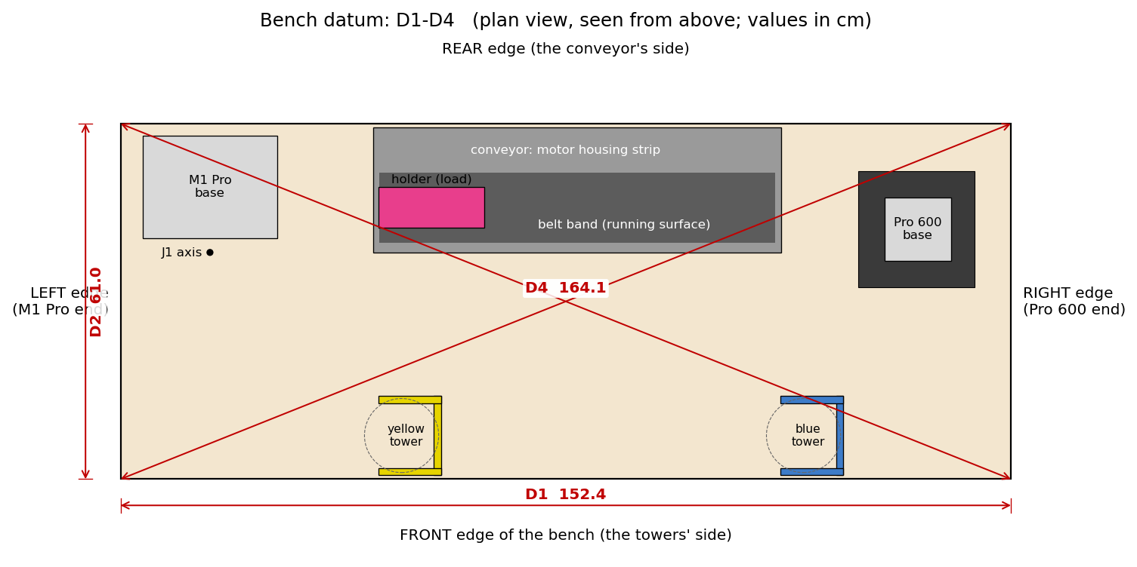
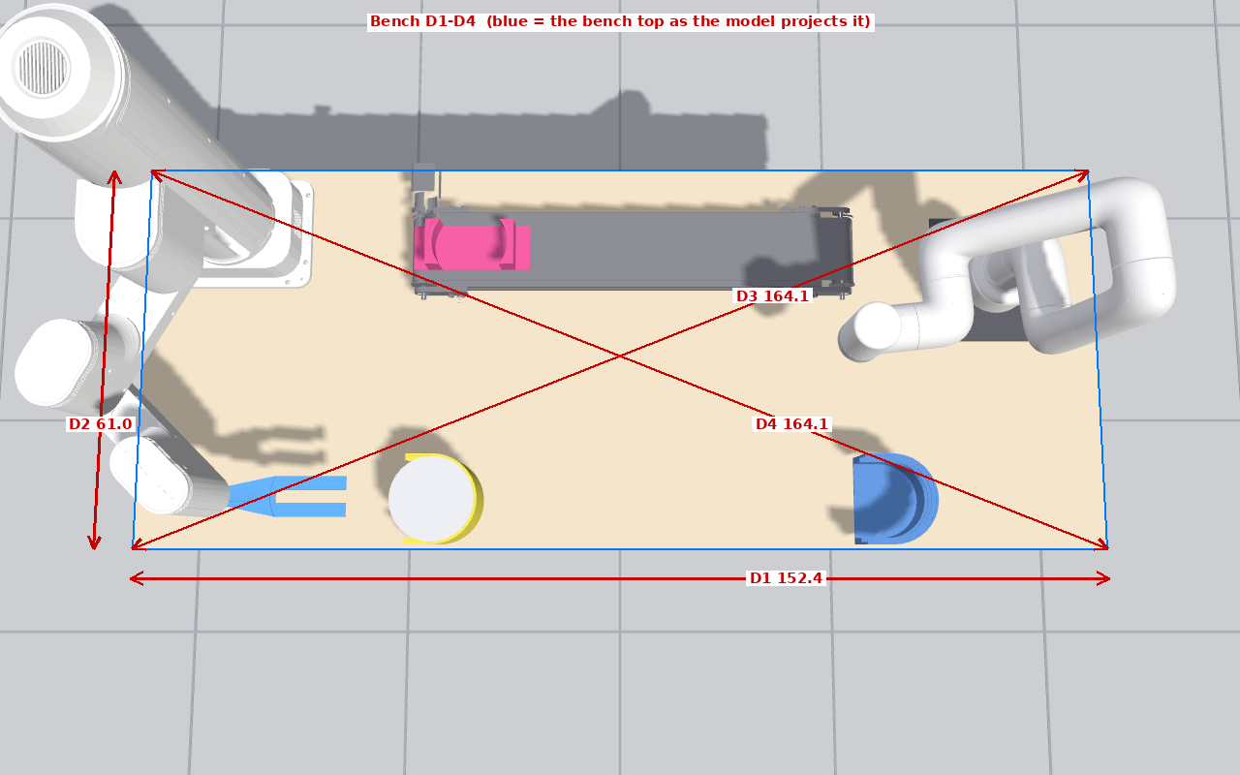
ID | What to measure (from → to) | Tool | Sim (cm) | Tag | Real (cm) | Notes / photo no.
D1 | Bench top length, left edge to right edge | tape | 152.4 | ASSUMED
D2 | Bench top depth, front edge to rear edge | tape | 61.0 | ASSUMED
D3 | Diagonal: left-front corner to right-rear corner | tape | 164.1 | CHECK
D4 | Diagonal: right-front corner to left-rear corner | tape | 164.1 | CHECK

4. Conveyor
The conveyor frame includes the motor housing on the rear side; the belt band is the narrower running surface inside it. D8 is expected to be tiny (the model puts the housing 0.6 cm from the rear edge).
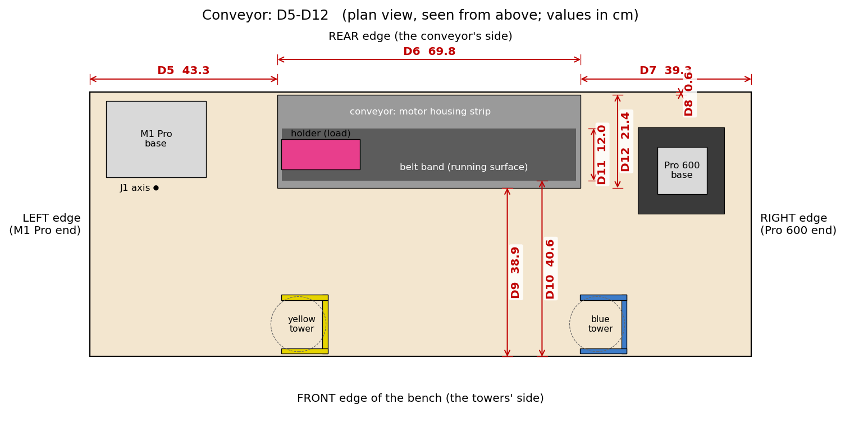
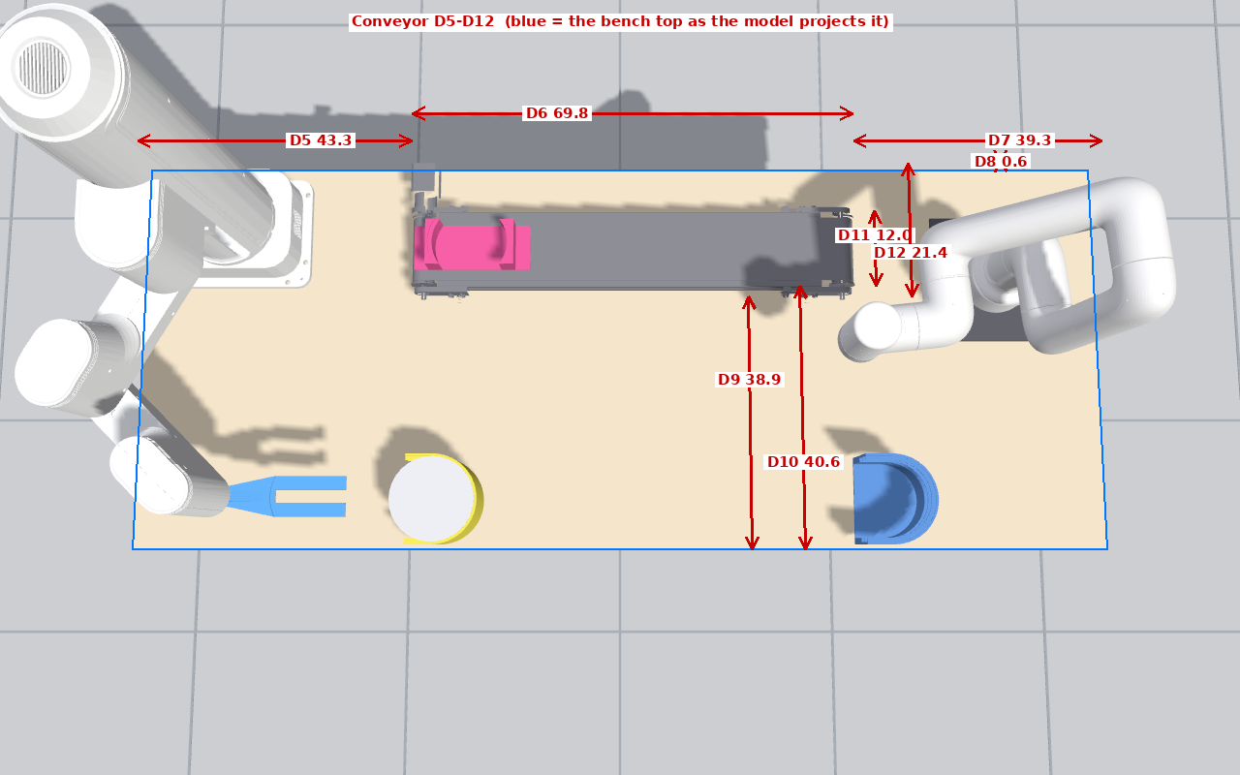
ID | What to measure (from → to) | Tool | Sim (cm) | Tag | Real (cm) | Notes / photo no.
D5 | Left bench edge to the conveyor's left end | tape | 43.3 | TAUGHT+OWNER
D6 | Conveyor frame length, left end to right end | tape | 69.8 | MESH
D7 | Conveyor's right end to the right bench edge | tape | 39.3 | TAUGHT+OWNER
D8 | Rear bench edge to the conveyor's rear side (motor housing) | tape | 0.6 | TAUGHT
D9 | Front bench edge to the conveyor's front rail | tape | 38.9 | TAUGHT
D10 | Front bench edge to the belt band's front edge (the running surface) | tape | 40.6 | TAUGHT
D11 | Belt band width (running surface, front edge to rear edge) | tape | 12.0 | MESH
D12 | Conveyor width incl. the motor housing, front rail to rear side | tape | 21.4 | MESH
D13 | Belt surface height above the bench top | tape | 6.3 | MESH

5. Carrier (magenta holder)
D14–D19 with the holder at its load position as the operator places it. D20–D22 after ONE belt index: run the belt once, then measure. For D20 run five indexes in a row, measure the total and divide by five; write the total and the count in Notes. The last picture is the holder at the load station seen from the rear.
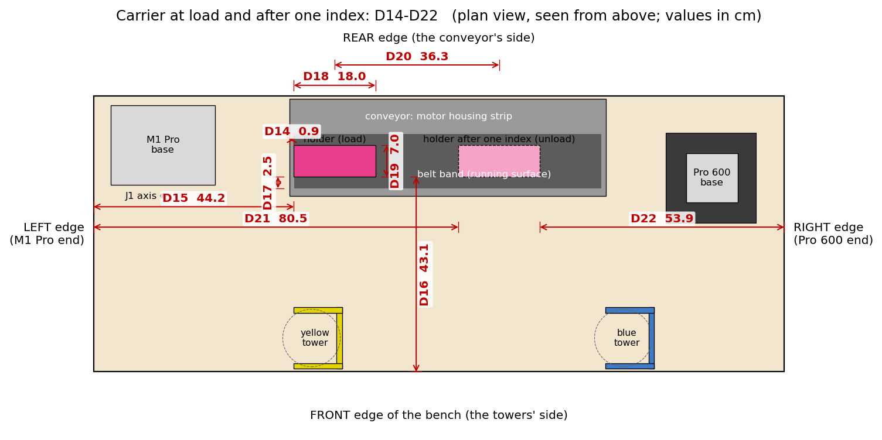
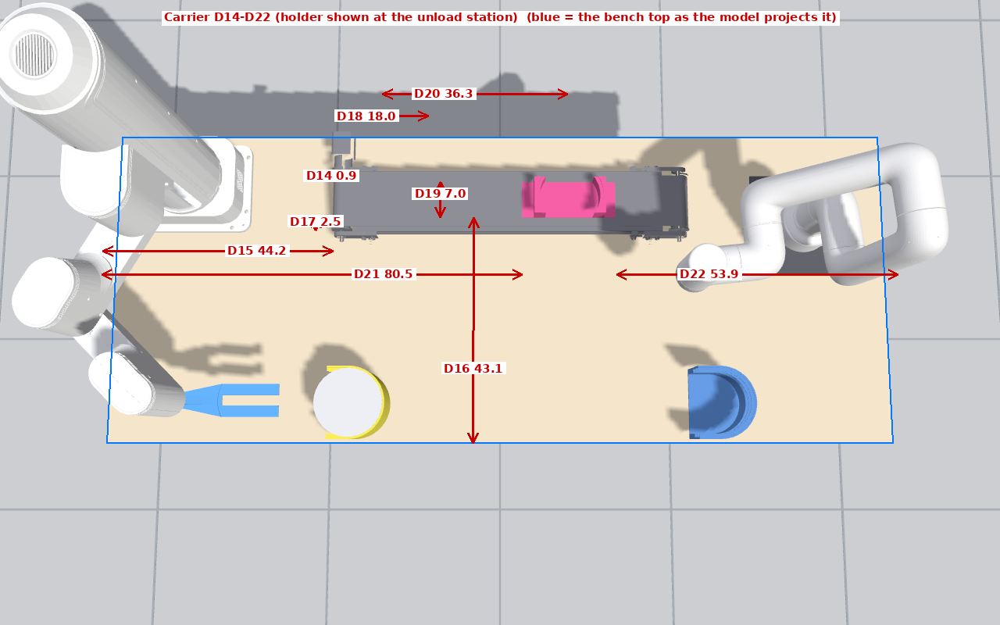
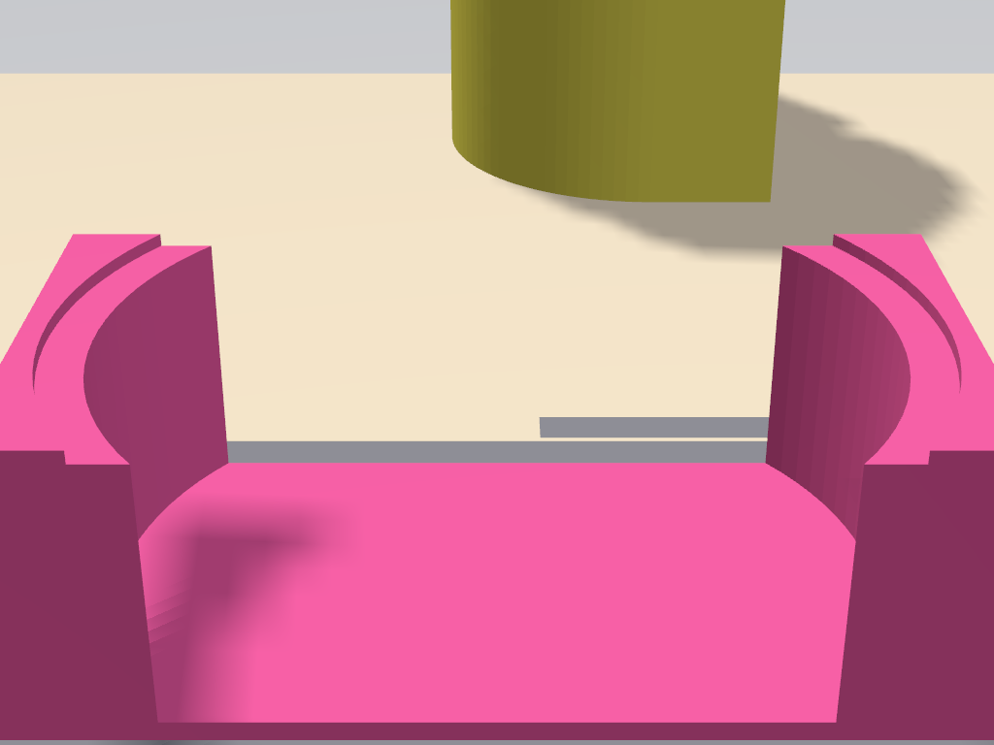
ID | What to measure (from → to) | Tool | Sim (cm) | Tag | Real (cm) | Notes / photo no.
D14 | Conveyor's left end to the holder's left end (holder at rest at the load station) [should be nearly flush] | ruler | 0.9 | OWNER video
D15 | Left bench edge to the holder's left end, at the load station | tape | 44.2 | TAUGHT
D16 | Front bench edge to the holder's front edge | tape | 43.1 | TAUGHT
D17 | Belt band visible in front of the holder (band front edge to holder front edge) [same amount behind it] | ruler | 2.5 | TAUGHT
D18 | Holder plate length (along the belt) | ruler | 18.0 | MESH
D19 | Holder plate width (across the belt) | ruler | 7.0 | MESH
D20 | Belt travel per index: holder centre at load to holder centre at unload [run 5 indexes, measure the total, divide by 5] | tape | 36.3 | TAUGHT prediction
D21 | Left bench edge to the holder's left end, at the unload station | tape | 80.5 | TAUGHT
D22 | Holder's right end at the unload station to the right bench edge | tape | 53.9 | TAUGHT
D23 | Holder seat ring height above the belt surface | ruler | 4.3 | MESH
D24 | Holder post height above the belt surface (plate bottom to post top) | ruler | 4.5 | MESH

6. Towers
Both towers are identical prints; D28, D29, D36–D39 need measuring on one of them only. D35 is not measured: it is D30 minus D25.
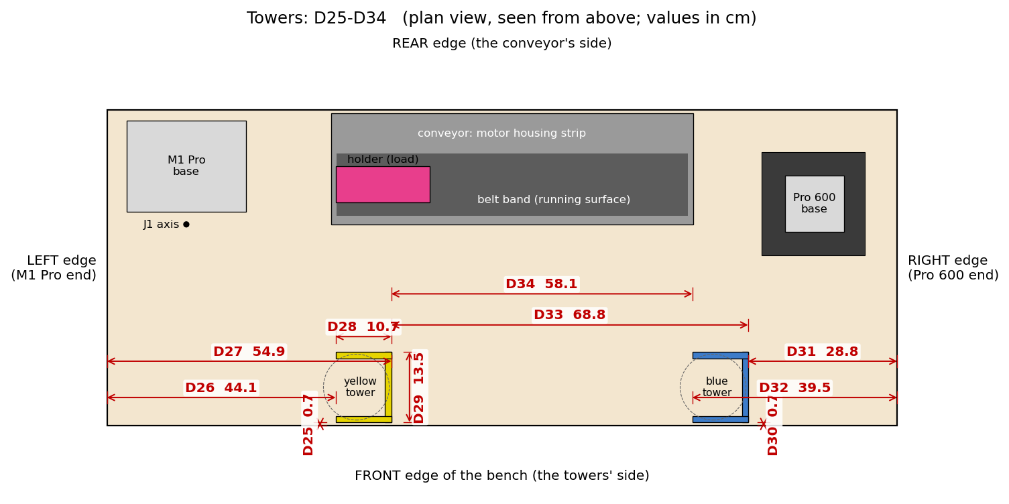
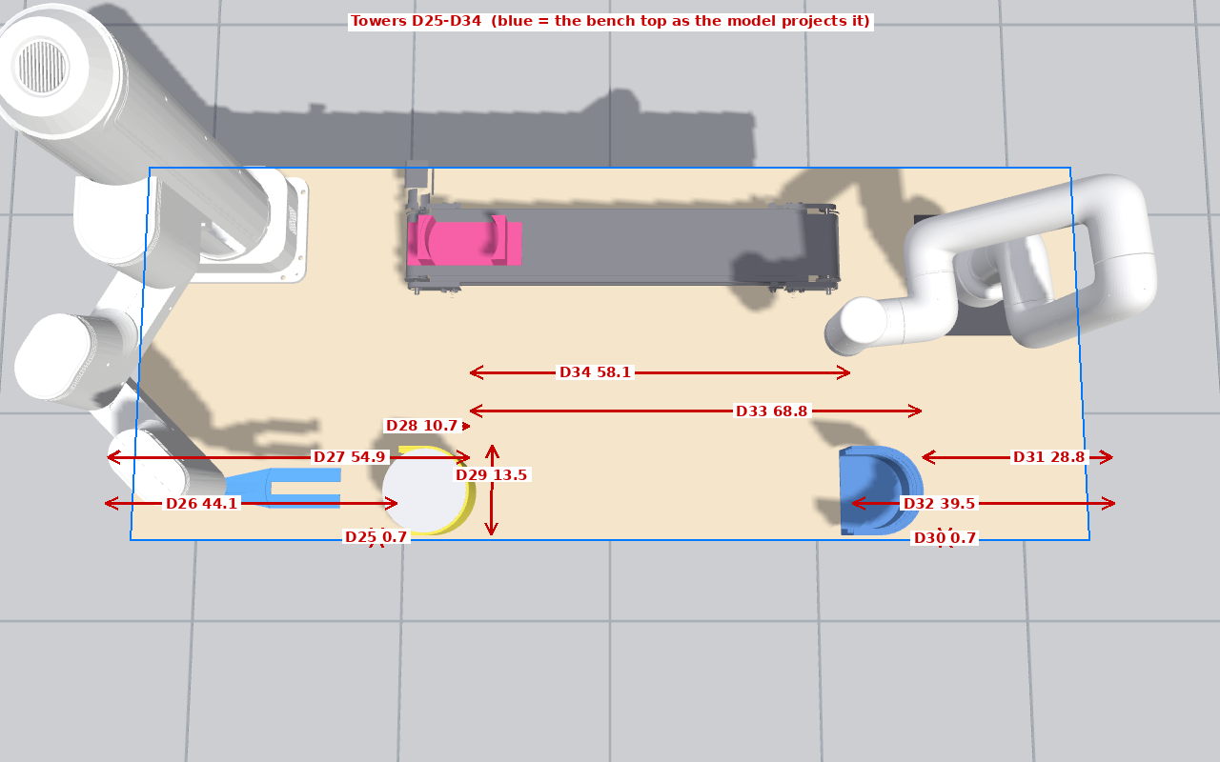
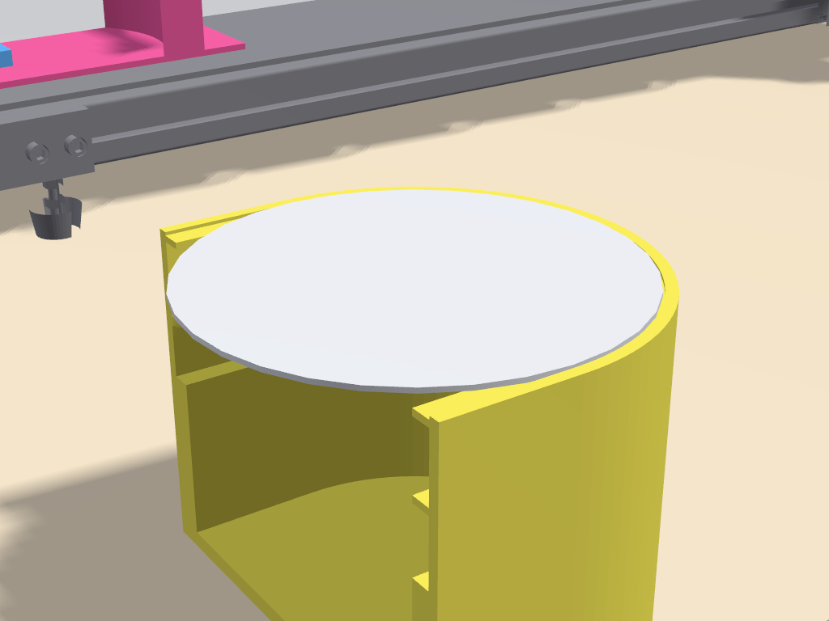
ID | What to measure (from → to) | Tool | Sim (cm) | Tag | Real (cm) | Notes / photo no.
D25 | Front bench edge to the yellow tower's front outer wall | ruler | 0.7 | TAUGHT
D26 | Left bench edge to the yellow tower's mouth (open side) | tape | 44.1 | TAUGHT
D27 | Left bench edge to the yellow tower's back wall (closed side) | tape | 54.9 | TAUGHT
D28 | Tower depth, mouth to back wall (outside) | ruler | 10.7 | MESH
D29 | Tower outer width, across | ruler | 13.5 | MESH
D30 | Front bench edge to the blue tower's front outer wall | ruler | 0.7 | OWNER intent
D31 | Blue tower's back wall to the right bench edge | tape | 28.8 | FIT
D32 | Blue tower's mouth to the right bench edge | tape | 39.5 | FIT
D33 | Yellow back wall to blue back wall (equals centre to centre) | tape | 68.8 | FIT
D34 | Gap: yellow back wall to blue mouth | tape | 58.1 | FIT
D35 | Both towers' front walls on one line: D30 minus D25 | computed | 0.0 | OWNER intent
D36 | Tower height, bench top to the top rim | ruler | 10.0 | MESH
D37 | Top slot: wafer underside height above the bench top (the slot the M1 picks from) | ruler | 9.9 | MESH
D38 | Middle slot: wafer underside height | ruler | 7.7 | MESH
D39 | Bottom slot: wafer underside height | ruler | 5.5 | MESH

7. M1 Pro
The "base plate" is the robot's own base (the black plate under the column). D48 asks where the big arm's vertical pivot (J1) is relative to the plate's front edge; in the model it is 2.5 cm AHEAD of the plate. If there is a separate mounting plate under the robot, describe it in D49.
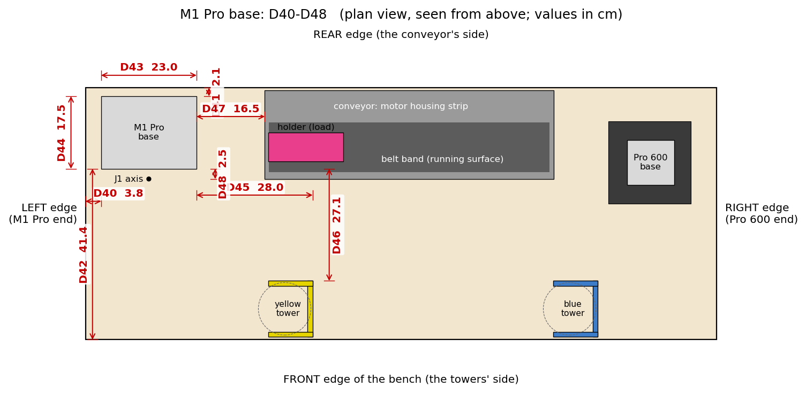
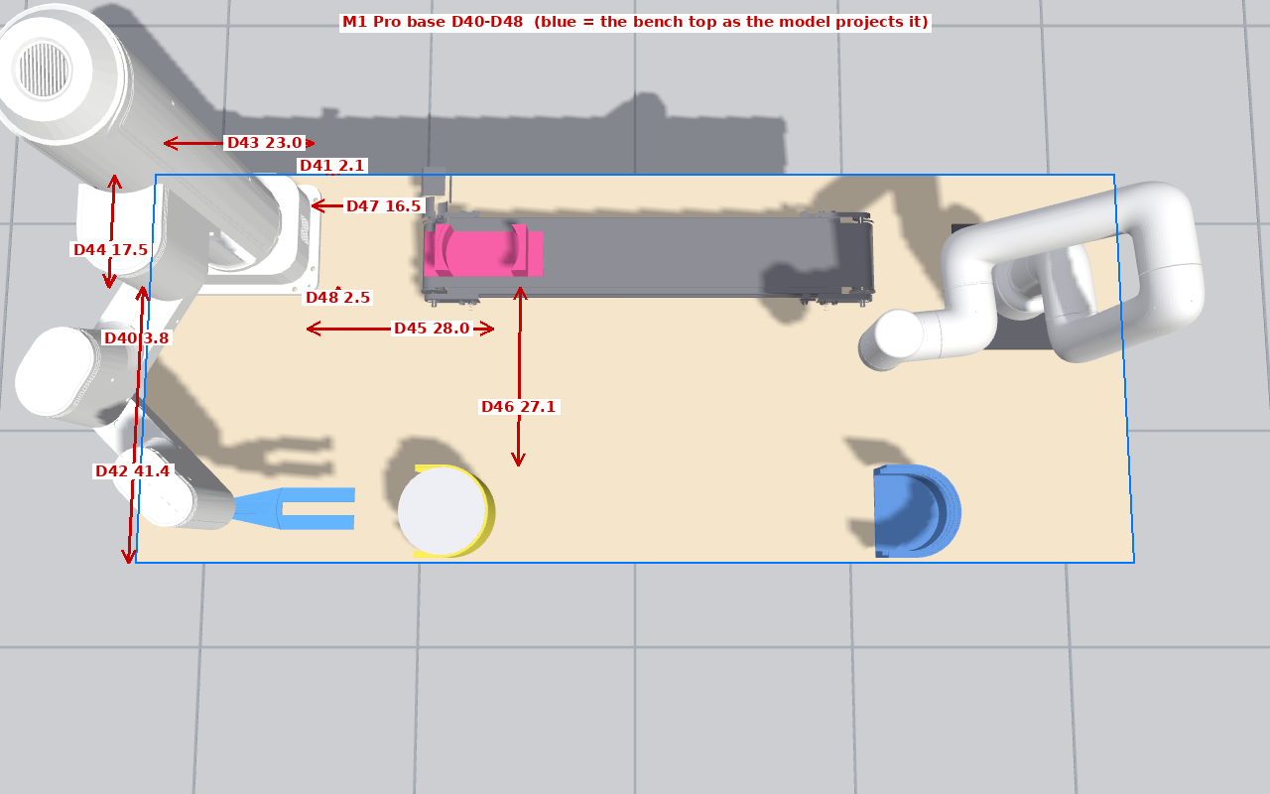
ID | What to measure (from → to) | Tool | Sim (cm) | Tag | Real (cm) | Notes / photo no.
D40 | Left bench edge to the M1 base plate's left edge | ruler | 3.8 | TAUGHT
D41 | M1 base plate's rear edge to the rear bench edge | ruler | 2.1 | TAUGHT
D42 | Front bench edge to the M1 base plate's front edge | tape | 41.4 | TAUGHT
D43 | M1 base plate length along the bench | ruler | 23.0 | MESH
D44 | M1 base plate width across the bench | ruler | 17.5 | MESH
D45 | M1 base plate's right edge to the yellow tower's back wall | tape | 28.0 | TAUGHT
D46 | M1 base plate's front edge to the yellow tower's rear outer wall | tape | 27.1 | TAUGHT
D47 | M1 base plate's right edge to the conveyor's left end | tape | 16.5 | TAUGHT+OWNER
D48 | M1 base plate's front edge to the centre of the J1 pivot (the big arm's vertical axis) [J1 axis is AHEAD of the plate front edge in the model] | ruler | 2.5 | MESH
D49 | Is there a separate mounting plate under the M1 Pro (other than its own base)? If yes, its size [the model has none] | ruler | — | QUESTION

8. Pro 600
Measure to the robot's own round base, not to the mounting plate; describe the plate in D57. The blue tower close-up shows the base plate behind the tower.
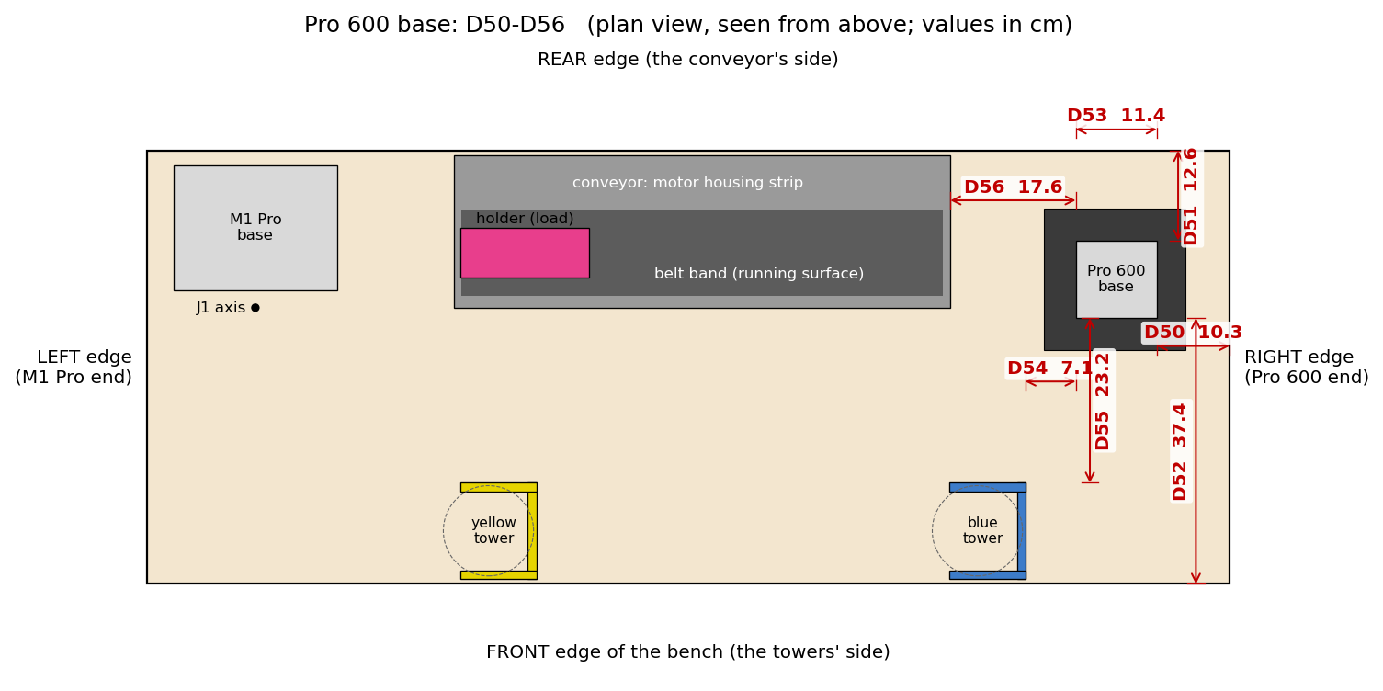
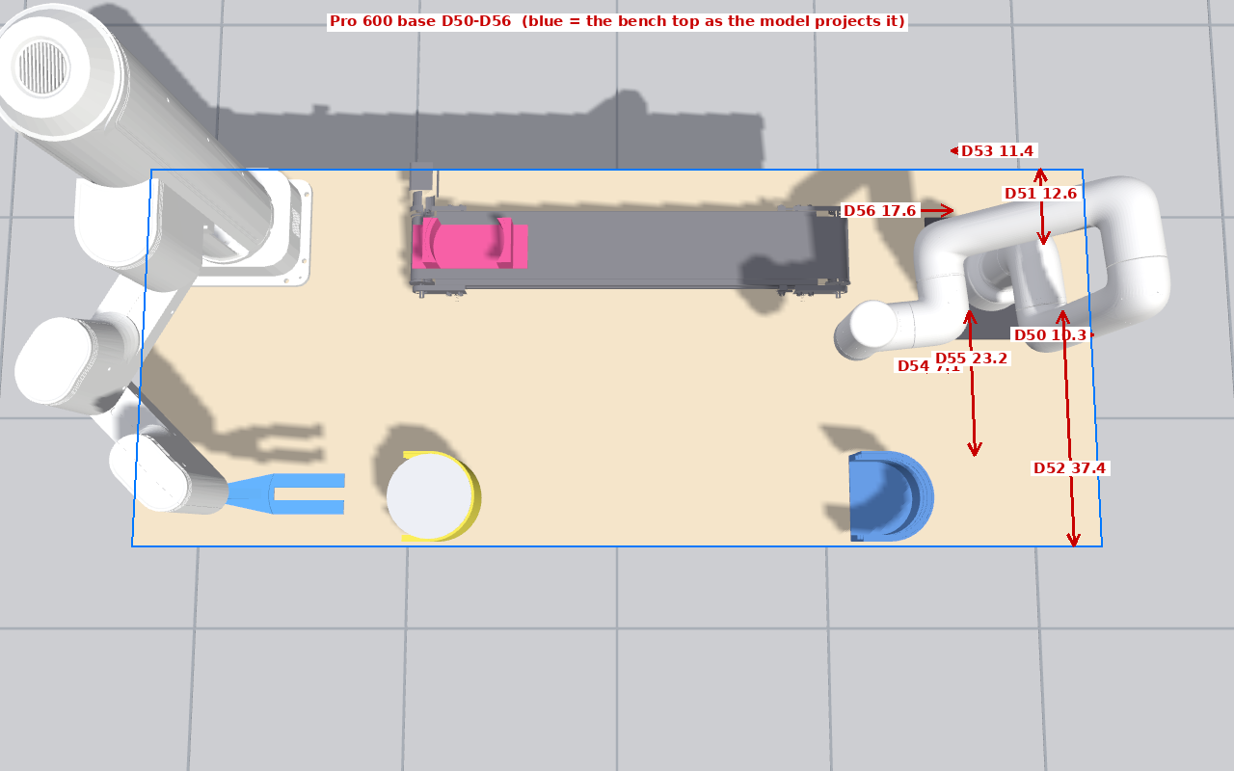
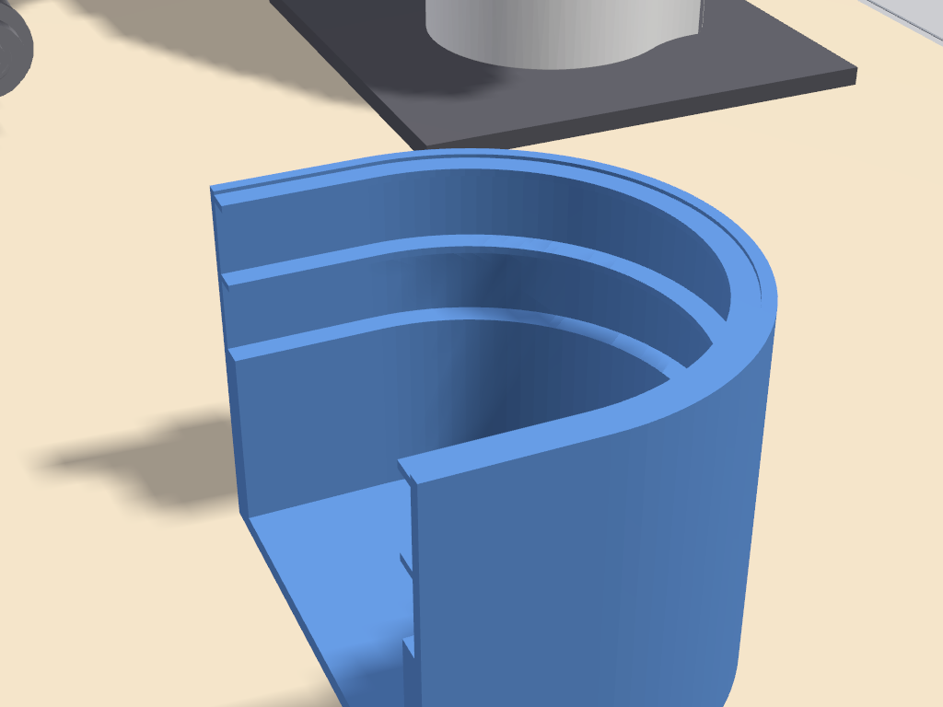
ID | What to measure (from → to) | Tool | Sim (cm) | Tag | Real (cm) | Notes / photo no.
D50 | Pro 600 base's right edge to the right bench edge | tape | 10.3 | FIT
D51 | Pro 600 base's rear edge to the rear bench edge | tape | 12.6 | FIT
D52 | Front bench edge to the Pro 600 base's front edge | tape | 37.4 | FIT
D53 | Pro 600 base diameter (the round base; model footprint 11.4 x 10.9) | ruler | 11.4 | MESH
D54 | Pro 600 base's left edge to the blue tower's back wall | tape | 7.1 | FIT
D55 | Pro 600 base's front edge to the blue tower's rear outer wall | tape | 23.2 | FIT
D56 | Conveyor's right end to the Pro 600 base's left edge | tape | 17.6 | FIT
D57 | Black plate under the Pro 600, if one exists: size along x across [model: 20.0 x 20.0] | ruler | 20.0 | PHOTO

9. Heights
All heights from the bench top surface. D58 and D60 need the robots at HOME; they tie the pendant's z values to the bench (his HOME is z = 157.12 mm for the M1 and 261.8 mm for the Pro 600 in the robots' own frames).
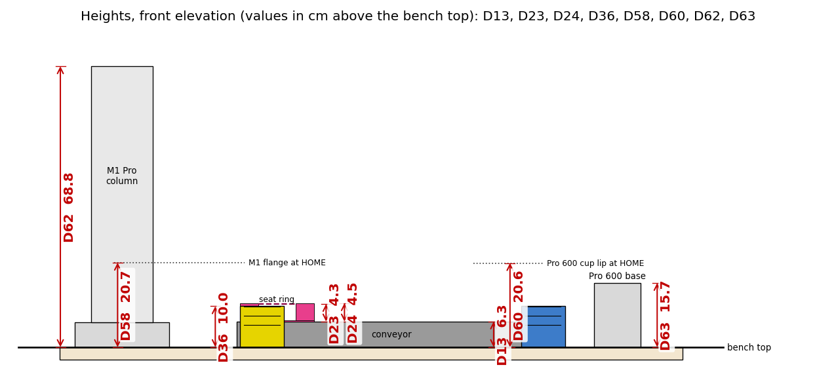
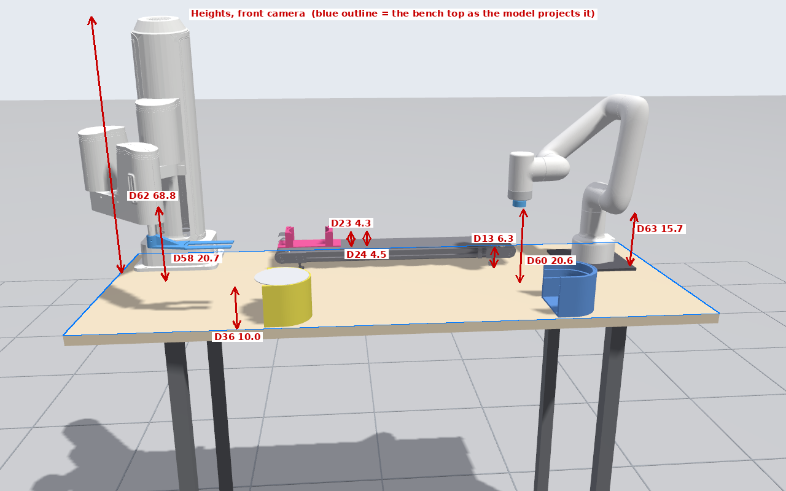
ID | What to measure (from → to) | Tool | Sim (cm) | Tag | Real (cm) | Notes / photo no.
D58 | M1 Pro flange underside height above the bench top, robot at HOME [his HOME z = 157.12 mm from the robot base frame; this finds where that frame's zero is] | tape | 20.7 | MODEL
D59 | M1 fork: flange underside to the blade's top surface (vertical) | ruler | 2.5 | MODEL
D60 | Pro 600 cup lip height above the bench top, robot at HOME [his HOME z = 261.8 mm in the robot's frame] | tape | 20.6 | MODEL
D61 | Pro 600 cup: flange face to the cup lip (the suction cup's length) | ruler | 2.1 | MODEL
D62 | M1 Pro column top height above the bench top | tape | 68.8 | MESH
D63 | Pro 600 fixed base height (bench top to the top of the non-moving base) | ruler | 15.7 | MESH

10. Parts and the fork (ruler / calipers)
D70 is the single most important number on this sheet: the distance from the centre of the M1's wrist shaft (J4) to the centre of a wafer resting on the fork. Measure it with the wafer on the fork. The last picture is the holder at the unload station.
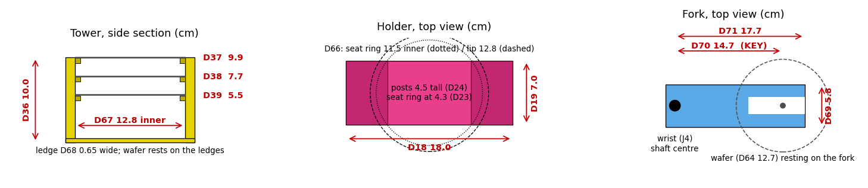
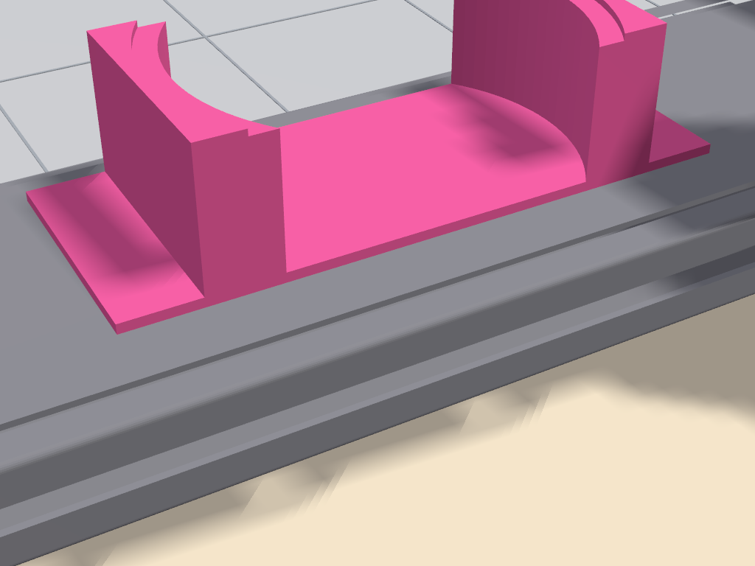
ID | What to measure (from → to) | Tool | Sim (cm) | Tag | Real (cm) | Notes / photo no.
D64 | Wafer diameter | calipers | 12.7 | MESH
D65 | Wafer thickness [the model exaggerates it for contact stability; the real value is wanted] | calipers | 0.1 | MODEL
D66 | Holder seat ring: inner diameter and outer (lip) diameter, write both [model: 11.5 inner / 12.8 lip] | calipers | 11.5 | MESH
D67 | Tower inner diameter at the slots | calipers | 12.8 | MESH
D68 | Tower slot ledge width (how far the ledge sticks in) | calipers | 0.7 | MESH
D69 | Fork blade width | calipers | 5.8 | MESH
D70 | Fork: centre of the wrist (J4) shaft to the centre of a wafer resting on the fork [the one number the whole M1 layout depends on] | ruler | 14.7 | ASSUMED - KEY
D71 | Fork: centre of the wrist shaft to the blade tip | ruler | 17.7 | ASSUMED
D72 | Fork blade overall length | ruler | 18.9 | MESH

11. Sum checks (fill from your own numbers; they catch misreads)
Each line must add up. If it does not, one of its terms was misread; re-measure those before sending the sheet back.
ID | Check | In the model | Your numbers
SC1 | D5 + D6 + D7 = D1 (left edge → conveyor → right edge) | 43.3 + 69.8 + 39.3 = 152.4 (D1 152.4)
SC2 | D26 + D28 = D27 (yellow mouth + tower depth = back wall) | 44.1 + 10.7 = 54.8 (D27 54.9)
SC3 | D32 − D31 = D28 (blue mouth − back wall = tower depth) | 39.5 − 28.8 = 10.7 (D28 10.7)
SC4 | D9 + D12 + D8 = D2 (front edge → conveyor → rear edge) | 38.9 + 21.4 + 0.6 = 60.9 (D2 61.0)
SC5 | D40 + D43 + D45 = D27 (left edge → M1 base → yellow back wall) | 3.8 + 23.0 + 28.0 = 54.8 (D27 54.9)
SC6 | D42 + D44 + D41 = D2 (front edge → M1 base → rear edge) | 41.4 + 17.5 + 2.1 = 61.0 (D2 61.0)
SC7 | D52 + D53(across) + D51 = D2 (front edge → Pro 600 base → rear edge) | 37.4 + 10.9 + 12.6 = 60.9 (D2 61.0)
SC8 | D33 = D34 + D28 (back wall to back wall = gap + tower depth) | 58.1 + 10.7 = 68.8 (D33 68.8)

12. Angle checks: measure at both ends
A single distance cannot show whether an object is turned. For each row measure the same thing at the two ends named; the difference is the object's rotation. In the model all differences are 0.0 because everything is drawn square to the bench.
ID | What to measure | Model (first / second) | Real first | Real second | Notes
A1 | Front bench edge → conveyor front rail, at the conveyor's LEFT end and at its RIGHT end (D9 at both ends) | 38.9 / 38.9
A2 | Front bench edge → M1 base plate's front edge, at the plate's LEFT corner and RIGHT corner (D42 at both corners) | 41.4 / 41.4
A3 | Rear bench edge → Pro 600 mounting plate's rear edge, at its LEFT and RIGHT corners | 8.1 / 8.1
A4 | Front bench edge → the two tips of the yellow tower's mouth (front tip and rear tip of the C opening) | 0.7 / 14.2
A5 | Front bench edge → the two tips of the blue tower's mouth | 0.7 / 14.2
A6 | Left bench edge → the holder's left end, at the holder's FRONT corner and REAR corner (is the holder square on the belt?) | 44.2 / 44.2

13. Questions about how the cell is operated
ID | Question | Answer
Q1 | When the operator puts the carrier back at the load station, is there a stop, a mark or a guide, or is it placed by eye? If by eye, roughly how much does the position vary from cycle to cycle (cm)?
Q2 | Which tower slot does the wafer start in (top / middle / bottom), and which slot of the blue tower does the Pro 600 place into?
Q3 | How is the carrier returned after a cycle (by hand along the belt, lifted off and put back)? Is the belt ever run backwards?
Q4 | The belt index: how many millimetres does the carrier travel per PLC move? (D20: five indexes, total ÷ 5.) Direction: towards the Pro 600?
Q5 | Belt drive: pulley pitch diameter, and is there a gearbox between motor and pulley (ratio)? Alonso's motion configuration units are 1.0 per revolution and 200 pulses per revolution.
Q6 | Is the bench top exactly 152.4 × 61.0 cm (60 × 24 inches)? If it is a different size, D1–D4 will show it; note the nominal size here.
Q7 | Is there anything on the bench the model does not show (the laser engraver, a PC, cable trays, stops) that an arm could touch?

14. What happens after the sheet comes back
- The layout is re-derived from all the real numbers at once (one least-squares pass), not row by row.
- Every disagreement between the tape and the taught poses is listed with its size, and the suspected cause named.
- The cycle and the Level 1 shadow are re-run headless and in the GUI, the six-camera recording is remade, and only then is the change committed.
Generated by docs/measurement_2026-09-11/make_measurement_docx.py from dims.json; the figures come from measure_dims.py (schematics) and measure_overlay.py (camera renders with projected dimension lines).

