## Mini Project Report On

**ELECTRICITY BILL SYSTEM**

## *Submitted By: Jatin Sharma Katian(1911985009)*

***I***

**CERTIFICATE**

*Certified that this is a bonafide record of the project work titled “***ELECTRICITY BILLING SYSTEM”**

*Done by*

*Jatin Sharma Katian*

*Id-1911985009*

*Virtussa 2019 Batch*

# ACKNOWLEDGEMENT

We take this occasion to thank God, almighty for blessing us with his grace and taking our endeavor to a successful culmination. We extend our sincere and heartfelt thanks to our esteemed guide, Mr. Mukesh and Mr. Mananjay Dubey , for providing us with the right guidance and advice at the crucial junctures and for showing me the right way. We also take this opportunity to express a deep sense of gratitude to our class coordinators Mr. Manik Gupta and Dr.Neha Kumra for their cordial support, valuable suggestions and guidance. We extend our sincere thanks to our respected **Head of the division Dr. Kuldeep Kumar** , for allowing us to use the facilities available. We would like to thank the other faculty members also, at this occasion. Last but not the least, we would like to thank our friends and family for the support and encouragement they have given us during the course of our work.

## TABLE OF CONTENTS

ABSTRACT 5

1. INTRODUCTION 6
   1. PROJECT AIMS AND OBJECTIVES 6
   2. BACKGROUND OF PROJECT 7
   3. OPERATION ENVIRONMENT 8
2. SYSTEM ANALYSIS 9
   1. SOFTWARE REQUIREMENT SPECIFICATION 9
   2. EXISTING VS PROPOSED 15
   3. SOFTWARE TOOL USED 16
3. SYSTEM DESIGN 20
   1. TABLE DESIGN 20
   2. DATA FLOW DIAGRAM’S 24
4. SYSTEM IMPLEMENTATION 30
   1. MODULE DESCRIPTION 30
   2. SCREEN SHOTS 80
5. SYSTEM TESTING 85
   1. UNIT TESTING 85
   2. INTEGRATION TESTING 87
6. CONCLUSION & FUTURE SCOPE 88
7. REFERENCES 89

#### ABSTRACT

The purpose of Electricity billing system is to automate the existing manual system by the help of computerized equipments and full-fledged computer software, fufuling their requirements , so that their valuable data /information can be stored for a longer period with easy accessing and manipulation of the same. The required software and hardware are easily available and easy to work with.

Electricity Billing system, as described above, can lead to error free, secure, reliable and fast

**CHAPTER 1 INTRODUCTION**

This chapter gives an overview about the aim , objectives ,background and operation environment of the system.

#### PROJECT AIMS AND OBJECTIVES

The project aims and objectives that will be achieved after completion of this project are discussed in this subchapter. The aims and objectives are as follows:

* + - Online billing issue
    - Manage the information of Bill.
    - It tracks all the information of Unit of Energy.
    - Manage the information of Electricity.
    - Integration of all records of Electricity Board.
    - Editing, adding and updating of Records is improved.

#### BACKGROUND OF PROJECT

The purpose of Electricity Billing System is to automate the existing manual system by the help of computerized equipmemts and full fledge computer software, fulfilling their requirements so that their valuable data/information can be stored for a longer period with easy accessing and manipulating of the same . The required software and hardware are easily available and easy to work with.

Electricity Billing System , as described above , can lead to error free,secure, reliable and fast management system. It can assist the user to concentrate on their other activities rather to concentrate on the record keeping. Thus it will help organization in better utilization of resources. The organization can maintain computerized records without reduntant entries.

#### OPERATION ENVIRONMENT

|  |  |
| --- | --- |
| PROCESSOR | INTEL CORE PROCESSOR OR BETTER PERFORMANCE |
| OPERATING SYSTEM | WINDOWS VISTA ,WINDOWS7, UBUNTU |
| MEMORY | 4 GB RAM OR MORE |
| HARD DISK SPACE | MINIMUM 3 GB FOR DATABASE USAGE FOR FUTURE |
| DATABASE | MY SQL |

**CHAPTER 2**

**SYSTEM ANALYSIS**

In this chapter, we will discuss and analyze about the developing process of Electricity Billing System including software requirement specification (SRS) and comparison between existing and proposed system . The functional and non functional requirements are included in SRS part to provide complete description and overview of system requirement before the developing process is carried out. Besides that, existing vs proposed provides a view of how the proposed system will be more efficient than the existing one.

#### SOFTWARE REQUIREMENT SPECIFICATION

* + 1. **GENERAL DESCRIPTION**

PRODUCT DESCRIPTION:

Electricity Billing System is a computerized system which helps user to manage the bill of electricity daily activity in electronic format. It reduces the risk of paper work such as file lost, file damaged and time consuming.

It can help user to manage the transaction or record more effectively and time- saving.

PROBLEM STATEMENT:

The problem occurred before having computerized system includes:

* + - File lost

When computerized system is not implemented file is always lost because of human environment.Some times due to some human error there may be a loss of records.

* + - File damaged When a computerized system is not there file is always lost due to some accdent like spilling of water by some member on file accidentally.Besides some natural disaster like floods or fires may also damage the files.
    - Difficult to search record

When there is no computerized system there is always a difficulty in searching of records if the records are large in number .

* + - Space consuming

After the number of records become large the space for physical storage of file and records also increases if no computerized system is implemented.

* + - Cost consuming

As there is no computerized system the to add each record paper will be needed which will increase the cost for the management of library.

#### SYSTEM OBJECTIVES

* + - Improvement in control and performance
    - Save cost
    - Save time
    - Manage the information of Store Record.
    - It deals with monitoring the information and transaction of Store record.
    - Have a Good user interface.

#### SYSTEM REQUIREMENTS

* + - 1. NON FUNCTIONAL REQUIREMENTS
         * Product Requirements EFFICIENCY REQUIREMENT

USABILITY REQUIREMENT

The system is designed for a user friendly environment so that student and staff of library can perform the various tasks easily and in an effective way.

ORGANIZATIONAL REQUIREMENT IMPLEMENTATION REQUIREMNTS

In implementing whole system it uses react in front end spring boot as backend which will be used the backend ie the database part is developed using mysql.

DELIVERY REQUIREMENTS

* + - 1. FUNCTIONAL REQUIREMENTS

1. NORMAL USER
   1. USER LOGIN Description of feature

This feature used by the user to login into system. They are required to enter user id and password before they are allowed to enter the system .The user id and password will be verified and if invalid id is there user is allowed to not enter the system.

Functional requirements

-user id is provided when they register

-The system must only allow user with valid id and password to enter the system

-The system performs authorization process which decides what user level can acess to.

-The user must be able to logout after they finished using system.

* 1. REGISTER NEW USER

Description of feature

This feature can be performed by all users to register new user to create account.

Functional requirements

-System must be able to verify information

-System must be able to delete information if information is wrong

Functional requirements

-System must be able to verify information

System also needs a search area.

Functional requirements

* System must be able to search the database based on select search type
* System need to update and delete the record.
* It also needs a security system to prevent data.

#### SOFTWARE AND HARDWARE REQUIREMENTS

This section describes the software and hardware requirements of the system

* + - 1. SOFTWARE REQUIREMENTS
         * Operating system- Windows 7 and more is used as the operating system as it is stable and supports more features and is more user friendly
         * Database MYSQL-MYSQL is used as database as it easy to maintain and retrieve records by simple queries which are in English language which are easy to understand and easy to write.
         * Development tools and Programming language- HTML , CSS and JS in React is used to write the whole code and develop webpages
      2. HARDWARE REQUIREMENTS
* Intel core i3 2nd generation is used as a processor because it is fast than other processors an provide reliable and stable and we can run our pc for longtime. By using this processor we can keep on developing our project without any worries.
* Ram 1 gb is used as it will provide fast reading and writing capabilities and will in turn support in processing

#### EXISTING VS PROPOSED SYSTEM

* + 1. Existing system does not have any facility of users login or where as proposed system will have a facility of login .
    2. Existing system does not have a facility of online payment whereas proposed system has a facility of Payment.
    3. Existing system does not has any option of information of Unit of Energy whereas proposed system will have this facility.
    4. Existing system does not have any facility to store the record of bill whereas proposed system provides this facility.

#### SOFTWARE TOOLS USED

The whole Project is divided in two parts the front end and the back end.

* + 1. Front end

The front end is designed using of html , ,css, Java script(React) in VSCode

* + 1. BACK END- The back end is designed using spring boot in IntelliJ
    2. DATABASES: MySQL.

## CHAPTER 3 SYSTEM DESIGN

#### TABLE DESIGN

VARIOUS TABELS TO MAINTAIN INFORMATION

 User Table for storing data of users

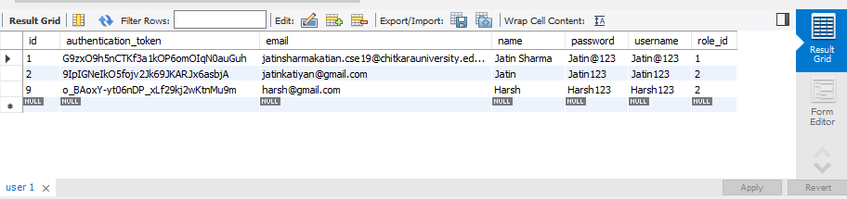

* EBBill TABLE FOR Billing INFORMATION

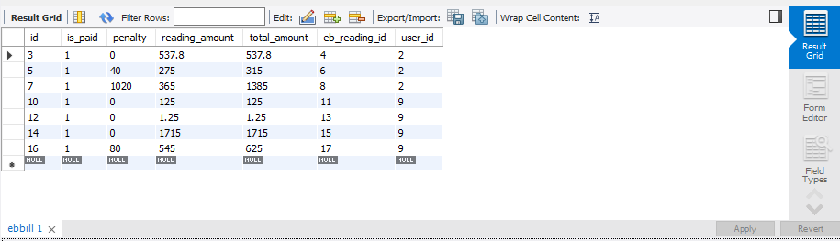

### Ebreading TABLE TO KEEP Energy Readings INFORMATION

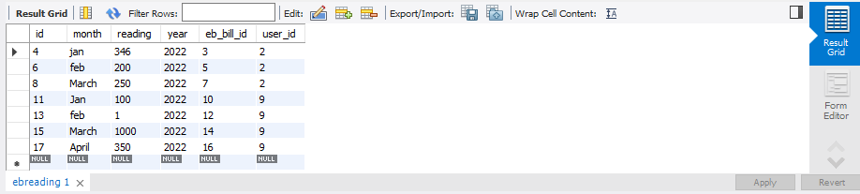

* Role table to keep track of roles assigned

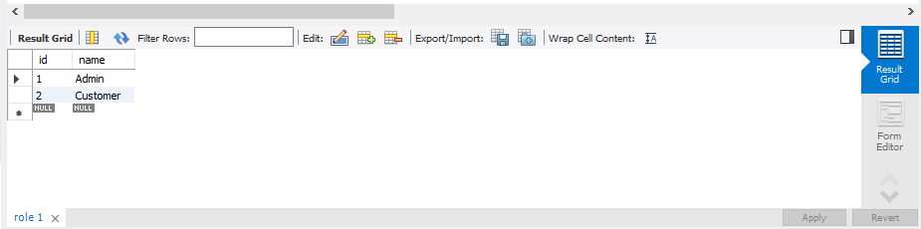

#### DATA FLOW DIAGRAMS

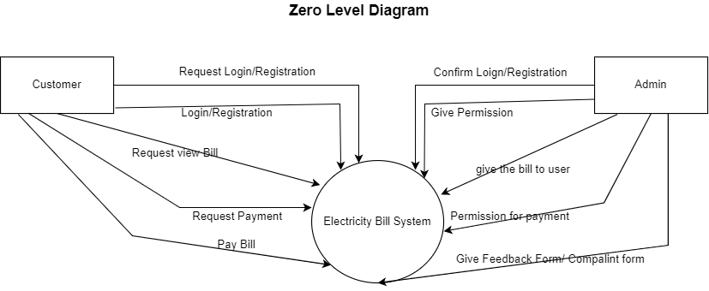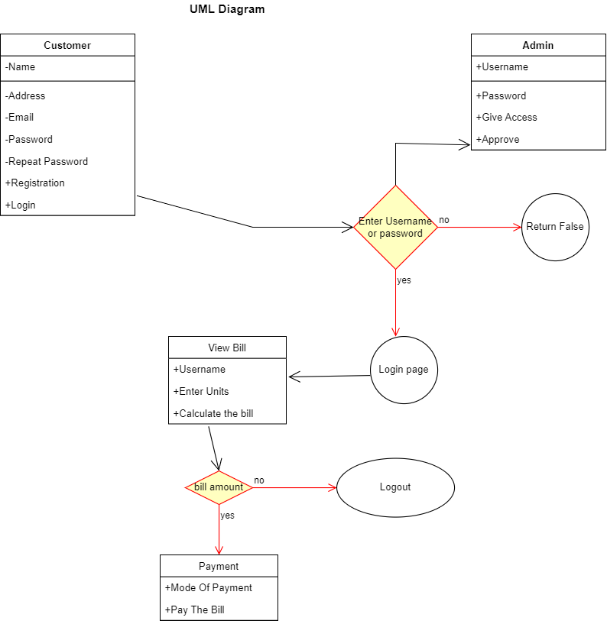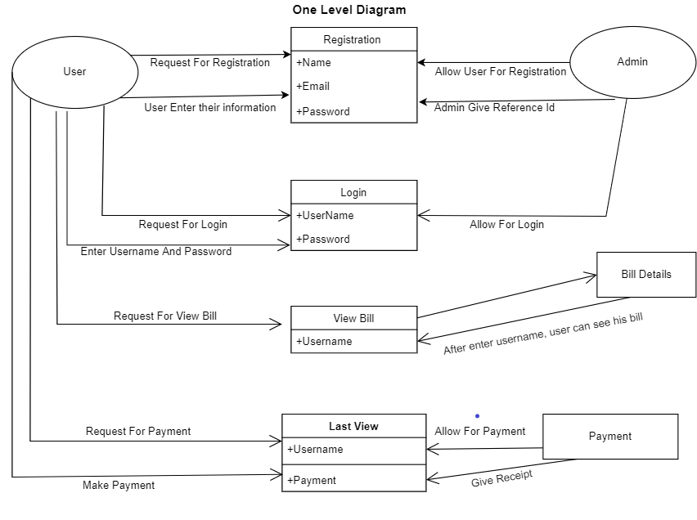

## CHAPTER 4

**SYSTEM IMPLEMENTATION**

###### 4.1.1 Screenshot for homepage

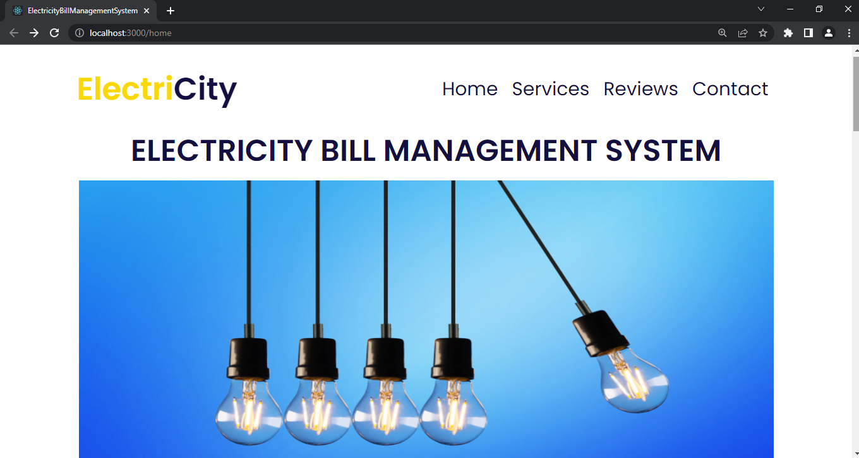

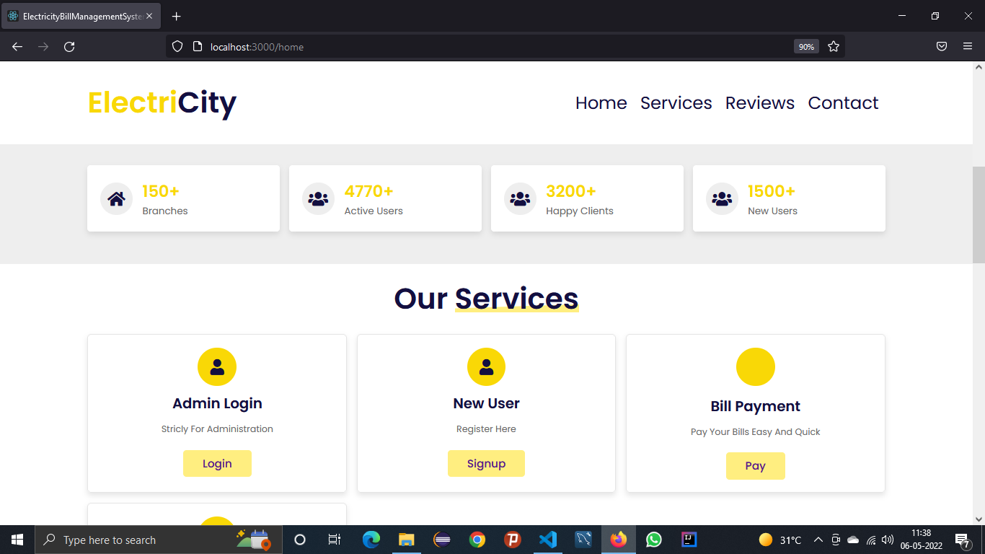

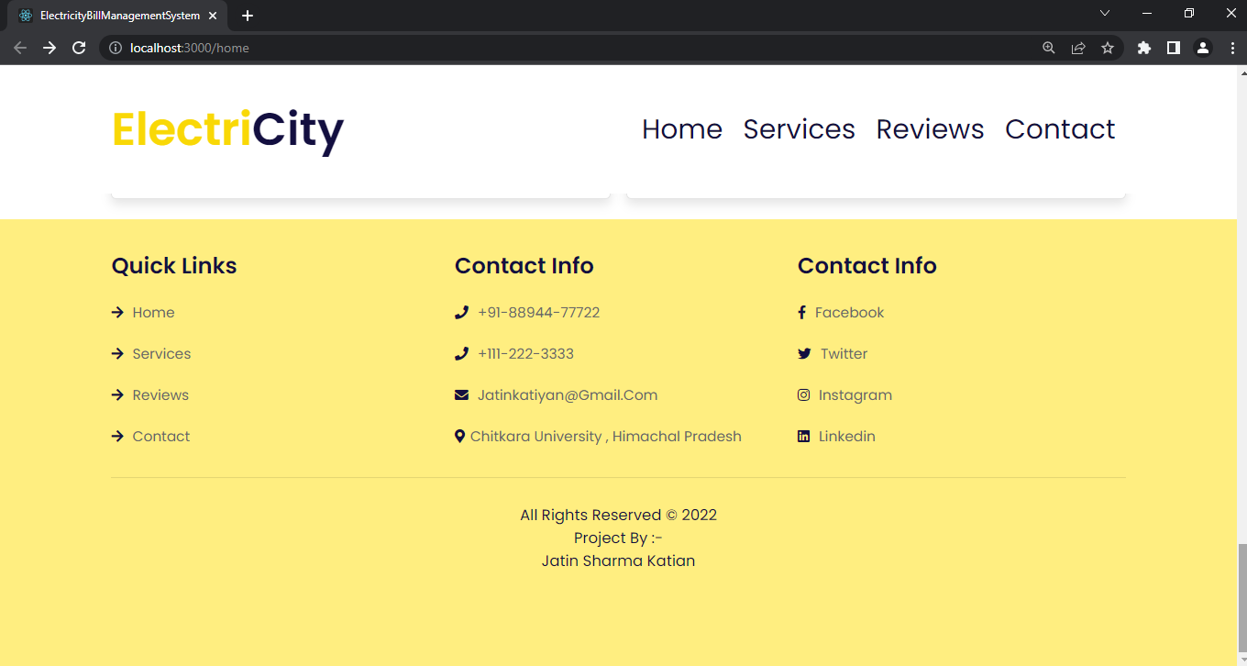

#### MODULE DESCRIPTION

For Electricity Bill Management System it is divided into the following Modules:

* + 1. **Admin Module**

Log out

Add Bill

ADMIN

View Bills

View Users

.

###### Screenshot for Admin login

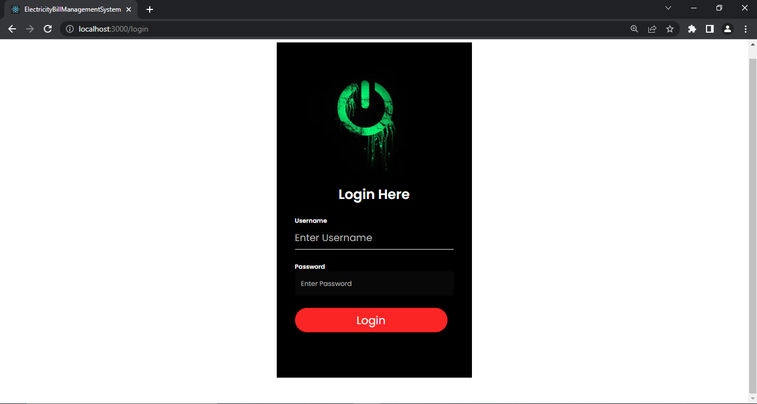

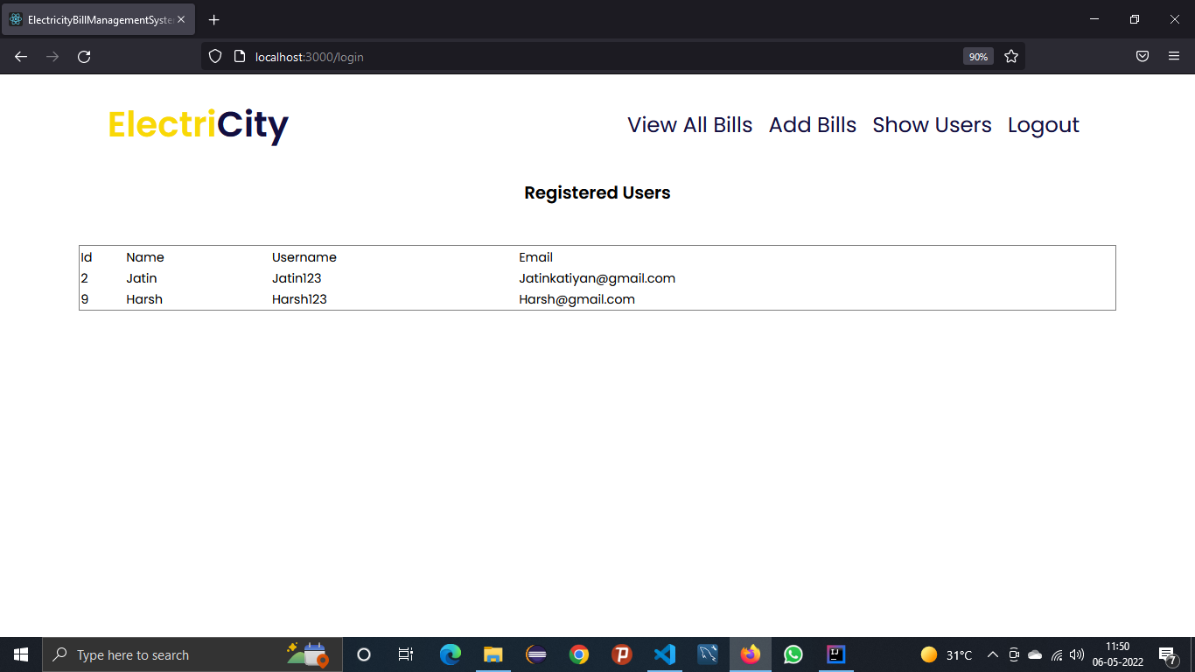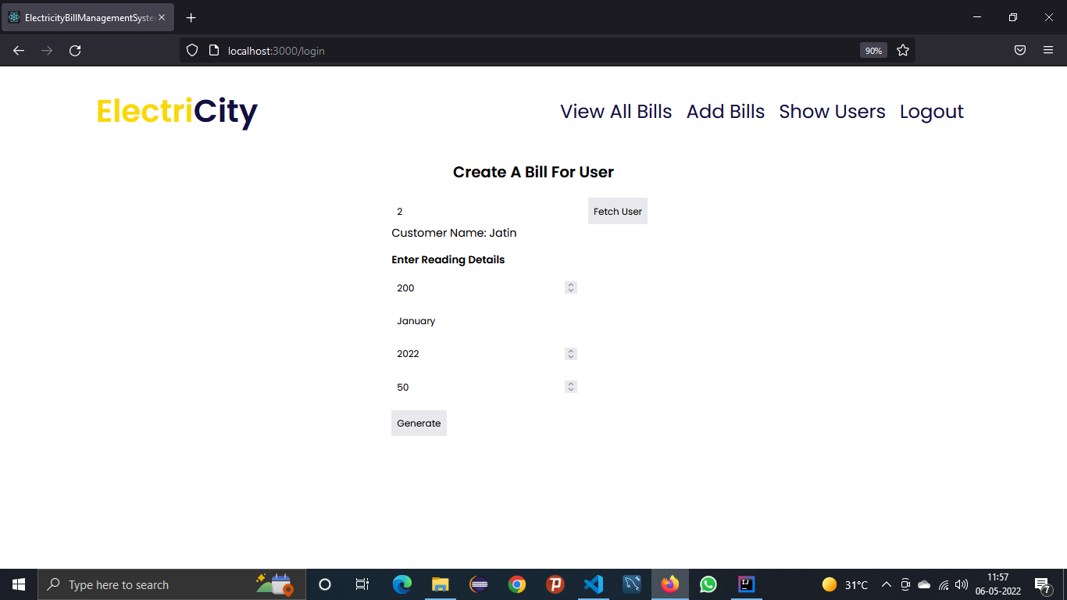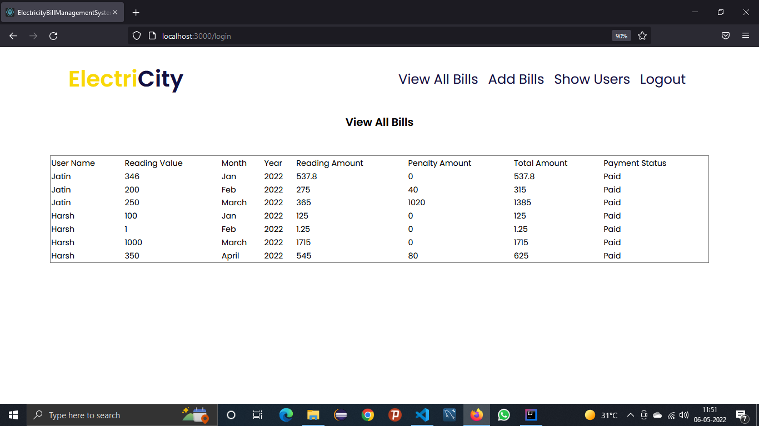

* + 1. **New User Module**

NEW USER

PASSWORD

USERNAME

CHECKBOX

REPEAT PASSWORD

EMAIL

NAME

###### 4.1.2 Screenshot for New User

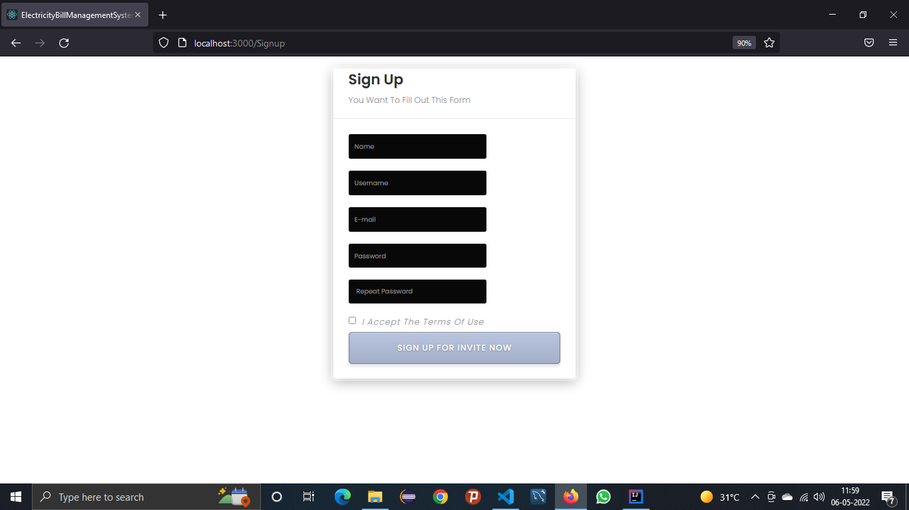

* **4.1.3 User Module**

LOGOUT

CHECK BILLS

USER LOGIN

PAY THE BILL

CHECK UNPAID

BILLS

* **Screenshots For User Module**

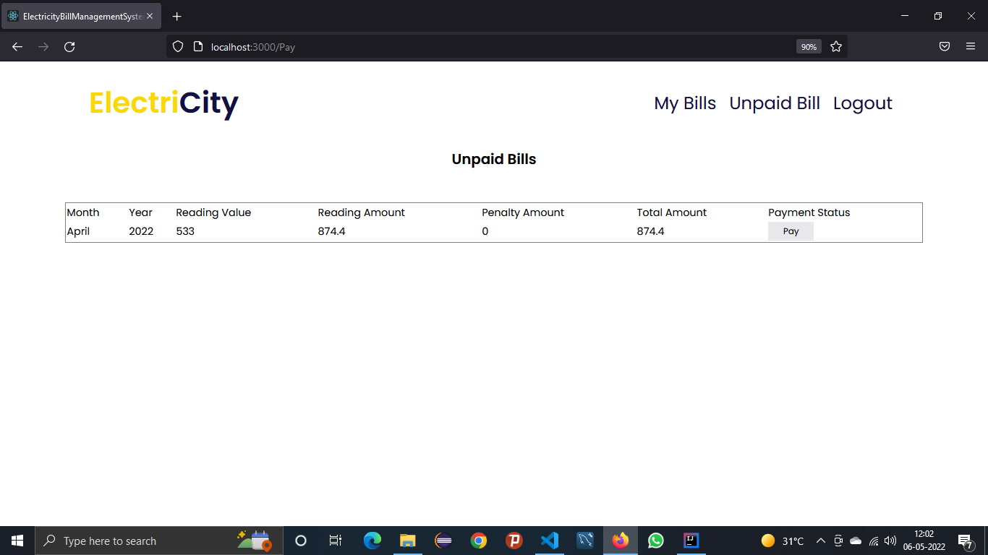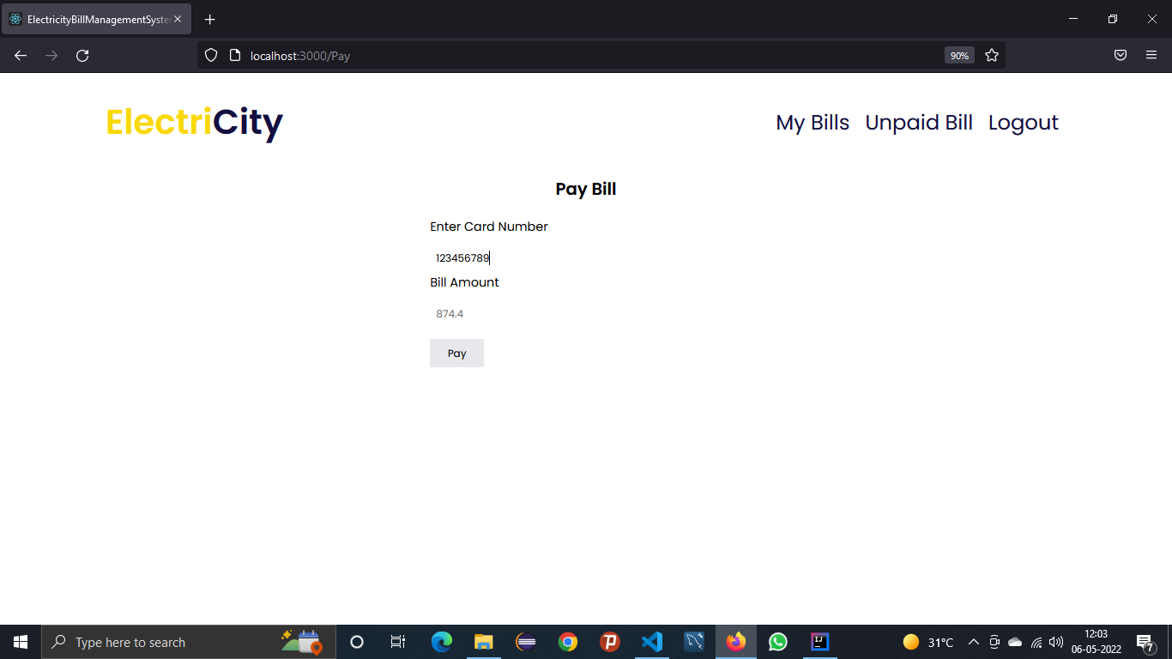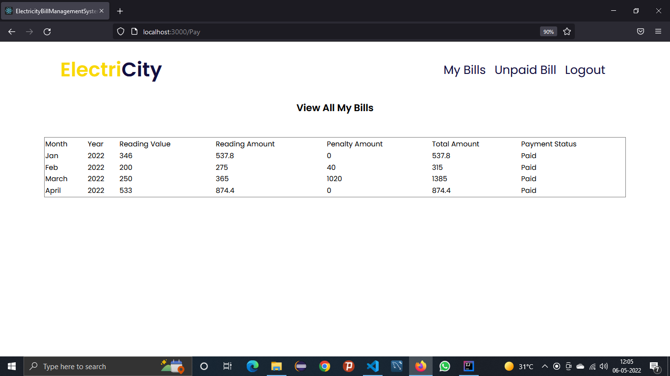

# CHAPTER 5 SYSTEM TESTING

The aim of the system testing process was to determine all defects in our project .The program was subjected to a set of test inputs and various observations were made and based on these observations it will be decided whether the program behaves as expected or not.

Our Project went through two levels of testing 1.Unit testing

1. integration testing

## UNIT TESTING

Unit testing is undertaken when a module has been created and succesfully reviewed .In order to test a single module we need to provide a complete environment ie besides the module we would require

* + The procedures belonging to other modules that the module under test calls
  + Non local data structures that module accesses
  + A procedure to call the functions of the module under test with appropriate parameters

Unit testing was done on each and every module that is described under module description of chapter 4

1. Test For the admin module
   * Testing admin login form-This form is used for log in of administrator of the system.In this we enter the username and password if both are correct administration page will open other wise if any of data is wrong it will get redirected back to the login page and again ask for username and password
   * Student account addition- In this section the admin can verify student details from student academinc info and then only add student details to main library database it contains add and delete buttons if user click add button data will be added to student database and if he clicks delete button the student data will be deleted
   * Book Addition- Admin can enter details of book and can add the details to the main book table also he can view the books requests .
2. Test for Student login module
   * Test for Student login Form-This form is used for log in of Student .In this we enter thelibraryid, username and password if all these are correct student login page will open other wise if any of data is wrong it will get redirected back to the login page and again ask for libraryid, username and password.
   * Test for account creation- This form is used for new account creation when student does not fill the form completely it asks again to fill the whole form when he fill the form fully it gets redirected to page which show waiting for conformation message as his data will be only added by administrator after verification.
3. Test for teacher login module-
   * Test for teacher login form- This form is used for logg in of teacher .In this we enter the username and password if all these are correct teacher login page will open other wise if any of data is wrong it will get redirected back to the login page and again ask for username and password.

## INTEGRATION TESTING

In this type of testing we test various integration of the project module by providing the input

.The primary objective is to test the module interfaces in order to ensure that no errors are occurring when one module invokes the other modul

# CHAPTER 6 CONCLUSION & FUTURE SCOPE

This website provides a computerized version of electricity management system which will benefit the students as well as the staff of the system.

It makes entire process online where users can search bills, staff can generate bills and check users and there transactions. It also has a facility for bill payment where users can login and can see status of bills issued as well as pay there outstanding bills.

There is a future scope of this facility that many more features such as online payment gateways , a feature of editing the users details,and fetching older readings to customize the human efforts for reading calculations and many more can be added.

# CHAPTER 7 REFERENCES

* <http://www.w3schools.com/html/html_intro.asp>
* <http://www.w3schools.com/css/css_background.asp>
* <http://www.w3schools.com/js/js_datatypes.asp>
* <http://www.w3schools.com/sql/sql_insert.asp>
* <http://www.w3schools.com/sql/sql_update.asp>
* <http://www.w3schools.com/php/php_forms.asp>
* Fundamentals of software engineering by Rajib mall, PHIlearning
* Web development and application development by Ivan Byross BPB publications