Student Wellness Advisor — Project Report
Generated on November 06, 2025

Introduction
Student Wellness Advisor is a data-driven web application that estimates a student's well-being across three dimensions—Anxiety (GAD-7), Depression (PHQ-9), and Life Satisfaction—based on lifestyle, environment, and study-related inputs. The system combines a machine-learning regressor for scoring with an optional local LLM to generate supportive, actionable suggestions.
Objectives:
• Collect relevant daily-life indicators from students in a simple UI.
• Predict three wellness scores using a trained Random Forest model.
• Provide a concise, empathetic summary and 3–5 suggestions via a local LLM (if available).

Data and preprocessing
Source: Student Wellness Survey (data).csv. Data is cleaned in backend/data_processing.py by:
• Normalizing column names and trimming strings.
• Converting categorical values (e.g., gender, roommate_situation) to numeric codes.
• Extracting numeric values from mixed-format strings (e.g., '2–3 cups' → 2 or 3).
• Casting scales to numeric and imputing remaining missing numeric values with column means.

Model training
A RandomForestRegressor (sklearn, 100 estimators, random_state=42) is trained on an 80/20 train/test split. The model predicts three continuous targets: Anxiety (GAD-7), Depression (PHQ-9), and Life Satisfaction. The trained model is persisted to backend/wellness_model.joblib.
Features used (29): age, gender, relationship_status, sleep_quality, water_intake_litres, food_quality, meals_count, caffeine_intake_cups, alcohol_consumption_drinks_week, smoking_status, chronic_health_issues, medication_use, physical_activity_minutes_day, sedentary_time_hours_day, environment_noise, lighting_quality, study_space_quality, roommate_situation, living_arrangement, commute_time_minutes_day, study_hours_last_24h, study_stress, upcoming_exam_assignment_stress, grades_estimate_gpa, financial_stress, mood_last_24h, screen_time_hours_day, social_media_time_hours_day, social_interaction_time_minutes_day
Targets: anxiety_score_gad_7, depression_score_phq_9, life_satisfaction

System architecture and workflow
The system follows a lightweight client–server architecture:
1. Frontend (frontend/index.html) presents a form collecting 29 numeric/categorical inputs.
2. Backend (Flask app in backend/app.py) exposes POST /predict. It:
• Loads the trained model (backend/wellness_model.joblib).
• Converts request JSON to a pandas DataFrame and runs model.predict().
• Optionally calls a local LLM via http://localhost:11434/api/generate to create a summary (model: 'deepseek-r1:1.5b') if an Ollama server is running.
3. Response includes the three scores and an optional supportive summary.

API contract (POST /predict)
Request: JSON object with the 29 feature keys listed above (numbers only).
Response: { anxiety_score: float, depression_score: float, life_satisfaction: float, summary: string }.

How to run
1) (Optional) Clean and prepare data: run backend/data_processing.py to generate backend/cleaned_data.csv.
2) Train the model: python backend/train_model.py (produces wellness_model.joblib and backend/test_results.json).
3) Start the backend: python backend/app.py (Flask on http://127.0.0.1:5000).
4) Open frontend/index.html in a browser and submit the form.
5) (Optional) For summaries, run a local LLM server compatible with Ollama API at http://localhost:11434.

Testing and results
Target | R² | MAE | MSE
anxiety_score_gad_7 | 0.433 | 1.167 | 2.223
depression_score_phq_9 | 0.488 | 1.840 | 4.511
life_satisfaction | 0.341 | 1.711 | 3.915

Summary (uniform average across targets): R²=0.421, MAE=1.573, MSE=3.550
Interpretation: R² values around 0.34–0.49 indicate moderate predictive power on this dataset. MAE and MSE provide absolute error magnitudes for each target; lower is better.

Limitations and future work
- Survey size and self-reported noise may cap accuracy; collect more diverse data.
- Try models with calibrated uncertainty (e.g., Gradient Boosting, NGBoost) and hyperparameter tuning.
- Add input validation and schema checks on /predict.
- Enhance UI/UX and mobile responsiveness; add visualization of score distributions.
- Secure and cache LLM calls; allow model selection and prompt customization.

Appendix: Key files
- backend/data_processing.py — cleans raw survey data and exports cleaned_data.csv
- backend/train_model.py — trains RandomForestRegressor and saves wellness_model.joblib
- backend/app.py — Flask API with POST /predict and optional LLM summary
- backend/test_results.json — evaluation metrics on the test split
- frontend/index.html — simple HTML form and fetch logic
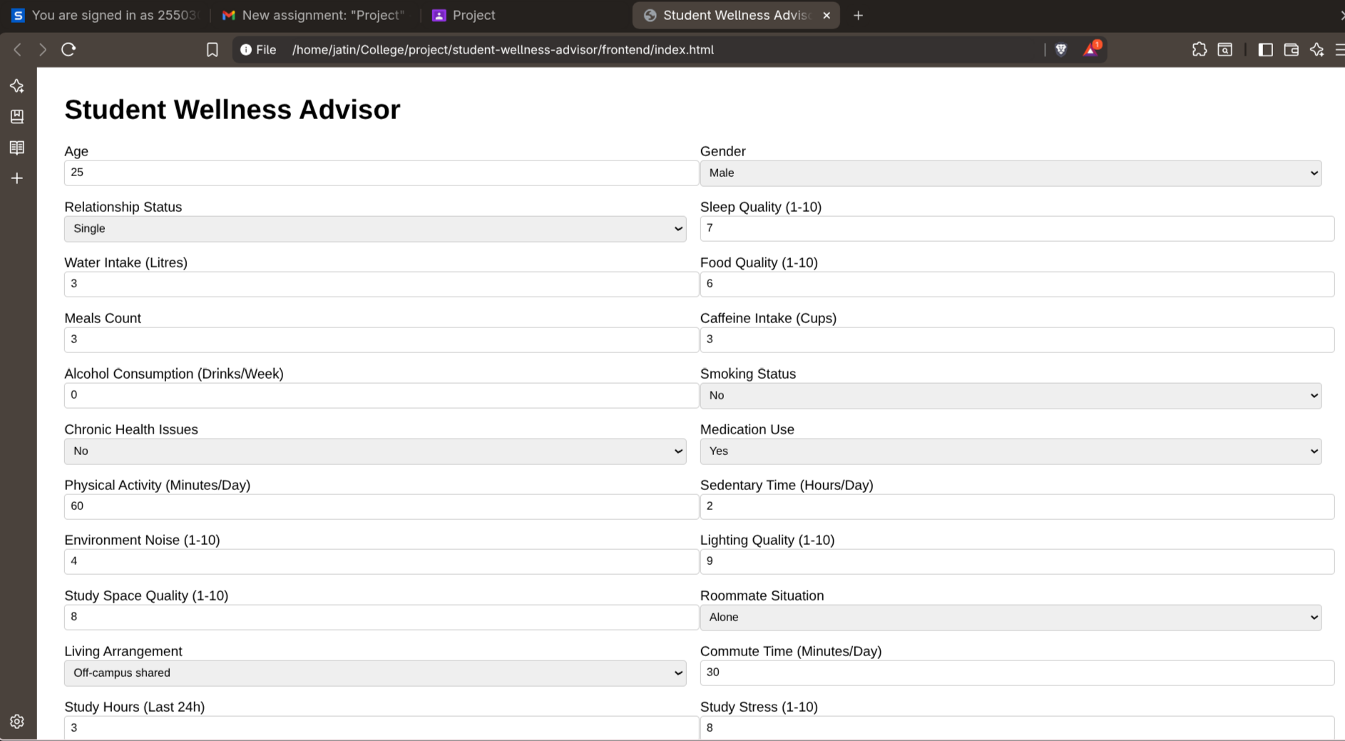
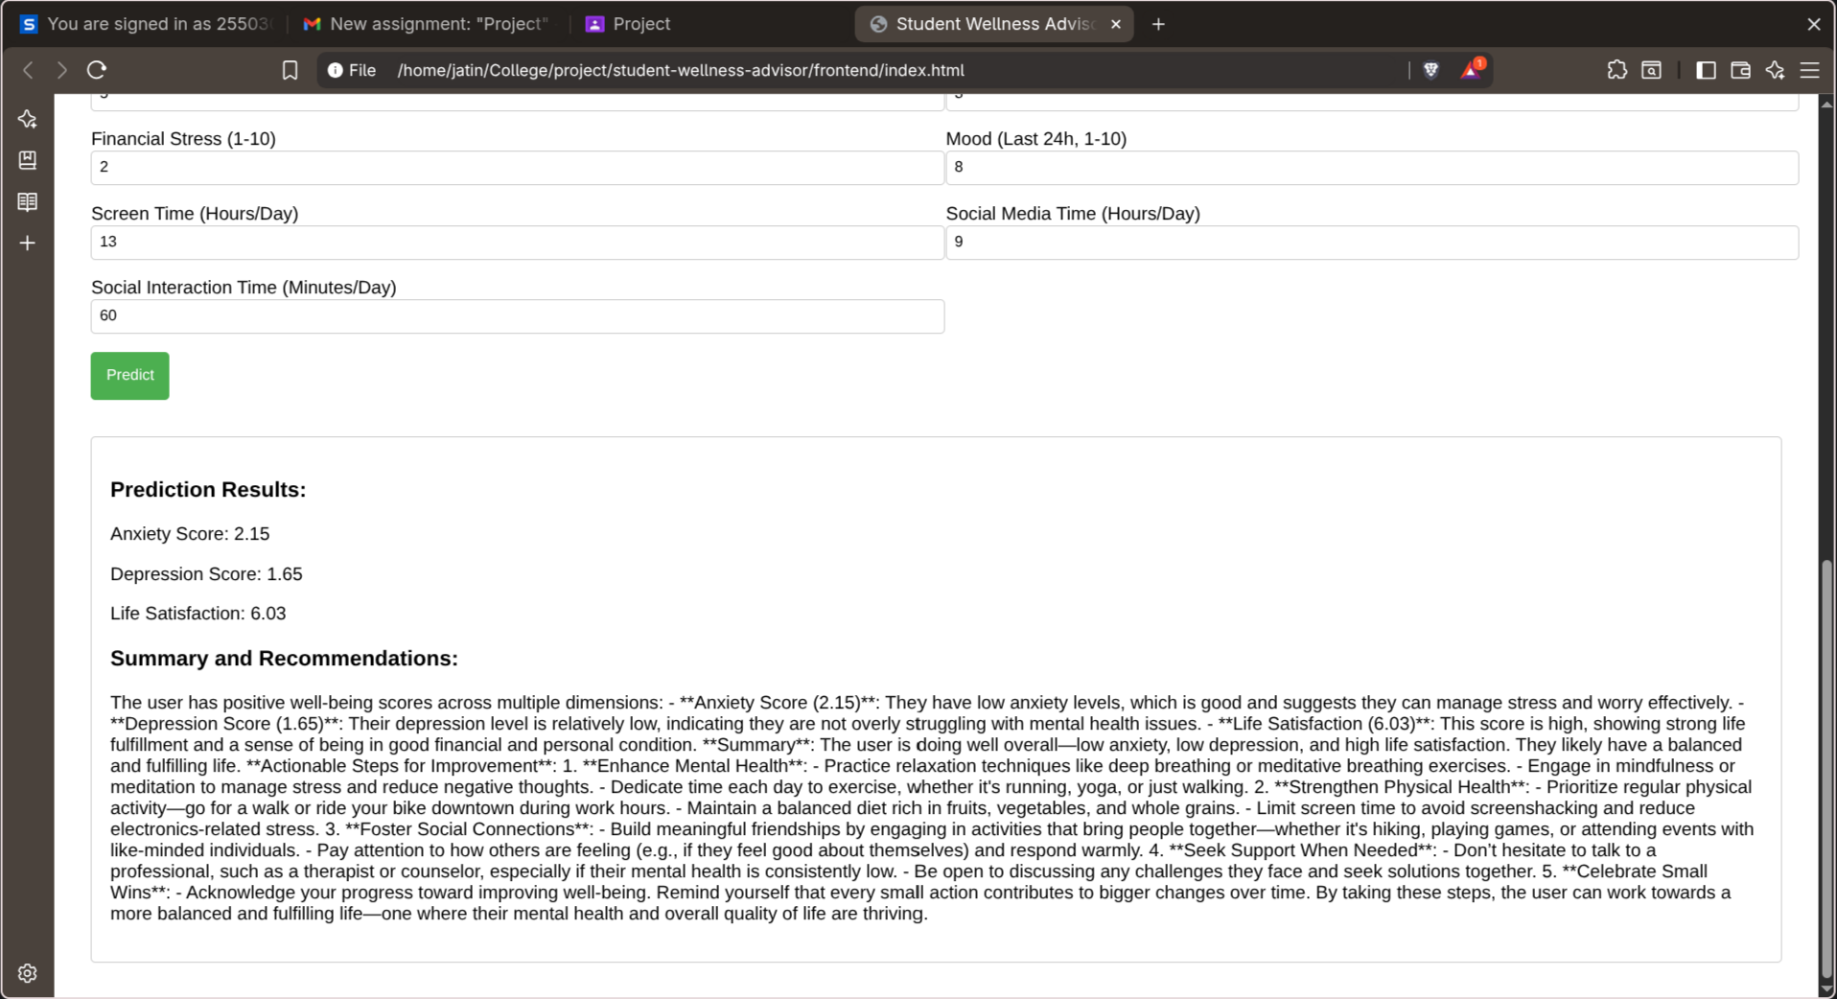
project images:

