HAPS FSO PROJECT
From OOK Transmission to Optical Jamming, Receiver Blinding and the ML Transition
Coverage: Baseline → EXP 11
Simulation Platform: MATLAB
System: HAPS-to-Ground Free-Space Optical Communication
Prepared from the actual project source archive and recorded experiment outputs.

Document Purpose and Reading Guide
This document is the master technical record of the HAPS FSO project through Experiment 11. It explains the system from first principles, maps every major MATLAB module to the underlying physics, documents the experiments and reconstructs the central results and patterns observed during development.
The primary source is the uploaded MATLAB project archive. Numerical plots for EXP 09–11 are reconstructed from recorded experiment outputs. Representative baseline turbulence values come from the baseline consolidated documentation contained in the project archive.

How to read this document
Reader | Recommended path
Beginner | Sections 1 → 7 → 10 → 14 → 20
MATLAB reviewer | Sections 3 → 13 and Appendix A
Research reviewer | Sections 14 → 24
Future ML developer | Sections 20 → 25

Project status at the end of this document
- The legitimate HAPS FSO baseline is modularized and validated.
- Constant and random optical jammer models are implemented separately.
- Constant-jammer power sweeps reveal a non-monotonic BER curve and a blinding transition.
- Random intermittent jamming is validated and swept by activity probability.
- EXP 11 compares constant and random jammers under the same average power budget.
- The next phase is ML-based attack detection, classification and mitigation.

Table of Contents
1. Project Overview and Research Story
2. High-Level End-to-End Architecture
3. Project Repository and Software Architecture
4. Default System Parameters
5. Binary Information and OOK Transmission
6. Geometrical Propagation
7. Atmospheric Attenuation
8. Pointing Error
9. Gamma-Gamma Atmospheric Turbulence
10. Combined Legitimate FSO Channel
11. Receiver
12. runBaseline Simulation Engine
13. Testing and Baseline Validation
14. Baseline Experiments EXP_BASE_01 to EXP_BASE_04
15. Threat Model: Optical Jamming
16. Constant Jammer and EXP 05–06
17. Random Jammer and EXP 07–08
18. Constant Blinding Attack: EXP 09
19. Random Blinding Attack: EXP 10
20. Fair Comparison: EXP 11
21. Cross-Experiment Patterns
22. Reproducibility and Debugging Lessons
23. Model Assumptions and Limitations
24. Research Conclusions
25. Bridge to Machine Learning
Appendix A. File-by-File Code Map
Appendix B. Key Equations
Appendix C. Key Experimental Results

1. Project Overview and Research Story
The project studies a HAPS-to-ground free-space optical (FSO) communication link using intensity modulation/direct detection. A binary source is converted into an on-off optical waveform, propagated through deterministic and random atmospheric effects, converted into receiver current, and detected with a fixed threshold. After the legitimate baseline is established, an adversarial optical source is added to study jamming and receiver blinding.

Research progression
Random bits
↓
OOK optical transmission
↓
Gaussian-beam geometrical coupling
↓
Atmospheric attenuation
↓
Pointing loss + Gamma-Gamma turbulence
↓
Received legitimate optical signal
↓
Photodetection + receiver noise + optional saturation
↓
Threshold decision → BER
↓
Constant optical jammer
↓
Random intermittent jammer
↓
Receiver blinding studies
↓
Fair constant-vs-random comparison
↓
ML detection / classification / mitigation

Core questions
- How do geometry, attenuation, pointing error and turbulence affect an OOK HAPS FSO link?
- How does constant optical jamming alter BER and error type?
- Why can small jammer power temporarily improve BER in this fixed-threshold model?
- How does intermittent jamming differ from continuous jamming?
- How does receiver saturation create a blinding regime?
- Under the same average power budget, which temporal attack structure is more damaging?
- Which receiver signatures should feed the next ML phase?

2. High-Level End-to-End Architecture
[Random Bits]
↓
[OOK Transmitter]
↓
[Gaussian Beam Geometry] ─ H_geo
↓
[Atmospheric Attenuation] ─ H_atm
↓
[Pointing Error] ───────── H_point(k)
↓
[Gamma-Gamma Turbulence] ─ H_turb(k)
↓
[Legitimate Received Optical Power]
↓
+ P_jammer(t) when attacked
↓
[Photodetector]
↓
[Receiver Noise]
↓
[Optional Saturation]
↓
[Mid-bit Sampling]
↓
[Threshold Detector]
↓
[Detected Bits + BER]
P_rx,legit = P_tx · H_geo · H_atm · H_point · H_turb
P_rx,total = P_rx,legit + P_jammer
The legitimate channel is multiplicative. The adversarial jammer is additive at the optical input before photodetection.

3. Project Repository and Software Architecture
HAPS_FSO_PROJECT/
├── baseline_model/
│ ├── defaultParameters.m
│ ├── main_baseline.m
│ ├── runBaseline.m
│ └── MainModels/
│ ├── generateOOK.m
│ ├── geometryModel.m
│ ├── atmosphericAttenuation.m
│ ├── pointingErrorModel.m
│ ├── gammaGammaTurbulence.m
│ └── receiverModel.m
├── baseline with jammer/
│ ├── jammerModel.m
│ └── randomJammerModel.m
├── experiments/
│ ├── EXP_BASE_01_distanceSweep.m
│ ├── EXP_BASE_02_turbulenceSweep.m
│ ├── EXP_BASE_03_pointingSweep.m
│ ├── EXP_BASE_04_channelRealization.m
│ ├── EXP_05_constantJammer.m
│ ├── EXP_06_jammerPowerSweep.m
│ ├── EXP_07_randomJammerValidation.m
│ ├── EXP_08_randomJammerSweep.m
│ ├── EXP_09_constantJammerBlindingAttack.m
│ ├── EXP_10_randomJammerBlindingAttack.m
│ └── EXP_11_fairJammerComparison.m
└── tests/
├── test01_perfectChannel.m
└── test02_receiverNoise.m
Layer | Responsibility
Parameters | Nominal simulation settings.
Transmitter | Bits, OOK symbols and waveform.
Propagation | Geometry and atmospheric attenuation.
Random channel | Pointing and turbulence.
Receiver | Photodetection, noise, saturation, sampling and decision.
System engine | End-to-end legitimate simulation and diagnostics.
Attack layer | Constant and random jammer generation.
Experiments | Sweeps, comparisons and plots.
Tests | Sanity and sensitivity validation.

4. Default System Parameters
Parameter | Symbol / meaning | Default
Number of bits | Nbits | 1000
Bit rate | Rb | 1×10^6 bit/s
Transmit power | Pt | 1 W
Samples/bit | samplesPerBit | 20
Wavelength | λ | 1550 nm
Divergence half-angle | θ | 0.01 mrad
Receiver diameter | D_Rx | 0.2 m
Responsivity | R | 0.8 A/W
Distance | L | 20 km
Atmospheric attenuation | α | 0.1 dB/km
Pointing std | σ_point | 0.02 m
Turbulence | Cn² | 1×10^-16
Noise std | σ_noise | 0.005 A
Saturation default | enableSaturation | false
Random seed | rngSeed | 1
T_b = 1/R_b = 1 μs
F_s = R_b · samplesPerBit = 20 MHz
The 20 samples per bit provide numerical waveform resolution. In the present implementation, pointing and turbulence are generated once per bit and repeated over that bit's samples.

5. Binary Information and OOK Transmission

5.1 Random bit source
bits = randi([0 1], 1, Nbits);
b_k ∈ {0,1}

5.2 On-Off Keying
ookSymbols = Pt * bits;
P_tx(k) = 0 for b_k=0, and P_t for b_k=1
OOK maps information directly to optical intensity: zero means no legitimate optical contribution in this simplified model; one means Pt.

5.3 Waveform expansion
txSignal = repelem(ookSymbols, samplesPerBit);
Each bit-level symbol is repeated across 20 samples so the waveform can be processed by the channel and receiver.

5.4 Time axis
Fs = Rb * samplesPerBit;
t = (0:length(txSignal)-1) / Fs;

6. Geometrical Propagation
geometryModel.m models Gaussian-beam spreading and the fraction of beam power captured by a finite circular receiver.
w_0 = λ/(πθ)
z_R = πw_0²/λ
w_Rx = w_0√(1+(L/z_R)²)
H_geo = 1−exp(−2R_Rx²/w_Rx²)
As propagation distance increases, the beam spreads. A finite receiver aperture therefore captures a changing fraction of the Gaussian optical power.
The baseline consolidated documentation recorded a representative 20 km operating point of H_geo ≈ 0.375821 and w_Rx ≈ 0.2060 m for the project parameterization.

7. Atmospheric Attenuation
L_km = L / 1e3;
H_atm = 10^(-alpha * L_km / 10);
H_atm = 10^(−αL_km/10)
This converts the dB/km attenuation coefficient into a linear optical power gain. The present model is path-averaged and deterministic.
H_total = H_geo · H_atm
At α=0.1 dB/km and L=20 km, the consolidated baseline documentation records H_atm ≈ 0.630957.

8. Pointing Error
x_error = sigmaPoint * randn(1,Nbits);
y_error = sigmaPoint * randn(1,Nbits);
r_error = sqrt(x_error.^2 + y_error.^2);
H_point = exp(-2*r_error.^2/wRx^2);
x_e,y_e ~ N(0,σ_point²)
r_e = √(x_e²+y_e²)
H_point(k)=exp(−2r_e(k)²/w_Rx²)
One random pointing loss is generated per bit and repeated across the samples of that bit. Severe misalignment reduces legitimate received power and increases the chance of 1→0 errors.

9. Gamma-Gamma Atmospheric Turbulence
gammaGammaTurbulence.m represents scintillation as a random multiplicative gain.
k = 2π/λ
σ_R² = 1.23 · Cn² · k^(7/6) · L^(11/6)
H_turb = X·Y
The implementation derives Gamma-Gamma parameters α_GG and β_GG from the Rytov variance, generates normalized Gamma variables X and Y, and multiplies them.
When Cn²=0, the source explicitly returns H_turb=1, giving a clean no-turbulence validation condition.
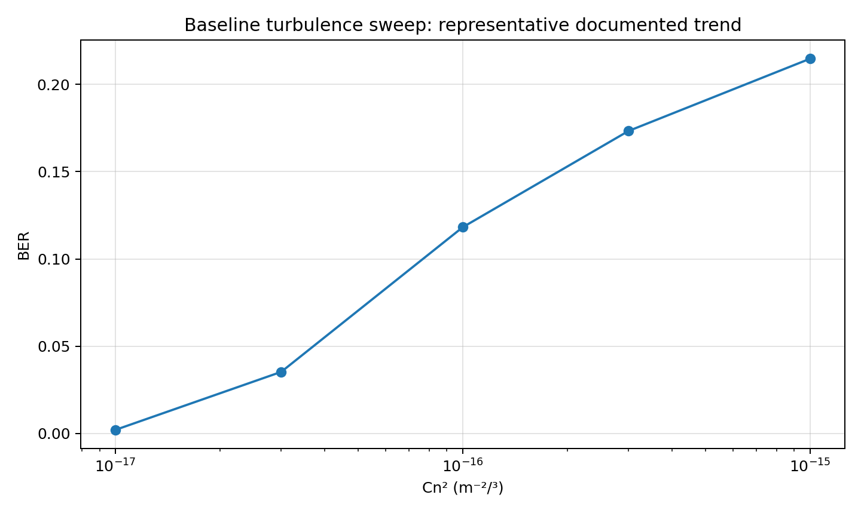
Representative baseline turbulence sweep trend documented in the project's consolidated baseline report.
The representative documented values rise from BER ≈0.0021 at Cn²=1×10^-17 to BER ≈0.2147 at Cn²=1×10^-15. Exact values depend on random realizations.

10. Combined Legitimate FSO Channel
P_rx(t)=P_tx(t)·H_geo·H_atm·H_point(t)·H_turb(t)
P_rx(t)=P_tx(t)·H_total·H_point(t)·H_turb(t)
rxOpticalSignal =
H_total .* H_point_signal .* H_turb_signal .* txSignal;
For bit 0, the legitimate optical contribution is ideally zero. For bit 1, received power fluctuates because pointing and turbulence vary.
A critical design choice is that the receiver threshold uses H_total rather than instantaneous H_total·H_point·H_turb. Consequently, severe fading can push legitimate ones below threshold.

11. Receiver: Photodetection, Noise, Saturation and Decision

11.1 Photodetection
I_photo(t)=R·P_rx(t)
rxCurrent = R * rxOpticalSignal;

11.2 Receiver noise
n(t)~N(0,σ_noise²)
I_noisy=I_photo+n
Noise is generated outside receiverModel so experiments can reuse the exact same realization.

11.3 Hard saturation
I_out=min(I_noisy,I_sat)
if enableSaturation
I_sat = 0.25;
rxCurrent = min(rxCurrent,I_sat);
end
This hard-clipping model is central to the blinding studies.

11.4 Mid-bit sampling
sampleIndices = samplesPerBit/2 : samplesPerBit : length(rxCurrent);

11.5 Threshold and decision
I_th = R·P_t·H_total/2
b̂_k=1 if I_sample,k>I_th; otherwise 0

11.6 BER and error types
BER = errors/Nbits
Errors_10=count(b=1,b̂=0), Errors_01=count(b=0,b̂=1)
The split between 1→0 and 0→1 errors becomes the main diagnostic tool for interpreting attack mechanisms.

12. The runBaseline Simulation Engine
runBaseline.m is intentionally the legitimate-system engine: no jammer is injected inside it.
Step | Action
1 | Set random seed.
2 | Generate bits and OOK waveform.
3 | Compute geometry.
4 | Compute atmospheric attenuation.
5 | Form H_total.
6 | Generate and expand pointing gains.
7 | Generate and expand turbulence gains.
8 | Apply multiplicative legitimate channel.
9 | Generate receiver noise.
10 | Run receiver.
11 | Store diagnostics, BER, error types and channel information.

Important returned fields
- bits / detectedBits
- txSignal / rxOpticalSignal
- rxCurrent / rxSamples
- receiverNoise
- mean and standard deviation of samples for transmitted 0 and 1
- BER, threshold, bitErrors, errors10, errors01
- H_geo, H_atm, H_total, H_point_bits, H_turb_bits
- wRx, w0, zR, alphaGG, betaGG, sigmaR2
Storing results.receiverNoise fixed an important development issue and enabled fair attacked-versus-clean comparisons.

13. Testing and Baseline Validation

Test 01 — Perfect / Ideal Channel
params.sigmaPoint = 0;
params.Cn2 = 0;
params.sigmaNoise = 0;
This verifies that the modulation, channel plumbing, sampling and decision logic can operate correctly when impairments are removed.

Test 02 — Receiver Noise Validation
The source uses a perfect channel and studies receiver-noise effects, with Nbits=100000 for more reliable BER statistics.

Validation philosophy
Question | Validation mechanism
Does the system work ideally? | Perfect-channel test.
Does noise hurt performance? | Noise validation.
Does distance affect propagation? | Distance sweep.
Does stronger turbulence degrade the link? | Cn² sweep.
Does misalignment degrade the link? | Pointing sweep.
Do gains actually vary? | Channel realization.

14. Baseline Experiments: EXP_BASE_01 to EXP_BASE_04

EXP_BASE_01 — Distance Sweep
The source sweeps distance from 1 km to 30 km. The intended physical trend is reduced received margin as propagation losses and beam spreading become more severe.
L↑ → received signal margin generally ↓ → BER eventually ↑

EXP_BASE_02 — Turbulence Sweep
Distance and pointing are fixed while Cn² is varied to isolate atmospheric scintillation.

EXP_BASE_03 — Pointing Sweep
Pointing-error standard deviation is varied to isolate misalignment-induced coupling loss.

EXP_BASE_04 — Channel Realization
This experiment emphasizes that the channel contains random per-bit gains rather than a single constant number.
Together, these experiments establish the legitimate physical baseline before adversarial optical injection is introduced.

15. Threat Model: Optical Jamming
P_total(t)=P_legitimate(t)+P_jammer(t)
The attacker injects optical power at the receiver input abstraction. The receiver then converts the total optical power into electrical current.
Attack family | Model
Constant jammer | P_jammer(t)=P_J continuously.
Random jammer | J_k~Bernoulli(p); P_jammer,k=P_ON·J_k.

Attack mechanisms
- Positive optical bias can shift samples relative to threshold.
- Strong bias can cause zeros to become false ones.
- Sufficient optical power can trigger hard receiver saturation and create a blinding regime.

16. Constant Jammer and EXP 05–06

jammerModel.m
if ~enableJammer
jammerSignal=zeros(1,Nsamples);
else
jammerSignal=jammerPower*ones(1,Nsamples);
end
P_jammer(t)=P_J

EXP 05 — Controlled constant-jammer comparison
The experiment explicitly aims to preserve transmitted bits, pointing realization, turbulence realization and receiver noise so that the jammer is the intended changing factor.

EXP 06 — Jammer power sweep
The sweep records BER and both error types. Development results exposed a non-monotonic curve: initially BER decreased as positive optical bias rescued faded ones; at larger power the attack created dominant 0→1 errors and BER approached 0.5.
Weak legitimate '1' below threshold → 1→0
Weak legitimate '1' + small jammer → may cross threshold correctly
Logical '0' + sufficiently strong jammer → crosses threshold → 0→1
The key lesson is that jammer power must be interpreted by mechanism, not by the simplistic rule 'more jammer always means more BER'.

17. Random Jammer and EXP 07–08

randomJammerModel.m
J_k~Bernoulli(p)
P_jammer,k=P_ON·J_k
jammerBits = rand(1,Nbits) < activityProbability;
jammerPowerBits = jammerPower .* jammerBits;
jammerSignal = repelem(jammerPowerBits,samplesPerBit);
The jammer chooses an ON/OFF state once per bit and remains in that state across the bit's 20 samples.

EXP 07 — Validation
A recorded 50-bit validation used requested p=0.30 and observed actual activity 0.38. This finite-sample deviation is expected.
Actual activity = number of ON bits / Nbits

EXP 08 — Activity sweep
Activity probability is swept from 0 to 1 at fixed ON-power. The experiment demonstrates that activity is an independent attack control parameter and that the resulting BER depends on the receiver operating regime, threshold and saturation configuration.

18. EXP 09 — Constant Jammer Blinding Attack
EXP 09 uses Nbits=10000, enables saturation and sweeps jammer power into the overload region.
Pj (W) | BER | 1→0 | 0→1 | Saturation
0.000 | 0.1177 | 1177 | 0 | 0.107
0.010 | 0.1006 | 1006 | 0 | 0.115
0.030 | 0.0643 | 643 | 0 | 0.133
0.050 | 0.0360 | 360 | 0 | 0.155
0.070 | 0.0151 | 151 | 0 | 0.177
0.100 | 0.0018 | 12 | 6 | 0.215
0.120 | 0.3026 | 0 | 3026 | 0.245
0.150 | 0.5076 | 0 | 5076 | 0.295
0.200 | 0.5076 | 0 | 5076 | 0.386
0.250 | 0.5076 | 0 | 5076 | 0.464
0.300 | 0.5076 | 0 | 5076 | 0.504
0.400 | 0.5076 | 0 | 5076 | 1.000
0.500 | 0.5076 | 0 | 5076 | 1.000
0.750 | 0.5076 | 0 | 5076 | 1.000
1.000 | 0.5076 | 0 | 5076 | 1.000
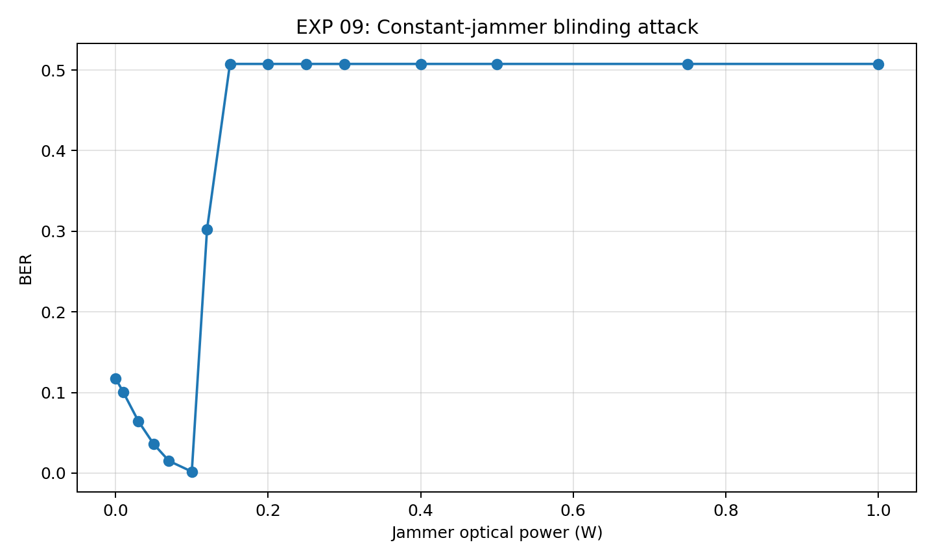
EXP 09: recorded BER versus constant jammer power.
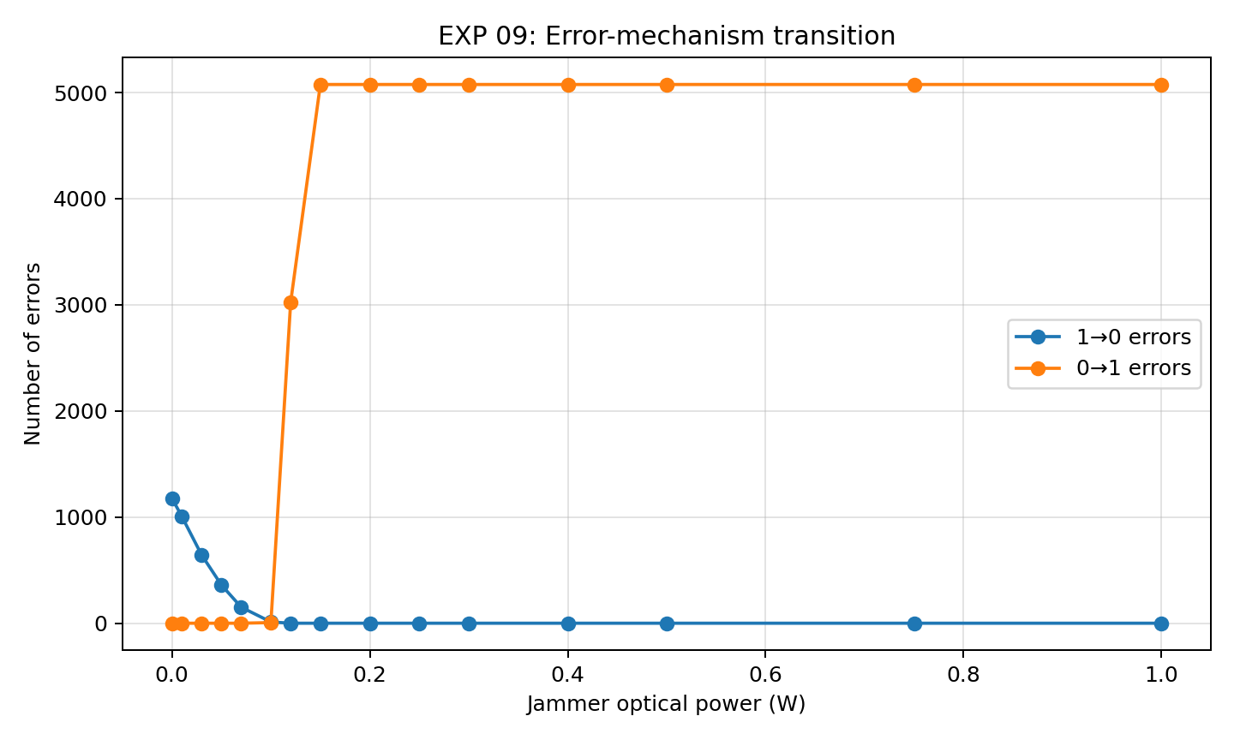
EXP 09: recorded error-mechanism transition.
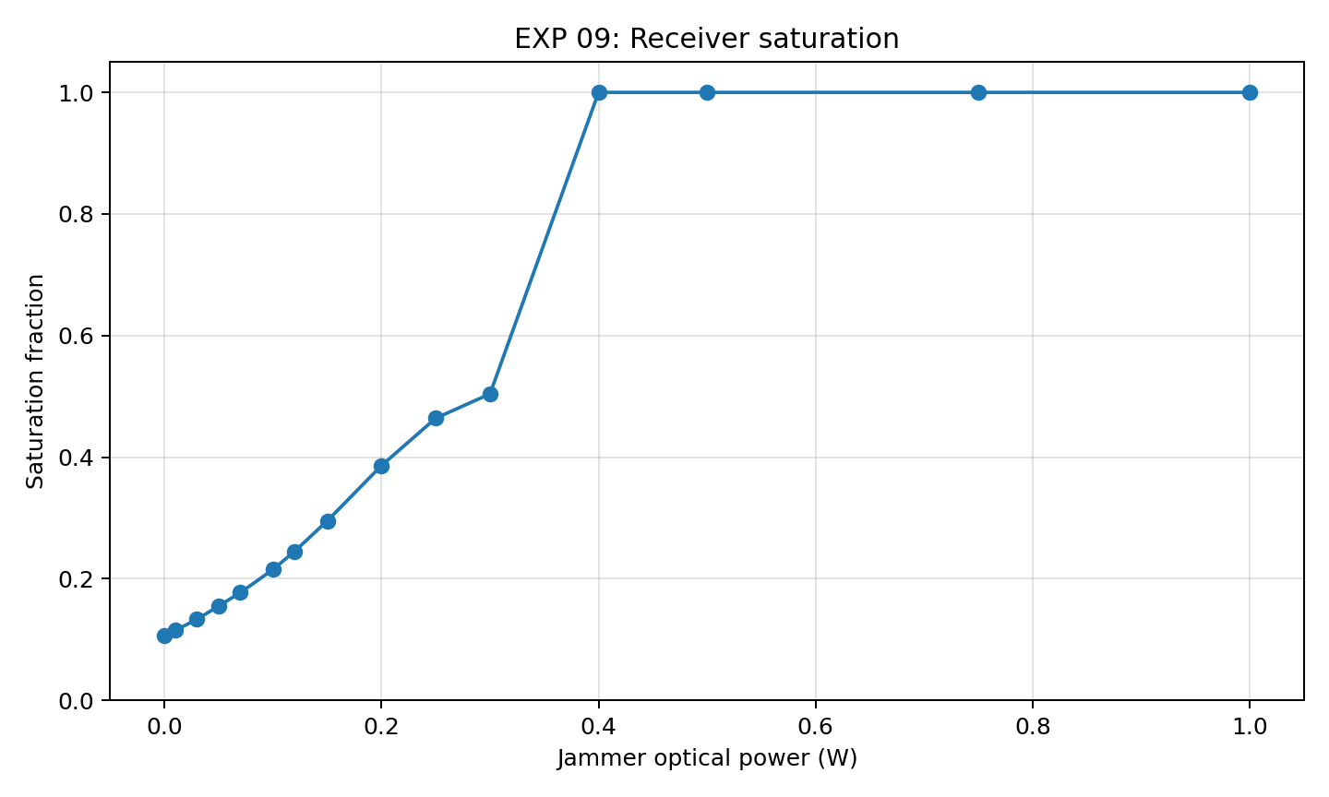
EXP 09: recorded receiver saturation fraction.

Regime interpretation
Region | Observed behavior | Mechanism
Baseline/weak | BER begins near 0.118 | Mostly fading-driven 1→0 errors.
Helpful bias | BER falls to 0.0018 near 0.10 W | Bias rescues faded ones.
Transition | BER jumps at 0.12 W | 0→1 errors dominate.
Blinding plateau | BER ≈0.5076 | Receiver effectively outputs one for nearly all bits.
Full saturation | Sat=1 at high power | Hard clipping active for all samples.
If b̂≈1 for all bits, BER≈fraction of transmitted zeros≈0.5
The recorded 0.5076 plateau corresponds to 5076 zero bits in the 10000-bit realization.

19. EXP 10 — Random Jammer Blinding Attack
EXP 10 fixes peak jammer power at 0.4 W and sweeps activity probability. The attacked signal is formed by adding the random jammer to the legitimate baseline signal, while the stored baseline receiver noise is reused.
Expected average jammer power = p·P_ON
p | Actual | BER | 1→0 | 0→1 | Sat | Avg Pj
0.0 | 0.000 | 0.1193 | 1193 | 0 | 0.108 | 0.0000
0.1 | 0.103 | 0.1586 | 1066 | 520 | 0.201 | 0.0412
0.2 | 0.210 | 0.2043 | 959 | 1084 | 0.296 | 0.0840
0.3 | 0.308 | 0.2398 | 835 | 1563 | 0.384 | 0.1234
0.4 | 0.412 | 0.2805 | 717 | 2088 | 0.476 | 0.1648
0.5 | 0.515 | 0.3180 | 586 | 2594 | 0.568 | 0.2060
0.6 | 0.611 | 0.3575 | 473 | 3102 | 0.655 | 0.2444
0.7 | 0.710 | 0.3954 | 368 | 3586 | 0.744 | 0.2839
0.8 | 0.810 | 0.4306 | 241 | 4065 | 0.833 | 0.3239
0.9 | 0.904 | 0.4654 | 130 | 4524 | 0.915 | 0.3617
1.0 | 1.000 | 0.4990 | 0 | 4990 | 1.000 | 0.4000
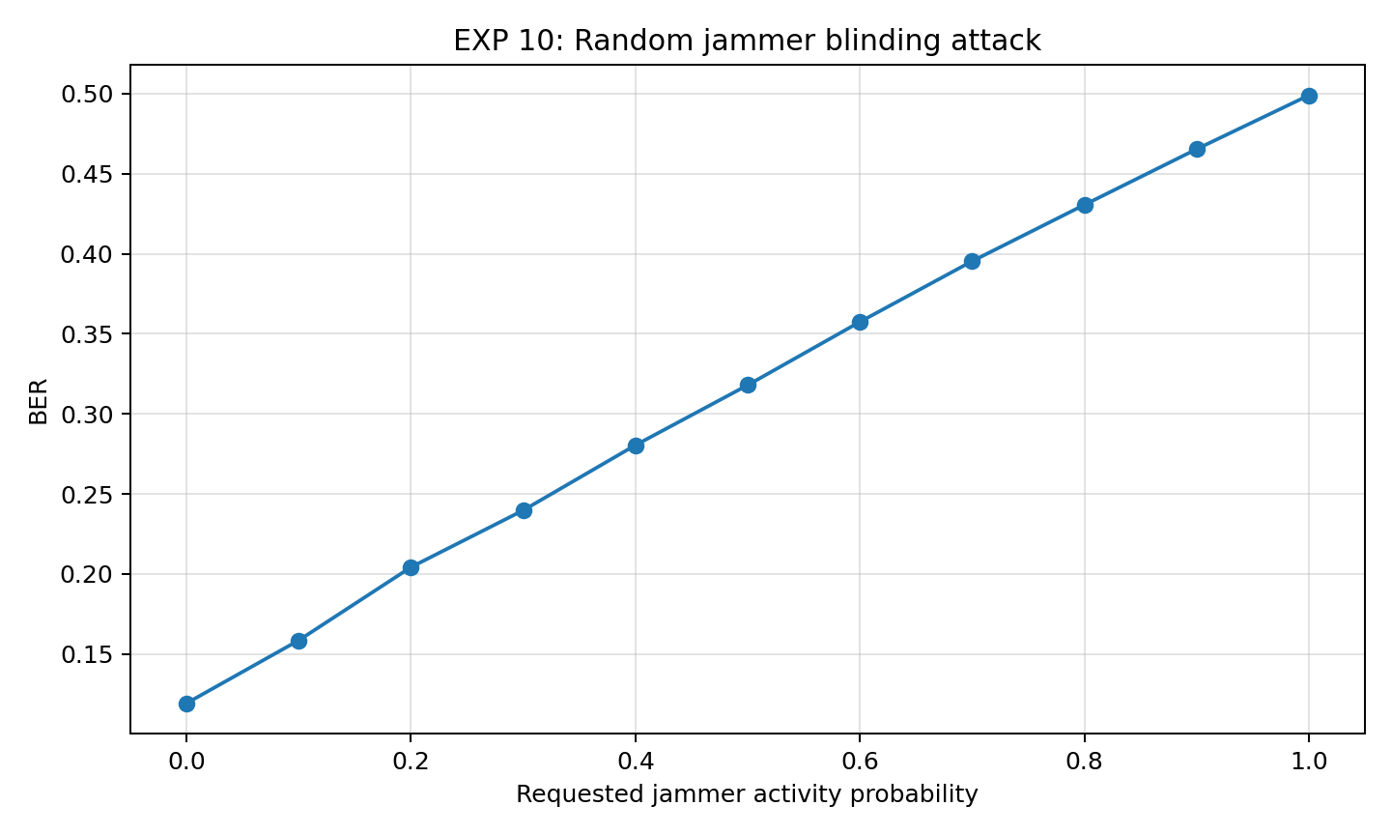
EXP 10: BER increases progressively with random jammer activity.
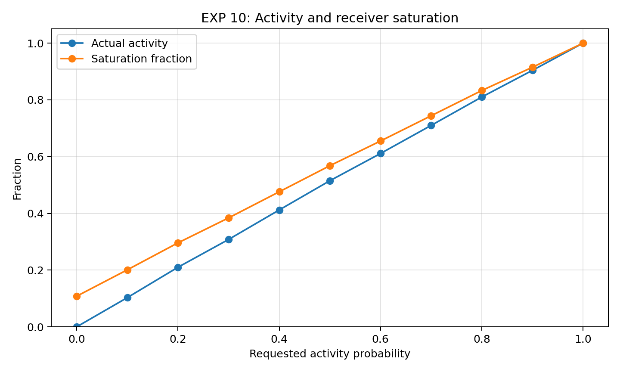
EXP 10: actual activity and saturation fraction.
As activity rises, 1→0 errors fall while 0→1 errors rise strongly. At p=1 the random jammer is continuously ON and the BER reaches approximately 0.499 with full saturation.

20. EXP 11 — Fair Constant vs Random Jammer Comparison
This experiment controls the average optical power budget, making it the strongest comparison experiment before the ML phase.

Fairness equation
P_avg=p·P_ON
p=P_avg/P_ON
The source fixes P_ON=0.4 W. The constant jammer uses P_avg continuously; the random jammer uses peak power 0.4 W with activity chosen from the equation above.
Pavg | Random p | Actual random Pavg | BER const | BER random | Sat const | Sat random
0.00 | 0.000 | 0.0000 | 0.111 | 0.111 | 0.113 | 0.113
0.05 | 0.117 | 0.0468 | 0.033 | 0.161 | 0.165 | 0.220
0.10 | 0.239 | 0.0956 | 0.003 | 0.207 | 0.231 | 0.323
0.15 | 0.365 | 0.1460 | 0.494 | 0.247 | 0.310 | 0.432
0.20 | 0.495 | 0.1980 | 0.494 | 0.304 | 0.407 | 0.552
0.25 | 0.618 | 0.2472 | 0.494 | 0.349 | 0.480 | 0.659
0.30 | 0.740 | 0.2960 | 0.494 | 0.397 | 0.518 | 0.770
0.35 | 0.868 | 0.3472 | 0.494 | 0.454 | 1.000 | 0.883
0.40 | 1.000 | 0.4000 | 0.494 | 0.494 | 1.000 | 1.000
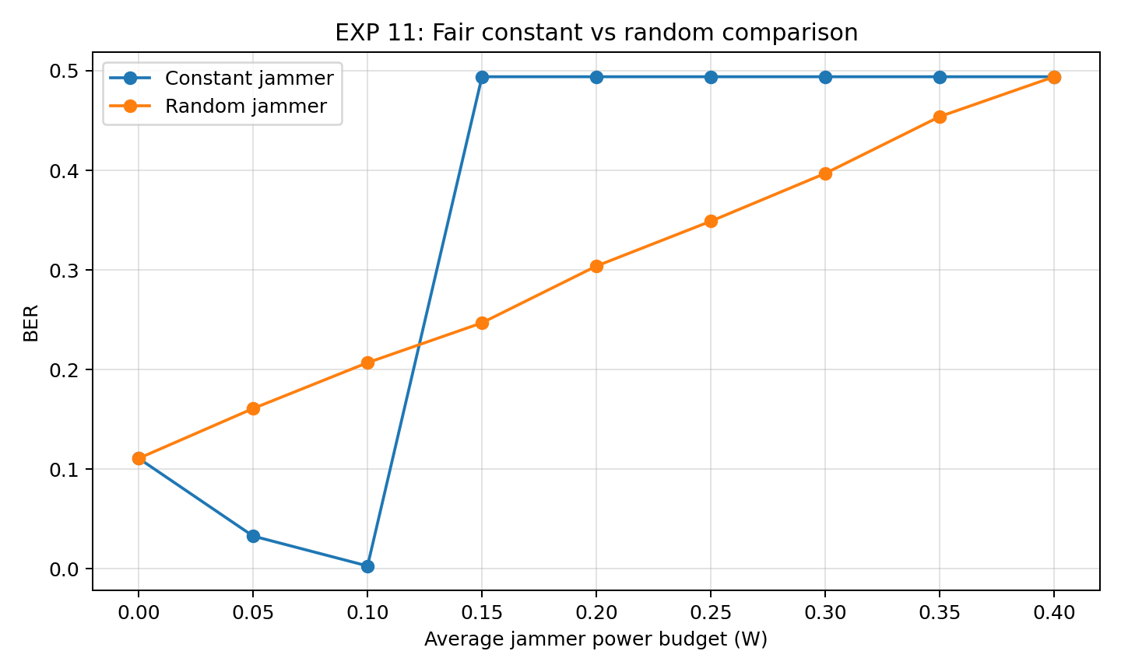
EXP 11: BER comparison under equal requested average power budget.
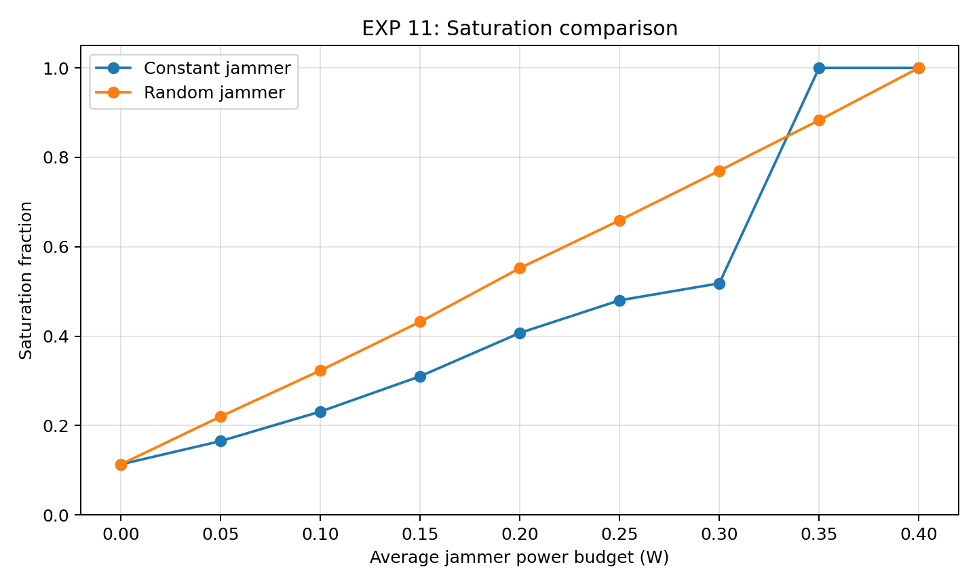
EXP 11: saturation comparison under equal requested average power budget.

Interpretation
At Pavg=0.05 and 0.10 W, the constant jammer sits in the helpful-bias region and produces very low BER, while the random jammer remains damaging because every ON event has a 0.4 W instantaneous amplitude. At Pavg=0.15 W the constant jammer abruptly enters its false-one regime. The random jammer degrades more gradually as a larger fraction of bits experience the strong ON-state.
This is the project's strongest evidence that average power alone does not determine attack impact. Temporal distribution and instantaneous peak power matter.

21. Cross-Experiment Patterns and Physical Interpretation

Pattern 1 — Non-monotonic BER
P_J↑ does not necessarily imply BER↑
Small positive bias can compensate for fading before becoming destructive.

Pattern 2 — Error asymmetry explains the curve
Weak/no jammer: mostly 1→0
Helpful bias: 1→0 decreases
Transition: 0→1 begins
Strong/blinding: almost entirely 0→1

Pattern 3 — Saturation and BER are different observables
Saturation can increase before BER reaches its maximum because BER depends on threshold crossings and symbol decisions.

Pattern 4 — Temporal attack structure matters
Constant jamming shifts every bit; random jamming alternates between normal and high-power attack states.

Pattern 5 — Blinding plateau near 0.5
An almost-always-one receiver makes every transmitted zero incorrect.

Pattern 6 — Peak power matters
EXP 11 shows that a random attack can be damaging despite a moderate average power because its instantaneous ON-power is high.

22. Reproducibility, Fairness and Debugging Lessons

Random seed control
Comparable simulations reset or fix RNG state so legitimate bits and channel realizations are reproducible.

Same legitimate realization
A jammer comparison should not simultaneously change turbulence, pointing or bits.

Same noise realization
runBaseline stores receiverNoise and attack experiments reuse it.

receiverNoise bug
The MATLAB error 'Unrecognized field name receiverNoise' was solved by storing results.receiverNoise=receiverNoise.

Finite statistics
Short validation runs can deviate substantially from requested probabilities; larger Nbits and Monte Carlo averaging improve confidence.

23. Model Assumptions and Limitations
- OOK uses 0 W for bit 0 and Pt for bit 1.
- Pointing and turbulence are independent block-fading realizations per bit.
- The turbulence process is not explicitly time-correlated across bits.
- Atmospheric attenuation is deterministic and path-averaged.
- The jammer is injected at the receiver optical-input abstraction; its own propagation path is not modeled separately.
- Receiver noise is additive Gaussian current noise.
- Saturation is hard clipping at I_sat=0.25 A.
- The threshold uses deterministic H_total rather than instantaneous fading estimates.
- The receiver samples once at mid-bit rather than integrating over the full bit.
- Single-run BER values retain finite-random-realization dependence.
These are appropriate simplifications for isolating causal mechanisms. A future version can increase physical realism after the ML objective is fixed.

24. Research Conclusions Through EXP 11
- The project successfully builds a modular HAPS FSO communication chain from bits to BER.
- Baseline fading primarily creates 1→0 errors under the fixed-threshold operating regime.
- A small constant optical bias can temporarily improve BER by rescuing faded ones.
- Beyond a transition point, optical injection creates dominant 0→1 errors.
- Strong optical injection plus receiver saturation produces a blinding regime with BER near 0.5.
- Random intermittent jamming is naturally controlled through a Bernoulli activity probability.
- Random and constant jammers produce different error and saturation signatures.
- Equal average jammer power does not imply equal damage because temporal structure and peak power matter.
- The signatures discovered through EXP 11 provide a principled basis for ML attack detection and mitigation.

25. Bridge to Machine Learning
The next phase should build ML on the physical signatures already discovered, rather than choosing a model first.

Possible tasks
Task | Output
Attack detection | Normal vs attacked
Attack classification | No attack / constant / random / blinding
Severity classification | Weak / transition / severe / blinded
Mitigation control | Adaptive receiver response

Candidate features already available
Feature | Meaning
meanBit0 / meanBit1 | Class-conditional received current levels.
stdBit0 / stdBit1 | Class-conditional variability.
BER | Aggregate degradation.
errors10 / errors01 | Mechanism asymmetry.
Saturation fraction | Receiver overload indicator.
Mean/max current | Operating level.
Threshold | Nominal decision boundary.
Channel statistics | Legitimate propagation context.

Recommended next architecture
Simulation scenarios
↓
Labelled dataset generation
↓
Feature extraction
↓
Train / validation / test split
↓
Baseline ML models
↓
Attack detection + classification
↓
Feature importance / interpretability
↓
Mitigation decision
↓
Adaptive receiver strategy
Do not train on BER alone. BER hides the difference between fading, helpful bias, transition and blinding. The ML dataset should preserve receiver-level statistics and error asymmetry.

Appendix A. File-by-File Code Map
File | Role
defaultParameters.m | Central nominal parameter factory.
main_baseline.m | Normal baseline entry point.
runBaseline.m | Complete legitimate simulation engine and results container.
generateOOK.m | Bits, OOK waveform and time axis.
geometryModel.m | Gaussian beam geometry and aperture coupling.
atmosphericAttenuation.m | dB/km to linear optical gain.
pointingErrorModel.m | Per-bit pointing displacement and coupling loss.
gammaGammaTurbulence.m | Rytov/Gamma-Gamma fading.
receiverModel.m | Photodetection, noise, saturation, sampling, threshold, BER.
jammerModel.m | Constant optical jammer.
randomJammerModel.m | Bernoulli intermittent jammer.
test01_perfectChannel.m | Ideal-channel validation.
test02_receiverNoise.m | Noise sensitivity validation.
EXP_BASE_01_distanceSweep.m | Distance study.
EXP_BASE_02_turbulenceSweep.m | Turbulence study.
EXP_BASE_03_pointingSweep.m | Pointing study.
EXP_BASE_04_channelRealization.m | Channel realization study.
EXP_05_constantJammer.m | Controlled constant-jammer comparison.
EXP_06_jammerPowerSweep.m | Constant jammer sweep.
EXP_07_randomJammerValidation.m | Random activity validation.
EXP_08_randomJammerSweep.m | Random activity sweep.
EXP_09_constantJammerBlindingAttack.m | Constant blinding sweep.
EXP_10_randomJammerBlindingAttack.m | Random blinding sweep.
EXP_11_fairJammerComparison.m | Equal-average-power comparison.

Appendix B. Key Equations
Quantity | Equation
Bit duration | T_b=1/R_b
Sampling frequency | F_s=R_b·samplesPerBit
OOK | P_tx,k=P_t b_k
Beam waist | w_0=λ/(πθ)
Rayleigh range | z_R=πw_0²/λ
Beam radius | w_Rx=w_0√(1+(L/z_R)²)
Geometric gain | H_geo=1−exp(−2R_Rx²/w_Rx²)
Atmospheric gain | H_atm=10^(−αL_km/10)
Deterministic gain | H_total=H_geoH_atm
Pointing gain | H_point=exp(−2r_e²/w_Rx²)
Rytov variance | σ_R²=1.23Cn²k^(7/6)L^(11/6)
Turbulence | H_turb=XY
Legitimate optical signal | P_legit=P_txH_totalH_pointH_turb
Attacked signal | P_total=P_legit+P_jammer
Photocurrent | I=RP_total+n
Saturation | I_out=min(I,I_sat)
Threshold | I_th=RP_tH_total/2
BER | BER=errors/Nbits
Random average power | P_avg=pP_ON
Fair activity | p=P_avg/P_ON

Appendix C. Key Experimental Results

EXP 09
Pj=0.000 W → BER 0.1177, mainly 1→0
Pj=0.100 W → BER 0.0018, helpful-bias region
Pj=0.120 W → BER 0.3026, strong 0→1 transition
Pj≥0.150 W → BER≈0.5076, false-one/blinding plateau
Pj≥0.400 W → saturation fraction=1.0 in recorded run

EXP 10
Activity 0.0 → BER 0.1193, Sat 0.108
Activity 0.5 → BER 0.3180, Sat 0.568
Activity 0.8 → BER 0.4306, Sat 0.833
Activity 1.0 → BER 0.4990, Sat 1.000

EXP 11
Pavg 0.05 W: Constant BER 0.033, Random BER 0.161
Pavg 0.10 W: Constant BER 0.003, Random BER 0.207
Pavg 0.15 W: Constant BER 0.494, Random BER 0.247
Pavg 0.30 W: Constant BER 0.494, Random BER 0.397
Pavg 0.40 W: Constant BER 0.494, Random BER 0.494

Final project narrative
The project has progressed from first-principles optical communication to an experimentally characterized physical-layer security problem. The baseline explains how legitimate information is transmitted and degraded. The jammer experiments reveal multiple attack regimes rather than a single monotonic failure mechanism. The blinding experiments connect excessive optical power to receiver saturation and information collapse. The fair comparison establishes that temporal attack structure and instantaneous peak power matter even under equal average power budgets. These signatures provide the correct foundation for the next ML phase.

