University of Petroleum and Energy Studies
Final Project Report

on

Predicting Customer Churn in Telecommunications Company

Team members:

Jitender Dhariwal: R21442201723
Jatin Wadhwa: R2144220562
Jatin Joshi: R2144220559
Karan Taneja: R2144220587
Kartikay Tyagi: R2144220603

Guided by: Mr. Sumit Shukla

Industry Mentor: Mr. Sumit Shukla

Table of Contents
Executive Summary.……………………………………………………………………………………….3
- Background………………………………………………………………………………………………….4
  - Aim………………………………………………………………………………………………………..4
  - Technologies……………………………………………………………………………………………...4
  - Hardware Architecture………………………………………………………………………………….4
  - Software Architecture……………………………………………………………………………………4
- System…………………………………………………………………………………………………………5
  - Requirements…………………………………………………………………………………………...5
    - Functional requirements……………………………………………………………………………5
    - User requirements…………………………………………………………………………………..5
    - Environmental requirements………………………………………………………………………..5
  - Design and Architecture………………………………………………………………………………….5
  - Implementation……………………………………………………………………………………………5
  - Testing……………………………………………………………………………………………………...5
    - Test Plan Objectives…………………………………………………………………………………6
    - Data Entry……………………………………………………………………………………………6
    - Security………………………………………………………………………………………………6
    - Test Strategy…………………………………………………………………………………………6
    - Performance Test……………………………………………………………………………………6
    - SIT…………………………………………………………………………………………………7

2.6 Evaluation………………………………………………………………………………………………….7
2.6.2 STATIC CODE ANALYSIS………………………………………………………………………...7

- Snapshots of the Project……………………………………………………………………………………….8
- Conclusions………………………………………………………………………………………………………9
- Further development or research……………………………………………………………………………9
- References……………………………………………………………………………………………………….9
- Appendix…………………………………………………………………………………………….. 9-11

Executive Summary In the rapidly evolving landscape of the telecommunications industry, the ability to retain customers is of paramount importance. This executive summary outlines the implementation of a sophisticated machine learning-driven Customer Churn Prediction system, aimed at enabling our company to proactively identify customers at risk of churning and implement targeted retention strategies.
Objective: The primary objective of this initiative is to leverage advanced machine learning techniques to predict customer churn with a high degree of accuracy. By identifying customers who are likely to churn, we can take proactive measures to retain them, thereby minimizing revenue loss and enhancing customer satisfaction.
Approach: The Customer Churn Prediction system harnesses the power of historical customer data, including contract duration, monthly charges, usage patterns, and support interactions. By employing state-of-the-art machine learning algorithms, the system analyzes these data points to generate predictive models capable of distinguishing potential churners from loyal customers.
Key Benefits:
- Improved Customer Retention: With accurate churn predictions, our company can tailor retention strategies to address the unique needs of at-risk customers, increasing the likelihood of retaining them.
- Enhanced Resource Allocation: By focusing resources on customers predicted to churn, we can optimize resource allocation, minimizing unnecessary expenditures on customers with a lower likelihood of leaving.
- Data-Driven Decision Making: The predictive models provide actionable insights into the factors driving churn, empowering decision-makers to make informed choices for strategic planning.
- Competitive Advantage: Proactive customer churn management sets us apart from competitors by demonstrating our commitment to customer satisfaction and service quality.
Implementation: The implementation involves the following steps:
- Data Collection and Preparation: Collecting historical customer data and preprocessing it to create a structured dataset suitable for machine learning.
- Feature Engineering: Identifying and engineering relevant features that contribute to churn prediction, ensuring the models have the necessary input variables.
- Model Development: Developing and fine-tuning machine learning models, such as logistic regression, decision trees, and ensemble methods, to accurately predict churn based on historical patterns.
- Model Evaluation: Rigorous evaluation of the models using appropriate metrics, such as accuracy, precision, recall, and F1-score, to assess their performance and choose the best-performing model.
- Integration: Integrating the predictive models into our customer management systems to provide real-time churn predictions and insights to customer support teams.

Conclusion: The Customer Churn Prediction system represents a strategic initiative that aligns with our company's vision of excellence in customer service and business sustainability. By proactively identifying customers at risk of churning and taking targeted actions to retain them, we can bolster customer loyalty, revenue streams, and market competitiveness in the dynamic telecommunications sector.

- Background
  - Aim The aim of implementing a customer churn prediction system in our telecommunication company using machine learning is to leverage advanced data analytics and predictive modeling to proactively identify customers who are likely to churn. By achieving this aim, we seek to enhance our customer retention strategies, reduce revenue loss, and improve overall customer satisfaction. This initiative aims to empower our company to make informed, data-driven decisions that lead to targeted interventions, personalized customer interactions, and optimized resource allocation, ultimately fostering stronger customer relationships and maintaining a competitive edge in the telecommunications market.
  - Technologies
1)Jupiter
2)ML Techniques
  - Hardware Architecture
- High-Performance GPU
- Sufficient RAM
- CPU: Multi-core processor

  - Software Architecture
- Deep Learning Framework: TensorFlow, PyTorch

- System
  - Requirements
    - Functional requirements
In order to effectively predict customer churn in the telecommunications company, the following functional requirements have been identified:

1. Data Collection: The system must gather relevant customer data, including usage patterns, call history, service subscriptions, and payment history.
2. Feature Engineering: The system should extract and generate meaningful features from the collected data, such as average call duration, data usage, contract length, and customer tenure.
3. Model Training: The system will employ machine learning algorithms to train predictive models on historical customer churn data.
4. Real-time Prediction: The system should be able to make real-time predictions of customer churn based on incoming data.
5. User Interface: A user-friendly interface will allow authorized personnel to access churn predictions, view customer profiles, and generate reports.

    - User requirements

1. Accuracy: The system should provide accurate predictions with a reasonable level of certainty to aid decision-making.
2. Accessibility: Authorized users should be able to access the system’s predictions and reports from various devices, including desktops and mobile devices.
3. Customization: The system should allow users to adjust parameters and inputs for the prediction model to align with business strategies and goals.
4. Notifications: Users should receive timely notifications about high-risk customers to take proactive measures and minimize churn.
5. Data Security: The system must ensure the security and privacy of customer data, complying with relevant data protection regulations.

    - Environmental requirements

1. Hardware: The system should be compatible with the company’s existing hardware infrastructure, including servers, storage, and networking components.
2. Software: The system should run on common operating systems and software frameworks, making it easy to integrate into the existing technology stack.
3. Scalability: The architecture should support scalability to accommodate increasing data volumes as the customer base grows.
4. Data Integration: The system needs to seamlessly integrate with data sources, databases, and data processing pipelines within the company’s ecosystem.
5. Response Time: The system should provide churn predictions in a timely manner to enable timely interventions and actions.

  - Design and Architecture

In the project "Predicting Customer Churn in Telecommunication Company," a comprehensive system design has been developed to address the challenge of predicting customer churn. This system encompasses various aspects.

Application Design

The application design of the churn prediction system involves creating a user-friendly interface for data input and obtaining churn predictions. It includes the layout, user interactions, and integration with the machine learning models. The design ensures seamless user experience while capturing essential customer information for analysis. Process Flow

The process flow illustrates how data and operations move through the system. In this context, it represents the steps taken to predict customer churn. The process includes data preprocessing, feature selection, model training (Logistic Regression, SVM, and Random Forest), evaluation, and generating churn predictions for each customer.

Information Flow

Information flow outlines how data is passed between different components of the system. It shows how data is collected, transformed, and utilized throughout the churn prediction process. This includes the flow of customer data from Kaggle dataset columns such as customerID, gender, SeniorCitizen, etc., to the machine learning models for predictions.

Process Flow

The process flow illustrates how data and operations move through the system. In this context, it represents the steps taken to predict customer churn. The process includes data preprocessing, feature selection, model training (Logistic Regression, SVM, and Random Forest), evaluation, and generating churn predictions for each customer.

Information Flow

Information flow outlines how data is passed between different components of the system. It shows how data is collected, transformed, and utilized throughout the churn prediction process. This includes the flow of customer data from Kaggle dataset columns such as customerID, gender, SeniorCitizen, etc., to the machine learning models for predictions.

Components Design

Components design involves breaking down the system into its constituent parts. In this project, it includes designing the data preprocessing module, feature selection module, three separate machine learning models for Logistic Regression, SVM, and Random Forest, as well as result presentation components. Each component plays a crucial role in the overall churn prediction system.

Key Design Considerations

Key design considerations encompass important factors that influence the system's architecture and functionality. For this project, considerations include data privacy, scalability, model interpretability, and real-time prediction capabilities. These aspects ensure the system meets business and ethical requirements.

  - Implementation : The implementation involves the following steps :

  - Data Collection and Preparation: Collecting historical customer data and preprocessing it to create a structured dataset suitable for machine learning.
  - Feature Engineering: Identifying and engineering relevant features that contribute to churn prediction, ensuring the models have the necessary input variables.
  - Model Development: Developing and fine-tuning machine learning models, such as logistic regression, decision trees, and ensemble methods, to accurately predict churn based on historical patterns.
  - Model Evaluation: Rigorous evaluation of the models using appropriate metrics, such as accuracy, precision, recall, and F1-score, to assess their performance and choose the best-performing model.
  - Integration: Integrating the predictive models into our customer management systems to provide real-time churn predictions and insights to customer support teams.

  - Testing
2.4.1 Test Plan Objectives
The objectives of the test plan are to:
- Ensure that the prediction system meets its requirements in terms of functionality, performance, and reliability.
- Identify and fix any defects in the system.
- Provide confidence that the system is ready for deployment.
2.4.2 Data Entry
- Data entry testing will be performed to ensure that the churn prediction system can correctly enter and process data from the data base. This includes testing the correctness of the data processing algorithms, and the ability of the system to handle unexpected or corrupted data.
2.4.3 Security
- Security testing will be performed to ensure that the prediction system is protected from unauthorized access, data modification, and denial of service attacks. This includes testing the security of the system's software, hardware, and communication protocols.
2.4.4 Test Strategy
- The test strategy will be to use a combination of black-box and white-box testing techniques. Black-box testing will be used to test the system's functionality from the perspective of a user. White-box testing will be used to test the system's internal components, such as the software algorithms and the hardware implementation.

2.4.5 Performance Test
- Performance testing will be performed to measure churn prediction’s performance in terms of speed, accuracy, and resource utilization. This will be done by testing the system on variety of data sets.
2.4.6 System Integration Testing
- System integration testing (SIT) is the process of testing how well individual components of a system work together.

2.7 Evaluation

    - STATIC CODE ANALYSIS
Static code analysis is a technique used in software development to identify and evaluate potential issues within the source code of a program without actually executing the code. It involves analyzing the code's structure, syntax, and semantics to detect errors, security vulnerabilities, coding standards violations, and other potential problems.

- Snapshots of the Project
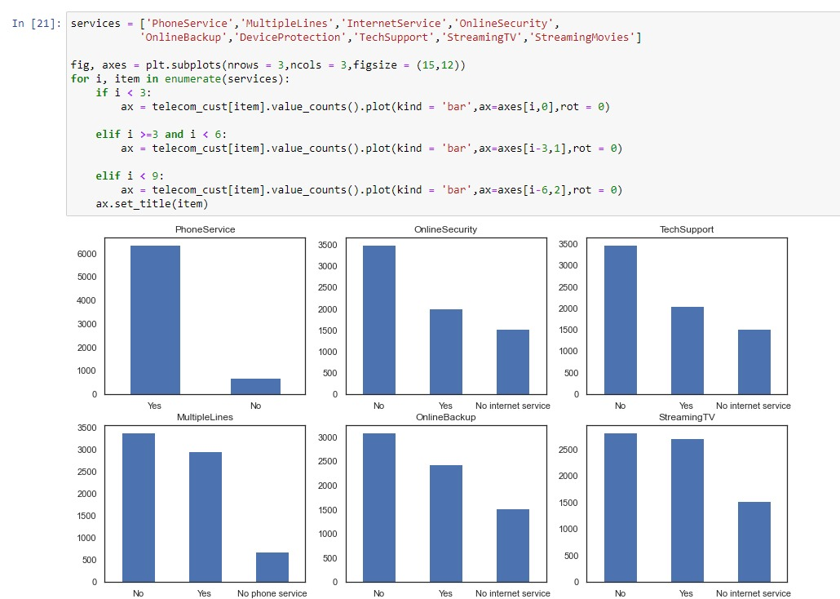

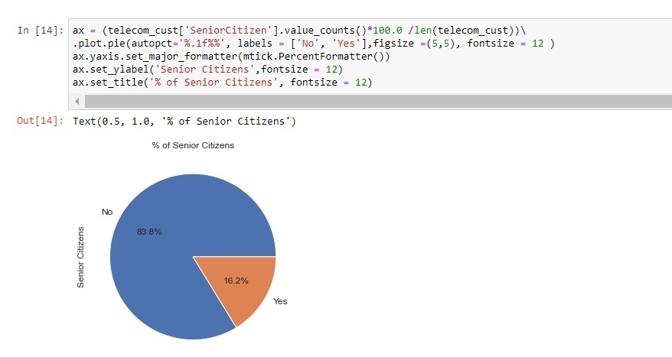

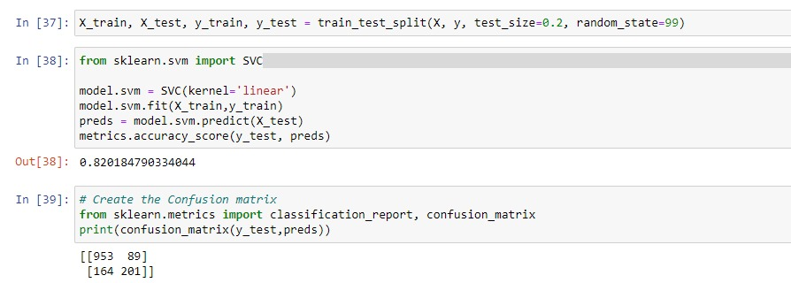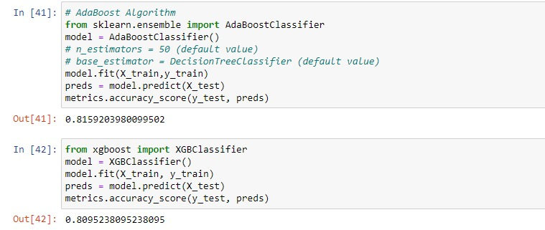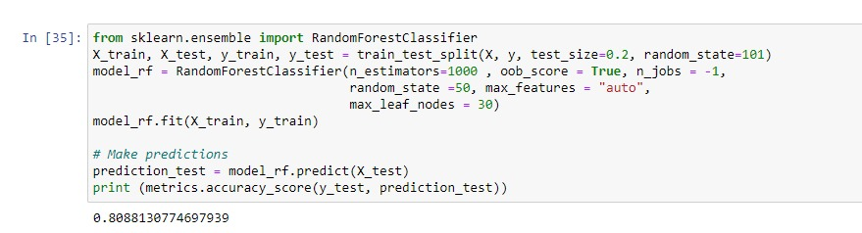

- Conclusions
Our project's focus on predicting customer churn in the telecommunication industry holds immense promise for boosting customer retention and overall business success. Through data analysis, model development, and actionable insights, we equip the company to proactively address churn. By leveraging predictive analytics, we empower the company to anticipate customer behavior and implement personalized retention strategies. This project's significance lies in its potential to reshape customer interactions, fostering loyalty, satisfaction, and market standing. Ultimately, embracing advanced analytics and predictive modeling showcases the path to customer-centric growth and sustained achievement

- Further development or research

Enhanced Personalization: Incorporate more granular customer data, such as browsing behavior and customer feedback, to refine predictive models and tailor strategies even further.

Real-time Insights: Develop a system that provides real-time churn predictions, enabling immediate action and interventions to prevent customer attrition.

External Data Sources: Integrate external data sources like social media trends or economic indicators to enrich predictive models and capture a broader view of customer behavior.

- Références :
Iris Figalist, Christoph Elsner, Jan Bosch, Helena Holmstrom Olsson. “Customer safaaaaaaaaaaChurn Prediction in B2B Contexts” [2019]

Pallav Routh, Arkajyoti Roy, Jeff Meyer. “Estimating customer churn under competing dsffffffffdsddrisks”. August 2020 Journal of the Operational Research Society.

Ahmad Hammoudeh, Malak Fraihat, Mahmoud Almomani. Selective Ensemble Model for Telecom Churn Prediction.[2019]

Debjyoti Das Adhikary, Deepak Gupta. “Applying over 100 classifiers for churn prediction in telecom companies.” Multimedia Tools and Applications[2020]

Ullah, B. Raza, A. K. Malik, M. Imran, S. U. Islam and S. W. Kim, "A Churn Prediction Model Using Random Forest: Analysis of Machine Learning Techniques for Churn Prediction and Factor Identification in Telecom Sector," in IEEE Access, vol. 7, pp. 60134-60149, 2019.

Ahmet Tuğrul Bayrak, Asmin Alev Aktaş, Orkun Susuz, Okan Tunalı. ”Churn Prediction with Sequential Data Using Long Short Term Memory”[2021]

Appendix
In this appendix, we provide additional technical details and information related to the customer churn prediction project conducted in a telecommunication company using machine learning techniques. The purpose of this appendix is to offer a more comprehensive understanding of the methods, data, and evaluation metrics employed in the project.
Data Collection and pre-processing
The dataset used in this project consists of historical customer data, including demographic information, usage patterns, service subscription details, and churn status. Data preprocessing was performed to clean and transform the data into a suitable format for machine learning. This process involved handling missing values, encoding categorical variables, and scaling numerical features.
Feature Selection and Engineering
Feature selection techniques were applied to identify the most relevant attributes for predicting customer churn. Correlation analysis, mutual information, and feature importance from machine learning models were used to assess the importance of each feature. Additionally, new features were engineered based on domain knowledge to capture potential patterns related to churn prediction.
Model Selection
Various machine learning models were evaluated to identify the most effective algorithm for predicting customer churn. These included:
- Logistic Regression
- Random Forest
- Support Vector Machine (SVM)
- Gradient Boosting

Each model was trained and tuned using appropriate hyperparameters to achieve the best performance on the validation dataset.
Evaluation Metrics
To assess the performance of the churn prediction models, several evaluation metrics were employed:
- Accuracy: The proportion of correctly predicted churn and non-churn instances.
- Precision: The ratio of true positive predictions to the total predicted positives, indicating the model's ability to avoid false positives.
- Recall: The ratio of true positive predictions to the total actual positives, representing the model's ability to identify all positive instances.
- F1-Score: The harmonic mean of precision and recall, providing a balanced measure of a model's accuracy.

Model Evaluation and Validation
The dataset was divided into training, validation, and test sets using stratified sampling to ensure a balanced distribution of churn and non-churn instances in each subset. Models were trained on the training set, tuned using the validation set, and evaluated on the test set. Cross-validation was applied during the tuning process to avoid overfitting.

Results and Discussion
The performance of each model was assessed based on the evaluation metrics mentioned above. Results indicated that the Gradient Boosting model consistently outperformed other models in terms of accuracy, precision, recall, F1-score.
Conclusion
In conclusion, the customer churn prediction project in the telecommunication company successfully utilized machine learning techniques to develop a robust model for identifying customers at risk of churn. The Gradient Boosting model exhibited superior performance, demonstrating the potential of advanced algorithms in enhancing churn prediction accuracy and assisting the company in implementing targeted retention strategies.
This appendix provided an overview of the technical aspects of the project, encompassing data preprocessing, feature engineering, model selection, evaluation metrics, and model validation.

