Data Analytics



SESSION 16: R FOR BUSINESS ANALYTICS (CONTD.)

Assignment 2

1
Data Analytics

Table of Contents

1. Introduction 3

2. Objective 3

3. Prerequisites 3

4. Associated Data Files 3

5. Problem Statement 3

6. Expected Output 3

7. Approximate Time to Complete Task 3

2
Data Analytics

- Introduction

This assignment will help you understand the concepts learnt in the session.

- Objective

To understand the concepts in R.

- Prerequisites

Not applicable.

- Associated Data Files

N/A

- Problem Statement

  - Write a function called sum_of_cubes, that calculates the sum of cubes of the first n natural numbers :

      - if we have two numbers : 1, 2 then sum of squares is 9 ( 1^3 + 2^3)

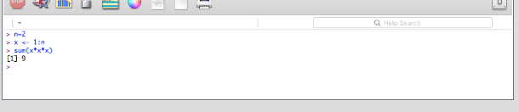

      - if we have three numbers : 1, 2, 3 then sum of squares is 36 ( 1^3 + 2^3 + 3^3)
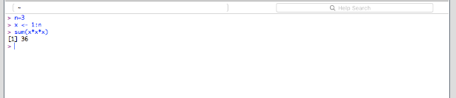

  - Write a function to calculate the mode (highest frequency) of the following vector:

    - = c(2,3,3,4,4,5,6,7,9,10)
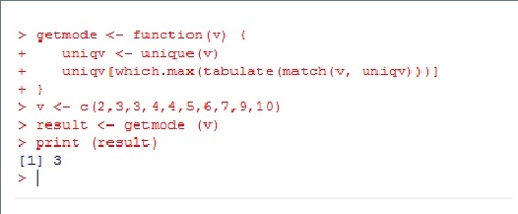

Write a function to calculate the no. of prime numbers of the following vector :
x = c(2,2,3,3,4,5,7,11,15,19,24,29)

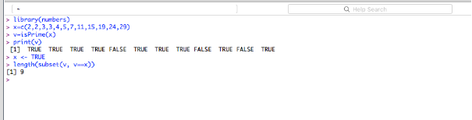

- Expected Output

N/A

- Approximate Time to Complete Task

3

