Data Analytics



SESSION 20: TABLEAU DESKTOP

(CONTD.)



Assignment 1

1

Data Analytics

**Table of Contents**

1. Introduction 3

2. Objective 3

3. Prerequisites 3

4. Associated Data Files 3

5. Problem Statement 3

6. Expected Output 3

7. Approximate Time to Complete Task 4

2

Data Analytics

1. **Introduction**

This assignment will help you understand the concepts learnt in the session.

1. **Objective**

To understand the concepts in Tableau.

1. **Prerequisites**

Not applicable.

1. **Associated Data Files**

N/A

1. **Problem Statement**
   1. Create a Waterfall chart which would show running total profit over a period of time.
   2. The color of the mark should be red if the profit recorded for that Month is less than the profit recorded compared to previous month, else Green
   3. Adjust the tooltip to show as given in the picture below.

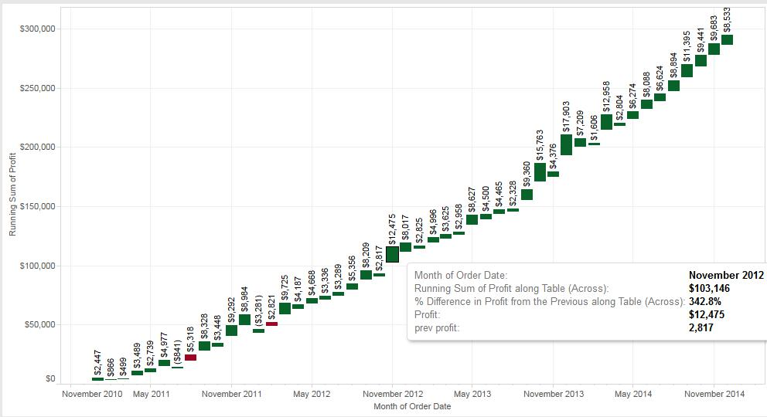

1. **Expected Output**

N/A

3

Data Analytics

1. **Approximate Time to Complete Task**

4