Dear Sir/Madam,

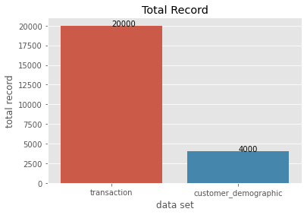
Thank you for providing the datasets for Sprocket Pty Ltd. The following graph illustrates the total record of different datasets.

We evaluated the quality of datasets and identified the discrepancy in the datasets. The following graphs illustrate the inconsistency: -
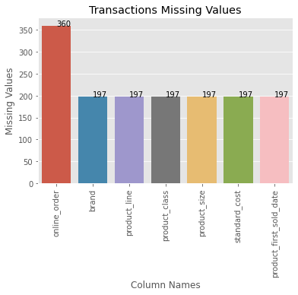

We discovered the missing values in an online order in transaction datasets, brand, product line, class, size, standard cost, and product first sold date. In addition, the product first sold date was incorrectly formatted, which led to errors in analysis.

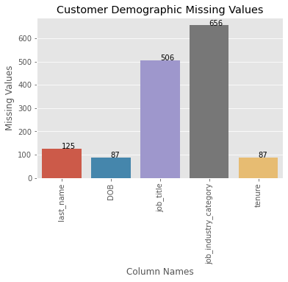

Customer demographic datasets were more inconsistent than others. For example, inaccuracy found in DOB, missing values in the last name, job title, job industry category and tenure. In addition, there was inconsistency in the gender.

Datasets contain many missing values; it is highly recommended that datasets be complete and updated regularly. For example, there were accuracy issues in the DOB column in the customer demographic dataset; we can add a column of age to overcome the DOB inconsistency. In the customer demographic dataset, the gender column contains discrepancies. For example, M, F, Femal, Female, Male; consistent terminology reduce this inconsistency. The product's first sold date format column should be formatted precisely numeric data for correct analysis.

We hope the above data quality analyses will help Sprocket Central Pty Ltd enhance its operational activities and make better business decisions.

Best Regards
Jatinder Singh Malhi

