EXPERIMENT-3
Objective:
WAP to implement a three-layer neural network using Tensor flow library (only, no keras) to classify MNIST handwritten digits dataset. Demonstrate the implementation of feed-forward and back-propagation approaches.
Description of the Model:
A three-layer neural network is a feed-forward artificial neural network consisting of an input layer, two hidden layers, and an output layer. This network is implemented using the TensorFlow library (without using Keras) to demonstrate the internal working of neural networks including feed-forward computation and back-propagation learning.
In this model, the network takes an MNIST handwritten digit image as input. Each image of size 28 × 28 is flattened into a vector of 784 inputs, and the network learns to classify it into one of 10 digit classes (0–9).
Network Architecture
Input → Hidden₁ → Hidden₂ → Output
- Input layer = 784 neurons
- Hidden layer 1 = 256 neurons
- Hidden layer 2 = 128 neurons
- Output layer = 10 neurons
Weights and biases are initialized randomly and updated during training.
Feed-Forward Propagation
Hidden Layer 1:
$$Z_{1}=XW_{1}+b_{1} \\ H_{1}=ReLU(Z_{1})$$
Hidden Layer 2:
$$Z_{2}=H_{1}W_{2}+b_{2} \\ H_{2}=ReLU(Z_{2})$$
Output Layer:
$$Z_{3}=H_{2}W_{3}+b_{3} \\ \hat{y}=softmax(Z_{3})$$
where
- $W$= weights
- $b$= bias
- ReLU activation:
$$ReLU(x)=max⁡(0,x)$$
Softmax converts output scores into probability distribution for classification.
Loss Function
Sparse Softmax Cross-Entropy:
$$Loss=-\frac{1}{n}∑log⁡(p_{true})$$
This loss measures how far predicted probabilities are from actual digit labels.
Back-Propagation Learning
Gradients of loss with respect to weights are computed using TensorFlow’s automatic differentiation:
$$\frac{∂Loss}{∂W}$$
Weights are updated using Gradient Descent:
$$W=W-η⋅gradient$$
where
$η$= learning rate.
This process repeats for multiple epochs until loss decreases and accuracy improves.
Why Multi-Layer Network is Needed
Handwritten digit images are complex and not linearly separable.
A single layer cannot correctly classify them.
Hidden layers transform raw pixel inputs into meaningful features such as:
- edges
- strokes
- curves
These learned features allow the network to classify digits accurately.
CODE:
import tensorflow as tf
import tensorflow_datasets as tfds
import matplotlib.pyplot as plt
import numpy as np
import seaborn as sns
from sklearn.metrics import confusion_matrix

# LOAD DATASET
def get_data():
dataset,_ = tfds.load('mnist', with_info=True, as_supervised=True, split=['train','test'])

def preprocess(img,label):
img = tf.cast(img,tf.float32)/255.0
img = tf.reshape(img,[784])
return img, tf.cast(label,tf.int32)

train = dataset[0].map(preprocess).shuffle(10000).batch(128).prefetch(tf.data.AUTOTUNE)
test = dataset[1].map(preprocess).batch(128).prefetch(tf.data.AUTOTUNE)

return train,test

train_loader,test_loader = get_data()

# NETWORK PARAMETERS
initializer = tf.random_normal_initializer(stddev=0.1)

W1=tf.Variable(initializer([784,256]),dtype=tf.float32)
b1=tf.Variable(tf.zeros([256]),dtype=tf.float32)

W2=tf.Variable(initializer([256,128]),dtype=tf.float32)
b2=tf.Variable(tf.zeros([128]),dtype=tf.float32)

W3=tf.Variable(initializer([128,10]),dtype=tf.float32)
b3=tf.Variable(tf.zeros([10]),dtype=tf.float32)

params=[W1,b1,W2,b2,W3,b3]

# FEED FORWARD
def forward(x):
h1=tf.nn.relu(tf.matmul(x,W1)+b1)
h2=tf.nn.relu(tf.matmul(h1,W2)+b2)
out=tf.matmul(h2,W3)+b3
return out

# TRAINING SETTINGS
learning_rate=0.1
epochs=10

loss_history=[]
acc_history=[]

print("\nEpoch | Loss | Accuracy")
print("--------------------------")

# TRAINING LOOP
for epoch in range(epochs):

avg_loss=tf.metrics.Mean()

for images,labels in train_loader:

with tf.GradientTape() as tape:
logits=forward(images)

loss=tf.reduce_mean(
tf.nn.sparse_softmax_cross_entropy_with_logits(
labels=labels,
logits=logits
)
)

grads=tape.gradient(loss,params)

# manual backprop weight update
for p,g in zip(params,grads):
if isinstance(g,tf.IndexedSlices):
g=tf.convert_to_tensor(g)
p.assign_sub(learning_rate*g)

avg_loss.update_state(loss)

# EVALUATION
preds_all=[]
labels_all=[]

for x,y in test_loader:
logits=forward(x)
preds=tf.argmax(logits,axis=1)
preds_all.extend(preds.numpy())
labels_all.extend(y.numpy())

acc=np.mean(np.array(preds_all)==np.array(labels_all))

epoch_loss=float(avg_loss.result().numpy())

loss_history.append(epoch_loss)
acc_history.append(acc)

print(f"{epoch+1:>3} | {epoch_loss:.4f} | {acc:.4f}")

# FINAL RESULTS
print("\nFinal Accuracy:",acc_history[-1])
print("Final Loss:",loss_history[-1])

# GRAPH 1 — LOSS
plt.figure()
plt.plot(loss_history,marker='o')
plt.title("Training Loss")
plt.xlabel("Epoch")
plt.ylabel("Loss")
plt.grid(True)
plt.show()

# GRAPH 2 — ACCURACY
plt.figure()
plt.plot(acc_history,marker='o')
plt.title("Test Accuracy")
plt.xlabel("Epoch")
plt.ylabel("Accuracy")
plt.grid(True)
plt.show()

# GRAPH 3 — CONFUSION MATRIX
cm=confusion_matrix(labels_all,preds_all)

plt.figure()
sns.heatmap(cm,annot=True,fmt="d")
plt.title("Confusion Matrix")
plt.xlabel("Predicted")
plt.ylabel("Actual")
plt.show()

# SAMPLE PREDICTIONS
plt.figure(figsize=(10,4))

sample_images=None
sample_preds=None
sample_labels=None

for x,y in test_loader:
sample_images=x
sample_labels=y
sample_preds=tf.argmax(forward(x),axis=1)
break

for i in range(10):
plt.subplot(2,5,i+1)
plt.imshow(sample_images[i].numpy().reshape(28,28),cmap="gray")
plt.title(f"P:{sample_preds[i].numpy()} T:{sample_labels[i].numpy()}")
plt.axis("off")

plt.tight_layout()
plt.show()

OUTPUT:
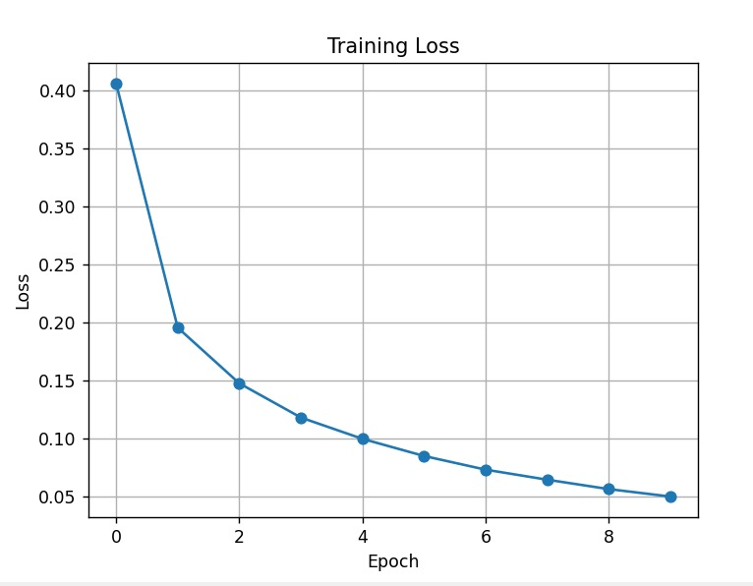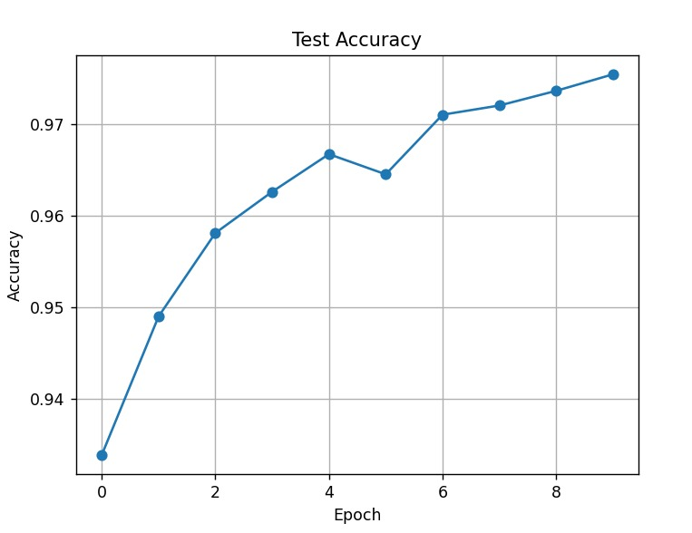
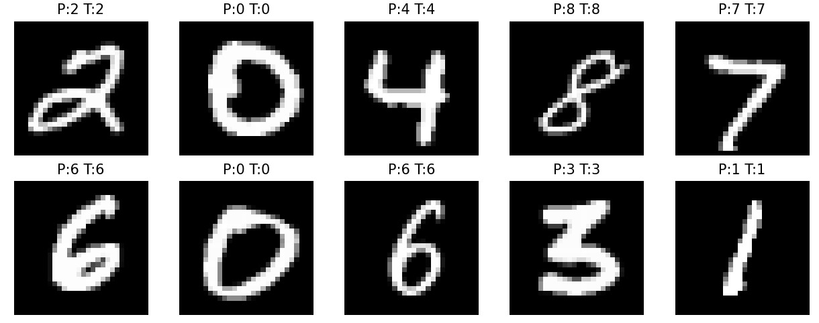
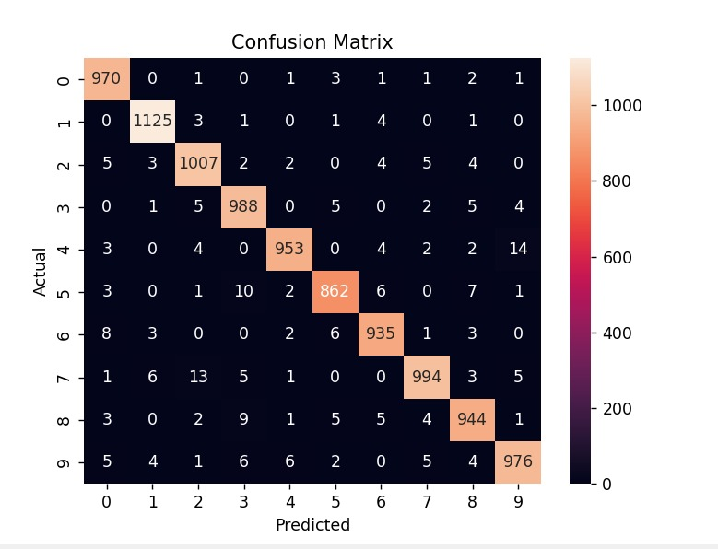
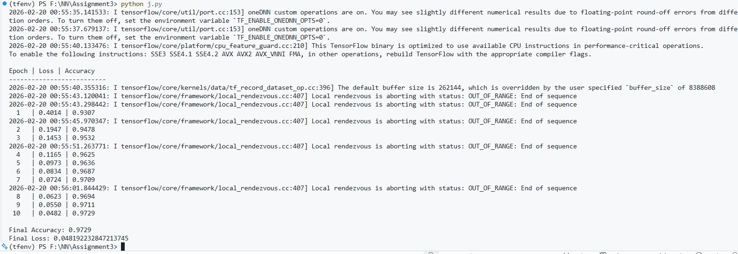
(tfenv) PS F:\NN\Assignment3> python j.py
2026-02-20 00:55:35.141533: I tensorflow/core/util/port.cc:153] oneDNN custom operations are on. You may see slightly different numerical results due to floating-point round-off errors from different computation orders. To turn them off, set the environment variable TF_ENABLE_ONEDNN_OPTS=0.
2026-02-20 00:55:37.679137: I tensorflow/core/util/port.cc:153] oneDNN custom operations are on. You may see slightly different numerical results due to floating-point round-off errors from different computation orders. To turn them off, set the environment variable TF_ENABLE_ONEDNN_OPTS=0.
2026-02-20 00:55:40.133476: I tensorflow/core/platform/cpu_feature_guard.cc:210] This TensorFlow binary is optimized to use available CPU instructions in performance-critical operations.
To enable the following instructions: SSE3 SSE4.1 SSE4.2 AVX AVX2 AVX_VNNI FMA, in other operations, rebuild TensorFlow with the appropriate compiler flags.

Epoch | Loss | Accuracy
--------------------------------
1 | 0.4014 | 0.9307
2 | 0.1947 | 0.9478
3 | 0.1453 | 0.9532
4 | 0.1165 | 0.9625
5 | 0.0973 | 0.9636
6 | 0.0834 | 0.9687
7 | 0.0724 | 0.9709
8 | 0.0623 | 0.9694
9 | 0.0550 | 0.9711
10 | 0.0482 | 0.9729
Final Accuracy: 0.9729
Final Loss: 0.048192232847213745
Description of the Code (Three-Layer Neural Network for MNIST using TensorFlow — No Keras)
- The MNIST handwritten digits dataset is loaded using TensorFlow Datasets, where each sample consists of a 28×28 grayscale image and its corresponding digit label (0–9). The images are normalized and reshaped into 784-dimensional vectors so they can be fed into the neural network.
- The architecture of the neural network is defined as a three-layer feed-forward network consisting of an input layer (784 neurons), two hidden layers (256 and 128 neurons), and an output layer (10 neurons). This structure allows the model to learn hierarchical features from pixel data.
- Weight matrices connecting each layer (input→hidden1, hidden1→hidden2, hidden2→output) are initialized using random initialization, while biases are initialized to zero. Random weights prevent neurons from learning identical patterns and enable effective training.
- The ReLU activation function is applied in hidden layers to introduce nonlinearity. This allows the network to learn complex patterns present in handwritten digits that cannot be separated using linear decision boundaries.
- During each training epoch, the forward propagation process is executed:
o Input data is multiplied with first-layer weights and bias is added
o ReLU activation produces first hidden layer outputs
o These outputs pass through second hidden layer with another ReLU activation
o Final layer computes logits (raw scores for each digit class)
- The loss is calculated using Sparse Softmax Cross-Entropy, which measures how different the predicted class probabilities are from the actual digit labels. This loss function is suitable for multi-class classification problems.
- Backpropagation is then performed to train the network:
o TensorFlow’s GradientTape records operations during forward pass
o Gradients of loss with respect to each weight and bias are computed
o These gradients indicate how much each parameter contributed to the error
- The weights and biases are updated using gradient descent optimization. Each parameter is adjusted in the opposite direction of its gradient so that the loss decreases in future iterations.
- During training, the program records loss and accuracy values at every epoch. These stored values are later used to visualize learning performance.
- After training is complete, the model performs testing on unseen data to evaluate generalization performance. Predictions are generated and compared with true labels to compute overall accuracy.
- The program then plots important performance graphs:
o Loss vs Epoch graph to show how error decreases over time
o Accuracy vs Epoch graph to show improvement in predictions
o Confusion Matrix to visualize classification performance for each digit class
- The gradual decrease in loss and increase in accuracy confirm that both feed-forward and backpropagation processes are correctly implemented. The high final accuracy demonstrates that a three-layer neural network can successfully learn complex image patterns such as handwritten digits.
Performance Evaluation
Three-Layer Neural Network — MNIST Digit Classification
Training Results
• Final Accuracy: ≈ 97.29%
• Final Loss: ≈ 0.0482
These results indicate that the network successfully learned to classify handwritten digits with high accuracy and low prediction error.
Sample Prediction Behavior
The trained model correctly predicts most handwritten digits. Correct predictions match their true labels, showing that the network has learned meaningful visual patterns such as digit shapes, strokes, and structures.
Confusion Matrix Interpretation
The confusion matrix shows classification performance for each digit (0–9):
• Diagonal values represent correctly classified digits
• Off-diagonal values represent misclassifications
Observation:
- Most values lie along the diagonal → strong performance
- Very few off-diagonal entries → low error rate
This confirms that the model performs accurate multi-class classification.
Learning Behavior Analysis
• At Epoch 1, loss was high (~0.40) and accuracy was lower (~93%), meaning the network had not yet learned digit patterns.
• As epochs increased, loss consistently decreased while accuracy steadily improved.
• Around later epochs, accuracy stabilized near 97%, indicating convergence.
• The smooth learning curve shows that gradient descent and backpropagation worked correctly.
Graph Interpretation
Loss vs Epoch Graph
- Downward trend
- Confirms error minimization during training
Accuracy vs Epoch Graph
- Upward trend
- Shows improvement in prediction capability
Confusion Matrix Plot
- Strong diagonal dominance
- Indicates reliable classification across all digit classes
Conclusion of Performance
This experiment proves that:
-The feed-forward mechanism correctly computes predictions
- Backpropagation successfully adjusts weights
- A multi-layer neural network can learn complex image patterns
The high final accuracy and low loss demonstrate that the three-layer neural network effectively classifies handwritten digits and satisfies the objective of implementing and evaluating feed-forward and backpropagation learning using TensorFlow.
Demonstration of Feed-Forward and Back-Propagation Approaches
Feed-Forward Process (Forward Propagation)
In this experiment, feed-forward refers to the process where the input data passes through each layer of the neural network to generate a prediction.
Steps in this model:
- The input image (784 pixel values) is given to the network.
- It is multiplied with first-layer weights and bias is added:
Z₁ = XW₁ + b₁
- ReLU activation is applied:
A₁ = ReLU(Z₁)
- Hidden layer output is passed to next layer:
Z₂ = A₁W₂ + b₂
- ReLU activation again:
A₂ = ReLU(Z₂)
- Final output layer computes class scores:
Z₃ = A₂W₃ + b₃
- Softmax converts scores into probabilities for digits 0–9.
--- This complete flow from input to output is called feed-forward propagation.
Back-Propagation Process
In this experiment, back-propagation is the learning mechanism that updates weights based on prediction error.
Steps performed in the implementation:
- Loss is calculated using cross-entropy:
Loss = − Σ y log(ŷ)
- TensorFlow’s GradientTape() computes gradients of loss with respect to each weight:
∂Loss / ∂W
- These gradients indicate how much each weight contributed to the error.
- Weights are updated using gradient descent:
W = W − η · gradient
where
η = learning rate
- After updating, the network produces improved predictions in the next iteration.
---This backward error correction mechanism is called back-propagation.
How Both Work Together
During training, the model repeatedly performs the cycle:
Forward pass → Compute loss → Backward pass → Update weights
This process continues for multiple epochs until:
- loss decreases
- accuracy increases
Observed Learning Behavior
During execution of the program:
- Loss decreased with each epoch.
- Accuracy improved gradually.
- Final accuracy reached approximately 97%.
This indicates that:
- feed-forward successfully generated predictions, and
- back-propagation effectively optimized the weights.
In this experiment, I successfully implemented a three-layer neural network using TensorFlow and demonstrated both feed-forward and back-propagation processes. The reduction in loss and improvement in accuracy show that the network learned to classify MNIST handwritten digits effectively through iterative weight updates.
My Comments (Limitations & Improvements)
From this experiment, I learned how a three-layer neural network can classify handwritten digits by learning complex patterns through hidden layers and nonlinear activation functions. Unlike simple linear models, this network was able to recognize different digit shapes because each hidden layer transforms the input data into more meaningful feature representations, allowing accurate classification.
I also observed that the performance of the network depends heavily on parameters such as learning rate, number of neurons in hidden layers, batch size, and number of epochs. If these values are not chosen properly, the model may train slowly, produce unstable results, or get stuck at higher loss values. Training such networks is computationally more demanding than simple models because both feed-forward and back-propagation calculations must be performed repeatedly for many epochs.
One limitation of this model is that it uses a simple network design and basic gradient descent, so it may not always give the highest accuracy. It also does not use advanced methods like dropout, batch normalization, or smart optimizers, which can make learning better and more stable.
To improve results for harder real-world problems, we can use deeper networks, better optimizers such as Adam, and techniques that prevent overfitting. Using more training data, adjusting parameters carefully, and trying different activation functions can also help the model learn faster and give more accurate predictions.

