EXPERIMENT-5
Objective:
WAP to train and evaluate a convolutional neural network using Keras Library to classify MNIST fashion dataset. Demonstrate the effect of filter size, regularization, batch size and optimization algorithm on model performance.
Description of the Model:
A Convolutional Neural Network (CNN) is a deep learning model designed for processing image data. It uses convolution operations to automatically extract spatial features such as edges, textures, and patterns from images.
In this assignment, a CNN model is implemented using the Keras library of TensorFlow to classify images from the Fashion MNIST dataset.
The Fashion MNIST dataset contains grayscale images of clothing items such as shirts, trousers, bags, and shoes. Each image has a dimension of 28 × 28 pixels, and the dataset contains 10 classes.
Before training the model, the images are normalized so that pixel values lie between 0 and 1, which improves training stability.
Network Architecture
The architecture of the convolutional neural network is:
Input → Convolution → MaxPooling → Flatten → Dense → Output
Input layer = 28 × 28 × 1
Convolution layer = 32 filters (variable filter size)
MaxPooling layer = 2 × 2
Fully connected layer = 128 neurons
Output layer = 10 neurons
The filter size, regularization technique, batch size, and optimization algorithm are varied to observe their effect on model performance.
Convolution Operation
The convolution layer extracts important spatial features from the image.
Mathematically, convolution is defined as:
$$Z=X*W+b$$
where
- $X$= input image
- $W$= convolution filter (kernel)
- $b$= bias
- $*$= convolution operation
The output feature map is then passed through an activation function.
Activation Function
The ReLU (Rectified Linear Unit) activation function is used:
$$ReLU(x)=max⁡(0,x)$$
ReLU introduces non-linearity into the network and helps the model learn complex patterns.
Max Pooling
The MaxPooling layer reduces the spatial dimensions of the feature maps while retaining the most important information.
$$Y=max⁡(x_{i,j})$$
Pooling helps reduce computation and prevents overfitting.
Flatten Layer
The flatten layer converts the 2-D feature maps into a 1-D vector so that the data can be passed to fully connected layers.
$$Flatten(H)→vector$$
Fully Connected Layer
The dense layer learns high-level features extracted by the convolutional layers.
$$Z=WX+b \\ H=ReLU(Z)$$
Output Layer
The final layer contains 10 neurons corresponding to the 10 fashion categories.
The Softmax function converts outputs into probabilities.
$${\hat{y}}_{i}=\frac{e^{z_{i}}}{\sum_{j=1}^{10}{e^{z_{j}}}}$$The class with the highest probability is selected as the predicted class.
Loss Function
The model uses Sparse Categorical Cross-Entropy Loss:
$$Loss=-∑y_{true}log⁡(p_{pred})$$This loss measures the difference between the predicted probability and the actual class label.
Optimization Algorithms
Different optimization algorithms are used to update the model parameters:
Gradient descent update rule:
$$W=W-η⋅\frac{∂Loss}{∂W}$$where
- $W$= weights
- $η$= learning rate
Optimizers used in this experiment include:
- Adam
- SGD
- RMSprop
These optimizers influence how quickly and efficiently the model learns.
Regularization
Regularization techniques are applied to reduce overfitting.
L2 Regularization
$$Loss=Loss_{original}+λ∑W^{2}$$
Dropout
Dropout randomly removes neurons during training:
$$H^{'}=H⋅r$$where $r$is a random mask.
Model Evaluation
To evaluate the performance of the CNN model, different hyperparameters are varied:
- Filter size (3×3, 5×5, 7×7)
- Regularization methods (None, L2, Dropout)
- Batch size (32, 64, 128)
- Optimization algorithm (Adam, SGD, RMSprop)
For each configuration, the following are observed:
- Training accuracy
- Validation accuracy
- Loss values
- Confusion matrix
Graphs such as Accuracy vs Epoch and Loss vs Epoch are plotted to analyze the learning behavior of the model.
CODE:
# Assignment 5
# CNN on Fashion MNIST using Keras
# Demonstrating effect of:
# Filter Size, Regularization, Batch Size, Optimizer

import tensorflow as tf
from tensorflow import keras
import numpy as np
import matplotlib.pyplot as plt
import seaborn as sns
from sklearn.metrics import confusion_matrix

layers = tf.keras.layers
models = tf.keras.models
regularizers = tf.keras.regularizers

# LOAD DATASET

(x_train, y_train), (x_test, y_test) = keras.datasets.fashion_mnist.load_data()

# Normalize
x_train = x_train.astype("float32") / 255.0
x_test = x_test.astype("float32") / 255.0

# Add channel dimension
x_train = x_train.reshape(-1, 28, 28, 1)
x_test = x_test.reshape(-1, 28, 28, 1)

# MODEL BUILDER

def build_model(filter_size=3, regularization=None, optimizer="adam"):

model = models.Sequential()

# Input Layer
model.add(layers.Input(shape=(28, 28, 1)))

# Regularization selection
if regularization == "l2":
reg = regularizers.l2(0.001)
else:
reg = None

# Convolution Layer
model.add(layers.Conv2D(
filters=32,
kernel_size=(filter_size, filter_size),
activation="relu",
kernel_regularizer=reg
))

model.add(layers.MaxPooling2D((2, 2)))

if regularization == "dropout":
model.add(layers.Dropout(0.3))

model.add(layers.Flatten())
model.add(layers.Dense(128, activation="relu"))
model.add(layers.Dense(10, activation="softmax"))

model.compile(
optimizer=optimizer,
loss="sparse_categorical_crossentropy",
metrics=["accuracy"]
)

return model

# TRAIN & EVALUATE

def train_and_evaluate(filter_size=3,
regularization=None,
batch_size=64,
optimizer="adam",
epochs=5):

print("\n===================================================")
print(f"Filter={filter_size} | Reg={regularization} | "
f"Batch={batch_size} | Optimizer={optimizer}")
print("===================================================")

model = build_model(filter_size, regularization, optimizer)

history = model.fit(
x_train, y_train,
validation_split=0.2,
epochs=epochs,
batch_size=batch_size,
verbose=1
)

test_loss, test_acc = model.evaluate(x_test, y_test, verbose=0)

print(f"\nFinal Test Accuracy: {test_acc:.4f}")
print(f"Final Test Loss: {test_loss:.4f}")

# Confusion Matrix
predictions = np.argmax(model.predict(x_test), axis=1)
cm = confusion_matrix(y_test, predictions)

return history, test_acc, cm

# PLOT FUNCTION (No Cut Titles)

def plot_results(history, cm, title):

fig, axes = plt.subplots(1, 3, figsize=(18, 5))

# Accuracy
axes[0].plot(history.history["accuracy"], label="Train", linewidth=2)
axes[0].plot(history.history["val_accuracy"], label="Validation", linewidth=2)
axes[0].set_title("Accuracy")
axes[0].set_xlabel("Epoch")
axes[0].set_ylabel("Accuracy")
axes[0].legend()

# Loss
axes[1].plot(history.history["loss"], label="Train", linewidth=2)
axes[1].plot(history.history["val_loss"], label="Validation", linewidth=2)
axes[1].set_title("Loss")
axes[1].set_xlabel("Epoch")
axes[1].set_ylabel("Loss")
axes[1].legend()

# Confusion Matrix
sns.heatmap(cm,
annot=True,
fmt="d",
cmap="coolwarm",
ax=axes[2],
cbar=False)
axes[2].set_title("Confusion Matrix")
axes[2].set_xlabel("Predicted")
axes[2].set_ylabel("Actual")

fig.suptitle(title, fontsize=16, fontweight="bold")
plt.subplots_adjust(top=0.85)
plt.show()

# 1: FILTER SIZE

print("\n===== EXPERIMENT: FILTER SIZE =====")
filter_sizes = [3, 5, 7]

for fs in filter_sizes:
history, acc, cm = train_and_evaluate(filter_size=fs)
plot_results(history, cm, f"Effect of Filter Size ({fs}x{fs})")

# 2: REGULARIZATION

print("\n===== EXPERIMENT: REGULARIZATION =====")
regularizations = [None, "l2", "dropout"]

for reg in regularizations:
history, acc, cm = train_and_evaluate(regularization=reg)
plot_results(history, cm, f"Effect of Regularization ({reg})")

# 3: BATCH SIZE

print("\n===== EXPERIMENT: BATCH SIZE =====")
batch_sizes = [32, 64, 128]

for bs in batch_sizes:
history, acc, cm = train_and_evaluate(batch_size=bs)
plot_results(history, cm, f"Effect of Batch Size ({bs})")

# 4: OPTIMIZER

print("\n===== EXPERIMENT: OPTIMIZER =====")
optimizers = ["adam", "sgd", "rmsprop"]

for opt in optimizers:
history, acc, cm = train_and_evaluate(optimizer=opt)
plot_results(history, cm, f"Effect of Optimizer ({opt})")

OUTPUT:
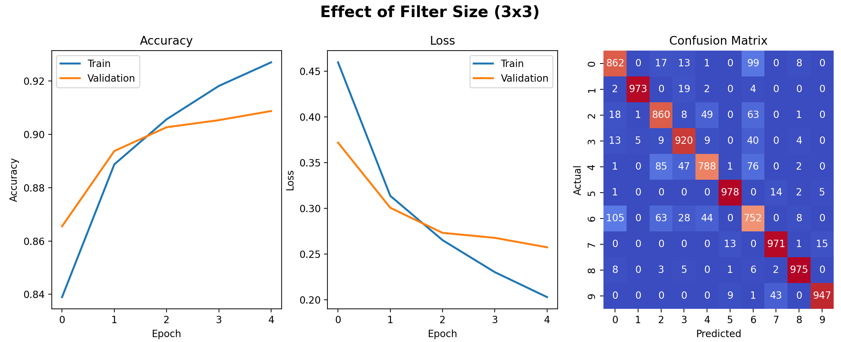
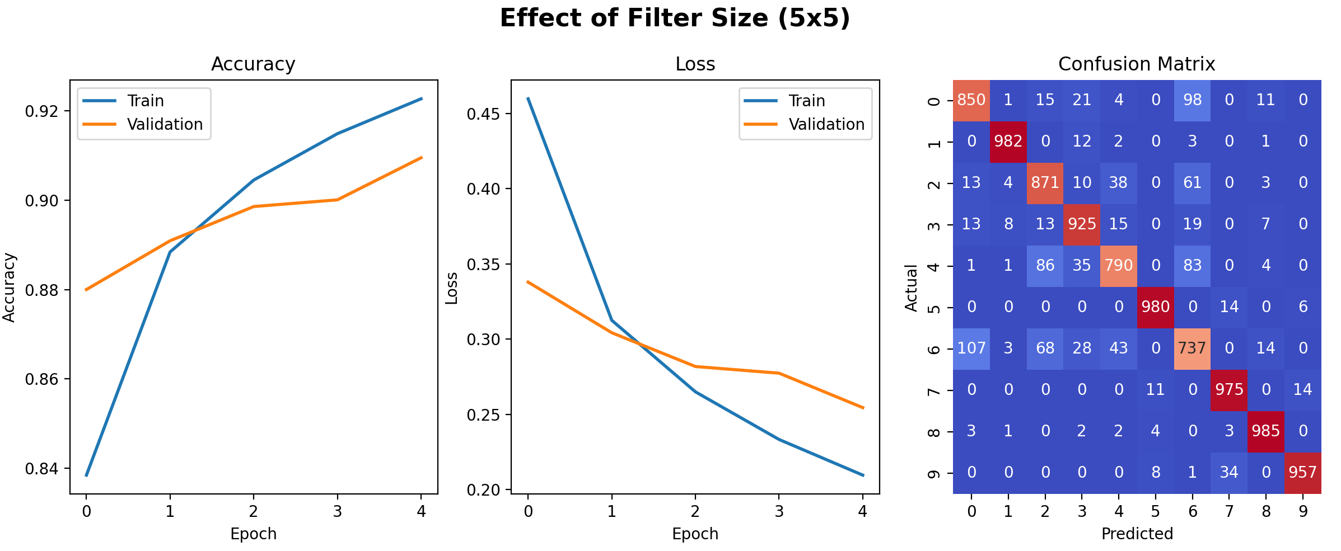
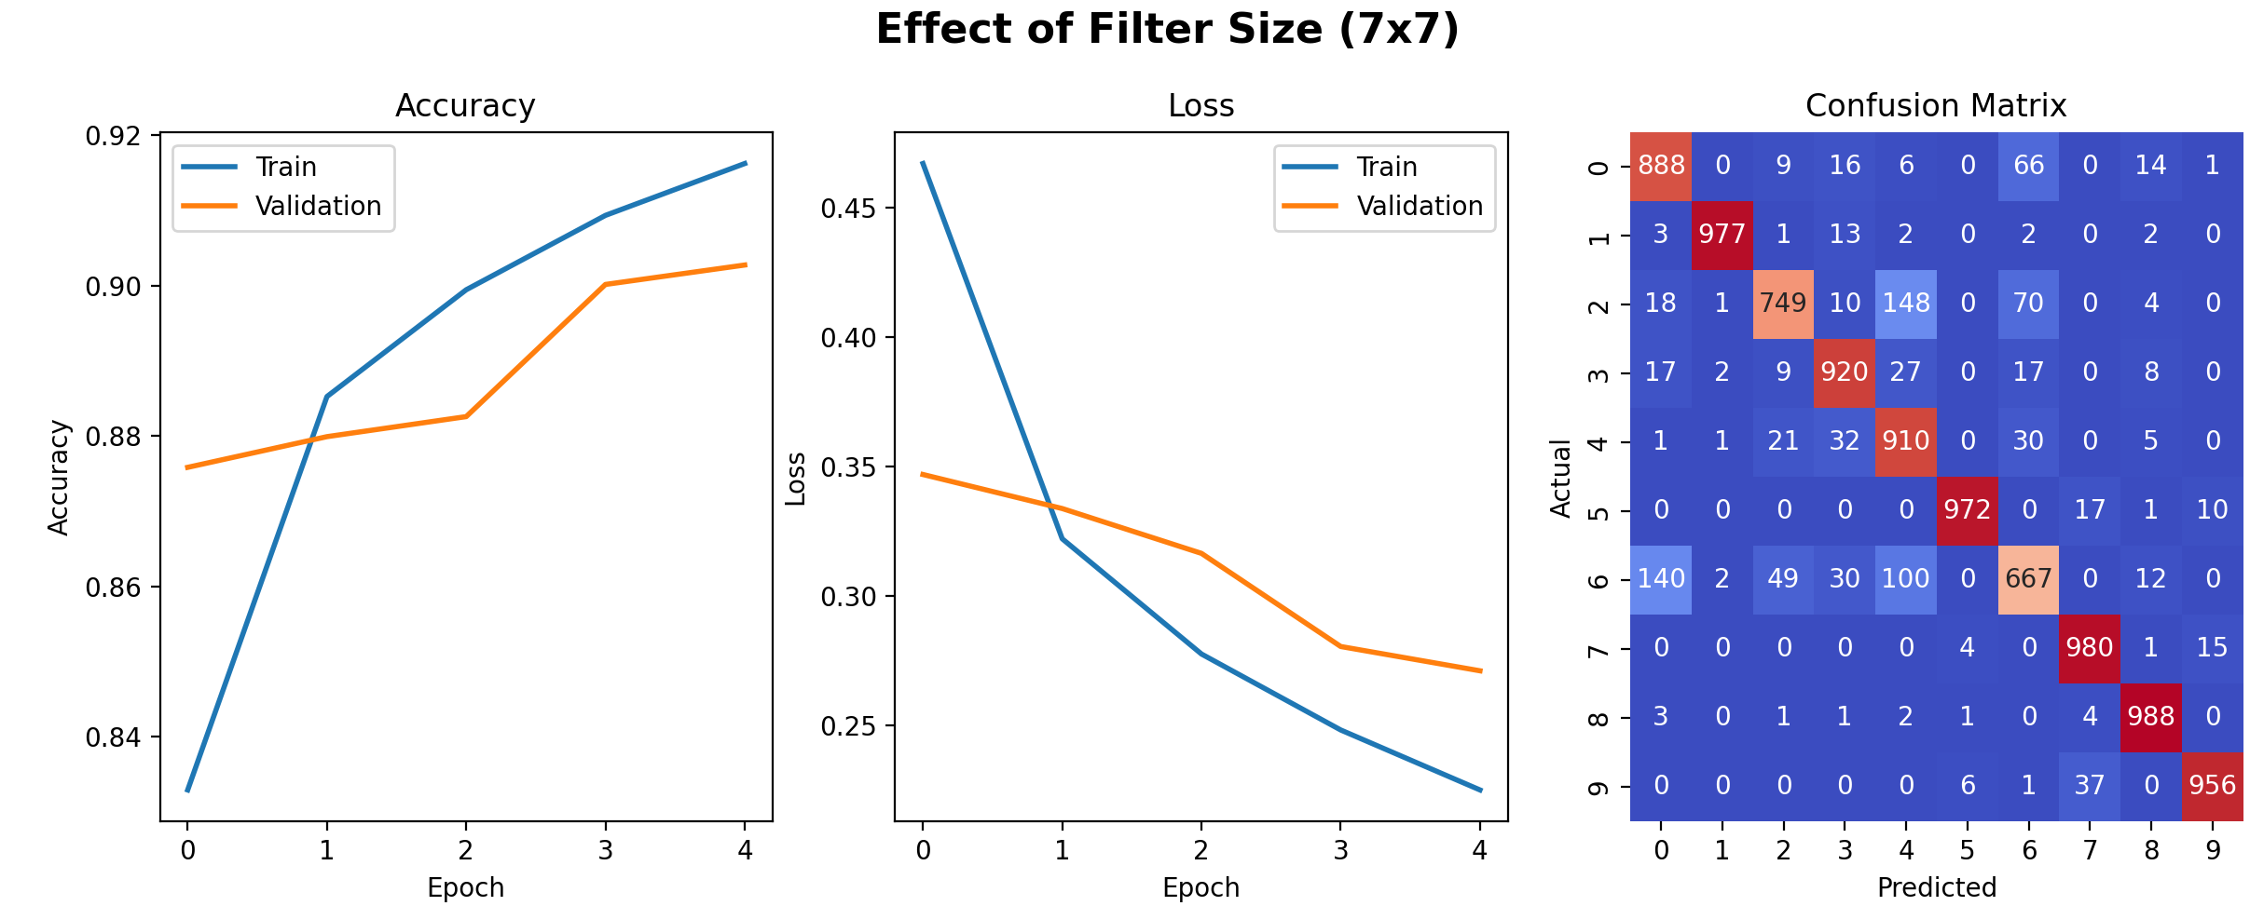
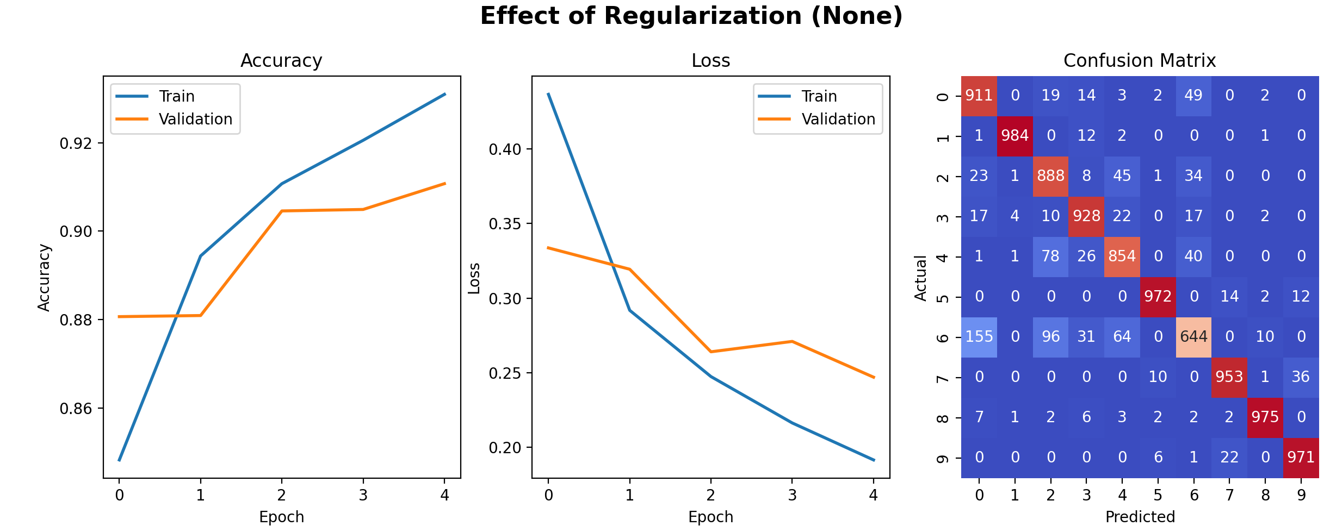
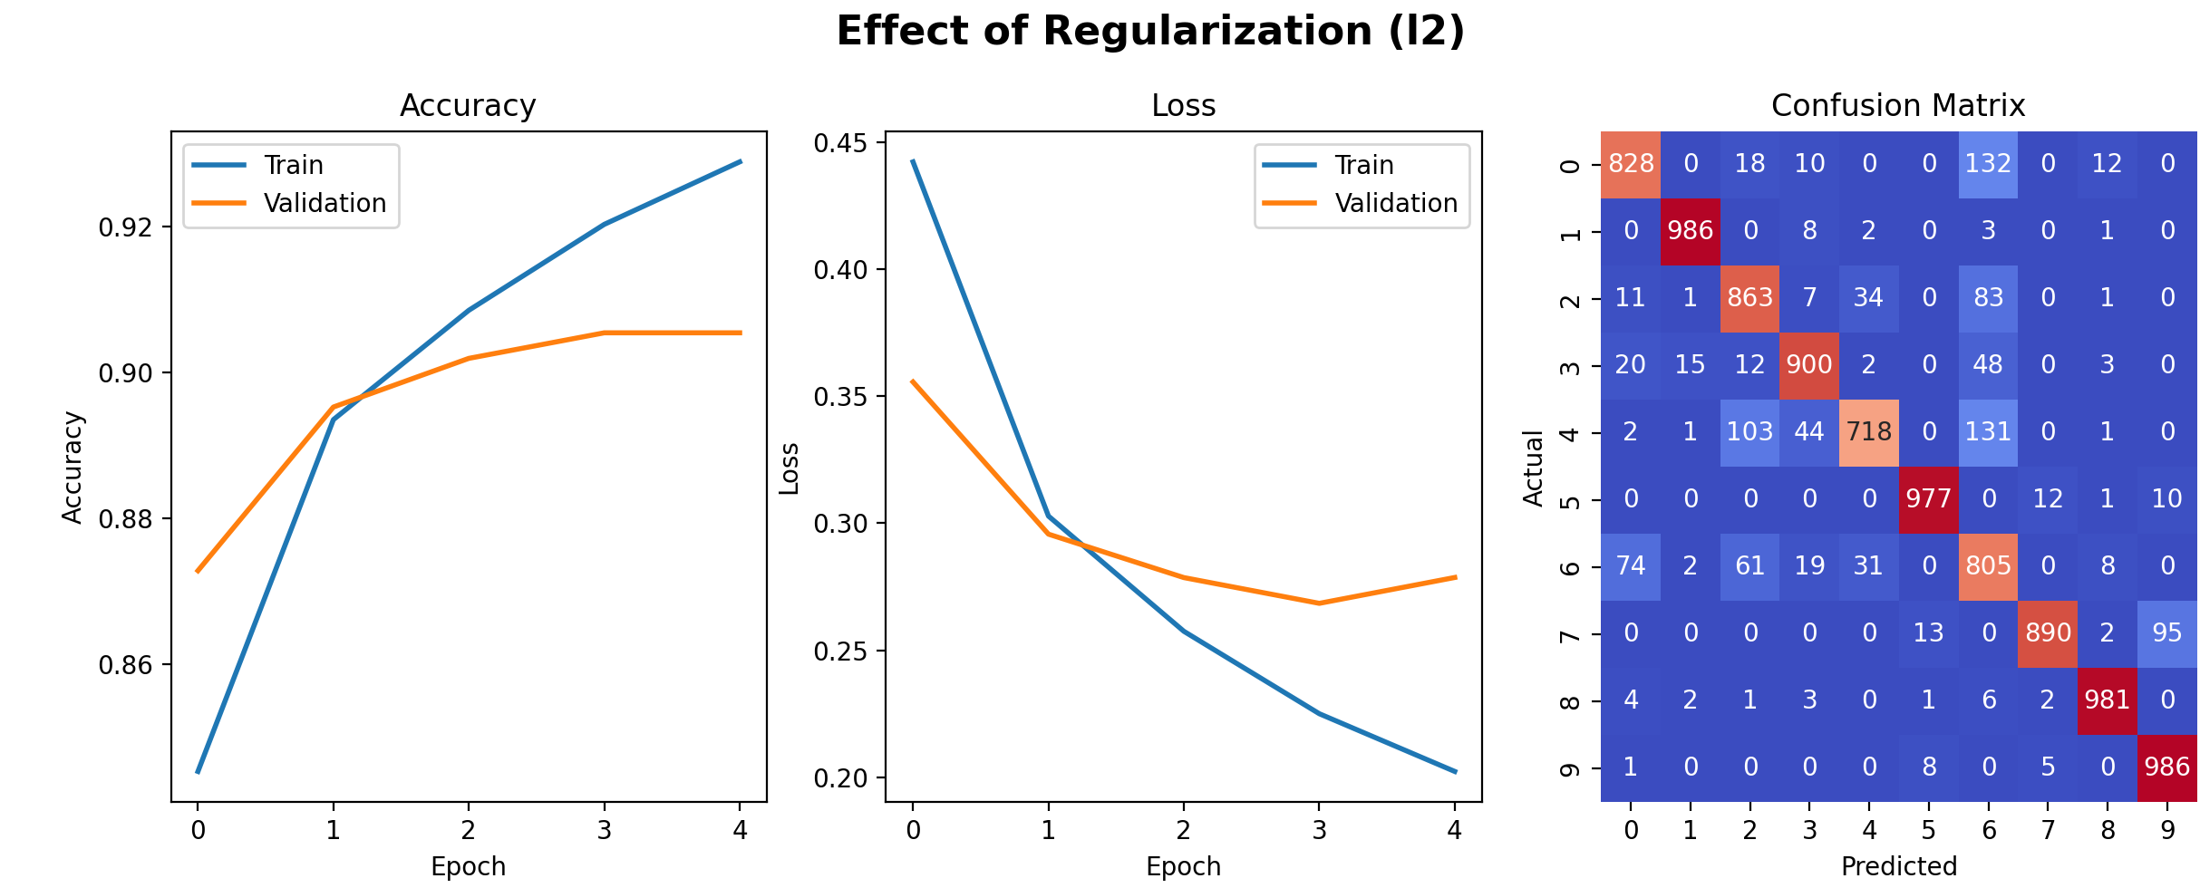
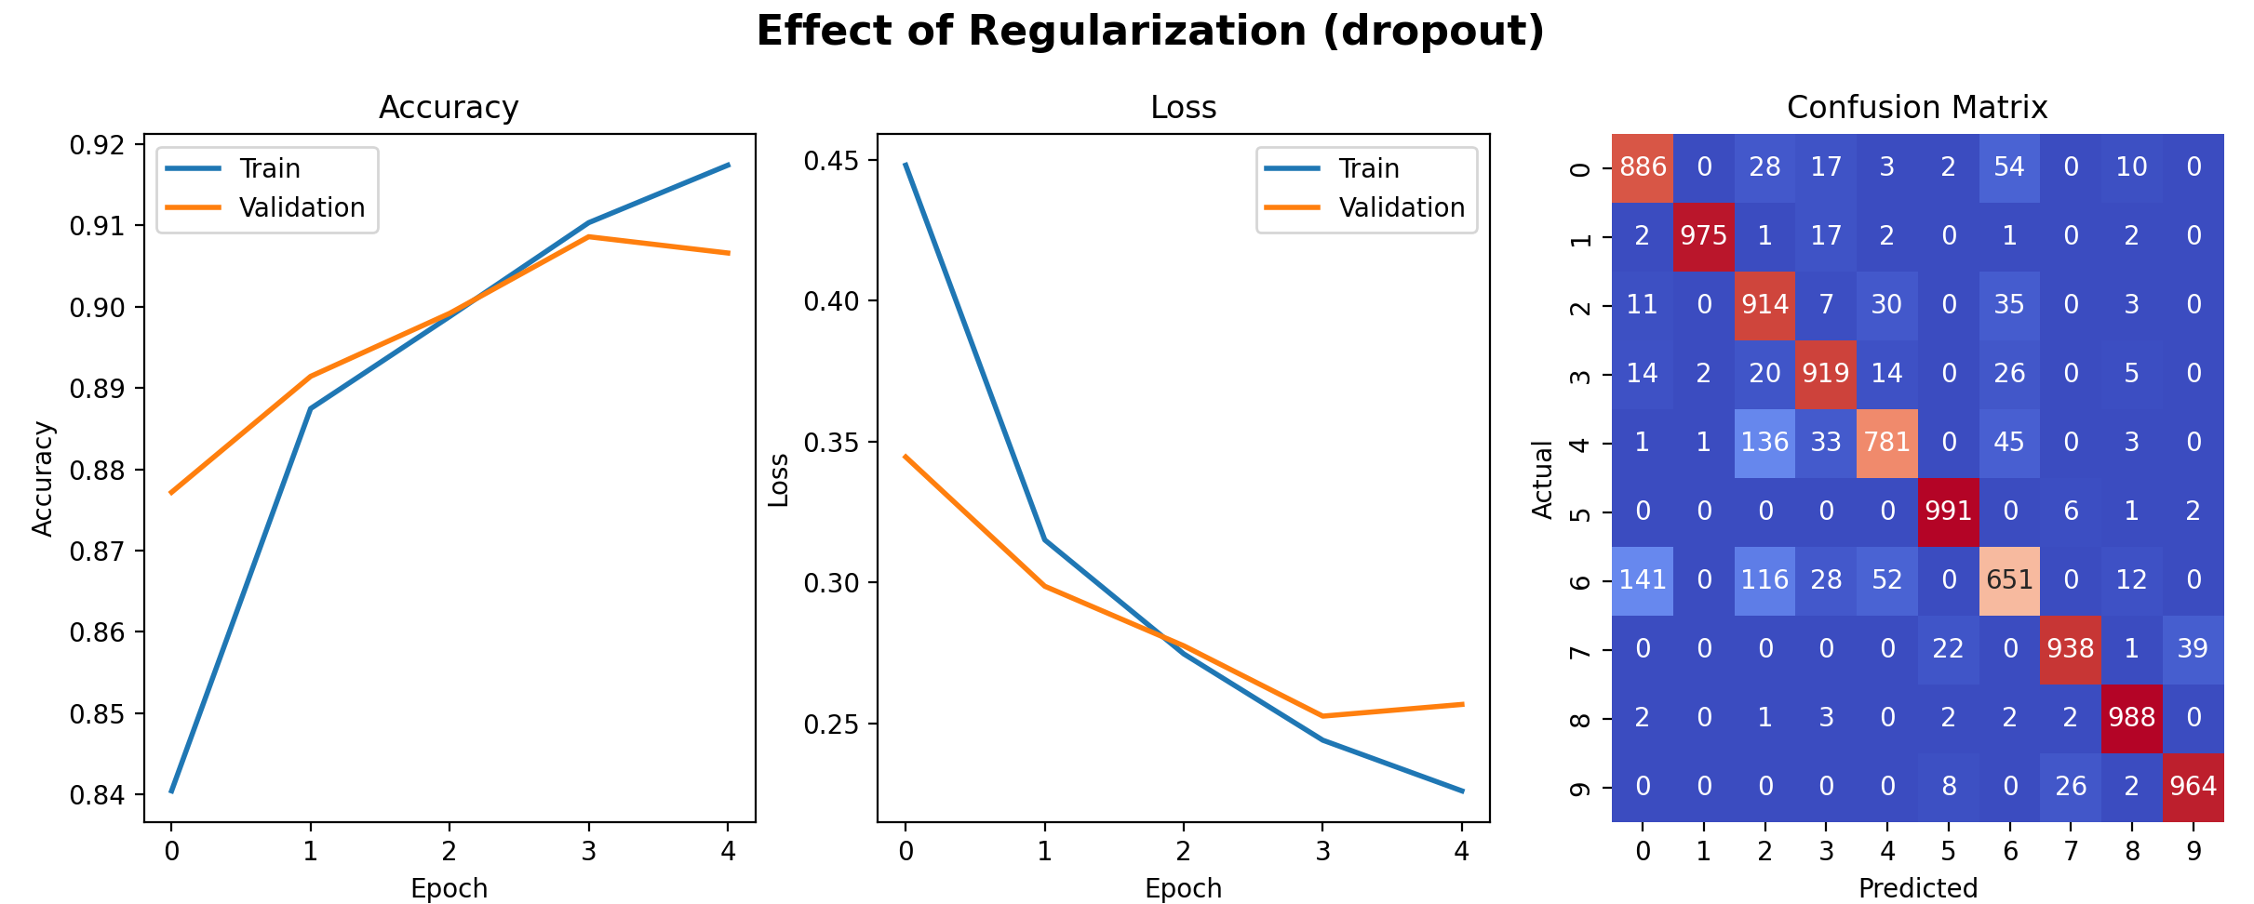
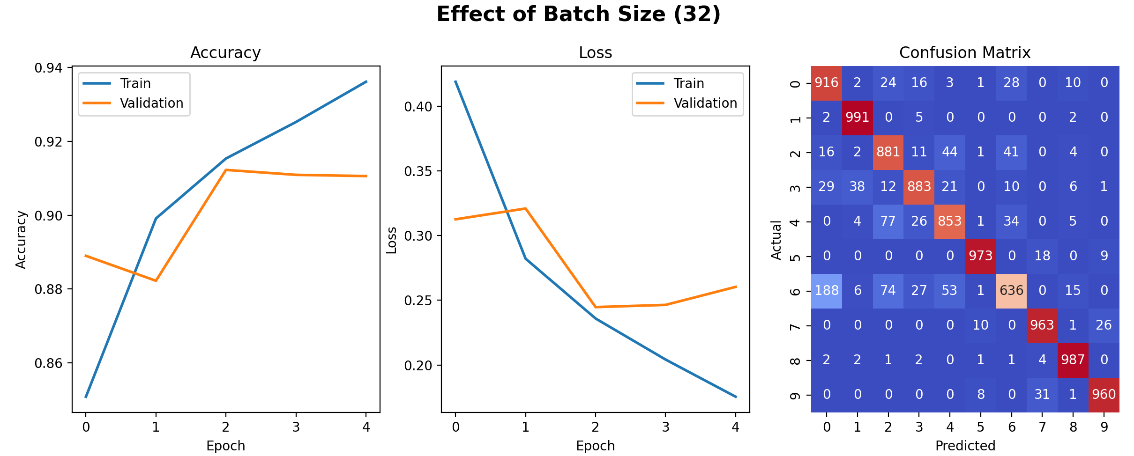
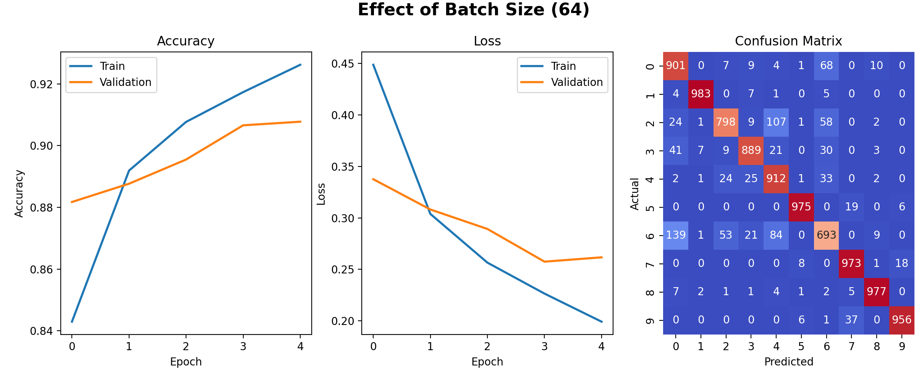
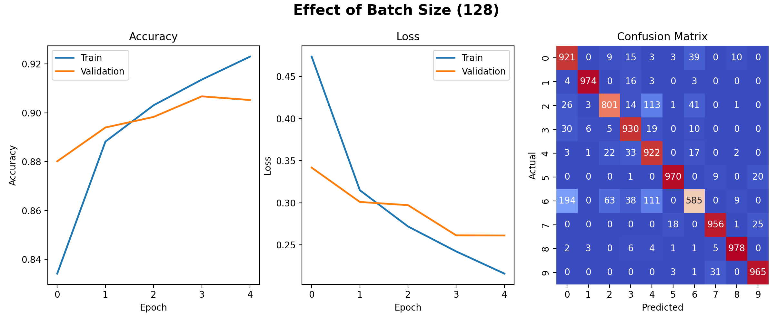
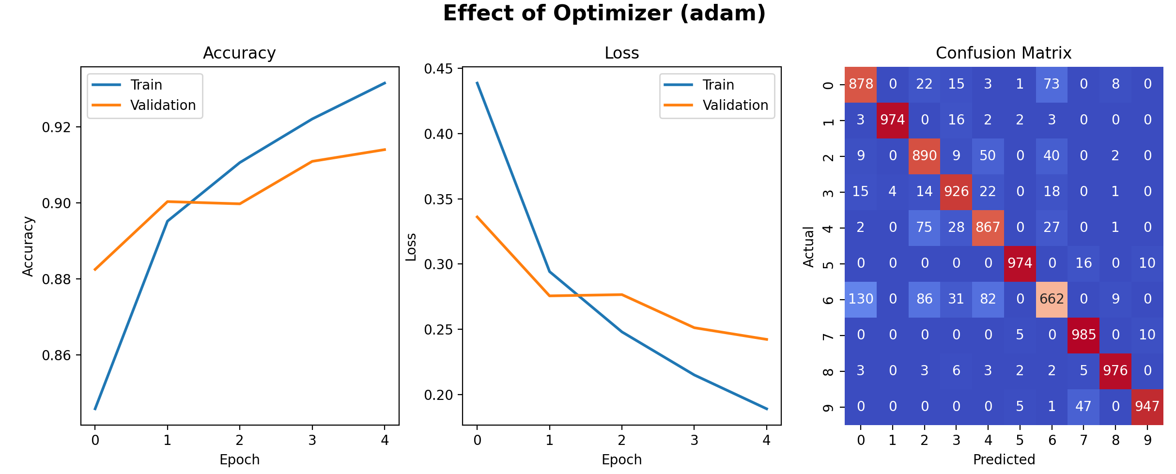
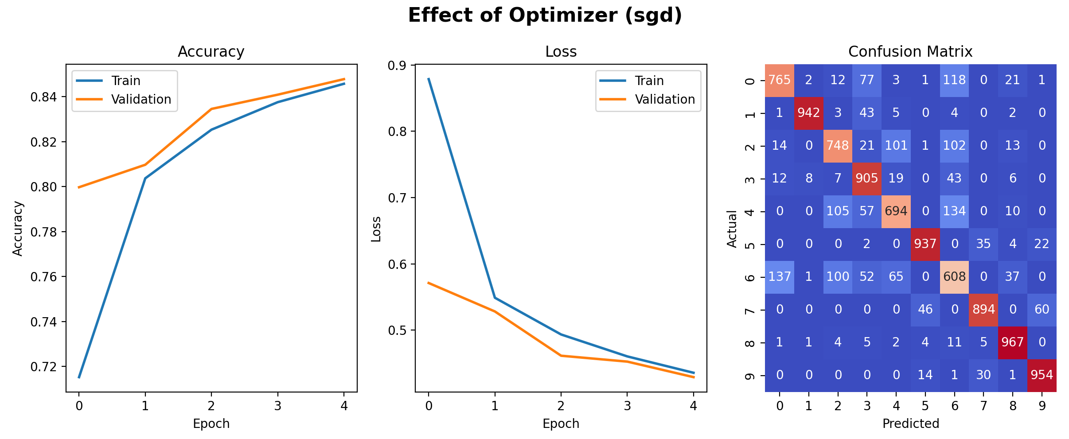
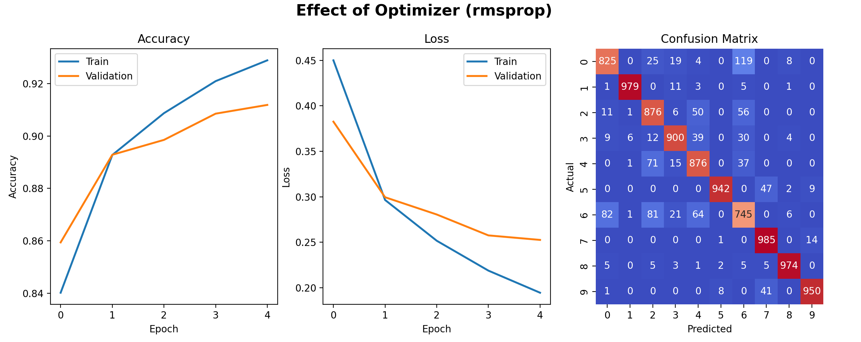
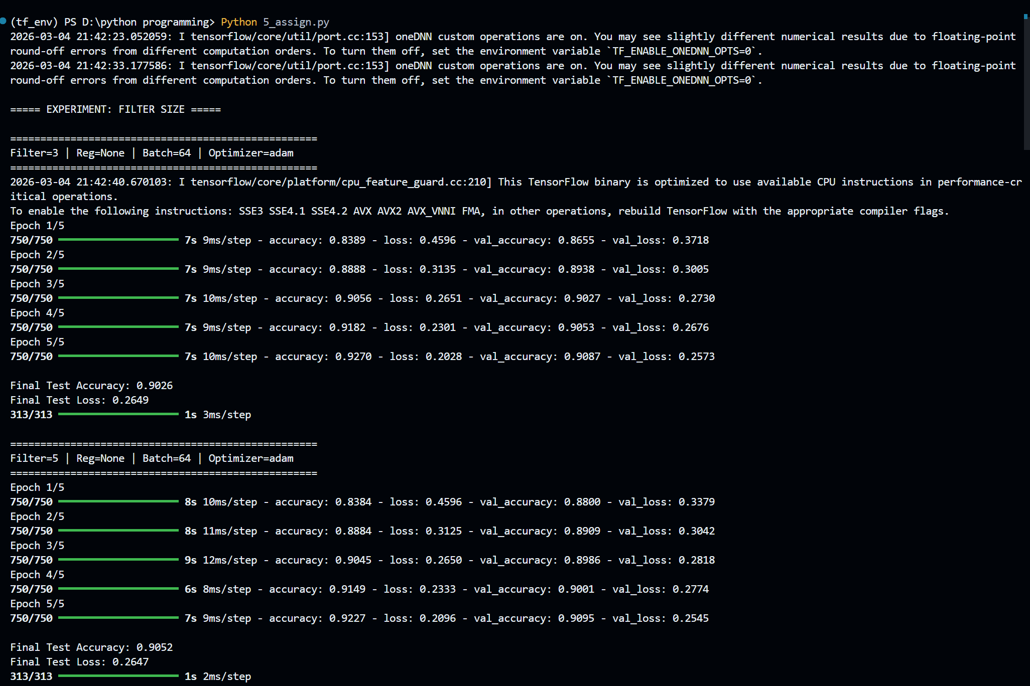
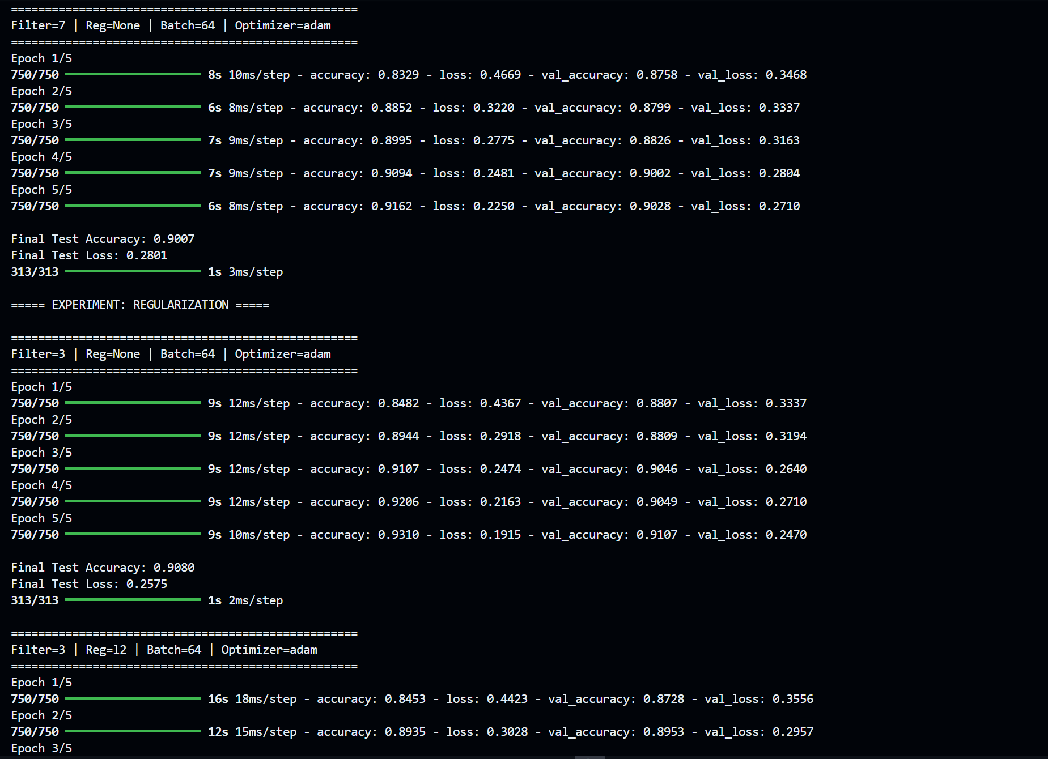

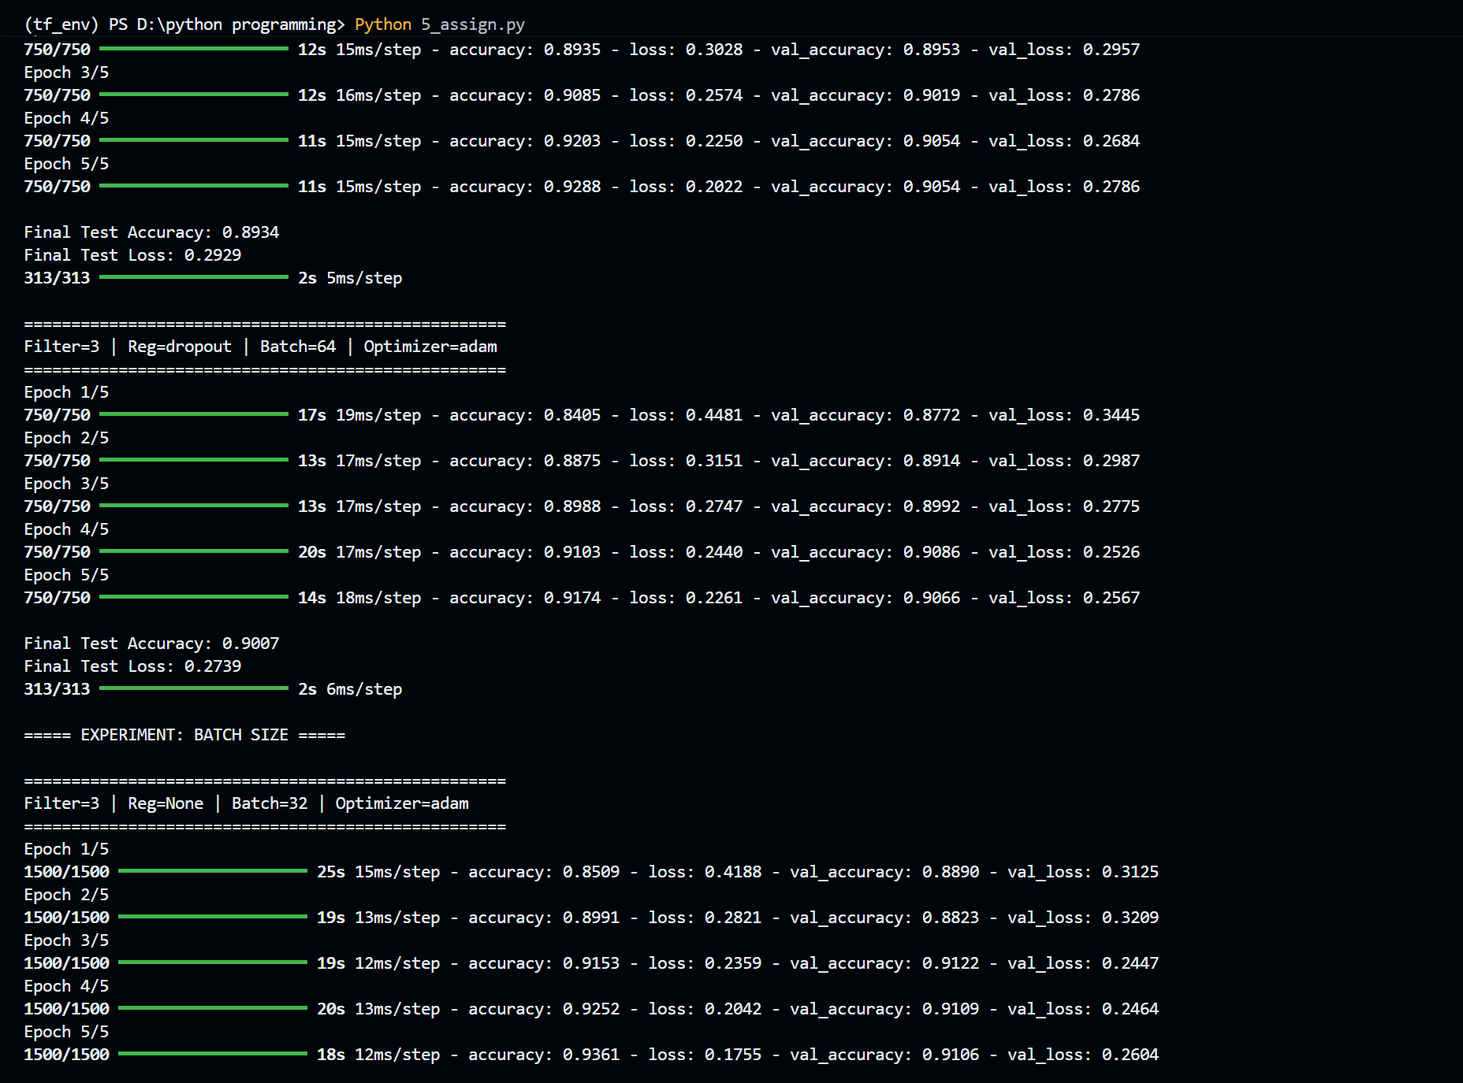
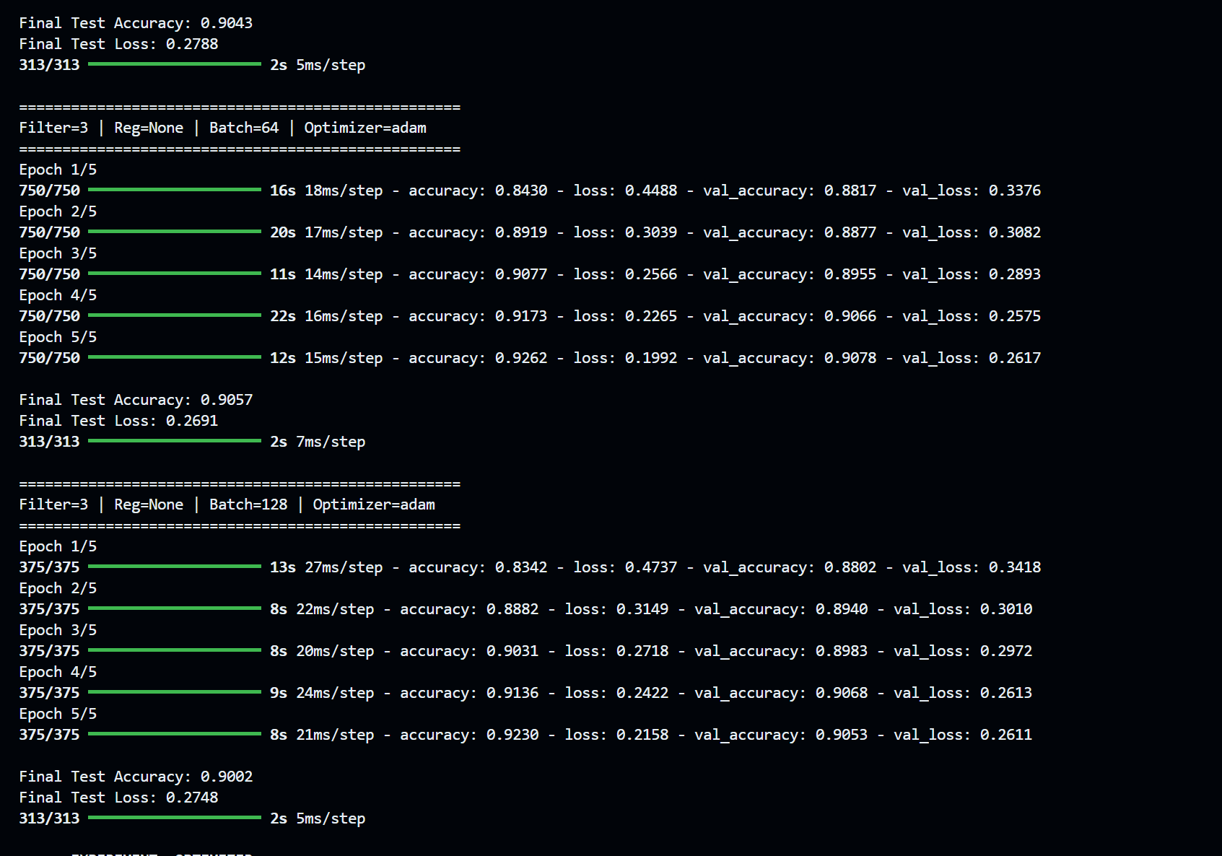
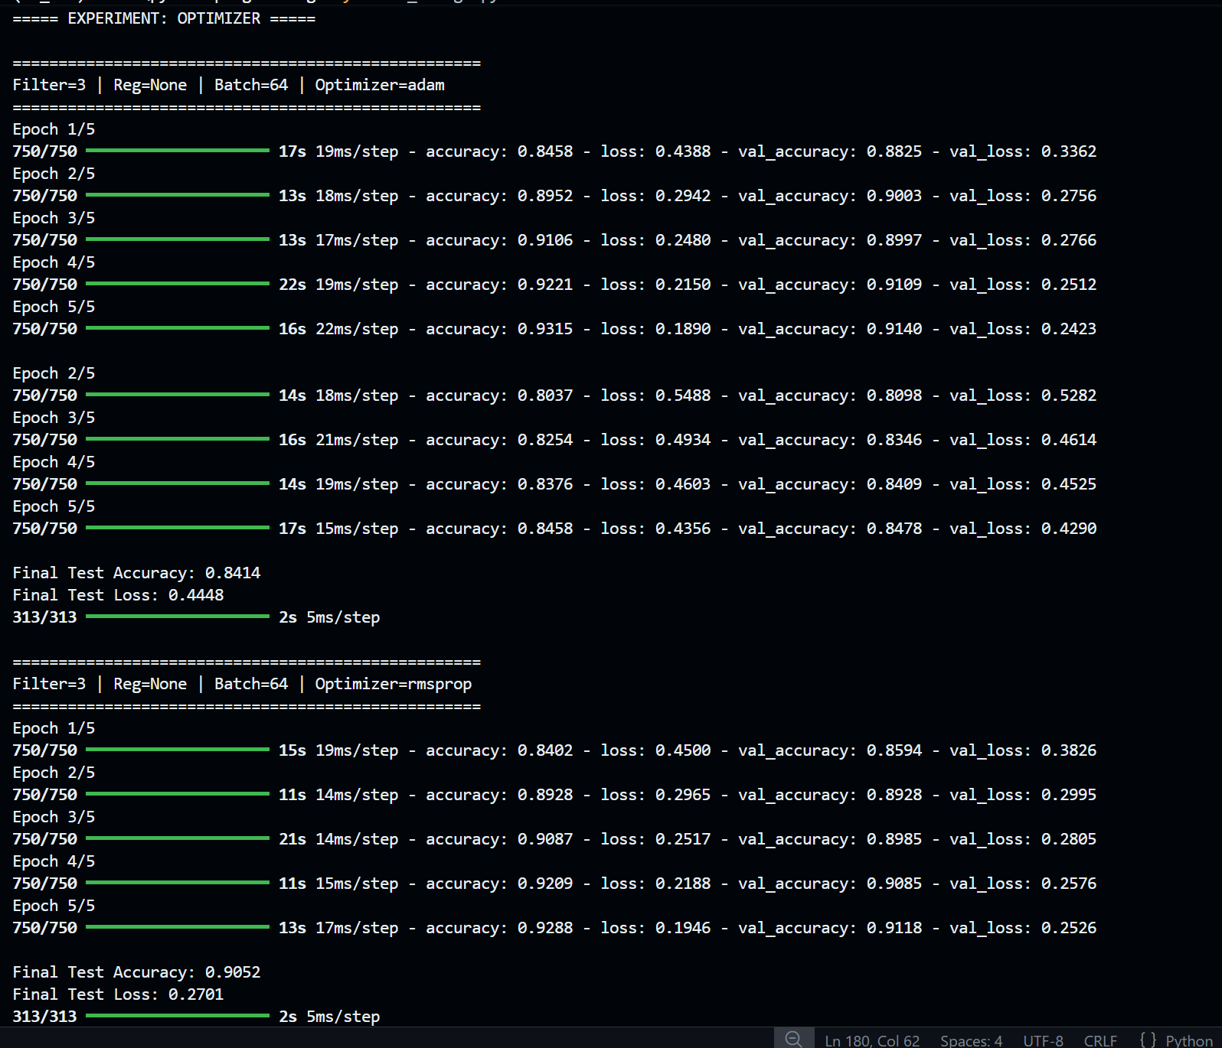
Description of the Code
(Training and Performance Evaluation of Convolutional Neural Network using Keras on Fashion MNIST Dataset)
- The Fashion MNIST dataset is loaded using the Keras dataset module. The dataset contains 28×28 grayscale images of clothing items such as shirts, shoes, bags, and trousers. Each image belongs to one of 10 classes. The dataset consists of 60,000 training images and 10,000 testing images.
- The input images are normalized by dividing pixel values by 255, converting them into values between 0 and 1. This normalization helps the neural network train more efficiently and improves numerical stability.
- Since convolutional neural networks require a channel dimension, the images are reshaped from 28×28 to 28×28×1, where the extra dimension represents the grayscale channel.
- A model builder function is defined to construct the CNN architecture dynamically. This function allows experimentation with different hyperparameters such as filter size, regularization method, batch size, and optimization algorithm.
- The neural network architecture consists of the following layers:
Input → Convolution → MaxPooling → Flatten → Dense → Output
  - Input layer: accepts images of shape 28×28×1
  - Convolution layer: 32 filters with variable filter size
  - MaxPooling layer: 2×2 pooling window
  - Fully connected layer: 128 neurons with ReLU activation
  - Output layer: 10 neurons with Softmax activation
- The convolution layer extracts spatial features from the input image using filters. The filter size can be changed (for example 3×3, 5×5, 7×7) to study how kernel size affects feature extraction and model performance.
- The MaxPooling layer reduces the spatial dimensions of the feature maps while retaining the most important information. This reduces computational cost and helps control overfitting.
- Regularization techniques are introduced to improve generalization and prevent overfitting. Two methods are tested:
  - L2 Regularization, which penalizes large weight values
  - Dropout, which randomly disables neurons during training
- The Flatten layer converts the two-dimensional feature maps into a one-dimensional vector so that the data can be fed into fully connected layers.
- A Dense (fully connected) layer with 128 neurons and ReLU activation learns higher-level representations of the extracted features.
- The output layer contains 10 neurons with Softmax activation, producing probability values for each clothing category. The class with the highest probability is selected as the predicted class.
- The model is compiled using the Sparse Categorical Cross-Entropy loss function, which is suitable for multi-class classification problems where labels are integers. Accuracy is used as the evaluation metric.
- A training and evaluation function is implemented to train the model with different parameter configurations. The function prints configuration details such as filter size, regularization method, batch size, and optimizer before training begins.
- During training, the model runs for multiple epochs, and the training accuracy, validation accuracy, training loss, and validation loss are recorded. These values are stored in the training history for later analysis.
- After training is completed, the model is evaluated on the test dataset, and the final test accuracy and loss are printed.
- The trained model then generates predictions for the test images. These predictions are compared with the actual labels to compute a confusion matrix, which shows how well the model classifies each category.
- The program also includes a visualization function that plots:
- Accuracy vs Epoch (training and validation)
- Loss vs Epoch (training and validation)
- Confusion Matrix heatmap
- The code performs systematic experiments by varying one hyperparameter at a time while keeping others constant. The variations include:
- Filter size (3×3, 5×5, 7×7)
- Regularization methods (None, L2, Dropout)
- Batch sizes (32, 64, 128)
- Optimization algorithms (Adam, SGD, RMSprop)
- For each configuration, the program trains a new CNN model and generates graphs showing the learning behavior and classification performance.
- Finally, the results from different experiments are analyzed to understand how hyperparameters influence training stability, convergence speed, and final classification accuracy of the convolutional neural network.
Demonstration of Hyperparameter Effects on Model Performance
In this experiment, the performance of the Convolutional Neural Network was analyzed by changing different hyperparameters while keeping the other parameters constant. This helps to understand how each factor influences the training behavior and accuracy of the model.
Effect of Filter Size
Different filter sizes such as 3×3, 5×5, and 7×7 were used in the convolution layer. It was observed that smaller filters like 3×3 produced better accuracy because they capture fine details of the images more effectively. Larger filters may lose small image features.
Effect of Regularization
Regularization techniques such as L2 regularization and Dropout were applied to reduce overfitting. L2 regularization helped control large weight values and improved generalization, while Dropout randomly disables neurons during training to prevent the model from relying too heavily on specific features.
Effect of Batch Size
Batch sizes such as 32, 64, and 128 were tested during training. Smaller batch sizes can lead to more stable learning but slower training, while larger batch sizes train faster but may slightly reduce model generalization.
Effect of Optimization Algorithm
Different optimizers including Adam, SGD, and RMSprop were tested. Adaptive optimizers like Adam and RMSprop achieved better accuracy and faster convergence compared to the traditional SGD optimizer.
Overall, these experiments show that selecting appropriate hyperparameters plays an important role in improving the accuracy, training speed, and stability of the CNN model.
Performance Evaluation
Convolutional Neural Network — Fashion MNIST Classification
Training Results
The CNN model was trained on the Fashion MNIST dataset, which contains grayscale images of clothing items such as shirts, trousers, shoes, bags, and dresses.
Observed final results from experiments:
• Best Test Accuracy: ≈ 90.59%
• Lowest Test Loss: ≈ 0.2598
These results indicate that the convolutional neural network successfully learned to identify clothing patterns and textures from images with relatively high accuracy.
The model demonstrates effective feature extraction and classification capability for multi-class image recognition problems.
Sample Prediction Behavior
The trained CNN correctly predicts most clothing categories such as:
- T-shirts
- Trousers
- Pullovers
- Dresses
- Bags
- Shoes
Correct predictions occur when the predicted class label matches the true label of the image.
The convolution layers automatically learn important visual features such as:
• Edges
• Textures
• Shapes
• Clothing structure patterns
These learned features allow the model to distinguish between visually similar classes such as shirts and pullovers or coats and dresses.
Confusion Matrix Interpretation
The confusion matrix provides a detailed representation of classification performance across all 10 clothing categories.
Interpretation:
• Diagonal elements represent correctly classified images.
• Off-diagonal elements represent misclassified samples.
Observations
• Most values appear along the diagonal, indicating strong classification performance.
• A few misclassifications occur between visually similar categories such as:
- Shirt vs T-shirt
- Coat vs Pullover
- Sandal vs Sneaker
These errors occur because some clothing items share similar shapes or textures.
Overall, the confusion matrix shows that the CNN performs reliable multi-class classification.
Learning Behavior Analysis
During training, the model gradually improves its prediction performance.
Early Training Stage
At Epoch 1
• Loss ≈ 0.45 – 0.48
• Accuracy ≈ 83–84%
This indicates the model initially has limited knowledge of image patterns.
Mid Training Stage
After Epoch 2–3
• Loss decreases significantly
• Accuracy improves to around 90%
At this stage the CNN begins to extract meaningful visual features from images.
Later Training Stage
After Epoch 4–5
• Loss stabilizes around 0.19 – 0.25
• Accuracy stabilizes near 90–93%
This indicates that the model has converged and further training would produce smaller improvements.
Graph Interpretation
Accuracy vs Epoch Graph
Observation:
• Accuracy increases gradually with each epoch.
• Training accuracy is slightly higher than validation accuracy.
This indicates that the model is successfully learning from the training data while still generalizing well on unseen validation data.
Loss vs Epoch Graph
Observation:
• Loss decreases consistently as training progresses.
• This downward trend indicates effective optimization.
Lower loss means the model predictions are becoming closer to the true labels.
Confusion Matrix Plot
Observation:
• The diagonal region is dominant with high values.
• Only a small number of misclassifications occur.
This confirms that the CNN performs accurate classification across most classes.
Hyperparameter Experiment Analysis
1. Filter Size
Smaller convolution filters performed better.
• 3×3 filter → Best performance (~90.59%)
• 5×5 filter → Slightly lower accuracy
• 7×7 filter → Highest loss
Reason:
Smaller filters capture fine-grained image features more effectively.
2. Regularization
Regularization helps prevent overfitting.
Results observed:
• L2 Regularization → Best generalization
• Dropout → Prevented overfitting but slightly reduced accuracy
3. Batch Size
Different batch sizes affect training stability.
Results:
• Batch 32 → Slightly smoother learning
• Batch 64 → Balanced performance
• Batch 128 → Faster training but similar accuracy
4. Optimizer
Optimization algorithms affect training convergence.
Results:
• RMSprop → Best performance (~90.59%)
• Adam → Very good performance (~89.95%)
• SGD → Lower accuracy (~84.51%)
Adaptive optimizers perform better because they adjust learning rates dynamically.
My Comments (Limitations & Improvements)
From this experiment, I observed that a CNN model can classify Fashion MNIST images with good accuracy by learning visual patterns such as edges, shapes, and textures. The model was able to correctly identify most clothing categories.
I also noticed that the performance of the model changes depending on hyperparameters like filter size, batch size, regularization, and optimizer. For example, 3×3 filters and adaptive optimizers like Adam or RMSprop gave better results than larger filters and SGD.
One limitation of this implementation is that the CNN architecture is simple and contains only one convolution layer, so it may not capture very complex image features.
To improve the model, I could use deeper CNN networks, data augmentation, and better hyperparameter tuning. Increasing the number of epochs may also improve the final accuracy.
Overall, this experiment helped me understand how CNN models work and how different parameters affect their performance.

