---------------------------------------------------------  HR ANALYTICS DASHBOARD  ---------------------------------------------------------  KPI SECTION  Total Employees | Active Employees | Attrition Rate | Avg Salary | Avg Tenure  ---------------------------------------------------------  Hiring Trend (Line Chart) Attrition Trend (Line Chart)  ---------------------------------------------------------  Employees by Department Gender Distribution  ---------------------------------------------------------  Attrition by Job Role Salary by Department  ---------------------------------------------------------  Job Satisfaction Analysis Overtime vs Attrition  ---------------------------------------------------------  Filters Panel  Department | Gender | Job Role | Education | Year  Analysis | Best Visual
Employee distribution | Bar chart
Gender ratio | Donut chart
Attrition analysis | Stacked column chart
Hiring trend | Line chart
Salary comparison | Column chart
------------------------------------------------
HR Analytics Dashboard
------------------------------------------------

KPI CARDS
Total Employees | Attrition Rate | Avg Salary | Avg Tenure

------------------------------------------------
Hiring Trend Attrition Trend
------------------------------------------------
Employees by Department Gender Distribution
------------------------------------------------
Attrition by Job Role Salary by Department
------------------------------------------------
Job Satisfaction Analysis
------------------------------------------------
Filters: Department | Gender | Job Role | Year

1️⃣ Top KPI Cards (Most Important Section)
These appear at the top of the dashboard.
Main HR KPIs:
KPI | Meaning
Total Employees | Total workforce in the company
New Hires | Employees hired in a period
Attrition Rate | Employees who left the company
Average Salary | Average employee salary
Average Age | Workforce age analysis
Average Tenure | Average years employees stay
Example KPI row:
Total Employees | New Hires | Attrition Rate | Avg Salary | Avg Tenure

2️⃣ Employee Distribution (Very Important)
Visuals to show workforce structure.
Best charts:
✔ Employees by Department (Bar chart)
✔ Employees by Gender (Pie or Donut chart)
✔ Employees by Job Role (Bar chart)
Example titles:
- Employees by Department
- Gender Distribution
- Job Role Distribution

3️⃣ Attrition Analysis (Critical for HR)
Companies care a lot about why employees leave.
Important visuals:
✔ Attrition by Department
✔ Attrition by Age Group
✔ Attrition by Job Role
✔ Attrition by Salary Range
Best chart type:
- Bar chart
- Stacked column chart

4️⃣ Hiring Trend (Recruitment Analysis)
Show how hiring changes over time.
Best visual:
📈 Line Chart
Example title:
Monthly Hiring Trend
This shows:
- recruitment growth
- seasonal hiring

5️⃣ Salary & Compensation Analysis
Important HR insights include salary distribution.
Charts:
✔ Average Salary by Department
✔ Salary by Job Role
✔ Salary Distribution

6️⃣ Employee Performance / Satisfaction (Optional but Advanced)
If the dataset has it:
Charts for:
✔ Job Satisfaction Level
✔ Performance Rating
✔ Overtime Analysis
Example titles:
- Job Satisfaction by Department
- Overtime vs Attrition

7️⃣ HR Filters (Very Important)
Add slicers so HR can analyze data easily.
Common filters:
- Department
- Gender
- Job Role
- Education
- Age Group
- Year

⭐ Ideal HR Dashboard Layout
------------------------------------------------
HR Analytics Dashboard
------------------------------------------------
KPI CARDS
Total Employees | Attrition Rate | Avg Salary | New Hires
------------------------------------------------
Hiring Trend Employees by Department
------------------------------------------------
Attrition Analysis Gender Distribution
------------------------------------------------
Salary Analysis Job Role Distribution
------------------------------------------------
Filters (Left Side)

⭐ Most Important Metric in HR Dashboard
If you must choose one key metric, it is:
Attrition Rate
Because companies want to know how many employees are leaving.

✅ Since you already built a Sales Dashboard, your next portfolio project should be an HR Dashboard.
If you want, I can also show you:
- A complete HR dataset structure (columns you should use)
- The exact HR dashboard layout used by real companies
- 10 KPIs that make an HR dashboard look professional.

1. Sales Performance Dashboard
Businesses want to track:
- Monthly sales
- Top products
- Region performance
- Sales growth
💰 Typical price: ₹5,000 – ₹20,000

2. Financial / Profit Dashboard
For small businesses to track:
- Revenue
- Expenses
- Profit margin
- Cash flow
💰 Price: ₹10,000 – ₹40,000

3. E-commerce Analytics Dashboard
Used by Amazon / Shopify sellers.
Metrics:
- Orders
- Conversion rate
- Top products
- Customer trends
💰 Price: ₹8,000 – ₹30,000

4. Inventory Management Dashboard
Companies track:
- Stock levels
- Reorder alerts
- Inventory turnover
💰 Price: ₹8,000 – ₹25,000

5. HR Analytics Dashboard
HR teams track:
- Employee performance
- Attrition rate
- Hiring metrics
💰 Price: ₹7,000 – ₹20,000

6. Marketing Campaign Dashboard
Tracks:
- Ad performance
- Leads generated
- Conversion rate
- ROI
💰 Price: ₹10,000 – ₹35,000

7. Project Management Dashboard
Used by managers to track:
- Tasks completed
- Timeline
- Budget
💰 Price: ₹6,000 – ₹20,000

8. KPI Business Dashboard
Executives track business KPIs:
- Revenue growth
- Customer acquisition
- Profit margin
💰 Price: ₹10,000 – ₹50,000

9. Customer Analytics Dashboard
Tracks:
- Customer behavior
- Repeat customers
- Sales by segment
💰 Price: ₹8,000 – ₹30,000

10. Automated Reporting Dashboard
Using:
- Power Query
- SQL connection
- Auto-refresh reports
💰 Price: ₹15,000 – ₹50,000

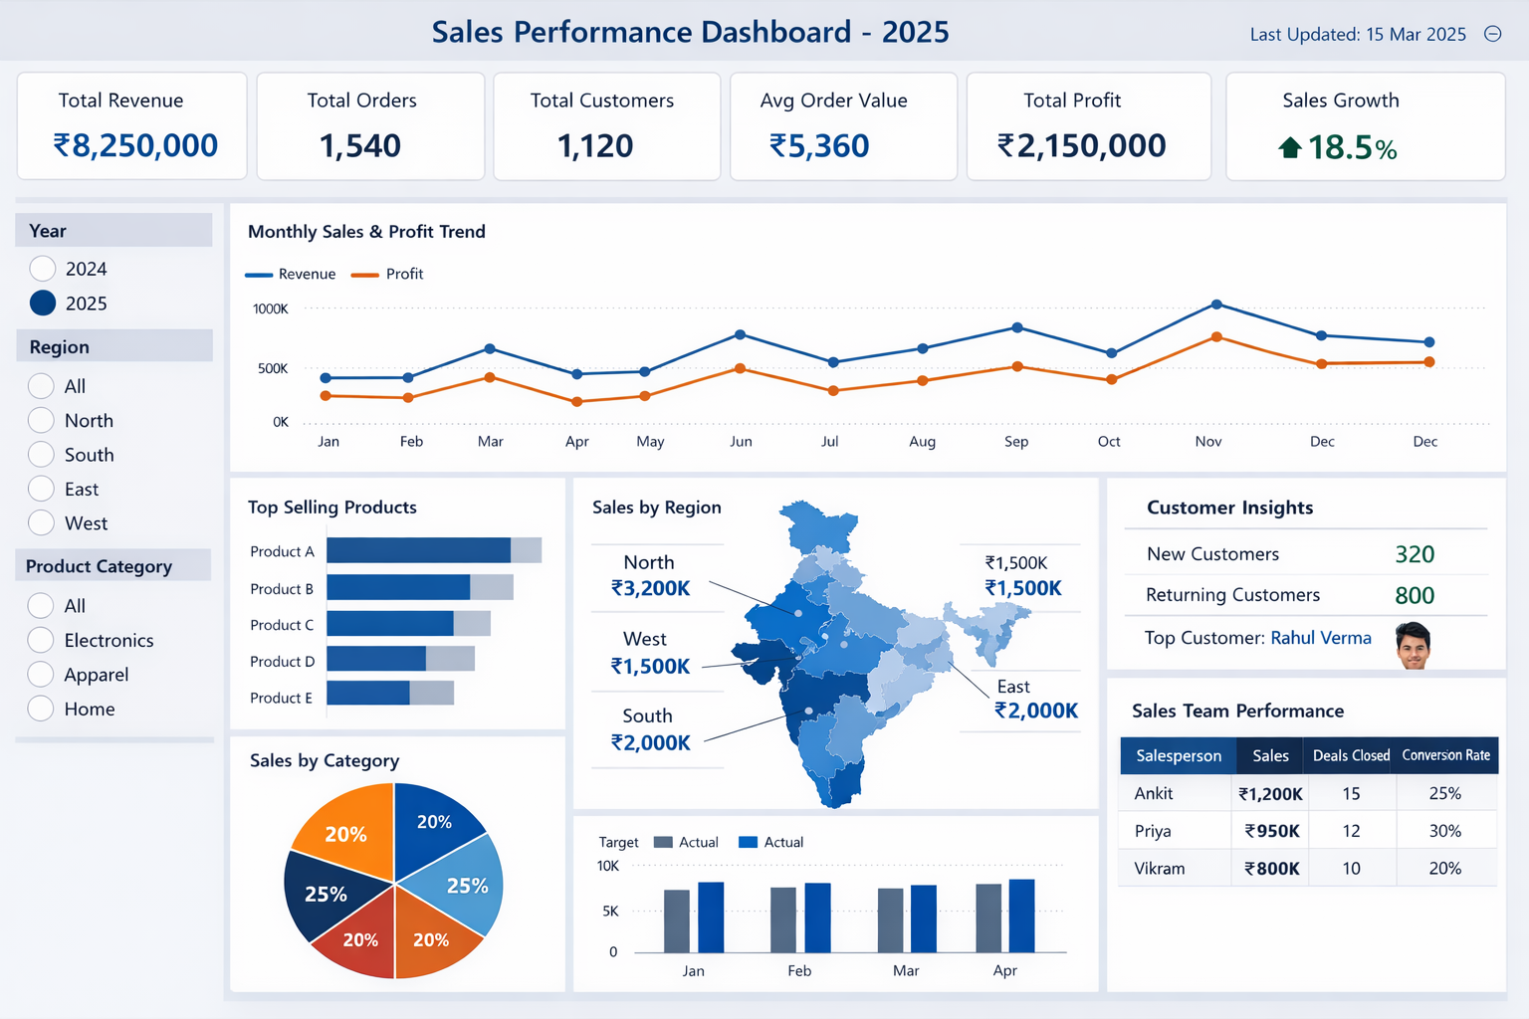

--------------------------------------------------
TITLE + DATE FILTER
--------------------------------------------------

KPI CARDS
Revenue | Orders | Customers | AOV | Profit | Growth

--------------------------------------------------

SALES TREND (Line Chart)

--------------------------------------------------

TOP PRODUCTS SALES BY CATEGORY

--------------------------------------------------

REGIONAL SALES CUSTOMER INSIGHTS

--------------------------------------------------

TARGET VS ACTUAL SALES TEAM PERFORMANCE

--------------------------------------------------

FILTERS / SLICERS
--------------------------------------------------

