##### A Report

**Submitted as a part of B.Tech year syllabus for the partial fulfillment for Bachelor of Technology in Computer Engineering**

**Submitted To**

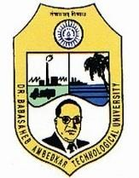

### Dr. Babasaheb Ambedkar Technological University, Lonere

**Submitted By:**

***Mr. Jatin Sukhadev Sathe***

***PRN No: 21516420181124510045***

### Period of Training: 1 Month

**DEPARTMENT OF COMPUTER ENGINEERING**

##### P.S.G.V.P. MANDAL’S

**D. N. PATEL COLLEGE OF ENGINEERING SHAHADA, DIST- NANDURBAR (M.S.)**

**YEAR 2021-2022**

### CERTIFICATE

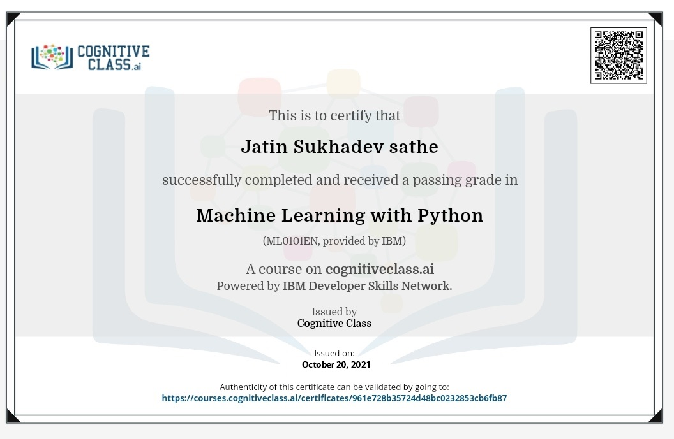

P.S.G.V.P. MANDAL’S

### D. N. PATEL COLLEGE OF ENGINEERING

SHAHADA, DIST- NANDURBAR (M.S.)



**CERTIFICATE**

***This is to certify that***

**Mr. Jatin Sukhadev Sathe PRN No: 21516420181124510045**

#### Has satisfactorily completed Field Training/Internship/Industrial

**Training entitled**

Machine Learning with Python

**As prescribed by Dr. Babasaheb Ambedkar Technological University, Lonere as a part of final year syllabus for the partial fulfillment for Bachelor of Technology in Computer Engineering.**

**TRAINING IN-CHARGE H.O.D.**

Prof. S. H. Shaikh Prof. V. S. Mahajan

##### PRINCIPAL

Prof. Dr. N. J. Patil

### TABLE OF CONTENT

##### Chapter No.

**Content Page**

|  |  |  |
| --- | --- | --- |
| **1.** | **ABSTRACT ACKNOWLEDGENT**  **INTRODUCTION OF THE ORGANIZATION** | **i Ii**  **1-2** |
|  | 1.1 History of the organization | 1 |
|  | 1.2 Organization background and nature of the business | 2 |
|  | 1.3 Competitive advantage of the organization |  |
| **2.** | **THE INDUSTRIAL TRAINING PROGRAM** | **3-4** |
|  | 2.1 Objectives of the industrial training program | 3 |
|  | 2.2 Scope of responsibility | 4 |
|  | 2.3 Introduction to Machine Learning With Python |  |
| **3** | **INNOVATIVE PRACTICES AND SUGGESTIONS** | **5-6** |
|  | 3.1 Innovative practices | 5 |
|  | 3.2 Suggestions | 6 |
| **4** | **CONCLUSION** | **7** |
| **5** | **REFERENCES** |  |

**No.**

# ABSTRACT



*Gain the core knowledge to begin with machine learning in python. in this course, instructor uses Python to explore the core concepts and structure of machine learning and helps you grasps what's going on under the hood. after going over basic statements and expressions in python, python is one such programming language that provides rich library of modules and packages for use in scientific computing and machine learning. Upon wrapping up this course, you will have knowledge you need to continue your machine learning journey in whichever language you have interest.*

# ACKNOWLEDGMENT



I would like to express my gratitude and appreciation to all those who gave me the possibility to complete this report. A special thanks to our training Coordinator, **Prof. S. H. Shaikh** whose help, suggestions and encouragement, helped me to complete my training especially in writing this report.

I Heartily Thank **Rahul Bhatt** Sir, who is the teacher for this course. I am Thankful for his wonderful teaching and his efforts towards explaining each thing very clearly so that I can grasp it soon.

Many people have contributed to the success of this. Although a single sentence hardly suffices, I would like to thank Almighty God for blessing us with his grace. I extend our sincere and heartily thanks to **Prof. V. S. Mahajan**, Head of Department ,Computer Engineering, for providing us the right ambiance for carrying out this work.

I also offer my most sincere thanks to Principal **Prof. Dr. N. J. Patil** for his valuable support. I express our immense pleasure and thankfulness to all the teachers and staff of the Department of Computer Engineer

**Mr. Jatin Sukhadev Sathe**

**B.Tech Comp Engg**

1. **INTRODUCTION OF THE ORAGANITION**

This report is based on Machine Learning With Python Course it helps learners from various educational and Professional background launch their high-growth tech careers. If anyone is from a Non Computer Science or Computer Science backgrounds, this platform will help you acquired the required various computer technologies skills.

IBM Skill Build offers free learning, support, and resources from secondary education (students aged 13-18) to adult seeking entry-level employment. We believe that new, entry-level tech jobs require skills, not just degrees. We knows that learners at all stages of the employment continuum need access to the skills that will allow them to compete in an ever- evolving economy. At IBM we believe that entry-level tech—new, entry-level tech jobs—require skills, not just degrees. IBM Skills Build offers free learning, support, and resources to foster STEM and new collar skills from secondary education (students aged 13-18) to entry-level employment.

### History Of the Organization

International Business Machines Corp (IBM) is an multinational technology corporation headquarter in Armonk, New York, with operations in over 171 countries.

IBM was founded in 1911 in [Endicott, New York,](https://en.wikipedia.org/wiki/Endicott%2C_New_York) as the [Computing-Tabulating-Recording](https://en.wikipedia.org/wiki/Computing-Tabulating-Recording_Company) [Company](https://en.wikipedia.org/wiki/Computing-Tabulating-Recording_Company) (CTR) and was renamed "International Business Machines" in 1924. IBM is incorporated in New York and has operations in over 170 countries.

**International Business Machines Corp** (**IBM**) is a American [multinational](https://en.wikipedia.org/wiki/Multinational_corporation) [technology](https://en.wikipedia.org/wiki/Technology_company) [corporation](https://en.wikipedia.org/wiki/Technology_company) headquartered in [Armonk, New York,](https://en.wikipedia.org/wiki/Armonk%2C_New_York) with operations in over 171 countries. The company began in 1911, founded in [Endicott, New York,](https://en.wikipedia.org/wiki/Endicott%2C_New_York) by businessman Charles Ranlett Flint, as the [Computing-Tabulating-Recording Company](https://en.wikipedia.org/wiki/Computing-Tabulating-Recording_Company) (CTR) and was renamed "International Business Machines" in 1924. IBM is incorporated in New York.

IBM was recognized as one of the Top 20 Best Workplaces for Commuters by the [United](https://en.wikipedia.org/wiki/United_States_Environmental_Protection_Agency) [States Environmental Protection Agency](https://en.wikipedia.org/wiki/United_States_Environmental_Protection_Agency) (EPA) in 2005, which recognized [Fortune](https://en.wikipedia.org/wiki/Fortune_500) [500](https://en.wikipedia.org/wiki/Fortune_500) companies that provided employees with excellent [commuter](https://en.wikipedia.org/wiki/Commuting) benefits to help reduce traffic and air pollution. In 2004, concerns were raised related to IBM's contribution in its early days to pollution in its original locations Endicott New York.

### Organization background and nature of the businesses

The courses hosted on IBM Skill Build Portal are in four quadrants:-

* + - Video lectures
    - Specially prepared reading material that can be downloaded/printed
    - Self-assessment tests through tests and quizzes
    - An Online

Discussion forum for clearing the doubts. Steps have been taken to enrich the learning experience by using audio-video and multi-media and state of the art pedagogy/technology.

### Competitive Advantage of the Organization

Following are some advantages of this organization

* Best-in-Class Instructors
* Weekly Assignments
* Proctored Exams
* Easy Credit Transfer
* Active Local Chapters
* Systematic Approach

## INDUSTRIAL TRAINING PROGRAM

### Objectives of the Industrial Training Program

* + 1. To provide comprehensive learning platform to student where they can
    2. enhance their employ ability skills and become job ready along with real corporate exposure.
    3. To enhance students’ knowledge in one particular technology.
    4. To increase self-confidence of students and helps in finding their own proficiency.
    5. To cultivate student’s leadership ability and responsibility to perform or execute

the given task.

### Scope Responsibility

I enrolled for an Online Certification Course “Machine Learning with Python” which is being conducted by “IBM Skill Build Program” on the Skill build Portal. I have completed course and gained knowledge in Machine Learning with Python. I solve many assignments that is given in the course. In this course I watch number of videos and learn Machine Learning with Python.

Machine Learning can be an incredibly beneficial tool to uncover hidden insights and predict future trends. This free Machine Learning with Python course will give you all the tools you need to get started with supervised and unsupervised learning.

### Introduction to Machine learning With Python

Machine learning is a type of artificial intelligence (AI) that provides computers with the ability to learn without being explicitly programmed. Machine learning focuses on the development of Computer Programs that can change when exposed to new data. In this article, we’ll see basics of Machine Learning, and implementation of a simple machine learning algorithm using python.

Machine Learning (ML) is basically that field of computer science with the help of which computer systems can provide sense to data in much the same way as human beings do. In simple words, ML is a type of artificial intelligence that extract patterns out of raw data by using an algorithm or method. The key focus of ML is to allow computer systems to learn from experience without being explicitly programmed or human intervention .Machine Learning can be an incredibly beneficial tool to uncover hidden

insights and predict future trends. This free Machine Learning with Python course will give you all the tools you need to get started with supervised and unsupervised learning.

## Innovative Practices and Suggestions

### Innovative Practices

* + - **Understand current and future student populations:** - “To best serve the online learner population now and in the future, it is critical to gain a thorough understanding of these educational consumers, including their potential risk factors, curricular interests, educational and career goals, and interventions

that will support their success," noted the report, adding that this population is likely to change dramatically over time. "By listening to education consumers and understanding the diversity of their experiences and their expectations, online providers can tailor programs and offerings to meet their needs while planning for future offerings." Design online programs and courses to deliver personalized learning. Here the report.

* + - **Explore multiple models for building community: -** Symposium participants Agreed that community building is key to the success of individual students, but all had approached that task in different ways. “There are lessons to be Learned across the approaches and interest in further exploring the key Ingredients within the various programs,” the report said
    - **Leverage new technologies to optimize the impact of human coaching and mentoring: -** Technology is not a replacement for human interaction, but tools such as data analytics can help make student advising and interventions more efficient and effective. "Using our student experience data to be at the right time and the right place with the right focus can be a powerful differentiator for online learning," the report said, and "delivering the appropriate balance between online group instruction, individualized virtual coaching and mentoring, and in-person meetings is important to keep students engaged, focused, and moving forward in their studies."
    - **Build a data-driven culture of innovation and accountability: -** “Using hard data that Everyone values as relevant can help build a culture that puts student success and lifelong Outcomes at the forefront and provides common ground to demonstrate success, share Information on what is working, and hold each other accountable for what is not,” the Report said. In particular, “it is crucial to agree, not only on outcome goals, but also on How these goals will be reached, how success will be measured, and how students and Faculty will be held accountable.” At the same time, institutions need to embrace Innovation: “In a fast-paced online learning environment, [that] means developing a Mindset that encourages institutions and individuals to reach and experiment while Learning quickly from failures as well as successes and adapting to address evolving Challenges.”

### Suggestions

In this course I found everything sufficiently efficient but It would be more convenient if the questions asked on forum get replied in time. The complexity of the assignment questions is also much harder than expected and also the questions sometimes are faulty.

## CONCLUSION

I believe the Machine Learning with Python has the bright future because of its following advantages:

* + - It has continuous improvement in his lifecycle.
    - It can use for automation for anything.
    - In this course I came to learn various Machine Learning algorithms and their used.
    - I gained knowledge in Machine Learning and Machine learning with Python also.
    - It made me able to understand its algorithm and where I can use it.
    - Learnt about the live session and found it helpful to interact with the instructor.
    - Also learnt the time bound answering to the questions asked

## 5.REFERENCES

**Dept. of Computer Engineering 8 D.N.Patel College of Engg. Shahada**

8

|  |  |
| --- | --- |
| [1] | “Introduction of the Organization” [https://IBM](https://ibm/) skill build.in/about |
| [2] | “Machine Learning with Python “https:[//w](http://www.geeksforgeeks.org/introduction-)ww[.geeksforgeeks.org/introduction-](http://www.geeksforgeeks.org/introduction-) machine-learning-using-python/ |
| [3] | “Completion Certificate” https://skills.yourlearning.ibm.com/activity/SN- COURSE-V1: COGNITIVECLASS+ML0101ENV3+V4 |

[4] “machinelearningmastery.com/machine-learning-in-python-step-by-step/