Part A:

The path of ftrace
/sys/kernel/debug/tracing

Issues encountered
First we change directory
cd /sys/kernel/debug/tracing
bash: cd: /sys/kernel/debug/tracing: Permission denied

Simple fix of running this in super user mode.
Sudo -s
cd /sys/kernel/debug/tracing

Refered documents
/sys/kernel/debug/tracing/README

How are the typical tracers look like and how to set the tracer

The command cat available_tracers will list out all the tracers avaiable for use.

To set a specific tracer we use echo function_graph > current_tracer to setup the current tracer as function_graph.

In order to check what is the current_tracer set as, we use cat current_tracer.
How to start and stop tracing

We can use echo 0 > tracing_on to disable the tracer and echo 1 > tracing_on to re-enable it.

how to get the trace log and analyse it

We can read a snipbit of the trace using cat trace | head -10
# tracer: function_graph
#
# CPU DURATION FUNCTION CALLS
# | | | | | | |
5) + 19.616 us | } /* do_sched_yield */
5) + 20.439 us | } /* __ia32_sys_sched_yield */
5) | syscall_slow_exit_work() {
5) | __audit_syscall_exit() {
5) | path_put() {
5) | dput() {

Analysis of a method load_balance().

7) | load_balance() {
7) | find_busiest_group() {
7) 0.070 us | update_nohz_stats();
7) 0.080 us | idle_cpu();
7) 0.070 us | update_nohz_stats();
7) 0.151 us | idle_cpu();
7) 3.246 us | }
7) 4.048 us | }
Link to the kernal’s code
https://github.com/torvalds/linux/blob/24b888d8d59847871387aa3b241b524661070a6e/kernel/sched/fair.c#L8909

Code take from Linux Kernal.
....
group = find_busiest_group(&env);
if (!group) {
schedstat_inc(sd->lb_nobusyg[idle]);
goto out_balanced;
}
.....
We can trace that find_busiest_group() has trigger in the load_balance() function.

Note that here printk("...") is a kernel exclusive function that prints to the kernel’s log file, which can be accessed by the command dmesg
This defines the prototype of the function of our System Call. asmlinkage is a keyword used to indicate that all parameters of the function would be available on the stack.

TASK
Question 1
a)Ftrace uses memory to keep the trace record. Before starting a new trace, the old traces are still kept in the memory by ftrace has to be emptied. How can this be done? (1 mark)

The command echo > trace is used to clear the old traces.

b) What is the command to change the maximum size of the trace file of ftrace? (1 mark)

The command cat buffer_size_kb shows the size of the current trace.Using the command echo 1408 > buffer_size_kb we can set the trace to the size of your choice.

c)Assuming you are changing the kernel code to insert a printk- like code to output hello world in ftrace and the message given by the print code is the only thing you want to trace, show your code (with comments) and also the tracer that should use in ftrace. You should provide a shell script that will run the tracing. (2 marks)

TODO

d) Use the function tracer to trace the kernel for about a few seconds. Give the screenshots of the first 20 lines of the trace file and analyse the basic structure of it. (2 marks)

Setup function tracer
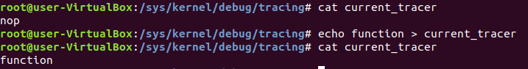
Print the first 20 lines
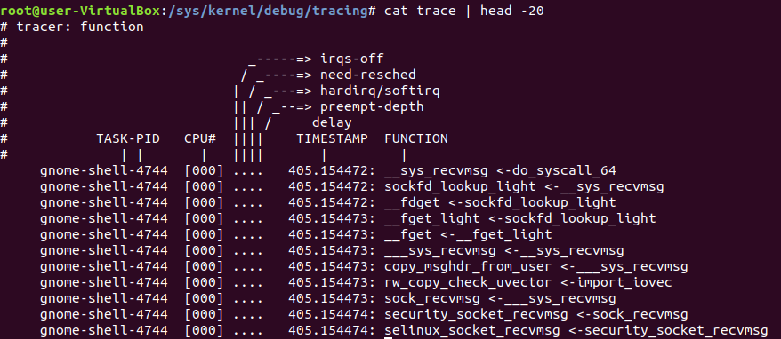

Question 2
Use the function_graph tracer in ftrace to trace the function call stack of three kernel functions, vfs_open, vfs_read and vfs_write and set the max function call depth to record as 10. Give the complete commands you use and analyse the trace result.
Note: the three functions should be traced at the same time.

Setup function_graph
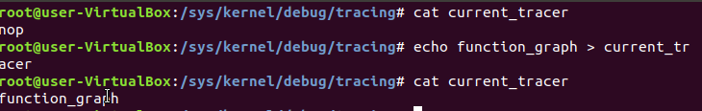
Setup max function call depth
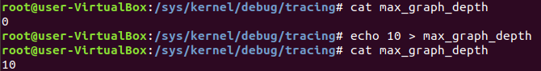

Setup the function filters
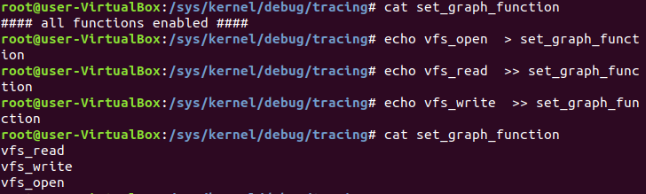

Reading the trace file

vfs_open
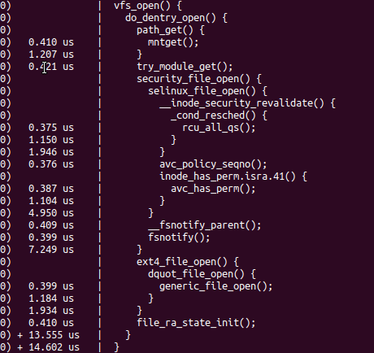

vfs_read
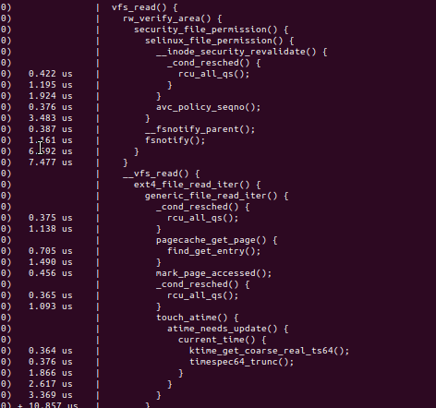

vfs_write
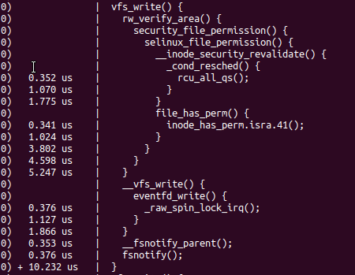

ssize_t vfs_write(struct file *file, const char __user *buf, size_t count, loff_t *pos)
{
ssize_t ret;
//This is bitwise comparion to check if the current use has the permission to write to the file
if (!(file->f_mode & FMODE_WRITE))
return -EBADF;
//This bitwise comparsion is to check if the file can be written to.
if (!(file->f_mode & FMODE_CAN_WRITE))
return -EINVAL;
if (unlikely(!access_ok(VERIFY_READ, buf, count)))
return -EFAULT;

ret = rw_verify_area(WRITE, file, pos, count);
if (!ret) {
if (count > MAX_RW_COUNT)
count = MAX_RW_COUNT;
file_start_write(file);
ret = __vfs_write(file, buf, count, pos);
if (ret > 0) {
fsnotify_modify(file);
add_wchar(current, ret);
}
inc_syscw(current);
file_end_write(file);
}

return ret;
}

Issues encountered

After installing the kernal I had access to only one tracer.
Inorder to enable function_graph
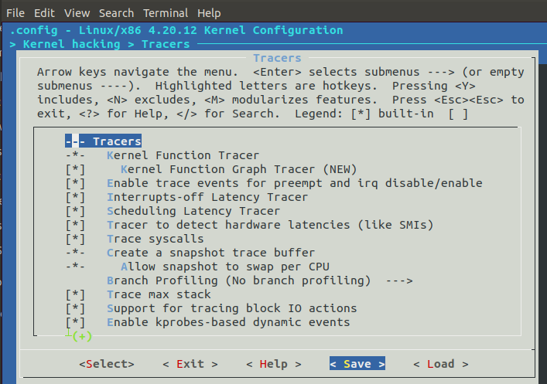
After installing the kernal

Setting up syscall function.

Refence to make syscall
https://medium.com/@jeremyphilemon/adding-a-quick-system-call-to-the-linux-kernel-cad55b421a7b

Commands
mannu@mannu-pc:~/Shared/linux-4.20.12$ mkdir myhello
mannu@mannu-pc:~/Shared/linux-4.20.12$ cd myhello/
mannu@mannu-pc:~/Shared/linux-4.20.12/myhello$ touch myhello.c
mannu@mannu-pc:~/Shared/linux-4.20.12/myhello$ cat myhello.c
#include <linux/kernel.h>

asmlinkage long sys_myhello(void) {
printk("Hello, Manpreet!\n");
return 0;
}
mannu@mannu-pc:~/Shared/linux-4.20.12/myhello$ touch Makefile
mannu@mannu-pc:~/Shared/linux-4.20.12/myhello$ cat Makefile
obj-y := myhello.o
mannu@mannu-pc:~/Shared/linux-4.20.12/myhello$ cd ..
mannu@mannu-pc:~/Shared/linux-4.20.12$ nano +973 Makefile
mannu@mannu-pc:~/Shared/linux-4.20.12$ cat -n Makefile | grep myhello
973 core-y += kernel/ certs/ mm/ fs/ ipc/ security/ crypto/ block/ hello/ myhello/

mannu@mannu-pc:~/Shared/linux-4.20.12$ nano arch/x86/entry/syscalls/syscall_64.tbl
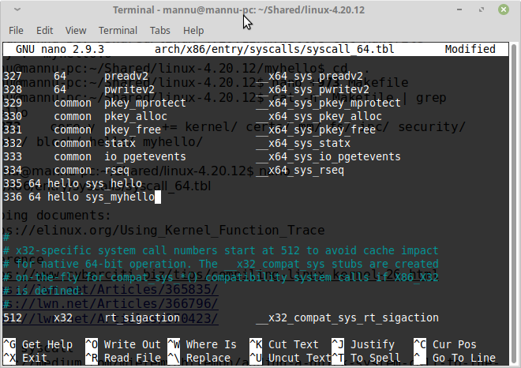

Helping documents:
https://elinux.org/Using_Kernel_Function_Trace

Reference
https://www.cyberciti.biz/tips/compiling-linux-kernel-26.html
https://lwn.net/Articles/365835/
https://lwn.net/Articles/366796/
https://lwn.net/Articles/370423/

Setup syscall
https://medium.com/@jeremyphilemon/adding-a-quick-system-call-to-the-linux-kernel-cad55b421a7b

mannu@mannu-pc:~/Shared/linux-4.20.12$ nano include/linux/syscalls.h
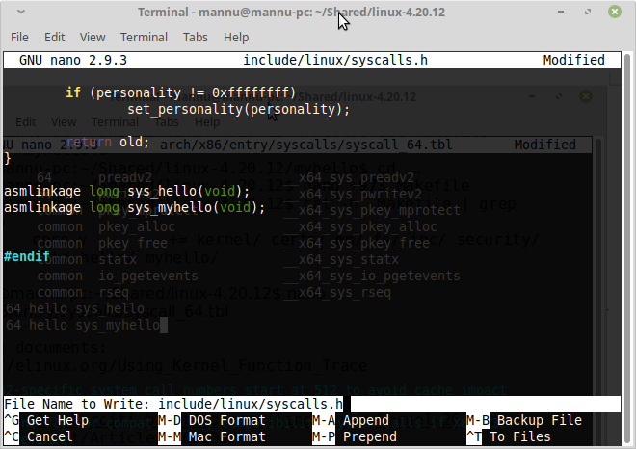
mannu@mannu-pc:~/Shared/linux-4.20.12$ make -j $(nproc)

