**Project objective:**

You are working as a DevOps engineer in an IT firm. You have been asked to create a Redis-based Docker image and deploy it on a Swarm cluster.

**Background of the problem statement:**

Your organization wants to use Redis in a Swarm cluster for the data storage and caching purpose. The development team has asked you to create a Redis-based Docker image using a Dockerfile and deploy this image on a Swarm cluster.

You have also been asked to publish this image on your organization's Docker Hub account so that other team members can also access this image.

**You must use the following:**

* Docker CLI: To create the Docker image and deploy it on Swarm cluster
* Docker Hub: To publish the image

**Following requirements should be met:**

* Follow the above-mentioned specifications
* Make sure you create an account on Docker Hub to push the Docker image
* Document the step-by-step process involved in completing this task

1. Login at AWS portal or login at simplilearn lab created 3 ubuntu vm

Installed docker and docker compose

Docker version

Client:

Version: 24.0.5

API version: 1.43

Go version: go1.20.3

Git commit: 24.0.5-0ubuntu1~22.04.1

Built: Mon Aug 21 19:50:14 2023

OS/Arch: linux/amd64

Context: default

Server:

Engine:

Version: 24.0.5

API version: 1.43 (minimum version 1.12)

Go version: go1.20.3

Git commit: 24.0.5-0ubuntu1~22.04.1

Built: Mon Aug 21 19:50:14 2023

OS/Arch: linux/amd64

Experimental: false

containerd:

Version: 1.7.2

GitCommit:

runc:

Version: 1.1.7-0ubuntu1~22.04.2

GitCommit:

docker-init:

Version: 0.19.0

Docker compose version

docker-compose version 1.27.0, build 980ec85b

1. master node run the command

docker swarm init

docker swarm join --token <token> <ip:port>

3) Login at master node created directory project

mkdir project

cd project

Note: version of docker and docker compose are mandatory

create Dockerfile

# Dockerfile

FROM alpine:latest

RUN apk add --no-cache redis

EXPOSE 6379

CMD ["redis-server"]

1. Create image from the docker file and tag the image to upload on the docker hub

docker build --pull --rm -f "Dockerfile" -t jatinmaan/redis:latest "."

docker tag jatinmaan/redis jatinmaan29/redis

docker images

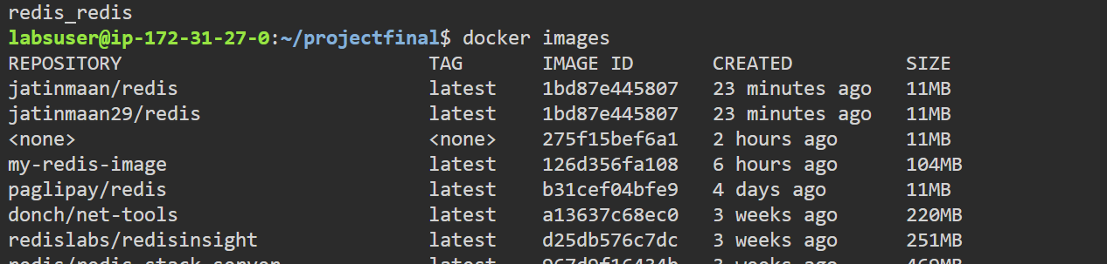

1. Login at docker using docker login

Pushed the docker image docker hub

docker push jatinmaan29/redis

1. Local testing the image

docker run --rm -it -p 6379:6379/tcp jatinmaan29/redis

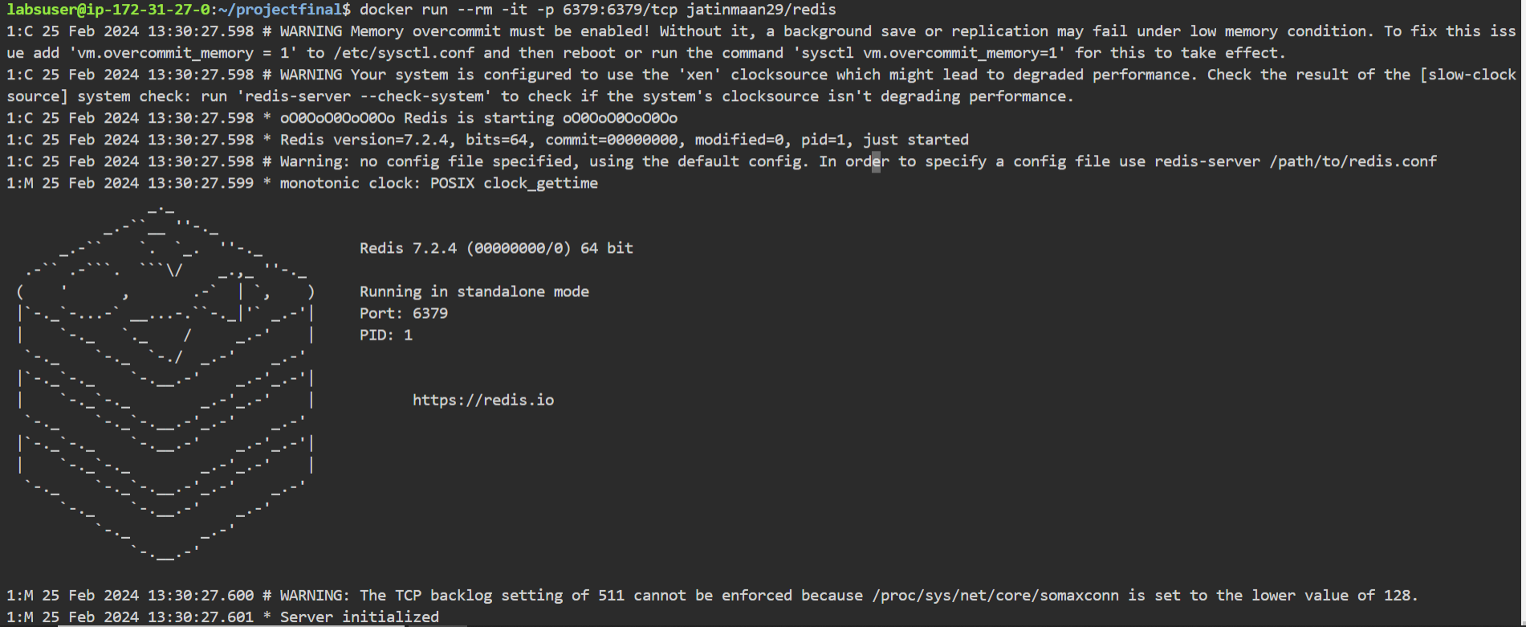

1. Deploy Image on Swarm Cluster Using Docker Compose:

Docker-compose.yml file

version: '3.9'

services:

redis:

image: jatinmaan29/redis:latest

deploy:

replicas: 3 # adjust the number of replicas as needed

ports:

- "6379:6379"

1. docker stack deploy -c docker-compose.yml redis

docker service ls

Links for docker hub and git hub

<https://hub.docker.com/repository/docker/jatinmaan29/redis/general>

<https://github.com/Jattinmaanking/redis-docker-swarn-project>