Java Player Registration System

Developing Database Applications using JDBC

Jaturaput Jongsubcharoen

Centennial College

2024, September 11

Project Overview
The Java Player Registration System is a Java-based database application for managing players, games, and gameplay records. The project integrates a JavaFX desktop interface with JDBC and Oracle SQL and was later expanded with a layered architecture, automated testing, CI, and a Spring Boot REST API.

Develop a GUI Java application that will allow the players to submit information about themselves and the games that they are playing on-line. The information will be stored in a simple Oracle database. The database tables are shown in the following picture:
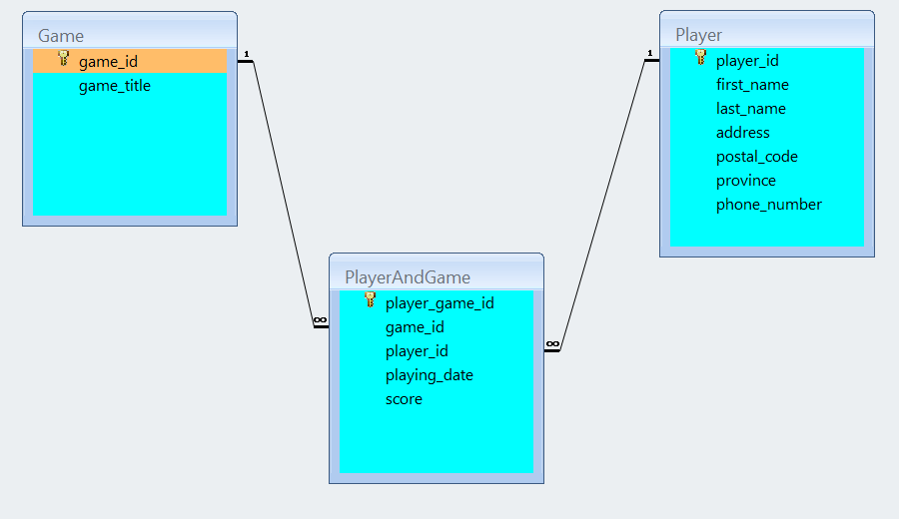

Technologies and Tools
Java 17, JavaFX 21, JDBC, Oracle SQL, Spring Boot 3, Spring Data JPA, Maven, JUnit 5, H2, Docker, GitHub Actions, Git/GitHub

Key Features
- Player and game creation, updating, deletion, and reporting
- JavaFX desktop user interface with input validation
- JDBC database integration using prepared statements
- Layered Service and DAO architecture
- Transaction management for multi-table operations
- Spring Boot REST API
- JUnit automated testing with H2
- GitHub Actions continuous integration

Architecture Diagram
JavaFX UI → Service Layer → DAO Layer → JDBC → Oracle Database
Spring Boot REST API → Spring Data JPA → Database
Solution: Output

Example: Insert game and player information into the database by clicking Create Player button.
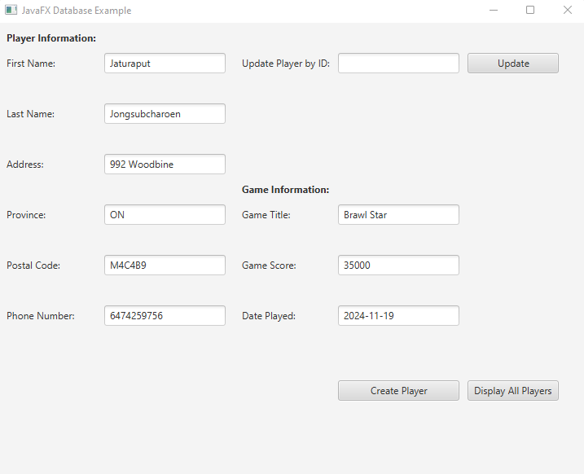
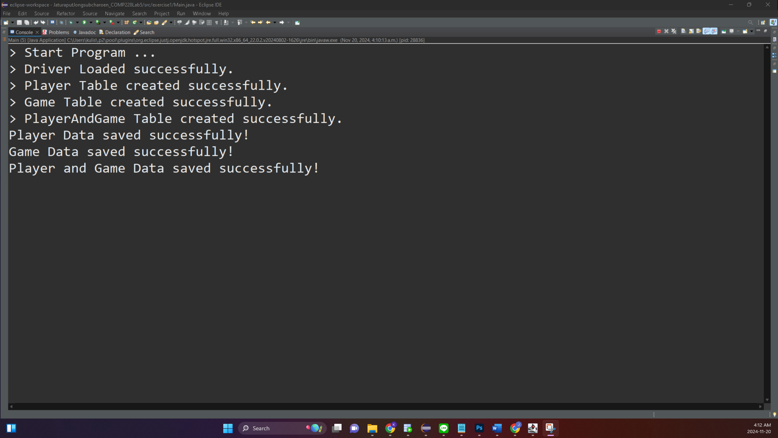
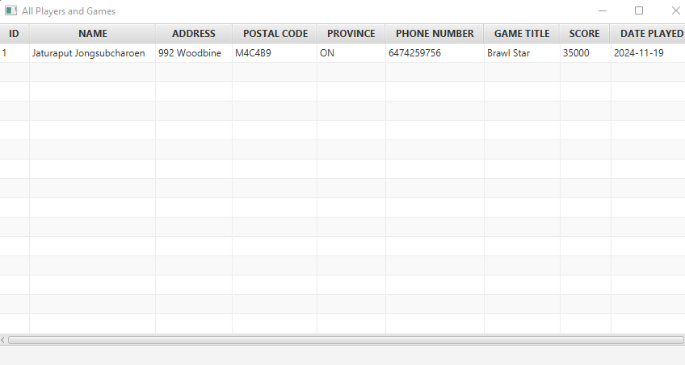

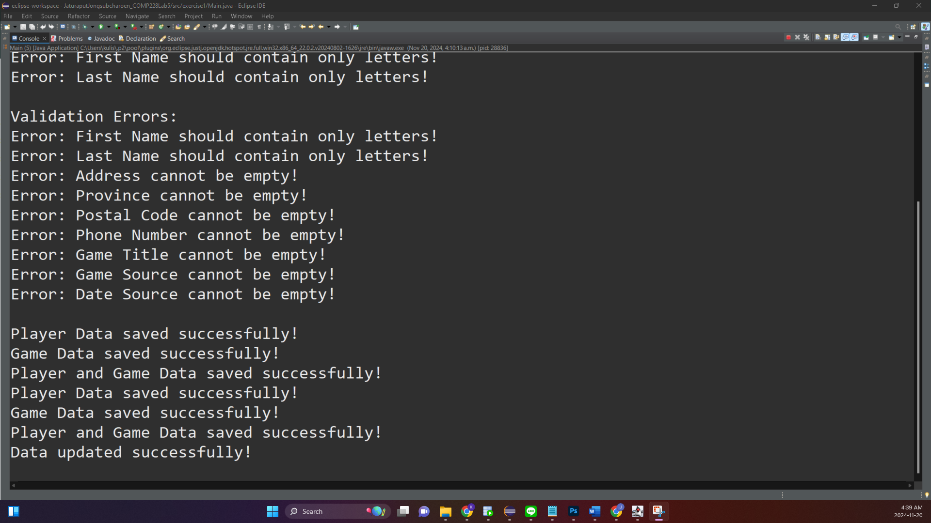
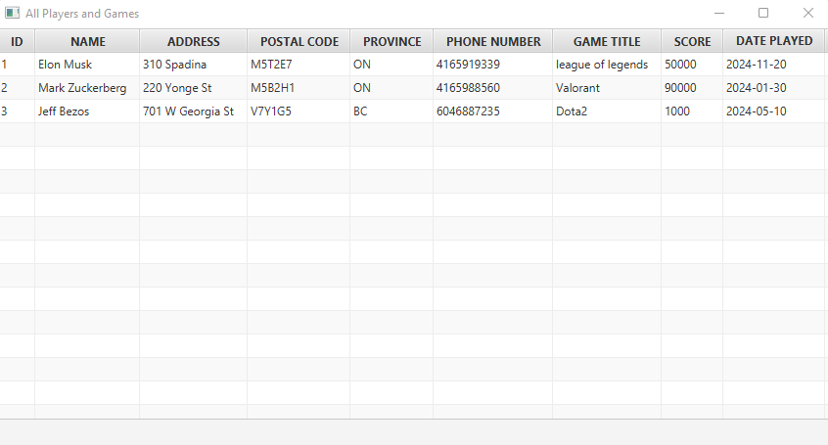

Example: Update game and player information into the database.
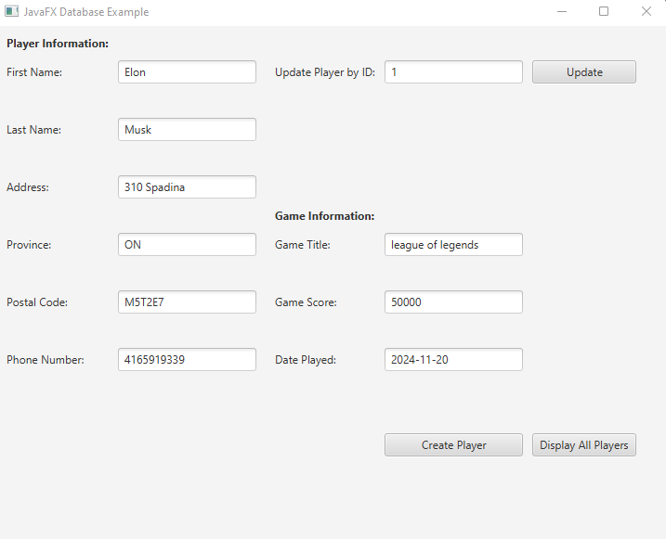

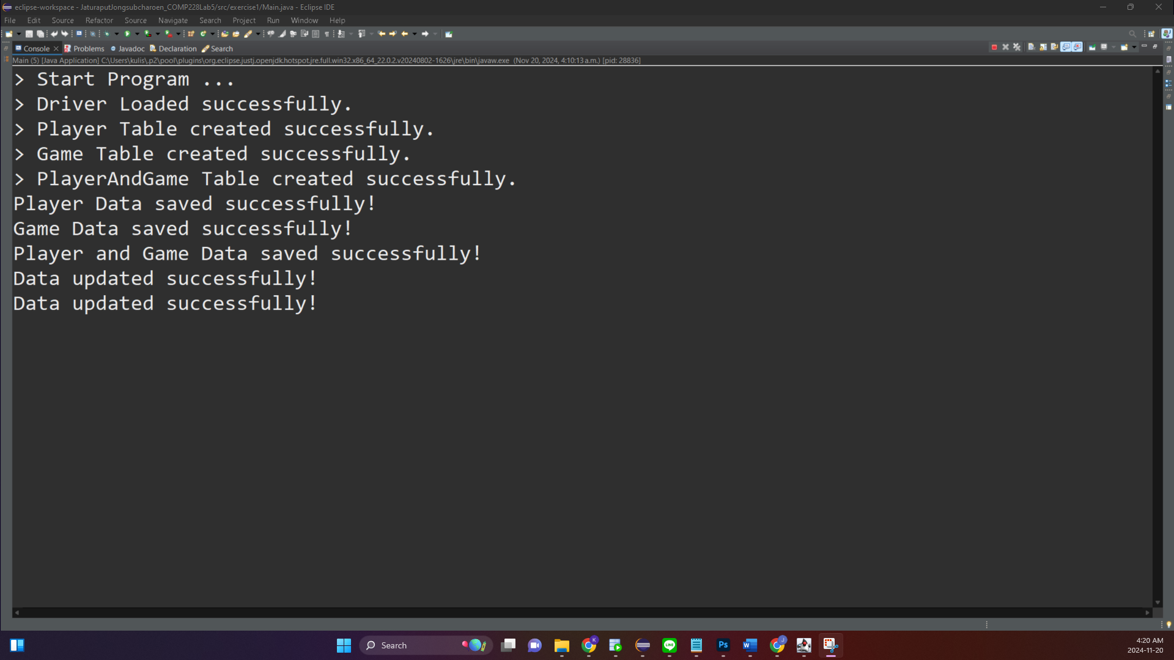



Example: Invalid Inputs
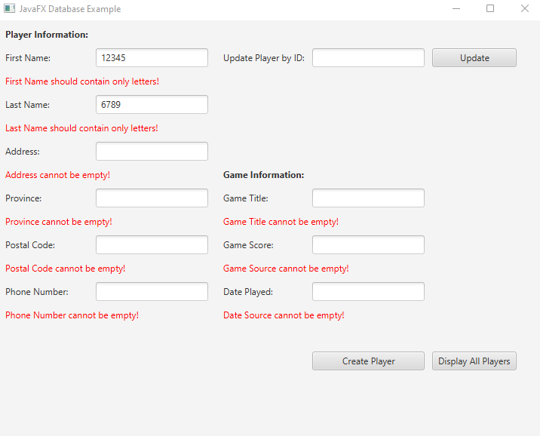

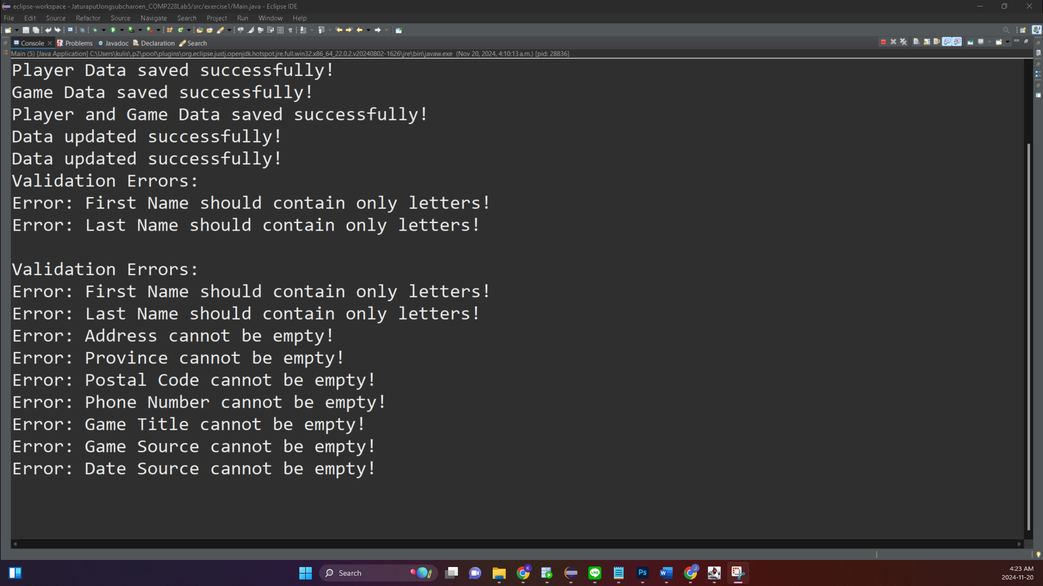

Solution of Exercise 1: Model output from Oracle SQL Developer
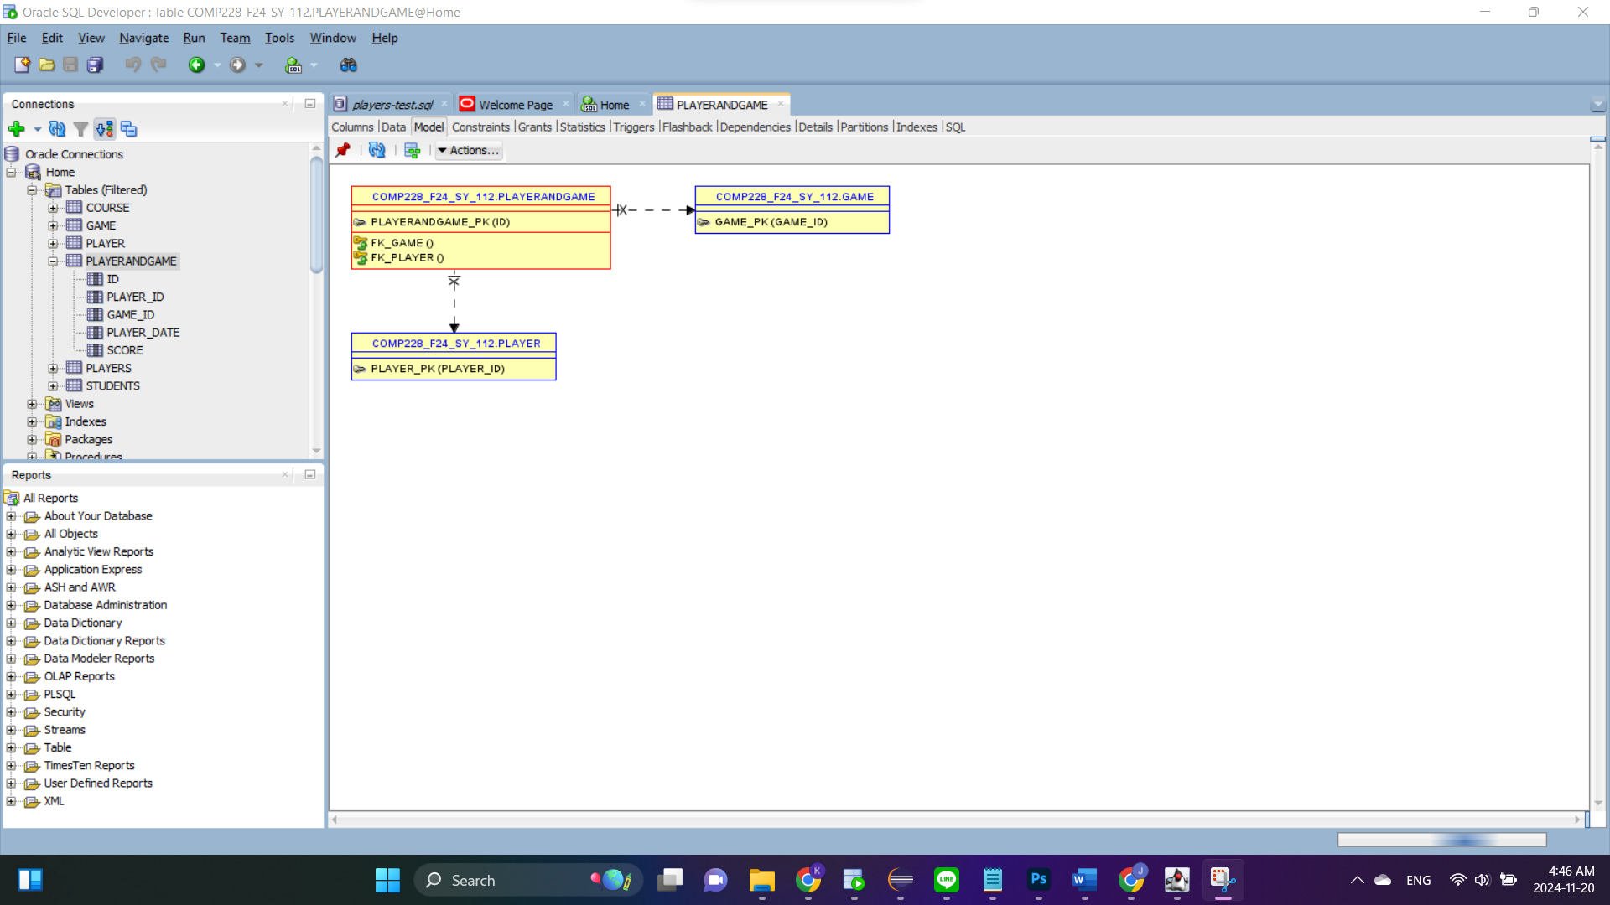

Solution: Code
- Insert game and player information into the database.
In sert Game in information into the database.
private void createGameDatabase() {
try (Connection conn = DriverManager.getConnection(DB_URL, DB_USER, DB_PASSWORD)) {
if (conn != null) {
String createTableSQL = """
CREATE TABLE Game (
game_id NUMBER GENERATED ALWAYS AS IDENTITY PRIMARY KEY,
game_title VARCHAR2(20) NOT NULL
)
""";
conn.createStatement().execute(createTableSQL);
System.out.println("> Game Table created successfully.");
}
} catch (SQLException e) {
System.out.println("> Game Table might already exist.");
}
}
private void saveToGameDatabase(String gameTitle) {
String insertSQL = "INSERT INTO Game (game_title) VALUES (?)";
try (Connection conn = DriverManager.getConnection(DB_URL, DB_USER, DB_PASSWORD);
PreparedStatement pstmt = conn.prepareStatement(insertSQL)) {
pstmt.setString(1, gameTitle);
pstmt.executeUpdate();
System.out.println("Game Data saved successfully!");
} catch (SQLException e) {
e.printStackTrace();
}
}

Insert Player in information into the database.
private void createPlayerDatabase() {
try (Connection conn = DriverManager.getConnection(DB_URL, DB_USER, DB_PASSWORD)) {
if (conn != null) {
String createTableSQL = """
CREATE TABLE Player (
player_id NUMBER GENERATED ALWAYS AS IDENTITY PRIMARY KEY,
first_name VARCHAR2(255) NOT NULL,
last_name VARCHAR2(255) NOT NULL,
address VARCHAR2(255) NOT NULL,
province VARCHAR2(2) NOT NULL,
postal_code VARCHAR2(6) NOT NULL,
phone_number NUMBER(10) NOT NULL
)
""";
conn.createStatement().execute(createTableSQL);
System.out.println("> Player Table created successfully.");
}
} catch (SQLException e) {
System.out.println("> Player Table might already exist.");
}
}
private void saveToPlayerDatabase(String firstName, String lastName, String address, String postalCode, String province, String phoneNumber) {
String insertSQL = "INSERT INTO Player (first_name, last_name, address, province, postal_code, phone_number) VALUES (?, ?, ?, ?, ?, ?)";
try (Connection conn = DriverManager.getConnection(DB_URL, DB_USER, DB_PASSWORD);
PreparedStatement pstmt = conn.prepareStatement(insertSQL)) {
pstmt.setString(1, firstName);
pstmt.setString(2, lastName);
pstmt.setString(3, address);
pstmt.setString(4, province);
pstmt.setString(5, postalCode);
pstmt.setString(6, phoneNumber); // Use String for phone number
pstmt.executeUpdate();
System.out.println("Player Data saved successfully!");
} catch (SQLException e) {
e.printStackTrace();
}
}

- Update the existing player information.
// Update database
try (Connection conn = DriverManager.getConnection(DB_URL, DB_USER, DB_PASSWORD)) {
// Update Player table
String updatePlayerSQL = """
UPDATE Player
SET first_name = ?, last_name = ?, address = ?, province = ?, postal_code = ?, phone_number = ?
WHERE player_id = ?
""";
try (PreparedStatement pstmt = conn.prepareStatement(updatePlayerSQL)) {
pstmt.setString(1, firstName);
pstmt.setString(2, lastName);
pstmt.setString(3, address);
pstmt.setString(4, province);
pstmt.setString(5, postalCode);
pstmt.setString(6, phoneNumber);
pstmt.setInt(7, playerId);
pstmt.executeUpdate();
}
// Update Game table
String updateGameSQL = """
UPDATE Game
SET game_title = ?
WHERE game_id = (
SELECT game_id FROM PlayerAndGame WHERE player_id = ?
)
""";
try (PreparedStatement pstmt = conn.prepareStatement(updateGameSQL)) {
pstmt.setString(1, gameTitle);
pstmt.setInt(2, playerId);
pstmt.executeUpdate();
}
// Update PlayerAndGame table
String updatePlayerGameSQL = """
UPDATE PlayerAndGame
SET player_date = ?, score = ?
WHERE player_id = ?
""";
try (PreparedStatement pstmt = conn.prepareStatement(updatePlayerGameSQL)) {
pstmt.setDate(1, datePlayed);
pstmt.setInt(2, gameScore);
pstmt.setInt(3, playerId);
pstmt.executeUpdate();
}
System.out.println("Data updated successfully!");
//System.out.println("Player and Game data updated successfully!");
} catch (SQLException ex) {
System.out.println("Error updating data in the database!");
ex.printStackTrace();
}

- Display reports with player and played games information. You may use a JTable or other components to display the reports. Allow the user to select player_id.
displayAllPlayersButton.setOnAction(e -> {
String fetchSQL = """
SELECT p.player_id AS ID,
p.first_name || ' ' || p.last_name AS NAME,
p.address AS ADDRESS,
p.postal_code AS POSTAL_CODE,
p.province AS PROVINCE,
p.phone_number AS PHONE_NUMBER,
g.game_title AS GAME_TITLE,
pg.score AS SCORE,
pg.player_date AS DATE_PLAYED
FROM Player p
JOIN PlayerAndGame pg ON p.player_id = pg.player_id
JOIN Game g ON pg.game_id = g.game_id
""";
try (Connection conn = DriverManager.getConnection(DB_URL, DB_USER, DB_PASSWORD);
PreparedStatement pstmt = conn.prepareStatement(fetchSQL);
ResultSet rs = pstmt.executeQuery()) {
ObservableList<PlayerGameInfo> data = FXCollections.observableArrayList();
while (rs.next()) {
data.add(new PlayerGameInfo(
rs.getInt("ID"),
rs.getString("NAME"),
rs.getString("ADDRESS"),
rs.getString("POSTAL_CODE"),
rs.getString("PROVINCE"),
rs.getString("PHONE_NUMBER"),
rs.getString("GAME_TITLE"),
rs.getInt("SCORE"),
rs.getDate("DATE_PLAYED").toString()
));
}
// Create TableView
TableView<PlayerGameInfo> tableView = new TableView<>();
tableView.setItems(data);
// Define Table Columns
TableColumn<PlayerGameInfo, Integer> idCol = new TableColumn<>("ID");
idCol.setCellValueFactory(new PropertyValueFactory<>("id"));
TableColumn<PlayerGameInfo, String> nameCol = new TableColumn<>("NAME");
nameCol.setCellValueFactory(new PropertyValueFactory<>("name"));
TableColumn<PlayerGameInfo, String> addressCol = new TableColumn<>("ADDRESS");
addressCol.setCellValueFactory(new PropertyValueFactory<>("address"));
TableColumn<PlayerGameInfo, String> postalCodeCol = new TableColumn<>("POSTAL CODE");
postalCodeCol.setCellValueFactory(new PropertyValueFactory<>("postalCode"));
TableColumn<PlayerGameInfo, String> provinceCol = new TableColumn<>("PROVINCE");
provinceCol.setCellValueFactory(new PropertyValueFactory<>("province"));
TableColumn<PlayerGameInfo, String> phoneNumberCol = new TableColumn<>("PHONE NUMBER");
phoneNumberCol.setCellValueFactory(new PropertyValueFactory<>("phoneNumber"));
TableColumn<PlayerGameInfo, String> gameTitleCol = new TableColumn<>("GAME TITLE");
gameTitleCol.setCellValueFactory(new PropertyValueFactory<>("gameTitle"));
TableColumn<PlayerGameInfo, Integer> scoreCol = new TableColumn<>("SCORE");
scoreCol.setCellValueFactory(new PropertyValueFactory<>("score"));
TableColumn<PlayerGameInfo, String> datePlayedCol = new TableColumn<>("DATE PLAYED");
datePlayedCol.setCellValueFactory(new PropertyValueFactory<>("datePlayed"));
// Add Columns to TableView
tableView.getColumns().addAll(idCol, nameCol, addressCol, postalCodeCol, provinceCol, phoneNumberCol, gameTitleCol, scoreCol, datePlayedCol);
// Display TableView in a new Scene
Scene tableScene = new Scene(new VBox(tableView), 800, 420);
Stage tableStage = new Stage();
tableStage.setScene(tableScene);
tableStage.setTitle("All Players and Games");
tableStage.show();
} catch (SQLException ex) {
System.out.println("Error fetching data: " + ex.getMessage());
ex.printStackTrace();
}
});

Main class

package exercise1;
//------------------------------------------
import javafx.application.Application;
//------------------------------------------
public class Main extends Application {
private static final String DB_URL = "jdbc:oracle:thin:@199.212.26.208:1521:SQLD";
private static final String DB_USER = "COMP228_F24_sy_112";
private static final String DB_PASSWORD = "password";
@SuppressWarnings("unchecked")
@Override
public void start(Stage primaryStage) {
try {
System.out.println("> Start Program ...");
Class.forName("oracle.jdbc.driver.OracleDriver");
System.out.println("> Driver Loaded successfully.");
} catch (Exception e) {
e.printStackTrace();
}
// GridPane for the form
GridPane grid = new GridPane();
grid.setPadding(new Insets(10));
grid.setHgap(10);
grid.setVgap(10);
// UI Components
//---------------------------------------------------------
Label lblPlayerInfo = new Label("Player Information:");
lblPlayerInfo.setStyle("-fx-font-weight: bold;");

Label firstNameLabel = new Label("First Name:");
TextField firstNameField = new TextField();

Label lastNameLabel = new Label("Last Name:");
TextField lastNameField = new TextField();
Label addressLabel = new Label("Address:");
TextField addressField = new TextField();

Label provinceLabel = new Label("Province:");
TextField provinceField = new TextField();

Label postalCodeLabel = new Label("Postal Code:");
TextField postalCodeField = new TextField();

Label phoneNumberLabel = new Label("Phone Number:");
TextField phoneNumberField = new TextField();

//---------------------------------------------------------
Label updatePlayerByIdLabel = new Label("Update Player by ID:");
TextField updatePlayerByIdField = new TextField();
Button updateButton = new Button("Update");
updateButton.setMaxWidth(Double.MAX_VALUE);

Label lblGameInfo = new Label("Game Information:");
lblGameInfo.setStyle("-fx-font-weight: bold;");

Label gameTitleLabel = new Label("Game Title:");
TextField gameTitleField = new TextField();

Label gameScoreLabel = new Label("Game Score:");
TextField gameScoreField = new TextField();

Label DatePlayedLabel = new Label("Date Played:");
TextField DatePlayedField = new TextField();

//---------------------------------------------------------
Button createPlayerButton = new Button("Create Player");
createPlayerButton.setMaxWidth(Double.MAX_VALUE);
Button displayAllPlayersButton = new Button("Display All Players");

//---------------------------------------------------------
grid.add(lblPlayerInfo, 0, 0);

grid.add(firstNameLabel, 0, 1);
grid.add(firstNameField, 1, 1);
grid.add(lastNameLabel, 0, 3);
grid.add(lastNameField, 1, 3);
grid.add(addressLabel, 0, 5);
grid.add(addressField, 1, 5);
grid.add(provinceLabel, 0, 7);
grid.add(provinceField, 1, 7);
grid.add(postalCodeLabel, 0, 9);
grid.add(postalCodeField, 1, 9);
grid.add(phoneNumberLabel, 0, 11);
grid.add(phoneNumberField, 1, 11);
/*---------------------------------------*/
grid.add(updatePlayerByIdLabel, 3, 1);
grid.add(updatePlayerByIdField, 4, 1);
grid.add(updateButton, 5, 1);

grid.add(lblGameInfo, 3, 6);

grid.add(gameTitleLabel, 3, 7);
grid.add(gameTitleField, 4, 7);
grid.add(gameScoreLabel, 3, 9);
grid.add(gameScoreField, 4, 9);
grid.add(DatePlayedLabel, 3, 11);
grid.add(DatePlayedField, 4, 11);

//-------------------------------------------
grid.add(createPlayerButton, 4, 16);
grid.add(displayAllPlayersButton, 5, 16);
//-------------------------------------------

// Create error labels for each field
Label firstNameErrorLabel = new Label();
firstNameErrorLabel.setStyle("-fx-text-fill: red;");
Label lastNameErrorLabel = new Label();
lastNameErrorLabel.setStyle("-fx-text-fill: red;");
Label addressErrorLabel = new Label();
addressErrorLabel.setStyle("-fx-text-fill: red;");
Label postalCodeErrorLabel = new Label();
postalCodeErrorLabel.setStyle("-fx-text-fill: red;");
Label provinceErrorLabel = new Label();
provinceErrorLabel.setStyle("-fx-text-fill: red;");
Label phoneNumberErrorLabel = new Label();
phoneNumberErrorLabel.setStyle("-fx-text-fill: red;");

Label updatePlayerByIdErrorLabel = new Label();
updatePlayerByIdErrorLabel.setStyle("-fx-text-fill: red;");
Label gameTitleErrorLabel = new Label();
gameTitleErrorLabel.setStyle("-fx-text-fill: red;");
Label gameScoreErrorLabel = new Label();
gameScoreErrorLabel.setStyle("-fx-text-fill: red;");
Label dateSourceErrorLabel = new Label();
dateSourceErrorLabel.setStyle("-fx-text-fill: red;");

// Add error labels to the grid
grid.add(firstNameErrorLabel, 0, 2, 2, 1); // Adjacent to First Name field
grid.add(lastNameErrorLabel, 0, 4, 2, 1); // Adjacent to Last Name field
grid.add(addressErrorLabel, 0, 6, 2, 1); // Adjacent to Address field
grid.add(provinceErrorLabel, 0, 8, 2, 1); // Adjacent to Postal Code field
grid.add(postalCodeErrorLabel, 0, 10, 2, 1); // Adjacent to Province field
grid.add(phoneNumberErrorLabel, 0, 12, 2, 1); // Adjacent to Phone Number field
/*---------------------------------------*/
grid.add(updatePlayerByIdErrorLabel, 3, 2, 2, 1); // Adjacent to Game Title field

grid.add(gameTitleErrorLabel, 3, 8, 2, 1); // Adjacent to Game Title field
grid.add(gameScoreErrorLabel, 3, 10, 2, 1); // Adjacent to Game Source field
grid.add(dateSourceErrorLabel, 3, 12, 2, 1); // Adjacent to Date Source field

//-------------------------------------------
createPlayerButton.setOnAction(e -> {
StringBuilder errorMessages = new StringBuilder(); // To collect all error messages
boolean hasError = false; // Track if there are any errors
// Clear all previous error messages
firstNameErrorLabel.setText("");
lastNameErrorLabel.setText("");
addressErrorLabel.setText("");
provinceErrorLabel.setText("");
postalCodeErrorLabel.setText("");
phoneNumberErrorLabel.setText("");
gameTitleErrorLabel.setText("");
gameScoreErrorLabel.setText("");
dateSourceErrorLabel.setText("");
try {
// Get input values for player
String firstName = firstNameField.getText();
String lastName = lastNameField.getText();
String address = addressField.getText();
String province = provinceField.getText().trim();
String postalCode = postalCodeField.getText().trim();
String phoneNumber = phoneNumberField.getText().trim();
// Validate first name
if (firstName.isEmpty()) {
errorMessages.append("Error: First Name cannot be empty!\n");
firstNameErrorLabel.setText("First Name cannot be empty!");
hasError = true;
} else if (!firstName.matches("[a-zA-Z]+")) {
errorMessages.append("Error: First Name should contain only letters!\n");
firstNameErrorLabel.setText("First Name should contain only letters!");
hasError = true;
}
// Validate last name
if (lastName.isEmpty()) {
errorMessages.append("Error: Last Name cannot be empty!\n");
lastNameErrorLabel.setText("Last Name cannot be empty!");
hasError = true;
} else if (!lastName.matches("[a-zA-Z]+")) {
errorMessages.append("Error: Last Name should contain only letters!\n");
lastNameErrorLabel.setText("Last Name should contain only letters!");
hasError = true;
}
// Validate address
if (address.isEmpty()) {
errorMessages.append("Error: Address cannot be empty!\n");
addressErrorLabel.setText("Address cannot be empty!");
hasError = true;
}

// Validate province
if (province.isEmpty()) {
errorMessages.append("Error: Province cannot be empty!\n");
provinceErrorLabel.setText("Province cannot be empty!");
hasError = true;
} else if (!province.matches("[a-zA-Z]{2}")) {
errorMessages.append("Error: Last Name should contain only letters and be exactly 2 characters long!\n");
provinceErrorLabel.setText("Last Name should contain only letters and be exactly 2 characters long!");
hasError = true;
}
// Validate postal code
if (postalCode.isEmpty()) {
errorMessages.append("Error: Postal Code cannot be empty!\n");
postalCodeErrorLabel.setText("Postal Code cannot be empty!");
hasError = true;
} else if (!postalCode.matches("[a-zA-Z0-9]{6}")) {
errorMessages.append("Error: Postal Code must be exactly 6 characters and contain only letters and digits!\n");
postalCodeErrorLabel.setText("Postal Code must be exactly 6 characters and contain only letters and digits!");
hasError = true;
}
// Validate phone number
if (phoneNumber.isEmpty()) {
errorMessages.append("Error: Phone Number cannot be empty!\n");
phoneNumberErrorLabel.setText("Phone Number cannot be empty!");
hasError = true;
} else if (!phoneNumber.matches("\\d{10}")) { // Regex to ensure exactly 10 digits
errorMessages.append("Error: Phone Number must be exactly 10 digits and contain only numbers!\n");
phoneNumberErrorLabel.setText("Phone Number must be exactly 10 digits and contain only numbers!");
hasError = true;
}

// Get and validate game inputs
String gameTitle = gameTitleField.getText();
if (gameTitle.isEmpty()) {
errorMessages.append("Error: Game Title cannot be empty!\n");
gameTitleErrorLabel.setText("Game Title cannot be empty!");
hasError = true;
}
String gameScoreInput = gameScoreField.getText();
if (gameScoreInput.isEmpty()) {
errorMessages.append("Error: Game Source cannot be empty!\n");
gameScoreErrorLabel.setText("Game Source cannot be empty!");
hasError = true;
} else {
try {
int gameSource = Integer.parseInt(gameScoreInput);
if (gameSource < 0) {
errorMessages.append("Error: Game Source cannot be negative!\n");
gameScoreErrorLabel.setText("Game Source cannot be negative!");
hasError = true;
}
} catch (NumberFormatException ex) {
errorMessages.append("Error: Game Source must contain only digits!\n");
gameScoreErrorLabel.setText("Game Source must contain only digits!");
hasError = true;
}
}
String datePlayedInput = DatePlayedField.getText();
if (datePlayedInput.isEmpty()) {
errorMessages.append("Error: Date Played cannot be empty!\n");
dateSourceErrorLabel.setText("Date Played cannot be empty!");
hasError = true;
} else {
try {
Date datePlayed = Date.valueOf(datePlayedInput); // Convert to SQL Date
Date today = new Date(System.currentTimeMillis()); // Get today's date
if (datePlayed.after(today)) {
errorMessages.append("Error: Date Played cannot be in the future!\n");
dateSourceErrorLabel.setText("Date Played cannot be in the future!");
hasError = true;
}
} catch (IllegalArgumentException ex) {
errorMessages.append("Error: Date Played must be in YYYY-MM-DD format!\n");
dateSourceErrorLabel.setText("Date Played must be in YYYY-MM-DD format!");
hasError = true;
}
}
// If there are errors, display messages and stop execution
if (hasError) {
System.out.println("Validation Errors:\n" + errorMessages.toString());
return;
} else {
updatePlayerByIdErrorLabel.setText("");
}

// Save data to database
saveToPlayerDatabase(firstName, lastName, address, postalCode, province, phoneNumber);
saveToGameDatabase(gameTitle);
int playerId = fetchLastInsertedPlayerId(); // Fetch the most recent player ID
int gameId = fetchLastInsertedGameId(); // Fetch the most recent game ID
saveToPlayerAndGameDatabase(playerId, gameId, Date.valueOf(datePlayedInput), Integer.parseInt(gameScoreInput));
//System.out.println("Player and game data saved successfully!");
} catch (Exception ex) {
System.out.println("Error: An unexpected error occurred!");
ex.printStackTrace();
}
});

//-------------------------------------------
updateButton.setOnAction(e -> {
StringBuilder errorMessages = new StringBuilder(); // Collect error messages
boolean hasError = false;

// Clear previous error messages
firstNameErrorLabel.setText("");
lastNameErrorLabel.setText("");
addressErrorLabel.setText("");
provinceErrorLabel.setText("");
postalCodeErrorLabel.setText("");
phoneNumberErrorLabel.setText("");
gameTitleErrorLabel.setText("");
dateSourceErrorLabel.setText("");
gameScoreErrorLabel.setText("");
try {
// Collect inputs
String idInput = updatePlayerByIdField.getText().trim();
String firstName = firstNameField.getText().trim();
String lastName = lastNameField.getText().trim();
String address = addressField.getText().trim();
String province = provinceField.getText().trim();
String postalCode = postalCodeField.getText().trim();
String phoneNumber = phoneNumberField.getText().trim();
String gameTitle = gameTitleField.getText().trim();
String datePlayedInput = DatePlayedField.getText().trim();
String gameScoreInput = gameScoreField.getText().trim();
// Validate inputs
if (idInput.isEmpty()) {
errorMessages.append("Error: ID cannot be empty!\n");
updatePlayerByIdErrorLabel.setText("Error: ID cannot be empty!");
hasError = true; // Set error flag
} else if (!idInput.matches("\\d+")) {
errorMessages.append("Error: ID must be a valid number!\n");
updatePlayerByIdErrorLabel.setText("Error: ID must be a valid number!");
hasError = true; // Set error flag
}
if (firstName.isEmpty() || !firstName.matches("[a-zA-Z]+")) {
errorMessages.append("Error: First Name should contain only letters!\n");
firstNameErrorLabel.setText("First Name should contain only letters!");
hasError = true;
}
if (lastName.isEmpty() || !lastName.matches("[a-zA-Z]+")) {
errorMessages.append("Error: Last Name should contain only letters!\n");
lastNameErrorLabel.setText("Last Name should contain only letters!");
hasError = true;
}
if (address.isEmpty()) {
errorMessages.append("Error: Address cannot be empty!\n");
addressErrorLabel.setText("Address cannot be empty!");
hasError = true;
}
if (province.isEmpty() || !province.matches("[a-zA-Z]{2}")) {
errorMessages.append("Error: Province must be 2 letters!\n");
provinceErrorLabel.setText("Province must be 2 letters!");
hasError = true;
}
if (postalCode.isEmpty() || !postalCode.matches("[a-zA-Z0-9]{6}")) {
errorMessages.append("Error: Postal Code must be 6 alphanumeric characters!\n");
postalCodeErrorLabel.setText("Postal Code must be 6 alphanumeric characters!");
hasError = true;
}
if (phoneNumber.isEmpty() || !phoneNumber.matches("\\d{10}")) {
errorMessages.append("Error: Phone Number must be 10 digits!\n");
phoneNumberErrorLabel.setText("Phone Number must be 10 digits!");
hasError = true;
}
if (gameTitle.isEmpty()) {
errorMessages.append("Error: Game Title cannot be empty!\n");
gameTitleErrorLabel.setText("Game Title cannot be empty!");
hasError = true;
}
if (datePlayedInput.isEmpty()) {
errorMessages.append("Error: Date Played cannot be empty!\n");
dateSourceErrorLabel.setText("Date Played cannot be empty!");
hasError = true;
} else {
try {
Date datePlayed = Date.valueOf(datePlayedInput); // Convert to SQL Date
Date today = new Date(System.currentTimeMillis()); // Get today's date
if (datePlayed.after(today)) {
errorMessages.append("Error: Date Played cannot be in the future!\n");
dateSourceErrorLabel.setText("Date Played cannot be in the future!");
hasError = true;
}
} catch (IllegalArgumentException ex) {
errorMessages.append("Error: Date Played must be in YYYY-MM-DD format!\n");
dateSourceErrorLabel.setText("Date Played must be in YYYY-MM-DD format!");
hasError = true;
}
}

if (gameScoreInput.isEmpty()) {
errorMessages.append("Error: Game Source cannot be empty!\n");
gameScoreErrorLabel.setText("Game Source cannot be empty!");
hasError = true;
} else {
try {
int gameSource = Integer.parseInt(gameScoreInput);
if (gameSource < 0) {
errorMessages.append("Error: Game Source cannot be negative!\n");
gameScoreErrorLabel.setText("Game Source cannot be negative!");
hasError = true;
}
} catch (NumberFormatException ex) {
errorMessages.append("Error: Game Source must contain only digits!\n");
gameScoreErrorLabel.setText("Game Source must contain only digits!");
hasError = true;
}
}
if (hasError) {
System.out.println("Validation Errors:\n" + errorMessages.toString());
return;
} else {
updatePlayerByIdErrorLabel.setText("");
}
int playerId = Integer.parseInt(idInput);
int gameScore = Integer.parseInt(gameScoreInput);
Date datePlayed = Date.valueOf(datePlayedInput);

// Check if player_id exists
boolean playerExists = false;
try (Connection conn = DriverManager.getConnection(DB_URL, DB_USER, DB_PASSWORD)) {
String checkPlayerSQL = "SELECT COUNT(*) AS count FROM Player WHERE player_id = ?";
try (PreparedStatement checkStmt = conn.prepareStatement(checkPlayerSQL)) {
checkStmt.setInt(1, playerId);
try (ResultSet rs = checkStmt.executeQuery()) {
if (rs.next() && rs.getInt("count") > 0) {
playerExists = true;
}
}
}
} catch (SQLException ex) {
System.out.println("Error checking player existence in the database!");
ex.printStackTrace();
return;
}
if (!playerExists) {
updatePlayerByIdErrorLabel.setText("Error: Player ID does not exist!");
System.out.println("Error: Player ID does not exist!");
return;
} else {
updatePlayerByIdErrorLabel.setText("Data updated successfully!");
System.out.println("Data updated successfully!");
}
// Update database
try (Connection conn = DriverManager.getConnection(DB_URL, DB_USER, DB_PASSWORD)) {
// Update Player table
String updatePlayerSQL = """
UPDATE Player
SET first_name = ?, last_name = ?, address = ?, province = ?, postal_code = ?, phone_number = ?
WHERE player_id = ?
""";
try (PreparedStatement pstmt = conn.prepareStatement(updatePlayerSQL)) {
pstmt.setString(1, firstName);
pstmt.setString(2, lastName);
pstmt.setString(3, address);
pstmt.setString(4, province);
pstmt.setString(5, postalCode);
pstmt.setString(6, phoneNumber);
pstmt.setInt(7, playerId);
pstmt.executeUpdate();
}
// Update Game table
String updateGameSQL = """
UPDATE Game
SET game_title = ?
WHERE game_id = (
SELECT game_id FROM PlayerAndGame WHERE player_id = ?
)
""";
try (PreparedStatement pstmt = conn.prepareStatement(updateGameSQL)) {
pstmt.setString(1, gameTitle);
pstmt.setInt(2, playerId);
pstmt.executeUpdate();
}
// Update PlayerAndGame table
String updatePlayerGameSQL = """
UPDATE PlayerAndGame
SET player_date = ?, score = ?
WHERE player_id = ?
""";
try (PreparedStatement pstmt = conn.prepareStatement(updatePlayerGameSQL)) {
pstmt.setDate(1, datePlayed);
pstmt.setInt(2, gameScore);
pstmt.setInt(3, playerId);
pstmt.executeUpdate();
}

} catch (SQLException ex) {
System.out.println("Error updating data in the database!");
ex.printStackTrace();
}
} catch (Exception ex) {
System.out.println("Error processing update!");
ex.printStackTrace();
}
});
//-------------------------------------------------------------------------------------------------------------------
displayAllPlayersButton.setOnAction(e -> {
String fetchSQL = """
SELECT p.player_id AS ID,
p.first_name || ' ' || p.last_name AS NAME,
p.address AS ADDRESS,
p.postal_code AS POSTAL_CODE,
p.province AS PROVINCE,
p.phone_number AS PHONE_NUMBER,
g.game_title AS GAME_TITLE,
pg.score AS SCORE,
pg.player_date AS DATE_PLAYED
FROM Player p
JOIN PlayerAndGame pg ON p.player_id = pg.player_id
JOIN Game g ON pg.game_id = g.game_id
WHERE pg.player_date = (
SELECT MAX(player_date)
FROM PlayerAndGame
WHERE player_id = p.player_id
)
""";
try (Connection conn = DriverManager.getConnection(DB_URL, DB_USER, DB_PASSWORD);
PreparedStatement pstmt = conn.prepareStatement(fetchSQL);
ResultSet rs = pstmt.executeQuery()) {

System.out.println("Database connection successful. Fetching data...");

ObservableList<PlayerGameInfo> data = FXCollections.observableArrayList();

while (rs.next()) {
data.add(new PlayerGameInfo(
rs.getInt("ID"),
rs.getString("NAME"),
rs.getString("ADDRESS"),
rs.getString("POSTAL_CODE"),
rs.getString("PROVINCE"),
rs.getString("PHONE_NUMBER"),
rs.getString("GAME_TITLE"),
rs.getInt("SCORE"),
rs.getDate("DATE_PLAYED").toString()
));
}
// Create TableView
TableView<PlayerGameInfo> tableView = new TableView<>();
tableView.setItems(data);
// Define Table Columns
TableColumn<PlayerGameInfo, Integer> idCol = new TableColumn<>("ID");
idCol.setCellValueFactory(new PropertyValueFactory<>("id"));
TableColumn<PlayerGameInfo, String> nameCol = new TableColumn<>("NAME");
nameCol.setCellValueFactory(new PropertyValueFactory<>("name"));
TableColumn<PlayerGameInfo, String> addressCol = new TableColumn<>("ADDRESS");
addressCol.setCellValueFactory(new PropertyValueFactory<>("address"));
TableColumn<PlayerGameInfo, String> postalCodeCol = new TableColumn<>("POSTAL CODE");
postalCodeCol.setCellValueFactory(new PropertyValueFactory<>("postalCode"));
TableColumn<PlayerGameInfo, String> provinceCol = new TableColumn<>("PROVINCE");
provinceCol.setCellValueFactory(new PropertyValueFactory<>("province"));
TableColumn<PlayerGameInfo, String> phoneNumberCol = new TableColumn<>("PHONE NUMBER");
phoneNumberCol.setCellValueFactory(new PropertyValueFactory<>("phoneNumber"));
TableColumn<PlayerGameInfo, String> gameTitleCol = new TableColumn<>("GAME TITLE");
gameTitleCol.setCellValueFactory(new PropertyValueFactory<>("gameTitle"));
TableColumn<PlayerGameInfo, Integer> scoreCol = new TableColumn<>("SCORE");
scoreCol.setCellValueFactory(new PropertyValueFactory<>("score"));
TableColumn<PlayerGameInfo, String> datePlayedCol = new TableColumn<>("DATE PLAYED");
datePlayedCol.setCellValueFactory(new PropertyValueFactory<>("datePlayed"));
// Add Columns to TableView
tableView.getColumns().addAll(idCol, nameCol, addressCol, postalCodeCol, provinceCol, phoneNumberCol, gameTitleCol, scoreCol, datePlayedCol);
/*------------------------------------------------------------------------------------------*/
// Add a row click listener
tableView.setRowFactory(tv -> {
TableRow<PlayerGameInfo> row = new TableRow<>();
row.setOnMouseClicked(event -> {
if (event.getClickCount() == 2 && !row.isEmpty()) {
PlayerGameInfo selectedPlayer = row.getItem();
// Confirm deletion
Alert alert = new Alert(Alert.AlertType.CONFIRMATION);
alert.setTitle("Delete Confirmation");
alert.setHeaderText(null);
alert.setContentText("Are you sure you want to delete Player ID: " + selectedPlayer.getId() + "?");
alert.showAndWait().ifPresent(response -> {
if (response == ButtonType.OK) {
try (Connection deleteConn = DriverManager.getConnection(DB_URL, DB_USER, DB_PASSWORD)) {
// Delete from Player table
String deletePlayerSQL = "DELETE FROM Player WHERE player_id = ?";
try (PreparedStatement deleteStmt = deleteConn.prepareStatement(deletePlayerSQL)) {
deleteStmt.setInt(1, selectedPlayer.getId());
deleteStmt.executeUpdate();
System.out.println("Player ID " + selectedPlayer.getId() + " deleted successfully.");
}
// Clean up orphaned games
String deleteUnusedGamesSQL = """
DELETE FROM Game
WHERE game_id NOT IN (SELECT game_id FROM PlayerAndGame)
""";
try (PreparedStatement deleteGamesStmt = deleteConn.prepareStatement(deleteUnusedGamesSQL)) {
int rowsAffected = deleteGamesStmt.executeUpdate();
System.out.println(rowsAffected + " unused games deleted.");
}
// Remove from ObservableList
data.remove(selectedPlayer);
} catch (SQLException ex) {
System.out.println("Error deleting player or cleaning up games: " + ex.getMessage());
ex.printStackTrace();
}
}
});
}
});
return row;
});

/*------------------------------------------------------------------------------------------*/
// Display TableView in a new Scene
Scene tableScene = new Scene(new VBox(tableView), 900, 420);
Stage tableStage = new Stage();
tableStage.setScene(tableScene);
tableStage.setTitle("All Players and Games");
tableStage.show();
} catch (SQLException ex) {
System.out.println("Error fetching data: " + ex.getMessage());
ex.printStackTrace();
}
});
/*--------------------------------------------------------------------------------------------*/
// Scene and Stage
Scene scene = new Scene(grid, 720, 550);
primaryStage.setTitle("JavaFX Database Example");
primaryStage.setScene(scene);
primaryStage.show();
// Initialize the database
createPlayerDatabase();
createGameDatabase();
createPlayerAndGemeDatabase();
}

/*--------------------------------------------------------------------------------------------*/
private void createPlayerDatabase() {
try (Connection conn = DriverManager.getConnection(DB_URL, DB_USER, DB_PASSWORD)) {
if (conn != null) {
String createTableSQL = """
CREATE TABLE Player (
player_id NUMBER GENERATED ALWAYS AS IDENTITY PRIMARY KEY,
first_name VARCHAR2(255) NOT NULL,
last_name VARCHAR2(255) NOT NULL,
address VARCHAR2(255) NOT NULL,
province VARCHAR2(2) NOT NULL,
postal_code VARCHAR2(6) NOT NULL,
phone_number NUMBER(10) NOT NULL
)
""";
conn.createStatement().execute(createTableSQL);
System.out.println("> Player Table created successfully.");
}
} catch (SQLException e) {
System.out.println("> Player Table might already exist.");
}
}
private void saveToPlayerDatabase(String firstName, String lastName, String address, String postalCode, String province, String phoneNumber) {
String insertSQL = "INSERT INTO Player (first_name, last_name, address, province, postal_code, phone_number) VALUES (?, ?, ?, ?, ?, ?)";
try (Connection conn = DriverManager.getConnection(DB_URL, DB_USER, DB_PASSWORD);
PreparedStatement pstmt = conn.prepareStatement(insertSQL)) {
pstmt.setString(1, firstName);
pstmt.setString(2, lastName);
pstmt.setString(3, address);
pstmt.setString(4, province);
pstmt.setString(5, postalCode);
pstmt.setString(6, phoneNumber); // Use String for phone number
pstmt.executeUpdate();
System.out.println("Player Data saved successfully!");
} catch (SQLException e) {
e.printStackTrace();
}
}
/*--------------------------------------------------------------------------------------------*/
private void createGameDatabase() {
try (Connection conn = DriverManager.getConnection(DB_URL, DB_USER, DB_PASSWORD)) {
if (conn != null) {
String createTableSQL = """
CREATE TABLE Game (
game_id NUMBER GENERATED ALWAYS AS IDENTITY PRIMARY KEY,
game_title VARCHAR2(20) NOT NULL
)
""";
conn.createStatement().execute(createTableSQL);
System.out.println("> Game Table created successfully.");
}
} catch (SQLException e) {
System.out.println("> Game Table might already exist.");
}
}
private void saveToGameDatabase(String gameTitle) {
String insertSQL = "INSERT INTO Game (game_title) VALUES (?)";
try (Connection conn = DriverManager.getConnection(DB_URL, DB_USER, DB_PASSWORD);
PreparedStatement pstmt = conn.prepareStatement(insertSQL)) {
pstmt.setString(1, gameTitle);
pstmt.executeUpdate();
System.out.println("Game Data saved successfully!");
} catch (SQLException e) {
e.printStackTrace();
}
}
/*--------------------------------------------------------------------------------------------*/
private void createPlayerAndGemeDatabase() {
try (Connection conn = DriverManager.getConnection(DB_URL, DB_USER, DB_PASSWORD)) {
if (conn != null) {
String createTableSQL = """
CREATE TABLE PlayerAndGame (
id NUMBER GENERATED ALWAYS AS IDENTITY PRIMARY KEY,
player_id NUMBER NOT NULL,
game_id NUMBER NOT NULL,
player_date DATE NOT NULL,
score NUMBER NOT NULL,
CONSTRAINT fk_player FOREIGN KEY (player_id) REFERENCES Player(player_id) ON DELETE CASCADE,
CONSTRAINT fk_game FOREIGN KEY (game_id) REFERENCES Game(game_id) ON DELETE CASCADE
)
""";
conn.createStatement().execute(createTableSQL);
System.out.println("> PlayerAndGame Table created successfully.");
}
} catch (SQLException e) {
System.out.println("> PlayerAndGame Table might already exist.");
//e.printStackTrace(); // Print the stack trace for debugging
}
}
private void saveToPlayerAndGameDatabase(int playerId, int gameId, Date playerDate, int score) {
String insertSQL = "INSERT INTO PlayerAndGame (player_id, game_id, player_date, score) VALUES (?, ?, ?, ?)";
try (Connection conn = DriverManager.getConnection(DB_URL, DB_USER, DB_PASSWORD);
PreparedStatement pstmt = conn.prepareStatement(insertSQL)) {
pstmt.setInt(1, playerId);
pstmt.setInt(2, gameId);
pstmt.setDate(3, playerDate);
pstmt.setInt(4, score);
pstmt.executeUpdate();
System.out.println("Player and Game Data saved successfully!");
} catch (SQLException e) {
e.printStackTrace();
}
}
/*--------------------------------------------------------------------------------------------*/
private int fetchLastInsertedPlayerId() {
String query = "SELECT MAX(player_id) AS last_id FROM Player";
try (Connection conn = DriverManager.getConnection(DB_URL, DB_USER, DB_PASSWORD);
PreparedStatement pstmt = conn.prepareStatement(query);
ResultSet rs = pstmt.executeQuery()) {
if (rs.next()) {
return rs.getInt("last_id");
}
} catch (SQLException e) {
e.printStackTrace();
}
return -1; // Return -1 if no ID is found
}
private int fetchLastInsertedGameId() {
String query = "SELECT MAX(game_id) AS last_id FROM Game";
try (Connection conn = DriverManager.getConnection(DB_URL, DB_USER, DB_PASSWORD);
PreparedStatement pstmt = conn.prepareStatement(query);
ResultSet rs = pstmt.executeQuery()) {
if (rs.next()) {
return rs.getInt("last_id");
}
} catch (SQLException e) {
e.printStackTrace();
}
return -1; // Return -1 if no ID is found
}
}

PlayerGameInfo class

package exercise1;
public class PlayerGameInfo {
private int id;
private String name;
private String address;
private String postalCode;
private String province;
private String phoneNumber;
private String gameTitle;
private int score;
private String datePlayed;
public PlayerGameInfo(int id, String name, String address, String postalCode, String province, String phoneNumber, String gameTitle, int score, String datePlayed) {
this.id = id;
this.name = name;
this.address = address;
this.postalCode = postalCode;
this.province = province;
this.phoneNumber = phoneNumber;
this.gameTitle = gameTitle;
this.score = score;
this.datePlayed = datePlayed;
}
// Getters for TableView
public int getId() { return id; }
public String getName() { return name; }
public String getAddress() { return address; }
public String getPostalCode() { return postalCode; }
public String getProvince() { return province; }
public String getPhoneNumber() { return phoneNumber; }
public String getGameTitle() { return gameTitle; }
public int getScore() { return score; }
public String getDatePlayed() { return datePlayed; }
}

