Team Project: Astro Track

Advanced Database Concepts

Jaturaput Jongsubcharoen 301391425

Centennial College

March 30th, 2025

Contents
Problem Domain Description: 3
1. Celestial Objects: 3
2. Events: 3
3. Affiliations: 3
4. Researchers: 3
5. Research Papers: 3
6. Telescopes: 3
7. Missions: 3
8. Observations: 3
9. Mission Observations: 4
10. Habitable Planets: 4
ER Diagram: 4
1. Mind Mapping – ER Diagram: 4
2. VISIO – ER Diagram: 5
3. Oracle SQL Developer – ER Diagram/Rational Model: 5
Screenshots of execution of front end with tables content (using programming units) 6
1. Main page: 6
2. Programming Unit: 6

Problem Domain Description:
This database system is proposed to help astronomical research by storing, analyzing data and managing. Indeed, it provides 10 tables, consisting of 7 entity tables and 3 bridge tables. According to Entity Tables, there are celestial objects, events, affiliations, research papers, researchers, telescopes, and missions. According to Bridge Tables, there are observations, mission observations and habitable planets.

1. Celestial Objects:
- This table is proposed to track various types of celestial objects.
- No foreign keys.

2. Events:
- This table is proposed to capture significant astronomical occurrences.
- No foreign keys.

3. Affiliations:
- This table is proposed to list institutions which conduct space research.
- No foreign keys.

4. Researchers:
- This table is proposed to store researchers’ details.
- It has a foreign key that references the Affiliations table.

5. Research Papers:
- This table is proposed to catalog articles published by researchers.
- It has a foreign key that references the Researchers table.

6. Telescopes:
- This table is proposed to manage observation data collected by telescopes.
- No foreign keys.

7. Missions:
- This table is proposed to manage records of mission in space.
- It has a foreign key that references the Researchers and Affiliations table.

8. Observations:
- This table is proposed to collect the specific observation in space based on Celestial Objects, Researchers, and Telescopes tables.
- It will provide many-to-many relational structures.
- It has foreign keys that reference the Celestial Objects, Researchers, and Telescopes table.

9. Mission Observations:
- This table is proposed to record detailed information about each observation’s role within a mission based on Missions and Observations tables.
- It will provide many-to-many relational structures.
- It has foreign keys that reference the Missions and Observations tables.

10. Habitable Planets:
- This table is proposed to evaluate the habitability potential of planets or exoplanets based on Celestial Objects table, Events, and Research Papers tables.
- It will provide many-to-many relational structures.
- It has foreign keys that reference the Celestial Objects, Events, Research Papers table.

ER Diagram:
The Astro track project has started with Mind Mapping which mentions only the name of table in order to design the connection between the entity and bridge tables. Then we used Microsoft Visio to define details of columns in each table. Once the table structures are confirmed within our team, we start to create all tables on Oracle SQL Developer and provide as rational models diagram.

1. Mind Mapping – ER Diagram:
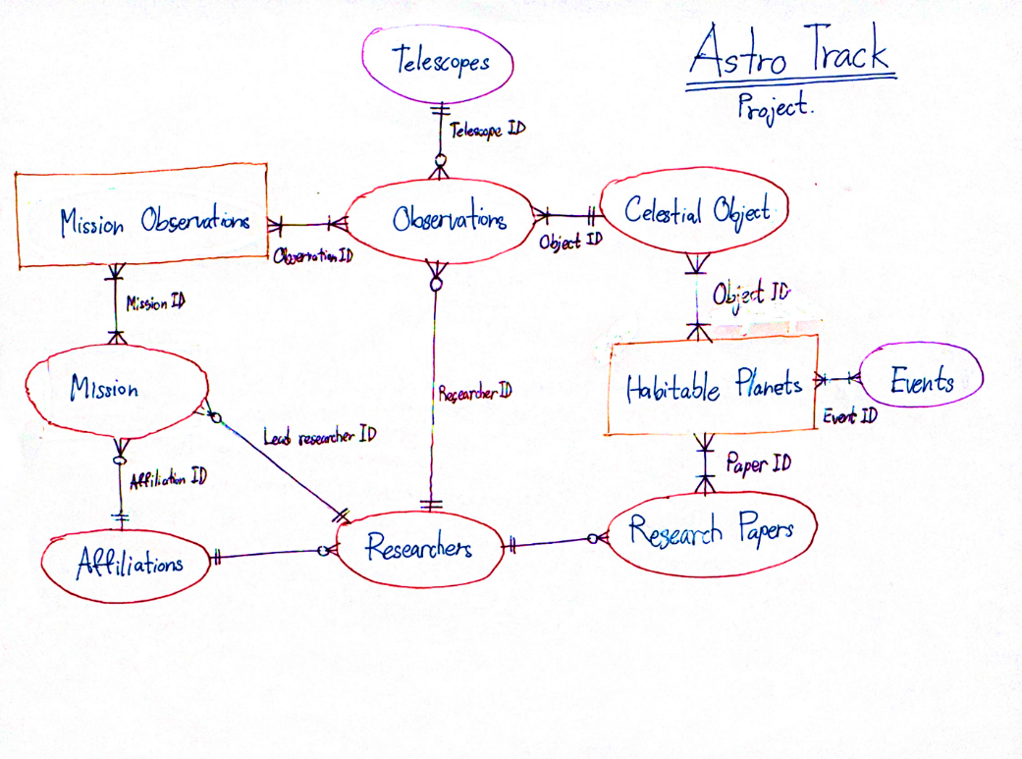

2. VISIO – ER Diagram:
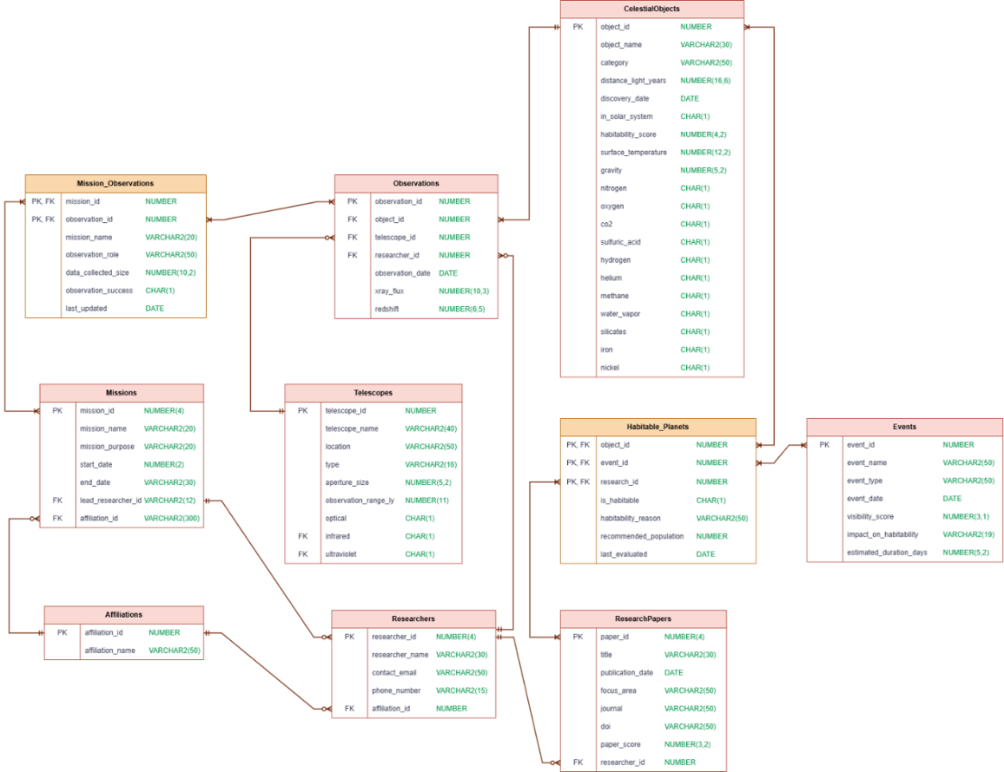

3. Oracle SQL Developer – ER Diagram/Rational Model:
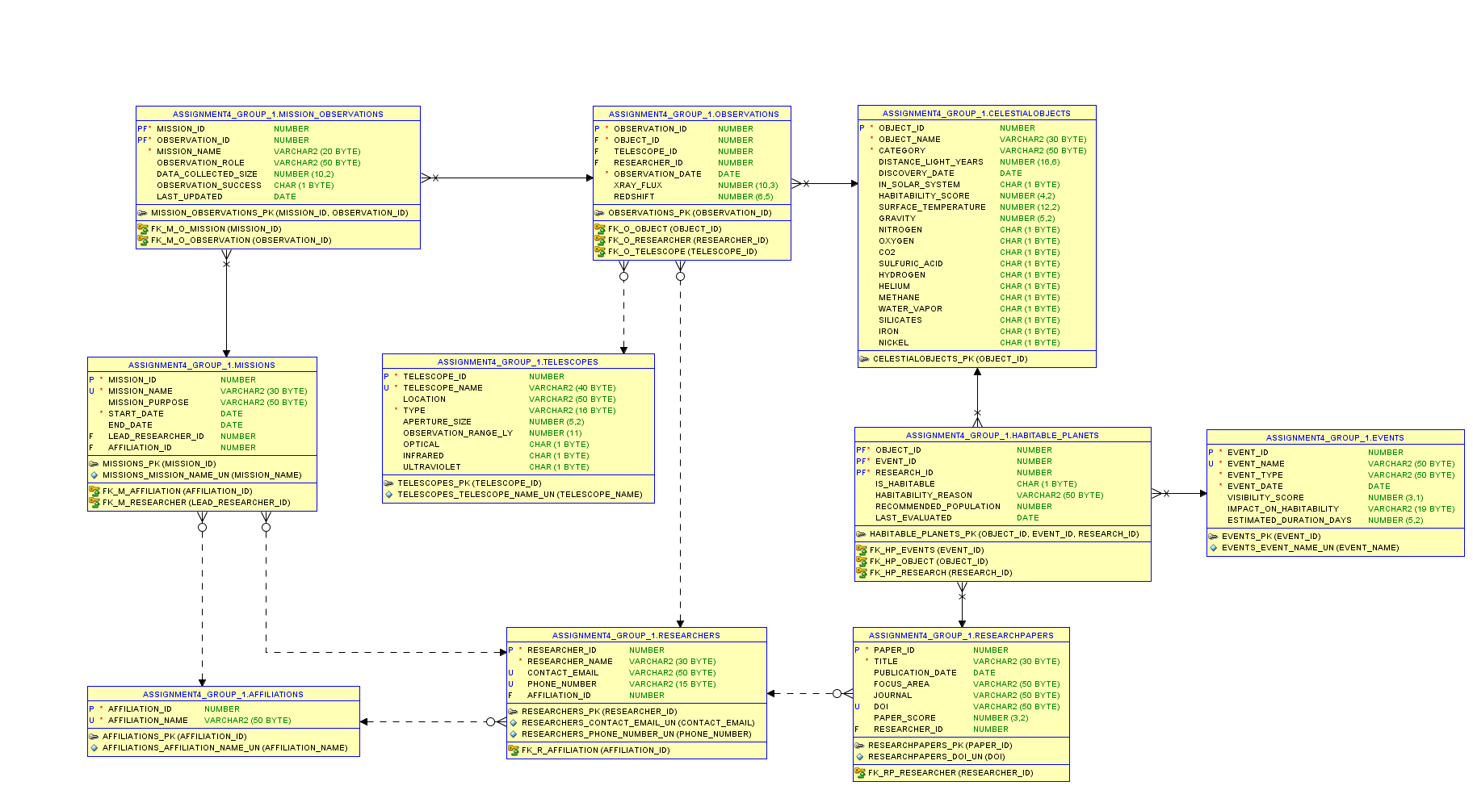

Screenshots of execution of front end with tables content (using programming units)
1. Main page: Astro Track
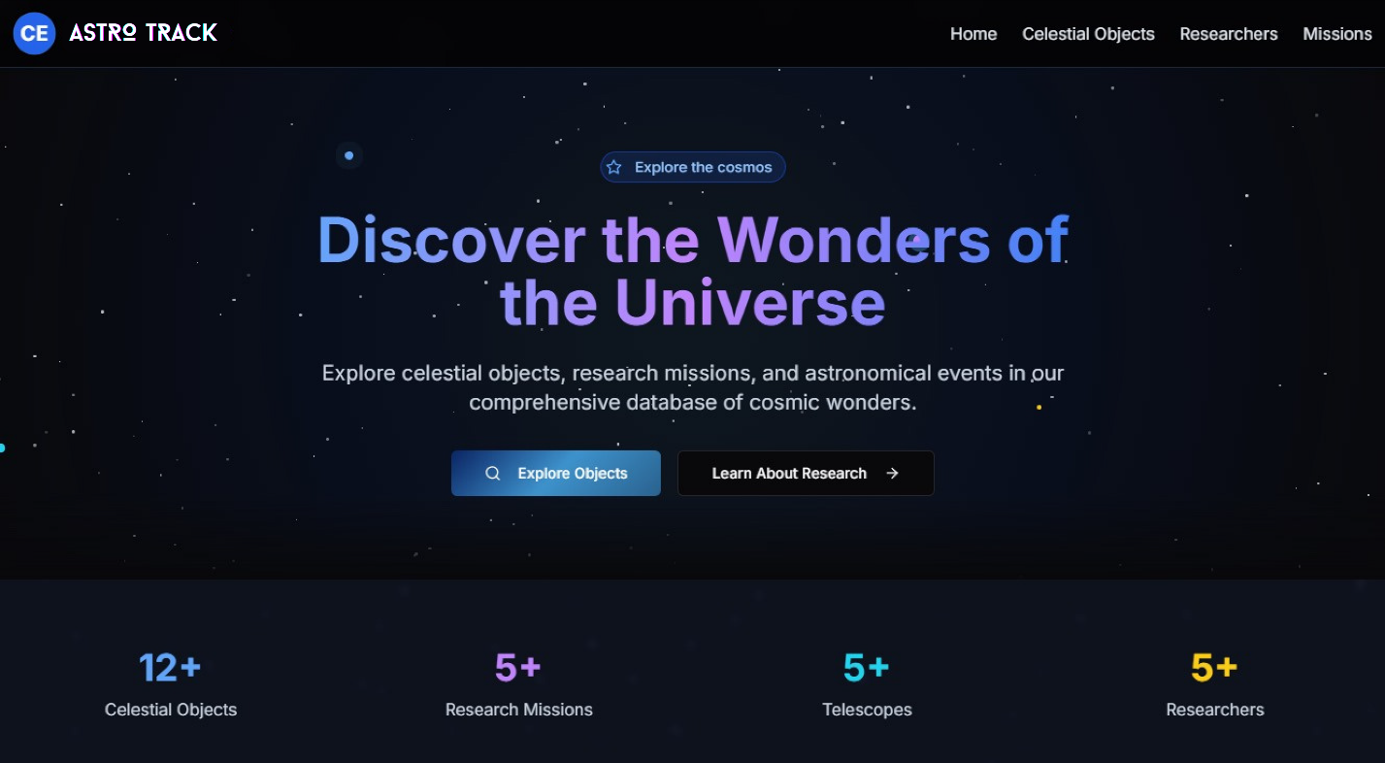

2. Programming Unit: The process of using PACKAGES of SEQUENCES to INSERT the values into Celestial Objects
2.1. Before inserting values
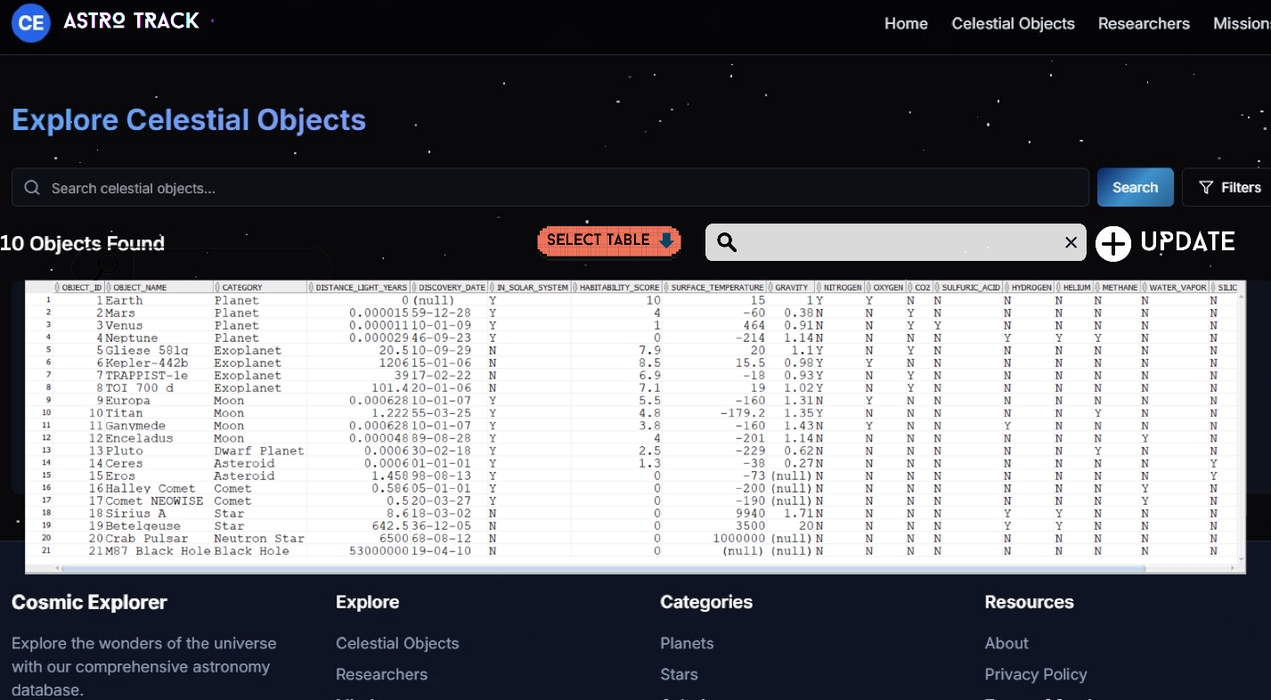
2.2. Click 'Filter' to display new rows based on your selected criteria. In this case, select the Celestial Objects table.
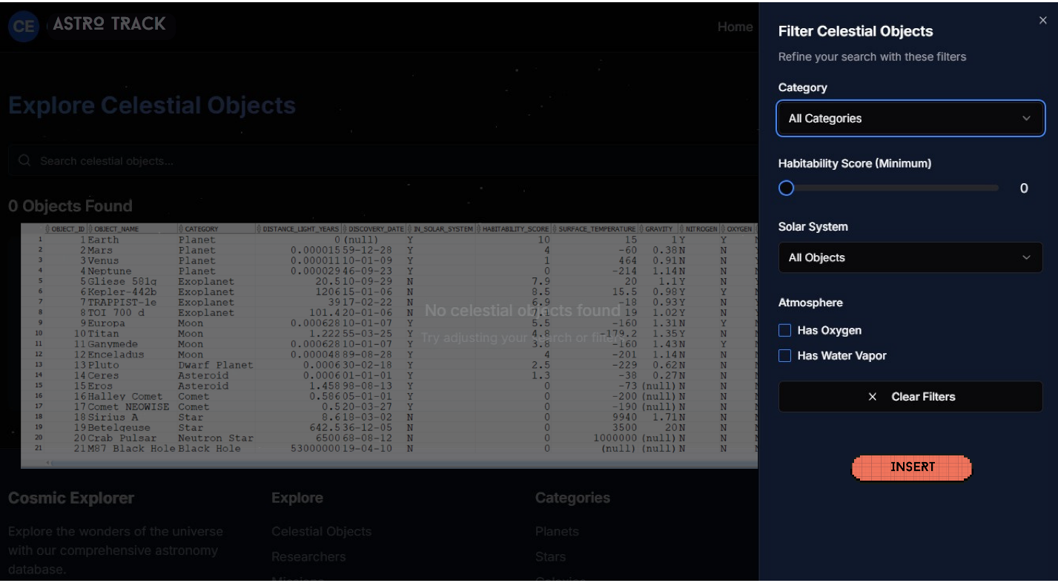
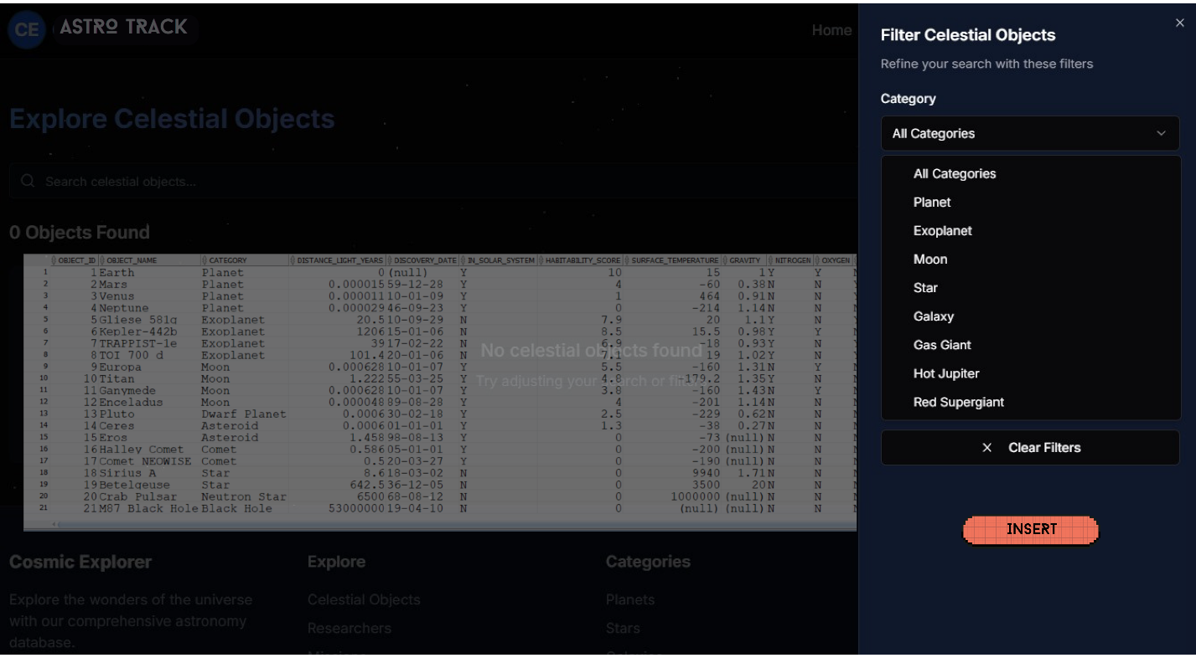

2.3. Click “Insert” to INSERT the values by using the PACKAGES of SEQUENCES
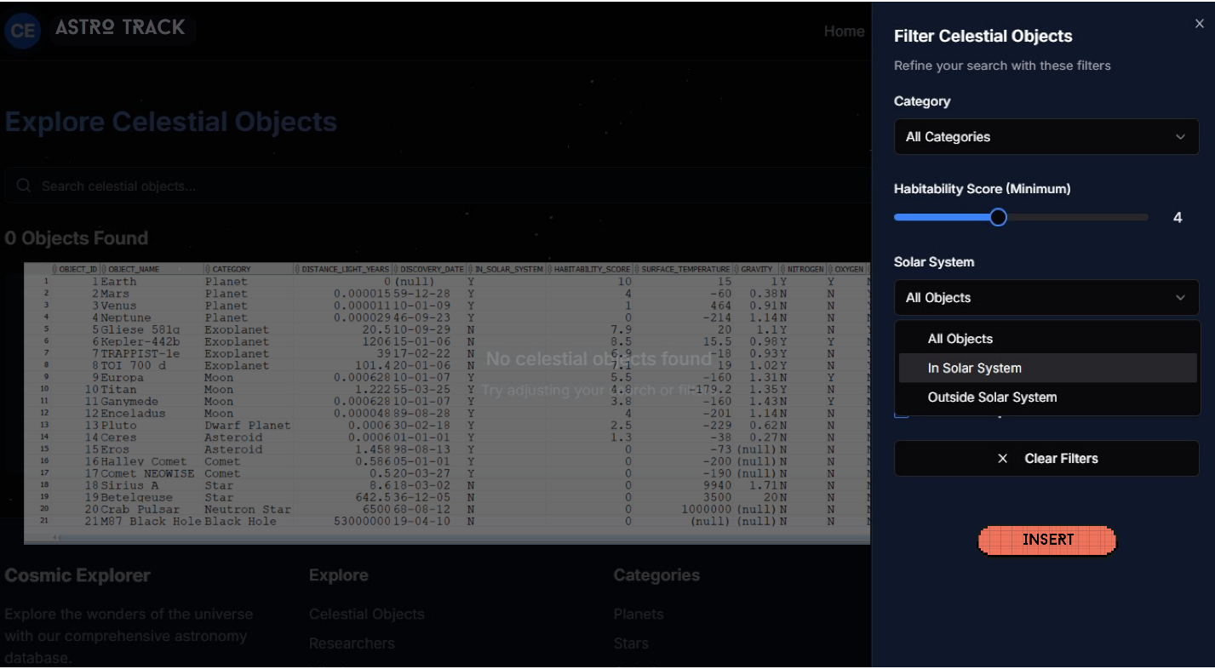

2.4. Click "All Statuses" to view the full list.
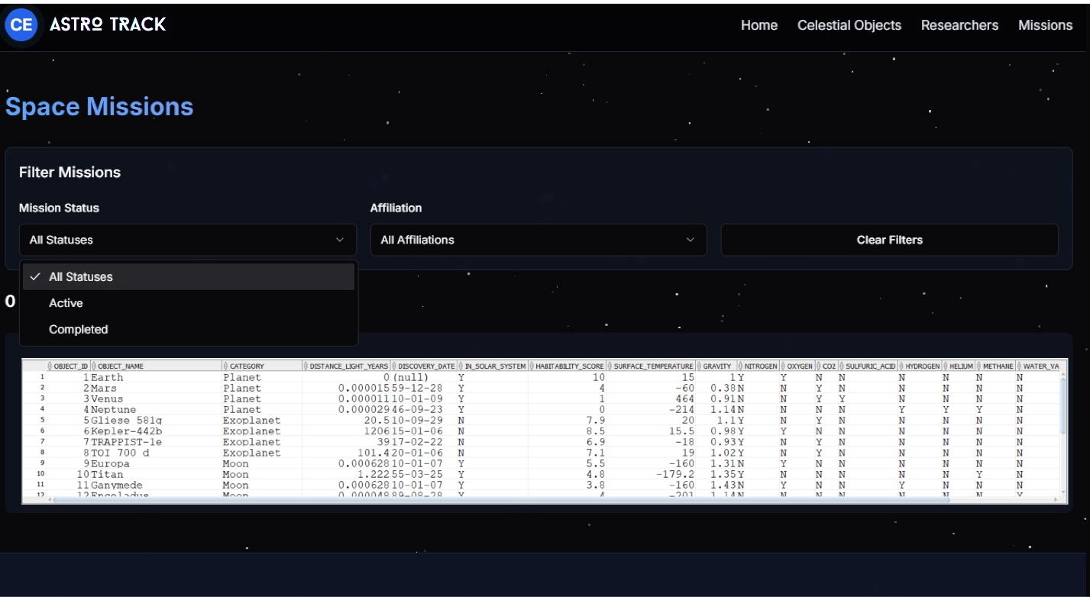

2.5. After inserting values result.
