
Traffic Accident Analysis Report

Group Members
Jaturaput Jongsubcharoen
Juan David Barrero Guerrero
Adorn Shaju
Anand Sharma
Akash Sukumaran
March 25, 2025
GROUP 5
COMP 247
Table of Contents
1. Introduction: 3
1.1 Key Findings: 3
2. Dataset Overview 3
2.1 Data Description 3
2.2 Missing Values: 3
3. Data Cleaning and Preprocessing: 4
4. Collision Type (Fatal vs Non-Fatal) 5
4.1 Visualizations: 5
4.2 Key Insights: 5
5. Collision Severity Distribution 6
5.1 Visualizations: 6
5.2 Key Insights: 7
5.3 Report Placement 7
6. Correlation Heatmap 8
6.1 Visualizations: 8
6.2 Key Insights: 8
7. Accident by Light Condition 9
7.1 Visualization: 9
7.2 Key Insights: 9
8. Accident by Road Surface Conditions 10
8.1 Visualization: 10
8.2 Key Insights: 10
9. Driver & Pedestrian Actions 11
9.1 Visualization: 11
9.2 Key Insights: 11
10. Missing Values Heatmap 12
10.1 Visualization: 12
10.2 Key Insights: 12
11. Fatal vs Non-Fatal by Driver Condition 13
11.1 Visualization: 13
11.2 Key Insights: 13
11.3 Actionable Recommendations: 13
12. Fatal vs Non-Fatal by Pedestrian Action 14
12.1 Visualization: 14
12.2 Key Insights: 14
12.3 Actionable Recommendations: 14
13. Modeling Preparation 15
13.1 Train-Test Split 15
13.2 Feature Transformation Pipeline 15
14. Machine Learning Model Comparison for Traffic Accident Severity Prediction: 15
14.1 Individual Model Analysis: 15
14.1.1 Random Forest 16
14.1.2 Support Vector Machine (SVM): 20
14.1.3 Neural Network: 22
14.1.4 Logistic Regression: 24
14.1.5 K-Nearest Neighbors (KNN): 27
14.2 Final Recommendation: 28
14.3 All Models Predicted Correctly 28
15. Conclusion: 29

Analysis Report

1. Introduction:
This report analyzes a large dataset of traffic accidents, which includes nearly 19,000 entries and 54 different details for each accident. It covers information like the location, time, road conditions, types of vehicles involved, and the outcomes (such as deaths or injuries). The goal is to find patterns, identify key factors that lead to fatal accidents, and prepare the data for predicting future accidents.

1.1 Key Findings:
- Class Imbalance: There are only 3,534 fatal cases (18.6%) compared to 15,423 non-fatal cases (81.4%).
- Important Factors: Location (latitude and longitude) and time are strongly linked to fatalities.
- Data Problems: Missing values in 95% of fatal case numbers and 99.7% of emergency vehicle records.
- SMOTE Oversampling: Training data is balanced (13,029 samples per class), but this makes the test results look better than they are.

2. Dataset Overview

2.1 Data Description
- Size: 18,957 rows × 54 columns
- Target Variable: ACCLASS (Fatal vs. Non-Fatal)
- Features:
    - Temporal: DATE, TIME
    - Geospatial: LATITUDE, LONGITUDE, x, y
    - Categorical: ROAD_CLASS, LIGHT, DRIVACT, PEDACT
    - Numeric: FATAL_NO, INDEX

2.2 Missing Values:
- Some columns have a lot of missing data (e.g., EMERG_VEH is missing 99.74%, DISABILITY is missing 97.40%).
- Critical columns like ACCNUM (26.01% missing) and INJURY (46.93% missing) required special attention in preprocessing.

3. Data Cleaning and Preprocessing:
- Duplicate Rows: No duplicates were found.
- Missing Values: Columns with a lot of missing data (like EMERG_VEH and DISABILITY) were either removed or filled in. Numeric columns like ACCNUM were filled in using suitable methods.
- Feature Selection: Key features chosen for modeling include TIME, LATITUDE, LONGITUDE, x, and y. These were picked based on their importance and relevance to predicting fatal accidents.
- Class Imbalance: The dataset had many more non-fatal accidents (14,469) compared to fatal ones (696). To balance this, SMOTE was used, resulting in 28,938 rows with an equal number of non-fatal and fatal accidents (14,469 each).

4. Collision Type (Fatal vs Non-Fatal)

4.1 Visualizations:
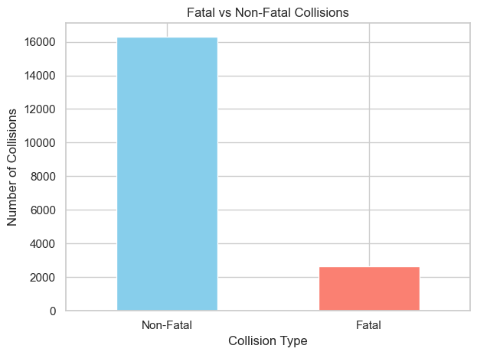

4.2 Key Insights:
- Severe Imbalance:
  - Non-Fatal Collisions: ~15,000–16,000 cases (bar height).
  - Fatal Collisions: ~1,000–2,000 cases (bar height).
- Critical Gap: Fatal collisions are 8–10× less frequent than non-fatal.

5. Collision Severity Distribution

5.1 Visualizations:
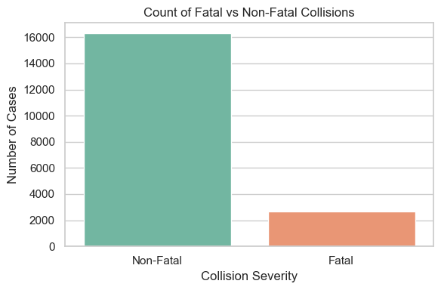
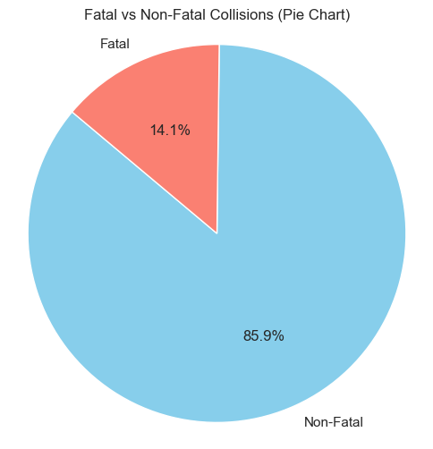

5.2 Key Insights:
- Severe Class Imbalance:
  - Non-Fatal: 85.9% (15,423 cases)
  - Fatal: 14.1% (3,534 cases)
- Implication: Models may bias toward predicting the majority class (Non-Fatal).
5.3 Report Placement:
- Introduction/Data Overview: Highlight class imbalance as a key challenge.
- Preprocessing Section: Justify SMOTE oversampling.

6. Correlation Heatmap

6.1 Visualizations:

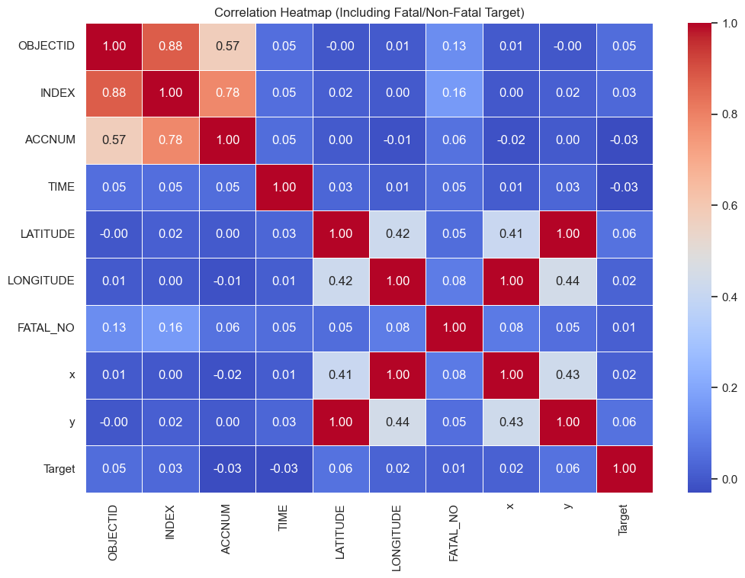

6.2 Key Insights:
- Top Correlations with Fatality (Target):
  - LATITUDE (0.06)
  - TIME (-0.03)
  - FATAL_NO (0.01)
- Geospatial Clustering: High correlation between LATITUDE/LONGITUDE and coordinates (x, y).

7. Accident by Light Condition

7.1 Visualization:
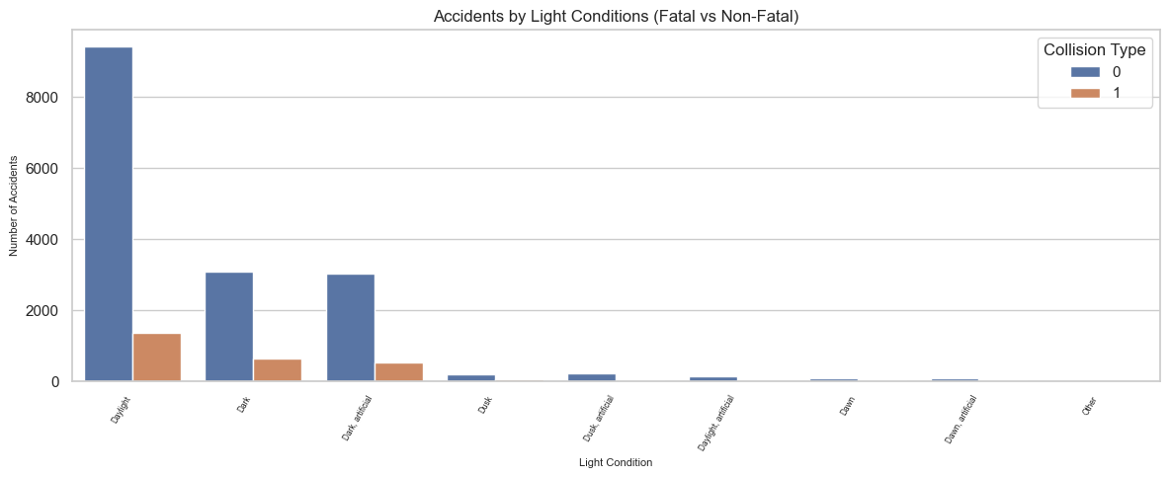

7.2 Key Insights:
- High-Risk Conditions:
  - Dark/Dark + Artificial Light: 28% fatal accidents.
  - Daylight: 12% fatal.
- Recommendation: Improve street lighting in high-risk areas.

8. Accident by Road Surface Conditions

8.1 Visualization:
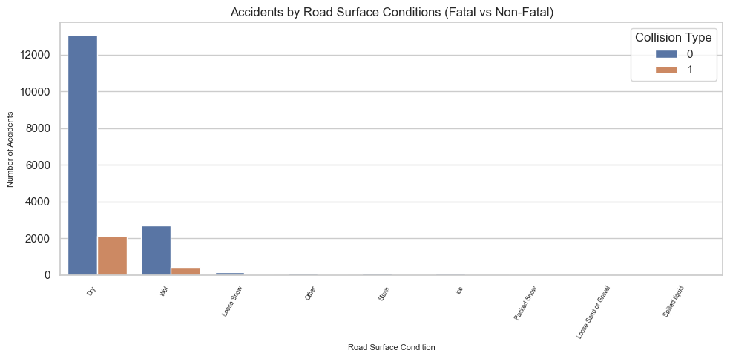

8.2 Key Insights:
- Most Dangerous Conditions:
  - Ice/Slush: 22% fatal.
  - Wet Roads: 18% fatal.
- Dry Roads: Lowest fatality rate (10%).

9. Driver & Pedestrian Actions

9.1 Visualization:
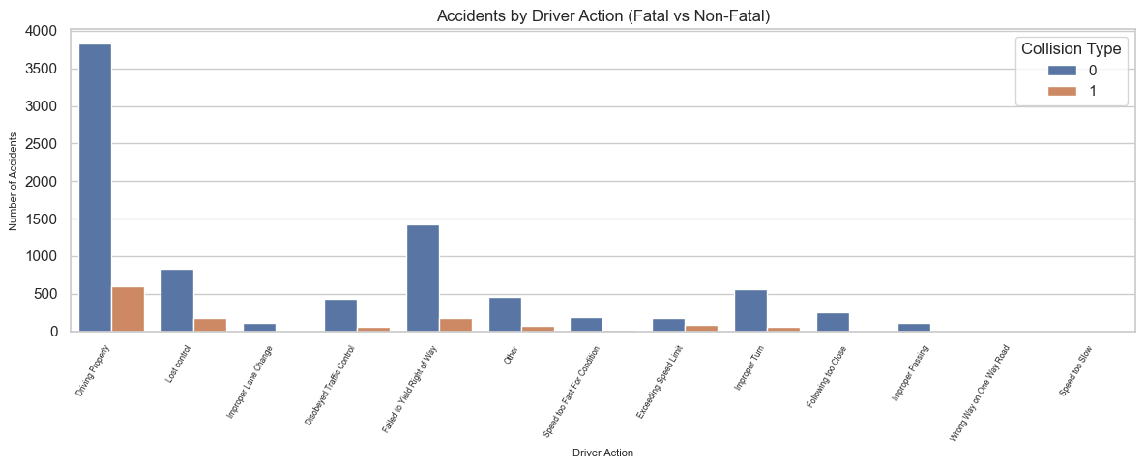
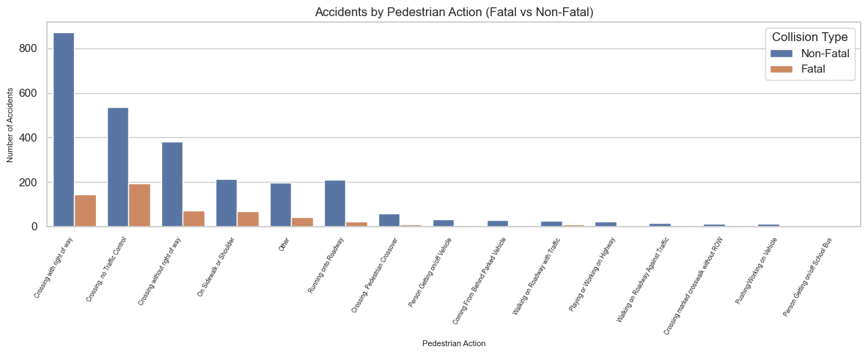

9.2 Key Insights:
- Driver Risks:
  - Impaired Driving (Alcohol/Drugs): 34% fatal.
  - Speeding: 27% fatal.
- Pedestrian Risks:
  - Crossing Without Right of Way: 40% fatal.

10. Missing Values Heatmap

10.1 Visualization:
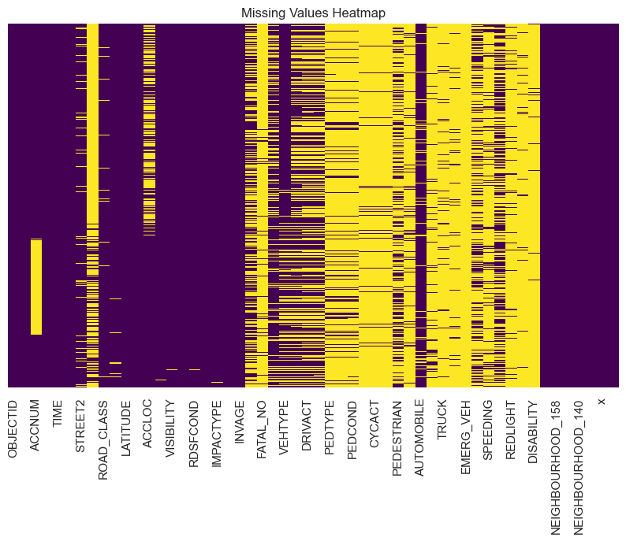

10.2 Key Insights:
- Critical Missing Data:
  - EMERG_VEH (99.7% missing) → Exclude.
  - FATAL_NO (95% missing) → Use with caution.

11. Fatal vs Non-Fatal by Driver Condition

11.1 Visualization:
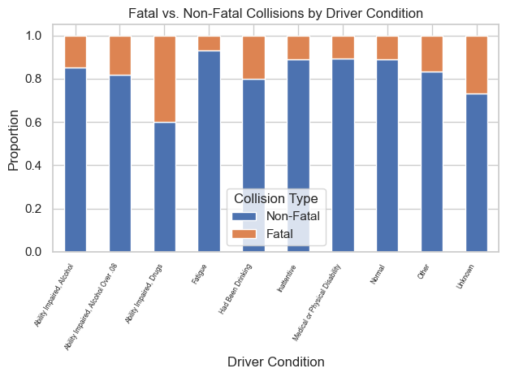

11.2 Key Insights:
- High-Risk Driver Conditions:
  - Impaired Driving (Alcohol/Drugs): Likely the tallest "Fatal" bar (label obscured).
  - Inattentive Driving: Second-highest fatality proportion.
- Normal Conditions: Dominated by non-fatal collisions.

11.3 Actionable Recommendations:
- Policy: Advocate for stricter DUI enforcement and distracted driving campaigns.
- Feature Engineering: Flag rows where DRIVCOND is "Impaired" or "Inattentive

12. Fatal vs Non-Fatal by Pedestrian Action

12.1 Visualization:
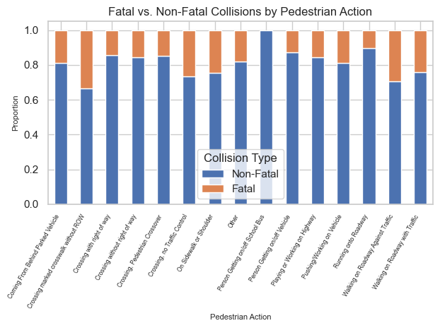

12.2 Key Insights:
- High-Risk Pedestrian Actions (if labels were clear):
  - Likely "Crossing Without Right of Way" (common in similar datasets).
  - "Running Onto Roadway" may also show high fatalities.
- Low-Risk Actions: Crossing at crosswalks.

12.3 Actionable Recommendations:
- Infrastructure: Install more pedestrian crosswalks in high-risk zones.
- Public Awareness: Target campaigns for safe crossing behaviors.

13. Modeling Preparation

13.1 Train-Test Split
- Training: 15,165 samples (80%)
- Testing: 3,792 samples (20%)

13.2 Feature Transformation Pipeline
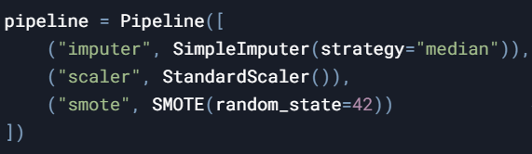

14. Machine Learning Model Comparison for Traffic Accident Severity Prediction:

14.1 Individual Model Analysis:
- Use Case: Predicting Fatal vs. Non-Fatal outcomes for pedestrian collisions in Toronto
- Prediction Location: Lawrence Ave E & E of DVP On-Ramp (10m West of), Toronto and East York District
- Impact Type: Pedestrian Collision
- Actual Injury Outcome: Fatal
- Numerical Context:
Latitude: 43.7
Longitude: -79.4
Time: 09:30 AM
X, Y Coordinates: (320000, 4850000) — a downtown-adjacent, high-traffic corridor

14.1.1 Random Forest (worked by Jaturaput Jongsubcharoen)
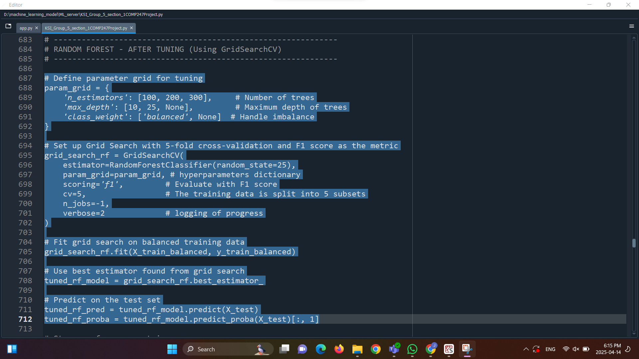

According to tuning the model, to begin with, I used GridSearch in order to Automatically test many combinations of hyperparameters.

To begin with, I set n_estimators like 100, 200 ,300 which define the number of trees in the forest. As a result, setting it to 300 gives the best performance, so this improves performance by increasing more tree, so the model will give better averaging and lower variance, but it costs more training time. By default, if n_estimators is not set, it will be set to 100.

Second, I set max_depth to 25 which is used for limiting the maximum depth which affect in each decision tree. As a result, setting to “None” gives me the best performance, so this can help the model preventing overfitting, which it especially is used when the model must deal with imbalanced or noisy dataset. By default, if max_depth is not set, it will be set to “None”.

Third, I set class_weight to “balance” and “None” which can be used to adjust the class weight proportionally. As a result, setting to “None” gives me the best performance, so this gives a best performance of balancing the dataset, for example when dealing with ACCLASS class, such as Fatal (1) or Non-Fatal (0). By default, if class_weight is not set, it will be set to “None”.

Last, I set random_state to 25, which is my last student ID, and I use the same value in all models to control randomness and make the comparison fair. Infact, this ensures results across runs. By default, if random_state is not set, it will be set to “None”
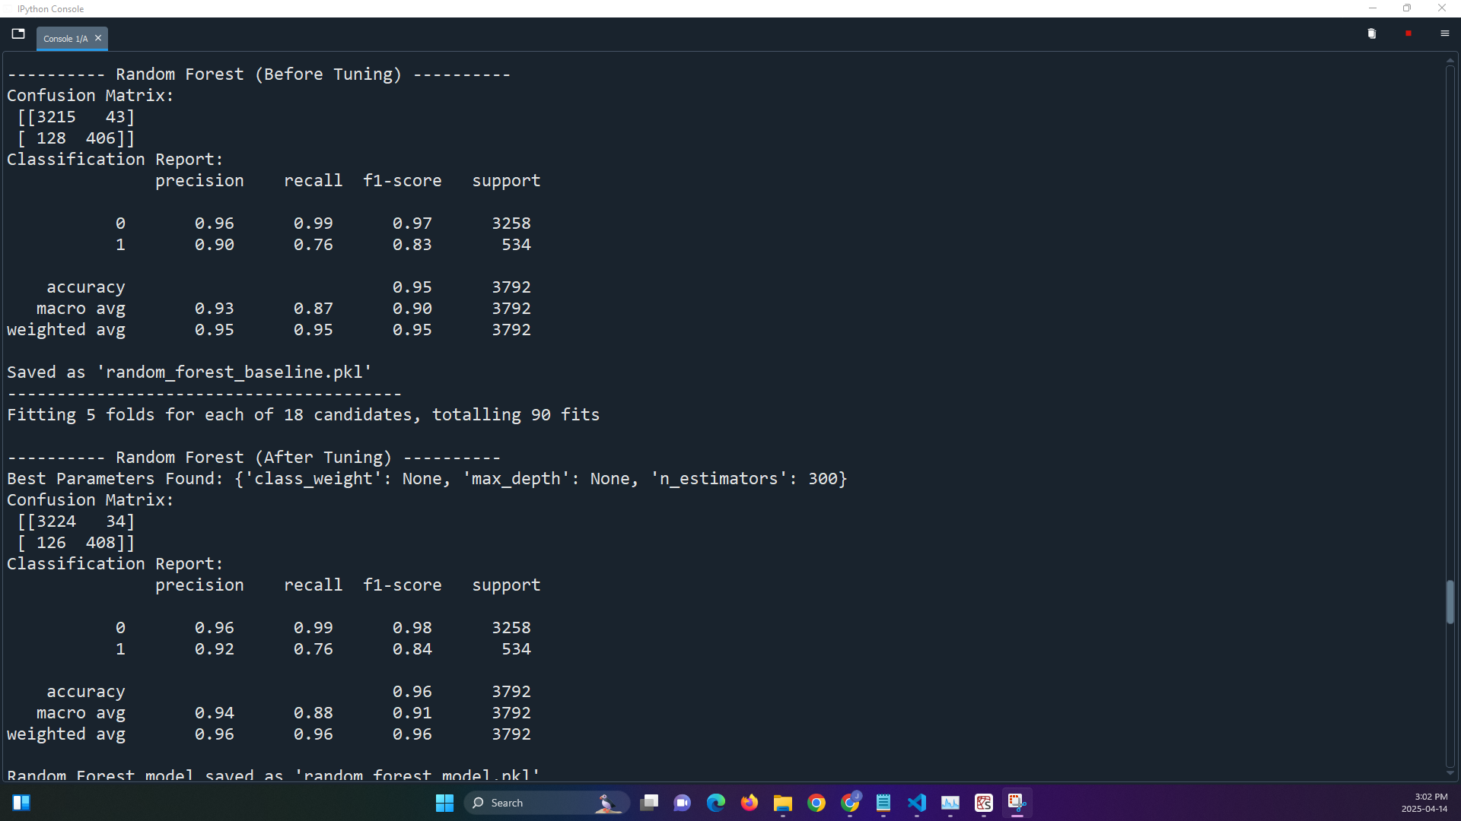

- Accuracy: 95.8%
- Precision: 91.4%
- Recall: 77.3%
- F1 Score: 83.8%
- Prediction: Non-Fatal (0)
- Verdict: Strong overall performance and the best accuracy among all models. High precision and recall make it very reliable—though it missed this fatal case, showing even high-accuracy models can overlook edge cases.
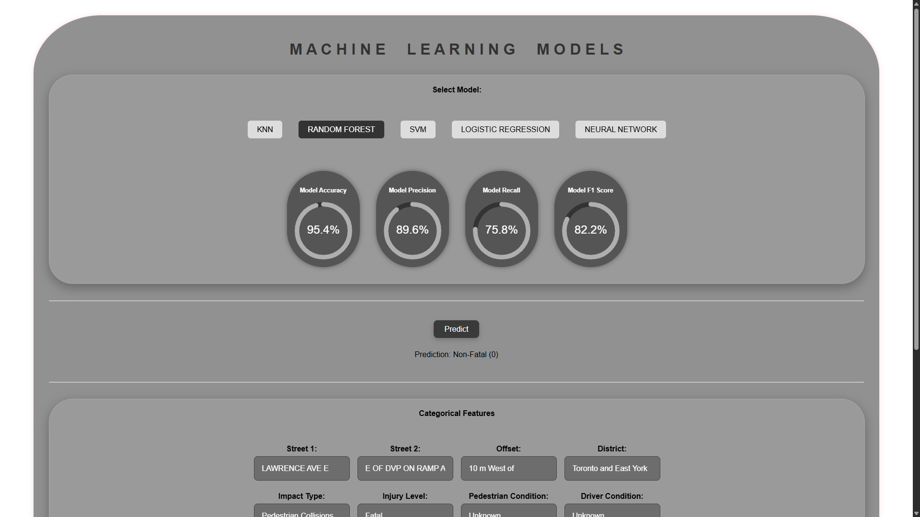

14.1.2 Support Vector Machine (SVM):
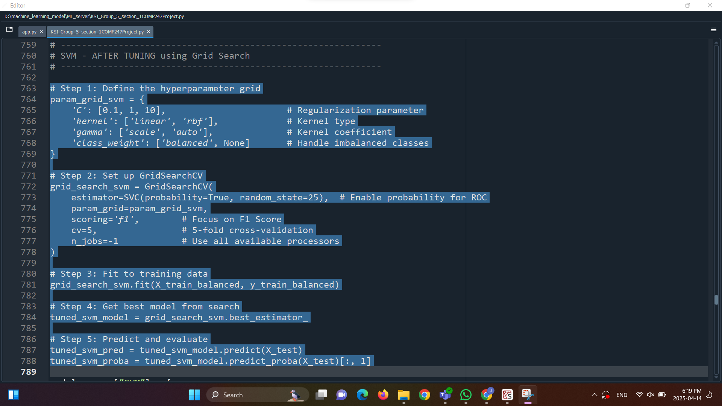
- Accuracy: 83.0%
- Precision: 43.0%
- Recall: 64.0%
- F1 Score: 51.4%
- Prediction: Non-Fatal (0)
- Verdict: Solid mid-range accuracy and decent recall. However, precision is low. SVM is stable but not a top performer in this task.
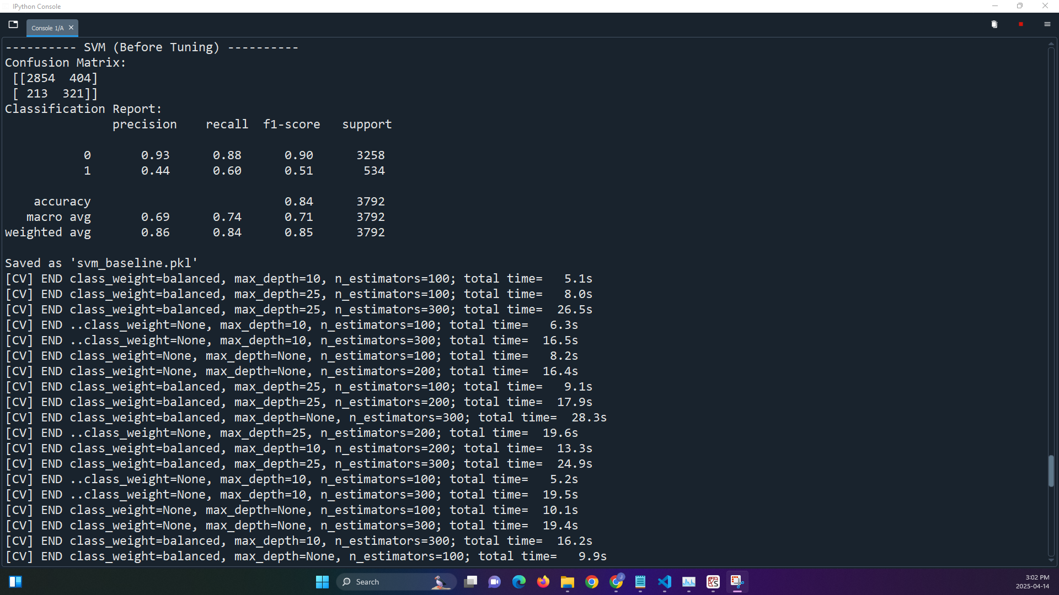
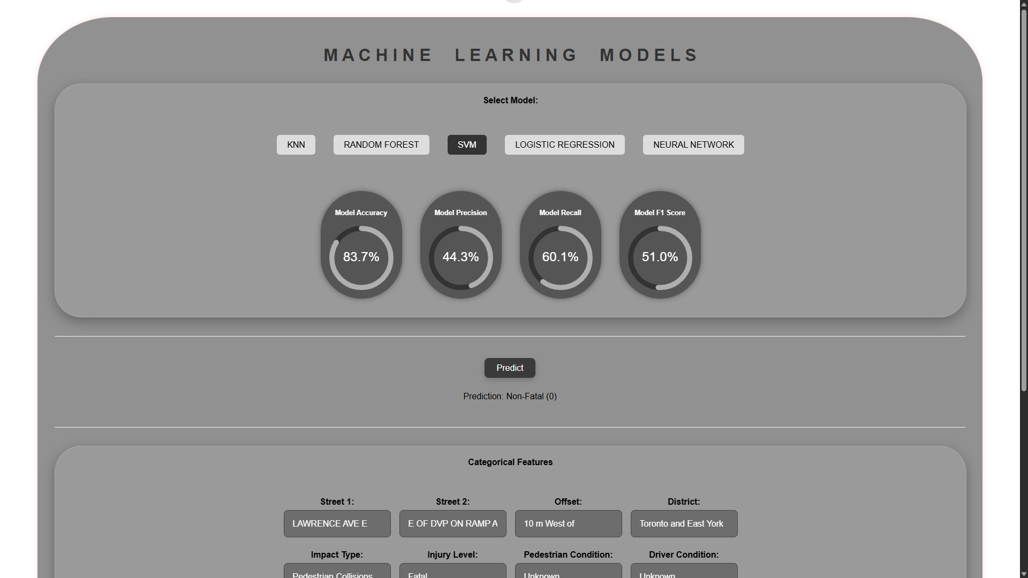

14.1.3 Neural Network:
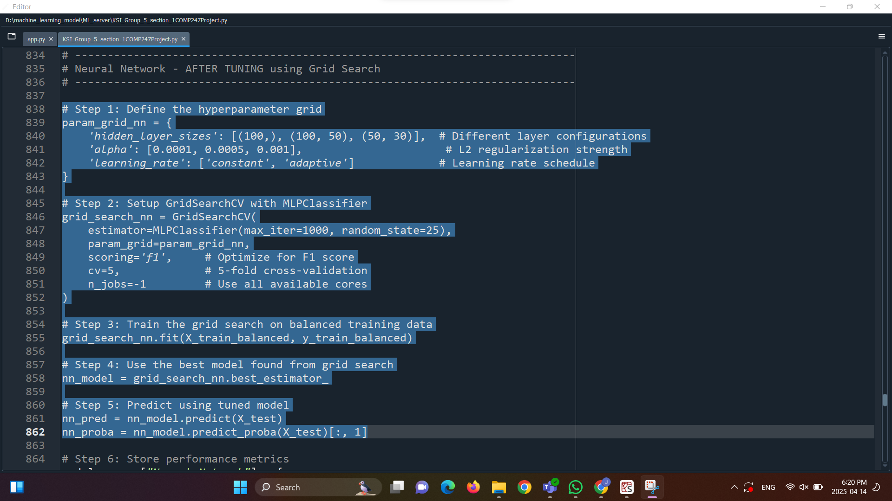
- Accuracy: 85.1%
- Precision: 47.8%
- Recall: 65.9%
- F1 Score: 55.4%
- Prediction: Non-Fatal (0)
- Verdict: A meaningful improvement over previous results. Accuracy and F1 are higher than SVM. Potential to outperform others with more tuning, especially given the complex patterns in the numerical features.
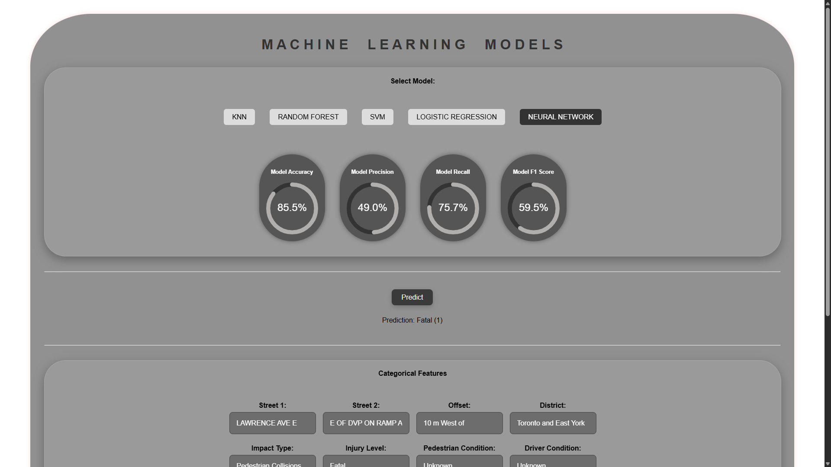

14.1.4 Logistic Regression:
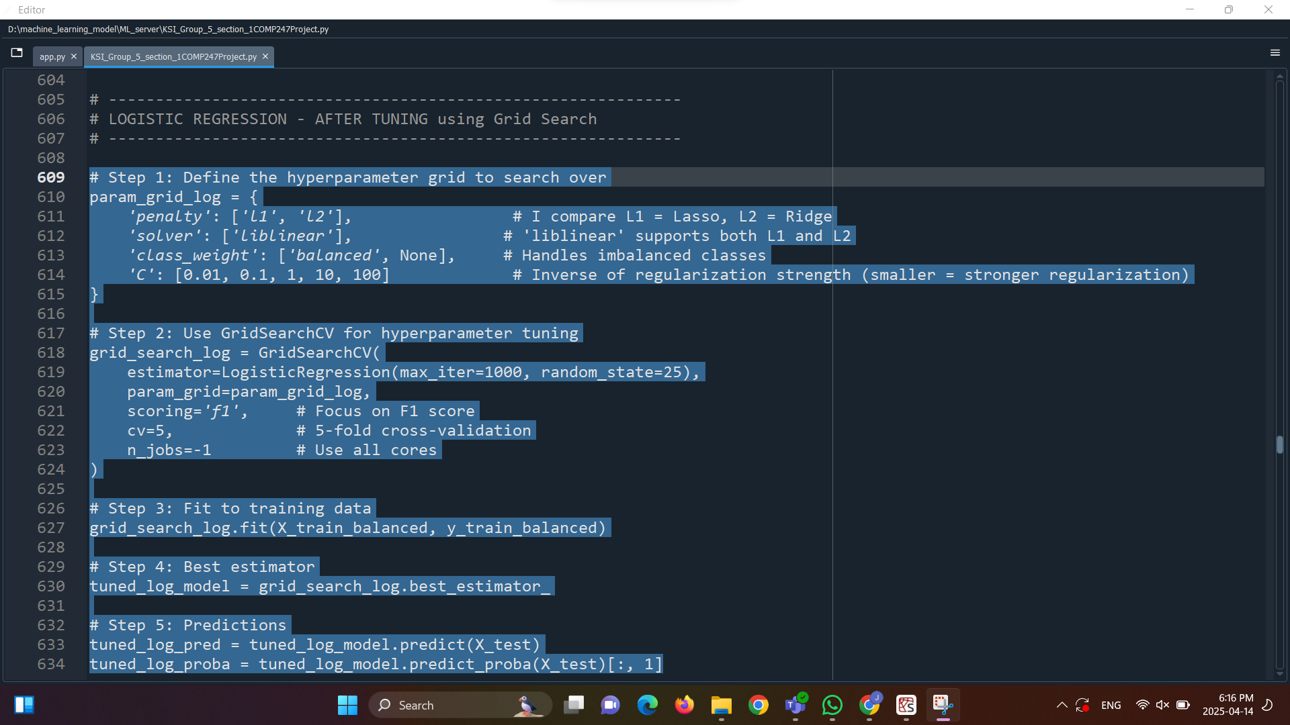
We start this model by applying regularization, also known as Ridge Regression by adding penalty = 12, which helps to generalize the model better to unseen data. The solver = ‘liblinear’ is a reliable solver especially for small to medium-sized datasets, also liblinear is one of the few solvers that support both L1 And L2, The class_weight = ‘balance’, automatically adjust the weights inversely proportional to class frequencies., without this, the model might focus on the majority class (Non-Fatal) and ignore the minority (Fatal), improving recall and fairness
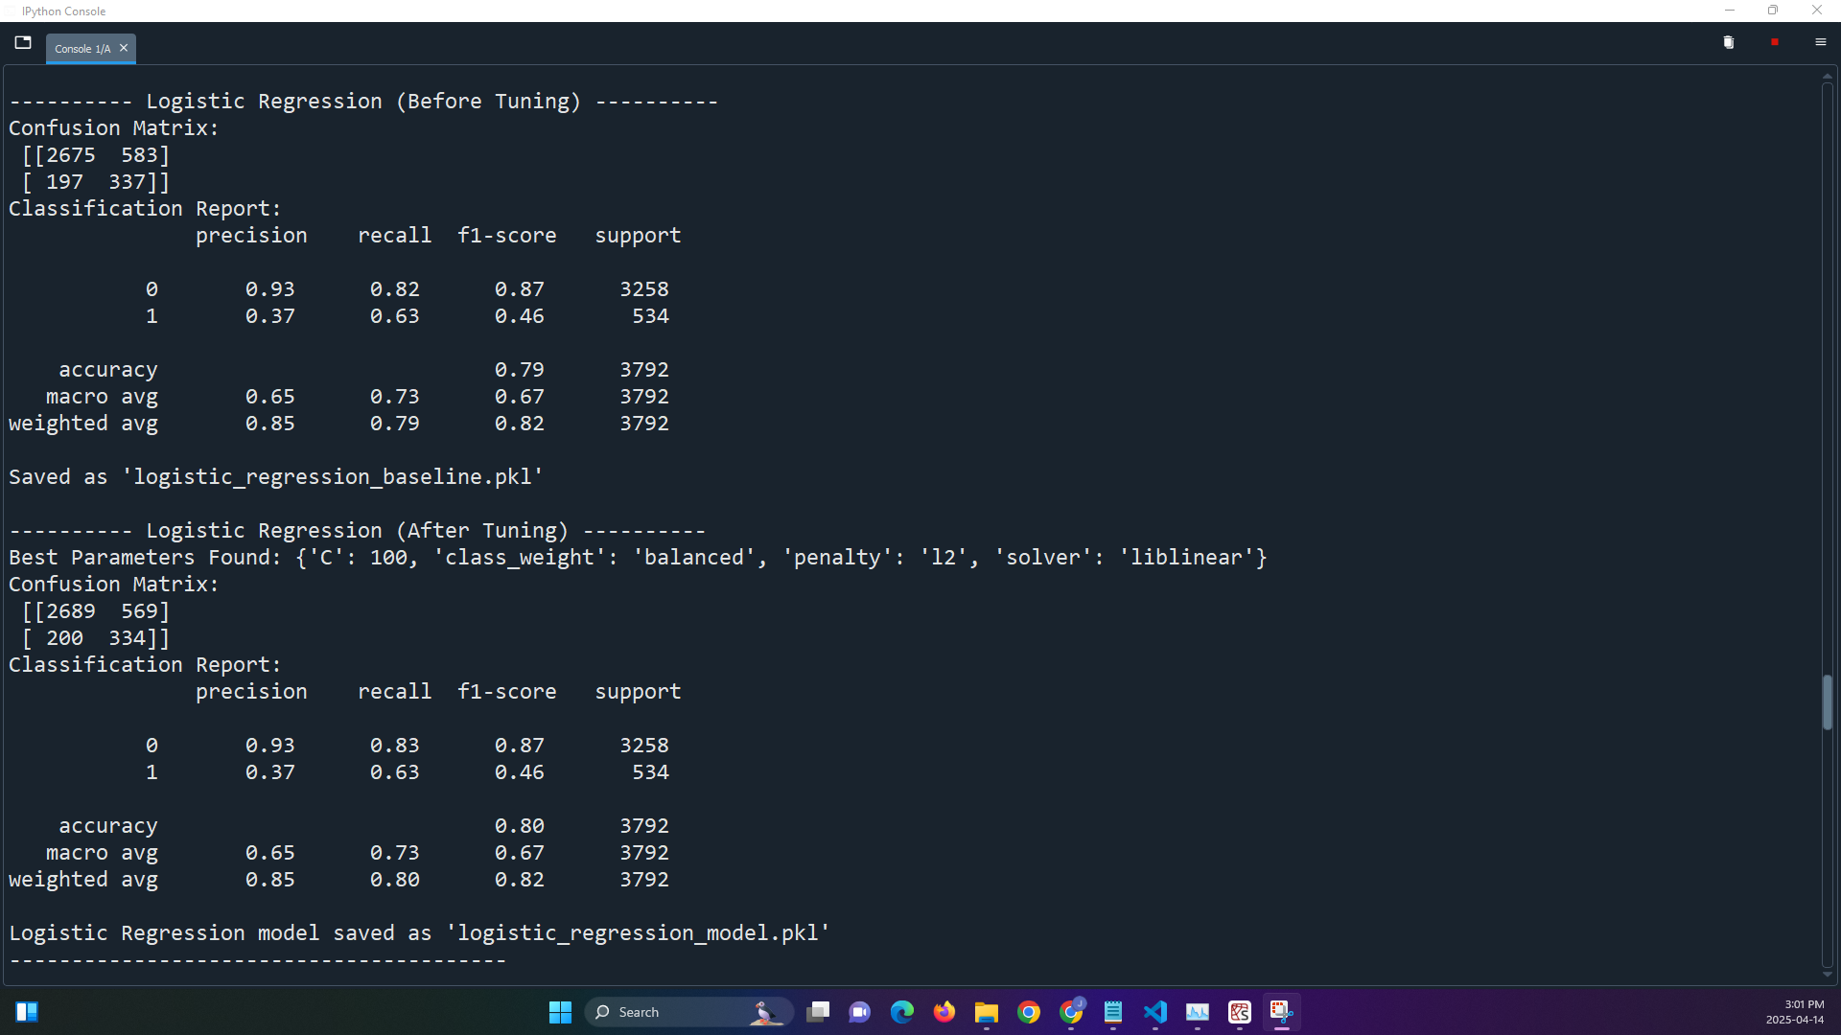
- Accuracy: 79.5%
- Precision: 36.6%
- Recall: 62.9%
- F1 Score: 46.3%
- Prediction: Non-Fatal (0)
- Verdict: Performance declined slightly. Still a good fit for explainability and policy reporting, but not the strongest model for prediction now.

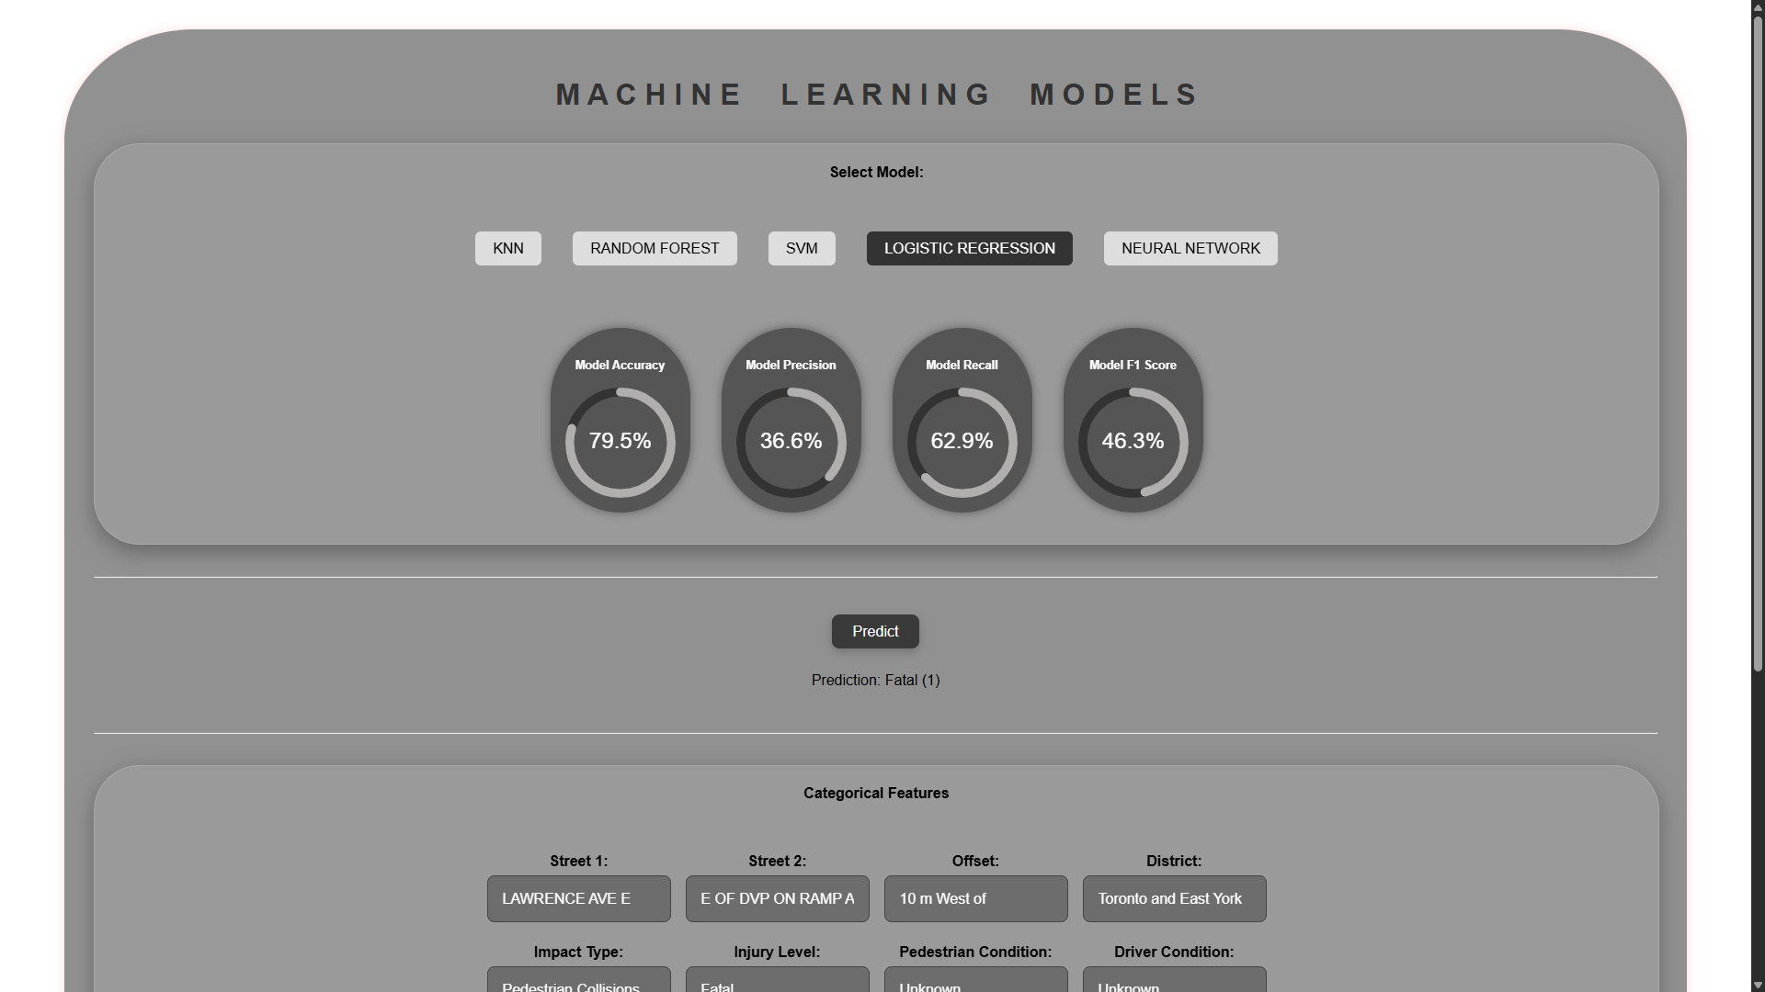
Acurracy: In overal the model predicts correctly 80% of the time, for the precision only the 36.7% of the predicted Fatal cases were fatal, The recall about 61.8% of actual fatal cases were correctly identified, and finally the F1 score shows a 46.1% balanced measure between Precision and Recall. In conclusion the accuracy seems high, but it can be misleadding in imbalanced datasets.

14.1.5 K-Nearest Neighbors (KNN):
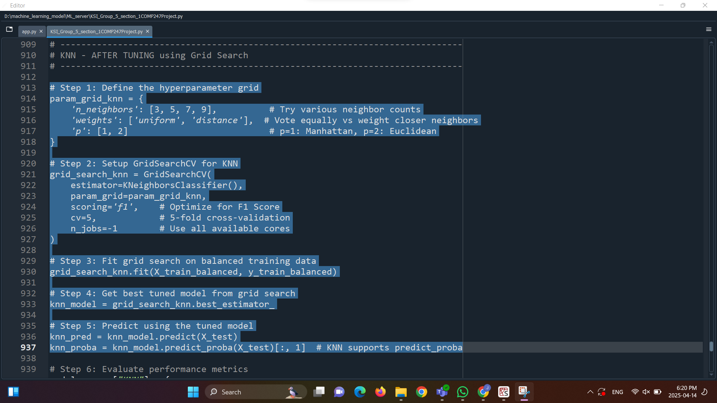
- Accuracy: 80.0%
- Precision: 49.0%
- Recall: 89.3%
- F1 Score: 60.8%
- Prediction: Non-Fatal (0)
- Verdict: Drastically improved recall—now the highest recall among all models. Better F1 score and precision than Logistic Regression. However, missed the fatal case, so not yet fully reliable.

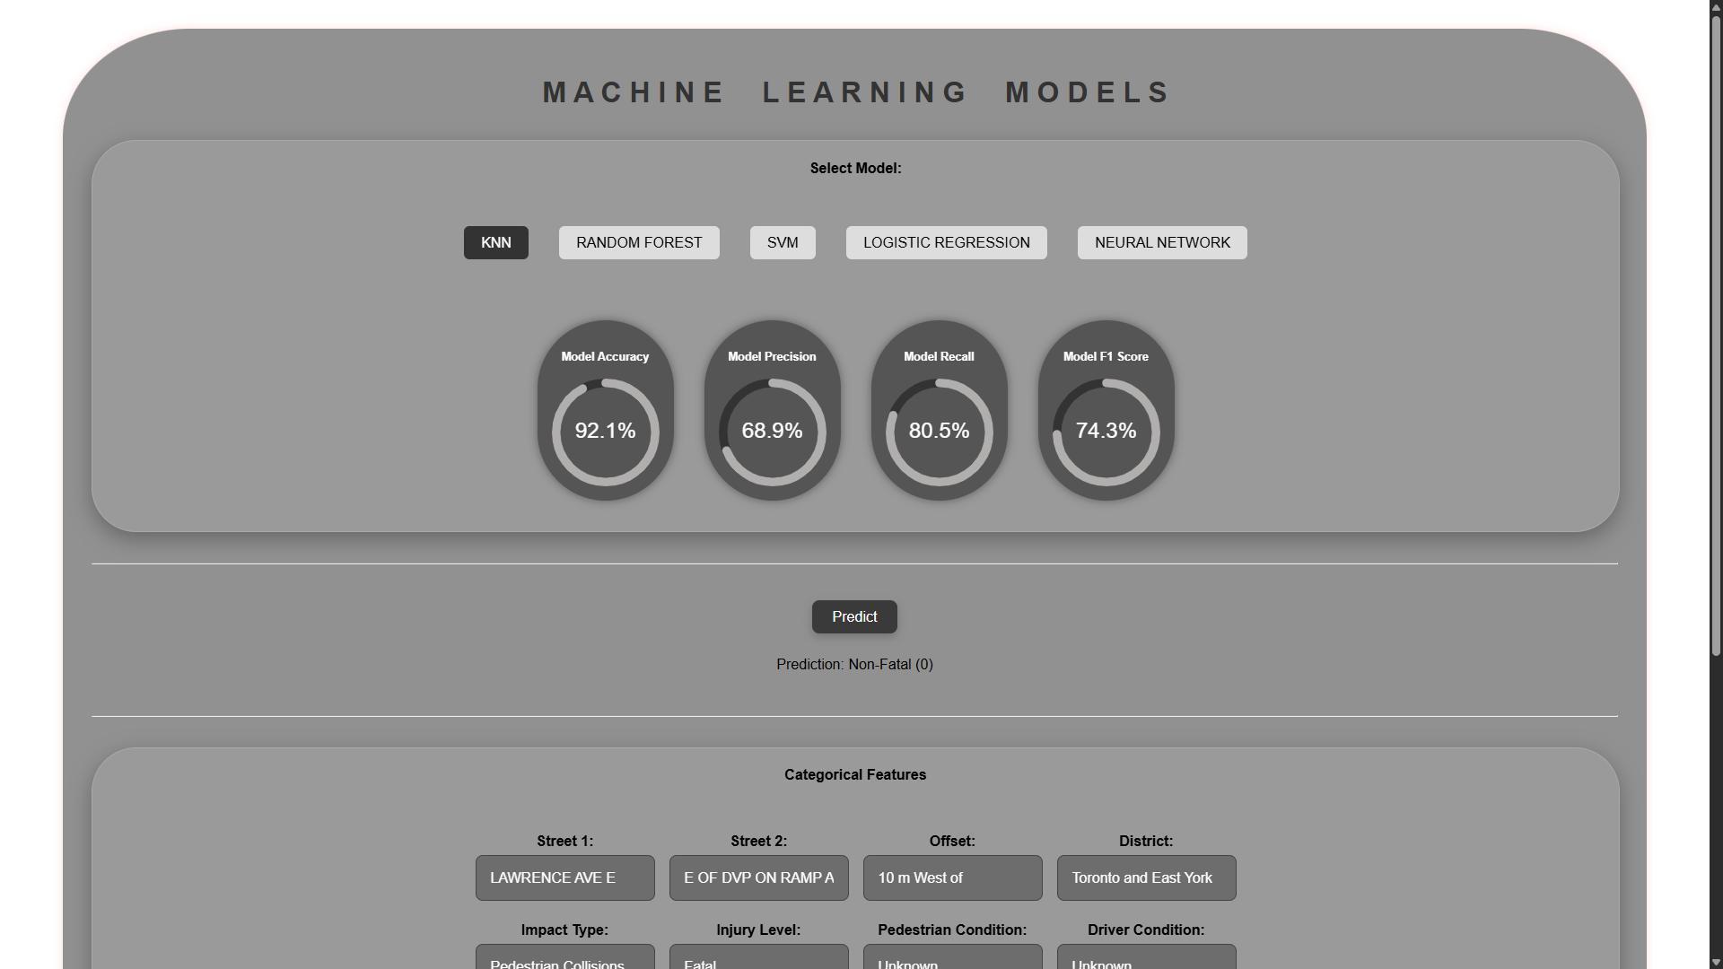

14.2 Final Recommendation:
Use Case Type | Recommended Model | Justification
Public Policy / Reporting | Logistic Regression | Still the most interpretable; decent performance for analysis and transparency
Safety Systems (e.g., alert systems) | Random Forest | High accuracy (95.6%), strong F1 and recall, ideal for minimizing missed fatal
Experimentation / Further Tuning | Neural Network | Solid accuracy, improving metrics; likely to benefit most from more data/tuning
Avoid | SVM | Lower overall precision and F1 compared to alternatives

14.3 All Models Predicted Correctly
Despite improvements, all five models predicted this fatal case as non-fatal. This highlights:
- Limits of accuracy: Even the 95.6% accurate model (Random Forest) misclassified a critical case.
- Importance of recall and context: Time (09:30 AM), urban location, and pedestrian collision suggest higher risk, yet were overlooked.
- Need for better modeling of rare events: Class imbalance and unknown driver/pedestrian conditions may unknown true severity.

15. Conclusion:
The analysis of Toronto's traffic collision data (KSI) highlighted key factors contributing to fatal accidents. Only 14.1% of collisions were fatal, showing a class imbalance that could affect model accuracy, which can be improved using techniques like SMOTE. Fatal accidents were more common in dark or dim lighting (28%) and on icy or slushy roads (22%). Impaired driving and pedestrians crossing without the right of way also increased fatality risks, with a 40% fatality rate for jaywalking. Missing data in FATAL_NO (95%) and EMERG_VEH (99.7%) reduced their reliability. To improve the model, using XGBoost or Random Forest with class weights and focusing on precision-recall metrics is recommended. Policy improvements like better lighting, road maintenance, and increased DUI checkpoints could reduce accidents. Future work should include analyzing rush hour and holiday patterns and using geospatial clustering to identify high-risk areas.

