Sentiment Analysis for Amazon Fashion Reviews
Final Project Report (Phase 1 & Phase 2)

Course: COMP 262

Daniela Diaz - 301281747
Jaturaput Jongsubcharoen - 301391425
Juan David Barrero - 301352353
Maria Paula Nova - 301374220
Anmol Shrestha - 301364068

Professor: Vijayalakshmi Tiruchengode Angamuthu
Date: 01/04/2026
Table of Contents
1. Introduction 5
2. Phase 1 - Lexicon-Based Sentiment Analysis 6
2.1 Dataset Data Exploration (EDA) 6
2.2 Text Basic Preprocessing 18
2.2.1 Labeling (Ratings to Sentiment Classes) 18
2.2.2 Column Selection 18
2.2.3 Cleaning and Quality Checks 19
2.2.4 Text Normalization Strategy (Model-Specific) 20
2.2.5 Outlier Treatment 21
2.3 Model 22
2.3.1 Lexicon Study and Selection 22
2.4 Sampling Procedure 23
2.4.1 Sampling Method 23
2.5 Evaluation Metrics 24
2.6 Result 25
2.7 Confusion Matrices 28
2.8 Discussion 30
3. Phase 2 - Machine Learning Sentiment Analysis and Advanced Applications 32
11. Modeling (Sentiment Analysis) – Machine Learning Approach 32
11.a Data Selection 32
11.b Data Exploration and Preprocessing 33
11.c Text Representation 33
11.d Train -Test Split 33
11.e Model Development 34
Logistic Regression 35
Support Vector Machine (SVM) 35
Multinomial Naïve Bayes 35
Gradient Boosting 35
Multi-Layer Perceptron (MLP) 35
12. Training Results 36
13. Testing and Evaluation 36
13.1 Logistic Regression Results 37
13.2 SVM Results 38
13.3 Naïve Bayes 39
13.4 Gradient Boosting 40
13.5 MLP 41
13.6 Findings from Model Evaluation 42
14. Experiment: Lexicon vs Machine Learning 42
14.a Experimental Design 42
14.c VADER 43
14.d TextBlob 44
14.e Final Findings from the Comparison 45
15. Enhancing Rating Values Using Review Data 45
15.a Enhancing Ratings with Review Text 45
15.b Selected Option, Diagram, and Pseudo-code 46
Pseudo-code 46
15.c Implementation and Results 46
Key Findings 47
16. LLM Review Summarization 47
Summarization Results 48
Summarization Key Findings 48
17. LLM Response Generation 48
Response Generation Results 48
Response Generation Key Findings 48
4. Conclusion 49
5. Assumptions 50
6. References 51
7. Appendix 1: Project plan 52
7.1 Project Objectives 52
7.4 Tools and Technologies 58
7.5 Phase 2 Completion Summary 59
8. Appendix 2: Meeting register (simple table showing date and time of each meeting, who attended, subjects discussed and assignments). 60

1. Introduction
In this project, sentiment analysis of the Amazon Fashion reviews data was conducted both with the help of lexicon-based and machine learning methods. The general aim was to integrate an entire and reproducible pipeline that comprises the dataset exploration, sentiment labeling, depending on the rating value, text preprocessing, model creation, assessment and sophisticated NLP applications.
The proxy ground-truth labels were in the form of ratings (1 to 5 stars) and converted to three categories of sentiment: Negative, Neutral and Positive. Phase 1 VADER and TextBlob Two lexicon-based models were used as baseline approaches in Phase 1 that used predefined sentiment dictionaries and scoring rules. Phase 2 involved the development of supervised machine learning models using TF-IDF text representation and tested and trained using experiments.
The project will be a combination of exploratory data analysis and the quantitative evaluation metrics, such as accuracy, precision, recall, F1-score, and confusion matrices. Other assignments like comparing lexicon with machine learning, enhancing rate of review with sentiment review, review summary and automated response generation were also accomplished. The findings show the possibility of the extension of sentiment analysis beyond basic baseline approaches to more sophisticated intelligent systems.

2. Phase 1 - Lexicon-Based Sentiment Analysis

2.1 Dataset Data Exploration (EDA)
Exploratory data analysis was performed on the Amazon Fashion review dataset to understand its structure, rating distribution, user and product activity, review length patterns, duplicate entries, and outliers. Statistical summaries and visualizations were generated to identify the main characteristics of the data before preprocessing and lexicon-based modeling.
Metric | Value
Rows before dropping invalid ratings | 3,176
Rows after dropping invalid ratings | 3,176
Average rating | 4.404
Median rating | 5.000
Unique users | 406
Unique products | 31
Missing review_text rows | 16
Duplicate full_text rows | 2,733
Duplicate (summary, review_text) pairs: | 2,733
Table 2.1. Key Statistics of the Amazon Fashion Review Dataset
The dataset shows a strong positive rating bias, as indicated by the median rating of 5. In addition, the relatively small number of users and products compared with the total number of reviews suggests repeated activity within a limited set of customers and items. The large number of duplicate text entries is also an important characteristic of the dataset and should be considered when interpreting model performance.

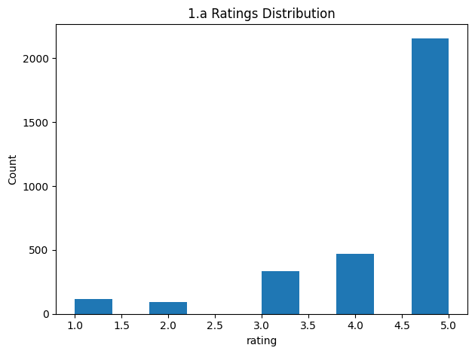
Figure 2.1. Rating Distribution of Amazon Fashion Reviews
The rating distribution is highly imbalanced, with 5-star reviews representing the largest portion of the dataset, while 1-star and 2-star reviews appear much less frequently. This confirms a strong positive skew, which is common in e-commerce review data.
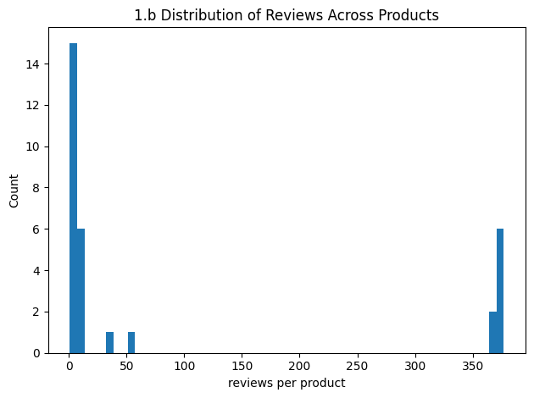
Figure 2.2. Distribution of Reviews Across Products
Review counts across products are highly uneven. Most products received only a small number of reviews, while a small number of products accumulated many reviews. This reflects a long-tail distribution of customer activity.

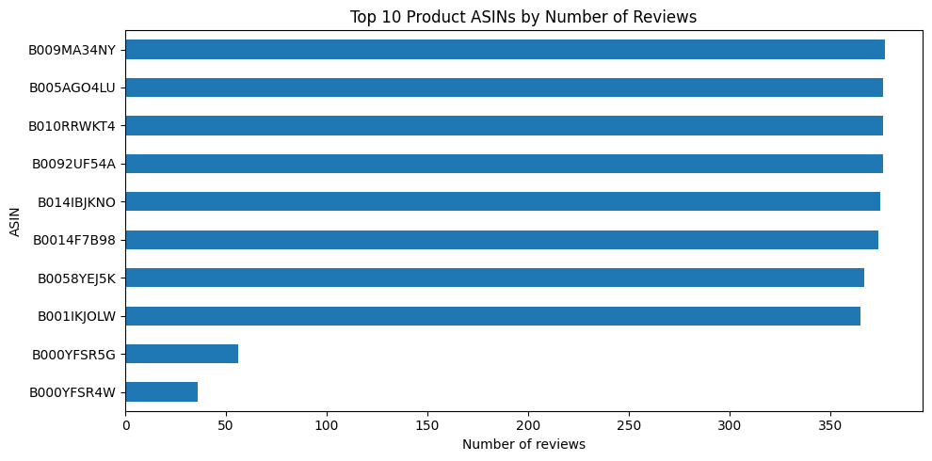
Figure 2.3. Top 10 Products by Number of Reviews
The top reviewed products are not equally represented. Several products received substantially more reviews than others, indicating that customer attention is concentrated on a small subset of popular items.

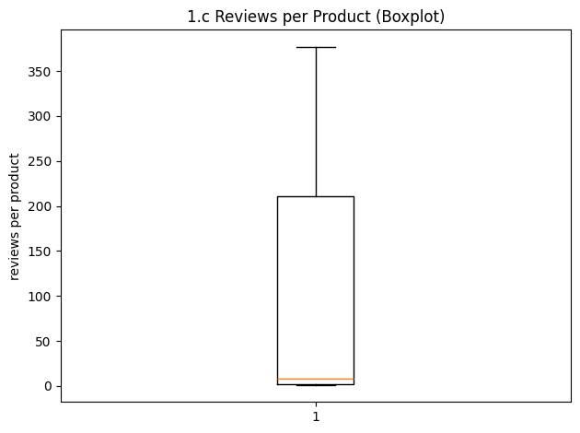
Figure 2.4. Reviews per Product (Boxplot)
Most products received very few reviews, while a small number of products received a large number of reviews. This confirms a highly skewed product-level distribution with visible outliers.

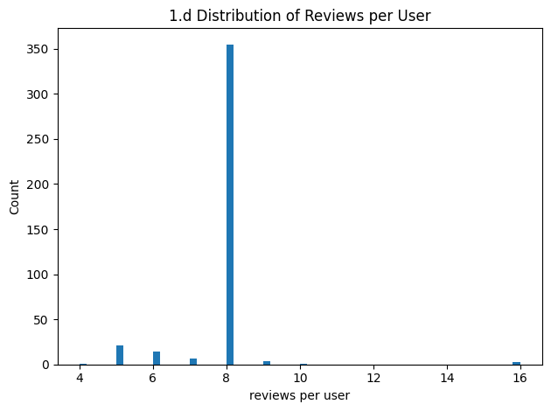
Figure 2.5. Distribution of Reviews per User
Most users contributed a moderate number of reviews, while fewer users contributed very high or very low numbers of reviews. This shows that reviewing activity varies across users.

Figure 2.5. Distribution of Reviews per User
Most users contributed a moderate number of reviews, while fewer users contributed very high or very low numbers of reviews. This shows that reviewing activity varies across users.
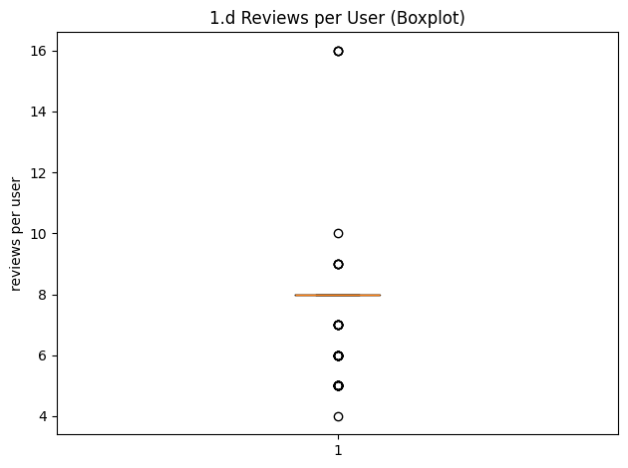
Figure 2.6. Reviews per User (Boxplot)
User review behavior is concentrated around the median value, with several users acting as outliers by contributing significantly more reviews than average.
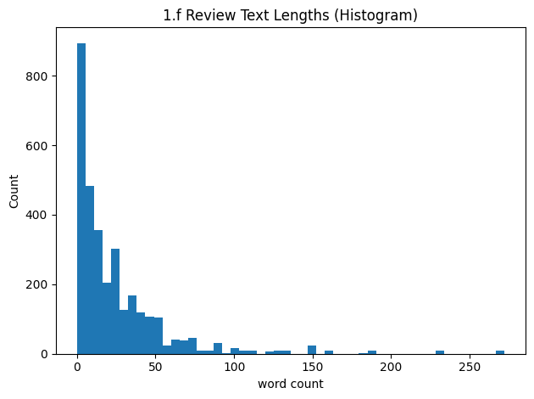
Figure 2.7. Review Length Distribution
Most reviews are relatively short, while a smaller number of reviews are much longer. This creates a right-skewed distribution of review lengths.
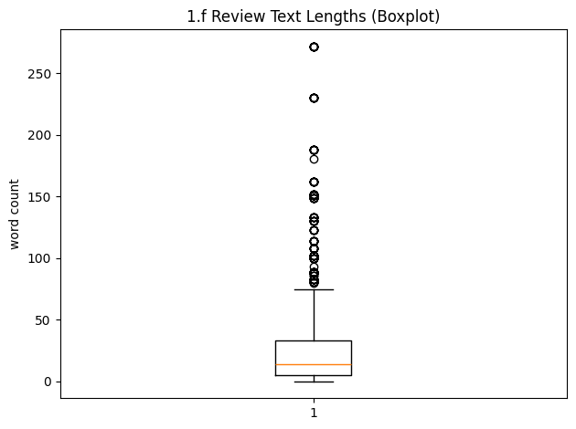
Figure 2.8. Review Length Boxplot
The boxplot highlights multiple review length outliers. Although most reviews are short, some reviews contain substantially more words than the average review.
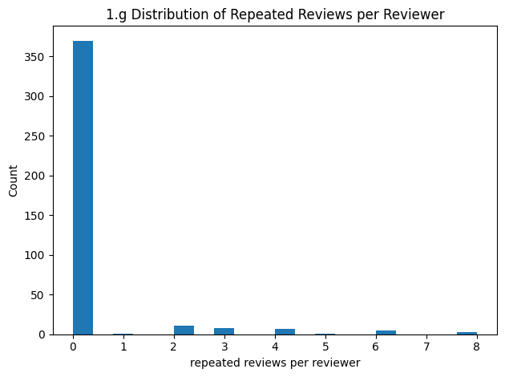
Figure 2.9. Distribution of Repeated Reviews per Reviewer
Repeated reviewer-product pairs are not evenly distributed across users. Most reviewers have no repeated reviews, while a small subset of reviewers accounts for multiple repeated entries.

2.2 Text Basic Preprocessing
Text basic preprocessing was performed to prepare the Amazon Fashion review data for lexicon-based sentiment analysis. The objective of this stage was to convert raw review data into a clean and structured format that could be consistently analyzed by the selected sentiment models. This included sentiment labeling, column selection, text cleaning, model-specific normalization, and outlier handling.

2.2.1 Labeling (Ratings to Sentiment Classes)
labels according to the project rubric. Ratings of 4 and 5 were labeled as Positive, a rating of 3 was labeled as Neutral, and ratings of 1 and 2 were labeled as Negative. This mapping treats numerical ratings as proxy ground-truth sentiment labels for evaluating model predictions.
Rating Value | Sentiment Label
4 – 5 | Positive
3 | Neutral
1 – 2 | Negative
Table 2.3. Rating-to-Sentiment Label Mapping
Because the dataset contains many 5-star reviews, this labeling strategy results in class imbalance, with the Positive class dominating the dataset.

2.2.2 Column Selection
The dataset contains two main textual fields: summary and review_text. Both columns were combined into a single feature called full_text. The summary field is usually short and opinion-focused, while the review_text field provides more detailed explanation and context. Combining both fields improves lexical coverage and increases the likelihood that sentiment-bearing words are captured by the models.

Column Name | Purpose
summary | Short opinion-focused text
review_text | Detailed review content
full_text | Combined feature used for analysis
Table 2.4. Selected Text Columns and Purpose

2.2.3 Cleaning and Quality Checks
Several cleaning and validation steps were applied before sentiment scoring. Reviews with invalid or non-numeric ratings were removed prior to labeling. Empty text entries were identified and counted after text conversion. No imputation was performed because lexicon-based models require actual textual content. Overall, the dataset did not require major structural correction.

Step | Purpose
Remove invalid ratings | Ensure valid label creation
Detect empty text rows | Identify missing review content
No imputation | Preserve real text-only analysis
Structural validation | Confirm dataset usability
Table 2.5. Data Cleaning and Quality Checks

2.2.4 Text Normalization Strategy (Model-Specific)
Different preprocessing strategies were applied depending on the sentiment model. This is important because VADER benefits from punctuation and emphasis signals, while TextBlob performs better with more normalized text.
2.2.4.1 Preprocessing for VADER
Minimal preprocessing was applied for VADER. URLs were removed and extra whitespace was normalized. Other signals such as punctuation, capitalization, and emphasis markers were preserved because they contribute to sentiment intensity scoring.
Step | Applied
Convert to lowercase | Yes
Remove URLs | Yes
Remove non-alphabetic characters | Yes
Normalize whitespace | Yes
Table 2.7. Preprocessing Steps for TextBlob
2.2.4.2 Preprocessing for TextBlob
More aggressive normalization was applied for TextBlob. Text was converted to lowercase, URLs were removed, non-alphabetic characters (except apostrophes) were removed, and whitespace was normalized. These steps help stabilize polarity scoring and reduce noise caused by formatting differences.
Step | Applied
Convert to lowercase | Yes
Remove URLs | Yes
Remove non-alphabetic characters | Yes
Normalize whitespace | Yes
Table 2.7. Preprocessing Steps for TextBlob

2.2.5 Outlier Treatment
Review length outliers identified during EDA were retained in the dataset. Since lexicon-based methods do not depend on fixed-length feature vectors, long reviews do not directly create dimensionality issues. Keeping these reviews preserves the natural variation of customer opinions and allows the models to evaluate both short and detailed feedback.

Outlier Type | Decision | Reason
Long reviews | Retained | Valid customer feedback
Duplicate text entries | Retained | Reflects dataset characteristic
Missing text rows | Counted / handled | Cannot score empty text
Table 2.8. Outlier Handling Strategy

2.3 Model
his section presents the lexicon-based sentiment models selected for Phase 1. A comparative review of candidate approaches was first conducted to identify models that were interpretable, efficient, and suitable for short customer review text. Based on this evaluation, VADER and TextBlob were selected for implementation and performance testing.

2.3.1 Lexicon Study and Selection
Three lexicon-based sentiment approaches were considered: VADER, TextBlob, and SentiWordNet. The selection criteria included suitability for review-style text, implementation complexity, interpretability, and computational efficiency. VADER and TextBlob were chosen because they are simple to implement, widely used in sentiment analysis tasks, and provide strong baseline performance without requiring model training. SentiWordNet was not selected because it requires additional steps such as part-of-speech tagging and word-sense disambiguation. These added preprocessing requirements increase complexity without guaranteeing better performance for short product reviews.
Model | Type | Strengths | Limitations | Selected
VADER | Rule-based lexicon | Handles punctuation, emphasis, negation | Less flexible for domain-specific language | Yes
TextBlob | Polarity lexicon | Simple, fast, easy baseline | Limited contextual understanding | Yes
SentiWordNet | Lexical resource | Rich sentiment vocabulary | Requires POS tagging and sense disambiguation | No
Table 2.1. Comparison of Lexicon-Based Sentiment Approaches

2.4 Sampling Procedure
To ensure fair and reproducible evaluation of the lexicon-based sentiment models, a fixed sample of reviews was selected from the dataset for Phase 1 testing. Sampling was used to create a manageable evaluation set while preserving the overall sentiment distribution of the original data. By using the same sampled data for both VADER and TextBlob, the comparison between models remained consistent and unbiased.

2.4.1 Sampling Method
A random sample of 1000 labeled reviews was selected from the dataset using a fixed random seed of 42. Random sampling helps reduce selection bias and ensures that the same reviews can be reproduced in future experiments. The sampled dataset was then used for all evaluation metrics reported in Phase 1.

Parameter | Value
Sampling Method | Random Sampling
Sample Size | 1000 Reviews
Random Seed | 42
Purpose | Fair model comparison
Used For | VADER and TextBlob evaluation

2.5 Evaluation Metrics
To evaluate the performance of the lexicon-based sentiment models, several classification metrics were used. Since the dataset is highly imbalanced toward Positive reviews, relying only on accuracy may not fully reflect model quality. Therefore, weighted precision, weighted recall, weighted F1-score, and confusion matrices were also included to provide a more complete and reliable assessment.
Metric | Purpose
Accuracy | Overall percentage of correct predictions
Precision (Weighted) | Correctness of predicted labels
Recall (Weighted) | Ability to identify actual labels
F1-score (Weighted) | Balance between precision and recall
Confusion Matrix | Class-by-class prediction behavior
Table 2.16. Evaluation Metrics Used in Phase 1
Weighted metrics were selected because the dataset contains many more Positive reviews than Negative or Neutral reviews. This ensures a fairer comparison between VADER and TextBlob.

2.6 Result
The performance of the two lexicon-based sentiment models was evaluated using the selected metrics on the same sampled dataset. The results show that both models were able to classify customer reviews effectively, with VADER achieving stronger overall performance than TextBlob.

Model | Accuracy | Precision (Weighted) | Recall (Weighted) | F1-score (Weighted)
VADER | 0.831 | 0.806 | 0.831 | 0.817
TextBlob | 0.783 | 0.780 | 0.783 | 0.779
Table 2.17. Performance Comparison of VADER and TextBlob
VADER achieved the highest overall accuracy at 83.1%, outperforming TextBlob at 78.3%. In addition, VADER produced stronger recall and F1-score values, indicating better overall classification balance across sentiment classes. Although TextBlob achieved competitive precision, its lower recall reduced its final F1-score.
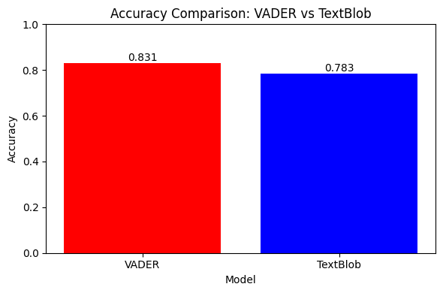
Figure 2.17. Accuracy Comparison: VADER vs TextBlob
This figure compares the overall accuracy of the two lexicon-based models. VADER achieved higher accuracy than TextBlob on the sampled evaluation dataset.
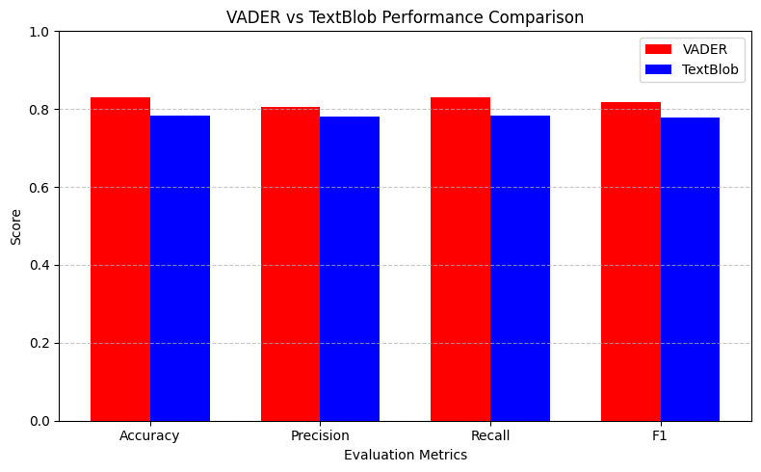
Figure 2.18. Performance Comparison Across Evaluation Metrics
This figure compares Accuracy, Precision, Recall, and F1-score for both models. VADER consistently achieved stronger performance across most evaluation metrics.
- VADER was the best-performing lexicon model.
- Both models performed best on the Positive class.
- Weighted metrics provided a fairer comparison because of class imbalance.
- TextBlob remained a useful baseline but showed weaker overall performance.
Overall, the results indicate that VADER provides the stronger lexicon-based baseline for the Amazon Fashion review dataset and is better suited for review-style sentiment analysis in this project.

2.7 Confusion Matrices
Confusion matrices were used to examine class-level prediction behavior for the two lexicon-based sentiment models. Unlike summary metrics such as accuracy or F1-score, confusion matrices show how many reviews were correctly classified in each sentiment category and where misclassifications occurred. This provides deeper insight into the strengths and weaknesses of each model.

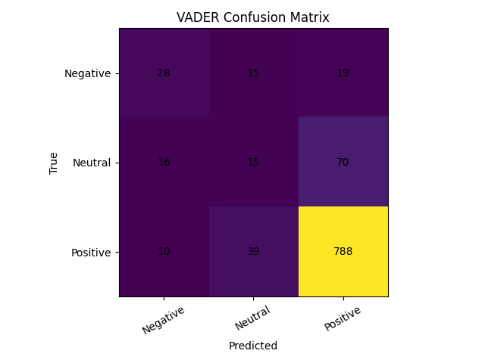
Figure 2.19. Confusion Matrix of VADER
The VADER confusion matrix shows strong performance on the Positive class, with most Positive reviews classified correctly. However, some Neutral and Negative reviews were misclassified as Positive, indicating a tendency to favor the dominant sentiment class.
- Strongest performance: Positive reviews
- Moderate performance: Neutral reviews
- Some Negative reviews predicted as Positive
- Better overall balance than TextBlob

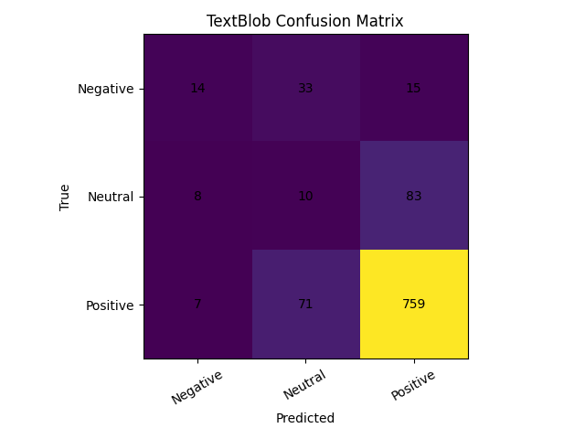
Figure 2.20. Confusion Matrix of TextBlob
The TextBlob confusion matrix also shows strongest performance on the Positive class, but weaker performance on Negative and Neutral reviews. It produced more confusion between minority classes and Positive reviews compared with VADER.
- Strongest performance: Positive reviews
- Weaker detection of Neutral reviews
- More errors on Negative class
- Greater bias toward Positive predictions
Both models performed best on the Positive class because Positive reviews dominate the dataset. Minority classes, especially Neutral reviews, were more difficult to classify because they contain weaker or less explicit sentiment signals. Overall, VADER demonstrated better class-level performance and fewer severe misclassifications than TextBlob.

2.8 Discussion
The results of Phase 1 show that lexicon-based sentiment analysis can provide an effective and interpretable baseline for classifying Amazon Fashion reviews. Both VADER and TextBlob were able to capture general sentiment patterns from review text, but their performance differed across evaluation metrics and sentiment classes.
Aspect | Observation
Best Model | VADER
Main Strength | Interpretable and efficient baseline
Main Challenge | Class imbalance
Weakest Area | Neutral and subtle sentiment detection
Next Step | Compare with machine learning models
Table 2.19. Summary of Phase 1 Findings
Overall, VADER provides the stronger lexicon-based baseline for this project, while TextBlob remains a useful reference model. The findings of Phase 1 highlight both the usefulness and the limitations of rule-based sentiment analysis for real-world review data.

3. Phase 2 - Machine Learning Sentiment Analysis and Advanced Applications

11. Modeling (Sentiment Analysis) – Machine Learning Approach

11.a Data Selection
A subset of the original dataset was selected to perform the machine learning analysis. A total of 2500 reviews were randomly sampled from the dataset to ensure computational efficiency while maintaining sufficient data for training and evaluation.
Random sampling was performed using a fixed random seed to ensure reproducibility. Additionally, the subset was validated by checking the class distribution of sentiment labels.
The resulting dataset distribution was:
Sentiment Label | Count | Percentage
Positive | 2066 | 82.64%
Neutral | 260 | 10.40%
Negative | 174 | 6.96%
Total | 2500 | 100.00%
Table 11.a. Class distribution of the selected Phase 2 subset (2500 reviews).
This indicates a class imbalance, with a strong dominance of positive reviews, this imbalance is important because it can influence model behavior, particularly causing models to favor the dominant class.

11.b Data Exploration and Preprocessing
Exploratory analysis was conducted to evaluate the quality and structure of the subset. This included examining class distribution and review length.
The following preprocessing steps were applied:
- Removal of missing values: Ensures data quality and avoids training issues
- Lowercasing text: Reduces feature dimensionality by normalizing words
- Removal of URLs: Eliminates irrelevant noise from the text
- Whitespace normalization: Ensures consistent formatting
- Label creation: Converts ratings into sentiment categories (Positive, Neutral, Negative)
These preprocessing steps ensure that the data is clean and suitable for machine learning models.

11.c Text Representation
Text was represented using TF-IDF
TF-IDF converts text into numerical feature vectors by assigning weights to words based on their importance in a document relative to the dataset.
TF-IDF was selected because:
- It reduces the impact of common words
- Highlights meaningful terms
- Is computationally efficient
- Performs well with linear models such as Logistic Regression and SVM

11.d Train -Test Split
The dataset was divided using a 70% training set and 30% testing set through train_test_split() with stratified sampling based on the sentiment labels.
This produced:
- Training samples: 1750
- Testing samples: 750
Stratification was applied using stratify = y_all to preserve the original class distribution in both subsets.
The resulting label proportions were:
Class | Training Set | Testing Set
Positive | 82.63% | 82.67%
Neutral | 10.40% | 10.40%
Negative | 6.97% | 6.93%
Table 11.d. Hyperparameter optimization results using GridSearchCV (3-fold cross-validation, weighted F1-score).
These nearly identical distributions confirm that the split was balanced and representative. This is important for imbalanced datasets because it prevents biased evaluation and ensures reliable model testing.

11.e Model Development
Two machine learning models were selected:
Five machine learning models were selected, trained, and optimized using GridSearchCV with 3-fold cross-validation. Weighted F1-score was used as the optimization metric because the dataset is imbalanced and this metric provides fair evaluation across all sentiment classes.
The selected models were:

Logistic Regression
Logistic Regression is a linear classification model widely used in text classification because of its simplicity, interpretability, and strong performance with TF-IDF features.

Support Vector Machine (SVM)
SVM is highly effective for high-dimensional text data such as TF-IDF vectors. It works by finding an optimal decision boundary between classes.

Multinomial Naïve Bayes
Naïve Bayes is a probabilistic classifier commonly used for text classification. It is fast and performs well on count-based or weighted text features.

Gradient Boosting
Gradient Boosting is an ensemble learning method that combines weak learners to create a stronger predictive model.

Multi-Layer Perceptron (MLP)
MLP is a neural network classifier capable of learning more complex decision boundaries from the feature space.
Model | Best Parameters | Best CV F1 (Weighted)
Logistic Regression | C = 2.0 | 0.9771
LinearSVC | C = 1.0 | 0.9842
MultinomialNB | alpha = 0.5 | 0.9148
Gradient Boosting | learning_rate = 0.1, n_estimators = 80 | 0.9808
MLPClassifier | hidden_layer_sizes = (100,) | 0.9848
Table 11.e. Hyperparameter optimization results using GridSearchCV (3-fold cross-validation, weighted F1-score).
The results show that MLPClassifier achieved the highest cross-validation score, followed closely by LinearSVC and Gradient Boosting. Multinomial Naïve Bayes produced the lowest score, indicating lower suitability for this dataset.

12. Training Results
During training, both models achieved high performance:
- Logistic Regression: approximately 98.5% accuracy
- SVM: approximately 99.6% accuracy
These results indicate that both models were able to learn meaningful patterns from the dataset.
However, the near-perfect accuracy observed for SVM may suggest a slight risk of overfitting, meaning the model may be highly tailored to the training data.

13. Testing and Evaluation
The trained models were evaluated using the test dataset (30%) based on the following metrics:
- Accuracy
- Precision
- Recall
- F1-score
- Confusion Matrix

13.1 Logistic Regression Results
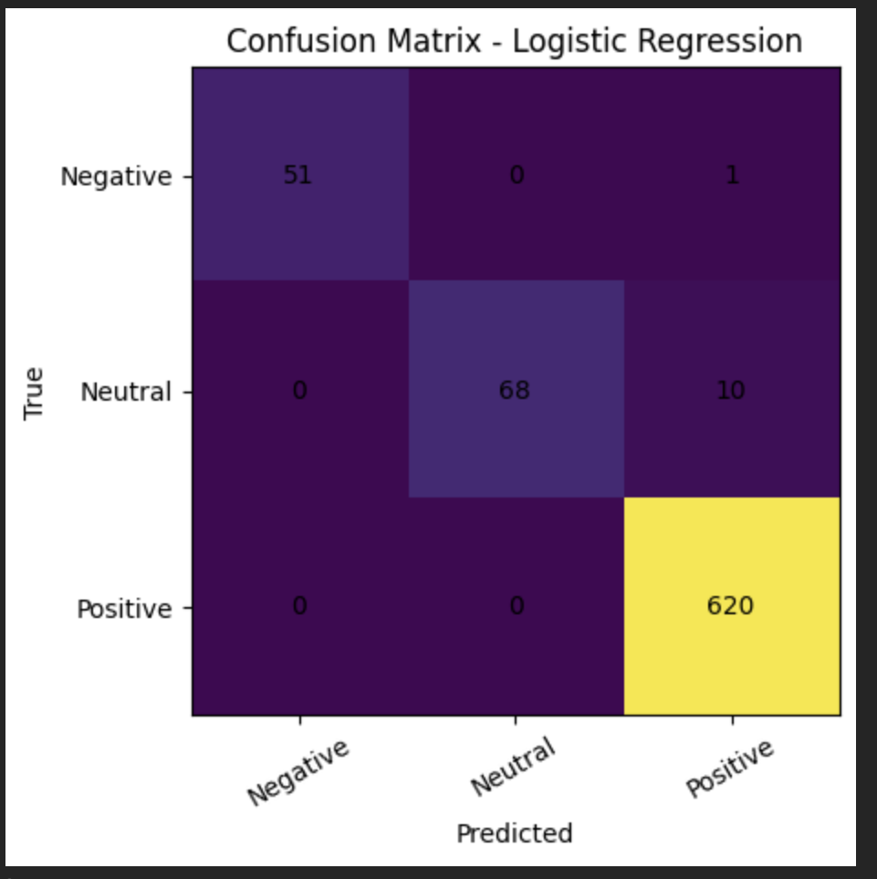
Figure 13.1. Confusion Matrix – Logistic Regression
The confusion matrix shows that:
- 51 negative reviews were correctly classified as Negative
- 68 neutral reviews were correctly classified as Neutral
- 620 positive reviews were correctly classified as Positive
- The main error occurred when 10 Neutral reviews were misclassified as Positive
- One Negative review was also misclassified as Positive
Logistic Regression has performed very well overall. It has classified the Positive and Negative classes very accurately. However, there is a slight tendency for it to classify the Neutral reviews as Positive, this is not unexpected, considering the large class imbalance. Even so, the model is very reliable.

13.2 SVM Results
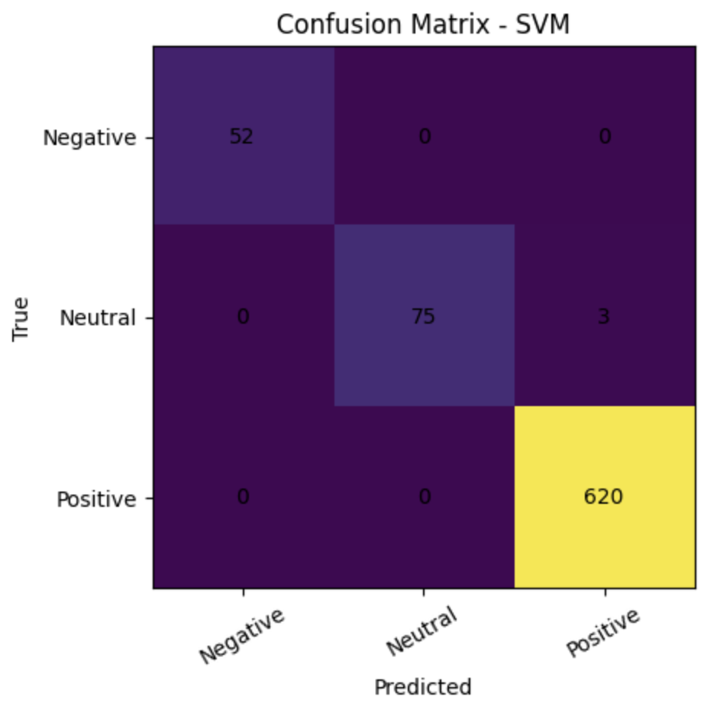
Figure 13.2. Confusion Matrix – Support Vector Machine (SVM)
The confusion matrix indicates:
- Nearly all predictions are correct
- Very few misclassifications across all classes
- Improved classification of Neutral reviews compared to Logistic Regression
SVM achieves near-perfect performance and demonstrates excellent generalization, SVM correctly classified all the Negative and Positive reviews in the test set, and it made only a small number of mistakes in the Neutral class, this proves that SVM works extremely well with high-dimensional TF-IDF features and can generalize extremely well.

13.3 Naïve Bayes
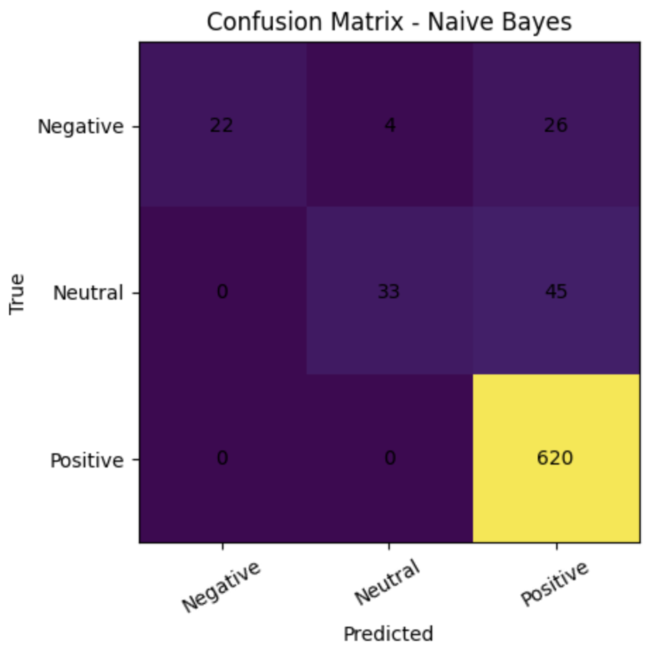
Figure 13.3. Confusion Matrix – Naïve Bayes
The Naïve Bayes confusion matrix shows:
- 22 negative reviews were correctly classified
- 33 neutral reviews were correctly classified
- 620 positive reviews were correctly classified
- 26 Negative reviews were misclassified as Positive
- 45 Neutral reviews were misclassified as Positive
Naïve Bayes was the weakest model among the five. Its main issue is a strong bias toward the Positive class, this is likely caused by the dataset imbalance, where Positive reviews dominate the subset. As a result, the model struggled to distinguish Negative and Neutral reviews and frequently predicted them as Positive. Although it classified Positive reviews perfectly, its poor performance on minority classes significantly reduced its overall usefulness.

13.4 Gradient Boosting
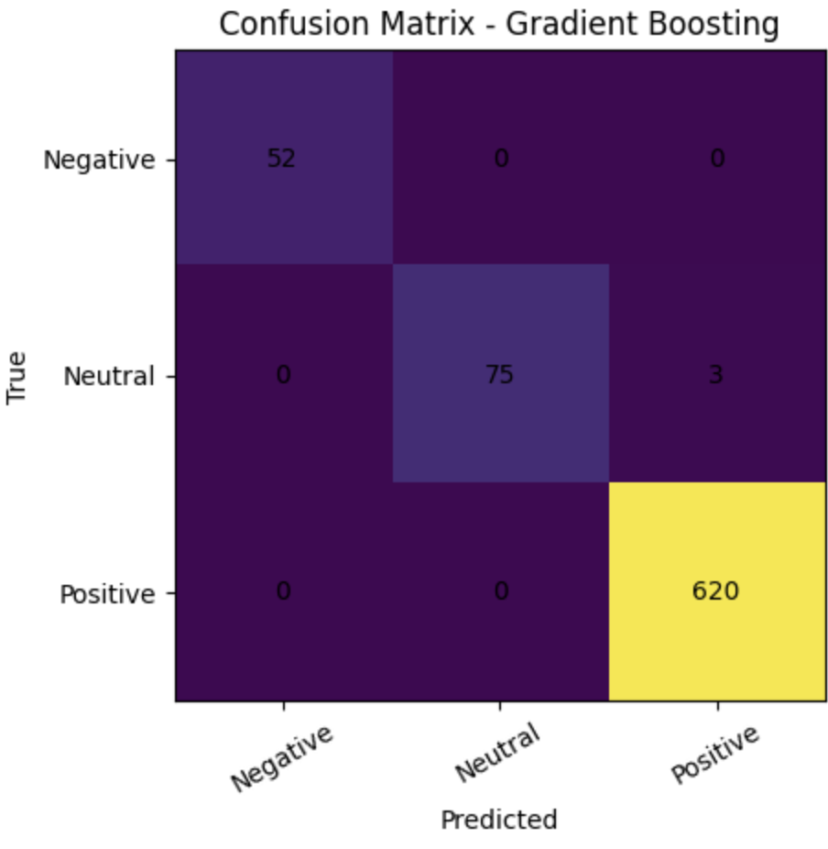
Figure 13.4. Confusion Matrix – Gradient Boosting
The Gradient Boosting confusion matrix shows:
- 52 negative reviews were correctly classified
- 75 neutral reviews were correctly classified
- 620 positive reviews were correctly classified
- Only 3 Neutral reviews were misclassified as Positive
Gradient Boosting achieved the same test performance as SVM. Its confusion matrix shows almost perfect classification, with only minimal error in the Neutral class. This indicates that the model was able to learn highly effective decision patterns. However, compared to SVM, Gradient Boosting required much longer training time, making it less efficient despite its excellent accuracy.

13.5 MLP
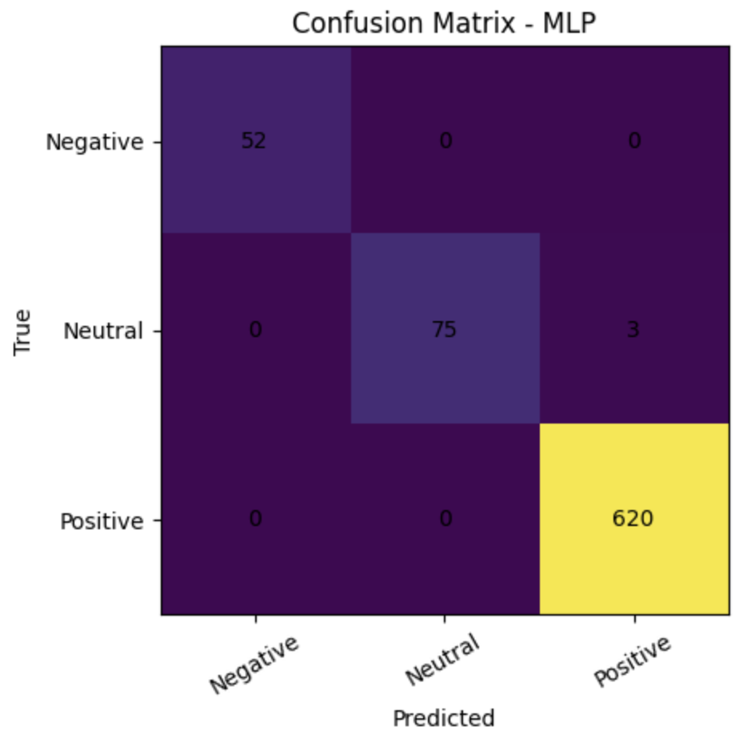
Figure 13.5. Confusion Matrix – Multi-Layer Perceptron (MLP)
The MLP confusion matrix shows:
- 52 negative reviews were correctly classified
- 75 neutral reviews were correctly classified
- 620 positive reviews were correctly classified
- Only 3 Neutral reviews were misclassified as Positive
The MLP model also achieved the same performance as SVM and Gradient Boosting. It classified nearly all reviews correctly and showed only minor confusion in the Neutral class. This demonstrates that a neural network can perform very well on this task. However, its performance advantage over simpler models is limited, especially considering that SVM achieved the same accuracy with lower training cost.

13.6 Findings from Model Evaluation
The test results suggest three main findings.
- SVM, Gradient Boosting, and MLP are the strongest-performing models on this dataset, each achieving extremely high scores across all evaluation metrics.
- Logistic Regression remains a highly effective and efficient model, with only a small performance gap relative to the best models.
- Naïve Bayes is clearly the least suitable model in this setting because it struggles with class imbalance and tends to over-predict the Positive class.
From a practical perspective, SVM appears to be the best choice because it combines excellent predictive performance with very fast training time.

14. Experiment: Lexicon vs Machine Learning

14.a Experimental Design
To ensure a fair comparison, the same test dataset was used for both:
- Lexicon-based models: VADER and TextBlob
- Machine learning models: SVM and MLP
This created an apples-to-apples comparison, since every model was evaluated on the exact same reviews.
model | accuracy | precision_w | recall_w | f1_w
MLP | 0.996000 | 0.996019 | 0.996000 | 0.995966
LinearSVC | 0.996000 | 0.996019 | 0.996000 | 0.995966
VADER | 0.797333 | 0.784866 | 0.797333 | 0.790828
TextBlob | 0.770667 | 0.769759 | 0.770667 | 0.766457
Table 14.1. Performance Comparison: Lexicon vs Machine Learning Models

This comparison clearly shows that the performance of the machine learning models is much better than the lexicon-based models. The performance of the SVM and MLP models was almost perfect, while the VADER and TextBlob models performed below 0.80.
This difference highlights an important finding: : machine learning models learn patterns directly from the dataset, while lexicon-based models rely on fixed sentiment rules. Because of this, lexicon approaches struggle more with contextual meaning, ambiguous language, and class imbalance.

14.c VADER
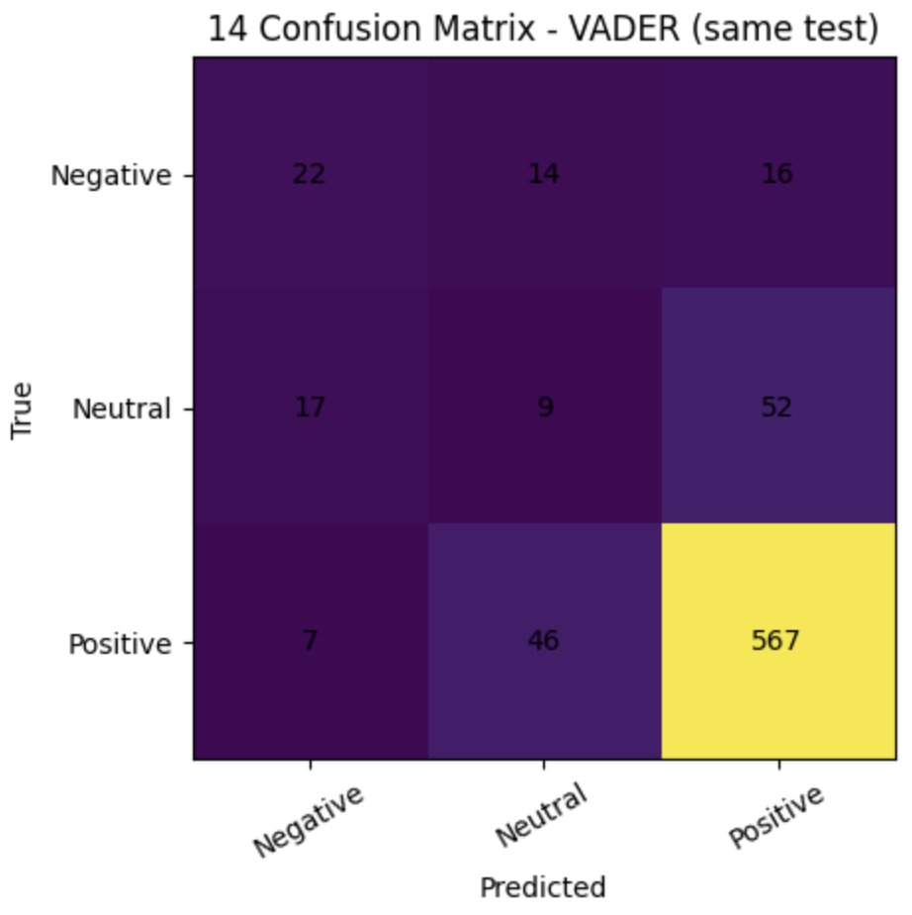
Figure 14.1. Confusion Matrix – VADER (Shared Test Dataset)
The VADER confusion matrix shows:
- 22 Negative reviews correctly classified
- 9 Neutral reviews correctly classified
- 567 Positive reviews correctly classified
- Many Neutral and Negative reviews were incorrectly classified as Positive
- 46 Positive reviews were also misclassified as Neutral
VADER performs moderately well on Positive reviews but struggles substantially with Negative and Neutral classes. Its rule-based design is not flexible enough to capture the specific language patterns of this review dataset. As a result, it often over-predicts positive sentiment.

14.d TextBlob
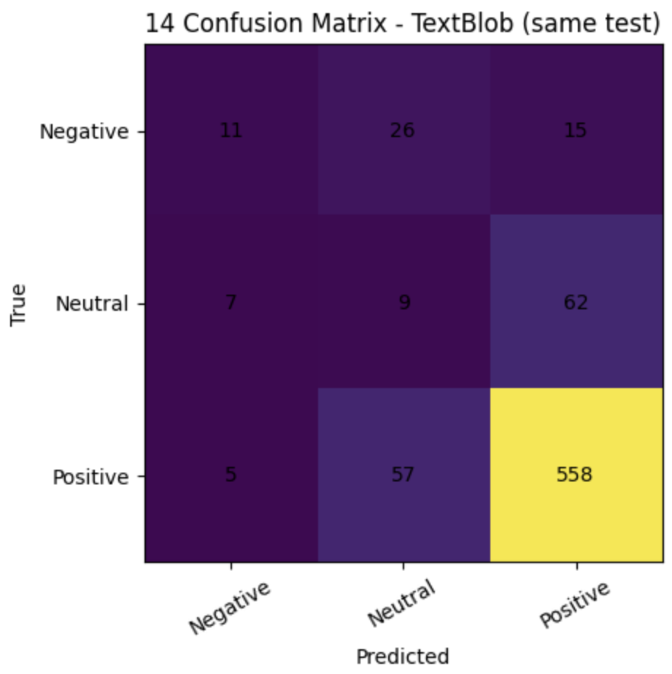
Figure 14.2. Confusion Matrix – TextBlob (Shared Test Dataset)
The TextBlob confusion matrix shows:
- 11 Negative reviews correctly classified
- 9 Neutral reviews correctly classified
- 558 Positive reviews correctly classified
- Many Negative and Neutral reviews were again misclassified as Positive or Neutral
TextBlob performed worse than VADER. It showed even lower ability to correctly classify Negative reviews and also struggled heavily with Neutral reviews. This suggests that its polarity-based approach is too simplistic for this dataset and lacks the contextual sensitivity needed for accurate sentiment classification.

14.e Final Findings from the Comparison
This experiment leads to a clear conclusion: machine learning models are substantially more effective than lexicon-based approaches for this sentiment analysis task.
The best-performing machine learning models, SVM and MLP, achieved almost perfect results on the same test data where VADER and TextBlob made many classification errors. This demonstrates that data-driven models are better suited for product review sentiment analysis, especially when the language is domain-specific and the class distribution is imbalanced.

15. Enhancing Rating Values Using Review Data

15.a Enhancing Ratings with Review Text
User ratings do not always fully reflect the sentiment expressed in the review text. For example, a review may contain strongly positive language while the user assigns a moderate rating, or a review may sound negative despite having a high rating. Because of this, review text can be used to refine rating values and make them more consistent with user opinion.
In this project, review text was used as an additional signal to enhance rating values. A sentiment prediction generated by the machine learning model was combined with the original numerical rating. Positive sentiment increased the rating, negative sentiment decreased it, and neutral sentiment kept the rating unchanged. This approach improves alignment between structured ratings and unstructured textual feedback.

15.b Selected Option, Diagram, and Pseudo-code
The selected option was a rating adjustment approach based on predicted sentiment. This method is simple, interpretable, and appropriate for demonstrating how review text can enhance recommendation data.

Pseudo-code
For each review:
predict sentiment using the trained ML model
if predicted sentiment is Positive:
increase rating by 1
else if predicted sentiment is Negative:
decrease rating by 1
else:
keep rating unchanged
keep rating within the 1 to 5 range

15.c Implementation and Results
This method was implemented using the predicted sentiment from the SVM model. Each review in the test set was matched with its original rating, and a delta value was assigned:
Predicted Sentiment | Rating Adjustment
Positive | Increase by 1
Neutral | No change
Negative | Decrease by 1
Table 15.c.1. Sentiment adjustment values.
After adjustment, all enhanced ratings were limited to the valid range of 1 to 5.
Metric | Value
Original Mean Rating | 4.4536
Enhanced Mean Rating | 4.5339
Number of Test Reviews | 4855
Table 15.c.2. Rating Enhancement Results Summary

Key Findings
- The enhancement aligned ratings more closely with the sentiment expressed in the review text.
- Reviews with inconsistent rating-text combinations were corrected in a simple and interpretable way.
- This approach can improve downstream systems such as recommender systems by making user feedback more consistent.

16. LLM Review Summarization
Ten reviews longer than 100 words were selected from the dataset and summarized into approximately 50 words using a locally hosted Hugging Face model. The implementation used a sequence-to-sequence transformer model, google/flan-t5-base, to generate summaries. A single shared model was selected for both LLM tasks to keep the workflow consistent while improving output quality compared with smaller baseline models.
Each review was processed using an instruction-based prompt requesting a concise summary that includes the overall sentiment, one product strength, and one issue. The generated summaries were then limited to approximately 50 words and saved to an output file.

Summarization Results
The summarization results showed that the model was able to reduce long reviews into shorter and more readable versions while preserving the main opinion and key product-related information.

Summarization Key Findings
- Long customer reviews were successfully condensed into shorter summaries.
- Important sentiment and product details were retained in the generated outputs.
- The selected model produced clearer summaries than smaller baseline models.
- This demonstrates a practical use of LLMs for automatic review summarization.

17. LLM Response Generation
One review containing a question-like structure was selected from the dataset, and a response was generated automatically using a locally hosted Hugging Face model. The implementation searched for a review containing a question mark and then used the same shared model, google/flan-t5-base, to generate a professional customer service reply.
An instruction-based prompt was used to produce a polite and helpful response. The generated output was formatted into exactly three sentences and saved to an output file.

Response Generation Results
The generated response addressed the customer review in a helpful and professional tone, simulating a realistic service representative reply.

Response Generation Key Findings
- The generated response was relevant to the customer review context.
- The tone was polite and appropriate for customer service communication.
- This demonstrates a practical NLP application for automated support systems.

4. Conclusion
The project was able to create an end-to-end sentiment analysis and NLP pipeline on the Amazon Fashion reviews data in two incremental steps.
Phase 1 In Phase 1, sentiment analysis workflow was deployed as a lexicon-based approach based on VADER and TextBlob. The analysis has started with the exploratory data analysis (EDA) that has indicated that the skew of the ratings is strong and positive, user and product activity are long-tailed, there are duplicates, and the length of the reviews is not uniform. Both lexicon models were assessed after preprocessing and sentiment labeling, and VADER achieved the highest performance compared to TextBlob and offered the best rule-based baseline.
Phase 2 involved the extension of the project through the supervised machine learning techniques. TF-IDF features were used to transform review text, and a variety of classification models were both trained and tested. The machine learning models also were stronger predictors compared to the lexicon models, indicating the advantage of the data-driven approach in sentiment classification.
Other experiments continued to enhance the practical value of the project. These consisted of direct comparison of lexicon and machine learning models, improvement of rating values with review sentiment, review summarization with a locally hosted Hugging Face model, and generation of automated customer responses to in the form of question-like reviews.

5. Assumptions
During the project the following assumptions were made:
- Numerical ratings (1- 5 stars) were considered proxy sentiment labels as ground-truth.
- The overall sentiment polarity is represented in an appropriate manner by mapping ratings into three classes (Negative, Neutral, Positive).
- The lexicon score classification thresholds ( + 0.05 in VADER, + 0.1 in TextBlob) are not based on research but rather on a heuristic and can affect the boundaries of prediction.
- Summary + review_text results in better lexical coverage and sentiment detection results.
- The 1000 reviews selected randomly in Phase 1 are representative of the larger distribution of data.
- The 2500 reviews in the Phase 2 subset are quite representative to train and test machine learning.
- The stratified 70/30 train-test divide maintains the proportions of classes and promotes just assessment.
- The TF-IDF presentation obtains significant textual patterns to be used in supervised classification of sentiments.
- Results of hyperparameter tuning that are achieved using cross-validation are applicable to previously unknown test data.
- The main meaning of the initial reviews is believed to be maintained in generated summaries and automated responses generated by local LLM models.

6. References
Bird, S., Klein, E., & Loper, E. (2009). Natural language processing with Python.
O’Reilly Media.
Hutto, C. J., & Gilbert, E. (2014). VADER: A parsimonious rule-based model for
sentiment analysis of social media text. Proceedings of the International AAAI
Conference on Web and Social Media, 8(1), 216–225.
https://ojs.aaai.org/index.php/ICWSM/article/view/14550
Loria, S. (n.d.). TextBlob: Simplified text processing. https://textblob.readthedocs.io/
McAuley, J. (n.d.). Recommender systems and personalization datasets. University of
California, San Diego. http://jmcauley.ucsd.edu/data/amazon/
Ni, J., Li, J., & McAuley, J. (2019). Amazon review data (2018). University of California,
San Diego. https://nijianmo.github.io/amazon/index.html

7. Appendix 1: Project plan

7.1 Project Objectives
The objective of this project is to construct a sentiment analysis model for Amazon Fashion product reviews using both lexicon-based and machine learning approaches.
Phase 1 focuses on dataset exploration, preprocessing, labeling, lexicon study, implementation of two lexicon-based sentiment classifiers, and validation of model performance using appropriate evaluation metrics.
Phase 2 extended the project through supervised machine learning models, text representation using TF-IDF, model optimization, testing and comparison against lexicon methods, review-based rating enhancement, and LLM applications including summarization and automated customer response generation.
The overall goal of the project was to build a complete, reproducible, and practical NLP pipeline that combines traditional sentiment analysis, machine learning, recommender enhancement concepts, and modern generative AI techniques.

Week | Activities | Status
Week 3 | Dataset selection and familiarization | Completed
Week 4 | Data exploration (EDA), statistics and visualization | Completed
Week 5 | Labeling and text preprocessing design | Completed
Week 6 | Implementation of VADER and TextBlob models | Completed
Week 7 | Model evaluation, comparison and documentation | Completed
Week 8 | Presentation preparation and final submission | Completed
Week 9 | Phase 2 subset selection and preprocessing | Completed
Week 10 | TF-IDF representation and train-test split | Completed
Week 11 | Machine learning model development | Completed
Week 12 | Hyperparameter tuning and training analysis | Completed
Week 13 | Testing, comparison, and rating enhancement | Completed
Week 14 | LLM tasks, final report, and presentation | Completed
Table 7.1. Project Plan and Weekly Progress
Task | Responsible Member | Description
Dataset Exploration  (Phase 1.1 a–g) | Daniela Diaz | Performed statistical analysis including counts, averages, distribution of reviews across products and users, review length analysis, duplicate detection, visualization generation, and EDA findings summary.
Preprocessing & Labeling  (Phase 1.2 a–c) | Maria Paula Nova | Implemented rating-to-sentiment mapping, column selection justification, text cleaning pipeline, quality checks, and outlier handling strategy.
VADER Implementation  (Phase 1.3 & 1.6) | Jaturaput Jongsubcharoen | Studied VADER lexicon, implemented sentiment classification using compound score thresholds, tuned classification boundaries, and validated model behavior.
TextBlob Implementation  (Phase 1.3 & 1.6) | Juan David Barrero | Studied TextBlob lexicon, implemented polarity-based classification, adjusted decision thresholds, and contributed to performance comparison.
Report Writing & Integration  (Phase 1.7 & Report Requirements) | Anmol Shrestha | Generated evaluation metrics (accuracy, precision, recall, F1), confusion matrices, comparison table, discussion analysis, and final documentation formatting.
Table 7.2. Team Roles and Contributions - Phase 1

Task | Responsible Member | Description
Data Selection, EDA, and Preprocessing (Steps 11.a–11.d) | Maria Paula Nova | Selected the 2500-review subset, performed exploratory analysis, applied preprocessing, implemented TF-IDF representation, and completed the stratified train-test split.
Train ML Models and Record Results (Steps 11.e, 12) | Jaturaput Jongsubcharoen | Built and trained machine learning sentiment models, recorded training outputs, and prepared summary result tables.
Model Testing and Evaluation (Step 13) | Daniela Diaz | Tested models on the evaluation set, calculated accuracy, precision, recall, F1-score, generated confusion matrices, and organized charts/tables.
Lexicon vs Machine Learning Comparison (Step 14) | Juan David Barrero | Compared lexicon and machine learning models using the same test data, created comparison tables, and summarized findings.
Recommendation Enhancement and LLM Tasks (Steps 15–17) | Anmol Shrestha | Implemented rating enhancement, recommendation tasks, review summarization, automated response generation, and documented advanced application outputs.
Table 7.3. Team Roles and Contributions - Phase 2

7.4 Tools and Technologies
- Python
- Pandas
- NumPy
- Matplotlib / Seaborn
- NLTK (VADER SentimentIntensityAnalyzer)
- TextBlob
- Scikit-learn
- TF-IDF Vectorizer
- Logistic Regression
- LinearSVC
- Multinomial Naïve Bayes
- Gradient Boosting
- MLPClassifier
- Hugging Face Transformers
- Google FLAN-T5-Base
- Jupyter Notebook / VS Code
All experiments were conducted using reproducible sampling with a fixed random seed.

7.5 Phase 2 Completion Summary
Phase 2 successfully extended the project beyond lexicon-based sentiment analysis by implementing supervised machine learning models and advanced NLP applications. Text data was transformed using TF-IDF features and evaluated using a stratified train-test split. Multiple machine learning models were trained, optimized, and compared against lexicon baselines.
Additional applications were also completed, including review-based rating enhancement, LLM-powered review summarization, and automated customer response generation using a locally hosted Hugging Face transformer model. These tasks demonstrated how sentiment analysis can be integrated with recommender systems and modern generative AI workflows.

8. Appendix 2: Meeting register (simple table showing date and time of each meeting, who attended, subjects discussed and assignments).
Date | Time | Attendees | Topics Discussed | Assigned Tasks
Feb 10, 2026 (Tue) | 7:00 - 7:45 PM | All Team Members | Project overview, dataset understanding, review of Phase 1 requirements | Daniela: EDA statistics; Juan: labeling design; Jaturaput: lexicon study; Maria: preprocessing planning
Feb 12, 2026 (Thu) | 7:30 - 8:15 PM | All Team Members | Initial EDA findings, rating distribution analysis | Daniela: finalize visualizations; Juan: duplicate/outlier checks
Feb 14, 2026 (Sat) | 6:30 - 7:30 PM | All Team Members | Labeling strategy (ratings to sentiment classes), column selection discussion | Maria: implement labeling; Jaturaput: normalization logic
Feb 16, 2026 (Mon) | 7:00 - 8:00 PM | All Team Members | Lexicon selection discussion (VADER vs TextBlob vs SentiWordNet) | Jaturaput: implement VADER;  Juan: implement TextBlob
Feb 18, 2026 (Wed) | 7:15 - 8:15 PM | All Team Members | Model evaluation metrics (accuracy, precision, recall, F1), confusion matrices | Juan: compute metrics  Team: interpret results
Feb 21, 2026 (Sat) | 6:00 - 7:00 PM | All Team Members | Final report review, formatting, presentation preparation | Anmol: finalize documentation and slides
Mar 02, 2026 (Mon) | 7:00 – 8:00 PM | All Team Members | Phase 2 overview, machine learning requirements, dataset subset planning | Maria: data selection & preprocessing; Mac: ML training
Mar 05, 2026 (Thu) | 7:15 – 8:15 PM | All Team Members | TF-IDF representation, train-test split, model setup discussion | Maria: TF-IDF + split; Mac: Logistic Regression / Naïve Bayes
Mar 09, 2026 (Mon) | 7:00 – 8:00 PM | All Team Members | Training progress review and summary outputs | Jaturaput: training tables; Team: review progress
Mar 12, 2026 (Thu) | 7:00 – 8:15 PM | All Team Members | Testing metrics, confusion matrices, evaluation planning | Daniela: testing & charts
Mar 16, 2026 (Mon) | 7:00 – 8:00 PM | All Team Members | Lexicon vs ML comparison using same test data | Juan: comparison table and conclusion
Mar 19, 2026 (Thu) | 7:15 – 8:15 PM | All Team Members | Rating enhancement, recommendation logic, LLM tasks planning | Anmol: Steps 15–17 implementation
Mar 23, 2026 (Mon) | 7:00 – 8:30 PM | All Team Members | Final report integration, Phase 2 review, presentation preparation | All members finalize deliverables
Table 8.1. Project Meeting Register

