| Experiment No.6 |
| --- |
| Implement a knowledge base for a medical diagnosis system using Prolog. |
| Date of Performance: 18/03/25 |
| Date of Submission: 25/03/25 |

**Aim:** Implement a knowledge base for a medical diagnosis system using Prolog.

**Objective:** Create a mdeical diagnosis knowledge base using AI language.

# Software Required:

* SWI-Prolog or any Prolog interpreter

**Theory:** Prolog is a logic programming language commonly used for artificial intelligence and expert systems. In this experiment, we will design a knowledge base that can diagnose common diseases based on symptoms provided by the user. The system will use Prolog rules and facts to infer a diagnosis.

# Procedure:

1. **Install SWI-Prolog:** Ensure that SWI-Prolog is installed on your system.
2. **Create a Prolog file:** Open a text editor and save the file with a .pl extension, e.g., medical_diagnosis.pl.
3. **Define the Knowledge Base:** List symptoms and corresponding diseases using facts and rules.
4. **Implement the Rule-based System:** Use conditional rules to infer the disease based on symptoms.
5. **Query the System:** Use Prolog queries to test the diagnosis system.

# Code Implementation:

% Facts defining diseases and their symptoms symptom(flu, fever).

symptom(flu, cough). symptom(flu, headache). symptom(common_cold, sneezing).

symptom(common_cold, runny_nose). symptom(common_cold, sore_throat). symptom(covid_19, fever). symptom(covid_19, cough). symptom(covid_19, loss_of_taste).

% Rule to diagnose disease based on symptoms diagnose(Disease) :-

symptom(Disease, Symptom1), symptom(Disease, Symptom2),

write('The patient may have '), write(Disease), nl.

% Sample Query

% ?- diagnose(Disease).

# Expected Output:

?- diagnose(Disease). The patient may have flu.

# Observations:

* The system successfully identifies a disease based on the symptoms provided.
* If multiple diseases share symptoms, the system may return multiple possible diagnoses.

**Your Program Code:**

% Facts defining diseases and their symptoms

symptom(flu, fever).

symptom(flu, cough).

symptom(flu, headache).

symptom(common_cold, sneezing).

symptom(common_cold, runny_nose).

symptom(common_cold, sore_throat).

symptom(covid_19, fever).

symptom(covid_19, cough).

symptom(covid_19, loss_of_taste).

% Rule to diagnose disease based on symptoms

diagnose(Disease) :-

symptom(Disease, Symptom1),

symptom(Disease, Symptom2),

Symptom1 \= Symptom2, % Ensure the symptoms are distinct

write('The patient may have '), write(Disease), nl.

% Rule to check for multiple diagnoses based on symptoms

diagnose_multiple :-

diagnose(Disease),

fail. % Forces Prolog to backtrack and find all possible solutions

diagnose_multiple. % Stops when no more diseases can be found

% Initialization goal to execute the diagnosis

:- initialization(diagnose_multiple).

**Output:**

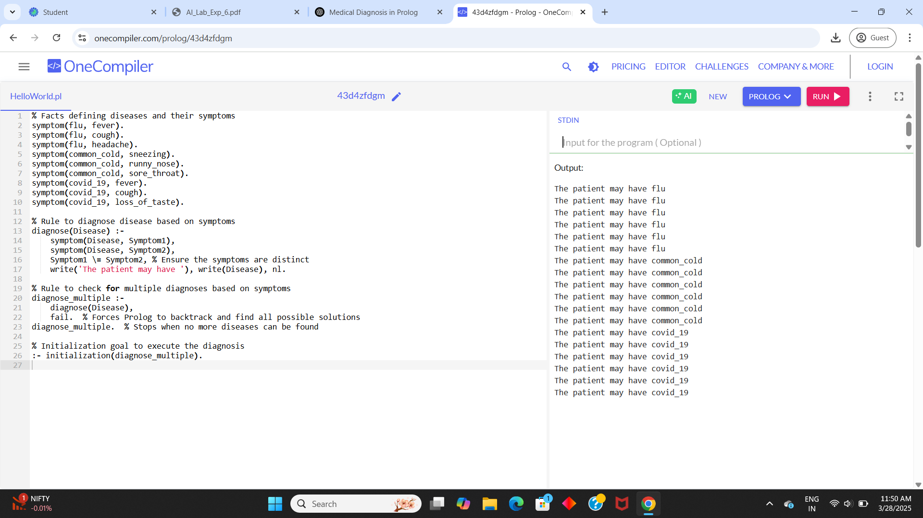

**Conclusion:**

This basic Prolog knowledge base demonstrates how symptoms can be associated with diseases, enabling diagnosis by matching symptoms to rules. It can be expanded for complex medical cases by adding more symptoms, diseases, and rules for comprehensive diagnostic capabilities.